**CAMPUS RESOURCE MANAGEMENT SYSTEM**

Subject: System Analysis and Design

Code: SECD2613

Section: 07

Prepared by

Abdalla Ali Abdalla Ali A23CS3022

EYAD AIMEN ELSHEIKH KHALIL A23CS3024

Othman Hassan Othman A23CS3026

Ali Isameldin Ali A23CS3001

23rd of APRIL

**Introduction:**

The management of the university recognized some issues in the current system related to students, teachers and staff members. So, the management decided to do some changes to solve the current problem.

This project is designed to solve this university systems issues. The main focus of the project is to deliver IS that handles the large amount of data and automates most of the processes to reduce errors.

**Problem statement:**

The current system suffers from frequent input errors and delaying of processes and the system output is usually similar or close to its input due to lack of critical processes. The system also lacks some essential technical hardware equipment, while depending mainly on human workforce without much computerized intervention.

Not to mention that the system is difficult to use for new users.

**Issues:**

1. A lot of manual processes.
2. Many inputs error.
3. Many human interventions.
4. Incorrect output.
5. Redundant storage.

**Scope:**

The project main focus is to solve problems in these areas (by creating computerized subsystem for each area):

1. Facility and booking management.

* Developing the reservation and booking management by installing a new software hardware system.

1. Event management.

* Enhancing the event management by modifying and automating some processes and develop a new user interface.

1. Student management.

* Develop a new website for students to register for the university and use the same website to manage the requests by staff.

1. Communication and notification.

* Add new ways to communicate with different stakeholders including teachers, students, and etc…

**Objective:**

1. Automate all the manual processes.
2. Minimize and detect input errors.
3. Minimize human intervention.
4. Reduce output errors.
5. Reduce redundant storage.

**Proposed solution:**

To develop more advanced subsystems that can function together to maximize the output of the program, reduce the input errors, speed up the processes and can ease the management processes.

|  |
| --- |
| Technical feasibility:   * **the technical hardware and software resources in the old system are not sufficient, new hardware equipment should be purchased.** * **This time the university will rely on their last year students and post graduates to develop the software rather than purchasing a new software package** |
| Operational resources:   * **The required human resources of software engineering, I.T. specialists and system analysts will be available to operate once the system is installed and the user's feedback will be obtained.** * **The users are happy with the change since it will decrease the effort when doing their work, so they will use the new system.** |
| Economical resources:  **Estimated development costs:**  **Cost of hardware = 20000$**  **Cost of software development = 10000$**  **Installation cost = 5000$.**  **Training cost = 5000$.**  **Data conversion cost = 7500$.**  **Estimated production costs:**  **Cost of upgrades = 500$ PER/YEAR.**  **Cost of system maintenance = 2000$ PER/YEAR.**  **Salaries of I.T. specialists and software engineers = 20000$**  **Estimated benefits:**  **Increase productivity = 50000$**  **Improved service = 25000$**  **(For PV analysis, the discount rate is 20%)** |

**Cost Benefit Analysis (CBA):**

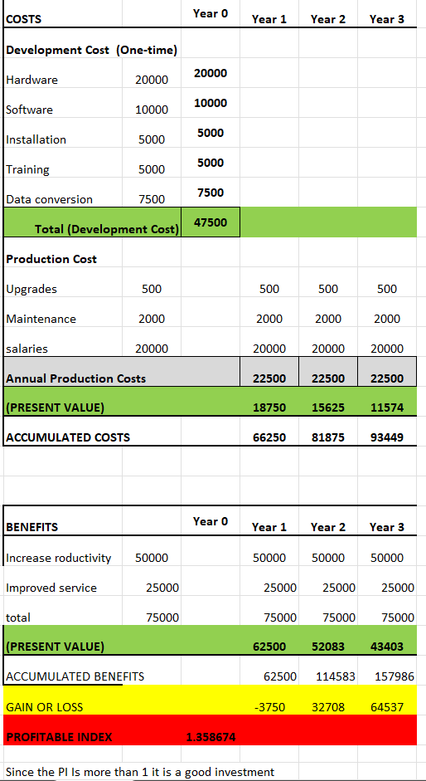

**Project planning:**

1. **Human resources:**

**The project will have 5 teams, the first 4 teams will work on each subsystem and the last team will mainly ensure clear communication between the other teams that may I interact during the project duration. Each team will have a leader that will manage them and ensure they are on track.**

1. **Work Break down Structure (WBS):**

|  |  |  |
| --- | --- | --- |
| 1.identify the Problem: | Duration in weeks | Predecessors |
| 1.1 gather information. | 2 | none |
| 1.2 Analyze the information | 3 | 1.1 |
| 1.3 Determine the problems and objectives | 1 | 1.2 |
| 2. Determine the resources: |  | 1 |
| 2.1 Determine and gather the required resources. | 4 | 1.3 |
| 2.2 Assess human resources. | 4 | 1.3 |
| 3. hardware deployment: |  | 2 |
| 3.1 Identify the required hardware. | 2 | 2.1 and 2.2 |
| 3.2 Purchase the required hardware | 2 | 3.1 |
| 4. software development: |  | 2 |
| 4.1 Analyze the required software | 3 | 2.1 and 2.2 |
| 4.2 Develop the required software | 7 | 4.1 |
| 5. software testing |  | 4 |
| 5.1 Test the new software | 2 | 4.2 |
| 5.2 Test the system on users | 1 | 5.1 |
| 6. system installation: |  | 5 |
| 6.1 Install the new system | 4 | 5.2 |
| 6.2 Evaluate the new system | 2 | 6.1 |
| 6.3 Get the user feedback  6.4 Data conversion to the new system  6.5 System integration | 1  2  2 | 6.2  6.2  6.4 |

