Name: Eyad Mohamed Abdelmohsen Ghanem
Homework 8
Design a 8×1 multiplexer using two 4×1 multiplexers and 2×1 multiplexer:
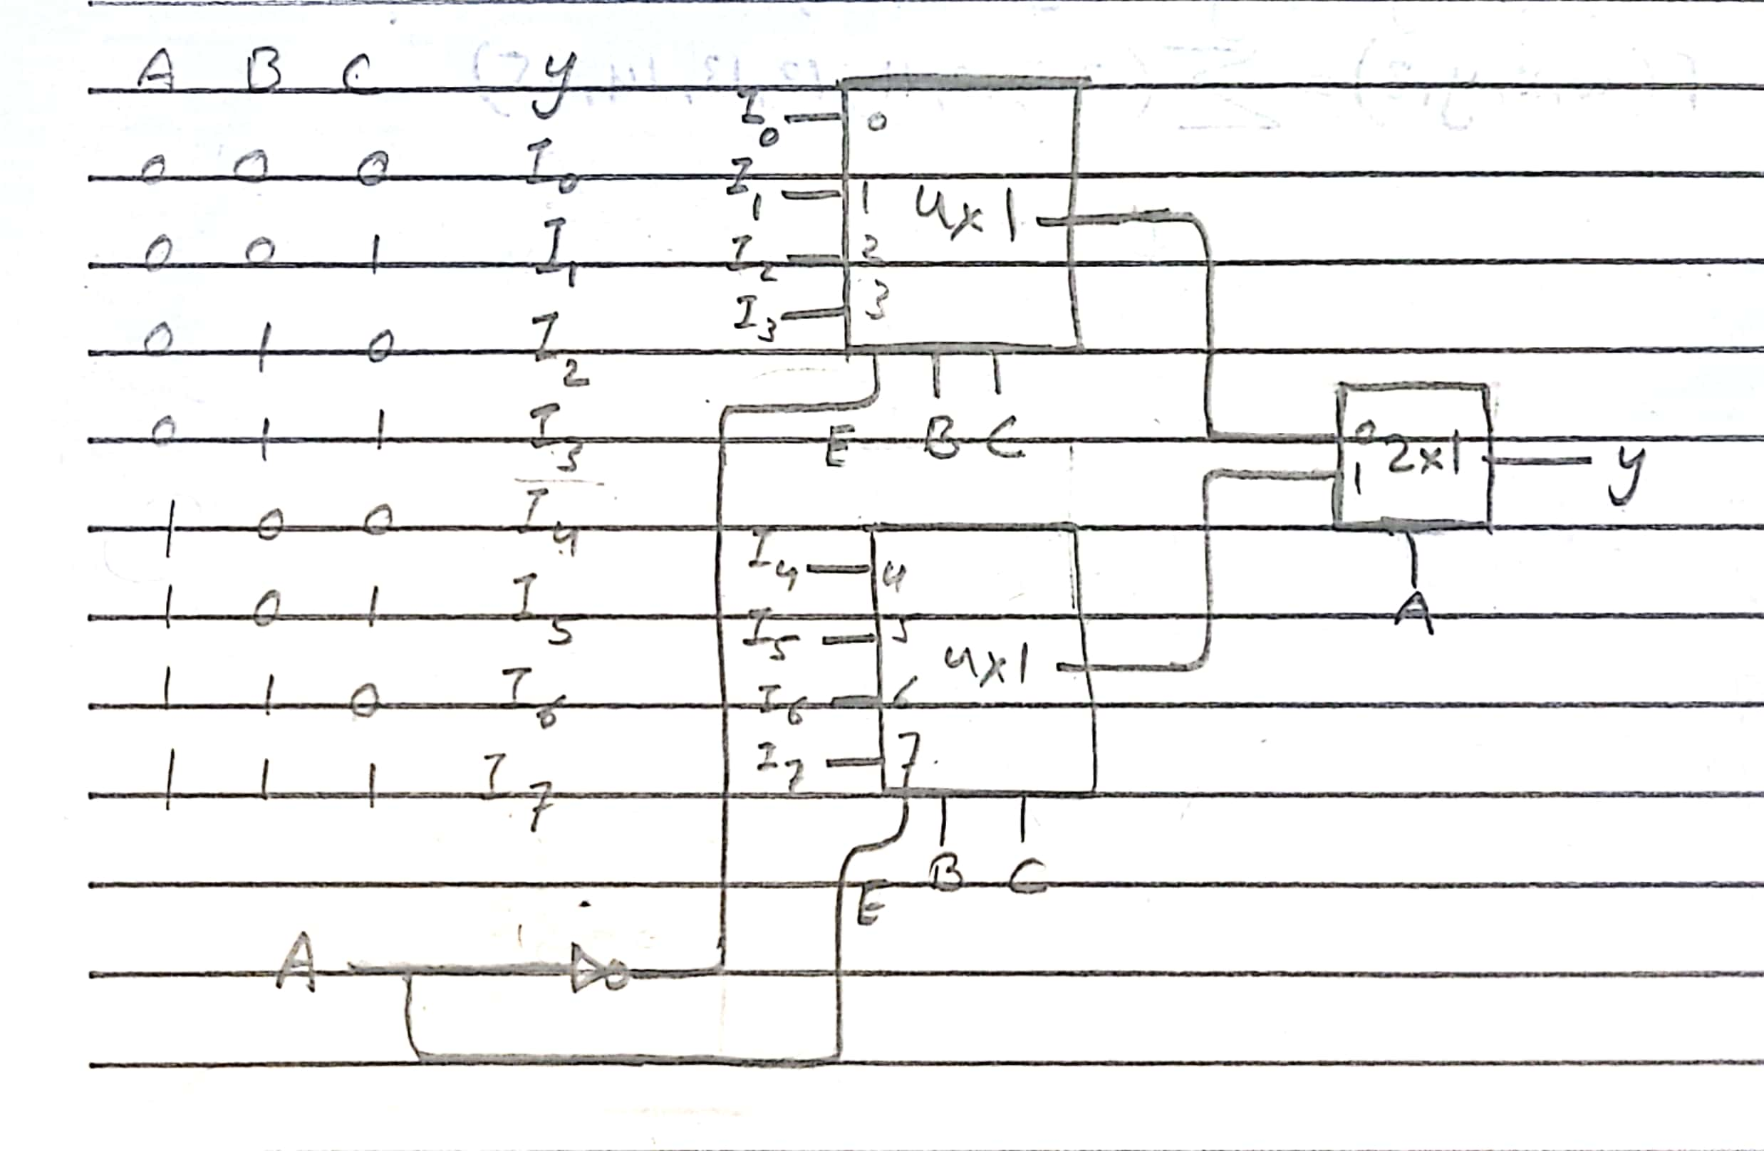
Implement the following using a 8×1 multiplexer:
$$F\left(w, x, y, z\right)= \sum{\left(2, 3, 10, 11, 12, 13, 14, 15\right)}$$
