Name: Eyad Mohamed Abdelmohsen Ghanem
Homework 3
Draw the logical diagrams for the following Boolean expressions:
- Y = A`B` + B(A+C)
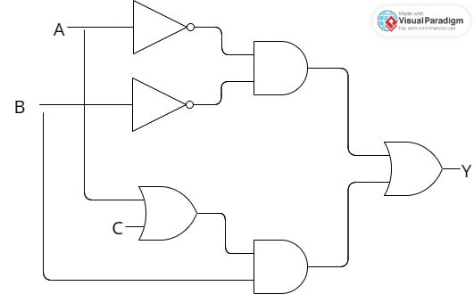
- Y = BC + AC`
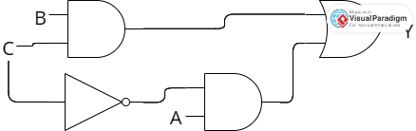
- Y = A + CD
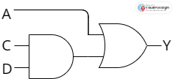
- Y = (A+B)(C`D)
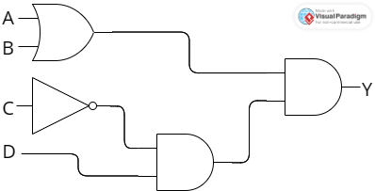
Problem 1-34:
Assume a 3-input AND gate with output F and a 3-input OR gate with G output.
Show the signals of the outputs F and G as functions of the three inputs ABC. Use all 8 possible combinations of ABC.

