Eyad Mohamed AbdelMohsen Ghanem
Project
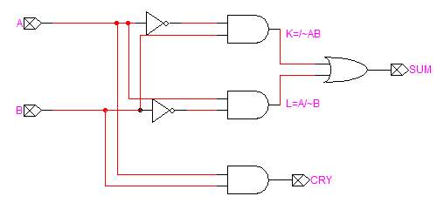
1_5_HA_1
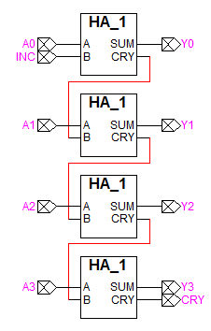
1_8_INC_4
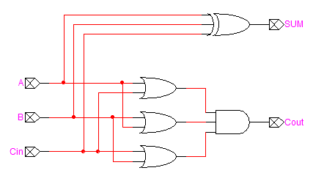
2_13_FA_1
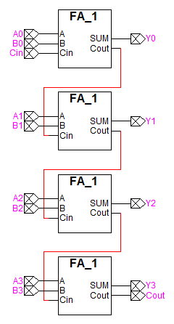
2_17_FA_4
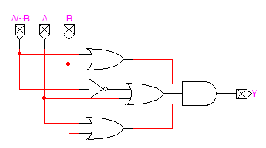
2_18_MUX_1
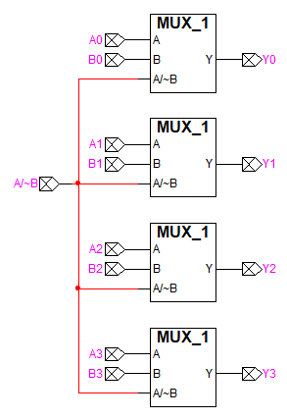
2_21_MUX_4
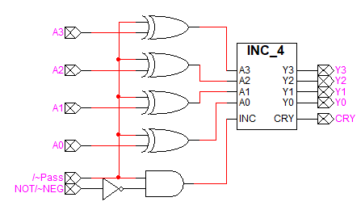
3_2_NOT_NEG
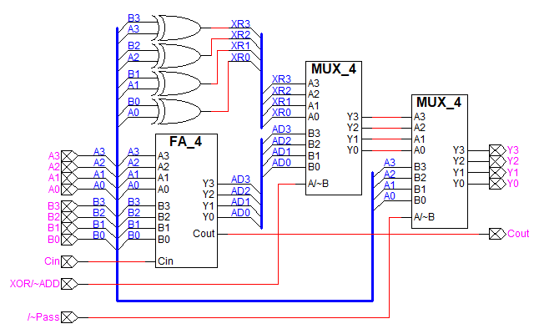
3_5_XOR_ADD circuit with pass-through

3_7_ALU
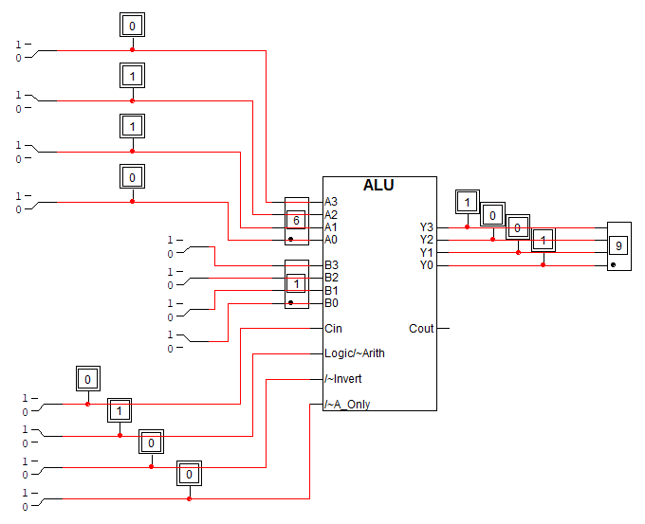
3_7_ALU_TESTING
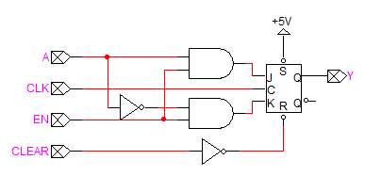
4_2_REG_1
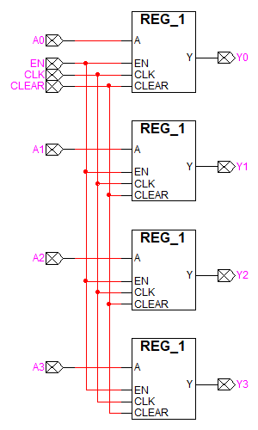
4_2_REG_4
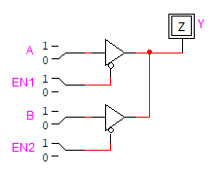
4_5_Three-state buffer circuit
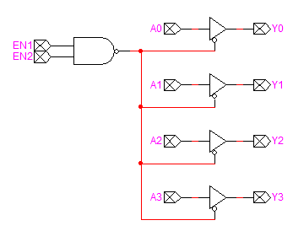
4_6_Three-state 4-bit buffer circuit
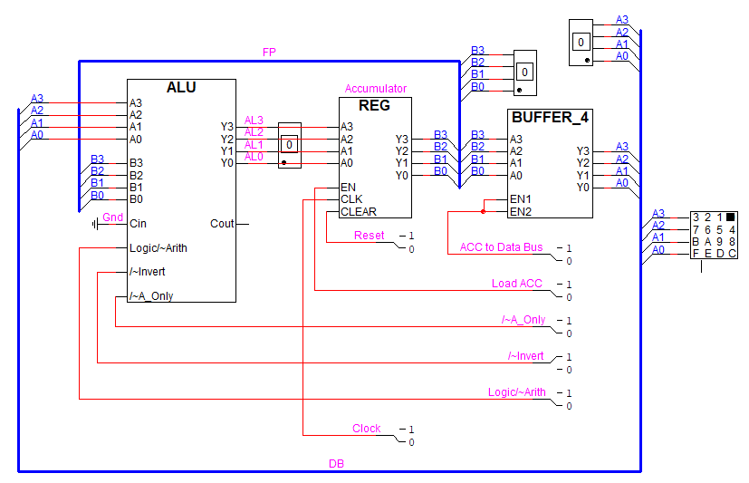
4_7_Schematic of brainless central processing unit
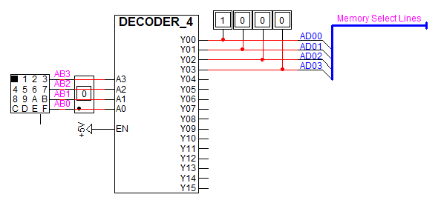
4_10_Addressing logic
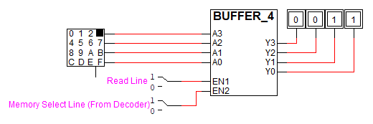
4_11_4-bit ROM memory cell
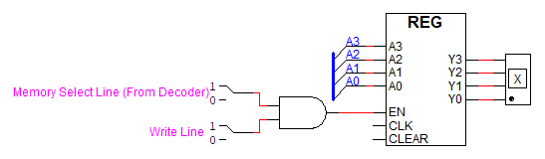
4_12_4-bit output device
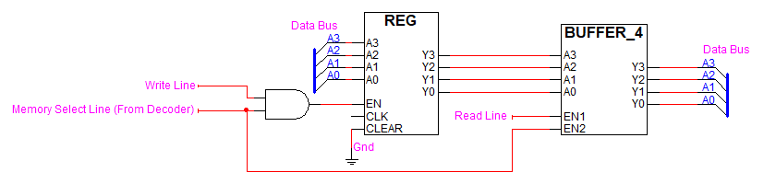
4_13_4-bit RAM
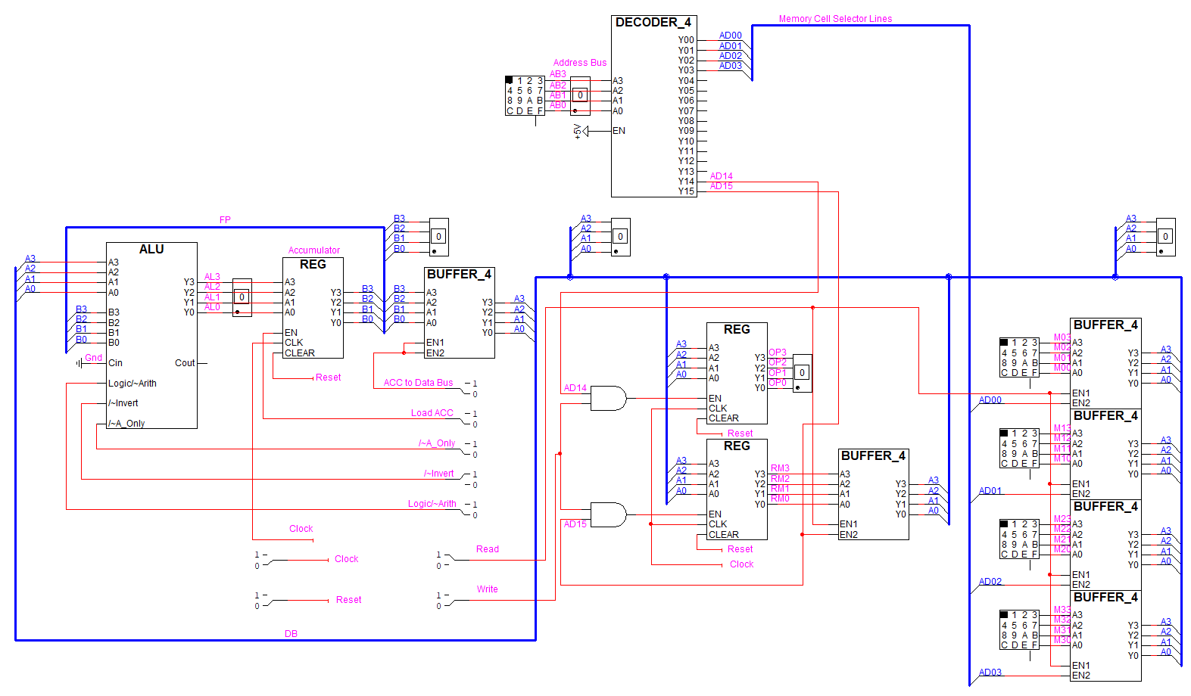
4_15_The brainless microprocessor
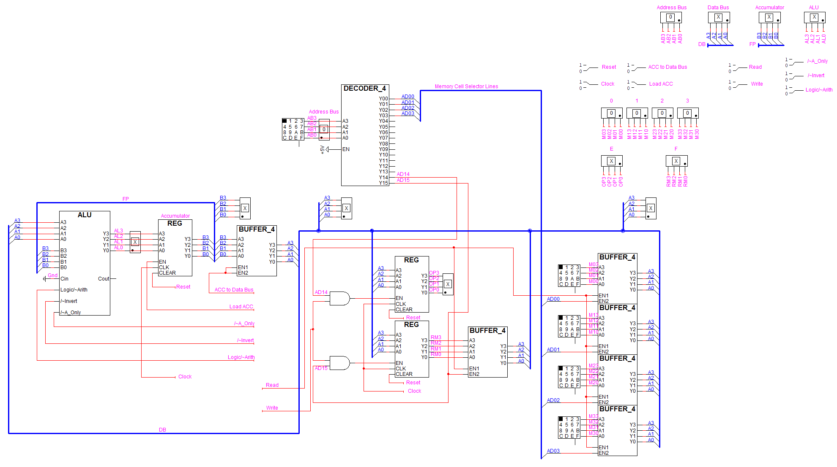
4_17_Brainless microprocessor with display_control panel
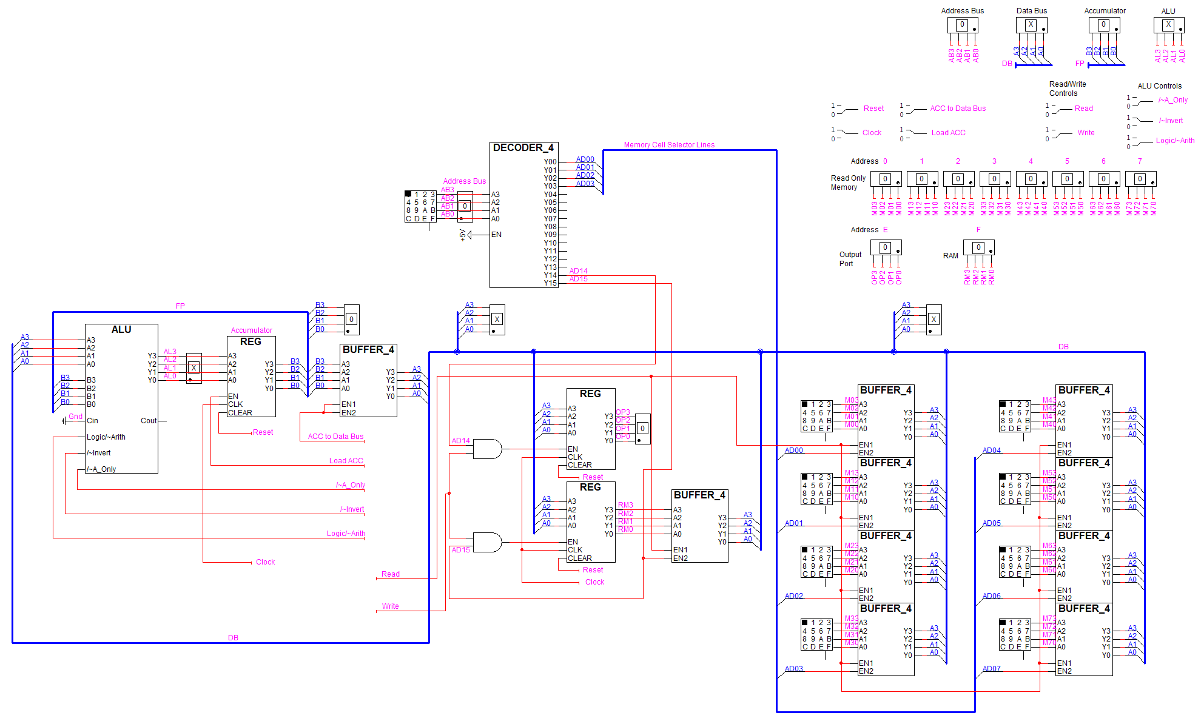
5_2_Schematic of brainless microprocessor showing added memory
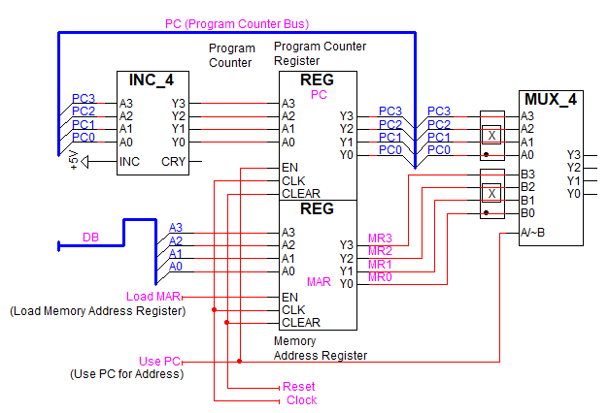
5_4_Memory address generation circuit
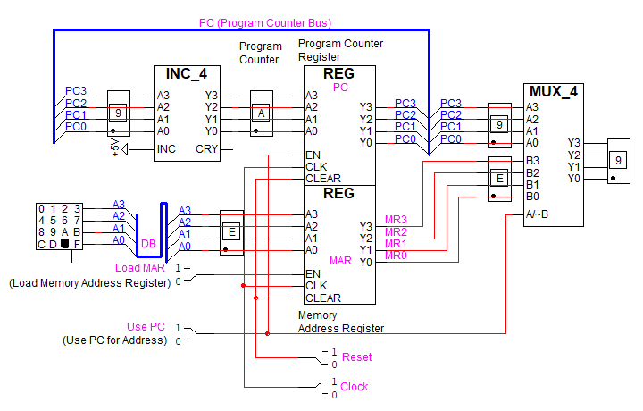
5_4_Memory address generation circuit_TESTING
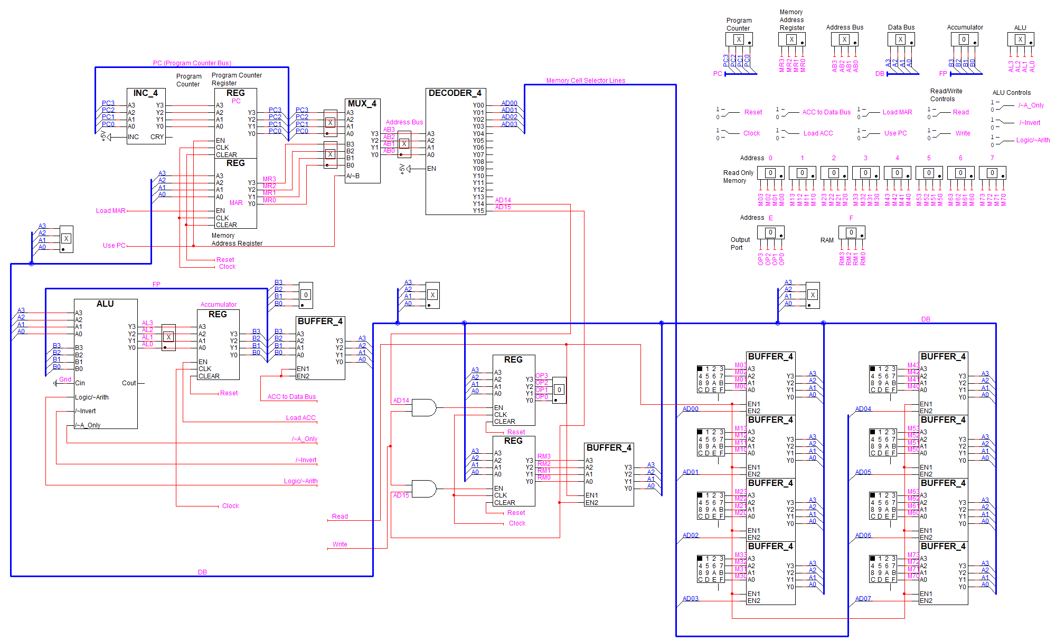
5_5_Schematic of brainless microprocessor emphasizing memory-address-generation circuitry
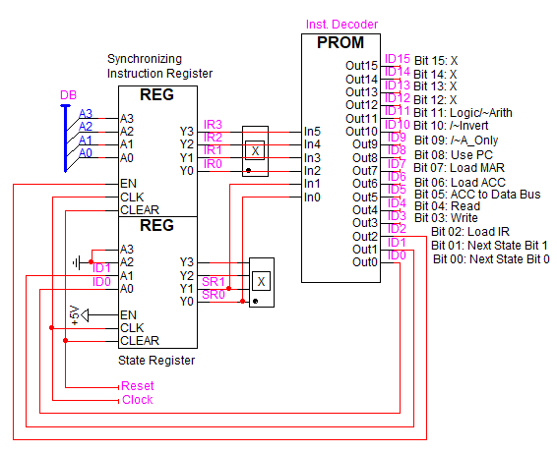
5_10_Microprocessor controller circuit
PROM.hex
0115 0550 0000 0000
0115 0750 0000 0000
0000 0000 0000 0000
0115 0001 0000 0000
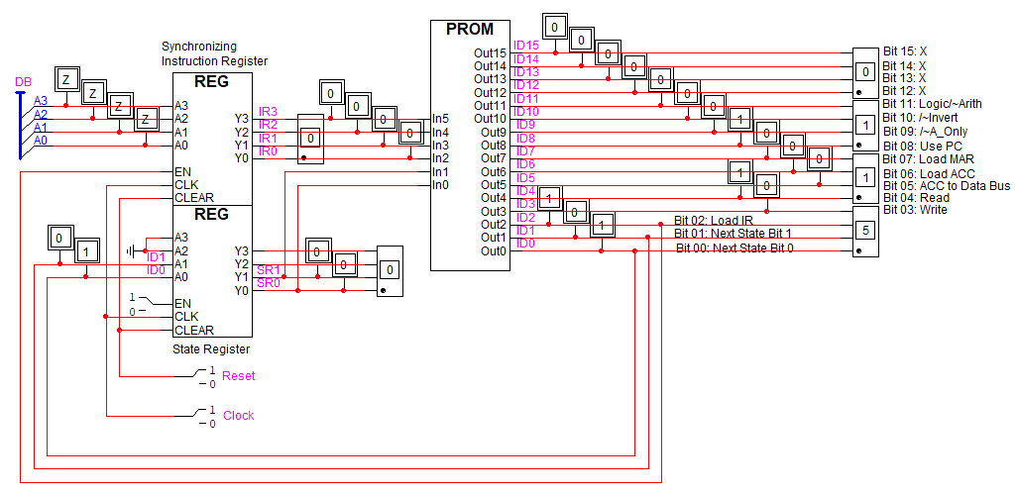
5_10_Microprocessor controller circuit_TESTING
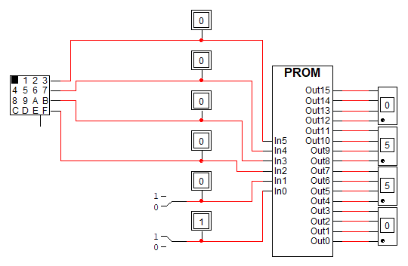
5_12_Test circuit for instruction decoder
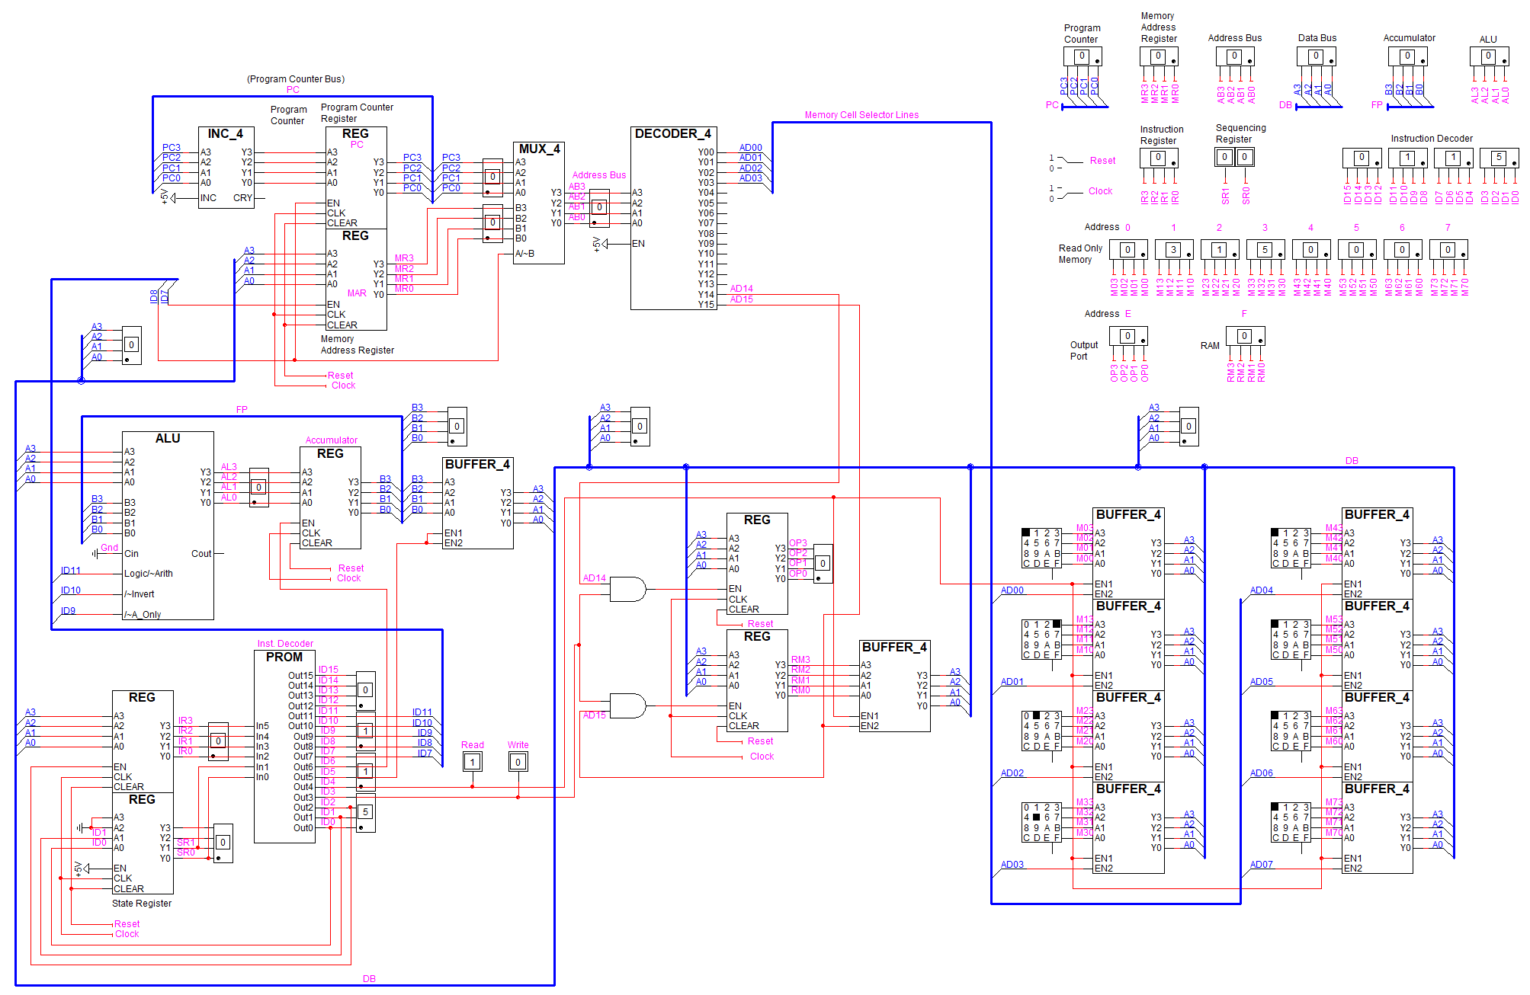
5_13_The complete microprocessor circuit

