***Name*:** Eyad Mohamed Abdelmohsen Ghanem

***Homework 8***

**Design a 8×1 multiplexer using two 4×1 multiplexers and 2×1 multiplexer:**

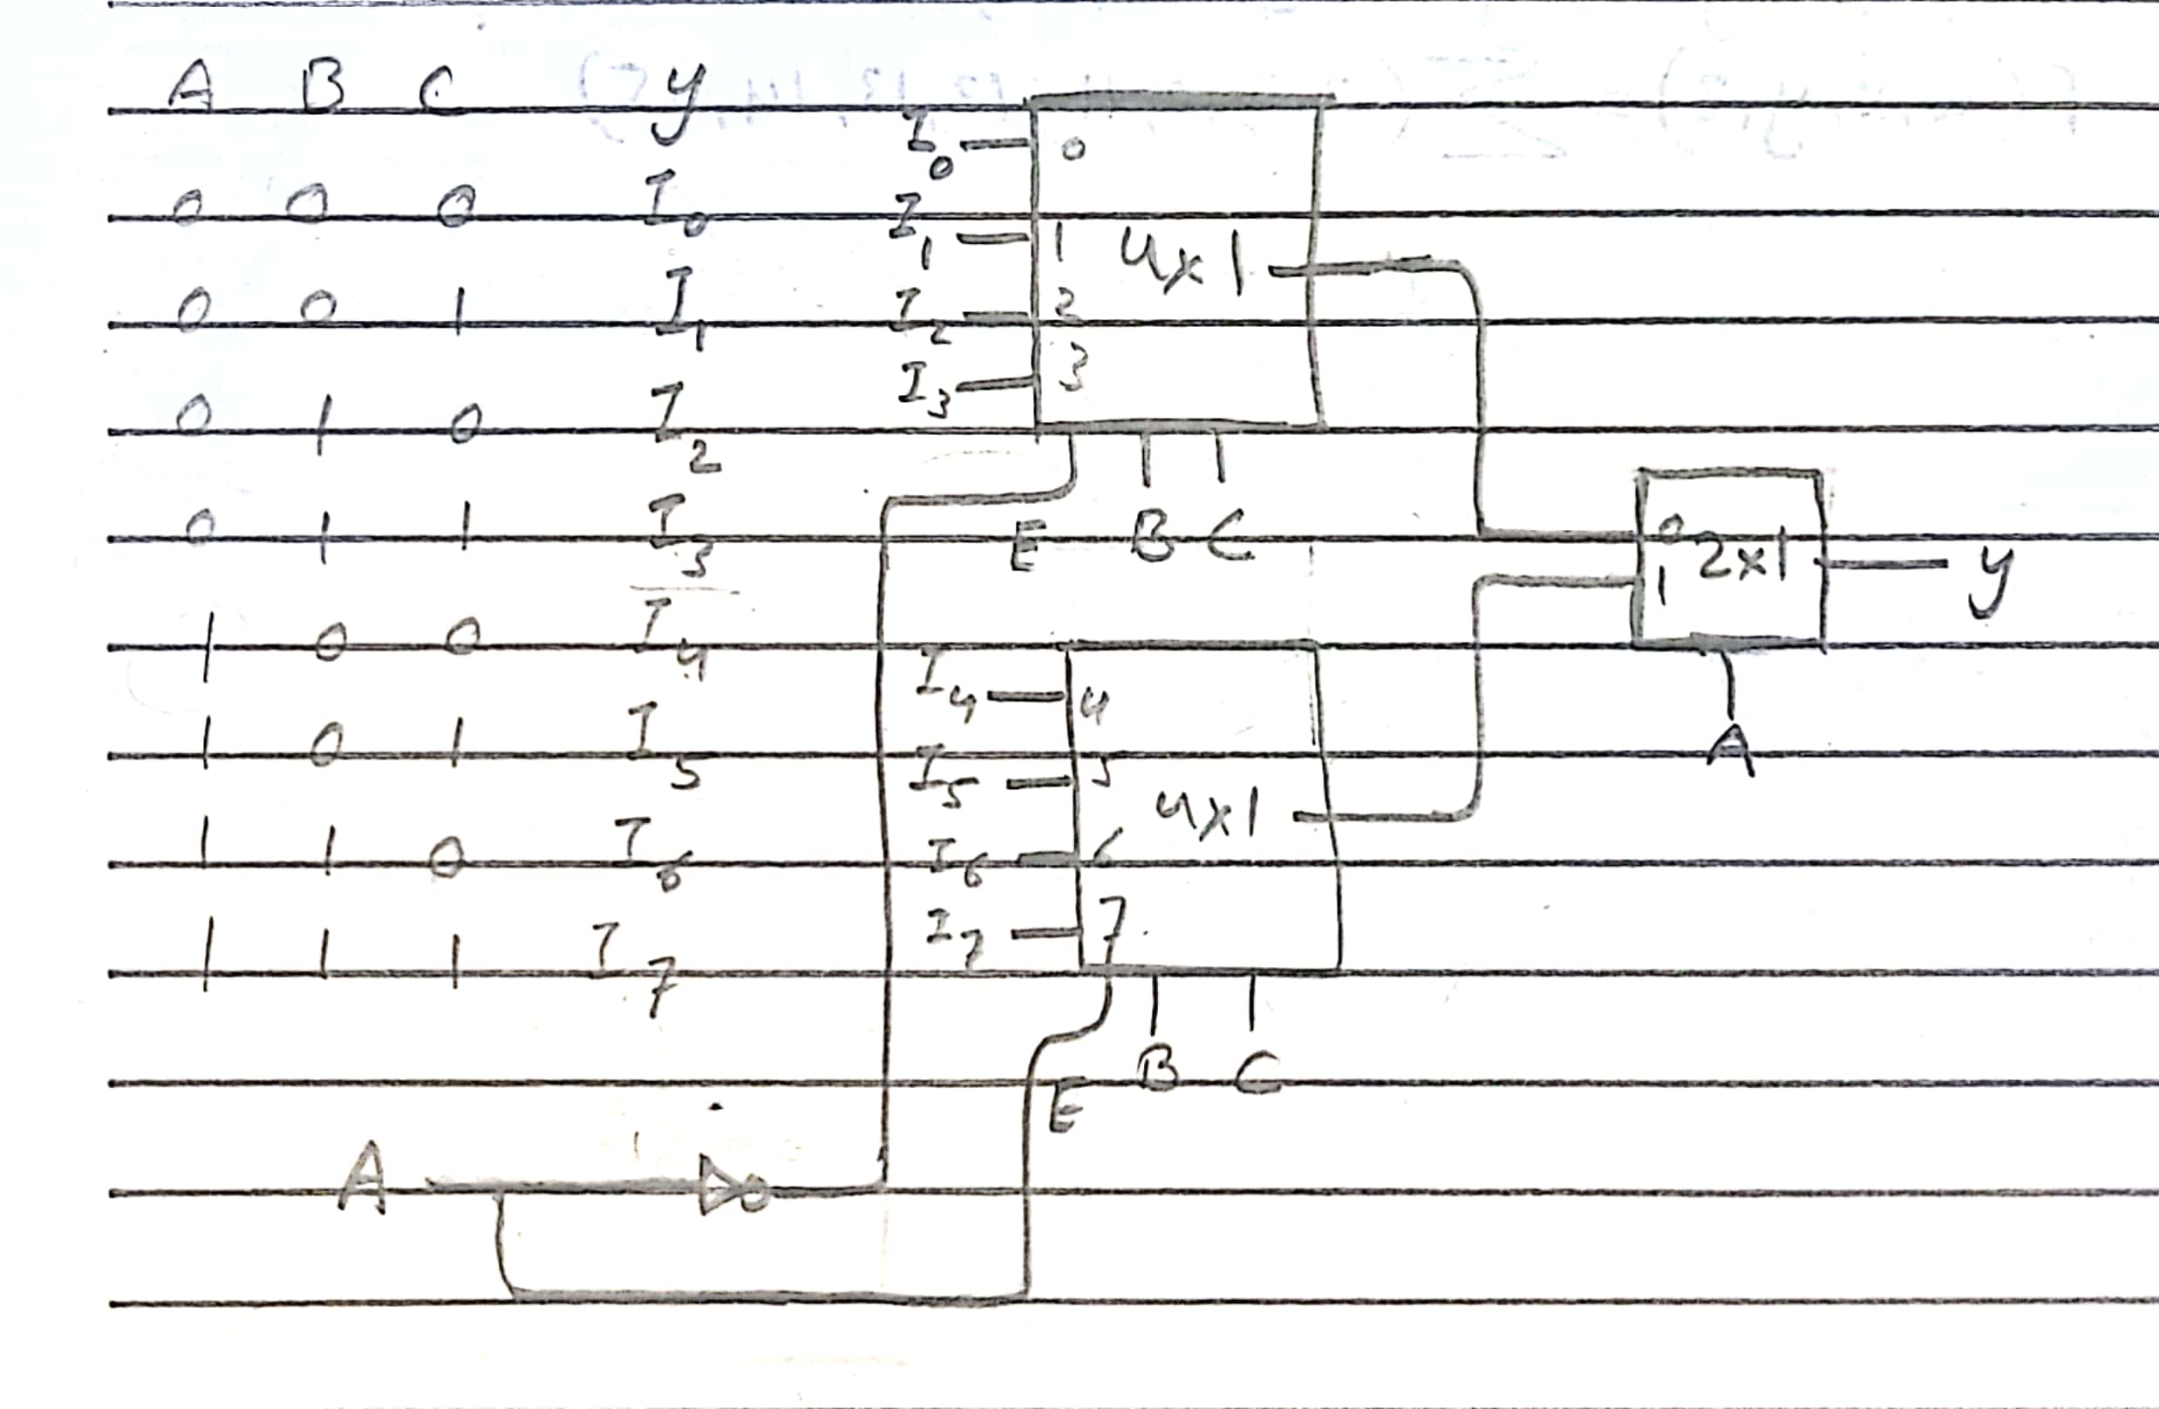

**Implement the following using a 8×1 multiplexer:**

