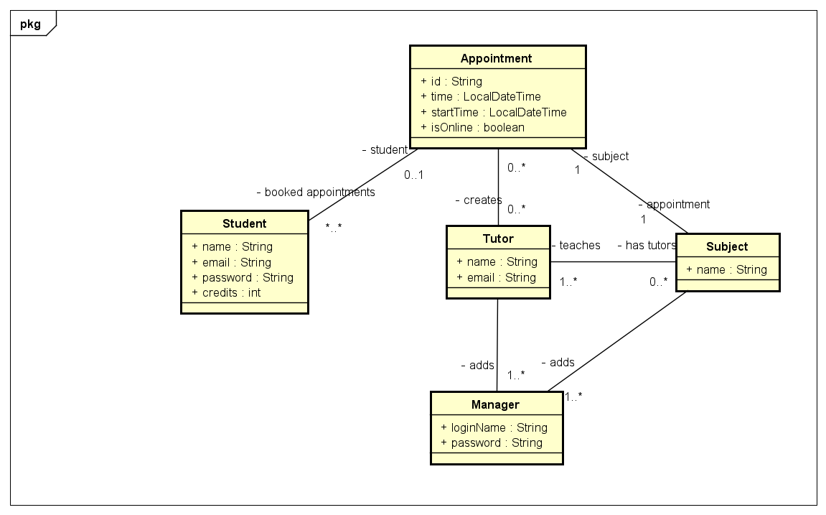

**Part 1: Domain Class Model (DCM)**

**Class Descriptions**

**Manager**

* Attributes:
  + loginName: String
  + password: String
* Responsibilities:
  + Add new subjects to the system
  + Add new tutors
  + Manage system login

**Tutor**

* Attributes:
  + name: String
  + email: String
* Responsibilities:
  + Sign up for subjects
  + Create appointments
  + Set new password

**Student**

* Attributes:
  + name: String
  + email: String
  + password: String
  + credits: int
* Responsibilities:
  + Sign up for the system
  + Buy credits
  + Book and cancel appointments

**Subject**

* Attributes:
  + name: String
* Responsibilities:
  + Represent teachable subjects in the system

**Appointment**

* Attributes:
  + id: String
  + time: LocalDateTime
  + startTime: LocalDateTime
  + isOnline: boolean
* Responsibilities:
  + Represent tutoring sessions
  + Link students, tutors, and subjects

**Diagram Explanation**

The Domain Class Model shows the key entities in the tutoring system and their relationships. Associations demonstrate how different classes interact, such as a student booking appointments or a tutor creating appointments for specific subjects.

**Part 2: Use Case Diagram**

**Manager Use Cases**

1. Add Subjects
   * Scenario: Manager enters a new subject name
   * Success: Subject added if it doesn't exist
   * Error: System notifies if subject already exists
2. Add Tutors
   * Scenario: Manager provides tutor's name and email
   * Success: Tutor added with temporary password
   * Error: System notifies if tutor already exists
3. Manage Login
   * Scenario: Manager logs into the system
   * Success: Access to system functions
   * Error: Access denied if credentials are incorrect

**Tutor Use Cases**

1. Sign up for Subjects
   * Scenario: Tutor selects subjects to teach
   * Success: Subjects linked to tutor's profile
   * Error: Cannot add non-existent subjects
2. Create Appointments
   * Scenario: Tutor sets available time and session type
   * Success: Appointment created
   * Error: Conflicting appointments or exceeding in-person limits
3. Set New Password
   * Scenario: Tutor changes account password
   * Success: Password updated
   * Error: Incorrect old password or invalid new password

**Student Use Cases**

1. Sign Up
   * Scenario: Student creates a new account
   * Success: Account created with provided details
   * Error: Email already in use
2. Buy Credits
   * Scenario: Student purchases tutoring credits
   * Success: Credits added to account
   * Error: Payment issues
3. Search Tutors/Subjects
   * Scenario: Student searches for tutoring options
   * Success: List of available appointments
   * Error: No matching tutors or subjects found
4. Book Appointment
   * Scenario: Student selects and books an appointment
   * Success: Appointment booked, credits deducted
   * Error: Insufficient credits or already booked appointment
5. Cancel Appointment
   * Scenario: Student cancels a booked appointment
   * Success: Appointment cancelled
     + 24 hours: Credit returned
     + <24 hours: No credit returned
   * Error: Appointment not found or already cancelled

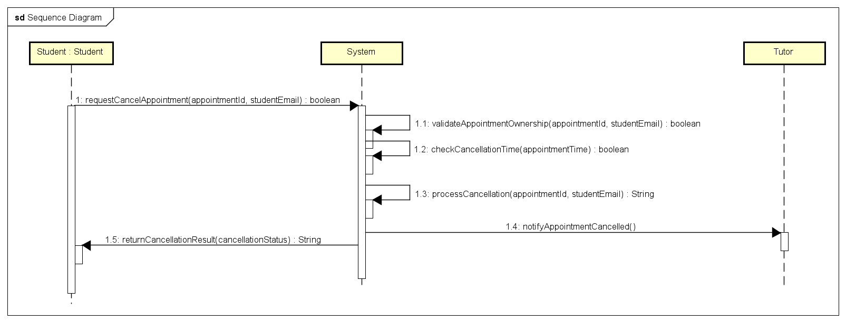

**Part 3: Sequence Diagram**

**Student Cancels Appointment Workflow**

The Sequence Diagram illustrates the process of a student cancelling an appointment:

1. Student requests appointment cancellation
2. System validates appointment ownership
3. System checks cancellation time
4. System processes cancellation
   * If >24 hours: Credit returned
   * If <24 hours: No credit returned
5. System notifies tutor with appointment cancellation.
6. System returns cancellation result to student

**Implementation Details**

**Key Design Considerations**

* Implemented high-level abstraction of tutoring system
* Focused on core functionality
* Demonstrated basic object interactions
* Implemented appointment cancellation logic

**Constraints and Assumptions**

* Campus appointments limited to 8am-6pm
* Online appointments can be scheduled anytime
* Credit system for appointment booking
* Unique email addresses for users

**Conclusion**

The design provides a flexible and extensible framework for a tutoring appointment system, capturing key interactions between managers, tutors, and students.