Activity Diagram

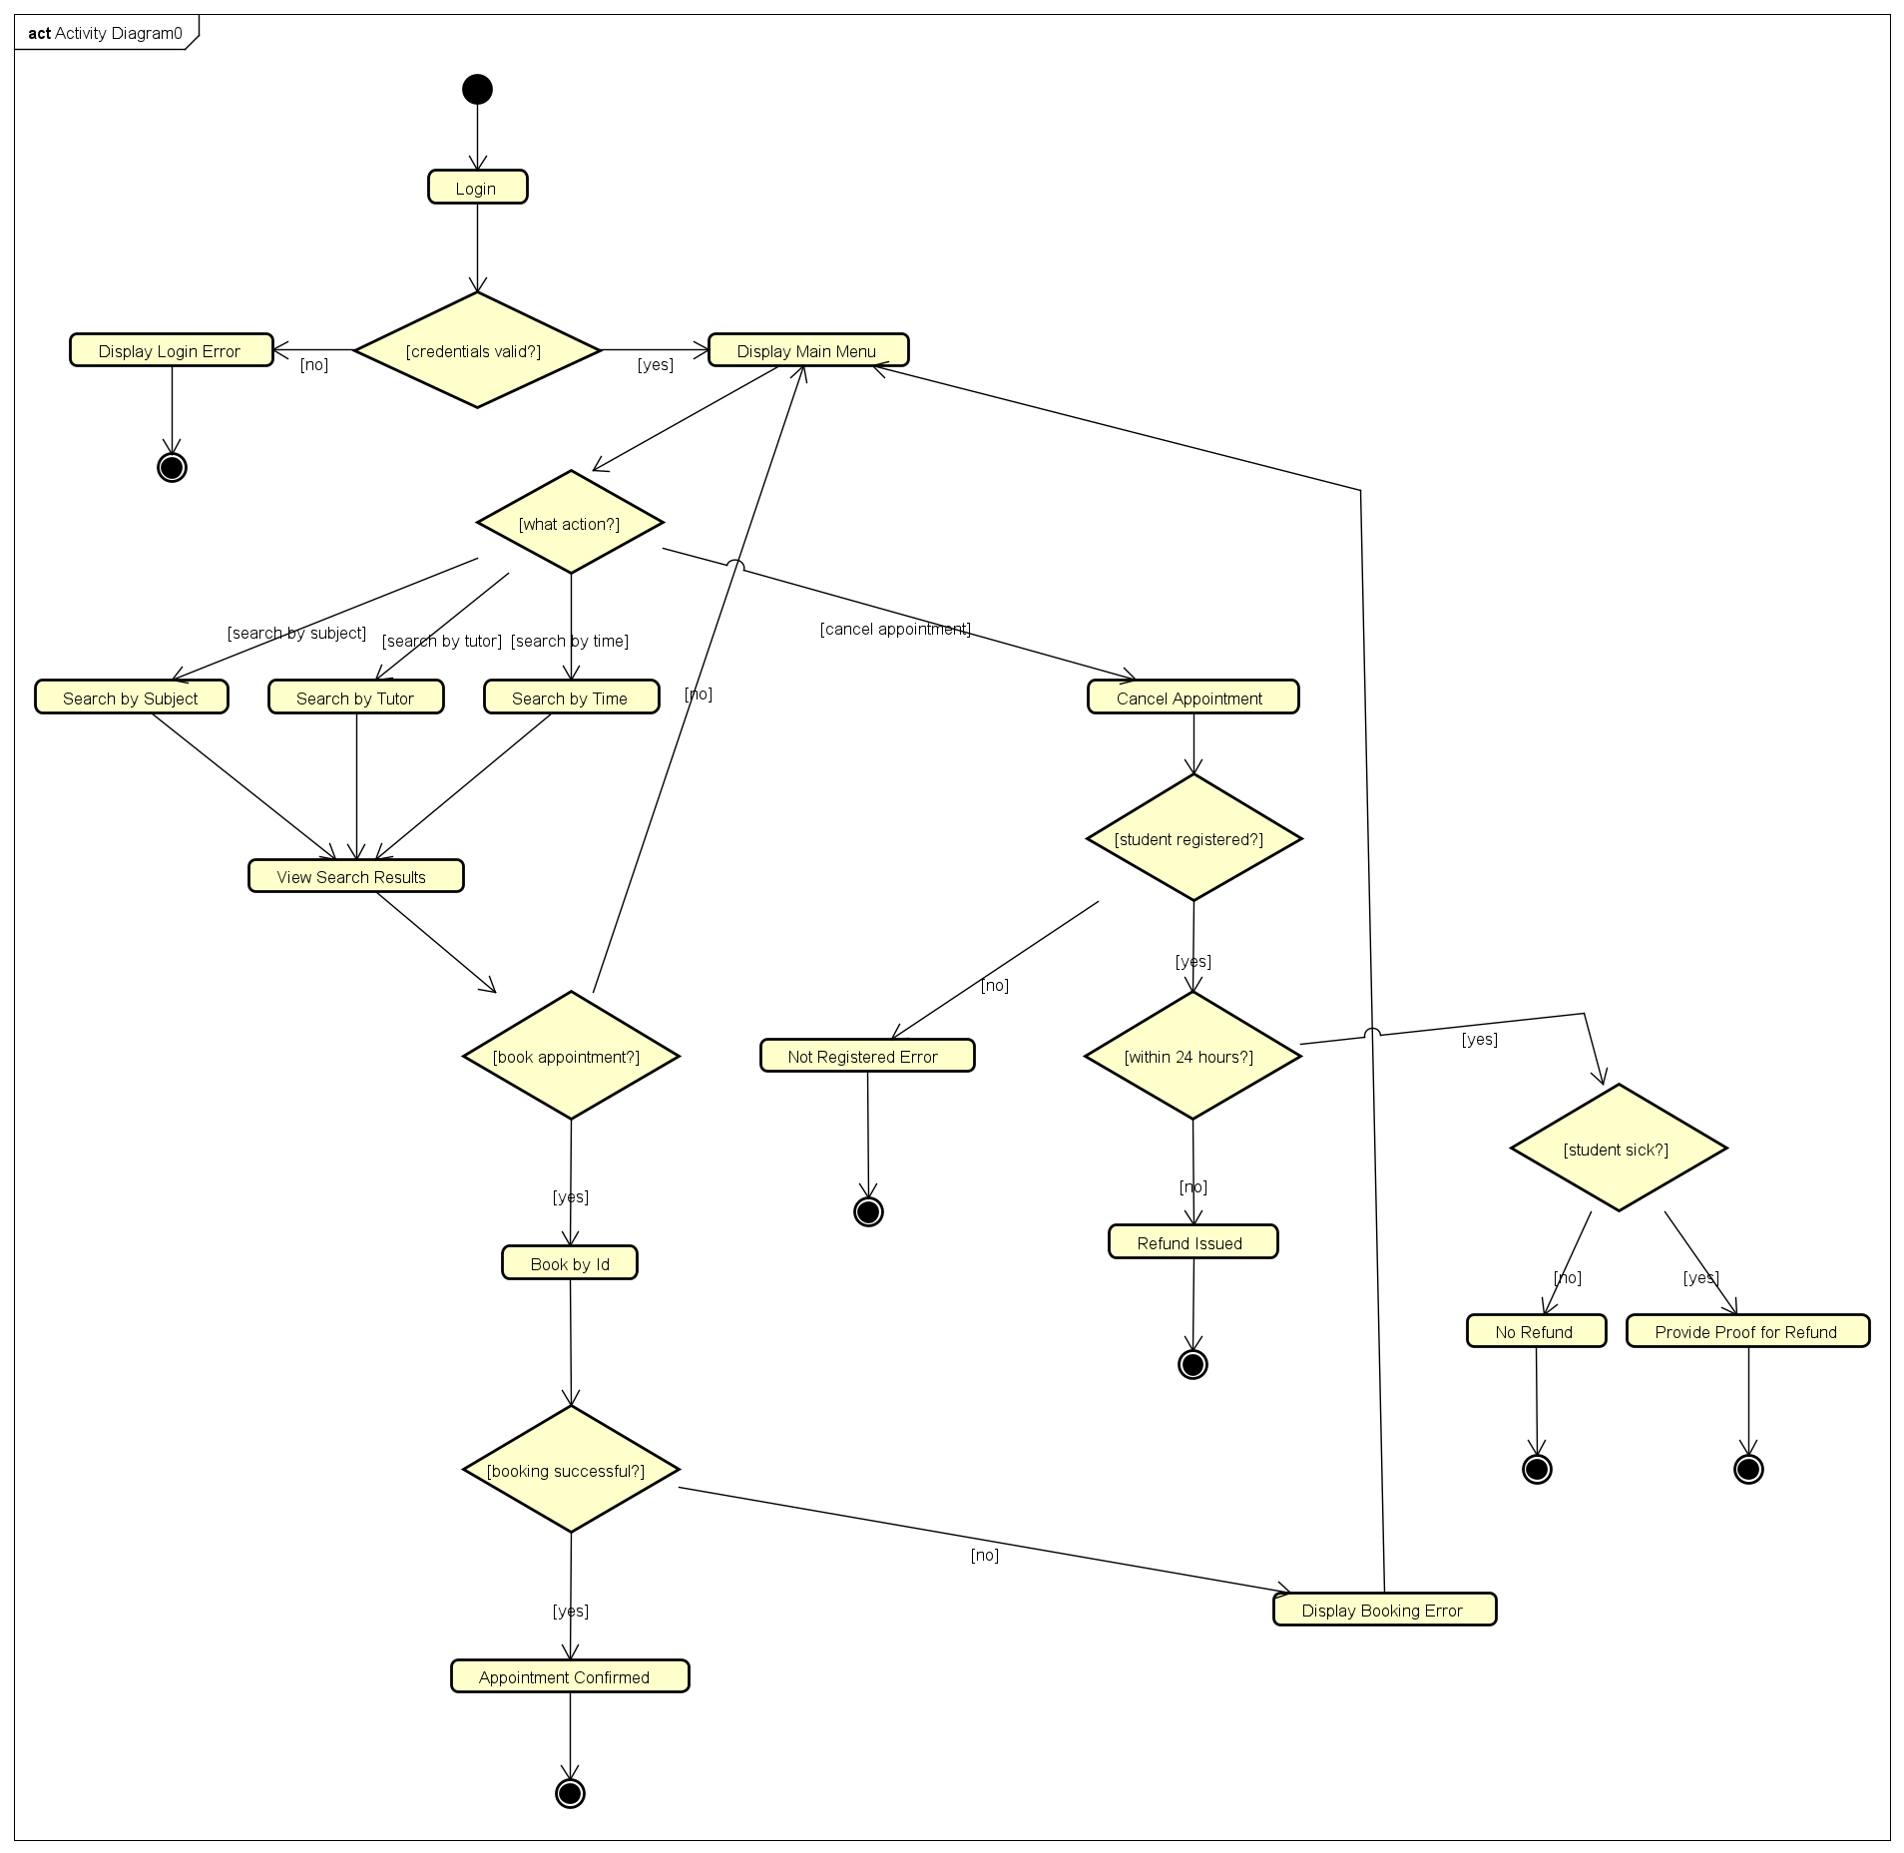

Student Pesrona

Tutor Persona

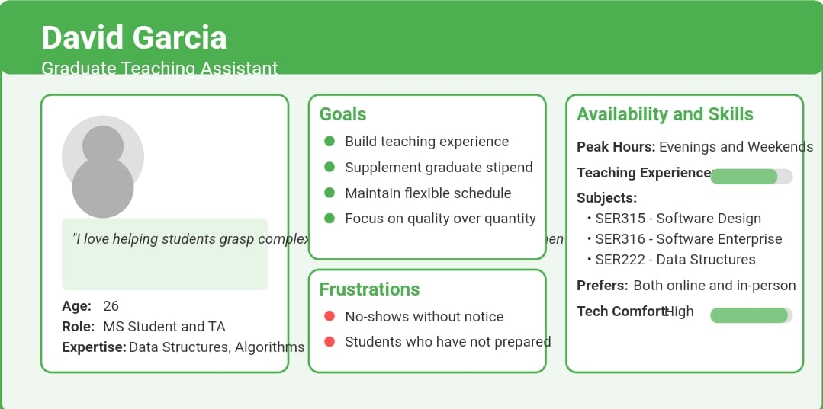

Manager Persona

Student UI – Draft

Comments:

UI Design Feedback

After obtaining feedback from a

fellow student, here are the key points

they mentioned about the Student UI

prototype:

1. The cancellation popup should be

more explicit about the refund policy

2. There's no clear way to see past

appointments or appointment history

3. The search functionality seems

limited to only one parameter at a

time

4. The interface lacks a help section for

students who are confused about the

process

5. The checkbox for "I am sick" needs a

more detailed explanation

Based on this feedback, I'll revise the UI

design:

Student UI – Final

Tutoring System - System Class Diagram

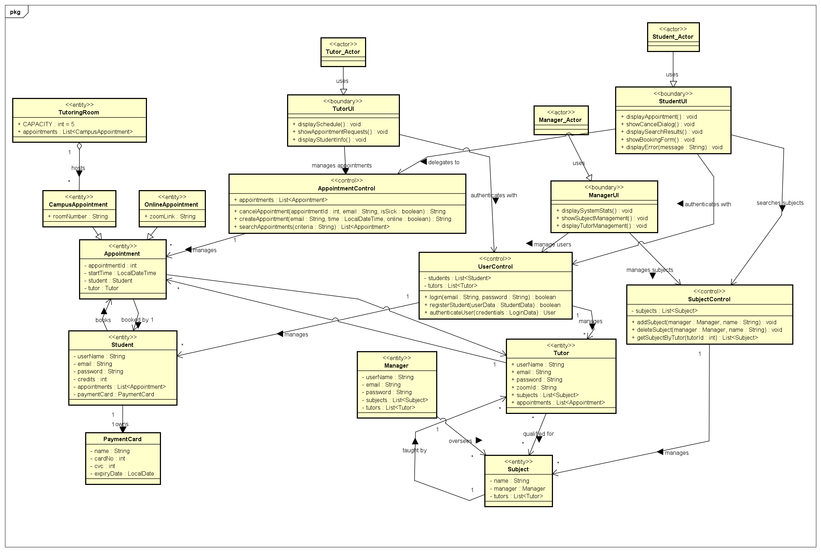

Object View – Tutoring System

