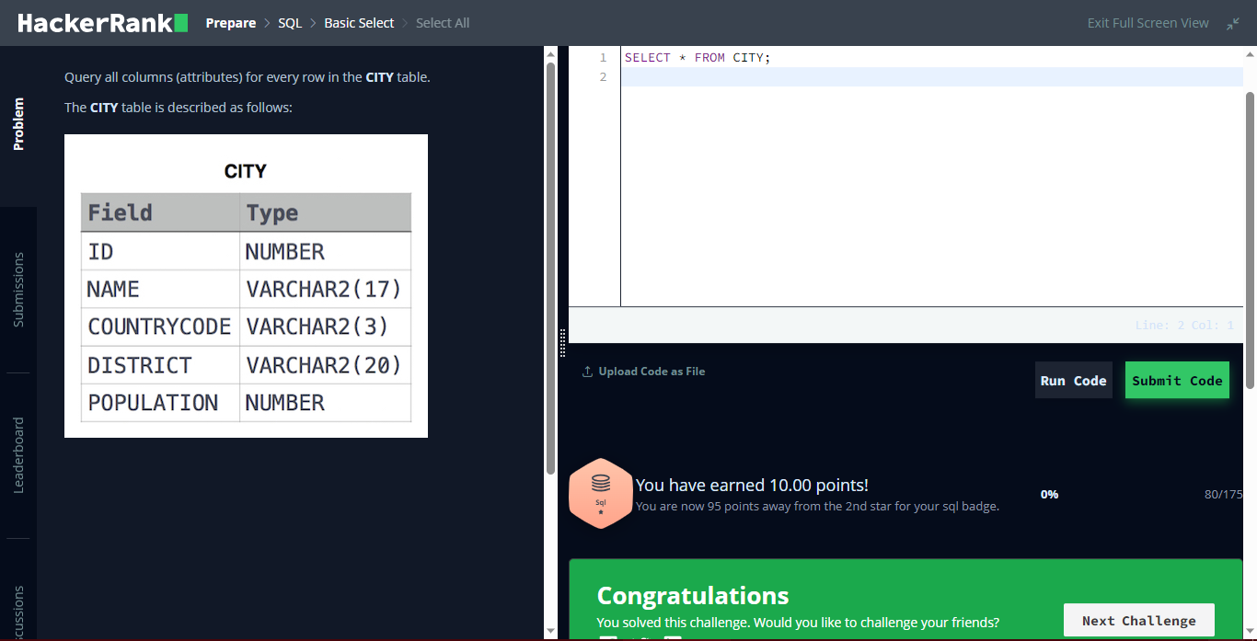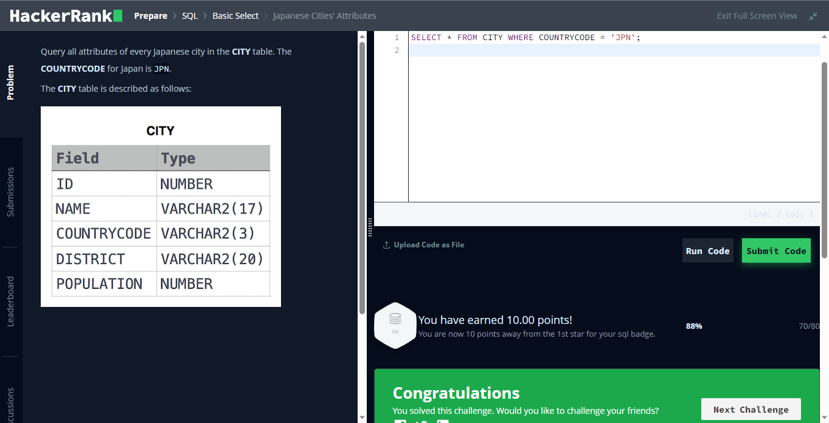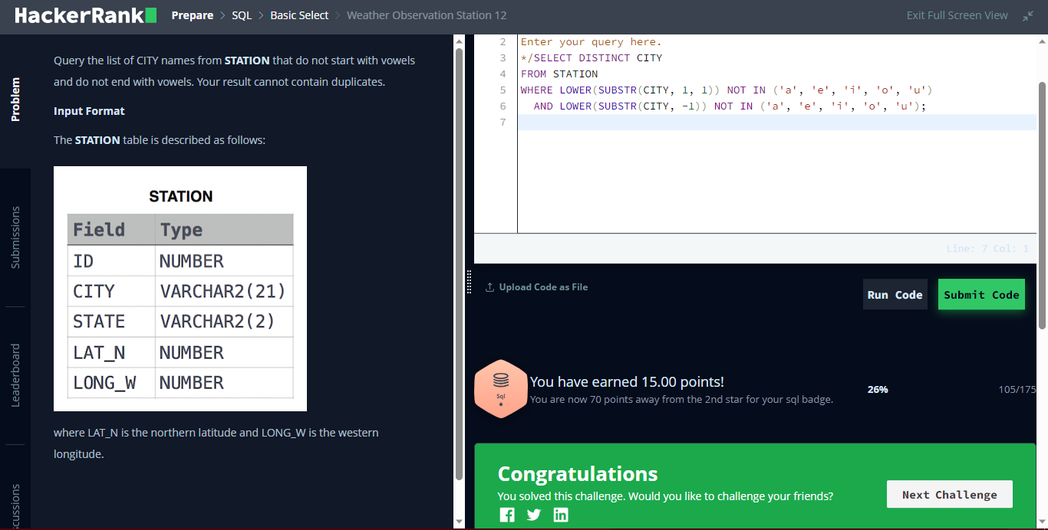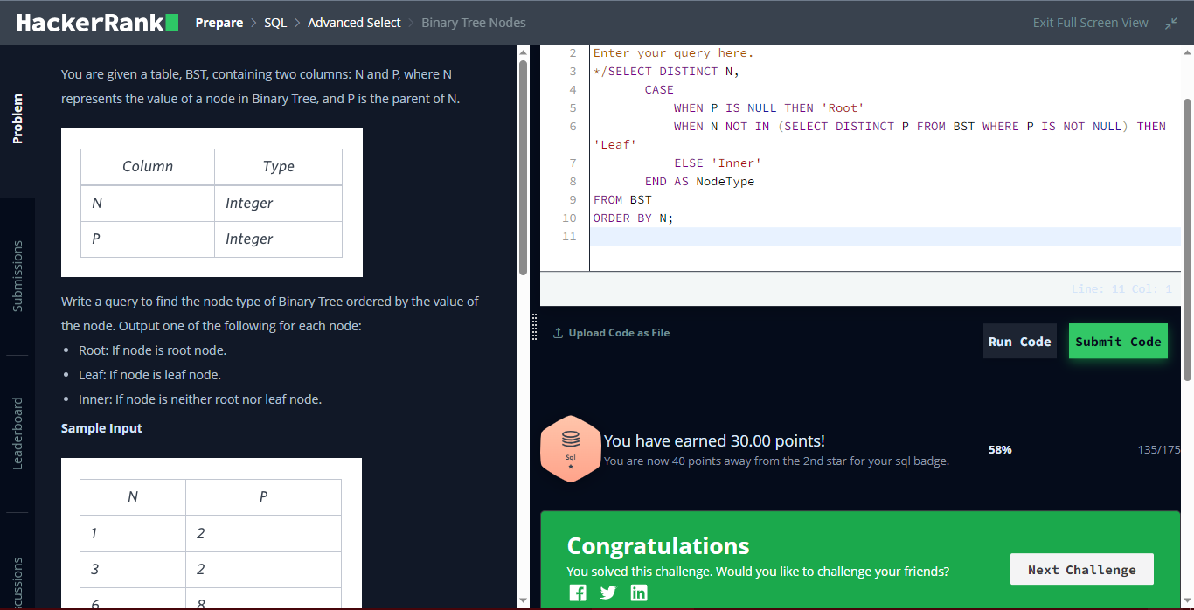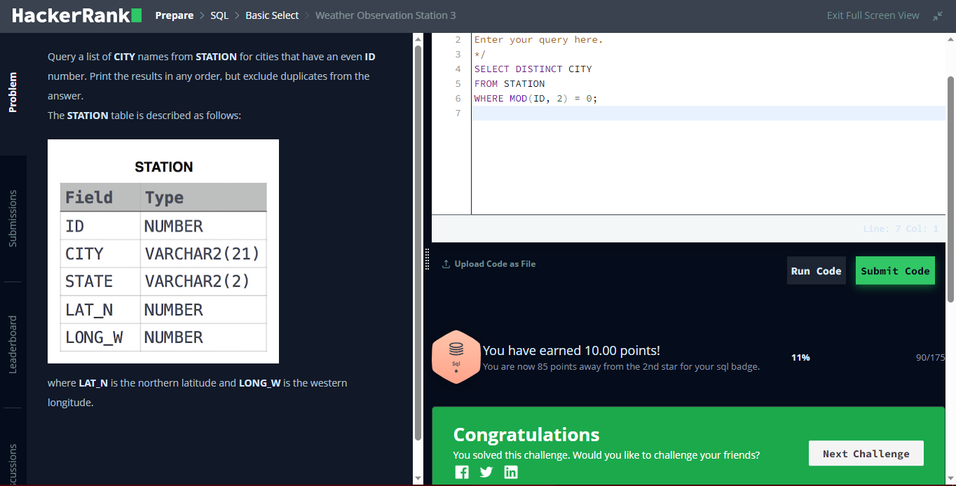

[Submission #223521493 - Codeforces](https://codeforces.com/contest/1788/submission/223521493)

[Submission #223521641 - Codeforces](https://codeforces.com/contest/1104/submission/223521641)