# React

## Setup

* **Create project**

### 

* **Run project**: cd <project name>, Npm start
* **Delete some stuff**: watch lecture recording for detailed setup.

this is how it should look like afterwards: 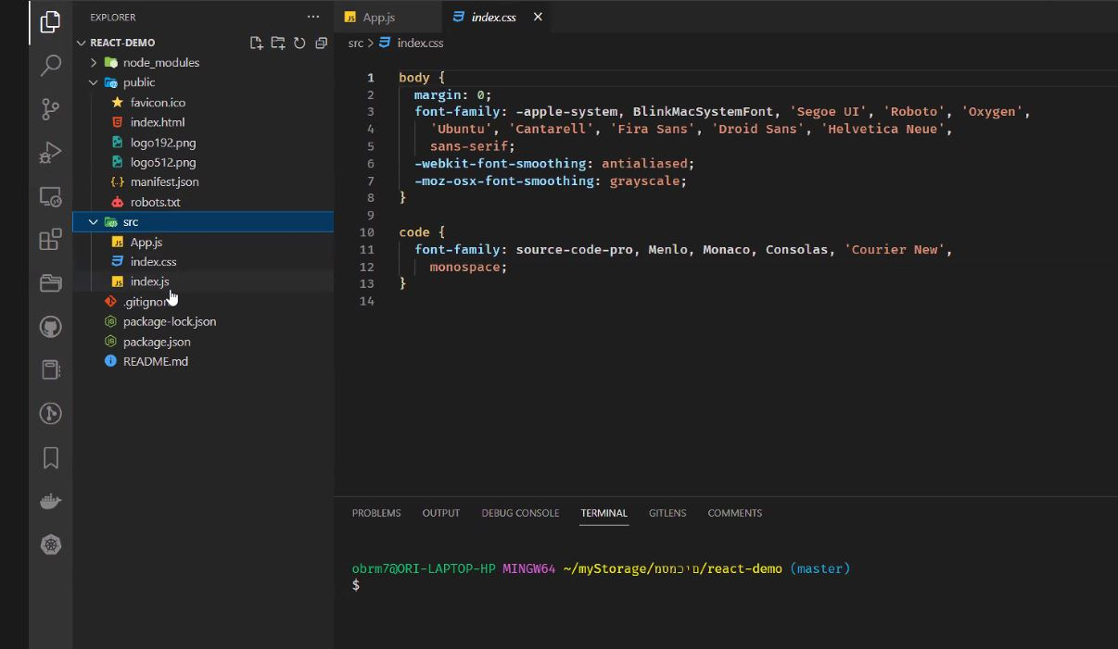

* **Index:**

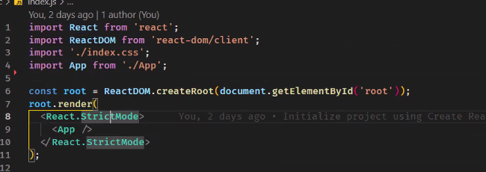

* **App:** empty function.
* **Create one template project**.
* For each project: Delete package lock, copy the src file and the and the packege json to the project file. When you save your stuff: save the packege json and the src file, not an entire project. If you want to continue working on a project (thus use the node modules again). When you’re in the file, you just do **npm i** (install the node modules).

### Project structure

* **At the bottom of each component code:**

export default app

### uploading to github

the files you need to upload to github:

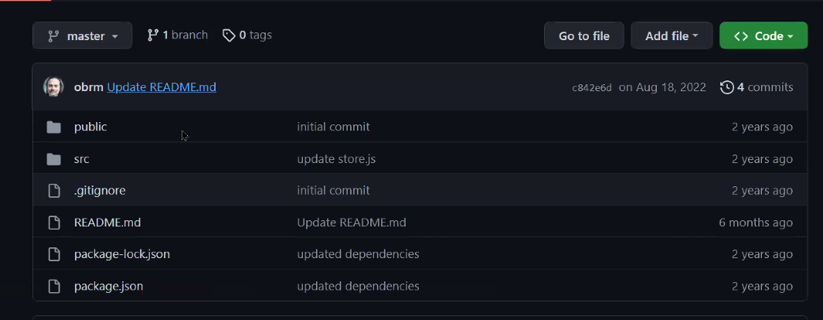

## Useful packages

### Helmet

A package that changes the name of the page to the name of the current component(השם בלמעלה בלשונית של האינטרנט)

Helmet.title = sth sth

## Basic terms

### Linter

Reads your code and checks for errors, bad code etc.

### JSX

JavaScript XML

### Imperative and __ approach

* Impeartive: giving clear, step by step „instructions“, telling the DOM what to do (e.g. create new element, element.innerText, append).
* Declaratig : defining the desired end state using syntactic sugar. React translates your input to valid browser code in the background.

## React functions

### Hooks

Set: renders a component

Case 1: change the value to sth new (if you update a value this syntax is wrong, for the right one see case 2.

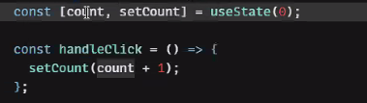

Case 2: using the old value to get a new one: use prevCount. OPTIONAL: add an anonymous function to wrap things up, like this console log.

