Q1

import numpy as np  
import math  
import matplotlib.pyplot as plt  
plt.style.use('seaborn-whitegrid')  
  
def get_spectral_radius(matrix):  
 eigan_vals = np.linalg.eigvals(matrix)  
 rho = max([math.fabs(val) for val in eigan_vals])  
  
 return rho  
  
def jacobi_iteration_matrix(matrix):  
 d = np.diag(np.diag(matrix))  
 eye = np.identity(len(matrix))  
 da = np.linalg.solve(d, matrix)  
  
 return np.subtract(eye, da)  
  
  
def GS_iteration_matrix(matrix):  
 l = np.tril(matrix)  
 eye = np.identity(len(matrix))  
 la = np.linalg.solve(l, matrix)  
  
 return np.subtract(eye, la)  
  
def lud_factorization(matrix):  
 l = np.zeros(matrix.shape)  
 u = np.zeros(matrix.shape)  
 d = np.zeros(matrix.shape)  
  
 for rowIndex, row in enumerate(matrix):  
 for colIndex, col in enumerate(row):  
 if rowIndex < colIndex:  
 l[rowIndex][colIndex] = matrix[rowIndex][colIndex]  
 elif rowIndex == colIndex:  
 d[rowIndex][colIndex] = matrix[rowIndex][colIndex]  
 else:  
 u[rowIndex][colIndex] = matrix[rowIndex][colIndex]  
  
 return l, u, d  
  
  
def GS_step (a_matrix, b_vector, previous_step, ld_inv):  
 ax_prev = np.dot(a_matrix, previous_step)  
 b_minus_ax = np.subtract(b_vector, ax_prev)  
  
 return np.add(previous_step, np.dot(ld_inv, b_minus_ax))  
  
  
  
def l2_norm(vector):  
 return math.sqrt(sum([math.pow(item, 2) for item in vector]))  
  
  
def get_residue_norm(a_matrix, b_vector, step_result):  
 ax = np.dot(a_matrix, step_result)  
 ax_minus_b = np.subtract(ax, b_vector)  
  
 return l2_norm(ax_minus_b)  
  
  
def GS (a_matrix, b_vector, initial_guess, max_residue):  
 l, u, d = lud_factorization(a_matrix)  
 ld_inv = np.linalg.inv(np.add(l, d))  
  
 step_results = [initial_guess]  
 residues = [get_residue_norm(a_matrix, b_vector, initial_guess)]  
  
 while residues[-1] > max_residue:  
 nextIteration = GS_step(a_matrix, b_vector, step_results[-1], ld_inv)  
  
 step_results.append(nextIteration)  
 residues.append(get_residue_norm(a_matrix, b_vector, nextIteration))  
  
 return step_results, residues  
  
  
def get_error_norms(a_matrix, b_vector, results_steps):  
 actual_results = np.linalg.solve(a_matrix, b_vector)  
 error_values = [np.subtract(result_step, actual_results)  
 for result_step in results_steps]  
  
 return [l2_norm(error) for error in error_values]  
  
def residue_ratio(residues):  
 ratios = []  
 for i, val in enumerate(residues[:-1]):  
 ratios.append(residues[i + 1] / residues[i])  
  
 return ratios  
  
  
  
def plot(step_results, residues, errors):  
 f, axarr = plt.subplots(4, 1)  
  
 axarr[0].set_title("Residue norms")  
 axarr[0].semilogy(residues)  
  
 axarr[1].set_title("Error norms")  
 axarr[1].semilogy(errors)  
  
 axarr[2].set_title("Results")  
 axarr[2].plot([tuple[0] for tuple in step_results], color='red', label="x1")  
 axarr[2].plot([tuple[1] for tuple in step_results], color='yellow', label="x2")  
 axarr[2].plot([tuple[2] for tuple in step_results], color='green', label="x3")  
 axarr[2].plot([tuple[3] for tuple in step_results], color='blue', label="x4")  
 axarr[2].plot([tuple[4] for tuple in step_results], color='purple', label="x5")  
  
 axarr[3].set_title("Residue ratio")  
 axarr[3].plot(residue_ratio(residues), color='red')  
  
 plt.show()  
  
  
  
a = np.array([[-5, 0.2, 0.2, 0.2, 0.2],  
 [0.2, -5, 0.2, 0.2, 0.2],  
 [0.2, 0.2, -5, 0.2, 0.2],  
 [0.2, 0.2, 0.2, -5, 0.2],  
 [0.2, 0.2, 0.2, 0.2, -5]  
 ])  
print("Jacobi spectral radius: " + str(get_spectral_radius(jacobi_iteration_matrix(a))))  
print("GS spectral radius: " + str(get_spectral_radius(GS_iteration_matrix(a))))  
  
b = np.array([1, 2, 3, 4, 5])  
initial_guess = np.array([1, 1, 1, 1, 1])  
  
results, residues = GS(a, b, initial_guess, 0.0000001)  
errors = get_error_norms(a, b, results)  
plot(results, residues, errors)



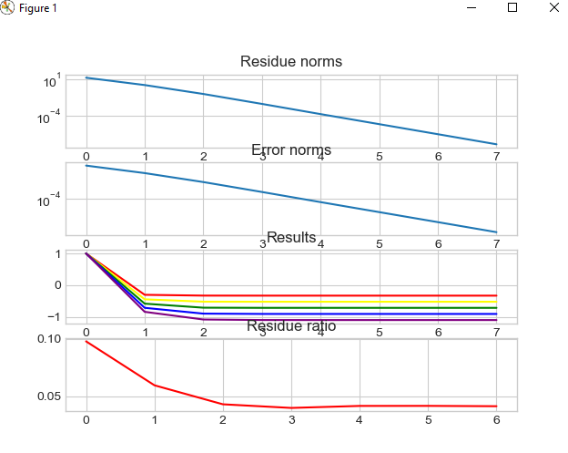

ד. לפי הגרף ניתו לראות כי יחס השארית מתאפס.