**Report K-Means**

No. iterations – 10

Centroids was given to us

**Graph for loss**

**Average Loss Function**

$$\frac{1}{n}*\sum_{i=1}^{n}{\min_{j=1…k}{abs\left(\left|\left|x_{i}-z_{i}\right|\right|\right)}}$$

**Compressed Images**

**K = 2:**

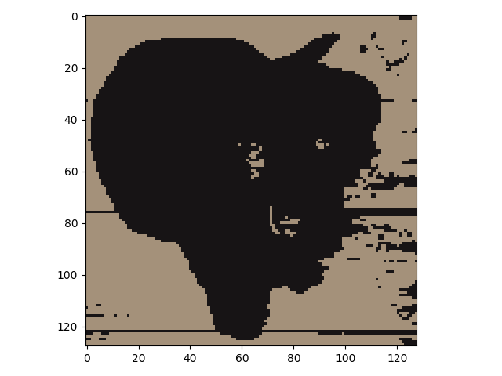

**K = 4:**

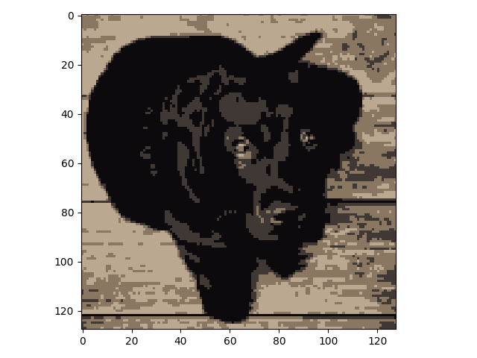

**K = 8:**

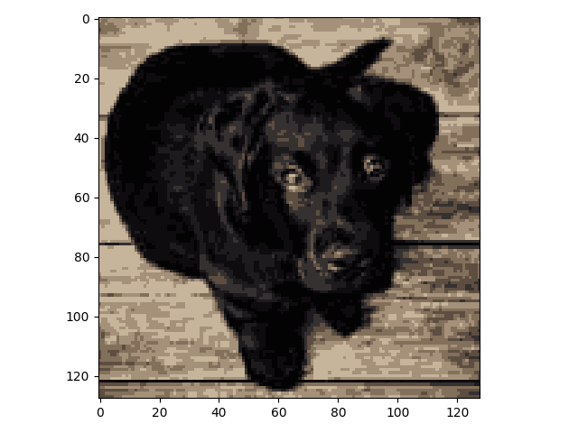

**K = 16:**

