Indian Flights Dashboard
An Interactive Visual Analytics Dashboard for Flight Price Exploration

Visualization of Information — Course Project Report
Dataset: airlines_flights_data.csv (Kaggle “Flight Price Prediction”, Indian domestic flights)
Repository: https://github.com/Eyalmied/Visualization-Project

[PLACEHOLDER — Team member names and roles (see PLAN.md → Team Task Breakdown for the 4 assigned roles: Data Lead, Traveler-View Lead, Airline-Analytics Lead, Integration & Report Lead)]
[PLACEHOLDER — Submission date / presentation slot used (2026-07-15 18:00–20:00 or 2026-07-16 20:00–21:00)]

Contents
- 1. Problem Definition
- 2. Data Understanding
- 3. Data Processing
- 4. Visualization & Interaction Design
- 5. AI Usage Documentation
- 6. Evaluation & Reflection
- 7. Deliverables Checklist

Note: In Word, right-click this list and choose “Update Field”, or replace it with References → Table of Contents once section pages are finalized.

1. Problem Definition

1.1 The analytics problem
Choosing a domestic flight in India means navigating six airlines, six major cities, three stop-count tiers, six departure/arrival time bands, and a booking window that runs from 49 days out to the day of travel — with prices that can differ by two orders of magnitude (₹1,105 to ₹123,071) depending on the combination chosen. Neither a single summary statistic nor a static chart can answer a concrete question like “when should I book my Delhi→Mumbai flight, and on which airline?” because the answer depends on which of these dimensions the traveler actually cares about, and those dimensions interact (see §2.3). The analytics problem this project addresses is: how can a decision-maker explore a 300,000-row, multi-dimensional fare dataset interactively enough to find a trustworthy, personally-relevant answer, rather than relying on a single misleading average?

1.2 Target users and decision-support goals
Persona | Decision-support goal | Dashboard tab
Traveler | Find the cheapest / best-value combination of route, airline, class, stop count, and booking lead time for an upcoming trip. | Traveler View
Airline / revenue analyst | Benchmark market share, average pricing, and route performance across the six competing carriers to inform pricing or route strategy. | Airline Analytics

1.3 How the interactive app solves the problem
The dashboard deliberately does not use a predictive model (see §6.2 for the rationale). Instead, decision support is delivered entirely through filtering and comparison: every chart on both tabs is driven by one shared, reactive, filtered dataset per tab, so a user narrows the data to exactly their situation (e.g. “Economy, Delhi→Mumbai, booking within 10 days”) and every chart, and every KPI tile, updates to reflect that specific slice — rather than forcing them to mentally re-derive an answer from an aggregate chart that mixes together situations that don't apply to them. This directly implements Shneiderman's Visual Information Seeking Mantra (“overview first, zoom/filter, details-on-demand”, Lecture 2) and Keim's extended version (Lecture 5): the KPI tiles give the overview, the sidebar filters do the zooming, and the charts plus hover tooltips give the detail.

2. Data Understanding

2.1 Source and structure
The dataset is airlines_flights_data.csv, the Kaggle “Flight Price Prediction” dataset covering Indian domestic flights. It contains 300,153 rows and 12 raw columns: index, airline, flight, source_city, departure_time, stops, arrival_time, destination_city, class, duration, days_left, and price. There is no real calendar date (only days_left, an integer 1–49 representing booking lead time) and no latitude/longitude — only city names for the six cities served (6 cities, 30 unique ordered route pairs, 6 airlines, 1,561 distinct flight codes). A full NA and duplicate-row check found 0 missing values and, once the meaningless row-number index column is excluded, 300,153 of 300,153 rows are unique (2 exact duplicate listings were removed — see §3.1).

2.2 Overall price and duration profile
Metric | Value
Price range | ₹1,105 – ₹123,071
Price mean / median | ₹20,890 / ₹7,425
Price standard deviation | ₹22,698
Duration range | 0.83 – 49.83 hours
Duration mean | 12.2 hours
Correlation (duration, price) | 0.204 (weak positive)

The mean price (₹20,890) is nearly three times the median (₹7,425) — a classic right-skew signature. This is the direct, data-driven justification for the log-scale toggle built into chart #1 (§4.2) and for citing Lecture 4's log-transform guidance rather than treating it as a generic best practice.

2.3 A genuine Anscombe's-Quartet-style finding: aggregate price by airline is misleading
A first pass at “average price by airline” produces a striking, almost bimodal split:
Airline | Mean price | Flights | Market share
AirAsia | ₹4,091 | 16,098 | 5.4%
Indigo | ₹5,324 | 43,120 | 14.4%
GO_FIRST | ₹5,652 | 23,173 | 7.7%
SpiceJet | ₹6,179 | 9,011 | 3%
Air_India | ₹23,507 | 80,892 | 27%
Vistara | ₹30,397 | 127,859 | 42.6%

Vistara and Air_India appear roughly 4–7× more expensive than the other four carriers. The instinctive reading — “Vistara and Air_India are the premium/expensive airlines” — is exactly the kind of conclusion Anscombe's Quartet (Lecture 1) warns against: a single aggregate statistic can look meaningful while hiding the actual structure of the data. Checking the class mix per airline reveals the real driver: AirAsia, GO_FIRST, Indigo, and SpiceJet operate Economy-only in this dataset, while Vistara and Air_India are the only two carriers that also sell Business class (47.4% and 40.7% of their flights respectively). Once price is conditioned on class, the picture changes substantially:
Airline | Class | Mean price | Flights
Air_India | Economy | ₹7,314 | 47,994
Air_India | Business | ₹47,131 | 32,898
Vistara | Economy | ₹7,807 | 67,270
Vistara | Business | ₹55,477 | 60,589
AirAsia | Economy | ₹4,091 | 16,098
GO_FIRST | Economy | ₹5,652 | 23,173
Indigo | Economy | ₹5,324 | 43,120
SpiceJet | Economy | ₹6,179 | 9,011

Within Economy, Vistara and Air_India are only modestly pricier than the budget carriers (₹7,300–₹7,800 vs ₹4,000–₹6,200) — the ~4–7× gap in the unconditioned averages is overwhelmingly a class-mix artifact, not a fair “which airline is expensive” comparison. The same pattern recurs with the stops column: the raw mean price by stop count (zero: ₹9,376; one: ₹22,901; two_or_more: ₹14,113) looks like one-stop flights are the most expensive, which is counter-intuitive. Checking Business-class share by stop count explains it: 33.6% of one-stop flights are Business class, versus 22.5% of nonstop and only 8.2% of two-or-more-stop flights — again, class mix, not stop count itself, is the dominant driver of the aggregate. This is precisely why the dashboard's class checkbox filter is not optional decoration: without it, a user comparing airlines or stop counts would draw the wrong conclusion from a chart that looks perfectly reasonable.

2.4 Booking-lead-time trend
Averaging across all flights, booking within the last 3 days before departure costs ₹28,069 on average, versus ₹19,276 when booking 30+ days out — a 45.6% premium for last-minute booking. This trend, and how it varies by class and airline, is the core content of chart #4 (§4.2).

2.5 Route-level patterns
Most expensive routes (avg.) | Cheapest routes (avg.) | Busiest routes (by flight count)
Chennai → Bangalore: ₹25,082 | Hyderabad → Delhi: ₹17,244 | Delhi → Mumbai: 15,289 flights
Kolkata → Chennai: ₹23,660 | Delhi → Hyderabad: ₹17,347 | Mumbai → Delhi: 14,809 flights
Bangalore → Kolkata: ₹23,500 | Bangalore → Delhi: ₹17,723 | Delhi → Bangalore: 14,012 flights

The busiest routes (Delhi↔Mumbai, Delhi→Bangalore) are not the cheapest or most expensive on average — route price and route volume are largely independent, which is exactly what chart #5's route heatmap and chart #6's route map are designed to let a user discover for themselves rather than read off a single ranked list.

3. Data Processing

3.1 Cleaning
The raw index column is dropped (it is a row-number artifact, not analytical data). NA and duplicate checks are run and logged on every load: 0 missing values were found; 2 exact duplicate rows (identical across every column except the meaningless index) were removed, taking the working dataset from 300,153 to 300,153 rows. Both checks are logged (not silently assumed) so the Data Understanding claim of “clean data” in §2.1 is verifiable, not asserted.

3.2 Factor ordering
departure_time, arrival_time, and stops arrive as plain strings that would sort alphabetically on a chart axis (e.g. “Afternoon, Early_Morning, Evening, Late_Night, Morning, Night”), misrepresenting the data's real order. Each is converted to an ordered factor with the correct real-world sequence (Early_Morning → Morning → Afternoon → Evening → Night → Late_Night for time-of-day; zero → one → two_or_more for stops). This is a direct application of Lecture 2's “order” property of visual variables: an axis that doesn't reflect the data's natural order is a graphical-integrity problem, not a cosmetic one — chart #8 (departure-time × airline grid) would be actively misleading without this fix.

3.3 Feature engineering
Feature | Definition | Why it was needed
price_per_hour | price / duration | Neither column alone lets a traveler compare “value” across a short vs. a long route, or an airline analyst compare pricing efficiency across carriers; this normalizes for flight length.
route | paste(source_city, "→", destination_city) | Collapses two categorical columns into one for route-level charts (heatmap, KPI tiles) without which grouping by “route” would require a two-column group_by everywhere it's used.
days_left_bucket | cut into Last-minute (1–7) / 2–4 weeks (8–28) / 1+ month (29–49) | 49 raw integer values is too granular for a clean group comparison; kept as a derived column while the raw days_left is retained for the continuous slider filter and the booking-curve chart.
src_lat / src_lon / dst_lat / dst_lon | joined from a hand-built 6-city lookup table | The raw data has no geospatial fields at all; a small manually-curated coordinate table (R/city_coords.R) is the only way to satisfy the confirmed India-route-map requirement.

3.4 Skew handling for price
price spans ₹1,105 to ₹123,071 (a ~111× range) and is strongly right-skewed (mean ₹20,890 vs. median ₹7,425, §2.2). High Business-class fares are not data errors — deleting them as “outliers” would misrepresent the real “how much more does Business cost” question a user might ask. Instead, chart #1 exposes a live log-scale toggle (scale_y_log10()) so a user can switch between the linear view (which shows absolute rupee gaps) and the log view (which shows proportional/relative differences and makes the shape of each class's distribution comparable) — directly applying Lecture 4's guidance on log-transforming skewed data, as an interactive choice rather than a single fixed decision made on the user's behalf.

4. Visualization & Interaction Design
Nine charts were built, deliberately spanning the task-based chart directory taught in Lecture 9 (Amounts, Distributions, Proportions, x-y relationships, and a geospatial view), and every encoding choice below is justified against a specific piece of course theory rather than aesthetic preference alone.

4.1 Chart-by-chart justification

Chart #1 — Price distribution by class
Violin + jittered points, Traveler tab.
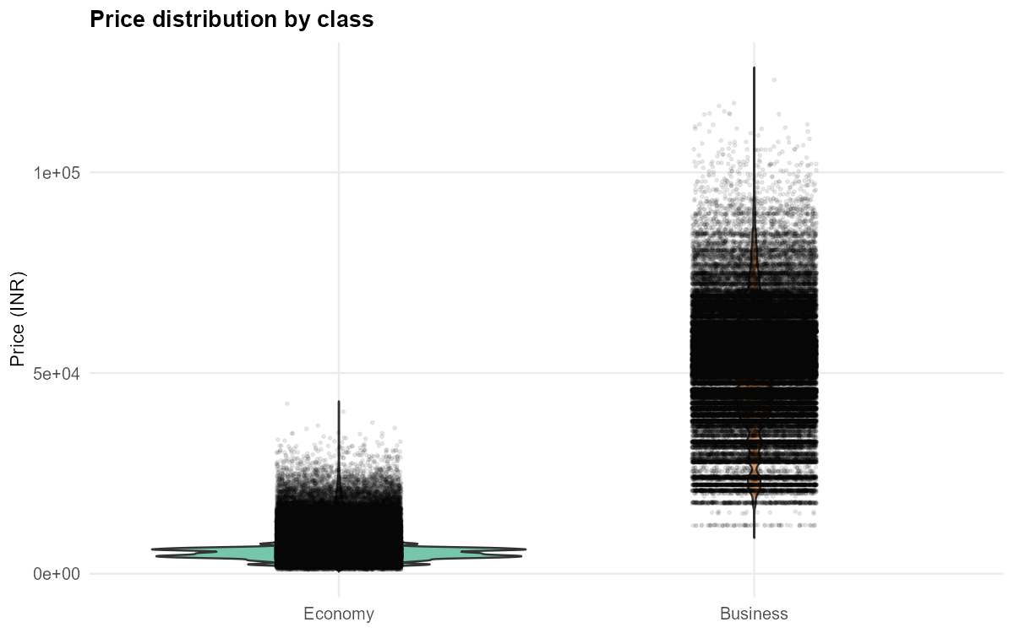
Chart #1 — Price distribution by class — static export for this report.
A violin plot was chosen over a boxplot because the Economy/Business price distribution is genuinely bimodal (§2.3) — a boxplot's five-number summary would compress two distinct populations into a single box and hide the bimodality entirely. Lecture 9 explicitly recommends violin/sina/ridgeline plots over boxplots for exactly this case. The log-scale toggle (§3.4) is wired to this chart.

Chart #2 — Average price by airline
Ordered horizontal bar, Airline Analytics tab.
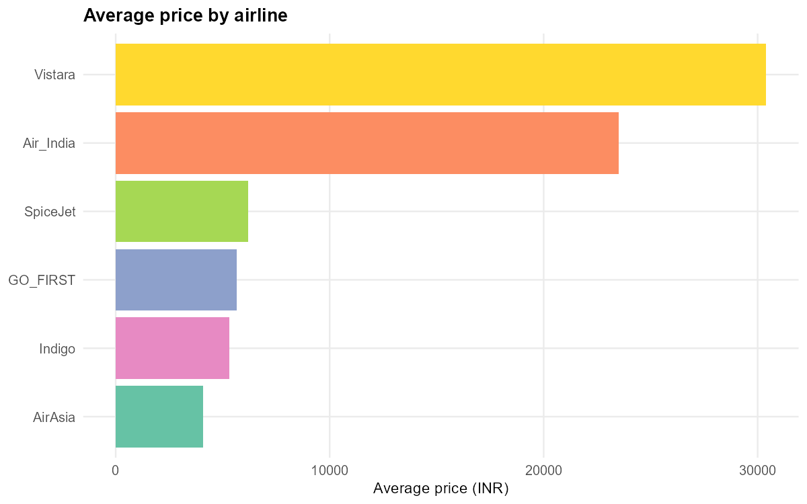
Chart #2 — Average price by airline — static export for this report.
Bar length encodes position on a common scale — Cleveland & McGill's empirically most accurate graphical-perception encoding (Lecture 2), and Stevens' Power Law gives bar length a perceptual exponent of ~1.0 (i.e. perceived magnitude matches actual magnitude almost exactly; Lecture 3). Bars are sorted by value, not alphabetically, for immediate rank readability.

Chart #3 — Market share by airline
Ordered bar (deliberately NOT a pie chart), Airline Analytics tab.
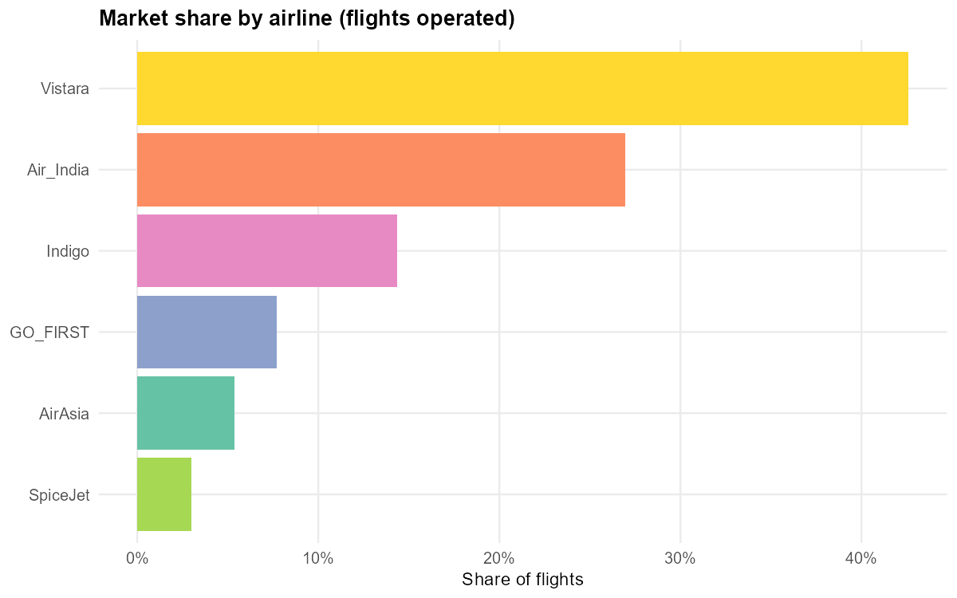
Chart #3 — Market share by airline — static export for this report.
See §4.3 for the full rejection rationale. In short: 6 categories with no extreme skew is exactly the regime where Cleveland & McGill's ranking (position/length > angle/area) predicts real ranking errors from a pie chart; a bar chart communicates the same “share” information with a provably more accurate encoding.

Chart #4 — Price vs. days-left booking curve
Mean price per days_left, per class, with a LOESS trend line, Traveler tab.
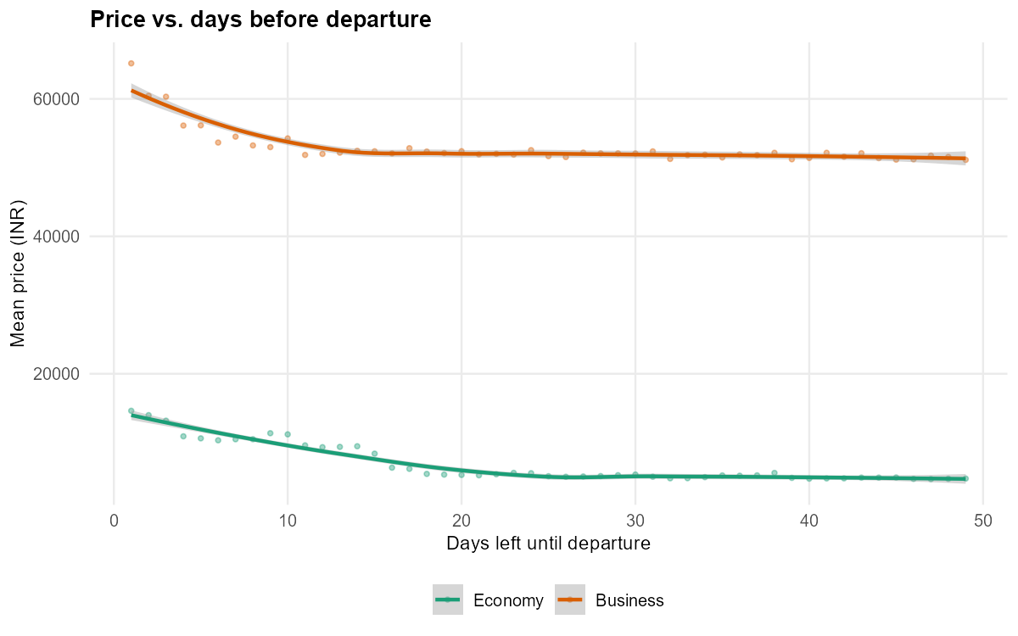
Chart #4 — Price vs. days-left booking curve — static export for this report.
Directly answers “when should I book?” (§2.4). Data is aggregated to (days_left, class) means before smoothing — fitting LOESS directly on the ~300k raw rows is computationally impractical (LOESS scales very poorly with n) and days_left only has 49 distinct values, so aggregating first is both faster and, arguably, a cleaner signal than a smooth fit over a raw point cloud. This follows Lecture 4's taught LOESS/geom_smooth technique for revealing trend in noisy data.

Chart #5 — Route heatmap
source_city × destination_city grid, fill = mean price or flight count (Reconfigure toggle), Airline Analytics tab.
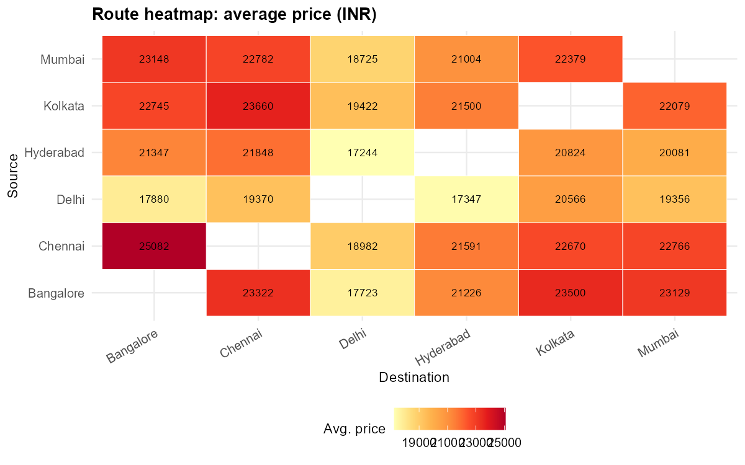
Chart #5 — Route heatmap — static export for this report.
Lecture 9 notes heatmaps are good for spotting broad trend but weak for precise value readout; in the live app this is compensated for with a plotly hover tooltip giving the exact number on demand (Shneiderman's “details-on-demand”, Lecture 2). The static image above therefore also prints the value directly on each cell, since a printed report page has no hover interaction.

Chart #6 — India route map
Geospatial flow map: 6 cities as points, routes as weighted line segments, Airline Analytics tab.
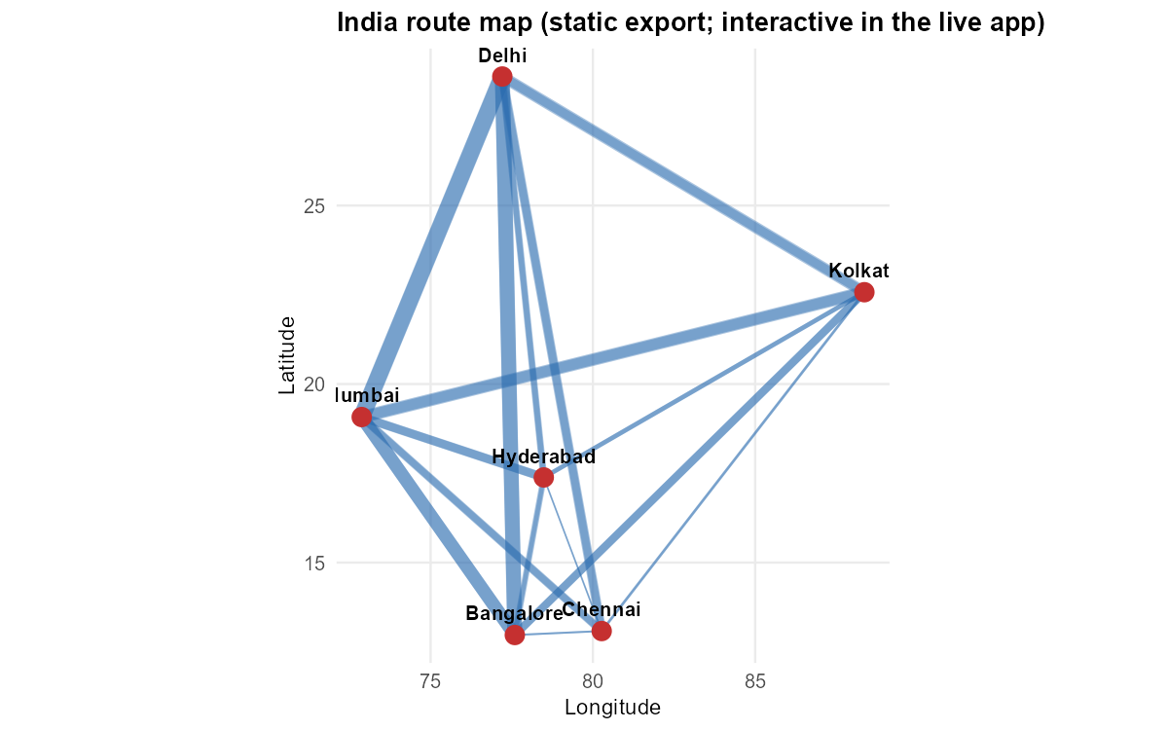
Chart #6 — India route map — static export for this report.
The dataset covers only 6 Indian cities (domestic routes) — a world map would misrepresent the data's actual geographic scope, so the map is deliberately India-only. In the live app this is an interactive leaflet map (line width/color encode flight volume or price, a flat 2D length/color encoding rather than a distorting 3D or bubble-volume encoding); the image above is a static ggplot equivalent generated purely for this report, since a printed page cannot embed the interactive leaflet widget.

Chart #7 — Duration vs. price scatter
Scatterplot colored by stops (or class / airline), Traveler tab, brushable in the live app.
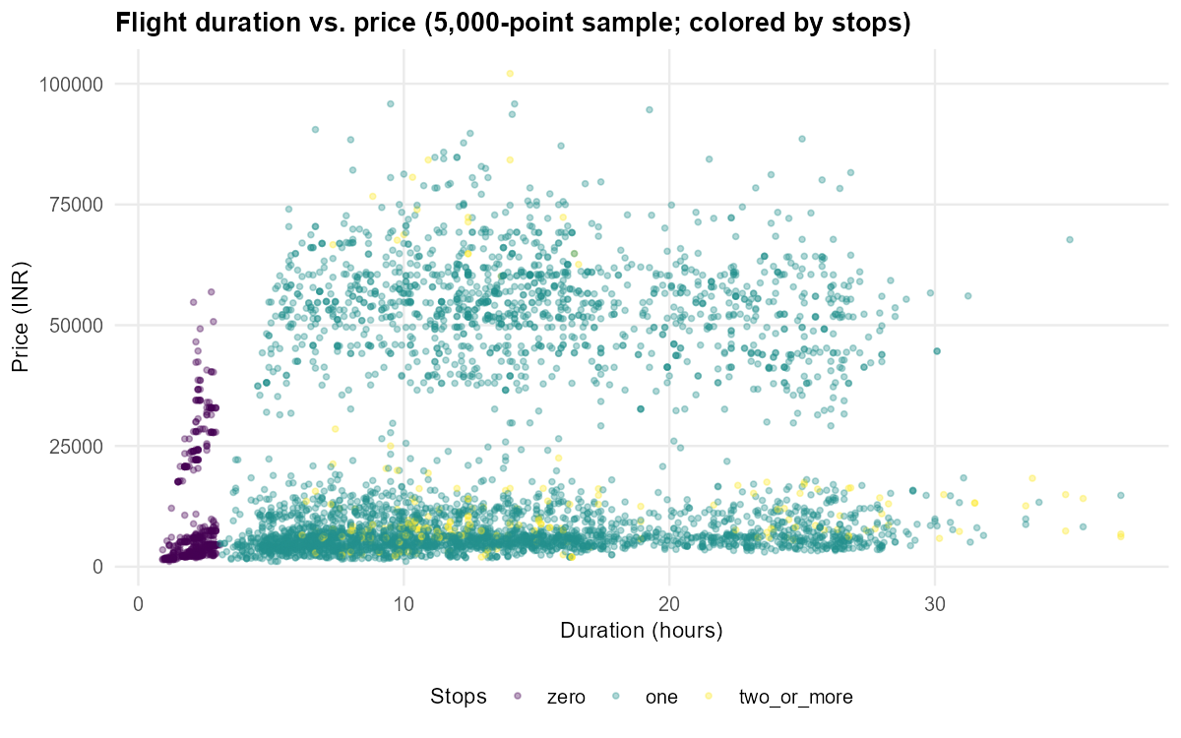
Chart #7 — Duration vs. price scatter — static export for this report.
A scatter (not a bubble chart) was used deliberately: Lecture 9 explicitly criticizes bubble charts for confounding two variables (position and size) in one mark, hurting perceptual accuracy. Color-by-stops uses a qualitative Bertin visual variable appropriately, since stops has only 3 ordered categories. In the live app, points are capped to a 5,000-point random sample for interactive rendering performance (the unfiltered dataset has ~300k rows, far more than a browser can smoothly render as individually hoverable/selectable marks); the sample preserves the overall shape of the relationship while keeping the chart responsive.

Chart #8 — Departure-time × airline grid
Small-multiple heatmap, rows ordered by time-of-day (not alphabetically, §3.2), Traveler tab.
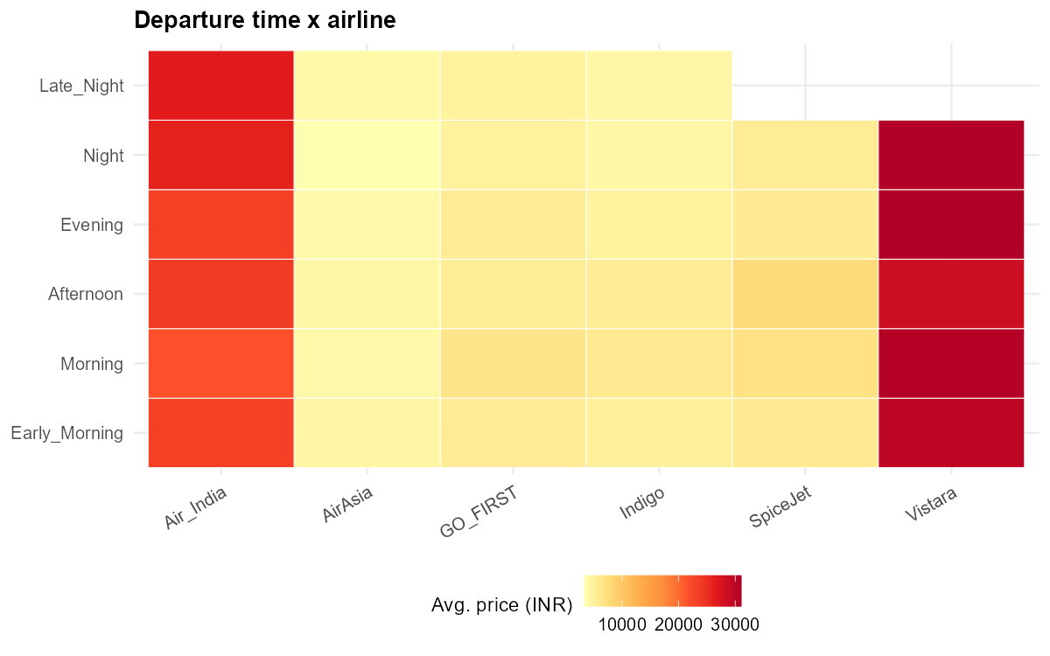
Chart #8 — Departure-time × airline grid — static export for this report.
Demonstrates multivariate encoding via small multiples (Bertin) and is the chart most directly used to showcase the Connect/linked-brushing interaction (§4.4): flights lasso-selected on chart #7 are highlighted here as an overlay, letting a user see where their selection concentrates across time-of-day and airline.

Chart #9 — KPI tiles
Four stat tiles (flight count, average price, average duration, average price-per-hour on the Traveler tab; flight count, market leader, cheapest-average airline, average price on the Airline tab) sit above the detail charts on both tabs, always reflecting the current filter state. This is Stephen Few's single-screen dashboard principle (Lecture 8) applied directly: an at-a-glance overview before any zooming/filtering, per Shneiderman's mantra.
[PLACEHOLDER — Screenshot of the live KPI tiles row from the running app (both tabs)]

4.2 The pie-chart decision
No pie chart is used anywhere in the app, despite airline (6 categories) and class/stops (2–3 categories) being exactly the kind of “simple category share” situation where a pie chart is tempting. Cleveland & McGill's perceptual-accuracy ranking (position on a common scale > position non-aligned > length/angle > area > volume > shading, Lecture 2) and Stevens' Power Law (Lecture 3: bar length exponent ≈1.0/accurate vs. area exponent ≈0.7/underestimated) both rank angle/area judgments — exactly what a pie chart requires — below simple length judgments. With 6 non-extreme-share airline categories (§2.3's market-share table shows shares ranging 3%–43%, several fairly close together), this is precisely the regime where pie-slice angle misjudgment causes real ranking errors. Chart #3 uses an ordered bar instead, communicating the same information with a provably more accurate encoding. This decision was made explicitly, not by default — see §5 for how an AI-suggested pie chart was reviewed and rejected during development.

4.3 Interaction design (9 operators)
Operator | Concrete implementation
Filter | Sidebar sliderInput (days_left, duration), checkboxGroupInput/selectInput (airline, class, stops, source/dest city) feeding one shared reactive() filtered dataset per tab.
Select | plotly event_data("plotly_click"/"plotly_selected") on the route heatmap and the scatter.
Explore / Change configuration (continuous) | Slider drag → live re-render of every chart on the tab.
Reconfigure | radioButtons metric toggle (Mean Price / Flight Count) re-fills the heatmap and the time×airline grid by a different measure without changing the chart type.
Encode | Log-scale checkbox on chart #1; color-by selector (stops/class/airline) on chart #7.
Abstract/Elaborate | KPI tiles (abstract, tab-wide) sit above the detail charts — overview-first, detail-on-demand.
Connect (linked brushing) | A lasso selection on chart #7 highlights the matching flights as an overlay on chart #8; a click on chart #5 highlights that route on chart #6.
Undo/Redo | “Reset all filters” button per tab restores every input to its default (a scoped, single-step interpretation of the operator, noted here explicitly rather than a full history stack).
Change configuration (persona) | The navbarPage tab switch between Traveler View and Airline Analytics changes the entire chart configuration/persona context.

4.4 Dashboard layout
Both tabs use a fixed sidebar (~25% width, filters + reset button) and a main panel (~75%, KPI row on top, then two rows of two charts) with no vertical scroll-chasing and no decorative gradients or borders — Stephen Few's single-screen, high-data-ink-ratio dashboard principle (Lecture 8). A single colorblind-safe qualitative palette (RColorBrewer “Set2”) is used consistently for airline across both tabs, so the same airline is always the same color everywhere it appears (Lecture 11: consistent, accessible color mapping).
[PLACEHOLDER — Full-page screenshot of the Traveler View tab (sidebar + KPI tiles + 4 charts)]
[PLACEHOLDER — Full-page screenshot of the Airline Analytics tab (sidebar + KPI tiles + 4 charts)]

5. AI Usage Documentation
The full, running prompt-by-prompt log is kept in report/ai_prompt_appendix.md and is updated by each team member as they work; this section summarizes it. Claude Code (Anthropic) was the AI tool used throughout the initial planning and implementation phase covered below; teammates should add their own tool(s) (ChatGPT, Copilot, etc.) and entries to the appendix as they contribute.

5.1 Capabilities used
Capability | Where it was used
Idea generation / research | Surveying all 11 lecture PDFs to identify which taught theory (Bertin, Cleveland-McGill, Stevens' Power Law, Tufte, the 9 interaction operators, Stephen Few, Pyramid Principle) should ground each design decision.
Code generation | The full R Shiny app — data_prep.R, all 9 chart functions, ui.R, server.R, app.R — plus the report-asset generation scripts.
Debugging | Diagnosing and fixing 3 concrete bugs found during verification (§6.2).
Data analysis | Running the EDA and uncovering the class-mix confound described in §2.3.
Visualization suggestions | Proposing and justifying each of the 9 chart types against course theory.
UI design | The two-tab, sidebar-plus-KPI-tiles dashboard layout (§4.4).
Refactoring | Extracting the shared theme/palette into R/theme.R so all 9 charts look like one system.
Documentation | PLAN.md, README.md, and this report.

5.2 How AI outputs were validated or corrected
AI-generated code and suggestions were not accepted uncritically. Concrete examples from this project:
- A first instinct to visualize market share with a pie chart was reconsidered and rejected in favor of an ordered bar chart, specifically because Cleveland-McGill/Stevens' theory (Lecture 2/3) predicts real misjudgment for 6 non-extreme-share categories — see §4.2.
- The scatter plot's linked-brushing selection was initially implemented using plotly's raw pointNumber as a row index; this was caught as incorrect once tested, because plotly resets pointNumber per color-trace when a categorical color mapping splits the chart into multiple traces. It was fixed by adding a stable row-id “key” aesthetic instead — caught by writing and running a headless smoke test, not assumed correct from the code alone.
- The heatmap-click and scatter-lasso interactions initially had no effect at all when tested with shiny::testServer() — plotly's event_data() silently returns nothing unless the chart explicitly calls event_register() for that event type. This is not obvious from reading the code and was only caught by actually exercising the reactive server logic programmatically.
- The booking-curve chart originally fit a LOESS smoother directly on the full ~300,000-row dataset; a live test run of the app hung during rendering. This was diagnosed as a genuine performance/scalability bug (LOESS scales very poorly with n) and fixed by aggregating to per-days_left means before smoothing, rather than papering over the symptom.
- The duration-range slider's default bounds used round(), which rounded the true maximum duration down and silently excluded a small number of legitimate boundary flights even at the slider's default “full range” position. This was only caught because a headless test explicitly asserted that the default filter state should return every row, and it didn't — fixed with floor()/ceiling() instead.
[PLACEHOLDER — Add each team member's own AI usage entries here (tool, prompt, capability, validation) as they complete their assigned section — see report/ai_prompt_appendix.md for the template]

6. Evaluation & Reflection

6.1 Strengths
- Dual-persona coverage: the same underlying data serves two genuinely different decision-support goals (traveler vs. airline analyst) without duplicating the data pipeline.
- Every encoding choice is justified against specific, citable course theory rather than default chart-library behavior — including a deliberate, reasoned rejection of a pie chart.
- The class-mix confound found in §2.3 is a genuine, non-obvious insight (not a canned dataset fact) that directly shaped why the class filter is a first-class, always-visible control rather than a secondary option.
- The tech stack (R + Shiny + ggplot2/plotly/leaflet) mirrors the course's own worked Lecture 6 example almost exactly, making the implementation easy to map back to what was taught.
- Headless verification (a chart-function smoke test and a full shiny::testServer() run of the reactive graph) caught real bugs before manual testing, rather than relying on visual inspection alone.

6.2 Limitations
- No real calendar dates — only days_left (booking lead time) — so no seasonal/day-of-week pricing patterns can be shown, only lead-time patterns.
- No flight-delay, cancellation, or on-time-performance data, so the “best airline” comparison is price/duration-only, not reliability-aware.
- The India route map is schematic (straight-line arcs between manually-curated city centroids), not a true flight-path or air-corridor visualization.
- This is a static snapshot of historical listings, not live/real-time pricing — the dashboard supports retrospective exploration, not real-time booking decisions.
- No predictive element by design (see §1.3) — the dashboard cannot forecast a specific future price, only show historical patterns by booking lead time.
- Formal usability evaluation (think-aloud testing, expert heuristic review — Lecture 11) was not performed due to project time constraints; verification here was technical (does the code work correctly) rather than user-facing (do real users find the intended insights).

6.3 What AI helped with vs. human decisions
AI accelerated: boilerplate Shiny wiring, first-draft chart code, the initial course-theory research pass across all 11 lectures, and this report's drafting. Human/team decisions (to be confirmed and adjusted by the team during review): which two personas to build around, the India-only map scope, the decision to exclude a predictive model, and — per §5.2 — catching and rejecting a suggested pie chart in favor of theory-backed alternatives.
[PLACEHOLDER — Team: replace/expand this subsection with your own account of which decisions were genuinely human judgment calls versus accepted AI suggestions, once you've reviewed the app together]

6.4 Lessons learned and future improvements
- Never trust an unconditioned aggregate statistic without checking for a lurking categorical variable (§2.3's class-mix confound is this project's own Anscombe's Quartet moment) — this is now baked into the app itself via the always-visible class filter, not just a report footnote.
- If a real, dated booking-price time series became available, chart #4 could show actual seasonal trends instead of only lead-time trends.
- Linked brushing (§4.3's Connect operator) is currently implemented between one chart pair per tab; a future iteration could extend it across all charts on a tab simultaneously.
- A structured usability pass (Lecture 11: think-aloud test with 2–3 people outside the team) would validate whether the intended insights (e.g. the booking-curve trend, the class-mix finding) are actually discoverable by a first-time user without guidance.

7. Deliverables Checklist
Deliverable | Status | Location
Report | Complete (this document) | Report.docx
Source code | Complete and verified | GitHub: Eyalmied/Visualization-Project
AI prompt appendix | Template + first entries in place; add your own as you work | report/ai_prompt_appendix.md
Working demo (10–15 min) | App built and verified; live walkthrough not yet rehearsed as a team | shiny::runApp() from the repo root

Suggested demo structure (Pyramid Principle, Lecture 11): open with the headline finding — e.g. “booking 30+ days out saves about 45.6% versus booking in the final 3 days, and that gap looks even bigger or smaller depending on which airline and class you pick” — then let each team member walk through their assigned tab/charts as supporting evidence, finishing with a live interactive demonstration of the filters and linked-brushing.

