Project 4:   
CS6035

Zhaoran Yang  
zyang625@gatech.edu

# Task 1 – Warm Up Exercises

**Activity 1:**

1. What is the value of the ‘CanYouSeeMe’ input?

**Answer:** A_Value_Between_One_And_Ten

1. The page references a single JavaScript file in a script tag. Name this file including the file extension.

**Answer:** project4.js

1. The script file has a JavaScript function named ‘runme’. Use the console to execute this function. What is the output that shows up in the console?

**Answer:** There are 42 bugs on the wall.

**Activity 2:**

1. What request method (http verb) was used in the request to the server?

**Answer:** POST

1. What status code did the server return?

**Answer:** 499

1. The server returned a cookie named ‘Samy’ for the browser to store. What is the value of this cookie?

**Answer:** but_most_of_all_samy_is_my_hero

**Activity 3:**

Please see activity3.html submitted and below screenshot as my answer.

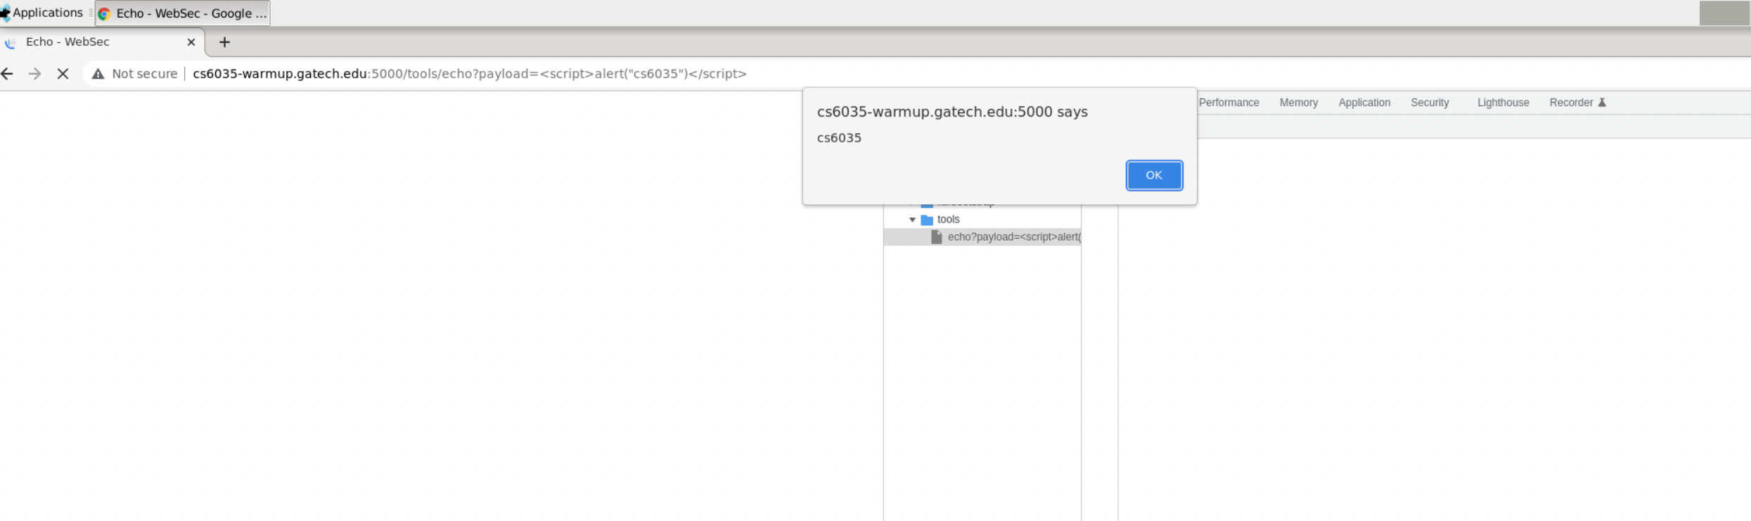

**Activity 4:**

Please see activity4.html submitted and below text I see as my answer.

**Answer:** Congratulations!, you've successfully finished this activity. The answer is Stuxnet (2010)

**Activity 5:**

Please see activity5.html submitted.

# TASK 3

# References