**Selenium With C# automation for ‘knockrentals’ application**

Execution Report:

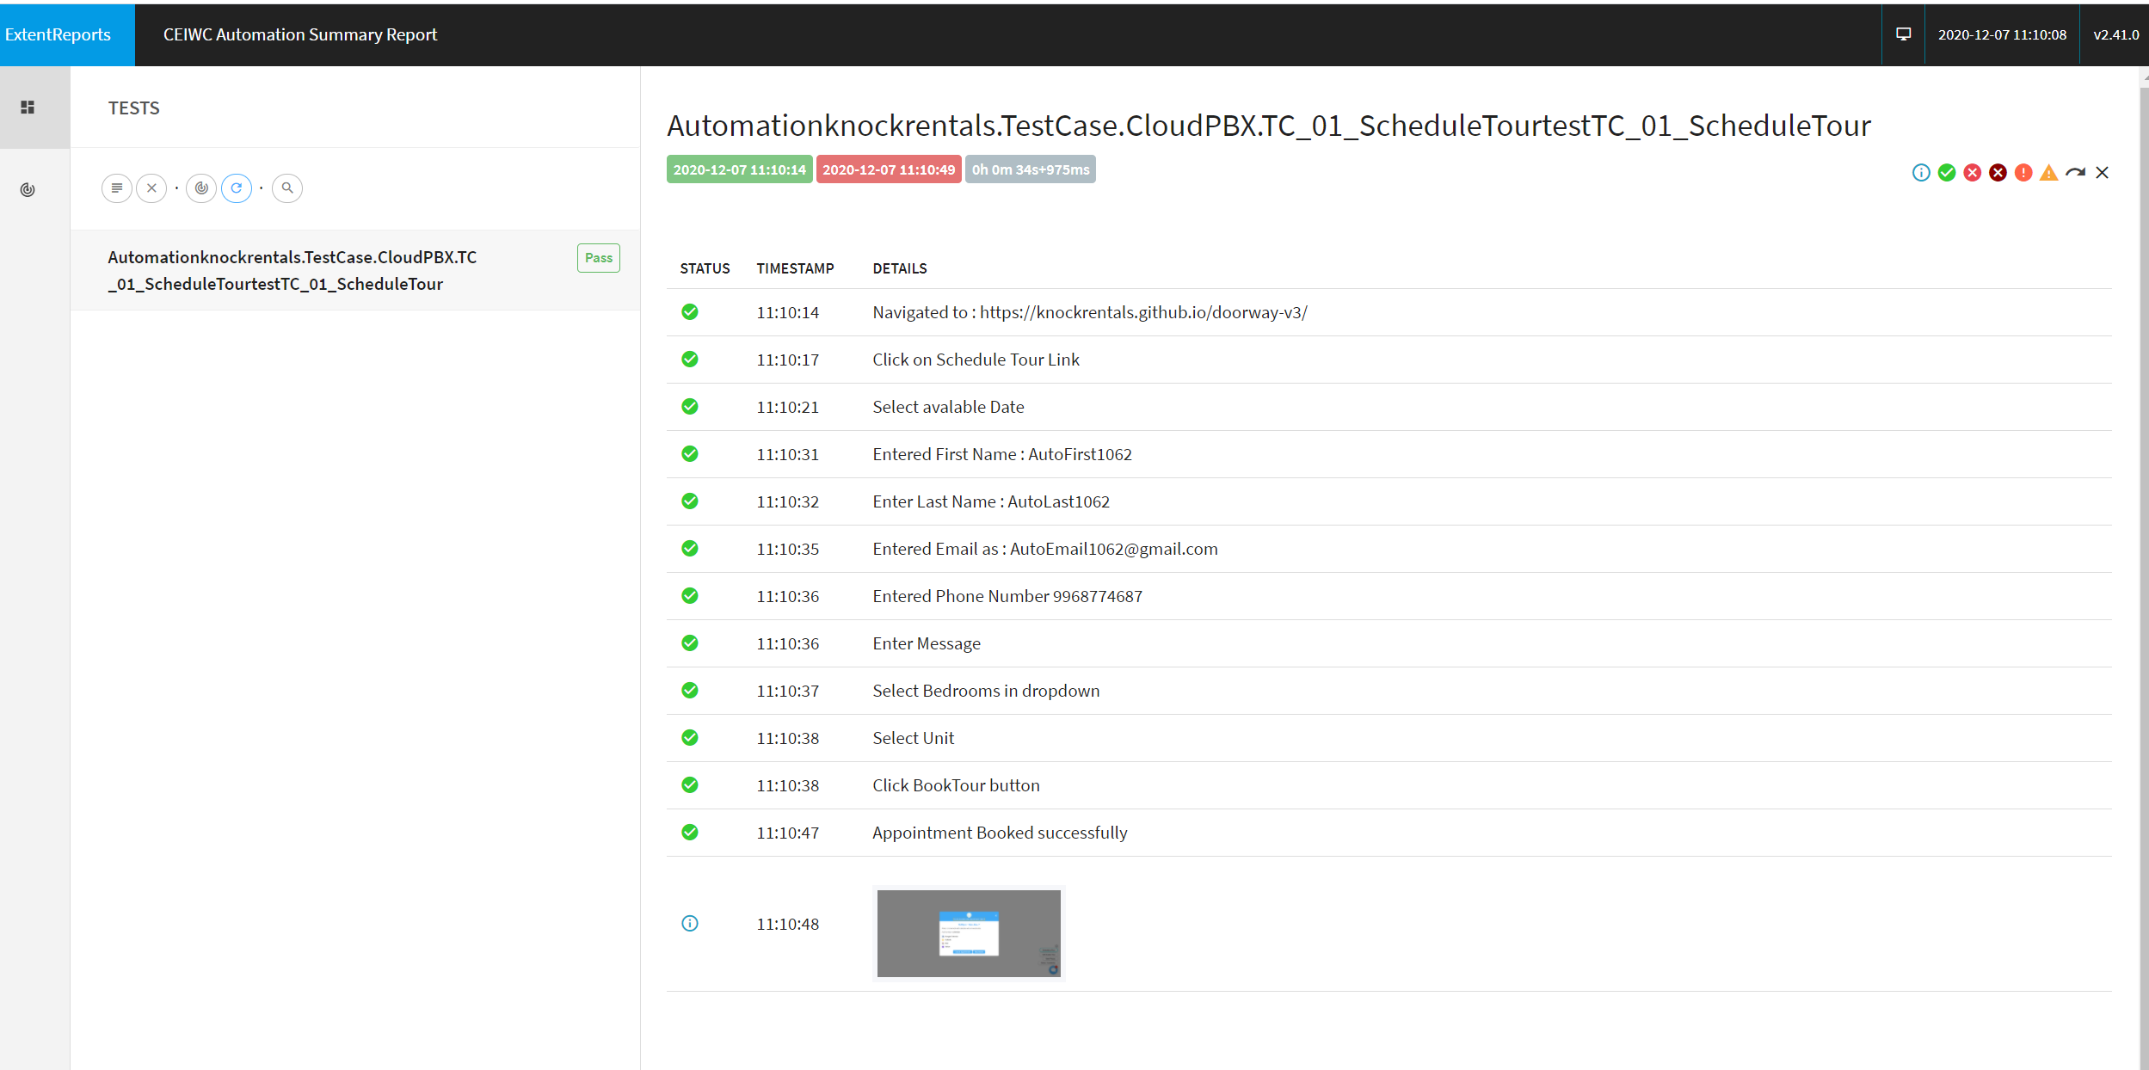

Execution Video Link:

<https://www.screencast.com/t/xxvANaOwt>

1. We created a framework with Nunit framework architecture.
2. Once solution download from the Repository……………………………….

Prerequisites:

1. Visual Studio should be installed in machine
2. Extract the downloaded solution
3. Open the Solution. Once Open the solution it looks like below

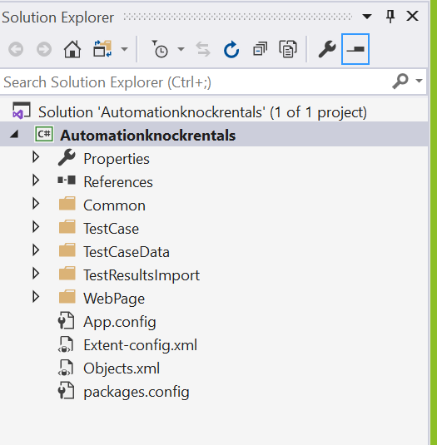

1. Clean the solution and Build the Solution once loaded like above.
2. To clean and build right click on the project able to view clean and build options.
3. After successful build message. To run the test case please follow below steps
4. Click on ‘Test’ in the Menu Items and click on ‘Test Explorer’.
5. Observed Test Explorer displayed like below

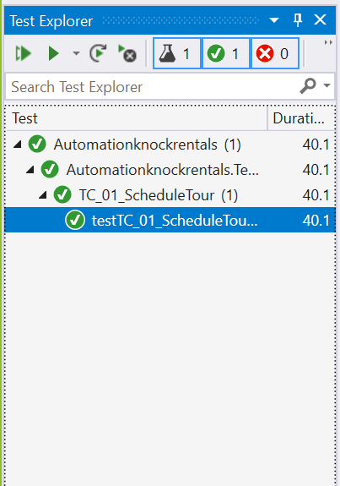

1. Right click on ‘’Tc_01’ and click run to test cases execution.

* How can this test be extended?
* This Test can be Validate the schedule a tour functionality. And for extended we can adding more functionality automation script.
* How else could this feature be tested?
* Each feature performed with assertion in our code to validate the functionality.
* What assumptions did you make when writing this test?
* In Terms of Automation script. Inspect each and every field objects and identify with multiple option like ID, Name, Class, Xpaths etc. used to click an objects with selenium web driver.
* How could this test be integrated into a CI/CD pipeline?
* This Nunit framework is more flexible to integrate Ci/CD pipelines in Azure.
  1. Once the solution is pushed in azure repository section
  2. We create a pipeline to run Automation scripts on dedicated agents.
  3. We can schedule an execution on scheduled time.