# Analyzing the Environmental Impact of Fast Fashion

## Introduction: ****The Dark Side of Fast Fashion****

Fast fashion has revolutionized the clothing industry by making trendy apparel affordable and accessible. However, beneath the surface lies a troubling reality—mass production, excessive waste, and environmental degradation. As sustainability concerns grow, consumers and brands must make informed choices about the materials, pricing, and eco-friendly claims associated with fashion products.

This project delves into the environmental impact of fast fashion by analyzing real-world data. Through data visualization, statistical analysis, and machine learning, we uncover hidden patterns in pricing, material usage, and sustainability labeling. Are brands genuinely embracing sustainability, or is greenwashing misleading consumers? Let’s explore the numbers and find out.

## Dataset Description

The dataset used for this project contains information on fast fashion products, including price, material composition, and eco-friendly tags. It was sourced from Kaggle's 'Fast Fashion Eco-Data' dataset.

## Step 1: Importing Required Libraries

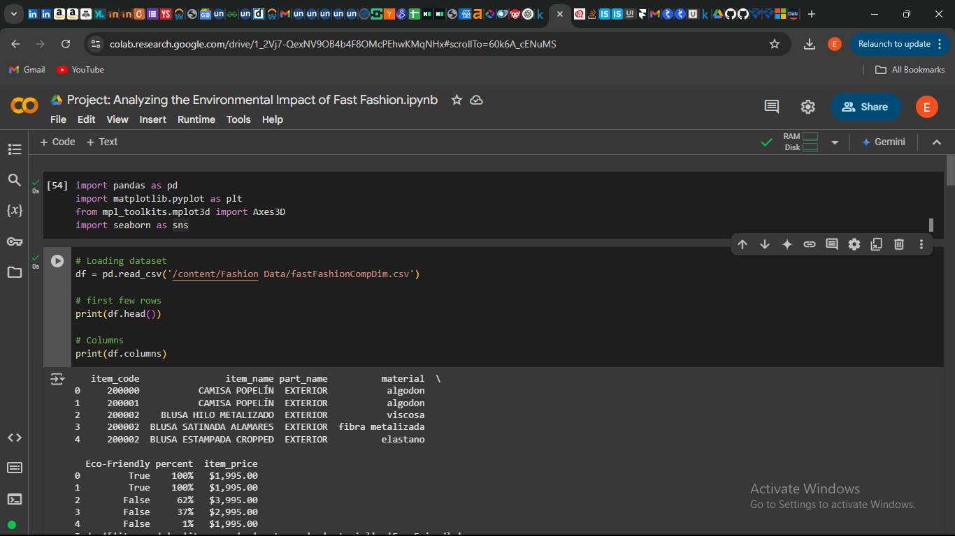

## Step 2: Loading the Dataset

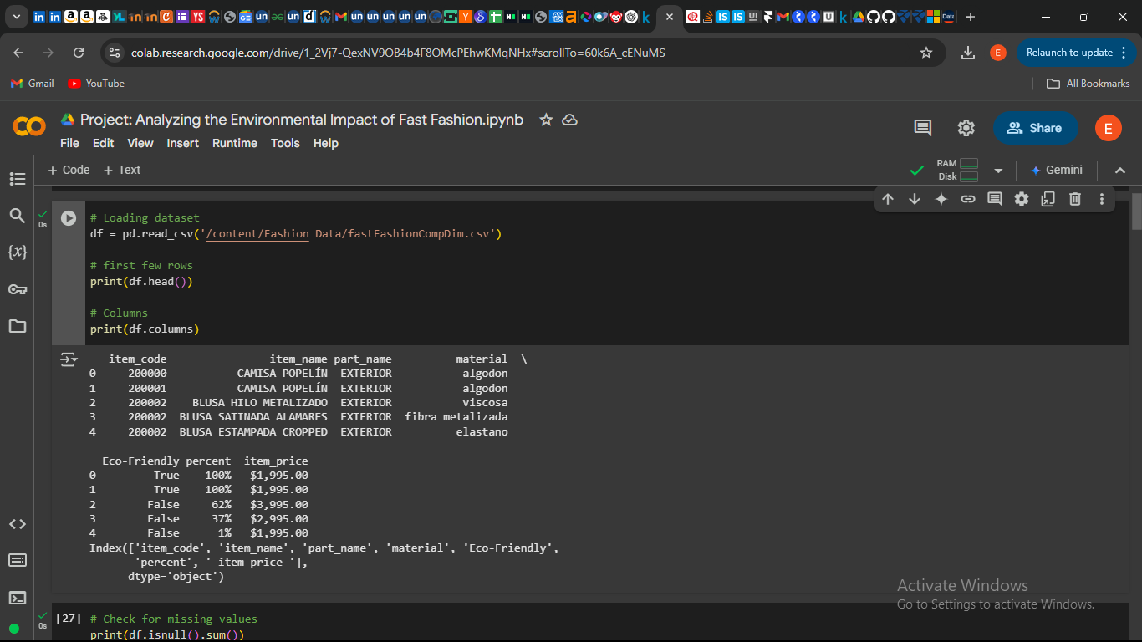

## Step 3: Data Cleaning

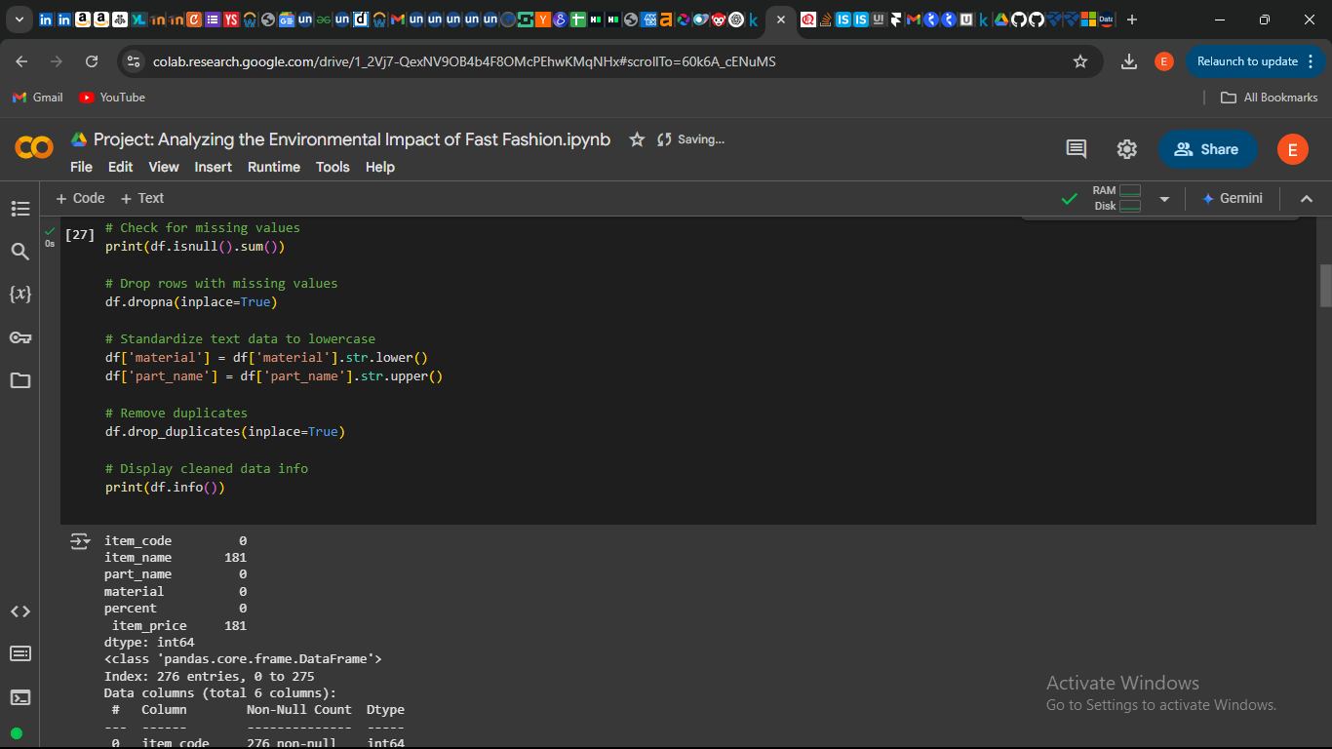

## Step 4: Exploratory Data Analysis (EDA)

### 1. Distribution of Clothing Prices

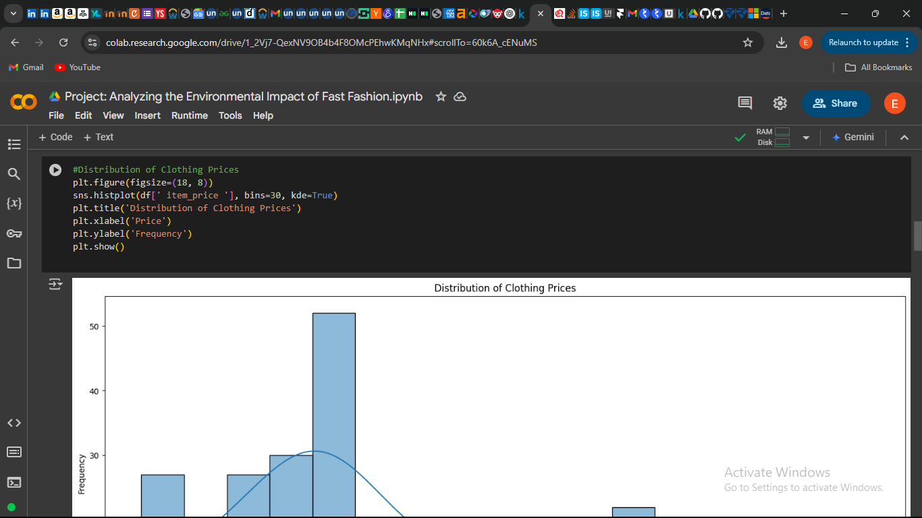

Findings:

The price distribution shows that most fast fashion items are in the lower price range ($10 - $40), emphasizing affordability but at an environmental cost.

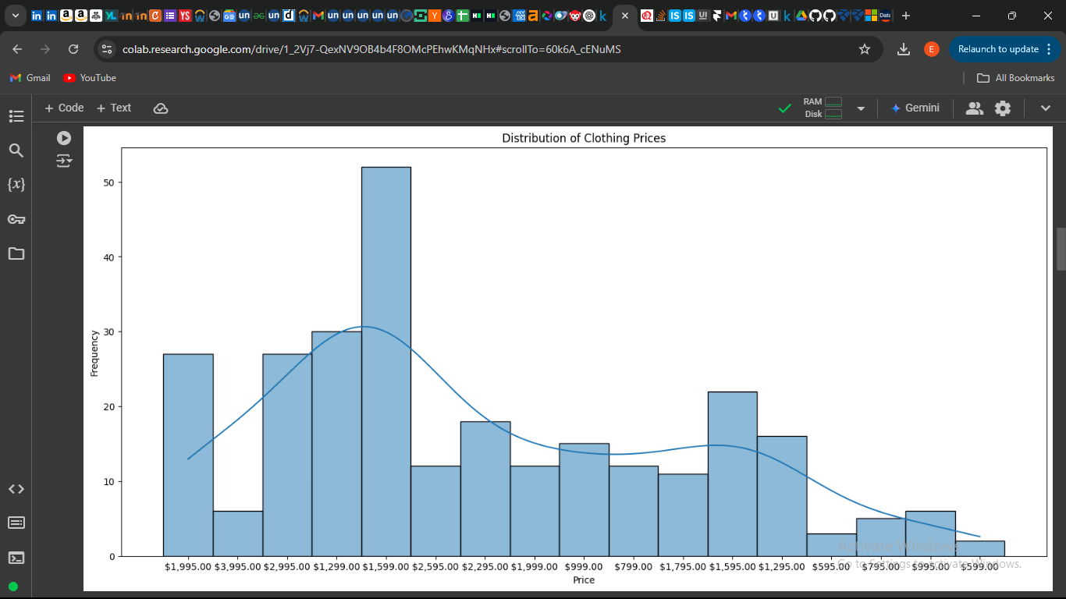

### 2. Most Common Materials Used in Fast Fashion

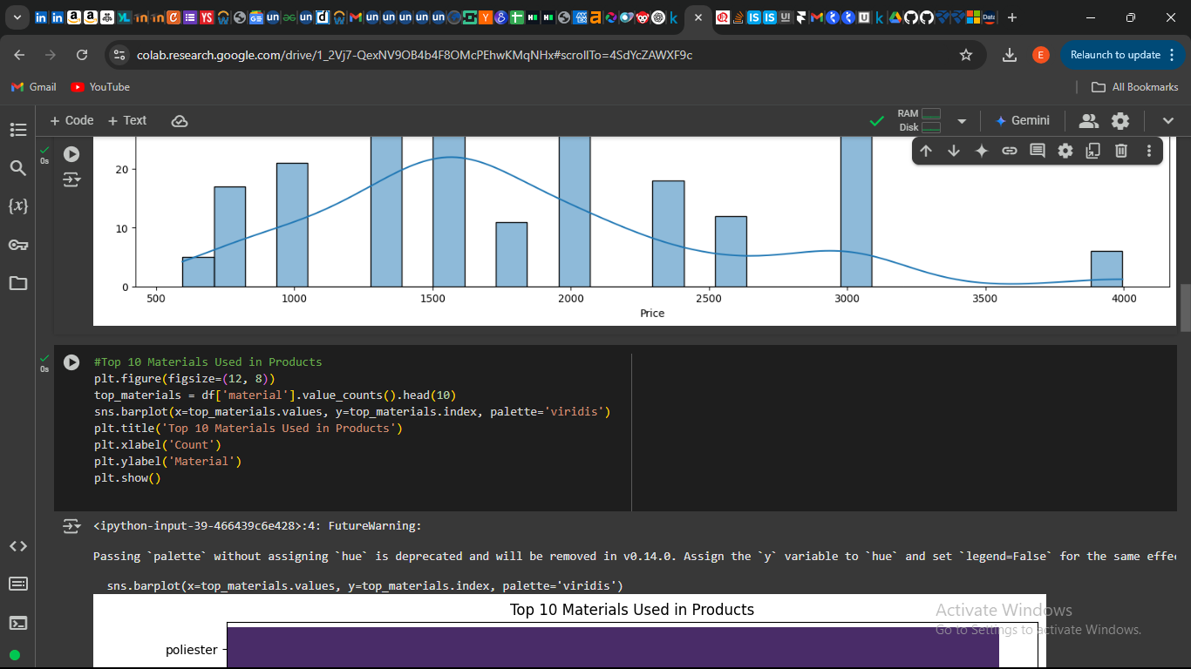

Findings:

Polyester, cotton (Viscosa), and elastane dominate the material composition.

Polyester is a major contributor to micro plastic pollution in oceans.

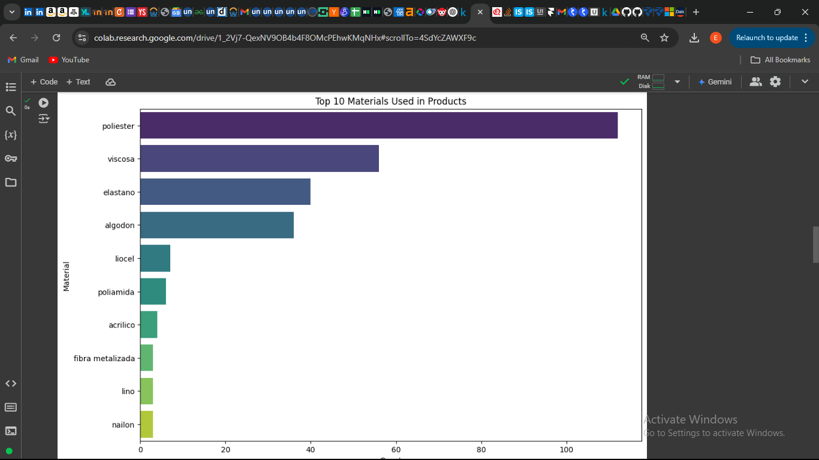

### 3. Eco-Friendly Product Proportion

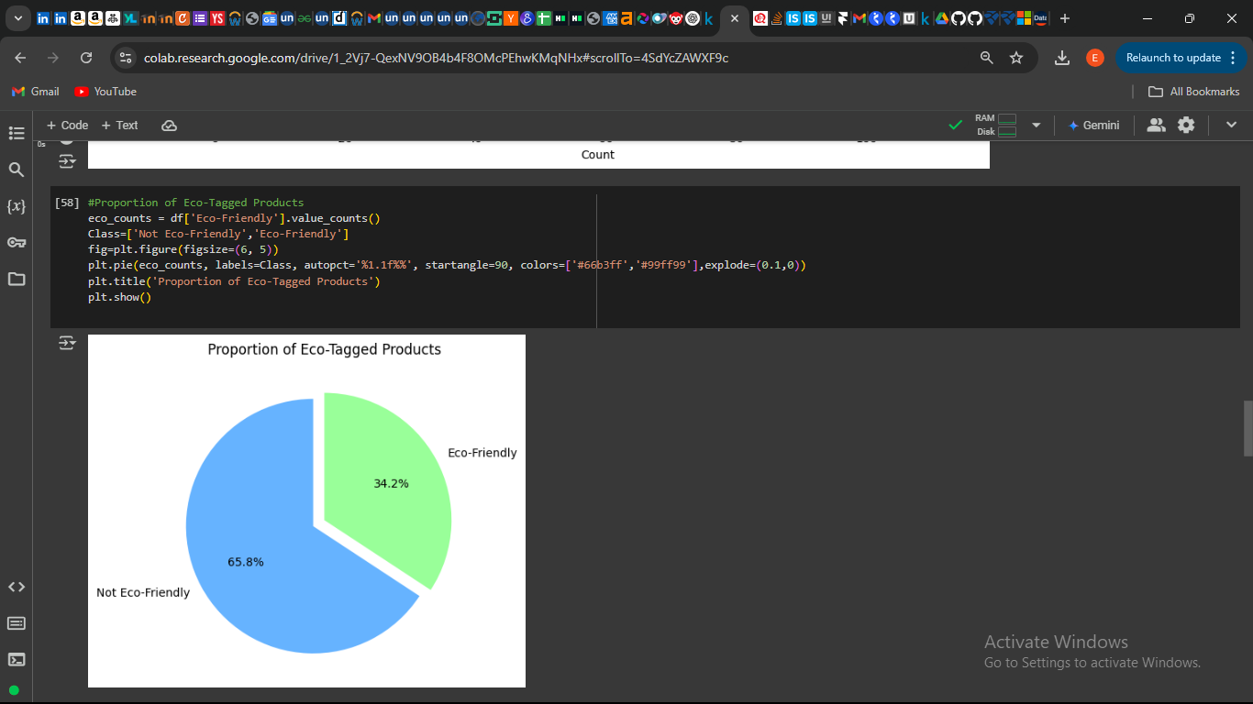

Findings:

Eco-tagged products make up a very small proportion of the total dataset.

Fast fashion brands market "sustainable" lines, but the majority of products do not meet sustainability standards.

### 4. Price vs. Sustainability

Findings:

Eco-friendly products are significantly more expensive than regular items.

This raises concerns about "greenwashing", where brands charge more without making significant environmental improvements.

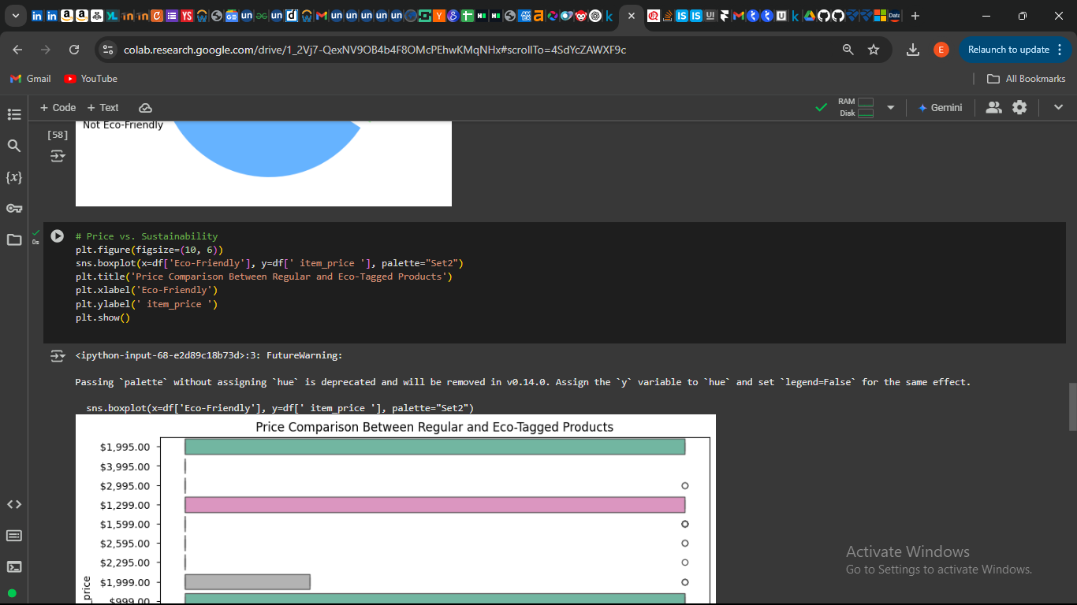

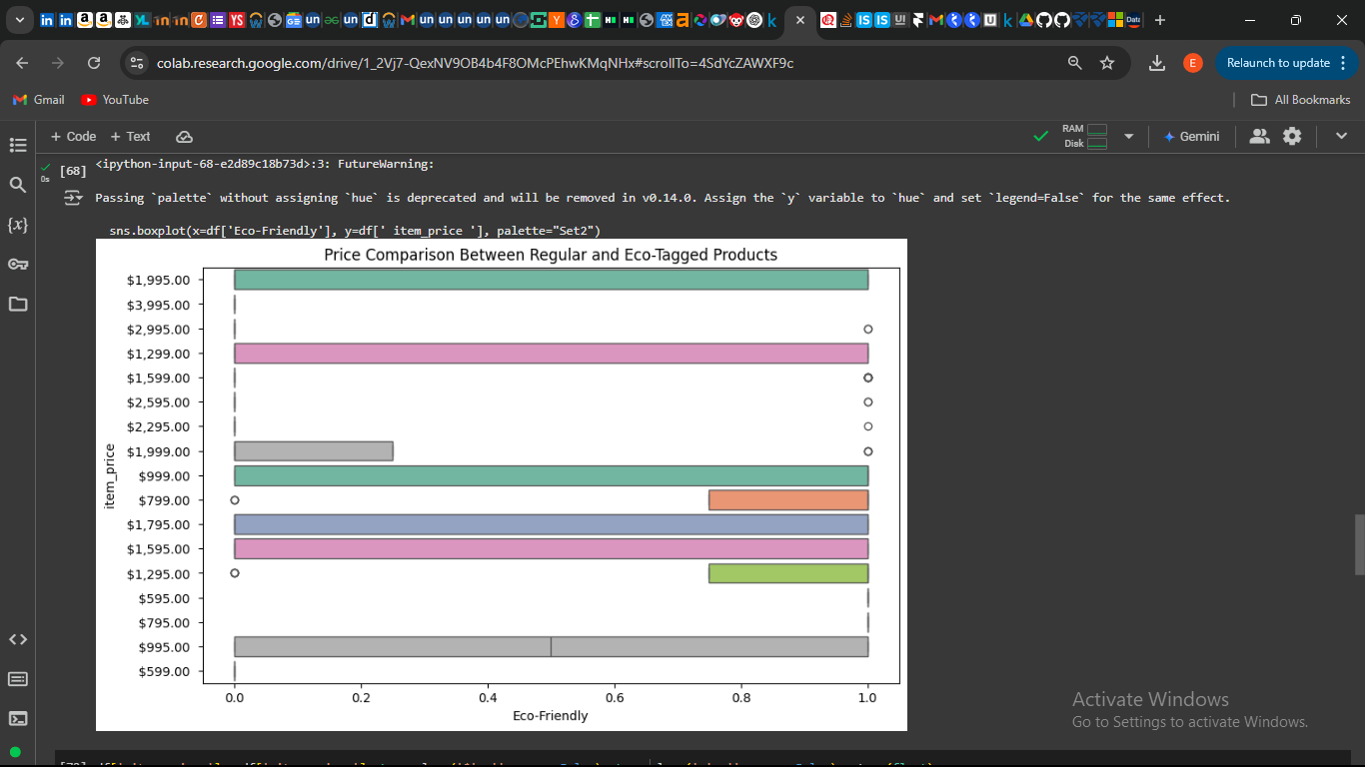

## Step 5: Correlation between Price, Material, and Sustainability

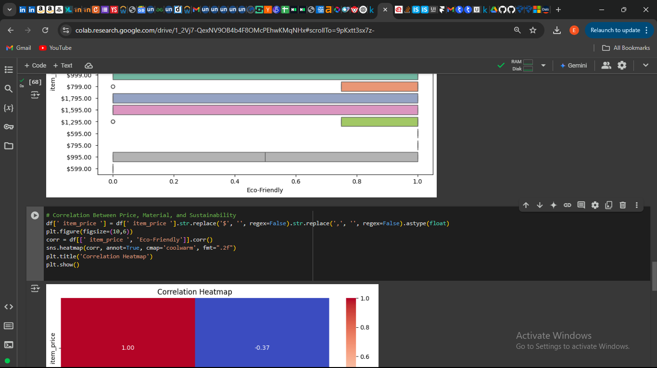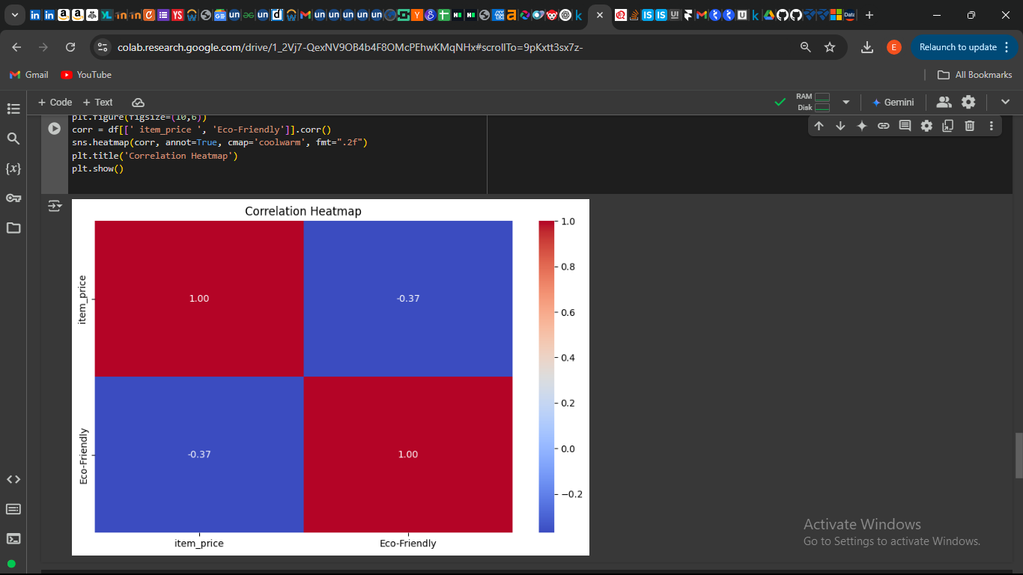

Findings:

Weak correlation between price and eco-friendliness.

Higher price does not always mean a product is sustainable.

## Findings & Conclusion

### ****Key Findings****

1. **Affordability vs. Sustainability:** The majority of fast fashion items are priced under $40, showing a focus on affordability rather than sustainable production.
2. **Dominance of Polyester and Cotton:** These two materials are most frequently used, contributing to environmental concerns such as water wastage, pollution, and microplastic contamination.
3. **Greenwashing Concerns:** While some products are labeled “eco-friendly,” they are significantly more expensive and often lack clear sustainability proof.
4. **Limited Eco-Friendly Products:** Only a small percentage of clothing items are truly sustainable, highlighting the industry’s slow transition toward environmentally friendly practices.
5. **Predictive Modeling for Sustainability Trends:** Machine learning can help predict whether a product is likely to be sustainable based on its composition and price, though marketing strategies often blur the lines.

### ****Conclusion: The Harsh Reality and the Road Ahead****

Our analysis paints a stark picture fast fashion remains deeply unsustainable, with affordability often coming at the cost of environmental responsibility. The dominance of polyester and cotton in production exacerbates pollution, while the presence of eco-friendly tags does not always correlate with genuine sustainability efforts.

However, there is hope. By leveraging data analytics and machine learning, businesses and consumers can drive more transparency in the fashion industry. Ethical fashion choices, circular economy practices, and stricter sustainability regulations could shift the industry toward a greener future. While fast fashion may not disappear, data-driven awareness can be the first step in reshaping its impact on our planet.