705.641.81: Natural Language Processing Self-Supervised Models
Homework 3: Building Your Neural Network!
For homework deadline and collaboration policy, please see our Canvas page.
Name: _______Morgan Zinn___________________
Collaborators, if any: ____________________________________________________
Sources used for your homework, if any: _______________________________________
This assignment is focusing on understanding the fundamental properties of neural networks and their training.
Homework goals: After completing this homework, you should be comfortable with:
- thinking about neural networks
- key implementation details of NNs, particularly in PyTorch,
- explaining and deriving Backpropagation,
- debugging your neural network in case it faces any failures.

Concepts, intuitions and big picture
- Suppose you have built a neural network. You decide to initialize the weights and biases to be zero. Which of the following statements are True? (Check all that apply)
$▫$ Each neuron in the first hidden layer will perform the same computation. So even after multiple iterations of gradient descent each neuron will be computing the same thing as other neurons in the same layer.
$▫$ Each neuron in the first hidden layer will perform the same computation in the first iteration. But after one iteration of gradient descent they will learn to compute different things because we have “broken symmetry”.
$▫$ Each neuron in the first hidden layer will compute the same thing, but neurons in different layers will compute different things, thus we have accomplished “symmetry breaking” as described in lecture.
$▫$ The first hidden layer’s neurons will perform different computations from each other even in the first iteration; their parameters will thus keep evolving in their own way.
- Vectorization allows you to compute forward propagation in an $L$-layer neural network without an explicit for-loop (or any other explicit iterative loop) over the layers $l=1,2,×,L$. True/False?
$▫$ True
$▫$ False
- The tanh activation usually works better than sigmoid activation function for hidden units because the mean of its output is closer to zero, and so it centers the data better for the next layer. True/False?
$▫$ True
$▫$ False
- Which of the following techniques does NOT prevent a model from overfitting?
$▫$ Data augmentation $▫$ Dropout $▫$ Early stopping $▫$ None of the above
- Why should dropout be applied during training? Why should dropout NOT be applied during evaluation?
During training, dropout randomly removes activations, reducing dependence on particular neurons and encouraging robust features. At evaluation, use all neurons for stable predictions from the full network. With inverted dropout, retained activations are scaled during training, so evaluation requires no additional scaling.
- Explain why initializing the parameters of a neural net with a constant is a bad idea.
Initializing all weights to the same constant makes hidden neurons identical. Their gradient updates remain identical, preventing them from learning distinct features. Zero bias initialization is generally fine when weights are initialized randomly.
- You design a fully connected neural network architecture where all activations are sigmoids. You initialize the weights with large positive numbers. Is this a good idea? Explain your answer.
This is a poor initialization. Large weights can give preactivations with large magnitudes, pushing sigmoid outputs toward 0 or 1, where derivatives approach zero. Backpropagated gradients therefore become small and learning slows or stalls.
$$σ'\left(z\right)=σ\left(z\right)\left(1-σ\left(z\right)\right).$$
- Explain what is the importance of “residual connections”.
Residual connections add a block’s input to its transformed output, providing a direct path for information and gradients through deep networks. The block can learn a correction to its input rather than a completely new representation.
$$h_{out}=h_{in}+F\left(h_{in}\right), \frac{∂h_{out}}{∂h_{in}}=I+J_{F}\left(h_{in}\right).$$
- What is cached (“memoized”) in the implementation of forward propagation and backward propagation?
$▫$ Variables computed during forward propagation are cached and passed on to the corresponding backward propagation step to compute derivatives.
$▫$ Caching is used to keep track of the hyperparameters that we are searching over, to speed up computation.
$▫$ Caching is used to pass variables computed during backward propagation to the corresponding forward propagation step. It contains useful values for forward propagation to compute activations.
- Which of the following statements is true?
$▫$ The deeper layers of a neural network are typically computing more complex features of the input than the earlier layers.
$▫$ The earlier layers of a neural network are typically computing more complex features of the input than the deeper layers.

Revisiting Jacobians
Recall that Jacobians are generalizations of multi-variate derivatives and are extremely useful in denoting the gradient computations in computation graph and Backpropagation. A potentially confusing aspect of using Jacobains is their dimensions and so, here we’re going focus on understanding Jacobian dimensions.

Recap:
Let’s first recap the formal definition of Jacobian. Suppose $f:R^{n}→R^{m}$ is a function takes a point $x∈R^{n}$ as input and produces the vector $f\left(x\right)∈R^{m}$ as output. Then the Jacobian matrix of $f$ is defined to be an $m×n$ matrix, denoted by $J_{f}\left(x\right)$, whose $\left(i,j\right)$th entry is $J_{ij}=\frac{∂f_{i}}{∂x_{j}}$, or:
$$J=\left[\begin{matrix}\frac{∂f}{∂x_{1}} & ⋯ & \frac{∂f}{∂x_{n}}\end{matrix}\right]=\left[\begin{matrix}∇^{⊤}f_{1} \\ ⋮ \\ ∇^{⊤}f_{m}\end{matrix}\right]=\left[\begin{matrix}\frac{∂f_{1}}{∂x_{1}} & ⋯ & \frac{∂f_{1}}{∂x_{n}} \\ ⋮ & ⋱ & ⋮ \\ \frac{∂f_{m}}{∂x_{1}} & ⋯ & \frac{∂f_{m}}{∂x_{n}}\end{matrix}\right]$$

Examples:
The shape of a Jacobian is an important notion to note. A Jacobian can be a vector, a matrix, or a tensor of arbitrary ranks. Consider the following special cases:
- If $f$ is a scalar and $\text{w}$ is a $d×1$ column vector, the Jacobian of $f$ with respect to w is a row vector with $1×d$ dimensions.
- If $\text{y}$ is a $n×1$ column vector and $\text{z}$ is a $d×1$ column vector, the Jacobian of $z$ with respect to $y$, or ${\text{J}}_{\text{z}}\left(\text{y}\right)$ is a $d×n$ matrix.
- Suppose $\text{A}∈R^{m×n}$ and $B∈R^{l×p×q}$. Then the Jacobian ${\text{J}}_{\text{A}}\left(\text{B}\right)$ is a tensor of shape $\left(m×n\right)×\left(l×p×q\right)$. More broadly, the shape of the Jacobian is determined as (shape of the output)$×$(shape of the input).

Problem setup:
Suppose we have:
- $X$, an $n×d$ matrix, $x_{i}∈R^{d×1}$ correspond to the rows of $X={\left[x_{1},…,x_{n}\right]}^{⊤}$
- $Y$, a $n×k$ matrix
- $W$, a $k×d$ matrix and $w$, a $d×1$ vector
For the following items, compute (1) the shape of each Jacobian, and (2) an expression for each Jacobian:
- $f\left(w\right)=c$ (constant)
$$f\left(w\right)=c, J_{f}\left(w\right)=0_{1×d}.$$
Shape: $1×d$. Every entry is zero because the output is independent of every component of $w$.
- $f\left(w\right)=∥w∥^{2}$ (squared L2-norm)
$$f\left(w\right)=∥w∥_{2}^{2}=\sum_{j=1}^{d}{w_{j}^{2}}, J_{f}\left(w\right)=2w^{⊤}.$$
Shape: $1×d$. The derivative with respect to $w_{j}$ is $2w_{j}$.
- $f\left(w\right)=w^{⊤}x_{i}$ (vector dot product)
$$f\left(w\right)=w^{⊤}x_{i}, J_{f}\left(w\right)=x_{i}^{⊤}.$$
Shape: $1×d$. The derivative with respect to $w_{j}$ is $x_{i,j}$.
- $f\left(w\right)=Xw$ (matrix-vector product)
$$f\left(w\right)=Xw, J_{f}\left(w\right)=X.$$
Shape: $n×d$, since $∂{\left(Xw\right)}_{i}/∂w_{j}=X_{ij}$.
- $f\left(w\right)=w$ (vector identity function)

$$f\left(w\right)=w, J_{f}\left(w\right)=I_{d}.$$
Shape: $d×d$, since $∂w_{i}/∂w_{j}=δ_{ij}$.
- $f\left(w\right)=w^{2}$ (element-wise power)
$$f\left(w\right)=w^{2}, J_{f}\left(w\right)=2diag\left(w\right).$$
Shape: $d×d$, since $∂w_{i}^{2}/∂w_{j}=2w_{i}δ_{ij}$.
- Extra Credit: $f\left(W\right)=XW^{⊤}$ (matrix multiplication)
$$f\left(W\right)=XW^{⊤}∈R^{n×k}.$$
The unflattened Jacobian has shape $\left(n×k\right)×\left(k×d\right)$, or $n×k×k×d$.
$$f{\left(W\right)}_{ia}=\sum_{r=1}^{d}{X_{ir}}W_{ar}, \frac{∂f{\left(W\right)}_{ia}}{∂W_{bj}}=δ_{ab}X_{ij}.$$

Activations Per Layer, Keeps Linearity Away!
Based on the content we saw at the class lectures, answer the following:
- Why are activation functions used in neural networks?
Nonlinear activations allow networks to represent nonlinear relationships. Without them, composing affine layers gives another affine transformation, so depth alone adds no nonlinear expressive power:
$$W_{2}\left(W_{1}x+b_{1}\right)+b_{2}=\left(W_{2}W_{1}\right)x+\left(W_{2}b_{1}+b_{2}\right).$$
- Write down the formula for three common action functions (sigmoid, ReLU, Tanh) and their derivatives (assume scalar input/output). Plot these activation functions and their derivatives on $\left(-∞,+∞\right)$.

Sigmoid:
$$σ\left(z\right)=\frac{1}{1+e^{-z}}, σ'\left(z\right)=σ\left(z\right)\left(1-σ\left(z\right)\right).$$
ReLU:
$$r\left(z\right)=max\left(0,z\right), r'\left(z\right)=\left\{\begin{matrix}0 & z<0, \\ 1 & z>0.\end{matrix}\right.$$
ReLU is not differentiable at zero; implementations commonly select a derivative of zero there.
Tanh:
$$t\left(z\right)=\frac{e^{z}-e^{-z}}{e^{z}+e^{-z}}, t'\left(z\right)=1-\tanh^{2}\left(z\right).$$
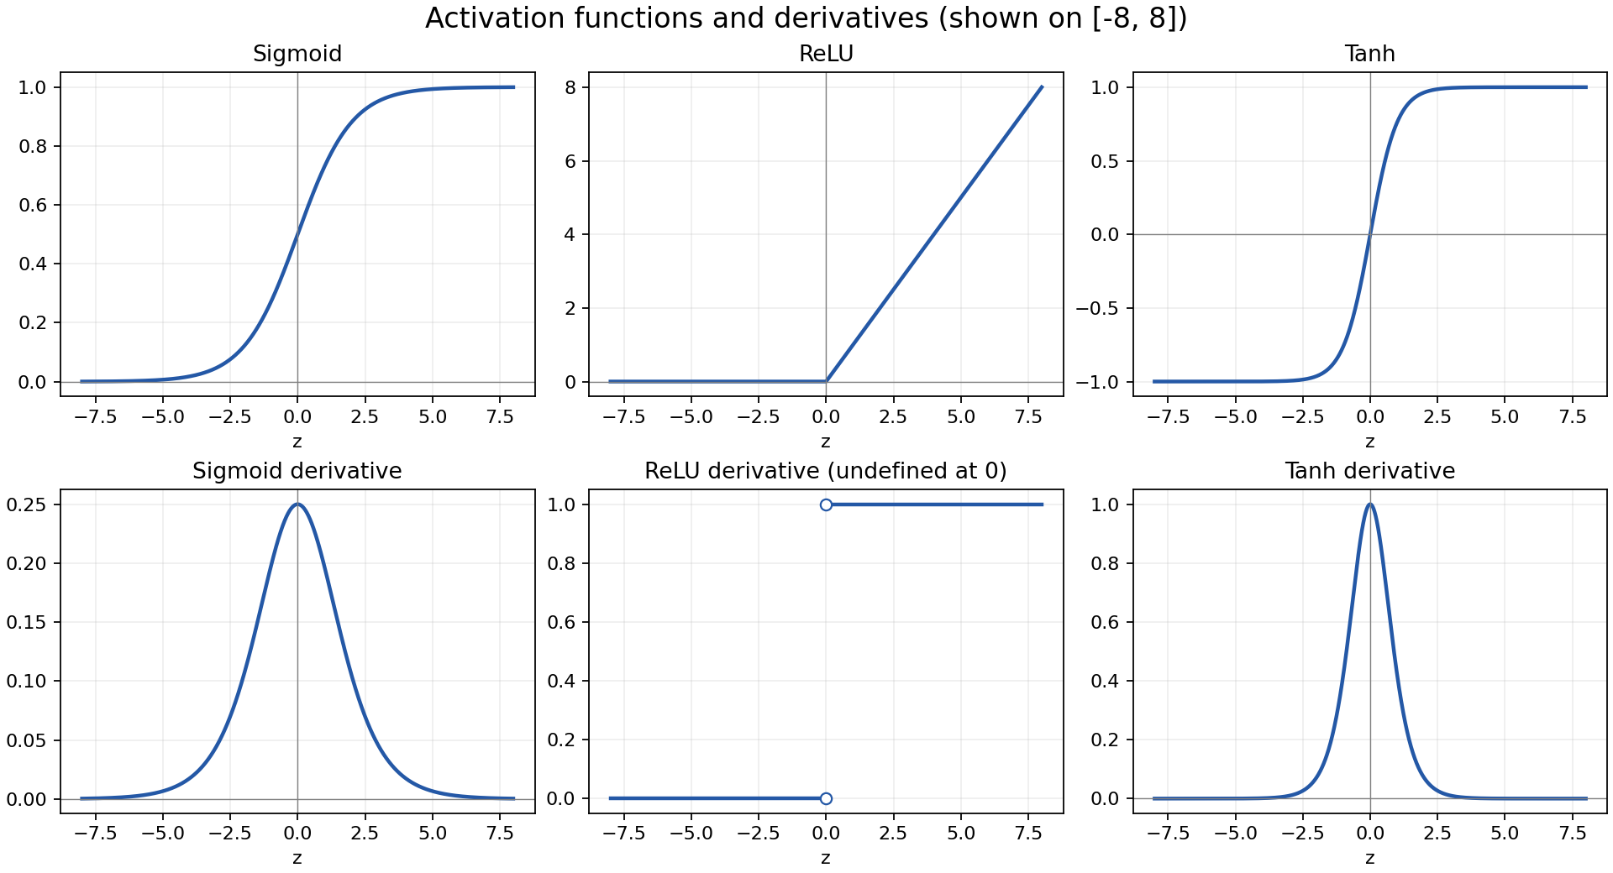
Activation functions and derivatives
The plots show the interval $\left[-8,8\right]$. On the full real line, sigmoid approaches 0 and 1, tanh approaches −1 and 1, and both derivatives approach zero as the input magnitude grows. ReLU is zero for negative inputs and increases linearly for positive inputs.
- What is the “vanishing gradient” problem? (respond in no more than 3 sentences) Which activation functions are subject to this issue and why? (respond in no more than 3 sentences).
Problem: Backpropagation multiplies successive layer derivatives. Repeated multiplication by factors with magnitudes below one can make gradients extremely small in earlier layers. Those layers consequently learn slowly.
Solution: Sigmoid and tanh are susceptible because their derivatives approach zero in saturated regions; sigmoid’s derivative is also at most 1/4. ReLU avoids positive-side saturation, but its zero derivative for negative inputs can stop learning through inactive neurons.
- Why zero-centered activation functions impact the results of Backprop?
For a neuron with preactivation $z=w^{⊤}a+b$,
$$\frac{∂L}{∂w_{j}}=\frac{∂L}{∂z}a_{j}.$$
If every input activation is positive, all components of this neuron’s weight gradient have the same sign for a given example. This restriction can lead to inefficient, zigzagging optimization. Zero-centered activations allow mixed-sign gradient components and can improve optimization, though they do not guarantee faster learning.
- Remember the Softmax function $σ\left(\text{z}\right)$ and how it extends sigmoid to multiple dimensions? Let’s compute the derivative of Softmax for each dimension. Prove that:
$$\frac{dσ{\left(z\right)}_{i}}{dz_{j}}=σ{\left(z\right)}_{i}\left(δ_{ij}-σ{\left(z\right)}_{j}\right)$$
- where $δ_{ij}$ is the Kronecker delta function.
Let $s_{i}=σ{\left(z\right)}_{i}=e^{z_{i}}/S$, where $S=\sum_{r=1}^{K}{e^{z_{r}}}$. By the quotient rule,
$$\frac{∂s_{i}}{∂z_{j}}=\frac{δ_{ij}e^{z_{i}}S-e^{z_{i}}e^{z_{j}}}{S^{2}}=\frac{e^{z_{i}}}{S}\left(δ_{ij}-\frac{e^{z_{j}}}{S}\right)=s_{i}\left(δ_{ij}-s_{j}\right).$$
Thus the diagonal entries are $s_{i}\left(1-s_{i}\right)$ and the off-diagonal entries are $-s_{i}s_{j}$.
- Use the above point to prove that the Jacobian of the Softmax function is the following:
$$J_{σ}\left(z\right)=\text{diag}\left(σ\left(z\right)\right)-σ\left(z\right)σ{\left(z\right)}^{⊤}$$
- where $\text{diag}\left(.\right)$ turns a vector into a diagonal matrix. Also, note that $J_{σ}\left(z\right)∈R^{K×K}.$.
The preceding result gives $J_{ij}=δ_{ij}s_{i}-s_{i}s_{j}$. The first term is the corresponding entry of a diagonal matrix and the second is the corresponding entry of an outer product. Therefore,
$$J_{σ}\left(z\right)=diag\left(σ\left(z\right)\right)-σ\left(z\right)σ{\left(z\right)}^{⊤}∈R^{K×K}.$$

Simulating XOR
- Can a single-layer network simulate (represent) an XOR function on $x=\left[x_{1},x_{2}\right]$?
$$y=\text{XOR}\left(x\right)=\left\{\begin{matrix}1, & \text{if }x=\left(0,1\right)\text{ or }x=\left(1,0\right) \\ 0, & \text{if }x=\left(1,1\right)\text{ or }x=\left(0,0\right).\end{matrix}\right.$$
- Explain your reasoning using the following single-layer network definition: $\hat{y}=\text{ReLU}\left(W⋅x+b\right)$
No. Write the preactivation as $w_{1}x_{1}+w_{2}x_{2}+b$. Matching the first three inputs requires
$$b≤0, w_{1}+b=1, w_{2}+b=1.$$
Hence $w_{1}=w_{2}=1-b$. At $\left(1,1\right)$, the preactivation is $2-b≥2$, whose ReLU output cannot be zero. This contradicts the XOR target.
- Repeat (1) with a two-layer network:
$$\begin{matrix}h=\text{ReLU}\left(W_{1}⋅x+b_{1}\right) \\ \hat{y}=W_{2}⋅h+b_{2}\end{matrix}$$
- Note that this model has an additional layer compared to the earlier question: an input layer $\text{x}∈R^{2}$, a hidden layer $\text{h}$ with ReLU activation functions that are applied component-wise, and a linear output layer, resulting in scalar prediction $\hat{y}$. Provide a set of weights $W_{1}$ and $W_{2}$ and biases ${\text{b}}_{1}$ and $b_{2}$ such that this model can accurately model the XOR problem.
Choose
$$W_{1}=\left(\begin{matrix}1 & -1 \\ -1 & 1\end{matrix}\right), b_{1}=\left(\begin{matrix}0 \\ 0\end{matrix}\right), W_{2}=\left(\begin{matrix}1 & 1\end{matrix}\right), b_{2}=0.$$
Then the hidden units detect the two opposite input differences:
$$h=\left(\begin{matrix}ReLU\left(x_{1}-x_{2}\right) \\ ReLU\left(x_{2}-x_{1}\right)\end{matrix}\right), \hat{y}=h_{1}+h_{2}.$$
Checking all inputs gives (0,0) → 0, (0,1) → 1, (1,0) → 1, and (1,1) → 0.
- Consider the same network as above (with ReLU activations for the hidden layer), with an arbitrary differentiable loss function $l:\left\{0,1\right\}×\left\{0,1\right\}→R$ which takes as input $\hat{y}$ and $y$, our prediction and ground truth labels, respectively. Suppose all weights and biases are initialized to zero. Show that a model trained using standard gradient descent will not learn the XOR function given this initialization.
Let $a=W_{1}x+b_{1}$, $h=ReLU\left(a\right)$, and $g=∂l/∂\hat{y}$. Backpropagation gives
$$\frac{∂l}{∂W_{2}}=gh^{⊤}, \frac{∂l}{∂b_{2}}=g,$$
$$\frac{∂l}{∂W_{1}}=\left[\left(W_{2}^{⊤}g\right)⊙ReLU'\left(a\right)\right]x^{⊤}, \frac{∂l}{∂b_{1}}=\left(W_{2}^{⊤}g\right)⊙ReLU'\left(a\right).$$
Initially $h=0$ and $W_{2}=0$, so the gradients of $W_{1}$, $b_{1}$, and $W_{2}$ are all zero. Only the output bias can change. This condition persists at every update, and the network always predicts the same value for every input, $\hat{y}=b_{2}$, which cannot represent XOR. The conclusion holds regardless of the usual finite derivative or subgradient selected for ReLU at zero.
- Extra Credit: Now let’s consider a more general case than the previous question: we have the same network with an arbitrary hidden layer activation function:
$$\begin{matrix}h=f\left(W_{1}⋅x+b_{1}\right) \\ \hat{y}=W_{2}⋅h+b_{2}\end{matrix}$$
- Show that if the initial weights are any uniform constant, then gradient descent will not learn the XOR function from this initialization.
The claim is false as written. Identically initialized hidden neurons remain identical under gradient descent, but that alone does not exclude XOR for an arbitrary nonmonotone activation.
For monotone activations such as sigmoid, tanh, or ReLU, identical hidden neurons reduce the network to
$$\hat{y}=Af\left(w^{⊤}x+b\right)+d.$$
This is monotone in one affine projection. Any thresholded prediction therefore has a linear separating boundary (or is constant), which cannot separate XOR. This establishes the intended result for those activations.
Counterexample to the arbitrary-activation claim: Use one hidden neuron with $f\left(t\right)=cos\left(πt\right)$ and initialize every weight and bias to 1:
$$W_{1}=\left(1,1\right), b_{1}=1, W_{2}=1, b_{2}=1.$$
For the four inputs, the hidden representation is
$$h=cos\left(π\left(x_{1}+x_{2}+1\right)\right)=\left\{\begin{matrix}-1 & \left(0,0\right),\left(1,1\right), \\ 1 & \left(0,1\right),\left(1,0\right).\end{matrix}\right.$$
The hidden derivative is zero at all these integer preactivations, so the hidden parameters remain fixed. Writing the output as $\hat{y}=ah+d$, the average half-squared-error loss over the four examples is
$$L\left(a,d\right)=\frac{1}{4}\left[{\left(d-a\right)}^{2}+{\left(a+d-1\right)}^{2}\right].$$
Its derivatives are
$$\frac{∂L}{∂a}=a-\frac{1}{2}, \frac{∂L}{∂d}=d-\frac{1}{2}.$$
Gradient descent with learning rate $0<η<2$ converges from $a=d=1$ to $a=d=1/2$. The resulting prediction is
$$\hat{y}=\frac{1}{2}h+\frac{1}{2}=XOR\left(x\right).$$
Thus uniform initialization does not universally prevent learning XOR when the activation is arbitrary. A monotonicity restriction would make the intended claim valid.
A computation graph, so elegantly designed
With nodes and edges, so easily combined
It starts with inputs, a simple array
And ends with outputs, in a computationally fair way
Each node performs, an operation with care
And passes its results, to those waiting to share
The edges connect, each node with its peers
And flow of information, they smoothly steer
It’s used to calculate, complex models so grand
And trains neural networks, with ease at hand
Backpropagation, it enables with grace
Making deep learning, a beautiful race
–ChatGPT Feb 3 2023

Neural Nets and Backpropagation
Draw the computation graph for $f\left(x,y,z\right)=lnx+exp\left(y\right)⋅z$. Each node in the graph should correspond to only one simple operation (addition, multiplication, exponentiation, etc.). Then we will follow the forward and backward propagation described in class to estimate the value of $f$ and partial derivatives $\frac{∂f}{∂x},\frac{∂f}{∂y},\frac{∂f}{∂z}$ at $\left[x,y,z\right]=\left[1,3,2\right]$. For each step, show you work.
- Draw the computation graph for $f\left(x,y,z\right)=lnx+exp\left(y\right)⋅z$. The graph should have three input nodes for $x,y,z$ and one output node $f$. Label each intermediate node $h_{i}$.
Each intermediate node performs one operation:
$$h_{1}=lnx, h_{2}=e^{y}, h_{3}=h_{2}z, f=h_{1}+h_{3}.$$
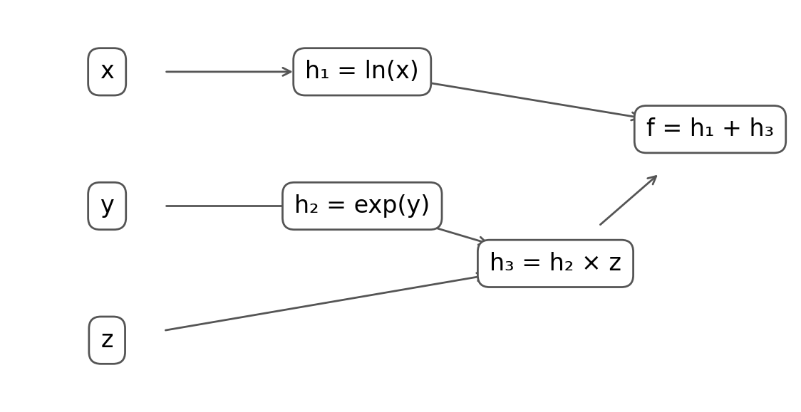
Computation graph
- Run the forward propagation and evaluate $f$ and $h_{i}$ ($i=1,2,…$) at $\left[x,y,z\right]=\left[1,3,2\right]$.
$$h_{1}=ln1=0, h_{2}=e^{3}≈20.085537,$$
$$h_{3}=2e^{3}≈40.171074, f=0+2e^{3}≈40.171074.$$
- Run the backward propagation and give partial derivatives for each intermediate operation, i.e., $\frac{∂h_{i}}{∂x}$, $\frac{∂h_{j}}{∂h_{i}}$, and $\frac{∂f}{∂h_{i}}$. Evaluate the partial derivatives at $\left[x,y,z\right]=\left[1,3,2\right]$.
The derivatives along the computation graph are
$$\frac{∂h_{1}}{∂x}=\frac{1}{x}=1, \frac{∂h_{2}}{∂y}=e^{y}=e^{3},$$
$$\frac{∂h_{3}}{∂h_{2}}=z=2, \frac{∂h_{3}}{∂z}=h_{2}=e^{3},$$
$$\frac{∂f}{∂h_{1}}=1, \frac{∂f}{∂h_{3}}=1.$$
Starting from $∂f/∂f=1$, the backward gradients at the intermediate nodes are
$$\frac{∂f}{∂h_{1}}=1, \frac{∂f}{∂h_{3}}=1, \frac{∂f}{∂h_{2}}=\frac{∂f}{∂h_{3}}\frac{∂h_{3}}{∂h_{2}}=2.$$
- Aggregate the results in (c) and evaluate the partial derivatives $\frac{∂f}{∂x},\frac{∂f}{∂y},\frac{∂f}{∂z}$ with chain rule. Show your work.
$$\frac{∂f}{∂x}=\frac{∂f}{∂h_{1}}\frac{∂h_{1}}{∂x}=1⋅\frac{1}{x}=1,$$
$$\frac{∂f}{∂y}=\frac{∂f}{∂h_{3}}\frac{∂h_{3}}{∂h_{2}}\frac{∂h_{2}}{∂y}=1⋅z⋅e^{y}=2e^{3}≈40.171074,$$
$$\frac{∂f}{∂z}=\frac{∂f}{∂h_{3}}\frac{∂h_{3}}{∂z}=1⋅h_{2}=e^{3}≈20.085537.$$

Programming
In this programming homework, we will
- implement MLP-based classifiers for the sentiment classification task of homework 1.

Skeleton Code and Structure:
The code base for this homework can be found at this GitHub repo under the hw3 directory. Your task is to fill in the missing parts in the skeleton code, following the requirements, guidance, and tips provided in this pdf and the comments in the corresponding .py files. The code base has the following structure:
- mlp.py reuse the sentiment classifier on movie reviews you implemented in homework 1, with additional requirements to implement MLP-based classifier architectures and forward pass .
- main.py provides the entry point to run your implementations mlp.py
- hw3.md provides instructions on how to setup the environment and run each part of the homework in main.py
TODOs — Your tasks include 1) generate plots and/or write short answers based on the results of running the code; 2) fill in the blanks in the skeleton to complete the code. We will explicitly mark these plotting, written answer, and filling-in-the-blank tasks as TODOs in the following descriptions, as well as a # TODO at the corresponding blank in the code.
TODOs (Copy from your HW1). We are reusing most of the model.py from homework 1 as the starting point for the mlp.py - you will see in the skeleton that they look very similar. Moreover, in order to make the skeleton complete, for all the # TODO (Copy from your HW1), please fill in the blank below them by copying and pasting the corresponding implementations you wrote for homework 1 (i.e. the corresponding # TODO in homework 1.)

Submission:
Your submission should contain two parts: 1) plots and short answers under the corresponding questions below; and 2) your completion of the skeleton code base, in a .zip file

MLP-based Sentiment Classifier
In both homework 1 & 2, our implementation of the SentimentClassifer is essentially a single-layer feedforward neural network that maps input features directly to 2-dimensional output logits. In this part of the programming homework, we will expand the architecture of our classifier to multi-layer perceptron (MLP).

Reuse Your HW1 Implementation
TODOs (Copy from your HW1): for all the # TODO (Copy from your HW1) in mlp.py, please fill in the blank below them by copying and pasting the corresponding implementations you wrote for homework 1 (i.e. the corresponding # TODO in the model.py in homework 1).

Build MLPs
Remember from the lecture that MLP is a multi-layer feedforward network with perceptrons as its nodes. A perceptron consists of non-linear activation of the affine (linear) transformation of inputs.
TODOs: Complete the __init__ and forward function of the SentimentClassifier class in mlp.py to build MLP classifiers that supports custom specification of architecture (i.e. number and dimension of hidden layers)
Hint: check the comments in the code for specific requirements about input, output, and implementation. Also, check out the document of nn.ModuleList about how to define and implement forward pass of MLPs as a stack of layers.

Train and Evaluate MLPs
We provide in main.py several MLP configurations and corresponding recipes for training them.
TODOs Once you finished 6.1.2, you can run load_data_mlp and explore_mlp_structures to train and evaluate these MLPs and paste two sets of plots here:
- 4 plots of train & dev loss for each MLP configuration
- 2 plots of dev losses and accuracies across MLP configurations
and describe in 2-3 sentences your findings.
Hint: what are the trends of train & dev loss and are they consistent across different configurations? Are deeper models always better? Why?
Across all four configurations, training and development loss fall initially and then largely plateau, with development loss fluctuating more than training loss. The best development accuracies for zero, one, two, and three hidden layers are 77.96%, 79.04%, 79.30%, and 77.66%, respectively. Deeper models are therefore not always better: additional capacity does not guarantee better generalization and can make optimization harder; these runs also use different learning rates, so the differences cannot be attributed to depth alone.
Train and development loss: no hidden layer
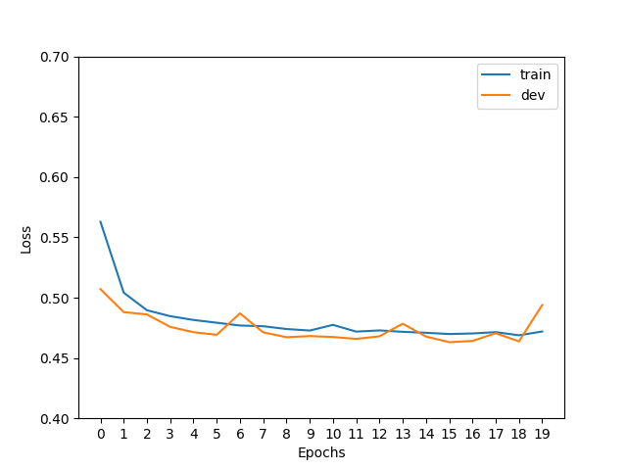
Train and development loss: one 512-unit hidden layer
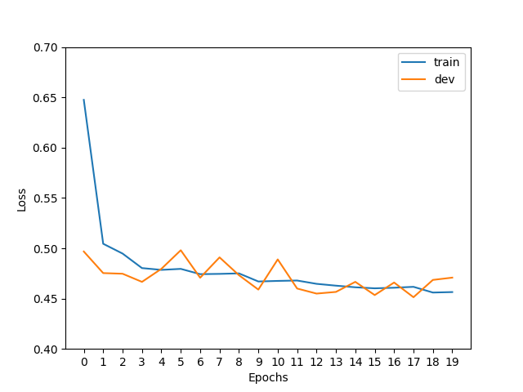
Train and development loss: two 512-unit hidden layers
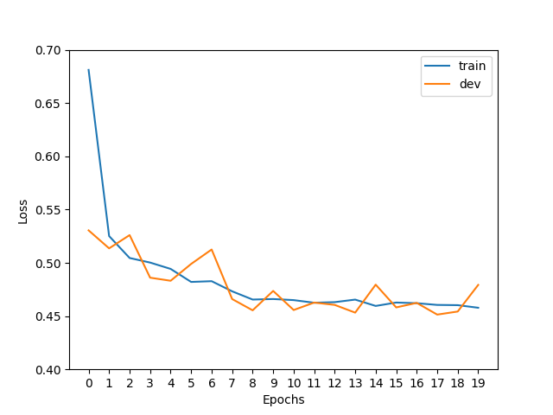
Train and development loss: three 512-unit hidden layers
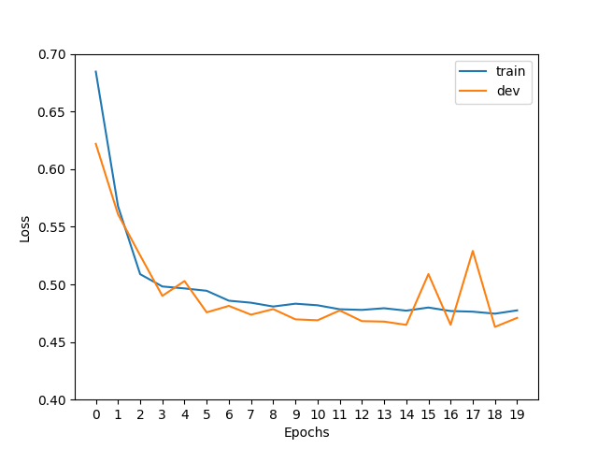
Development loss across MLP configurations
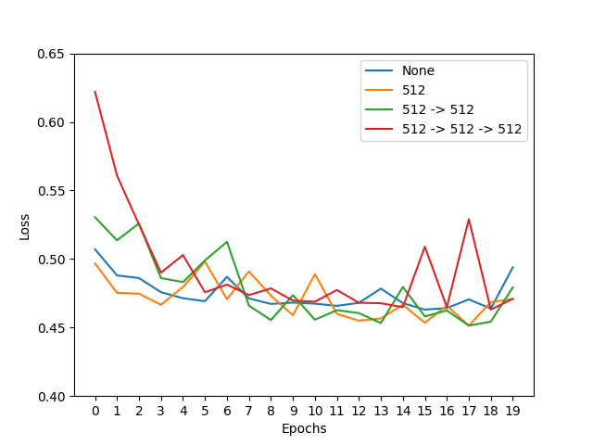
Development accuracy across MLP configurations
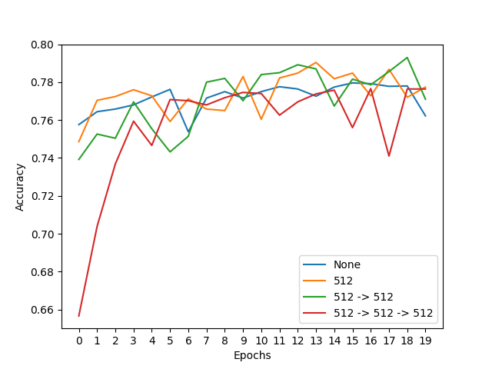

Embrace Non-linearity: The Activation Functions
Remember we have learned why adding non-linearity is useful in neural nets and gotten familiar with several non-linear activation functions both in the class and 3. Now it is time to try them out in our MLPs!
Note: for the following TODO and the TODO in 6.1.5, we fix the MLP structure to be with a single 512-dimension hidden layer, as specified in the code. You only need to run experiments on this architecture.
TODOs: Read and complete the missing lines of the two following functions:
- __init__ function of the SentimentClassifier class: define different activation functions given the input activation type.
Hint: we have provided you with a demonstration of defining the Sigmoid activation, you can search for the other nn.<activation> in PyTorch documentation.
- explore_mlp_activations in main.py: iterate over the activation options, define the corresponding training configurations, train and evaluate the model, and visualize the results. Note: you only need to generate the plots of dev loss and dev acc across different configurations, by calling visualize_configs, you do not need to plot the train-dev loss curves for each configuration (i.e. no need to call visualize_epochs). We provide you with a few choices of common activation functions, but feel free to try out the others.
Hint: You can refer to explore_mlp_structure as a demonstration of how to define training configurations with fixed hyper-parameters & iterate over hyper-parameters/design choices of interests (e.g. hidden dimensions, choice of activation), and plot the evaluation results across configurations.
Once you complete the above functions, run explore_mlp_activations and paste the two generated plots here. Describe in 2-3 sentences your findings.
With one 512-unit hidden layer, GeLU reaches the highest development accuracy (79.40%), followed by Sigmoid (78.82%), ReLU (78.68%), and Tanh (77.80%). ReLU and GeLU generally maintain lower, steadier development losses, while Tanh has larger spikes and Sigmoid shows an isolated spike. GeLU performs best in this run, but the small accuracy differences do not establish that it will always outperform the other activations.
Development loss across activation functions
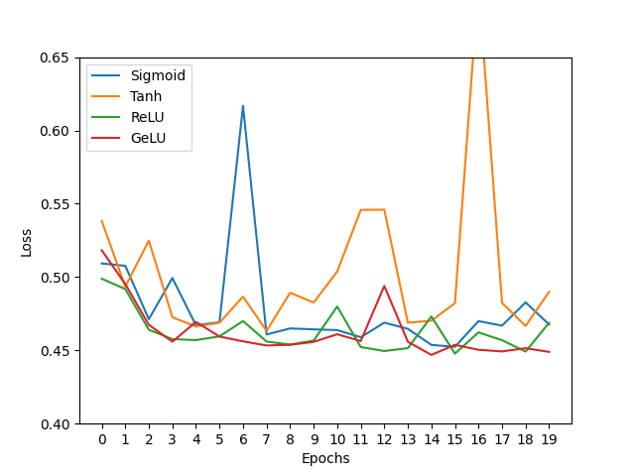
Development accuracy across activation functions
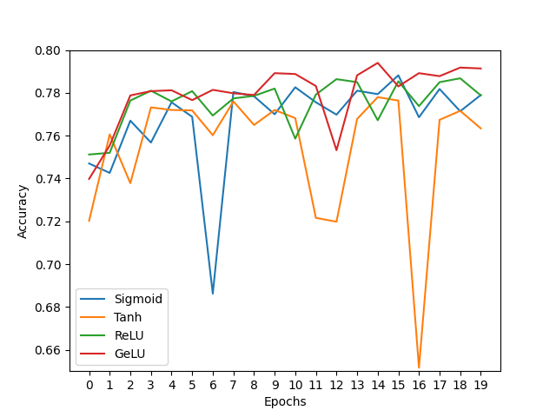

Hyper-parameter Tuning: Learning Rate
The training process mostly involves learning model parameters, which are automatically performed by gradient-based methods. However, certain parameters are “unlearnable" through gradient optimization while playing a crucial role in affecting model performance, for example, learning rate and batch size. We typically refer to these parameters as Hyper-parameters.
We will now take the first step to tune these hyper-parameters by exploring the choices of one of the most important one - learning rate, on our MLP. (There are lots of tutorials on how to tune the learning rate manually or automatically in practice, for example this note can serve as a starting point.)
TODOs: Read and complete the missing lines in explore_mlp_learning_rates in main.py to iterate over different learning rate values, define the training configurations, train and evaluate the model, and visualize the results. Note: same as above, you only need to generate the plots of dev loss and dev acc across different configurations, by calling visualize_configs, you do not need to plot the train-dev loss curves for each configuration (i.e. no need to call visualize_epochs). We provide you with the default learning rate we set to start with, and we encourage you to add more learning rate values to explore and include in your final plots curves of at least 4 different representative learning rates.
Hint: again, you can checkout explore_mlp_structure as a demonstration for how to perform hyper-parameter search.
Once you complete the above functions, run explore_mlp_learning_rates and paste the two generated plots here. Describe in 2-3 sentences your findings.
Among learning rates 0.1, 0.02, 0.005, and 0.001, 0.02 gives the best development accuracy (79.08%), followed by 0.005 (78.58%), 0.001 (77.86%), and 0.1 (77.74%). The 0.1 run remains near chance accuracy with loss around 0.69 for its first seven epochs before improving, whereas 0.001 reduces loss more gradually than 0.02. I would select 0.02 from this sweep using development accuracy; the results show that an overly large step can impede early learning, while an overly small step can slow progress within a fixed training budget.
Development loss across learning rates
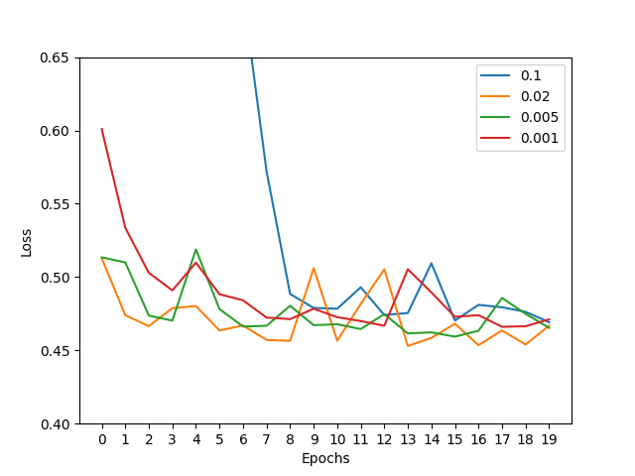
Development accuracy across learning rates
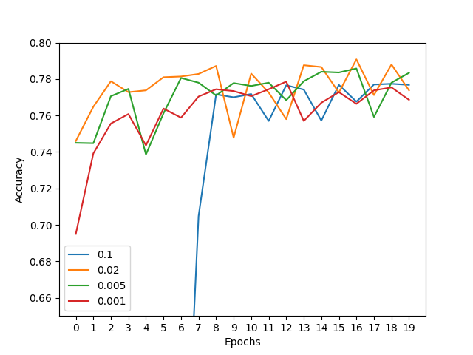

https://en.wikipedia.org/wiki/Kronecker_delta

