CS 601.471/671 NLP: Self-supervised Models
Homework 4: Neural Language Modeling + Fixed-Window LMs
For homework deadline and collaboration policy, check the calendar on the course website
Name: __________________________
Collaborators, if any: ____________________________________________________
Sources used for your homework, if any: course notes/starter code; PyTorch documentation; Hugging Face documentation and datasets.
This assignment focuses on language modeling, while continuing to build up on our prior knowledge of neural networks. We will review several aspects about training neural nets and also extend it to modeling sequences in language.
Homework goals: After completing this homework, you should be comfortable with:
- thinking more deeply about training neural networks; debugging your neural network
- getting more engaged in using PyTorch for training NNs
- training your first neural LM

Concepts, intuitions and big picture

Multiple-choice questions.
- Select the sentence that best describes the terms “model”, “architecture”, and “weights”.
$▫$ Model and weights are the same; they form a succession of mathematical functions to build an architecture.
$▫$ An architecture is a succession of mathematical functions to build a model and its weights are those functions parameters.
- During forward propagation, in the forward function for a layer $l$ you need to know what is the activation function in a layer (Sigmoid, tanh, ReLU, etc.). During Backpropagation, the corresponding backward function does not need to know the activation function for layer $l$ since the gradient does not depends on it.
$▫$ True
$▫$ False
- You have built a network using the tanh activation for all the hidden units. You initialize the weights to relative large values, using randn(..,..)*1000. What will happen?
$▫$ It doesn’t matter. So long as you initialize the weights randomly gradient descent is not affected by whether the weights are large or small.
$▫$ This will cause the inputs of the tanh to also be very large, thus causing gradients to also become large. You therefore have to set the learning rate to be very small to prevent divergence; this will slow down learning.
$▫$ This will cause the inputs of the tanh to also be very large, causing the units to be “highly activated” and thus speed up learning compared to if the weights had to start from small values.
$▫$ This will cause the inputs of the tanh to also be very large, thus causing gradients to be close to zero. The optimization algorithm will thus become slow.
- What is the “cache" used for in our implementation of forward propagation and backward propagation? $▫$ It is used to cache the intermediate values of the cost function during training.
$▫$ We use it to pass variables computed during forward propagation to the corresponding backward propagation step. It contains useful values for backward propagation to compute derivatives.
$▫$ It is used to keep track of the hyperparameters that we are searching over, to speed up computation.
$▫$ We use it to pass variables computed during backward propagation to the corresponding forward propagation step. It contains useful values for forward propagation to compute activations.
- Among the following, which ones are "hyperparameters"? (Check all that apply.)
$▫$ size of the hidden layers.
$▫$ learning rate
$▫$ number of iterations
$▫$ number of layers in the neural network
- True/False? Vectorization allows you to compute forward propagation in an $L$-layer neural network without an explicit for-loop (or any other explicit iterative loop) over the layers $l=1,2,…,L$. $▫$ True $▫$ False
- True or false? A language model usually does not need labels annotated by humans for its pretraining. $▫$ True $▫$ False
- What is the order of the language modeling pipeline?
$▫$ First, the model, which handles text and returns raw predictions. The tokenizer then makes sense of these predictions and converts them back to text when needed.
$▫$ First, the tokenizer, which handles text and returns IDs. The model handles these IDs and outputs a prediction, which can be some text.
$▫$ The tokenizer handles text and returns IDs. The model handles these IDs and outputs a prediction. The tokenizer can then be used once again to convert these predictions back to some text.

Short answer questions
- Look at the definition of [Stochastic] Gradient Descent in PyTorch: https://pytorch.org/docs/stable/generated/torch.optim.SGD.html. You will see that this is a bit more complex than what we have seen in the class. Let’s understand a few nuances here.
  - Notice the maximize parameter which controls whether we are running a maximization or minimization. In the algorithm the effect of this parameter is shown as essentially a change in the sign of the gradients:
  - 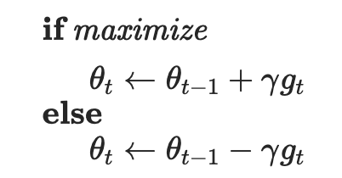
  - How do you think this change leads to the desired outcome (maximization vs minimization)?
The gradient points in the direction of steepest local increase. For a sufficiently small learning rate $η>0$, a first-order expansion gives
$$f\left(θ±η∇f\left(θ\right)\right)≈f\left(θ\right)±η∥∇f\left(θ\right)∥^{2}.$$
Adding the gradient therefore performs ascent for maximization, while subtracting it performs descent for minimization. In SGD, the minibatch gradient estimates the full-objective gradient, so individual updates need not improve the full objective.
Source: PyTorch SGD documentation.
  - The next set of parameters momentum, dampening, weight_decay. What do you think the impact of these parameters are? Read the documentations and interpret their roles.
Momentum retains a fraction $μ$ of the previous update buffer, reinforcing consistent directions and reducing oscillation. Dampening $d$ reduces the current gradient’s contribution to that buffer: $b_{t}=μb_{t-1}+\left(1-d\right)g_{t}$ after the first step; PyTorch initializes $b_{1}=g_{1}$, without dampening. Weight decay $λ$ adds $λθ$ to the gradient, encouraging smaller weights; for minimization this corresponds to an L2 penalty $λ∥θ∥^{2}/2$, which can reduce overfitting.
Source: PyTorch SGD documentation.
- What are few benefits to using Fixed-Window-LM over $n$-grams language models? (limit your answer to less then 5 sentences).
A neural fixed-window LM learns dense word embeddings and shares parameters across contexts, allowing similar words and contexts to share statistical strength. It can assign useful probabilities to unseen word combinations instead of relying on exact n-gram counts. Its parameter count does not require storing a separate entry for every possible n-gram, and nonlinear layers learn interactions among context words.
- When searching over hyperparameters, a typical recommendation is to do random search rather than a systematic grid search. Why do you think that is the case? (less than 2 sentences).
When only a few hyperparameters strongly affect performance, random search tests more distinct values of those important parameters within a fixed budget, whereas a grid repeatedly tests the same values while varying less influential parameters.
- Remember the normalization layer that we saw during the class. Here is the corresponding PyTorch page: https://pytorch.org/docs/stable/generated/torch.nn.LayerNorm.html. In the normalization formula, why do we use epsilon $ϵ$ in the denominator?
LayerNorm divides by $\sqrt{Var\left(x\right)+ϵ}$; a small positive $ϵ$ prevents division by zero when the variance is zero and limits numerical instability when it is very small.

Softmax Smackdown: Squishing the Competition

Softmax gradient
You might remember in the midterm exam that we saw a neural network with a Softmax and a cross-entropy loss:
$$\hat{\text{y}}=\text{Softmax}\left(\text{h}\right), J=\text{CE}\left(y,\hat{y}\right), \text{h},y,\hat{y}∈R^{d}.$$
Basically here $\hat{y}$ is a $d$-dimensional probability distribution over $d$ possible options (i.e. i​yi=1 and $∀i:y_{i}∈\left[0,1\right]$). $y$ is a $d$-dimensional one-hot vector, i.e., all of these values are zeros except one that corresponds to the correct label.
Here we want to prove the hint that was provided in the exam, which was:
$$∇_{h}J=\hat{y}-y.$$
Prove the above statement. In your proof, use the statement that you proved in HW3 about gradient of Softmax function: $\frac{d{\hat{\text{y}}}_{i}}{d{\text{h}}_{j}}={\hat{\text{y}}}_{i}\left(δ_{ij}-{\hat{\text{y}}}_{j}\right),$ where $δ_{ij}$ is the Kronecker delta function and ${\hat{\text{y}}}_{i}$ is the value in the $i$-th index of $\hat{\text{y}}$.
Write the cross-entropy for one example as
$$J=-\sum_{i=1}^{d}{y_{i}}log{\hat{y}}_{i}.$$
Using the supplied softmax derivative and the chain rule, for each logit $h_{j}$,
∂J∂hj=i​∂J∂yi∂yi∂hj
=i​-yiyiyiδij-yj
=-i​yiδij+yji​yi=-yj+yj.
The last equality uses i​yi=1 because $y$ is one-hot. Therefore, collecting all components gives $∇_{h}J=\hat{y}-y$.

Softmax temperature
Remember the softmax function, $σ\left(z\right)$? Here we will add a temperature parameter $τ∈R^{+}$ to this function:
$$\text{Softmax: }σ{\left(z;τ\right)}_{i}=\frac{e^{z_{i}/τ}}{\sum_{j=1}^{K}{e^{z_{j}/τ}}} \text{ for }i=1,…,K$$
Show the following:
- In the limit as temperature goes to zero $τ→0$, softmax becomes the same as greedy action selection, argmax.
First assume a unique maximum at $m=arg\max_{j}z_{j}$. Dividing numerator and denominator by $e^{z_{m}/τ}$ gives
σz;τi=ezi-zm/τj​ezj-zm/τ.
For $i=m$ the numerator is 1; for every other $i$, $z_{i}-z_{m}<0$, so its numerator tends to 0 as $τ→0^{+}$. The denominator tends to 1, so the limiting distribution assigns probability 1 to the maximizing action, reproducing greedy selection.
If $r$ actions tie for the maximum, the limit assigns $1/r$ to each maximizing action and 0 elsewhere; it does not specify a deterministic tie-breaking rule.
- In the limit as temperature goes to infinity $τ→+∞$, softmax gives equiprobable selection among all actions.
For every finite logit $z_{i}$, $z_{i}/τ→0$ as $τ→+∞$, so $e^{z_{i}/τ}→1$. Thus
$$\lim_{τ→+∞}σ{\left(z;τ\right)}_{i}=\frac{1}{\sum_{j=1}^{K}{1}}=\frac{1}{K},$$
which gives equal probability to all $K$ actions.

Backprop Through Residual Connections
As you know, When neural networks become very deep (i.e. have many layers), they become difficult to train due to the vanishing gradient problem – as the gradient is back-propagated through many layers, repeated multiplication can make the gradient extremely small, so that performance plateaus or even degrades. An effective approach is to add skip connections that skip one or more layers. See the provided network.
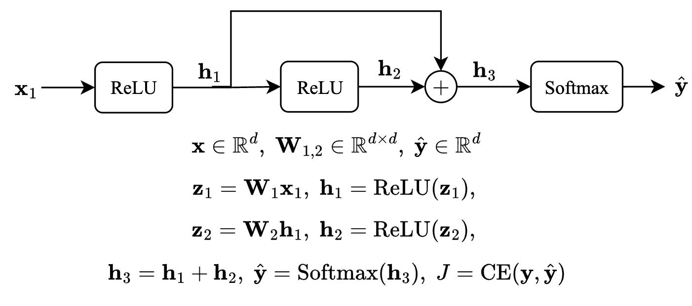
- You have seen this in the quiz, but lets try again. Prove that: $\frac{∂}{∂{\text{z}}_{i}}\text{ReLU}\left(\text{z}\right)=1\{{\text{z}}_{i}>0\}$ where $1\{x>0\}=\left\{\begin{matrix}1 & \text{if} x>0 \\ 0 & \text{if} x≤0 \\ & \end{matrix}\right.$. More generally, $∇_{\text{z}}\text{ReLU}\left(\text{z}\right)=\text{diag}\left(1\{\text{z}>0\}\right)$ where $1\{.\}$ is applied per each dimension and $\text{diag}\left(.\right)$ turns a vector into a diagonal matrix.
For one coordinate, $ReLU\left(z_{i}\right)=max\left(0,z_{i}\right)$ equals $z_{i}$ when $z_{i}>0$ and equals 0 when $z_{i}<0$, so its derivative is 1 in the first case and 0 in the second. At $z_{i}=0$, the ordinary derivative is undefined; using the conventional subgradient 0 yields the assignment’s indicator formula.
Each output coordinate depends only on its matching input coordinate, so the off-diagonal partial derivatives are zero. Consequently, with the same convention at zero, the Jacobian is
$$\frac{∂ReLU\left(z\right)}{∂z}=diag\left(1_{\{z>0\}}\right).$$
- As you see, a single variable ($h_{2}$ in the example) feeds into two different layers of the network. Here we want to show that the two upstream signals stemming from this node are merged as summation during Backprop. Specifically prove that:
$$\frac{∂h_{3}}{∂h_{1}}=\text{I}+\frac{∂h_{2}}{∂z_{2}}\frac{∂z_{2}}{∂h_{1}}$$
In the diagram, the branching variable is $h_{1}$: it feeds both the residual branch and the identity skip connection. Since
$$h_{3}=h_{1}+h_{2}, h_{2}=ReLU\left(z_{2}\right), z_{2}=W_{2}h_{1},$$
differentiating the sum and applying the chain rule gives
$$\frac{∂h_{3}}{∂h_{1}}=I+\frac{∂h_{2}}{∂z_{2}}\frac{∂z_{2}}{∂h_{1}}=I+D_{2}W_{2},$$
where $D_{2}=diag\left(1_{\{z_{2}>0\}}\right)$. For an upstream column gradient $g_{3}=∇_{h_{3}}J$, backpropagation therefore gives
$$∇_{h_{1}}J={\left(I+D_{2}W_{2}\right)}^{T}g_{3}=g_{3}+W_{2}^{T}D_{2}g_{3}.$$
The two terms are the contributions from the two outgoing paths, demonstrating why they add at a branch.
- In the given neural network your task is to compute the gradient $\frac{∂J}{∂x}.$ You are allowed (and highly encouraged) to use variables to represent intermediate gradients.
- Hint 1: Compute these gradients in order to build up your answer: $\frac{∂J}{∂{\text{h}}_{3}}$, $\frac{∂J}{∂{\text{h}}_{2}}$, $\frac{∂J}{∂{\text{z}}_{2}}$, $\frac{∂J}{∂{\text{h}}_{1}}$, $\frac{∂J}{∂{\text{z}}_{1}}$, $\frac{∂J}{∂\text{x}}$. Show your work so we are able to give partial credit!
- Hint 2: Recall that downstream = upstream * local.
Use column gradients $g_{v}=∇_{v}J$ and define $D_{k}=diag\left(1_{\{z_{k}>0\}}\right)$ for $k=1,2$, with ReLU subgradient 0 at zero. Write $x$ for the input labeled $x_{1}$ in the diagram. The forward equations are $z_{1}=W_{1}x$, $h_{1}=ReLU\left(z_{1}\right)$, $z_{2}=W_{2}h_{1}$, $h_{2}=ReLU\left(z_{2}\right)$, and $h_{3}=h_{1}+h_{2}$.
1. From the softmax–cross-entropy result,
$$g_{h_{3}}=\hat{y}-y.$$
2. The addition $h_{3}=h_{1}+h_{2}$ has identity Jacobian with respect to $h_{2}$:
$$g_{h_{2}}=g_{h_{3}}=\hat{y}-y.$$
3. Backpropagate through the second ReLU:
$$g_{z_{2}}=D_{2}g_{h_{2}}=D_{2}\left(\hat{y}-y\right).$$
4. At $h_{1}$, add the skip-path contribution to the contribution through $W_{2}$:
$$g_{h_{1}}=g_{h_{3}}+W_{2}^{T}g_{z_{2}}=\left(I+W_{2}^{T}D_{2}\right)\left(\hat{y}-y\right).$$
5. Backpropagate through the first ReLU:
$$g_{z_{1}}=D_{1}g_{h_{1}}=D_{1}\left(I+W_{2}^{T}D_{2}\right)\left(\hat{y}-y\right).$$
6. Finally, since $z_{1}=W_{1}x$,
$$\boxed{∇_{x}J=W_{1}^{T}D_{1}\left(I+W_{2}^{T}D_{2}\right)\left(\hat{y}-y\right).}$$
The transposes arise because the reverse-mode update for column gradients is $g_{\text{input}}={\left(∂ \text{output}/∂ \text{input}\right)}^{T}g_{\text{output}}$.
- Based on your derivations, explain why residual connections help mitigate vanishing gradients.
Without the skip connection, $g_{h_{1}}=W_{2}^{T}D_{2}g_{h_{3}}$, so all gradient flow passes through the weights and ReLU mask. With the skip connection, $g_{h_{1}}=g_{h_{3}}+W_{2}^{T}D_{2}g_{h_{3}}$, providing a direct identity path that bypasses that transformation. Across many residual blocks, such paths reduce reliance on long products of potentially small derivatives and help gradients reach earlier layers. They mitigate rather than guarantee elimination of vanishing gradients: cancellation and gates elsewhere in the network can still suppress the gradient.

Programming
In this programming homework, we will
- implement your own subword tokenizer.
- implement fixed-window MLP language models

Skeleton Code and Structure:
The code base for this homework can be found at this GitHub repo under the hw3 directory. Your task is to fill in the missing parts in the skeleton code, following the requirements, guidance, and tips provided in this pdf and the comments in the corresponding .py files. The code base has the following structure:
- tokenization.py implements the Byte-Pair Encoding algorithm for subword tokenization.
- mlp_lm.py implements a fixed-window MLP-based language model on a subset of Wikipedia.
- main.py provides the entry point to run your implementations in both tokenizatiton.py and mlp_lm.py.
- hw4.md provides instructions on how to setup the environment and run each part of the homework in main.py
TODOs — Your tasks include 1) generate plots and/or write short answers based on the results of running the code; 2) fill in the blanks in the skeleton to complete the code. We will explicitly mark these plotting, written answer, and filling-in-the-blank tasks as TODOs in the following descriptions, as well as a # TODO at the corresponding blank in the code.

Submission:
Your submission should contain two parts: 1) plots and short answers under the corresponding questions below; and 2) your completion of the skeleton code base, in a .zip file

Tokenization Algorithms
All NLP systems have at least three main components that help machines understand natural language:
- Tokenization
- Embedding
- Model architectures
Models like BERT, GPT-2 or GPT-3 all share the same components but with different architectures that distinguish one model from another. We are going to focus on the first component of an NLP pipeline which is tokenization. An often overlooked concept but it is a field of research in itself. Though we have SOTA algorithms for tokenization it’s always a good practice to understand the evolution trail.
Here’s what we’ll cover:
- What is tokenization?
- Why do we need a tokenizer?
- Types of tokenization - Word, Character and Subword.
- Byte Pair Encoding Algorithm
- Other tokenization algorithms:
  - Unigram Algorithm
  - WordPiece - BERT transformer
  - SentencePiece - End-to-End tokenizer system

What is Tokenization?
Tokenization is the process of representing raw text in smaller units called tokens. These tokens can then be mapped with numbers to further feed to an NLP model.
Read and run the full_word_tokenization_demo in tokenization.py for an overly simplified example of what a tokenizer does.
This is a very simple example where we just split a text string in to “whole words” on white spaces, and we have not considered grammar, punctuation, or compound words (like “test”, “test-ify”, “test-ing”, etc.).

Problems with word tokenization:

- Missing words in the training data: With word tokens, your model won’t recognize the variants of words that were not part of the data on which the model was trained. So, if your model has seen ‘foot‘ and ‘ball‘ in the training data but the final text has “football”, the model won’t be able to recognize the word and it will be treated with a “<UNK>” token. Similarly, punctuations pose another problem, “let” or “let’s” will need individual tokens and it is an inefficient solution. This will require a huge vocabulary to make sure you’ve every variant of the word. Even if you add a lemmatizer to solve this problem, you’re adding an extra step in your processing pipeline.
- Not all languages use space for separating words: For a language like Chinese, which doesn’t use spaces for word separation, this tokenizer will fail.

Character-based tokenization
To resolve the problems associated with word-based tokenization, an alternative approach of character-by-character tokenization was tried. This solves the problem of missing words as now we are dealing with characters that can be encoded using ASCII or Unicode and it could generate embedding for any word now.
Every character, be it space, apostrophes, or colons, can now be assigned a symbol to generate a sequence of vectors. But this approach had its cons. Character-based models will treat each character and will lead to longer sequences. For a 5-word long sentence, you may need to process 30 tokens instead of 5 word-tokens.

Subword Tokenizaiton
To address the earlier issues, we could think of breaking down the words based on a set of prefixes and suffixes. For example, we can build a system that can identify subwords like “##s”, “##ing”, “##ify”, “un##” etc., where the position of double hash “##” denotes prefix and suffixes. So, a word like “unhappily” is tokenized using subwords like “un##”, “happ”, and “##ily”.
BPE (Byte-Pair Encoding) was originally a data compression algorithm that is used to find the best way to represent data by identifying the common byte pairs. It is now used in NLP to find the best representation of text using the least number of tokens.
Here’s how it works:
- Add a “</w>” at the end of each word to identify the end of a word and then calculate the word frequency in the text.
- Split the word into characters and then calculate the character frequency.
- For a predefined number of iterations (set by you), count the frequency of the consecutive tokens and merge the most frequently occurring pairings.
- Keep iterating until you have reached the iteration limit or if you have reached the token limit.
We will now go through this algorithm step by step.
Read the get_word_freq function in tokenization.py that implements the step 1 above to preprocess each word and count its frequency.
TODOs: Read and complete the missing lines in the get_pairs function in tokenization.py to implement the step 2 above. This function takes the word frequency record returned from get_word_freq as input, split the words into tokens (characters at this initial step), and counts token-pairs frequency.
Hint: follow the comments in the code for specific requirements.
Read the get_most_frequent_pair and merge_byte_pairs functions in tokenization.py that implements the step 3 above, merge the top-1 frequent token-pairs in all the words.
In practise, after iterating over the input text for a desired number of times, we extract the resulting tokenization as our subword dictionary. For this purpose, we provide get_subword_tokens function in tokenization.py
With all these functions, we can now run one step of the BPE algorithm!
Read and run the test_one_step_bpe.py in main.py to test the BPE algorithm for one step. A correct implementation of get_pairs should pass all the tests.

Complete the BPE Algorithm
With the above implementations, we can complete all the steps of the BPE algorithm that iterates over the input corpus.
TODOs: Read and complete the missing lines in the exract_bpe_subwords function in tokenization.py that implements the full BPE algorithm. Once you finished, run the test_bpe function in main.py, a correct implementation of exract_bpe_subwords should pass all the tests.
Hint: follow the comments in the code and you can reuse the helper functions provided/you implemented above.
So as we iterate with each best pair, we merge (concatenating) the pair and you can see as we recalculate the frequency, the original character token frequency is reduced and the new paired token frequency pops up in the token dictionary.

Running BPE on a subset of Wikipedia
Now, let’s run this algorithm on a larger scale. In particular, we will run on many Wikipedia paragraphs. As usual, let’s use the Huggingface library to download the data (the load_bpe_data function).
TODOs: Read and run the bpe_on_wikitext in main.py that iterates the BPE algorithm on a subset of Wikipedia, and interprets the final subwords extracted from the Wikipedia documents. In particular, identify examples of subwords that correspond to
- complete words
- part of a word
- non-English words(including other languages or common sequence special characters)
Explain why these subwords have come about. (no more than 10 sentences)
Answer: After 2,000 merges on the last 5,000 WikiText-2 training examples, complete-word tokens include “Wales</w>,” “military</w>,” “starlings</w>,” and “temperature</w>.” Parts of words include “Wal,” “pre,” “tical,” “Thunder,” and “charac,” which remain available because their continuations vary across the corpus. Non-English symbols such as “ა,” “წ,” “რ,” “é,” and “ž” survive because multilingual names and text occur in Wikipedia. Special tokens and character sequences include “@-@</w>,” “@,@</w>,” “€,” quotation marks, and the end-of-word marker “</w>.” Frequent adjacent characters merge first, so common words can become whole tokens while less frequent or morphologically variable words remain split into reusable pieces.

Additonal Readings: Other Tokenization Algorithms

WordPiece
WordPiece is the subword tokenization algorithm used for BERT, DistilBERT, and Electra. The algorithm was outlined in and is very similar to BPE. WordPiece first initializes the vocabulary to include every character present in the training data and progressively learns a given number of merge rules. In contrast to BPE, WordPiece does not choose the most frequent symbol pair, but the one that maximizes the likelihood of the training data once added to the vocabulary.
So what does this mean exactly? Referring to the previous example, maximizing the likelihood of the training data is equivalent to finding the symbol pair, whose probability is divided by the probabilities of its first symbol followed by its second symbol is the greatest among all symbol pairs. E.g. “u”, followed by “g” would have only been merged if the probability of “ug” divided by “u”, “g” would have been greater than for any other symbol pair. Intuitively, WordPiece is slightly different from BPE in that it evaluates what it loses by merging two symbols to ensure it’s worth it.

Unigram
Unigram is a subword tokenization algorithm introduced in . In contrast to BPE or WordPiece, Unigram initializes its base vocabulary to a large number of symbols and progressively trims down each symbol to obtain a smaller vocabulary. The base vocabulary could for instance correspond to all pre-tokenized words and the most common substrings. Unigram is not used directly for any of the models in the transformers, but it’s used in conjunction with SentencePiece([paragraph:sentetncepiece]).
At each training step, the Unigram algorithm defines a loss (often defined as the log-likelihood) over the training data given the current vocabulary and a unigram language model. Then, for each symbol in the vocabulary, the algorithm computes how much the overall loss would increase if the symbol was to be removed from the vocabulary. Unigram then removes p (with p usually being 10% or 20%) percent of the symbols whose loss increase is the lowest, i.e. those symbols that least affect the overall loss over the training data. This process is repeated until the vocabulary has reached the desired size. The Unigram algorithm always keeps the base characters so that any word can be tokenized.
Because Unigram is not based on merge rules (in contrast to BPE and WordPiece), the algorithm has several ways of tokenizing new text after training. As an example, if a trained Unigram tokenizer exhibits the vocabulary:
[“b”, “g”, “h”, “n”, “p”, “s”, “u”, “ug”, “un”, “hug”],
“hugs” could be tokenized both as [“hug”, “s”], [“h”, “ug”, “s”] or [“h”, “u”, “g”, “s”]. So which one to choose? Unigram saves the probability of each token in the training corpus on top of saving the vocabulary so that the probability of each possible tokenization can be computed after training. The algorithm simply picks the most likely tokenization in practice but also offers the possibility to sample a possible tokenization according to their probabilities.
Those probabilities are defined by the loss the tokenizer is trained on. Assuming that the training data consists of the words $x_{1},…,x_{N}$ and that the set of all possible tokenizations for a word $x_{i}$ is defined as $S\left(x_{i}\right)$, then the overall loss is defined as
L=-i=1Nlogx∈Sxi​px

SentencePiece
All tokenization algorithms described so far have the same problem: It is assumed that the input text uses spaces to separate words. However, not all languages use spaces to separate words. One possible solution is to use language-specific pre-tokenizers, e.g. XLM uses a specific Chinese, Japanese, and Thai pre-tokenizer). To solve this problem more generally, treats the input as a raw input stream, thus including the space in the set of characters to use. It then uses the BPE or unigram algorithm to construct the appropriate vocabulary.
The XLNetTokenizer uses SentencePiece for example, which is also why in the example earlier the “” character was included in the vocabulary. Decoding with SentencePiece is very easy since all tokens can just be concatenated and “” is replaced by a space.
All transformer models in the library that use SentencePiece use it in combination with unigram. Examples of models using SentencePiece are ALBERT XLNet,Marian, and T5.

Fixed-Window MLP Language Models
In the second part of the homework, we will build, train, and evaluate fixed-window MLP language models as we learned in class: given the context words in the fixed-size window on the left hand side, predict the next word continuation.
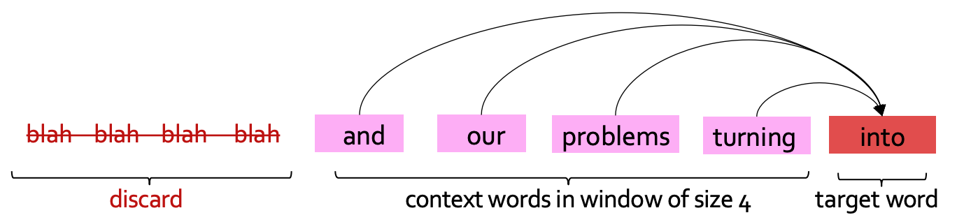
Fixed-window LM

Data Loading and Preprocessing
We will be using the same WikiText dataset we used for building n-gram LM in homework 2. We follow similar preprocessing steps to split paragraphs into sentences followed by tokenization (Now we have learned more about subword tokenization in class and the previous question!).
TODOs read the preprocess_data function in ngram_lm.py and complete the missing lines to prepare input-output pairs for training fixed-window LMs.
Hint: follow the requirements in the code comments.

Build our LM
Let’s now turn to building our model. Here, we are following the footsteps of the neural probabilistic language model (NPLM) , which is extending earlier studies such as .
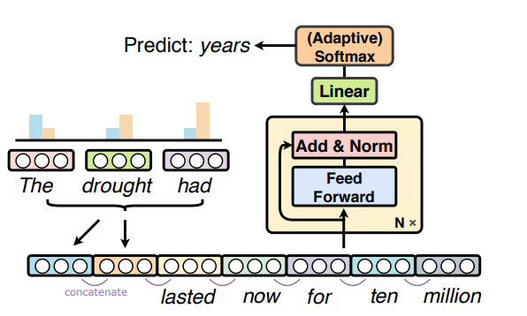
NPLM Architecture
We will follow a modular design for our implementation to make it more interpretable. In particular, will implement 3 layers:
- The input layer which loops up word embeddings, concatenates them, and transforms them into a hidden representation.
- The middle layer transforms the representation with a non-linearity.
- The output layer which transforms a hidden vector to a probability distribution over the words
Let’s get to work!
TODOs: read and complete the forward functions for the following classes
- NPLM_first_block: input layer that embeds the input token ids into embedding vectors, concatenates the embeddings, applies linear transformation, layer normalization, and dropout
- NPLM_block: middle layers with linear transformation, tanh activation, residual connection, layer normalization, and dropout.
- NPLM_final_block: output layer that transforms hidden representation to log probability over the vocabulary with log softmax.
Hint: check out nn.LayerNorm and nn.Dropout, torch.tanh and nn.functional.log_softmax for more details on these layers and operations. For embedding concatenation, you may find torch.Tensor.view useful. Also, follow the step-by-step comments in the code for the requirements of the implementation.
TODOs: read and complete the __init__ and forward functions for the NPLM class, which is the final model that stacks all the above layers.
Hint: remember to apply ReLU non-linear activation after each middle layer, details at nn.functional.relu.

Train and Evaluate the LM
Now it’s time to train and evaluate it! Like the previous homework, we will use cross-entropy loss between the predictions of our language model and actual words that appeared in our training data. Note that we applied log softmax to the final output of the LM, as described in homework to, we will use negative log-likelihood loss as the training criterion to calculate the cross-entropy loss.
As introduced in the class, we will use Perplexity to evaluate our LM, as a measure of predictive quality of a language model.
TODOs Read and complete the missing lines in train and evaluate functions in mlp_lm.py to calculate the perplexity.
Hint: remember in the class we discussed the connection between perplexity and cross-entropy loss, and note that in our implementation we took natural logarithm instead of the base of 2.
Note we are using Adam (Adaptive Moment Estimation) , which is a popular optimization algorithm used in deep learning and machine learning. It is a stochastic gradient descent (SGD) optimization algorithm that is well suited for training deep neural networks. The algorithm has some internal estimates to dynamically adjust the learning rates for each parameter based on its past gradients, which can result in faster convergence and improved performance compared to traditional SGD.
TODOs Once you finished all the implementations, run load_data_mlp_lm and single_run_mlp_lm in main.py to train and evaluate the model and paste the plots of loss and Perplexity here.
Training result: The five-epoch CUDA run completed successfully. Validation loss decreased to 7.5337 and validation perplexity decreased to 1,869.98.
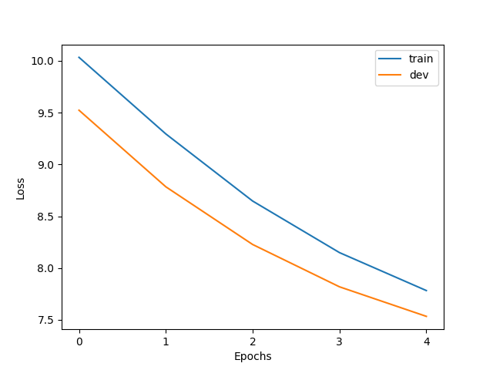
Training and validation loss across five epochs
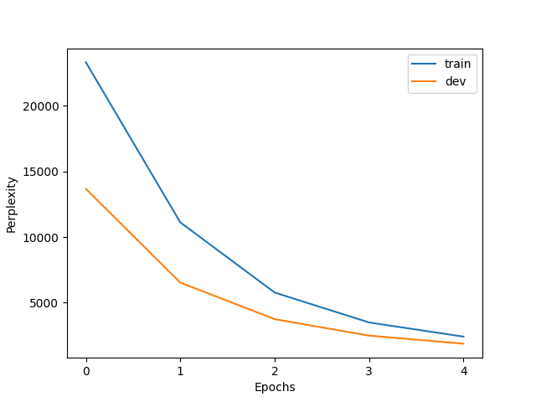
Training and validation perplexity across five epochs

Sample From a Pre-trained LM
Note that compared with the original NPLM implementation, we reduce the model size by shrinking both the width and depth of our model, and we only use a small subset of the data. It is expected to take an hour or so to train the model on the CPU of your PC. Training the above LM with full size model and data might take hours to days. To save you time, we have trained a language model for you to play with. All you have to do is to download its weight parameters. Download the pre-trained weights and copy it to your local directory under /hw4/.
Now that we have the model weight downloaded, we can instantiate a model with these parameters. This will work in two steps.
- First we will need to create a new model (with potentially random weights).
- Then, we will copy the parameter values to the model using load_state_dict function.
We then evaluate the loaded model on the dev set. Now that we have loaded a pre-trained LM, how can we sample from it? We will implement two strategies, greedy decoding and top-p sampling that we briefly discussed in homework 2.
For greedy, we select the most probable words (argmax).
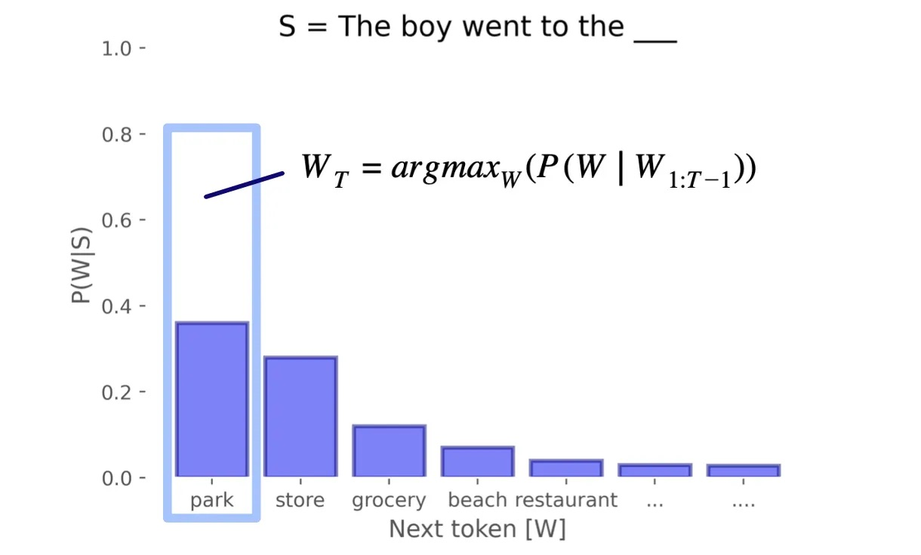
Greedy Decoding
For top-p, we sample from the distribution proportional to word probabilities. Words with higher probabilities will be more likely to be sampled. However, we also have an option of filtering the low-probability tokens, and instead retaining tokens that constitute top_p probability.
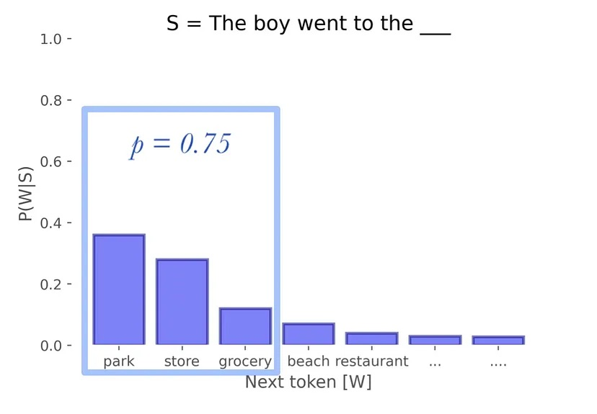
Greedy Decoding
Read generate_text and sample_from_mlp_lm in mlp_lm.py for more details about how to load the pre-trained model, evaluate on dev set and perform greedy/top-p sampling. You can learn more about top-p sampling implementation at TopPLogitsWarper.
TODOs Run the sample_from_trained_mlp_lm in main.py to sample from the pre-trained LM, paste the completion to the prefix under different sampling strategies here, and describe in 2-3 sentences your findings.
Hint: compare the output of the above generations, which one is your favorite? Explain why this choice of sampling leads to better text generation.
Greedy: The best perks of living on the east side of the city. ". "... ".... ". "... ".... ". "
Top-p, p = 0.0: The best perks of living on the east side of the city. ". "... ".... ". "... ".... ". "
Top-p, p = 0.3: The best perks of living on the east of the B @ - @ 17 in the same year. "... [ a ] we had to get out of the area. ",
Top-p, p = 1.0: The best perks of living on the east side were concrete victorious. " Alllay " out of the X mind. D. Roosevelt in the 40 % of his mind, within composing trails "
Findings: Greedy decoding and top-p with p = 0.0 are identical and quickly fall into a repetitive punctuation pattern because both always choose the most likely next token. Increasing p adds diversity, but the p = 1.0 sample is the least coherent because it permits sampling from the full distribution; p = 0.3 gives a better diversity–coherence tradeoff.
Pretrained checkpoint evaluation: development loss = 5.5179; development perplexity = 249.11.

Optional Feedback
Have feedback for this assignment? Found something confusing? We’d love to hear from you!

https://self-supervised.cs.jhu.edu/sp2024/

