BT05-A mini BLE Bluetooth V4.0 iBeacon
Similar modules sold as DX-BT05. This module is based on the Bolutek CC41-A. This is the same form factor as the HM-11, however, the layout is different. The BT05 is sometimes sold as a HM-10 and regarded as a copy of the HM-10, however, I don’t see these as copies more like a different version of the same thing. Not sure where these originate from as I can’t find this version on the bolutek website nor can I find a manufacturer (didn’t spend too long looking though).
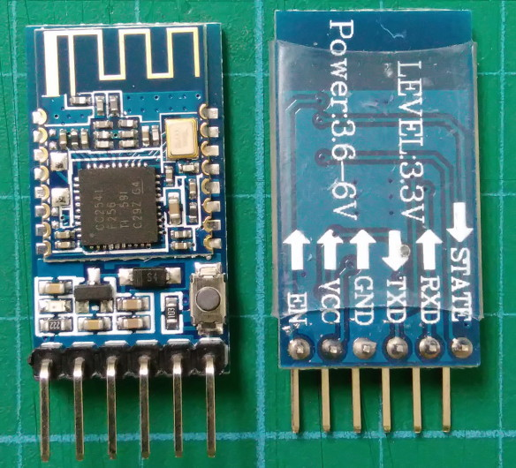
The break out pins are standard layout with a STATE pin and a EN pin.
CC2540 or CC2541 chip.
Bluetooth version 4.0
Firmware is reported as Firmware V3.0.6,Bluetooth V4.0 LE.
Default baud rate is 9600
Default PIN is 000000
The modules report themselves as BT05-A.
This is a Bluetooth 4.0 BLE module and not compatible with Bluetooth 2.0 or 2.1. The model I received includes the CC2541 chip as opposed to the CC2540 chip.
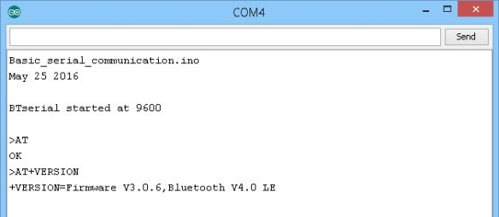
AT commands require line ending characters (\r\n). Since the firmware is by Bolutek AT+HELP gets you a list of the available commands.
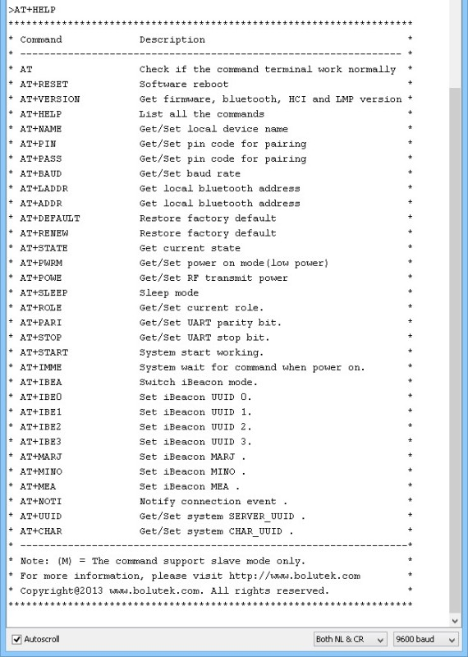
The modules boot in to AT mode and go in to communication mode when a connection is made.
These are smaller than most other modules. Both the breakout board and the actual Bluetooth board are smaller than similar modules. The modules include a small push button switch which I have not investigated yet. A Google search for “DX-BT05 4.0″ will get results for similar boards using the regular sized breakout board.
The STATE pin is LOW when no connection and HIGH when there is an active connection.
The EN pin looks like it is connected to pin 16 on the small Bluetooth board (not confirmed), when brought LOW, it will break an active connection. It does not disable the module though.

Pins
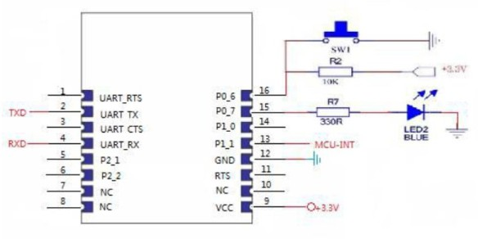
Pin 16 (P0_6)
When the module is in sleep mode, briefly bringing PIN 16 LOW will wake up the module and the module will respond with “+WAKE\r\nOK\r\n”.
When there is a connection, briefly bringing PIN 16 LOW will initiate a disconnection request.

Sleep Mode
Sleep mode is entered using “AT+SLEEP\r\n”. The module will return “+ SLEEP\r\nOK\r\n”
To wake, either send a string of 80 or more characters (the string cannot contain AT commands) or bring pin 16 LOW for a short period. If the module wakes successfully it will return “+WAKE\r\nOK\r\n”

LED in master mode
– quick flash 300ms on, 300ms off – searching/waiting for a connection.
– on – connected.

LED in slave mode
– slow flash (800ms on, 800ms off) – waiting for pairing
– on – connected
According to the seller this is compatible with Android 4.3 or later as long as the device supports Bluetooth 4.0/BLE. It is compatible with iphone 4s onwards and also ipad 3,4,and the ipad minis.
If your Android device does not find the BT module the module may be in master/central mode. Change to slave/peripheral mode using the command AT+ROLE0
Sony Z3 Compact:
The modules show up in Settings => Bluetooth as “BT05-A” but it does not pair (I think is it not required). If you try to pair you briefly get a “trying to pair message” and then it goes back to just showing the name.
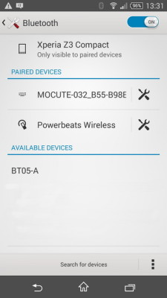
The B-BLE app connects without the need for the PIN.
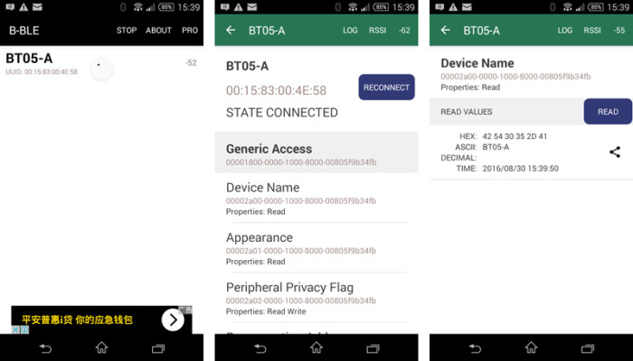
Huawei honor 6 pro:
The BT-05A does not show up in the Settings => search for Bluetooth devices. It does show up in the B-BLE app as a BT05-A
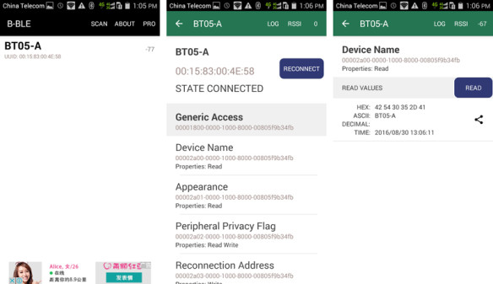
Serial Connection:
The HMBLE Terminal app on the Sony finds and connects to the BT-05A and serial communication works as expected:
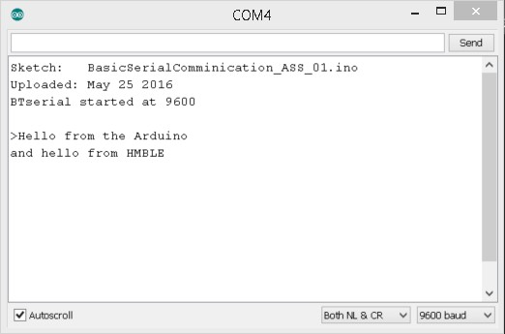
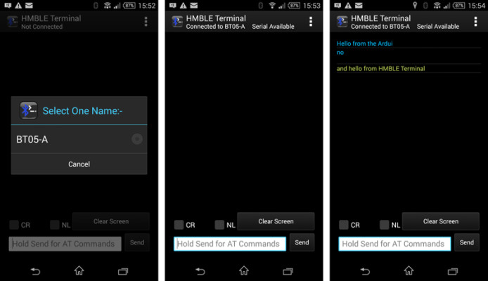
A PC running Windows 8.1 with Bluetooth BLE finds and connects. A PIN is not required to make a connection.
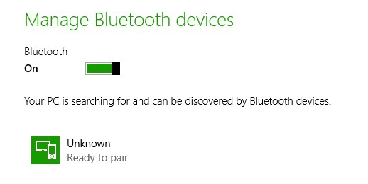
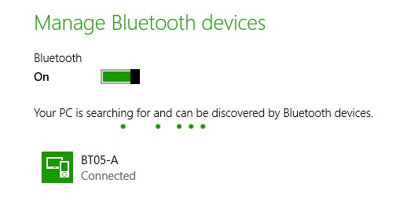

Downloads
Basic spec sheet in Chinese
http://www.martyncurrey.com/?wpdmdl=3119
AT Commands (Chinese)
http://www.martyncurrey.com/?wpdmdl=3123
BLE-CC41-A basic AT commands
http://www.martyncurrey.com/?wpdmdl=3028

Further Information
Arduino forum: Hm-10 ble device not working
http://forum.arduino.cc/index.php?topic=334466.0
Bolutek website
http://www.bolutek.com/index.jsp
Uploading firmware. Not tested.
http://ladvien.github.io/robots/advancedish-hm-10/

