SUPRA on oneAPI  
Release Notes

Release Notes

22 September 2020

## Version History/Revision History

These are the main releases of SUPRA on oneAPI:

|  |  |  |
| --- | --- | --- |
| Date | Revision | Description |
| Sept, 2020 | 1.0 | Initialize version |
|  |  |  |
|  |  |  |

## Intended Audience

Software developers from OEM / ODM / SI / ISV

## Customer Support

For technical support, including answers to questions not addressed in this product, report issues on github, <https://github.com/intel/supra-on-oneapi/issues>

## 

## Legal Notices and Disclaimers

Intel technologies may require enabled hardware, software or service activation.

You may not use or facilitate the use of this document in connection with any infringement or other legal analysis concerning Intel products described herein. You agree to grant Intel a non-exclusive, royalty-free license to any patent claim thereafter drafted which includes subject matter disclosed herein.

No license (express or implied, by estoppel or otherwise) to any intellectual property rights is granted by this document.

The products described may contain design defects or errors known as errata which may cause the product to deviate from published specifications.  Current characterized errata are available on request.

Intel disclaims all express and implied warranties, including without limitation, the implied warranties of merchantability, fitness for a particular purpose, and non-infringement, as well as any warranty arising from course of performance, course of dealing, or usage in trade.

© Intel Corporation.  Intel, the Intel logo, and other Intel marks are trademarks of Intel Corporation or its subsidiaries.  Other names and brands may be claimed as the property of others.

Contents:

1 Introduction 4

2 New in This Release 5

3 Fixed Issues 6

4 Known Issues 7

5 Related Documentation 8

6 Where to Find the Release 9

7 Release Content 10

8 Best Known Configuration 11

9 Hardware and Software Compatibility 12

10 Acronyms and Terms 13

11 Legal Information 14

# Introduction

We use oneAPI toolkit -- Intel® DPC++ Compatibility Tool, to implement the migration from CUDA to standard DPC++, for more detail of the tool, please refer to : <https://software.intel.com/content/www/us/en/develop/tools/oneapi/components/dpc-compatibility-tool.html>

The CUDA-based sample application is SUPRA. It is an open source software defined ultrasound processing for real-time applications. Covering everything from beamforming to output of B-Mode images, SUPRA can help reproducibility of results and allows modifications to the image acquisition.

It includes all processing stages of a usual ultrasound pipeline, it can be executed in 2D and 3D on consumer GPUs in real- time. Pipeline shown as below:

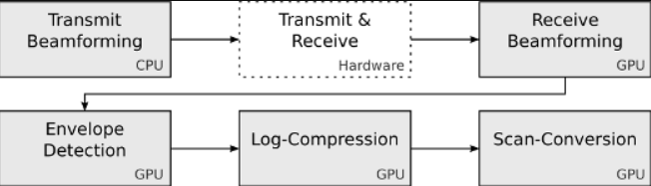

More detail of SUPRA project, please refer to <https://github.com/IFL-CAMP/supra>.

The key algorithm is written in CUDA code. Now, we use Compatibility Tool to migrate the SUPRA CUDA-based code to DPC++-based code, shown as below:

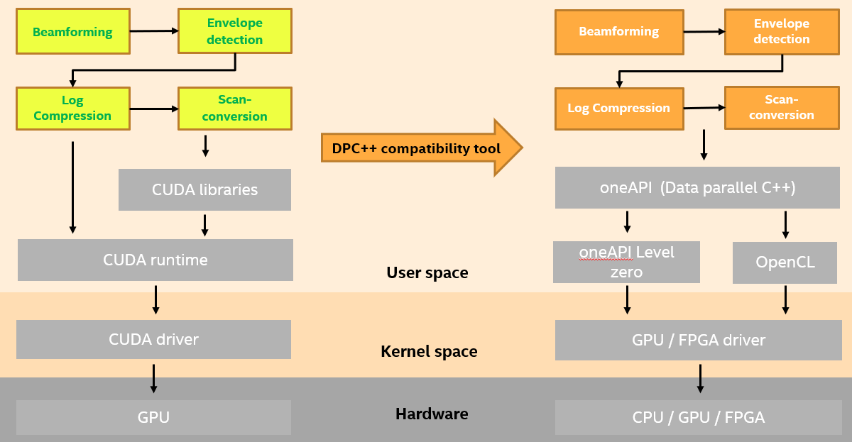

To learn more about this product, see:

* New features listed in the New in this Release section below
* Reference documentation listed in the Related Documentation section below

# New in This Release

## New Features

* Provide sample patch on how to migrate from CUDA to DPC++ by compatibility tool
* Provide sample patch of manually change after oneAPI compatibility tool automatic migration
* Provide optimize based on DPC++
* Provide getting start guide

# Fixed Issues

NULL

# Known Issues

We make use of oneAPI toolkit to implement all the functionality. Please refer to <https://software.intel.com/content/www/us/en/develop/articles/intel-oneapi-base-toolkit-system-requirements.html>, for oneAPI system requirement.

And, you can also get more information from <https://software.intel.com/oneapi>.

**[Note]** The oneAPI toolkit used in ‘SUPRA on oneAPI’ is still in Beta stage, it is at Beta07. All the code handled by oneAPI is not qualified for “production” purpose.

|  |  |  |  |  |  |  |
| --- | --- | --- | --- | --- | --- | --- |
| Reference ID | Description | symptom | Impact | Workaround/Resolution | Affected component/module/driver | Affected OS |
| 1 | Do not support running on Atom GPU. | GUI crashes during startup. | GUI crashes during startup. The demo is not able to run on the platform with Atom GPU, if you choose opencl path. | No. | Atom SOC, such as ApolloLake SOC. | Atom SOC. For example, ApolloLake E3950 |
|  |  |  |  |  |  |  |
|  |  |  |  |  |  |  |

## Non-Intel Issues

NULL

# Related Documentation

SUPRA on oneAPI Getting Start Guide.pdf

# Where to Find the Release

Please use git to download source code from git project, <https://github.com/intel/supra-on-oneapi>

## How to Install this Release

* Please refer to **SUPRA on oneAPI Getting Start Guide.pdf**.

# Release Content

Table 1-1 Revision numbers of components of the Production Candidate release.

|  |  |  |
| --- | --- | --- |
| Subproject (component) | Location | Revision |
| Patches | <https://github.com/intel/supra-on-oneapi> | 2020.09.r1 |
| Getting start guide | <https://github.com/intel/supra-on-oneapi> | 2020.09.r1 |

## External Dependencies

* oneAPI beta07, <http://registrationcenter-download.intel.com/akdlm/irc_nas/16702/l_BaseKit_b_2021.1.7.1506_offline.tar.gzd>

# Best Known Configuration

Please refer to **SUPRA on oneAPI Getting Start Guide.pdf**

# Hardware and Software Compatibility

* For system requirement, please refer to <https://software.intel.com/content/www/us/en/develop/articles/intel-oneapi-base-toolkit-system-requirements.html>
* We have verified on below systems:

1. An Intel NUC with below configuration:

CPU: Intel(R) Core(TM) i7-6700 CPU @ 3.40GHZ x4

GPU: Intel Corporation Sky Lake Integrated Graphics (rev 06)

OS: Ubuntu 18.04.4 LTS, Linux version 5.4.0-42-generic

1. An X86 desktop with below configuration:

CPU: Intel(R) Core(TM) i7-7567U CPU @ 3.5GHz x4

GPU: Intel(R) Iris Plus Graphics 650 (Kaby lake GT3e)

OS: Ubuntu 10.04.1 (kernel 5.4.0-42-generic)

1. An X86 desktop with below configuration:

CPU: Intel Core i7-8700K CPU @3.7GHz x12

GPU: Intel UHD Graphics 630

OS: Ubuntu 18.04.2 (kernel 5.4.0-45-generic)

## Supported Operating Systems

Ubuntu 18.04

# Acronyms and Terms

The following acronyms and terms are used in this document (arranged in alphabetic order):

|  |  |
| --- | --- |
| Acronym/Term | Description |
| Intel® oneAPI™ | oneAPI is a cross-industry, open, standards-based unified programming model that delivers a common developer experience across accelerator architectures—for faster application performance, more productivity, and greater innovation. Please refer to <https://www.oneapi.com/>.  Intel® oneAPI products will deliver the tools needed to deploy applications and solutions across the architectures. Please refer to <https://software.intel.com/content/www/us/en/develop/tools/oneapi.html> |
| SUPRA | An open-source pipeline for fully software defined ultrasound processing for real-time applications. Covering everything from beamforming to output of B-Mode images, SUPRA can help reproducibility of results and allows modifications to the image acquisition. |
| DPC++ | At the core of the oneAPI specification is DPC++, an open, cross-architecture language built upon the ISO C++ and Khronos SYCL standards. |
| Intel® DPC++ Compatibility Tool | The Intel® DPC++ Compatibility Tool assists in migrating your existing CUDA code to Data Parallel C++ (DPC++) code. Refer to <https://software.intel.com/content/www/us/en/develop/tools/oneapi/components/dpc-compatibility-tool.html> |

# Legal Information

|  |  |
| --- | --- |
| Component | License |
| SUPRA on oneAPI | LGPL 2.1 |