Community Service Hub
Software Design Document
By: Eyimofe Ajagunna
Course: Software Engineering
Instructor: Dr. Khaled Sabahein
Mississippi Valley State University
Date: 1st May 2026

Table of Contents
1. Document Structure 4
1.1 Purpose 4
1.2 Scope 4
1.3 Definitions and Abbreviations 5
1.4 References 5
1.5 Document Overview 5
2. Overall System Design 6
2.1 Three-Tier Architecture 6
2.2 System Components 6
2.3 Core Data Flow — Opportunity Lifecycle 7
2.4 Technology Stack 7
2.5 Deployment Architecture 7
3. Interface Design 8
3.1 Design Principles 8
3.2 Splash and Welcome Page 8
3.3 Sign Up Page 8
3.4 Email Verification Page 9
3.5 Sign In Page 9
3.6 Student Dashboard 9
3.7 Browse Opportunities (Student) 9
3.8 Registered Opportunities (Student) 9
3.9 Completed Opportunities (Student) 9
3.10 Student Messages 9
3.11 Faculty Dashboard 10
3.12 Create Opportunity (Faculty) 10
3.13 Faculty Attendance Submission 10
3.14 Faculty Messages 10
3.15 Approver Dashboard 10
3.16 Admin Dashboard 11
3.17 Navigation Structure 11
4. Use Cases 11
4.1 Actors 12
4.2 Use Case Summary 12
4.3 Detailed Use Cases 14
5. Dynamic Models 16
5.1 Sequence Diagram — User Authentication 16
5.2 Sequence Diagram — Opportunity Approval Workflow 17
5.3 State Diagram — Opportunity Lifecycle 17
5.4 Activity Diagram — Complete Community Service Workflow 18
6. Data Design 19
6.1 Entity-Relationship Overview 19
6.2 Entity-Relationship Diagram 19
6.3 Key Relationships 20
6.4 Data Integrity Rules 21
7. Non-Functional Requirements 21
7.1 Performance 21
7.2 Security 22
7.3 Usability 22
7.4 Scalability 22
7.5 Reliability and Availability 23
7.6 Maintainability 23

1. Document Structure

1.1 Purpose
This Software Design Document (SDD) describes the architectural and detailed design of the Community Service Hub web application. It serves as the primary technical reference for developers, reviewers, and evaluators by documenting system architecture, interface design, use cases, dynamic models, data design, and non-functional requirements. The document captures all design decisions made during the development of the system and provides a foundation for ongoing maintenance and future enhancement.

1.2 Scope
Community Service Hub is a full-stack web platform designed for Mississippi Valley State University (MVSU). It provides:
- A fair and reliable mechanism for students to discover, register for, and track approved community service opportunities.
- A structured workflow for faculty to propose and manage service events, and to validate student participation through attendance recording.
- A role-based approval pipeline that ensures only legitimate opportunities, reviewed by a designated faculty approver, are made visible to students.
- An administrative layer that provides system-wide oversight, including user management, opportunity management, and approver assignment.
The system restricts registration to verified MVSU email addresses, ensuring that only enrolled students and current faculty can participate. Opportunities cannot be created for past dates, and only hourly start/end times are permitted to maintain scheduling consistency.

1.3 Definitions and Abbreviations
Term / Abbreviation | Definition
SDD | Software Design Document
API | Application Programming Interface — a defined set of HTTP endpoints the backend exposes to the frontend
JWT | JSON Web Token — a compact, self-contained token used for stateless authentication
REST | Representational State Transfer — an architectural style for designing networked APIs
RBAC | Role-Based Access Control — permissions enforced based on the authenticated user's role
MVSU | Mississippi Valley State University
SPA | Single-Page Application — a web app that dynamically rewrites the current page rather than loading new pages from the server
ORM | Object-Relational Mapping — a technique for interacting with a relational database using an object-oriented paradigm
UI | User Interface
ER / ERD | Entity-Relationship (Diagram) — a graphical representation of the database schema
DXA | Twentieth of a point — a unit of measurement used in Word document formatting
Approver | A faculty member who has been granted elevated privileges by an administrator to review and approve or reject proposed opportunities
Pending | The default status of a newly submitted opportunity, awaiting approver review
Registered | The status of a student who has signed up for an approved opportunity

1.4 References
React Documentation — https://react.dev
Express.js — https://expressjs.com
MySQL Documentation — https://dev.mysql.com/doc/
JSON Web Tokens — RFC 7519 — https://datatracker.ietf.org/doc/html/rfc7519
Nodemailer — https://nodemailer.com
bcrypt (node.bcrypt.js) — https://github.com/kelektiv/node.bcrypt.js
Axios HTTP Client — https://axios-http.com
mysql2 Driver — https://github.com/sidorares/node-mysql2
Project Repository (GitHub) — https://github.com/bakridiyaolu/community-service-hub

1.5 Document Overview
The remainder of this document is organized as follows: Section 2 presents the Overall System Design including the three-tier architecture and technology stack. Section 3 covers Interface Design with a description of each screen organized by user role. Section 4 details Use Cases for all actors. Section 5 presents Dynamic Models including sequence, state, and activity diagrams. Section 6 describes the Data Design via the Entity-Relationship model. Section 7 enumerates Non-Functional Requirements covering performance, security, usability, scalability, reliability, and maintainability.

2. Overall System Design

2.1 Three-Tier Architecture
Community Service Hub follows a classic three-tier client-server architecture consisting of a Presentation Tier (React SPA), an Application Tier (Node.js/Express REST API), and a Data Tier (MySQL relational database). The diagram below illustrates the three tiers and the communication channels between them.

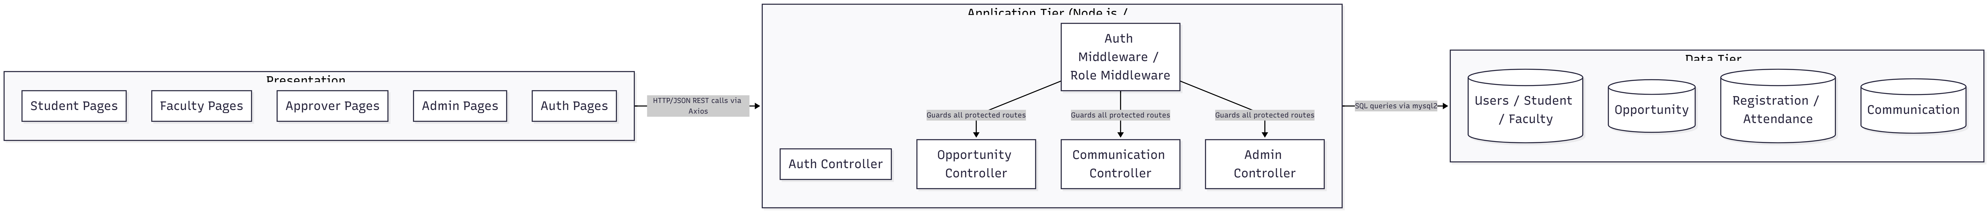
Figure 2.1. Three-Tier System Architecture
Each tier communicates over HTTP/JSON. The frontend sends JWT tokens in the Authorization header; the backend middleware validates the token and enforces role permissions before reaching any controller.

2.2 System Components
The application is partitioned into six major functional modules, each with a well-defined responsibility boundary.
Module | Location | Responsibility
Authentication Module | backend/controllers/authController.js | Handles signup (with MVSU email validation and 6-digit code verification), login, and JWT issuance
Opportunity Management | backend/controllers/opportunityController.js | Faculty creation, approver approval/rejection, student browsing, and listing utilities
Student Registration | backend/controllers/opportunityController.js | Student registration and unregistration for approved future opportunities
Attendance Module | backend/controllers/opportunityController.js | Faculty marks per-student attendance; hours are accumulated on the Student record
Communication Module | backend/controllers/communicationController.js | Faculty posts announcements per opportunity; students and faculty read messages
Admin Module | backend/controllers/adminController.js | System-wide oversight: user listing, opportunity management, approver promotion/demotion, opportunity reassignment
Auth & Role Middleware | backend/middleware/ | authMiddleware.js validates JWT on every protected route; roleMiddleware.js enforces role-specific access

2.3 Core Data Flow — Opportunity Lifecycle
The central workflow of the system is the Opportunity Lifecycle. The following diagram shows how data flows from opportunity creation through student attendance recording.
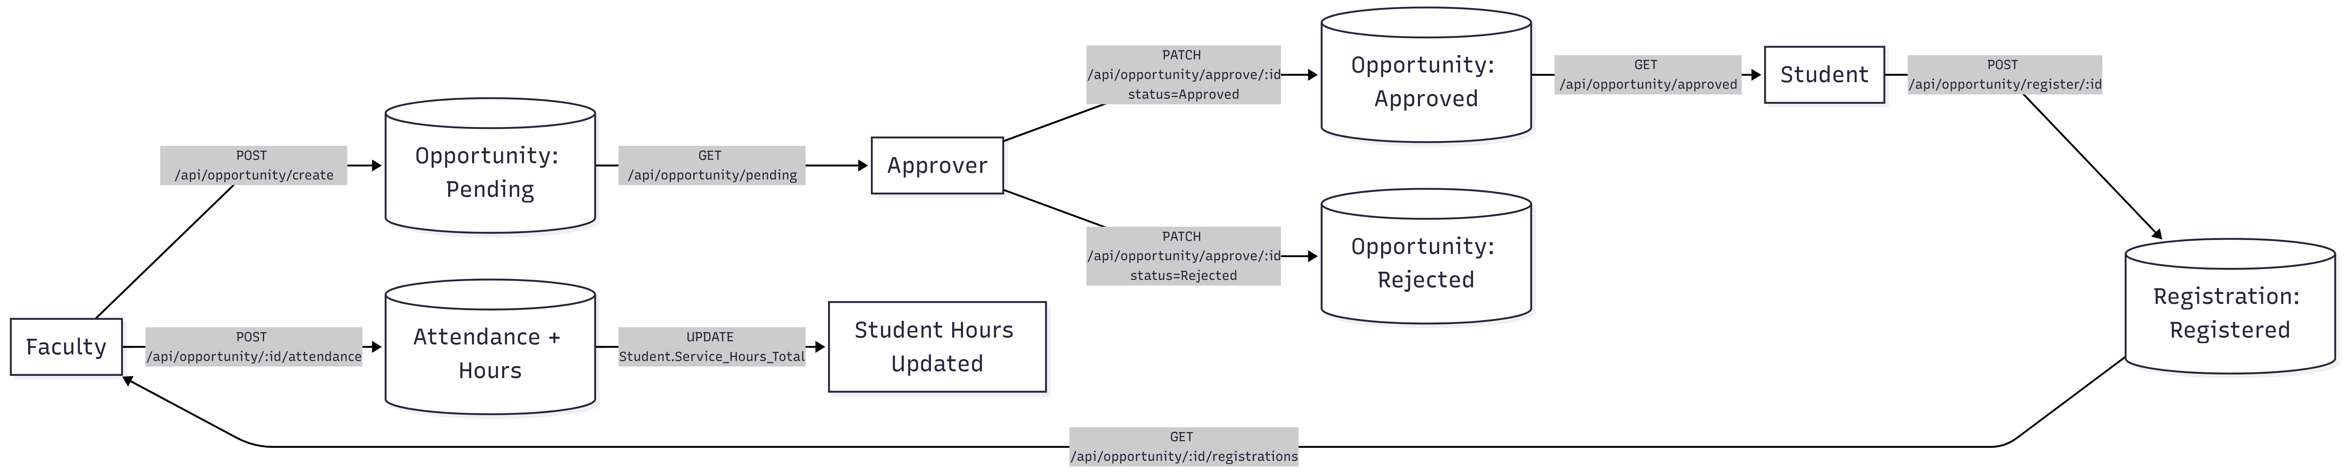
Figure 2.2. Core Opportunity Data Flow
Faculty submits an opportunity (status: Pending). An approver reviews it and either approves or rejects it. Only approved, future opportunities appear in the student browse view. Students register, and after the event the faculty member submits attendance, which increments each attending student's total service hours.

2.4 Technology Stack
Layer | Technology | Role in the System
Frontend Framework | React 18 | Component-based SPA; routing via React Router; role-specific page trees
HTTP Client | Axios | All REST calls from the frontend to the backend; centralized in src/api/axios.js with base URL and auth header injection
Backend Framework | Node.js + Express.js | REST API server; modular route registration; runs on port 5000
Authentication | jsonwebtoken (JWT) | Signs tokens on login with userId and role; tokens expire after 24 hours; verified in authMiddleware
Password Security | bcrypt | Hashes passwords at salt rounds = 10 before storage; plaintext passwords are never persisted
Email Verification | Nodemailer | Sends 6-digit one-time verification codes to @mvsu.edu addresses during signup
In-Memory Store | verificationStore (Map) | Temporarily holds pending verification entries (email → code + expiry + user data) for up to 10 minutes
Database | MySQL | Relational store for all persistent data; enforces referential integrity via foreign keys
Database Driver | mysql2 | Promise-based MySQL client used throughout the backend; connection pool via db.js
Environment Config | dotenv | Loads DB credentials, JWT secret, and SMTP settings from .env at server startup
Cross-Origin | cors | Express CORS middleware; allows the React dev server and production frontend to call the API

2.5 Deployment Architecture
The application is designed for university server deployment. The source code is version-controlled on GitHub and can be cloned and started on any compatible Linux server environment. The intended production topology is as follows:
- Frontend — The React application is built with `npm run build`, producing a static asset bundle that is served by the university's web server (e.g., Apache or Nginx) as a static site.
- Backend — The Node.js/Express process runs persistently on the university server (port 5000), managed by a process supervisor such as PM2 to ensure automatic restart on failure.
- Database — A MySQL 8 instance runs on the university server. The schema is initialized separately via the project's SQL setup scripts.
- Environment Variables — All secrets (JWT_SECRET, database credentials, SMTP credentials) are stored in a server-side .env file that is never committed to the repository.
- Version Control — The full project is hosted on GitHub, enabling collaborative development, code review, and deployment via git pull on the server.

3. Interface Design

3.1 Design Principles
Role Awareness: Navigation and available features adapt entirely based on the authenticated user's role. Students, faculty, approvers, and administrators each see a tailored sidebar and a distinct set of pages.
Clarity: Each screen has a single primary action. Information density is kept low to avoid overwhelming the user.
Consistency: A unified color palette, typography, and component structure is used throughout all role-specific page trees.
Responsiveness: Layouts use flexible CSS to adapt across desktop and tablet viewports. Each role has a dedicated sidebar component (StudentSidebar, FacultySidebar) that provides persistent primary navigation.
Feedback: Loading states and inline error messages are displayed after every asynchronous operation (form submission, registration, attendance upload).
Security UX: Users are redirected to the appropriate dashboard immediately after login based on their JWT-decoded role. Unauthorized routes do not render.

3.2 Splash and Welcome Pages
The Splash page (Splash.jsx) is the application's initial entry point. It presents the Community Service Hub branding and provides navigation links to Sign In and Sign Up. The Welcome page (Welcome.jsx) is displayed after a successful email verification, confirming account creation and directing the newly registered user to the Sign In page.

3.3 Sign Up Page
The Sign Up page (Signup.jsx) collects the information required to create a new user account. The form captures the following fields:
- First Name and Last Name
- Email address — must end with @mvsu.edu; any other domain is rejected with an inline error
- Password
- Role — either Student or Faculty (selected from a dropdown)
- Department (optional, shown only when Faculty is selected)
On submission, the backend sends a 6-digit verification code to the provided MVSU email address. The user is then redirected to the Email Verification page.

3.4 Email Verification Page
The Verify page (Verify.jsx) prompts the user to enter the 6-digit code sent to their MVSU email. The code expires after 10 minutes. If the code is correct and has not expired, the backend inserts the user record and the appropriate subtype record (Student or Faculty) into the database. The user is then redirected to the Welcome page. If the code is incorrect or expired, an error message is displayed inline.

3.5 Sign In Page
The Sign In page (Login.jsx) presents email and password fields. On successful authentication, the backend returns a JWT token alongside the user's role and profile data. The frontend stores the token and uses the role to redirect the user to their role-specific dashboard: Student Dashboard, Faculty Dashboard, Approver Dashboard, or Admin Dashboard.

3.6 Student Dashboard
The Student Dashboard (studentDashboard.jsx) is the primary landing page for authenticated students. It displays a personalized greeting using the student's first name and provides quick-access navigation cards to the main student features: Browse Opportunities, My Registrations, and Completed Opportunities. It also shows the student's total accumulated service hours retrieved from the Student table.

3.7 Browse Opportunities (Student)
This page lists all opportunities that are Approved, have a future date, and have not yet had attendance recorded. Each opportunity card displays the Title, Date, Start and End Time, Duration, Location, and the name of the Person In Charge. A Register button on each card triggers a POST to /api/opportunity/register/:id. If the student is already registered, the button changes to Unregister.

3.8 Registered Opportunities (Student)
The Registered Opportunities page (RegisteredOpportunities.jsx) shows all opportunities for which the student has an active registration. Each card includes the opportunity details and the current Registration_Status. If attendance has been submitted for an entry, the Attended flag and Hours_Earned are also displayed. Students can unregister from an opportunity as long as attendance has not been submitted.

3.9 Completed Opportunities (Student)
The Completed Opportunities page (CompletedOpportunities.jsx) displays opportunities for which attendance has been recorded for the student. Each card shows whether the student was marked as attended and how many hours were earned. This page serves as the student's community service history and contributes to their total hours display on the dashboard.

3.10 Student Messages
The Student Messages page (StudentMessages.jsx) allows students to read announcements posted by faculty for a specific opportunity. Messages are fetched via GET /api/communication/:opportunityId and displayed in chronological order, showing the message content and timestamp. Students cannot post messages; this is a read-only view for them.

3.11 Faculty Dashboard
The Faculty Dashboard (FacultyDashboard.jsx) is the landing page for authenticated faculty members. It displays a personalized greeting and provides quick-access navigation to Create Opportunity, My Submissions, Faculty Attendance, and Faculty Messages. Faculty members can see a summary of their submitted opportunities and their current approval statuses (Pending, Approved, or Rejected).

3.12 Create Opportunity (Faculty)
The Create Opportunity page (FacultyCreateOpportunity.jsx) presents a form for faculty to submit a new community service opportunity. The form includes the following fields:
- Title (required) — short name for the opportunity
- Description (optional) — additional details about the event
- Date (required) — must be today or a future date; past dates are rejected server-side
- Start Time (required) — must be an exact hour (e.g., 09:00, 14:00); non-hourly times are rejected
- End Time (required) — must be an exact hour later than Start Time
- Duration (required) — expressed in hours as a decimal (e.g., 2.0)
- Location (optional) — physical or virtual meeting location
Upon submission, the opportunity is inserted with Approval_Status = 'Pending' and the faculty member's name is auto-populated into the Person_In_Charge field from the Users table. The faculty member is then redirected to their submissions list.

3.13 Faculty Attendance Submission
The Faculty Attendance page (FacultyAttendance.jsx) allows a faculty member to record attendance for an opportunity they own. After selecting an opportunity, the page displays a list of all registered students (fetched via GET /api/opportunity/:id/registrations). For each student, the faculty member can toggle whether they attended and specify the hours earned. Submitting the form sends a POST to /api/opportunity/:id/attendance with the full attendance array. The backend uses an INSERT ... ON DUPLICATE KEY UPDATE pattern to handle re-submissions, and increments Service_Hours_Total on the Student record for each student marked as attended.

3.14 Faculty Messages
The Faculty Messages page (FacultyMessages.jsx) allows faculty to post announcements for a specific opportunity they own. Faculty select the opportunity from a list, type a message, and submit it via POST /api/communication/:opportunityId. Existing messages are also displayed on this page. This feature enables faculty to communicate schedule changes, instructions, or reminders to registered students.

3.15 Approver Dashboard
The Approver Dashboard (ApproverDashboard.jsx) is the landing page for faculty members who have been designated as approvers by an administrator. The dashboard displays three sections:
- Pending Opportunities — A list of all opportunities with Approval_Status = 'Pending'. Each card provides Approve and Reject buttons. Clicking Reject opens a required rejection reason input field.
- Approved by Me — Opportunities this approver has previously approved, shown for reference.
- Rejected by Me — Opportunities this approver has previously rejected, along with the rejection reason recorded at the time.
An approver is blocked by the system from approving or rejecting an opportunity they personally created. This constraint is enforced server-side in the approveOpportunity controller.

3.16 Admin Dashboard
The Admin Dashboard provides full system-wide oversight and management capabilities. Admin users are created through a bootstrap process and cannot be created through the normal signup flow. The admin dashboard exposes the following capabilities:
- User Management — View all registered users across all roles.
- Opportunity Management — View all opportunities regardless of status; approve or reject any opportunity directly; assign a different approver or faculty member to any opportunity.
- Approver Management — Promote a faculty member to approver status or demote an existing approver back to regular faculty via PATCH /api/admin/faculty/:userId/approver.
- System Logs — View all registrations and attendance records across the entire system for auditing purposes.
- Communication View — View all communication messages posted across all opportunities.

3.17 Navigation Structure
Each role has a dedicated sidebar component that renders a role-filtered set of navigation links. The table below summarizes the navigation available to each role.
Role | Navigation Items
Student | Dashboard | Browse Opportunities | My Registrations | Completed Opportunities | Messages
Faculty | Dashboard | Create Opportunity | My Submissions | Attendance | Messages
Approver | Dashboard (Pending / Approved-by-Me / Rejected-by-Me)
Admin | Dashboard | Users | Opportunities | Registrations | Attendance | Communications

4. Use Cases

4.1 Actors
Actor | Description
Student | An MVSU student registered on the platform. Can browse and register for approved opportunities and view their service history.
Faculty | An MVSU faculty or staff member. Can create community service opportunities and manage student attendance and messaging for their own events.
Approver | A faculty member elevated by an administrator. Has all Faculty capabilities plus the ability to approve or reject pending opportunities submitted by other faculty.
Admin | A system administrator. Has unrestricted access to all entities, users, and management operations. Cannot create opportunities directly.

4.2 Use Case Summary
UC ID | Use Case Name | Primary Actor(s) | Brief Description
UC-01 | Register Account | Student, Faculty | User creates an account using an MVSU email address, confirmed by a 6-digit code
UC-02 | Verify Email | Student, Faculty | User enters the emailed code to activate their account
UC-03 | Login | All roles | User authenticates with email/password; receives a JWT and is redirected to their dashboard
UC-04 | Create Opportunity | Faculty | Faculty submits a new community service event for approver review
UC-05 | Approve / Reject Opportunity | Approver | Approver reviews a pending opportunity and approves or rejects it (rejection requires a reason)
UC-06 | Register for Opportunity | Student | Student registers for an approved, future opportunity
UC-07 | Unregister from Opportunity | Student | Student cancels their registration before attendance is recorded
UC-08 | Submit Attendance | Faculty | Faculty marks each registered student as attended or absent and records hours earned
UC-09 | View Completed Opportunities | Student | Student reviews opportunities where their attendance has been recorded
UC-10 | Post Message | Faculty | Faculty posts an announcement for a specific opportunity
UC-11 | Read Messages | Student, Faculty | User reads messages posted for an opportunity they are associated with
UC-12 | Manage Users / Opportunities | Admin | Admin views, modifies, and reassigns users and opportunities system-wide
UC-13 | Promote / Demote Approver | Admin | Admin grants or revokes approver privileges for a faculty member

4.3 Detailed Use Cases

UC-01: Register Account
Use Case ID | UC-01
Name | Register Account
Primary Actor | Student or Faculty
Preconditions | The user has a valid @mvsu.edu email address and is not already registered.
Main Flow | 1. User navigates to the Sign Up page.  2. User enters First Name, Last Name, MVSU email, password, and role (Student or Faculty).  3. Faculty users optionally enter their department.  4. User submits the form.  5. System validates all required fields, confirms email domain is @mvsu.edu, and checks for duplicate email.  6. System generates a 6-digit verification code, stores it in-memory with a 10-minute expiry, and sends it to the provided email via Nodemailer.  7. System redirects user to the Email Verification page (UC-02).
Alternative / Exception Flows | E1 — Non-MVSU email: System returns HTTP 400 with 'Only mvsu.edu emails are allowed.'  E2 — Duplicate email: System returns HTTP 400 with 'Email already registered.'  E3 — Missing fields: System returns HTTP 400 listing the missing required fields.  E4 — Invalid role: System returns HTTP 400 with 'Invalid role.'
Postconditions | A pending verification entry is stored in memory. The account is not yet created in the database.

UC-02: Verify Email
Use Case ID | UC-02
Name | Verify Email
Primary Actor | Student or Faculty
Preconditions | UC-01 completed successfully. The user has received the 6-digit code via email.
Main Flow | 1. User is on the Verify page.  2. User enters the 6-digit code.  3. System looks up the in-memory entry for the email.  4. System checks that the code has not expired and matches the stored code.  5. System hashes the password with bcrypt (10 salt rounds).  6. System inserts a new row into the Users table.  7. System inserts a corresponding row into the Student table (with Service_Hours_Total = 0) or the Faculty table (with Approver = false).  8. System deletes the in-memory entry and returns HTTP 201.  9. User is redirected to the Welcome page.
Alternative / Exception Flows | E1 — No pending entry: System returns HTTP 400 with 'No verification request found.'  E2 — Expired code: In-memory entry is deleted; system returns HTTP 400 with 'Verification code expired.'  E3 — Wrong code: System returns HTTP 400 with 'Invalid verification code.'
Postconditions | A fully verified user record exists in the Users table and the appropriate subtype table.

UC-03: Login
Use Case ID | UC-03
Name | Login
Primary Actor | Any registered user
Preconditions | The user has a verified account.
Main Flow | 1. User navigates to the Sign In page.  2. User enters their email and password.  3. System fetches the user record from the Users table.  4. System verifies the password against the stored bcrypt hash.  5. For faculty users, system fetches the Faculty subtype to detect the Approver flag.  6. System issues a JWT signed with JWT_SECRET, embedding userId and the effective role (student / faculty / approver / admin), with a 24-hour expiry.  7. System returns the token, role, userId, and profile.  8. Frontend stores the token and redirects the user to their role-specific dashboard.
Alternative / Exception Flows | E1 — Email not found: System returns HTTP 400 with 'Invalid email or password.'  E2 — Wrong password: System returns HTTP 400 with 'Invalid email or password.'  E3 — Missing fields: System returns HTTP 400 with 'Email and password required.'
Postconditions | User is authenticated; JWT token is stored on the client; user is on their dashboard.

UC-04: Create Opportunity
Use Case ID | UC-04
Name | Create Opportunity
Primary Actor | Faculty (regular — Approver flag = false)
Preconditions | User is authenticated as faculty (non-approver). The proposed date is today or in the future.
Main Flow | 1. Faculty navigates to Create Opportunity.  2. Faculty fills in Title, Date, Start Time, End Time, Duration, and optionally Description and Location.  3. Faculty submits the form.  4. System validates required fields, confirms the date is not in the past, and verifies that Start Time and End Time are exact hours.  5. System fetches the faculty member's name from the Users table.  6. System inserts a row into the Opportunity table with Approval_Status = 'Pending', Person_In_Charge = faculty name, and Approver_ID = NULL.  7. System returns HTTP 201 with the new Opportunity_ID.
Alternative / Exception Flows | E1 — Past date: System returns HTTP 400 with 'You cannot create an opportunity for a past date.'  E2 — Non-hourly time: System returns HTTP 400 with 'Start Time and End Time must be hourly.'  E3 — Missing required fields: System returns HTTP 400 listing missing fields.  E4 — Approver attempts creation: roleMiddleware returns HTTP 403 with 'Approvers cannot create opportunities.'
Postconditions | A new Opportunity row exists with Approval_Status = 'Pending'. It is now visible in the approver's pending list.

UC-05: Approve / Reject Opportunity
Use Case ID | UC-05
Name | Approve / Reject Opportunity
Primary Actor | Approver
Preconditions | User is authenticated as an approver. At least one opportunity has Approval_Status = 'Pending'. The opportunity was not created by this approver.
Main Flow | 1. Approver views the Pending Opportunities list on the Approver Dashboard.  2. Approver selects an opportunity and clicks Approve or Reject.  3. If rejecting, approver enters a rejection reason.  4. Approver submits the decision.  5. System validates the status value and confirms the approver is not the opportunity's creator.  6. System updates the Opportunity row: Approval_Status = 'Approved' or 'Rejected', Approver_ID = approverId, Rejection_Reason = provided reason (or NULL for approvals).  7. System returns HTTP 200.
Alternative / Exception Flows | E1 — Self-approval attempt: System returns HTTP 403 with 'You cannot approve or reject an opportunity you created.'  E2 — Missing rejection reason: System returns HTTP 400 with 'Rejection reason is required when rejecting.'  E3 — Opportunity not found: System returns HTTP 404.
Postconditions | The opportunity's Approval_Status is updated. If approved, the opportunity becomes visible to students in the Browse view. If rejected, the faculty member's My Submissions view shows the rejection reason.

UC-06: Register for Opportunity
Use Case ID | UC-06
Name | Register for Opportunity
Primary Actor | Student
Preconditions | User is authenticated as a student. The selected opportunity is Approved and has a future date.
Main Flow | 1. Student navigates to Browse Opportunities.  2. Student reviews available opportunities and clicks Register on a chosen opportunity.  3. System verifies the opportunity exists, is Approved, and checks for a duplicate registration.  4. System inserts a Registration row with Registration_Status = 'Registered'.  5. System returns HTTP 201.
Alternative / Exception Flows | E1 — Already registered: System returns HTTP 400 with 'You are already registered for this opportunity.'  E2 — Opportunity not approved: System returns HTTP 400 with 'You can only register for approved opportunities.'  E3 — Opportunity not found: System returns HTTP 404.
Postconditions | A Registration row links the student to the opportunity. The student can see the opportunity on their Registered Opportunities page.

UC-08: Submit Attendance
Use Case ID | UC-08
Name | Submit Attendance
Primary Actor | Faculty
Preconditions | User is authenticated as the faculty member who owns the opportunity. At least one student is registered.
Main Flow | 1. Faculty navigates to the Attendance page and selects the opportunity.  2. System retrieves all registered students with any existing attendance data.  3. Faculty marks each student as attended (true/false) and enters hours earned.  4. Faculty submits the attendance form.  5. System verifies the faculty owns the opportunity.  6. For each student entry, system executes INSERT ... ON DUPLICATE KEY UPDATE on the Attendance table.  7. For each student marked as attended, system increments Student.Service_Hours_Total by the hours earned.  8. System returns HTTP 200.
Alternative / Exception Flows | E1 — Faculty does not own opportunity: System returns HTTP 403.  E2 — Empty attendance array: Loop executes zero iterations; system returns HTTP 200 with no changes.
Postconditions | Attendance rows are created or updated. Attending students have their Service_Hours_Total incremented. The opportunity no longer appears in the student Browse view.

5. Dynamic Models

5.1 Sequence Diagram — User Authentication
The following sequence diagram describes the full login flow from the browser through the Express API to the MySQL database and back to the client.
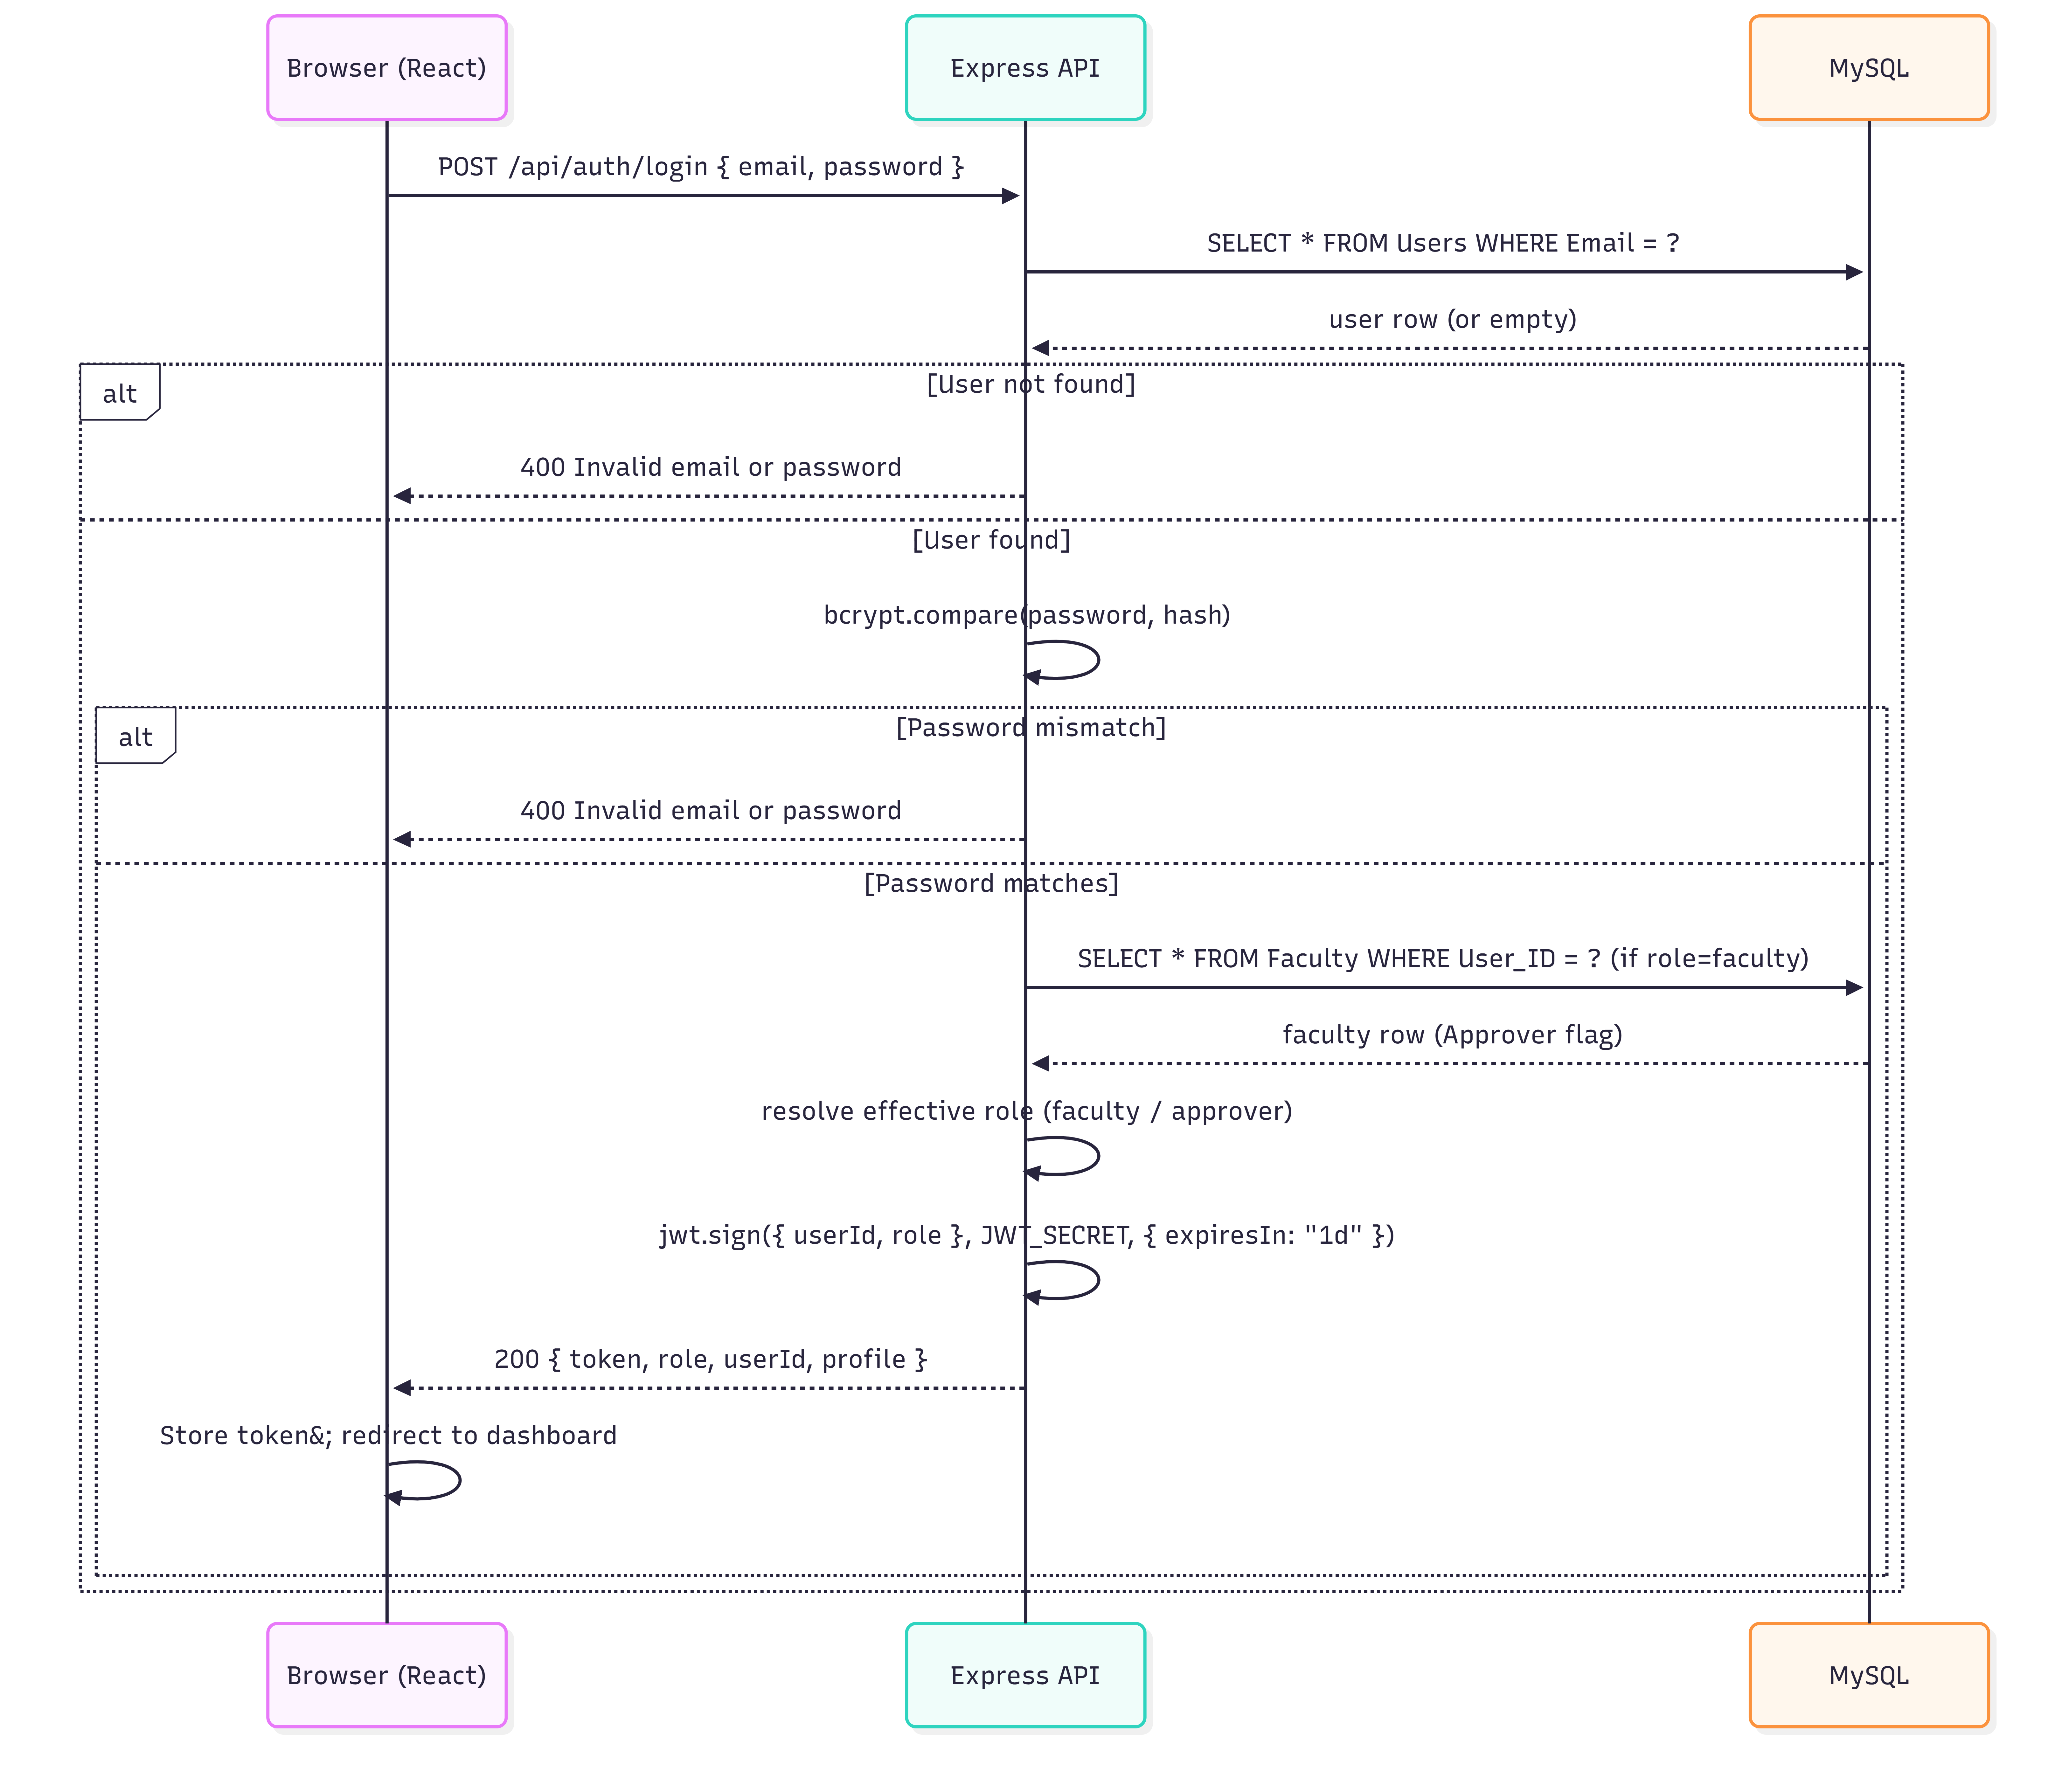
Figure 5.1. Sequence — User Authentication
The backend always performs a second query for faculty users to determine whether the Approver flag is set, which overrides the token role to 'approver' and controls frontend routing.

5.2 Sequence Diagram — Opportunity Approval Workflow
This sequence covers the end-to-end flow from a faculty member submitting an opportunity through approver review to the opportunity becoming visible to students.

Figure 5.2. Sequence — Opportunity Approval Workflow
The self-approval guard is checked at step PATCH /approve/:id — if the approver's userId matches the opportunity's Faculty_ID, the request is rejected with HTTP 403.

5.3 State Diagram — Opportunity Lifecycle
An opportunity passes through the following states from creation to completion. All state transitions are enforced server-side.
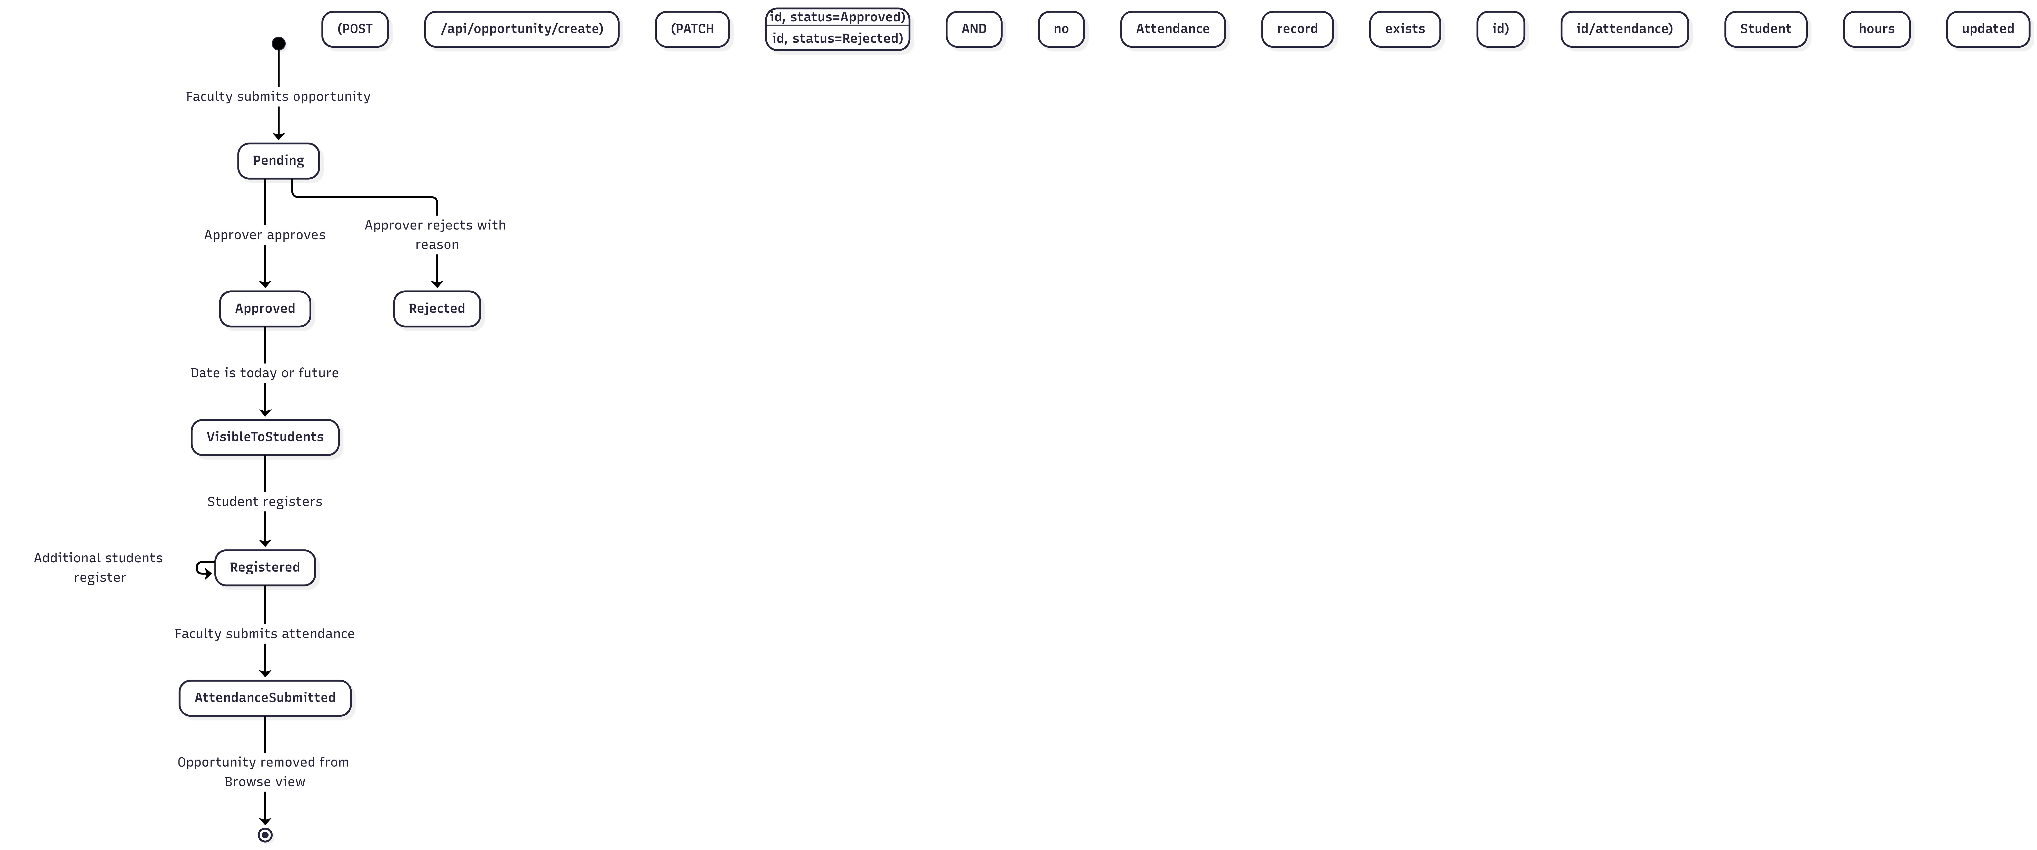
Figure 5.3. State — Opportunity Lifecycle
A rejected opportunity cannot be re-submitted or transitioned to Approved without admin intervention. An opportunity with submitted attendance is excluded from the student Browse view by the NOT IN (SELECT Opportunity_ID FROM Attendance) filter in the listApproved query.

5.4 Activity Diagram — Complete Community Service Workflow
The following activity diagram shows the end-to-end workflow from opportunity proposal to service hours being recorded for a student.

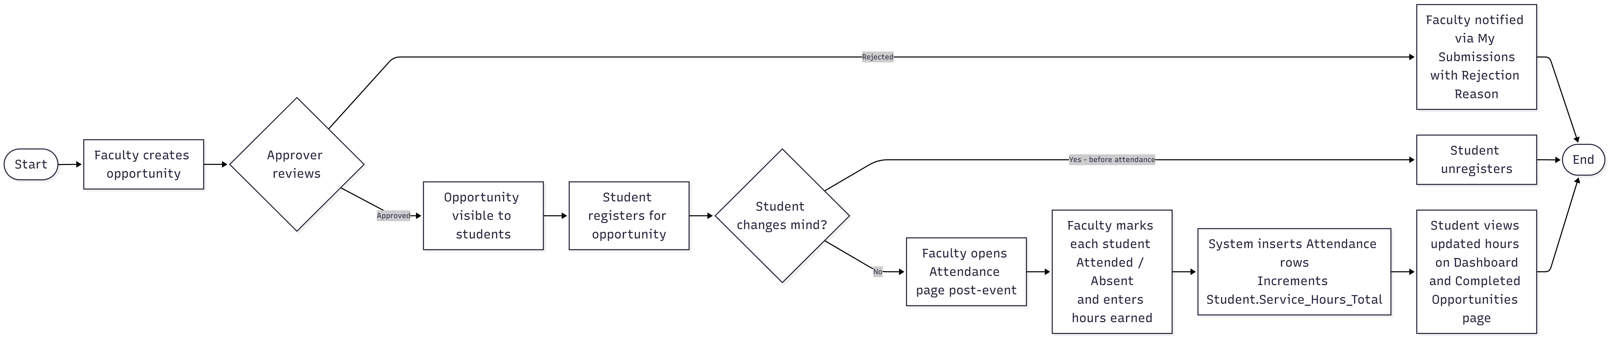
Figure 5.4. Activity — Complete Community Service Workflow
Faculty messaging can occur at any point after the opportunity is created. Faculty can post messages before, during, or after the event. Students can read messages from the Student Messages page at any time.

6. Data Design

6.1 Entity-Relationship Overview
The Community Service Hub database consists of seven primary entities organized around a user subtype hierarchy and an opportunity-centric data model. The schema supports role-based access, attendance tracking, and inter-party communication.
Entity | Description
users | Central entity. Stores identity data for all users. The Role column ('student' or 'faculty') determines which subtype table is populated at registration. Admin accounts are created separately.
student | Subtype of users. Stores student-specific data. Service_Hours_Total accumulates hours earned across all attended opportunities.
faculty | Subtype of users. Stores faculty-specific data. Faculty_Dept records department affiliation. The Approver TINYINT(1) flag determines whether the user has approver privileges.
opportunity | Central operational entity. Records all proposed service events. Faculty_ID references the creating faculty member. Approver_ID references the faculty approver who reviewed it. Approval_Status is an ENUM: Pending, Approved, Rejected.
registration | Join table linking students to opportunities. Registration_Status tracks whether the registration is active. One student may register for many opportunities; one opportunity may have many registered students.
attendance | Records the outcome of a student's participation in an opportunity. Attended (TINYINT) indicates presence; Hours_Earned records the service credit. Created by faculty via the attendance submission endpoint.
communication | Stores faculty-posted messages associated with a specific opportunity. Faculty_ID identifies the posting faculty. Messages are read-only for students.

6.2 Entity-Relationship Diagram
The diagram below illustrates the full database schema, including all entities, attributes, primary keys, foreign key relationships, and cardinality constraints. Insert the ERD image exported from your MySQL Workbench or diagramming tool below.
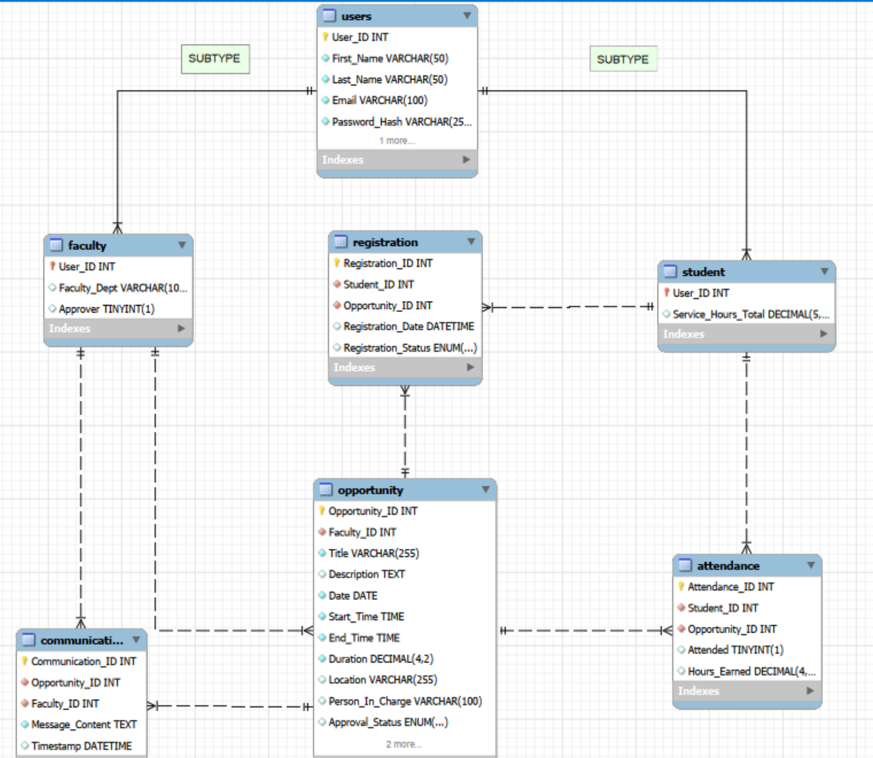

Figure 6.1. Community Service Hub — Entity-Relationship Diagram

6.3 Key Relationships
Relationship | Cardinality | Description
users → student | 1:1 (optional subtype) | Every student user has exactly one Student row; faculty users do not.
users → faculty | 1:1 (optional subtype) | Every faculty user has exactly one Faculty row; student users do not.
faculty → opportunity | 1:Many | One faculty member may create many opportunities; each opportunity has exactly one creating faculty.
faculty → opportunity (approver) | 1:Many | One approver may approve many opportunities; each approved/rejected opportunity references exactly one approver.
opportunity → registration | 1:Many | One opportunity may have many registrations; each registration belongs to exactly one opportunity.
student → registration | Many:Many (via Registration) | One student may register for many opportunities; each opportunity may have many registered students.
opportunity → attendance | 1:Many | One opportunity has one attendance record per registered student.
student → attendance | 1:Many | One student has one attendance record per attended opportunity.
opportunity → communication | 1:Many | One opportunity may have many communication messages.
faculty → communication | 1:Many | One faculty member may post many messages across opportunities they manage.

6.4 Data Integrity Rules
- Role in Users must be 'student', 'faculty', or 'admin' — enforced via ENUM constraint.
- Email in Users must be unique across the entire table — enforced via UNIQUE INDEX.
- Approval_Status in Opportunity must be exactly 'Pending', 'Approved', or 'Rejected' — enforced via ENUM.
- Registration_Status in Registration must be 'Registered' or 'Cancelled' — enforced via ENUM.
- Opportunity.Date must be today or a future date — validated server-side in createOpportunity before INSERT.
- Opportunity.Start_Time and End_Time must be exact hours (minutes = 00) — validated via regex server-side.
- An approver cannot approve or reject an opportunity they created — enforced via comparison of Faculty_ID and approverId in approveOpportunity.
- A student cannot register twice for the same opportunity — enforced via pre-insert duplicate check (SELECT before INSERT).
- Attendance submission is idempotent — INSERT ... ON DUPLICATE KEY UPDATE ensures re-submission overwrites rather than duplicates.
- Rejection_Reason is required when Approval_Status is set to 'Rejected' — enforced server-side in approveOpportunity.
- Approver flag change (faculty ↔ approver) is restricted to Admin users — enforced via isAdmin middleware on /api/admin/faculty/:userId/approver.
- Admin accounts cannot be created via the public signup endpoint — admin bootstrap is a separate one-time endpoint that disables itself after use.

7. Non-Functional Requirements

7.1 Performance
- Response Time — API endpoints that query a single table or a simple join (e.g., list approved opportunities, list my registrations) must return within 500 milliseconds under normal load.
- Throughput — The system must support concurrent sessions from all active MVSU students and faculty without degradation, given university-scale usage patterns.
- Database Connection Pooling — The mysql2 driver is configured with a connection pool (db.js) to efficiently serve concurrent requests without exhausting database connections.
- Pagination — The approved opportunities list and the admin views filter by status and date server-side to prevent full-table scans as data grows over time.
- Static Asset Delivery — The React build output (HTML, JS, CSS bundles) is served as static files by the university web server, minimizing backend load for non-API traffic.

7.2 Security
- Authentication — All protected routes require a valid JWT in the Authorization header (Bearer scheme). Tokens are verified in authMiddleware.js using the server-side JWT_SECRET. Tokens expire after 24 hours.
- Password Storage — Passwords are hashed with bcrypt at 10 salt rounds. Plaintext passwords are never stored, logged, or returned in any API response.
- Role Enforcement — roleMiddleware.js verifies the user's role on every protected request. Students cannot access faculty or admin endpoints; faculty cannot access student-only or admin endpoints; admins cannot create opportunities.
- Email Domain Restriction — Signup is limited to @mvsu.edu addresses, preventing external account creation. Validated server-side in authController before any data is stored.
- Input Validation — Required fields, date constraints, and time format rules are validated server-side before any database write. This prevents malformed data insertion.
- Self-Approval Prevention — An approver is blocked from approving or rejecting any opportunity they created, ensuring independence in the review process.
- HTTPS — All communication between the React frontend and the Express backend must use TLS/HTTPS in the production university server environment.
- Environment Secrets — JWT_SECRET, database credentials, and SMTP credentials are stored in a .env file on the server that is excluded from version control via .gitignore.
- Bootstrap Admin Security — The admin bootstrap endpoint (POST /api/admin/bootstrap-admin) is a one-time-use endpoint designed to disable itself after the first admin account is created, preventing unauthorized elevation.

7.3 Usability
- Role-Aware Navigation — Each role sees only the navigation items relevant to them. No role is shown features they cannot use, reducing cognitive load.
- Inline Error Feedback — All validation errors (missing fields, wrong email domain, past date, non-hourly time, duplicate registration) are returned in the API response and displayed to the user as inline messages, not generic popups.
- Learnability — A first-time student user should be able to browse and register for a community service opportunity within 5 minutes of logging in, without documentation.
- Descriptive Rejection Reasons — When an approver rejects an opportunity, a rejection reason is required. This reason is displayed to the submitting faculty member on their My Submissions page, enabling them to understand and address the issue.
- Role Redirect on Login — Upon successful login, the backend returns the user's effective role. The frontend uses this to immediately redirect to the correct dashboard, ensuring users always land on a contextually appropriate page.

7.4 Scalability
- Stateless API — JWT-based authentication means any backend instance can handle any request without sticky sessions, enabling horizontal scaling if the university server environment supports it.
- Modular Route Structure — Backend routes are organized into separate files (authRoutes, opportunityRoutes, communicationRoutes, adminRoutes). Adding new features requires only new route and controller files without modifying existing ones.
- Server-Side Filtering — The listApproved query excludes past-dated and already-attended opportunities at the database layer (WHERE Date >= CURDATE() AND NOT IN Attendance), preventing unbounded result sets.
- Separation of Concerns — Frontend and backend are fully decoupled, allowing either tier to be scaled, replaced, or redeployed independently.

7.5 Reliability and Availability
- Atomic Attendance Updates — The attendance submission loop handles each student entry independently. A failure on one entry does not roll back previously processed entries. For production hardening, a database transaction could be added to make the entire batch atomic.
- Idempotent Attendance — INSERT ... ON DUPLICATE KEY UPDATE ensures that re-submitting attendance for an opportunity updates existing records rather than creating duplicates, protecting data integrity on re-runs.
- Process Supervision — In the production university server deployment, the Node.js backend should be managed by PM2 or an equivalent process supervisor to enable automatic restart on crash.
- Target Uptime — The system targets 99% uptime during the academic year, the period of active student and faculty use.
- Verification Code Expiry — In-memory verification entries expire after 10 minutes. Expired entries are deleted on the next verification attempt, preventing stale data accumulation.
- Error Logging — All controller catch blocks log errors to the server console (console.error with stack trace), providing diagnostic information for debugging runtime failures.

7.6 Maintainability
- Codebase Structure — The backend follows a layered architecture: routes define endpoints, middleware enforces access control, and controllers implement business logic. This separation makes individual layers testable and replaceable.
- Environment Configuration — All environment-specific values (database host, JWT secret, SMTP credentials) are externalized to a .env file. Deploying to a new environment requires only updating this file.
- Commented Code — The roleMiddleware.js file retains commented-out prior implementations for reference, documenting design evolution and alternative approaches.
- GitHub Version Control — The full project history is maintained on GitHub, enabling rollback, branching for new features, and collaborative development by future maintainers.
- Consistent API Pattern — All controllers follow a consistent pattern: validate input, execute database query, return appropriate HTTP status and JSON body. This predictability reduces onboarding time for new developers.
- Modular Frontend — The React frontend is organized by role (auth/, student/, faculty/, approver/, admin/) with shared API utilities in src/api/. New role-specific features can be added without modifying other role trees.

