**CSCI 1411: Fundamentals of Computing**

**Lab 8**

**Due Date: March 23, 2022**

**Name: Malachi Milton-Brewer**

**Goals:**

* To understand how to write user-defined functions
* To understand details of function calls and parameter passing in Python

**Development Environment:** IDLE

**Deliverables:**

1. This lab handout with 6 screen shots (2 for part I, 2 for part II and 2 for part III).
2. Your Python code for Part I of this lab. Name the file using the following format:  
   yourlastnameFirstnameLab08a.py

Example: If your name is Jamal Jones then you will name the file as follows:  
JonesJamalLab08a.py

1. Your Python code for Part II of this lab. Name the file using the following format:  
   yourlastnameFirstnameLab08b.py  
   Example: If your name is Jamal Jones then you will name the file as follows:  
   JonesJamalLab08b.py
2. Your Python code for Part III of this lab. Name the file using the following format:  
   yourlastnameFirstnameLab08c.py  
   Example: If your name is Jamal Jones then you will name the file as follows:  
   JonesJamalLab08c.py

How to take a **screen shot**:

* For a Windows 10: Use Snipping Tool to copy and CTRL + V to paste screen shot.
* For Mac: Shift + Command + 4 to copy and CTRL + V to paste screen shot.

**Part I – Skill Practice (10 Points)**

* Start IDLE
* Create a new file.
* Type the following code in the file. …..**Do not cut and paste.** You will learn more by typing it in.
* Remember to update the first 3 lines with your own first name, last name and the date of the lab.
* In this lab, we have provided three functions.
  + The first function is the example how we can pass parameter and return a value. First function converts the Fahrenheit temperature into Celsius temperature and return the Celsius temperature.
  + The second function is the example how we can pass a List data type as a parameter. This function demonstrates that if you pass a list as a parameter, this will change the list in the calling function.
  + The third function is the main function. This function invokes the first two functions.

# Your first name

# Your last name

# Date: The current date

# Description: This program shows techniques of defining function,

# parameter passing and function invocation.

# fahrenToCel function

# parameter: A temperature value in Fahrenheit

# returns equivalent temperature in Celsius

def fahrenToCel(fahren):

result = (fahren - 32) * (5.0 / 9.0);

return result

# fahrenToCelList function

# parameter: a list of temperature values in Fahrenheit

# coverts the list to equivalent temperatures in Celsius

# If you pass a list as an argument, this will change the value

# in calling function

def fahrenToCelList(fahrenList):

for i in range(len(fahrenList)):

fahren = fahrenList[i]

celsius = (fahren - 32) * (5.0 / 9.0)

fahrenList[i] = round(celsius,2)

# main function

def main():

fval = float(input("Please enter the temperature in Fahrenheite: "))

# call the function fahrenToCel

cval = fahrenToCel(fval)

print("Equivalent temperature in Celcius is {0:0.2f} ".format(cval))

fahrenheiteList = []

# Take 5 temperature as inputs and store them in fahrenhiteList

for i in range(5):

fahren = float(input("Enter temperature in Fahrenheit: "))

fahrenheiteList.append(fahren)

# call the function fahrenToCelList

fahrenToCelList(fahrenheiteList)

print("The converted temperature list")

print(fahrenheiteList)

* Save the file as “YourLastNameYourFirstNameLab08a.py”
* Click Run -> Run Module
* If you get any syntax error, try to correct the syntax error.
* If no syntax error, this will redirect you to the output screen.
* Type main()
* Output will look like the following:

* Take two screenshots of your outputs and attach them here.

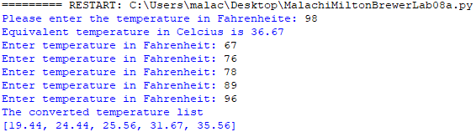

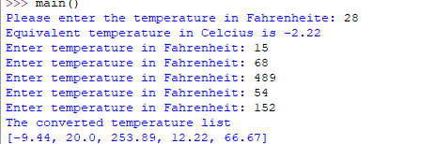

**Part II – Convert the Date format (8 Points)**

* In this program you will convert the date format from “mm/dd/yyyy” to “month day, year”. For example, date format “01/23/2020” will be converted to January 23, 2020.
* Write a Python function ***dateConvert*** that will take a date in “mm/dd/yyyy” format as parameter. Your function will convert the date in “month day, year” format and return the date in “month day, year” format.
* Write a main function that will do the following
  + Ask user for a date input in “mm/dd/yyyy” format.
  + Call the function ***dateConvert***
  + ***dateConvert*** that will take a date in “mm/dd/yyyy” format as parameter. Your function will convert the date in “month day, year” format and return the date in “month day, year” format.
  + Your program will print the date in converted format.
* Save the python program as “lasnameFirstnameLab08b.py”
* The sample input and output will look like the following:
  + Sample input/output 1

* Sample input/output 2:

* Please capture 2 screenshots with your output with 2 different inputs and paste them here.





**Part III – Double the values of a list (7 Points)**

* In this program you will double the values of a List.
* Write a python function ***findDoubles*** that will take a List as a parameter. Your function will double the values of the list.
* Write a main function that will do the following:
  + Ask user for 5 numbers and store them in a List
  + Call ***findDoubles*** function
  + ***findDoubles*** function will take a List as a parameter. This function will double the values of the list.
  + Print the result.
* Save the python program as “lasnameFirstnameLab08c.py”
* The sample input and output will look like the following:
  + Sample input/output 1

* Capture 2 screenshots and paste it here



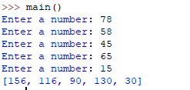

* Upload this lab handout with required screen shots and your code file to Canvas to submit the lab.