**CSCI 1411: Fundamentals of Computing**

**Lab 7**

**Due Date: March 16, 2022**

**Name: Malachi Milton-Brewer**

**Goals:**

* Understanding the basic file processing concepts and techniques for reading and writing text files in Python.

**Development Environment:** IDLE

**Deliverables:**

1. This lab handout with 4 screen shots (2 for part I, 2 for part II).
2. Your Python code for Part I of this lab. Name the file using the following format:  
   yourlastnameFirstnameLab07a.py

Example: If your name is Jamal Jones then you will name the file as follows:  
JonesJamalLab07a.py

1. Output file for Part I of this lab.
2. Your Python code for Part II of this lab. Name the file using the following format:  
   yourlastnameFirstnameLab07b.py  
   Example: If your name is Jamal Jones then you will name the file as follows:  
   JonesJamalLab05b.py
3. Input file and output file for Part II of this lab.

How to take a **screen shot**:

* For a Windows 10: Use Snipping Tool to copy and CTRL + V to paste screen shot.
* For Mac: Shift + Command + 4 to copy and CTRL + V to paste screen shot.

**Part I – Skill Practice(10 pts)**

* Start IDLE
* Create a new file.
* Type the following code in the file. …..**Do not cut and paste.** You will learn more by typing it in.
* The following program will read the names (first name and last name) from a file (“in.txt”). Email addresses and user names will be generated using the names and will be written to a new file.
* Remember to update the first 3 lines with your own first name, last name and the date of the lab.

# Your first name

# Your last name

# Date: The current date

# Description: This program shows techniques of reading and writing text files in Python

def main():

print("This program creates a file of emails and usernames from a file of names")

# open the input file

infile = open("in.txt", "r")

# get the file names of output file

outfileName = input("What file should the usernames go in? ")

# open the output file

outfile = open(outfileName, "w")

# process each line of the input file

for line in infile:

# get the first and last names from line

first, last = line.split()

# create the ucdenver email address

email = (first + "." + last).lower() + "@ucdenver.edu"

uname = (last[:]+first[0]).lower()

# write it to the output file print(uname, file=outfile)

print(email + " " + uname, file=outfile)

# close both files

infile.close()

outfile.close()

print("Emails and usernames have been written to", outfileName)

* Save the file as “YourLastNameYourFirstNameLab07a.py”
* Save “in.txt” file in the same folder as your “YourLastNameYourFirstNameLab07a.py” file is located.
* Click Run -> Run Module
* If you get any syntax error, try to correct the syntax error.
* Type main()
* The program will ask for the output file name.
* Output will look like the following:

* “Out.txt” file will be located in the same folder as your Python program.
* Open the “Out.txt” file.
* Sample “in.txt” file:

John Doe

Jane Smith

Sara Thomas

Frank Brown

Mike Devis

William Smith

Jessica Garcia

Bob Lopez

* Sample output file (“Out.txt”):

john.doe@ucdenver.edu doej

jane.smith@ucdenver.edu smithj

sara.thomas@ucdenver.edu thomass

frank.brown@ucdenver.edu brownf

mike.devis@ucdenver.edu devism

william.smith@ucdenver.edu smithw

jessica.garcia@ucdenver.edu garciaj

bob.lopez@ucdenver.edu lopezb

* Capture 1 screenshot of your output and attach it here.

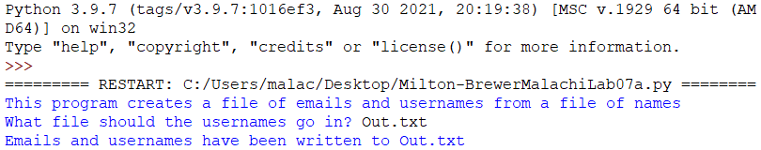

* Capture 1 screenshot of your output file and attach it here.

**Part II – Finding the average score (15 Points)**

* Write a program to calculate the average scores of the students.
* Your program should read input from a file
* Each line of the file contains the username of the student (1 word) followed by 5 quiz scores
* Your program will read input from file and calculate the average scores for each student.
* Your program will write the output in another file.
* In the output file, your program should write the student’s name followed by their average score.
* Your program will do the following:
  + Ask user for an input file name
  + Read the name and quiz scores from the file
  + Calculate the average score for each student
  + Ask user for an output file name
  + Write the username followed by the average score of the student in the output file.
* Sample input file:

johnd 20 30 12 25 50

janeb 10 10 20 23 10

saran 23 10 30 30 30

frankb 25 21 22 30 23

marys 10 10 10 10 10

* Sample Input/Output:

* The sample output file:

johnd 27.4

janeb 14.6

saran 24.6

frankb 24.2

marys 10.0

* Capture 1 screenshot of your output and attach it here.

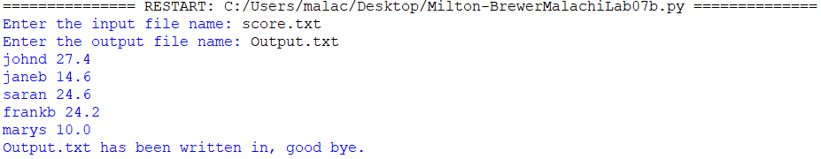

* Capture 1 screenshot of your output file and attach it here.

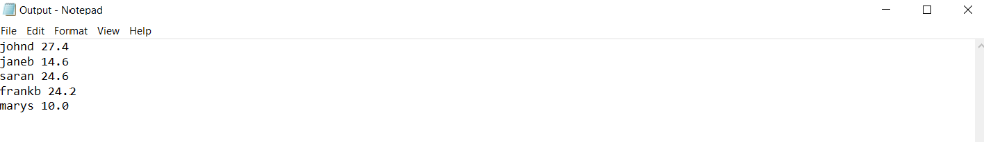

* Upload this lab handout with required screen shots and your code file to Canvas to submit the lab.