KIDTASK PROJECT FINAL REPORT
SENG 383
1: REPOSITORY ACCESS
Project Name: KidTask
Developer: Serra Selci - Role: Student A
GitHub Repository Link:
https://github.com/Eylultrnc/-SENG383-project
Presentation Video Link:
https://github.com/Eylultrnc/-SENG383-project/blob/main/KidTaskVideo.md
2: FINAL DESIGN ARTIFACTS
2.1.Class Diagram
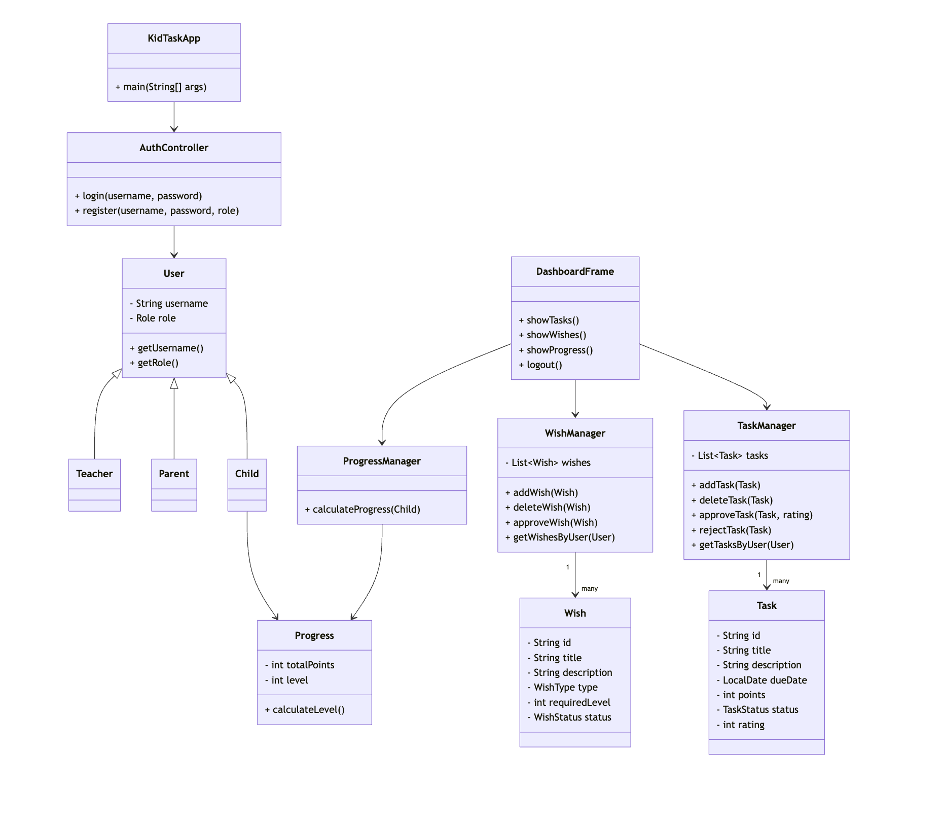
2.2.Activity Diagrams

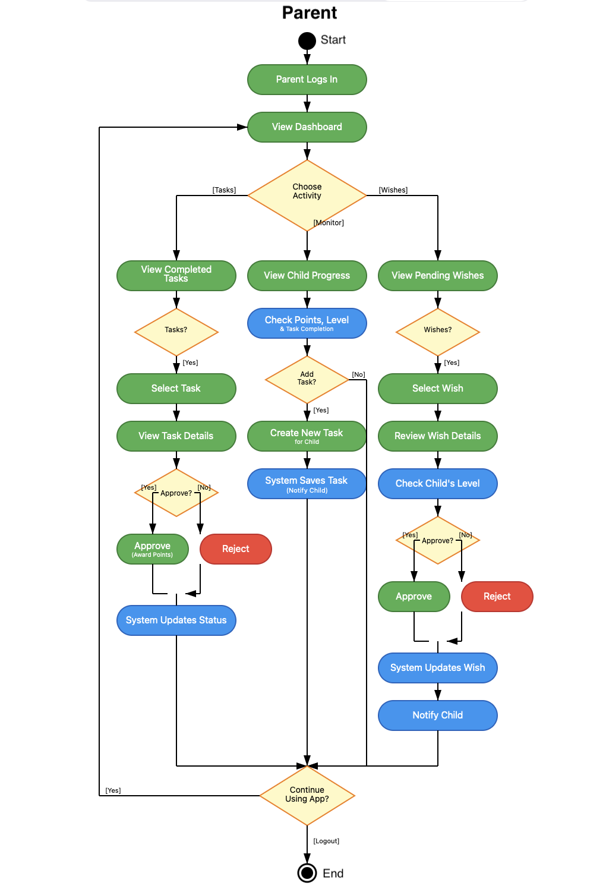
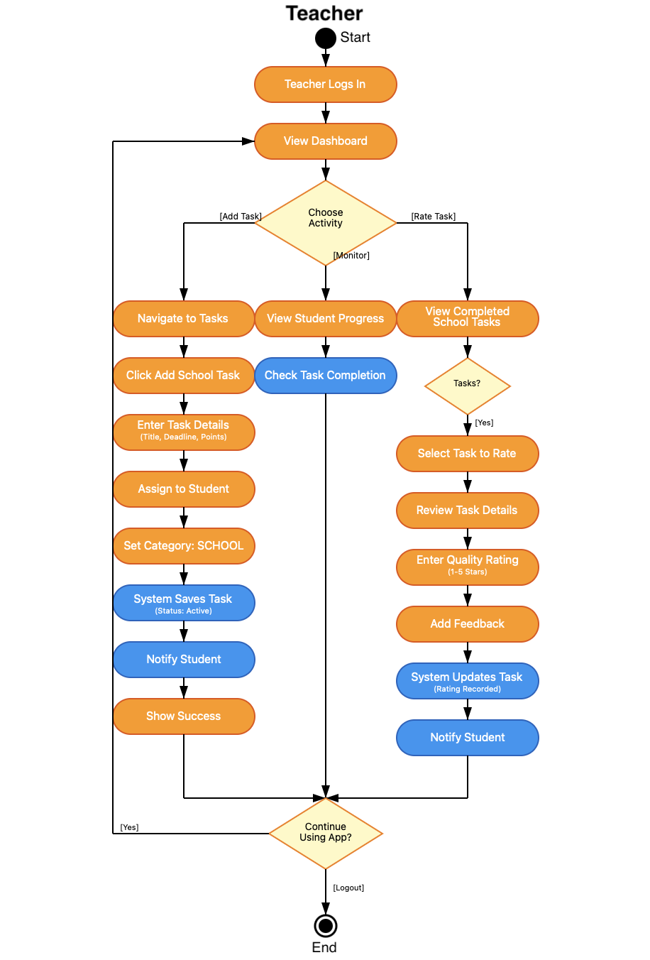

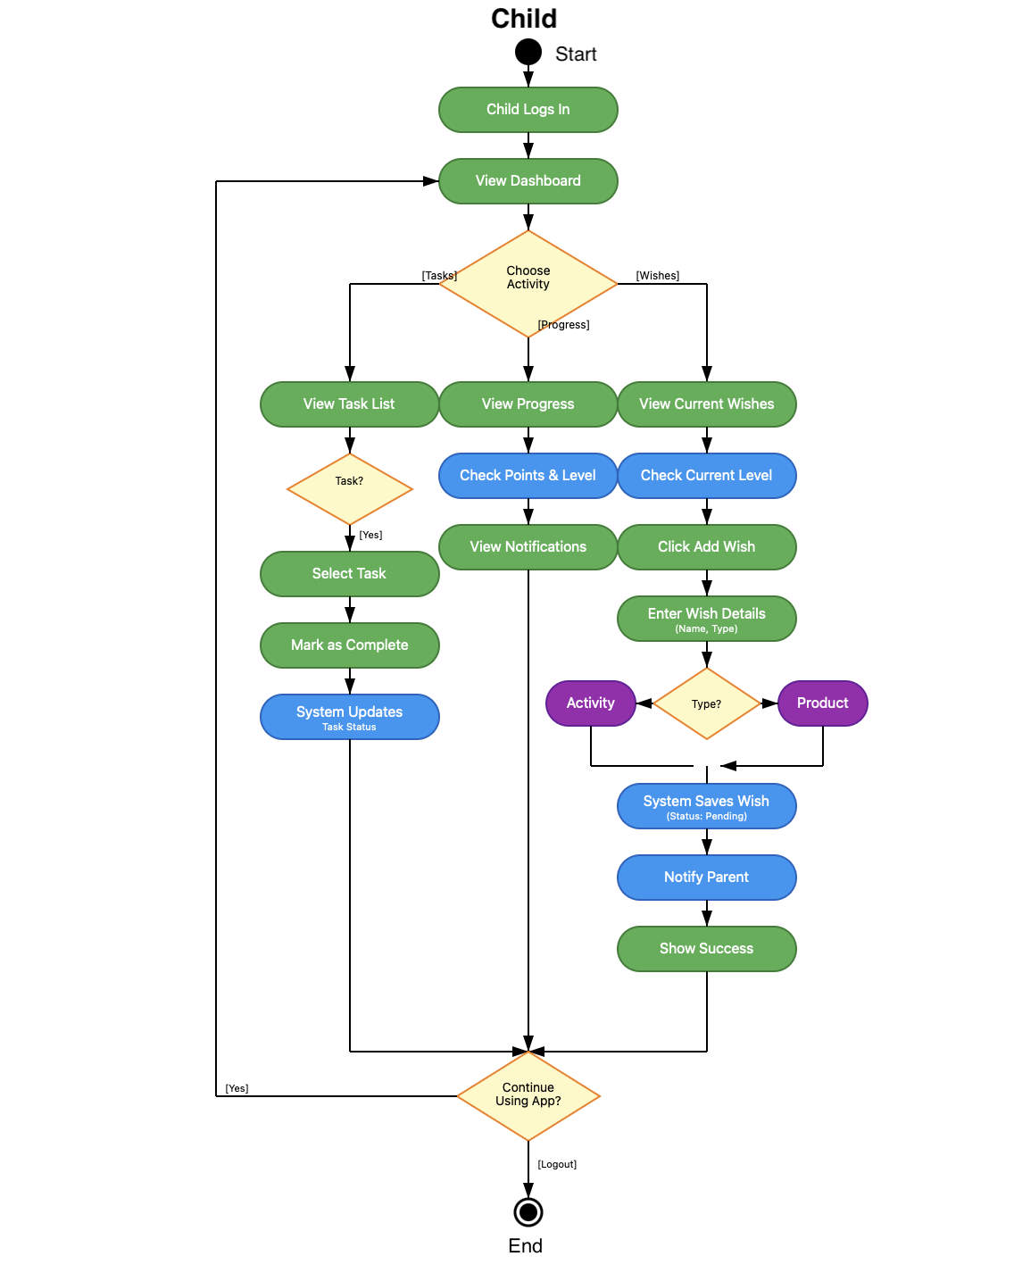

2.3.GUI

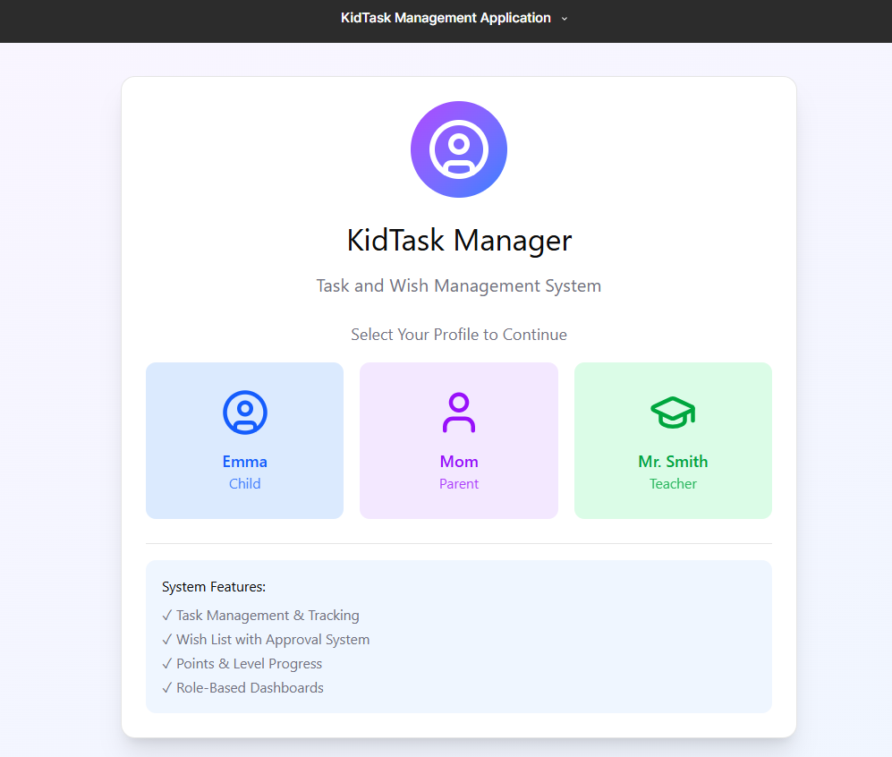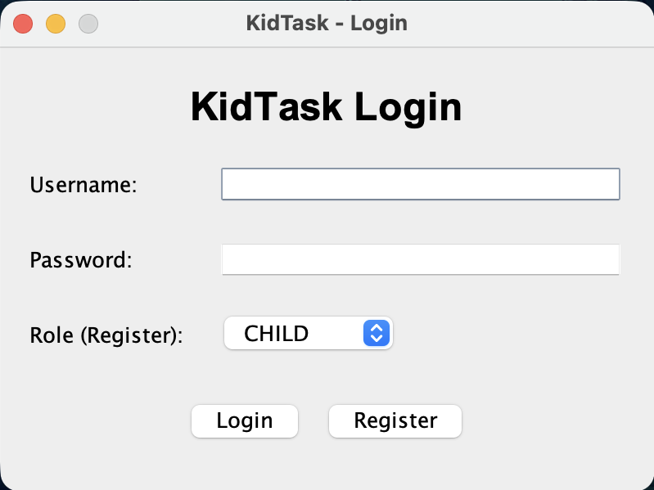

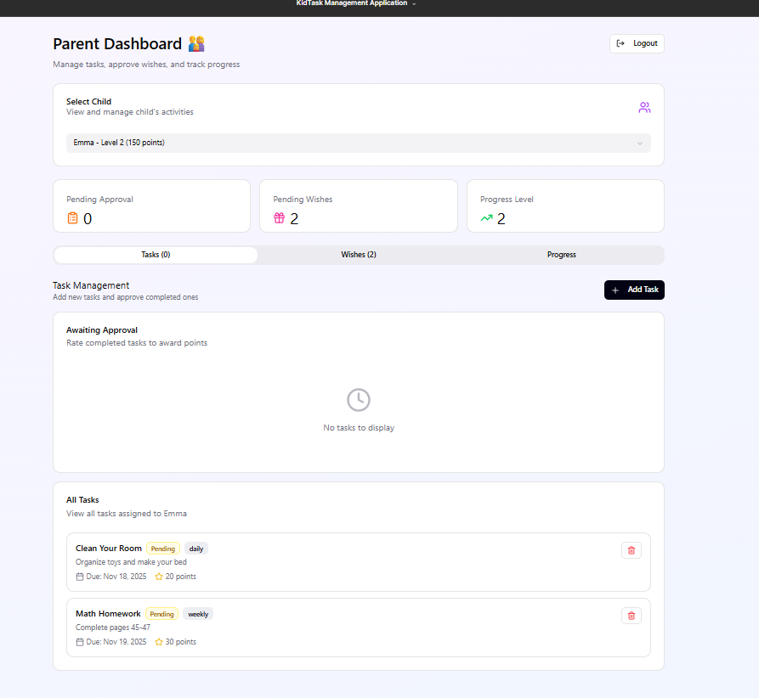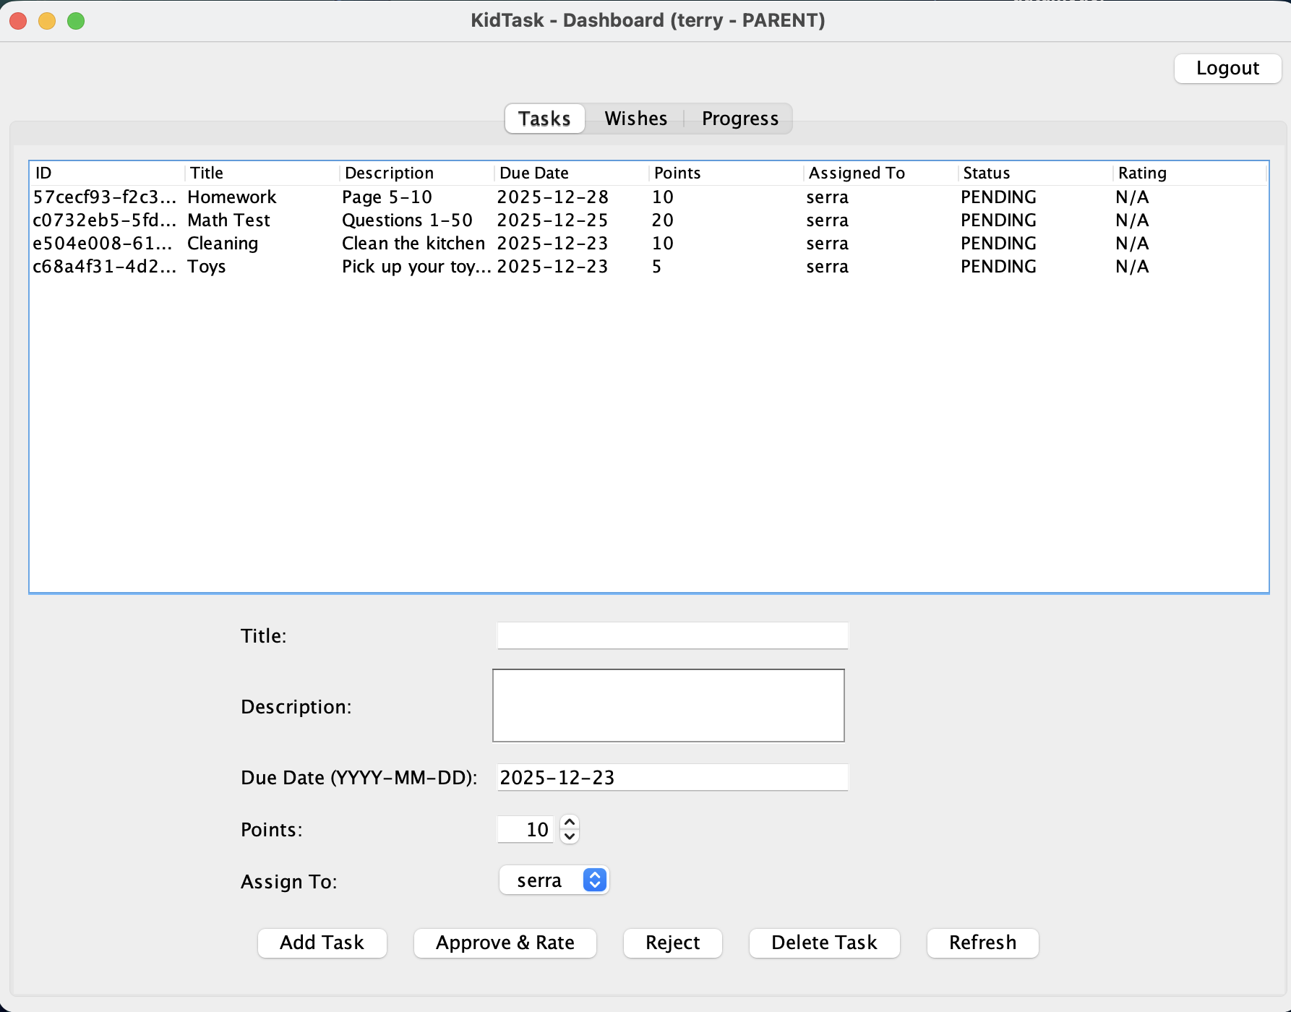

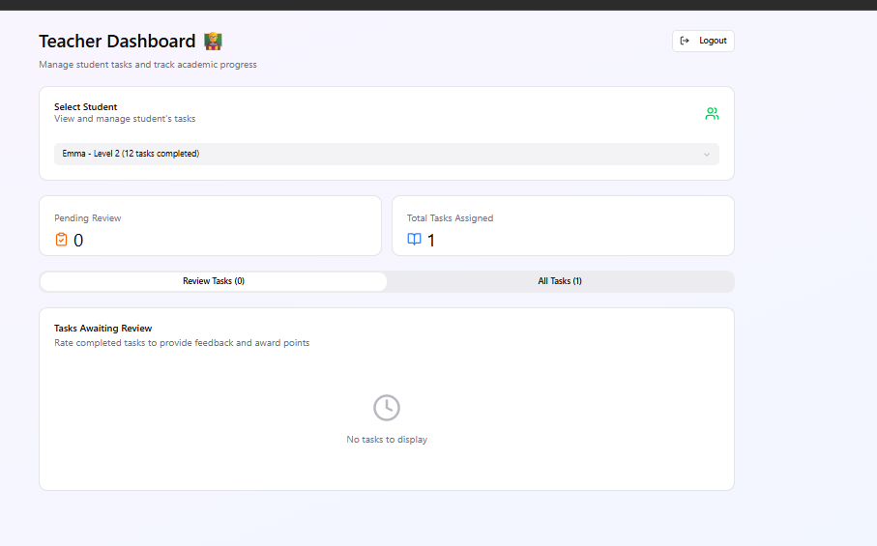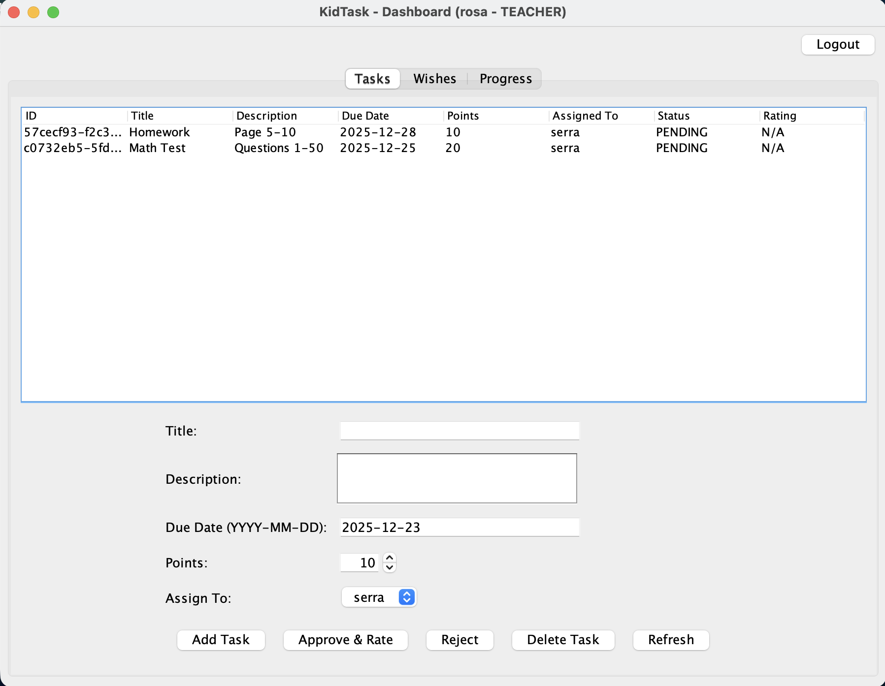
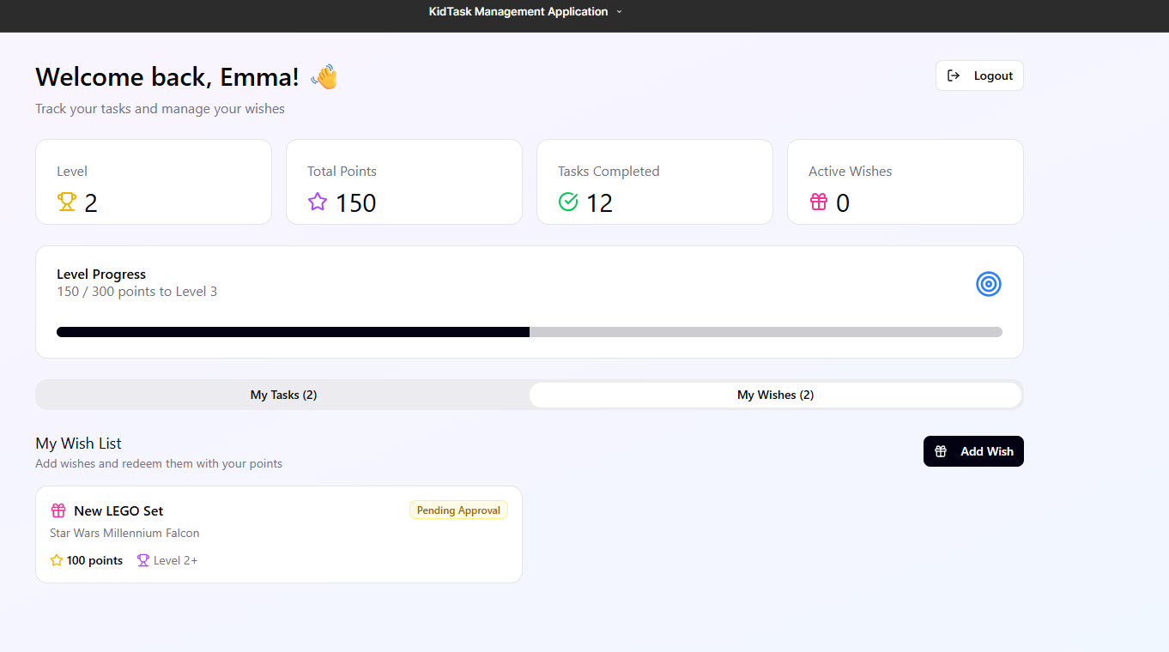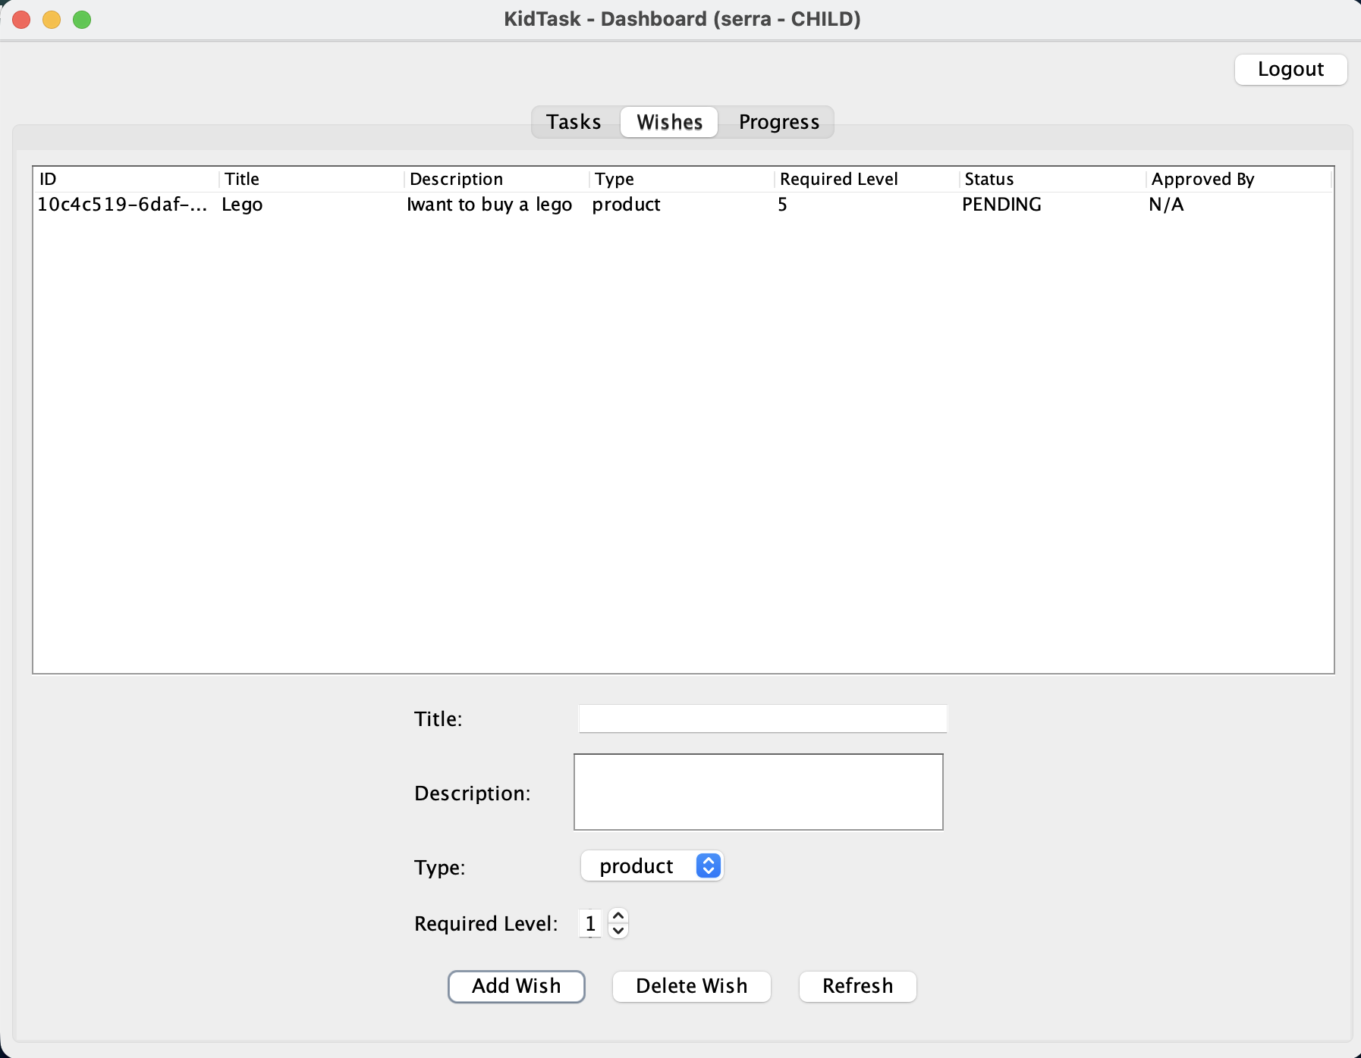

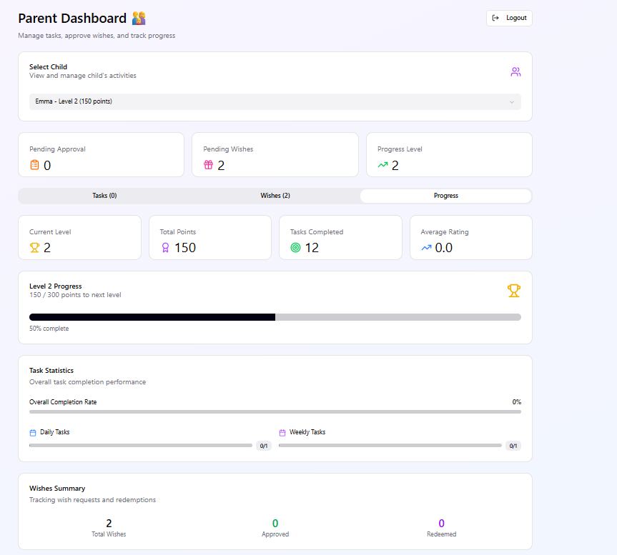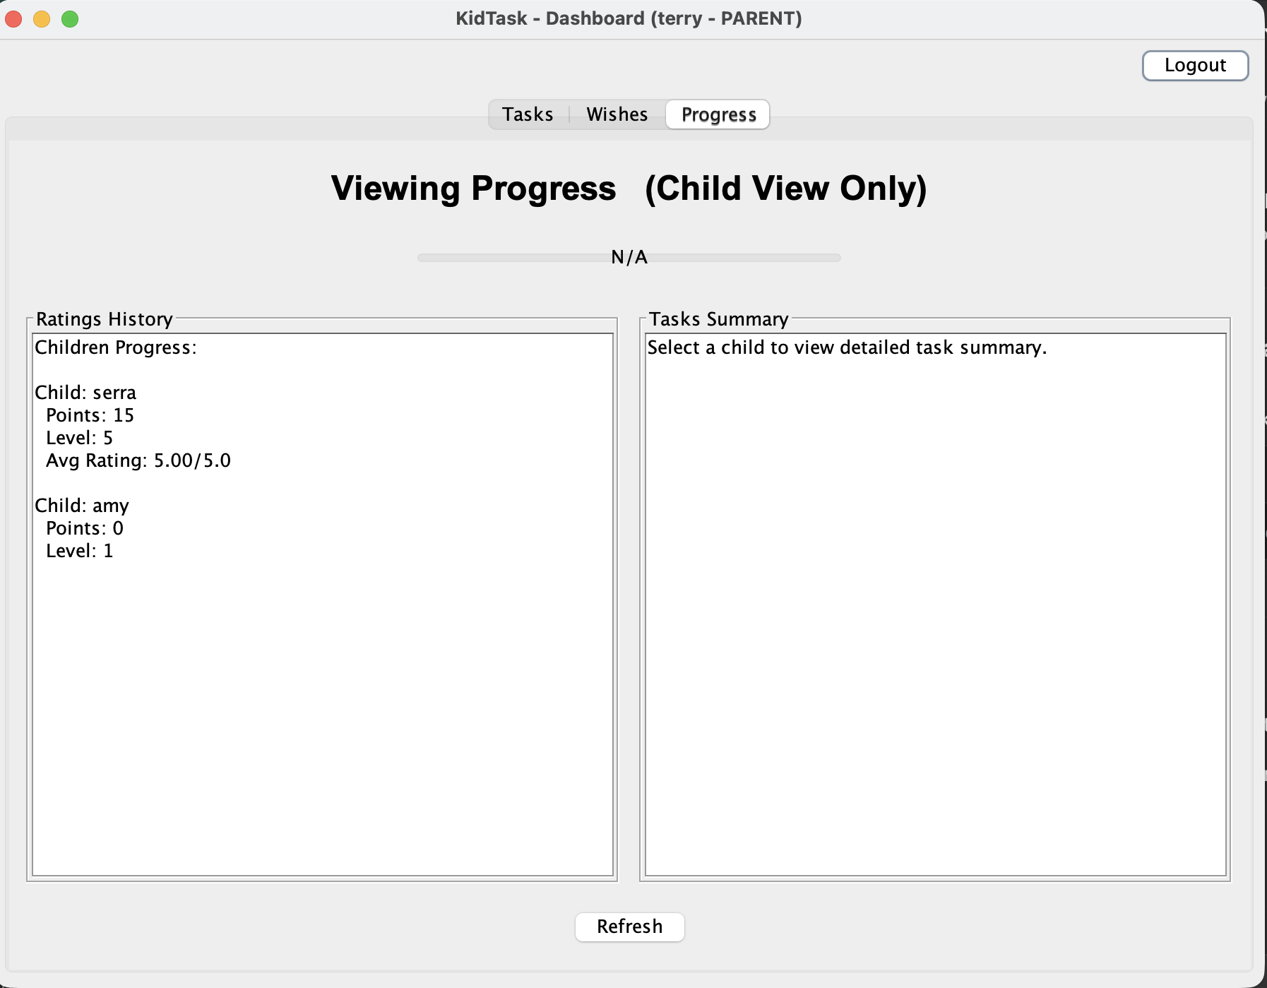

3.AI USAGE AND PROMPTS

Process | AI Tool Used | Prompt Example | AI Output Analysis | Human Revision
GUI Design | Figma | Create a child friendly task management GUI | The initial output provided a basic but incomplete user interface structure. | The design was refined through iterative prompt adjustments to better match application requirements.
Coding | Cursor | Implement a Java Swing GUI for a task management app | Generated basic GUI and logic correctly | Code refactored, naming improved, validation added
Reporting | Gemini | Write a formal project report section for coding phase | Output was overly generic | Content rewritten to match project-specific details

4. Verification & Validation (V&V) Report

Test Case | Input | Expected Result | Actual Result
Login | Correct Username, Wrong password | Error message displayed | Successful
Login | Username and password empty | Error message displayed | Successful
Add task | Valid name | Task added to list | Successful
Add task | Empty input | Error message displayed | Successful
Delete task | Existing task selected | Task removed | Successful
GUI launch | Application start | Main windows open | Successful
Mark task completed | Child ”Mark Completed” | Task status updated to “Completed” | Successful
Rate Task | Rating value = 6 | Rejection | Successful
Logout | Click logout button | User redirected to login screen | Successful

Peer Review Findings
During the peer review process, Student B evaluated the KidTask implementation with a focus on code structure, usability, and role-based functionality. The review highlighted that while the application was functionally complete, some responsibilities were concentrated within a limited number of classes. As a result, conceptual separation between user interface handling and task management logic was recommended.Additionally, minor usability improvements were suggested, such as clearer feedback messages for invalid user actions and more consistent behavior across different user roles. Based on this feedback, the code was revised to improve readability, logical grouping of responsibilities, and overall maintainability.

Conclusion
Within the scope of the KidTask project, a role-based task management application was developed, and AI-assisted tools were utilized during the software development process. These tools were mainly used through prompt-based interactions across the design, coding, testing, and reporting phases.
Throughout development, the generated outputs were reviewed and adjusted to ensure consistency with project requirements. The resulting system meets the objectives defined in the course schedule and provides a foundation that can be extended in future work.

