Final Project Report: BeePlan
1. Project Identity and Repository Access
- Project Name: BeePlan
- Developer: [Eylul Turunc] – Role: Student B
- GitHub Repository Link: [https://github.com/Eylultrnc/-SENG383-project]
- Repository Content Check:
  - /src: Python source codes (Clean Code & Error Handling): https://github.com/Eylultrnc/-SENG383-project/blob/main/coding/BeePlan/GUI/beeplan_gui/beeplan_gui.py
  - /docs: Updated diagrams and this report: https://github.com/Eylultrnc/-SENG383-project/blob/main/design/BeePlandesign/Diagrams/Activity-page1.png
  - /video:https://drive.google.com/file/d/15hWpQ5iXBDH_PNWHUFWV05dyfLCS21lR/view?usp=sharing
  - README.md: Installation and running instructions

2. Final Design Artifacts
This section showcases the final versions of the diagrams as implemented in the code.
- Class Diagram: Represents the final structure of Python classes: Room, Course, InstructorAvailability, and the Scheduler engine which handles the logic for FRIDAY_BLOCKED and slot assignments.
- Activity Diagram: Illustrates the user flow: Importing data (CSV/JSON) -> Setting Constraints -> Generating Schedule -> Handling Violations.
- GUI Screenshots: Comparison between the initial wireframes and the final PyQt5 application.

Activity Diagram:

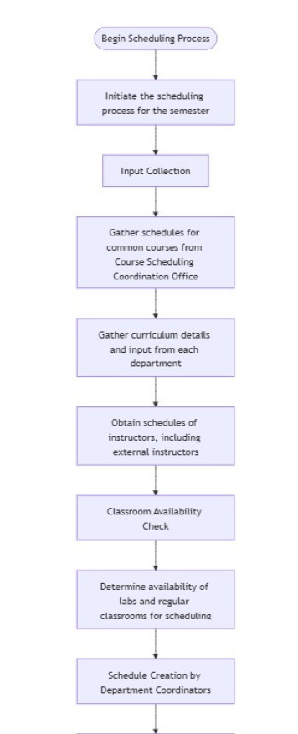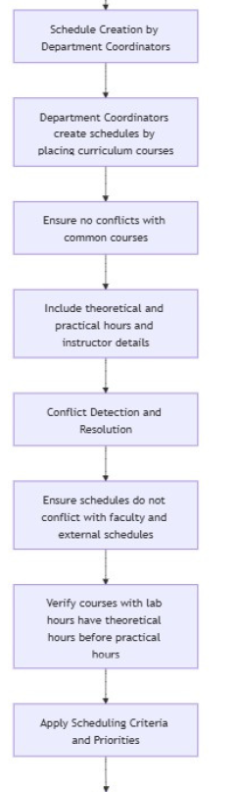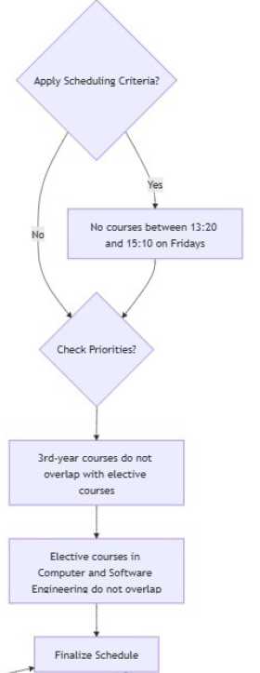

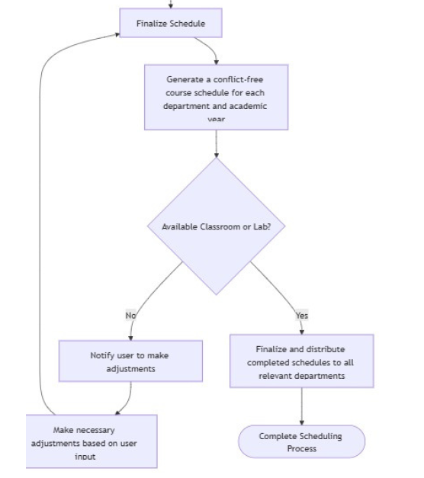

Class Diagram:
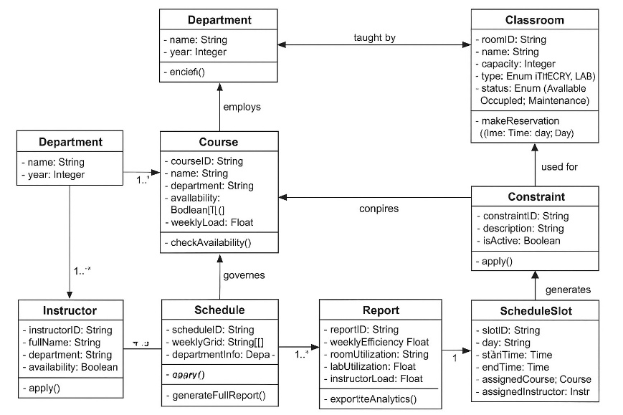

Initial Wireframe (Design)
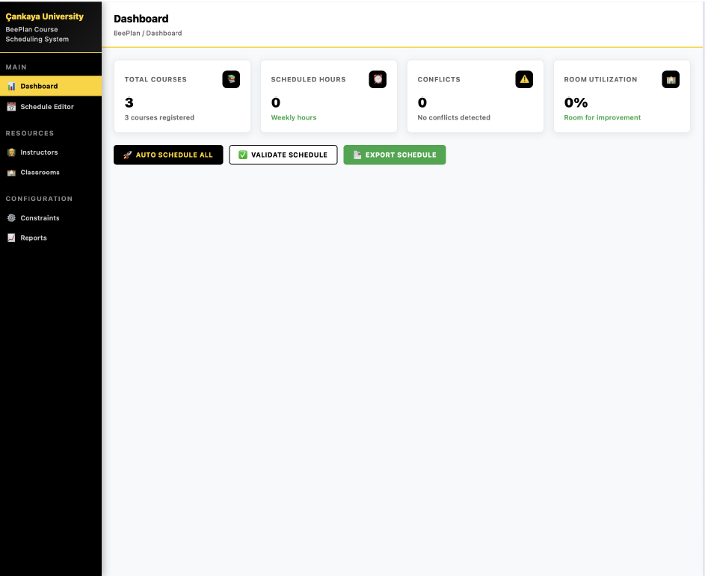

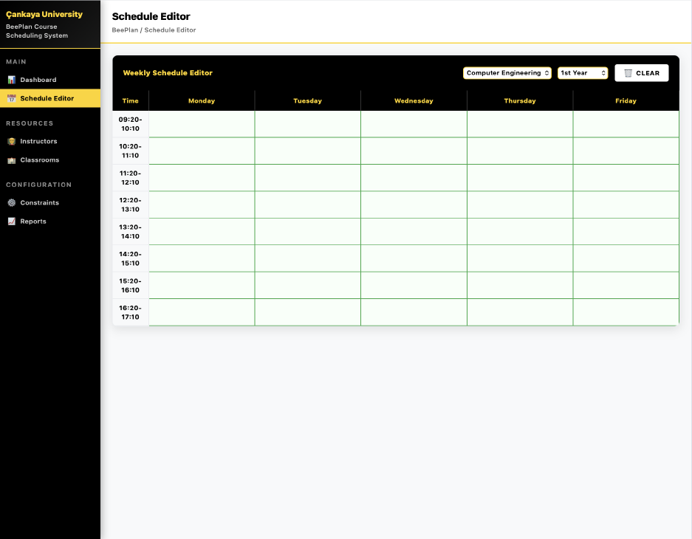

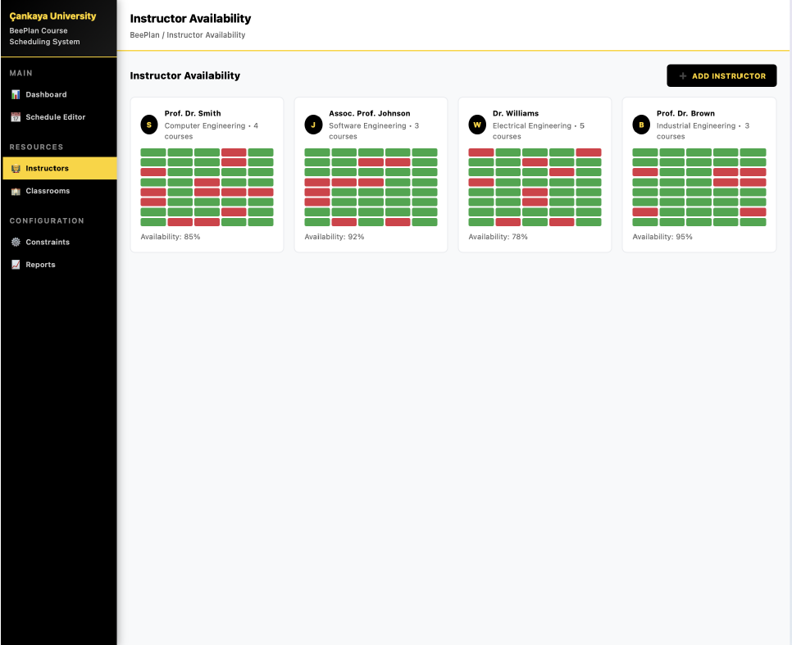
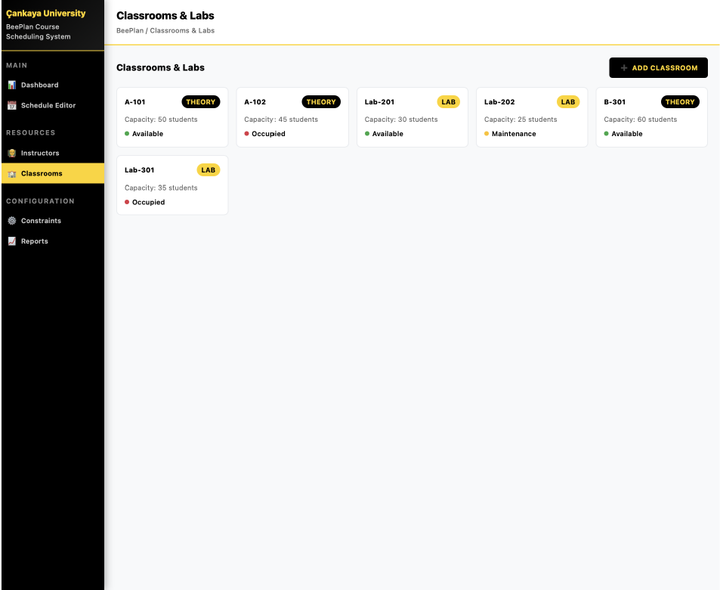
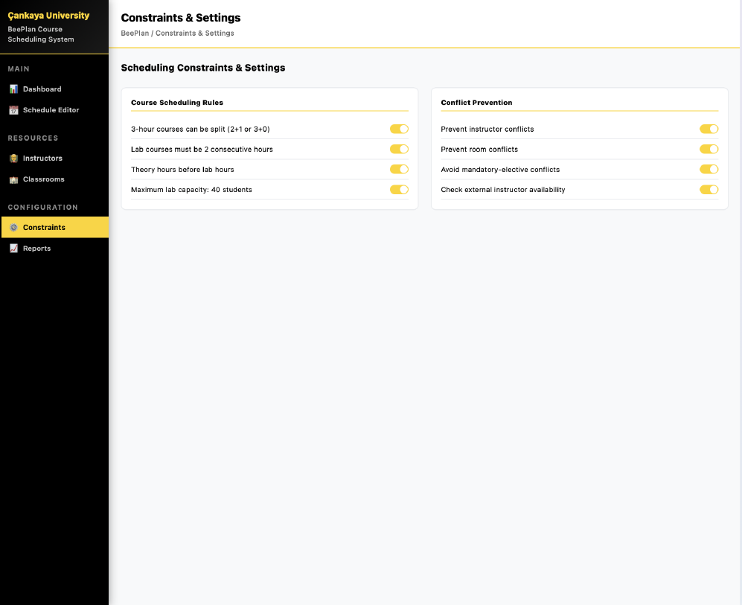
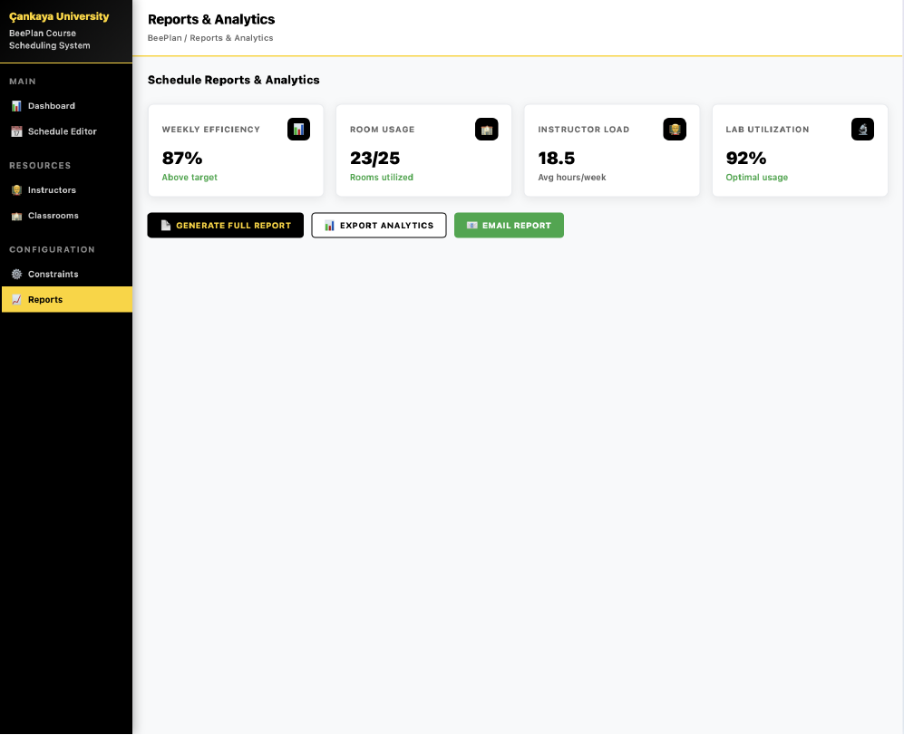

Final Wireframe (Design)

These are the tables when there are no breaches, so the table will not show a breach message error.
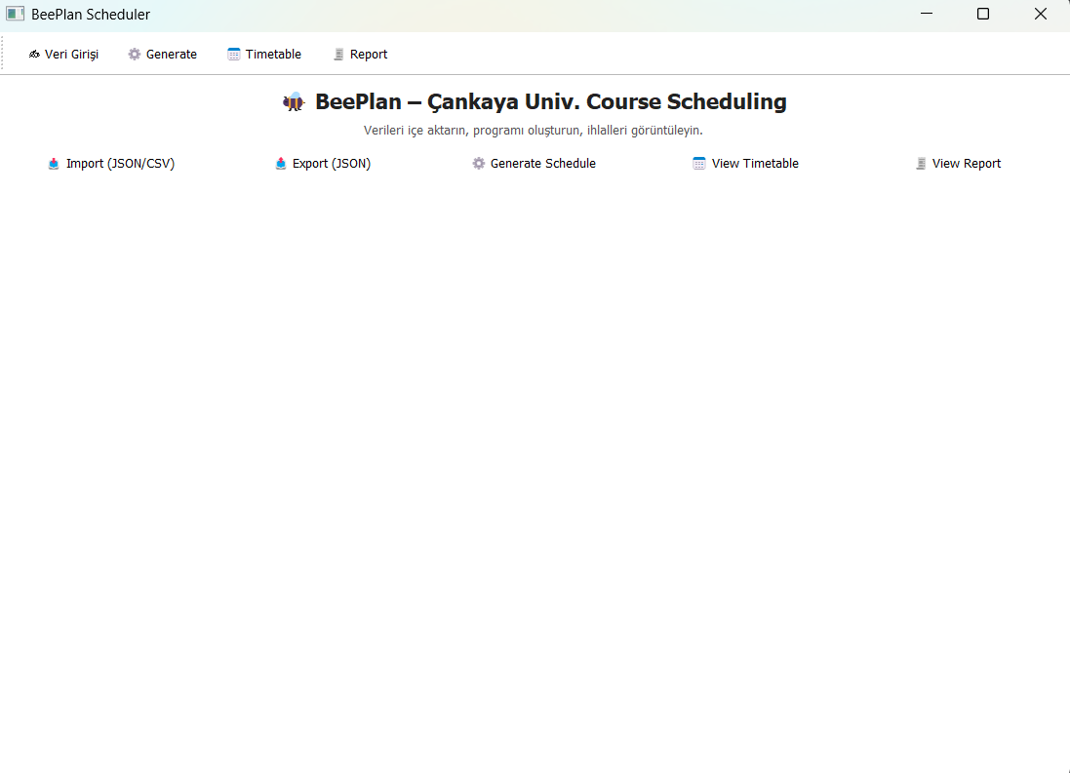

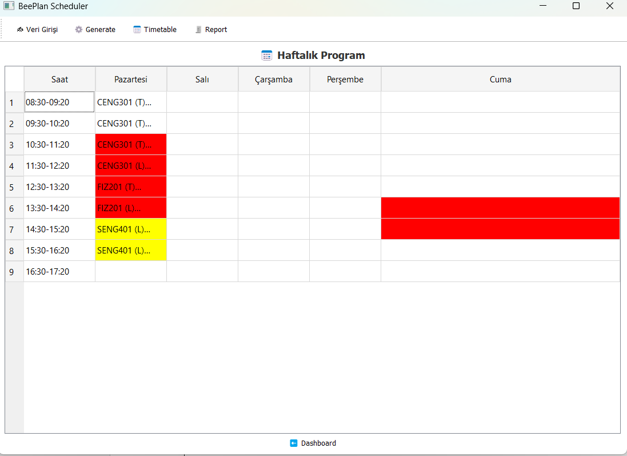

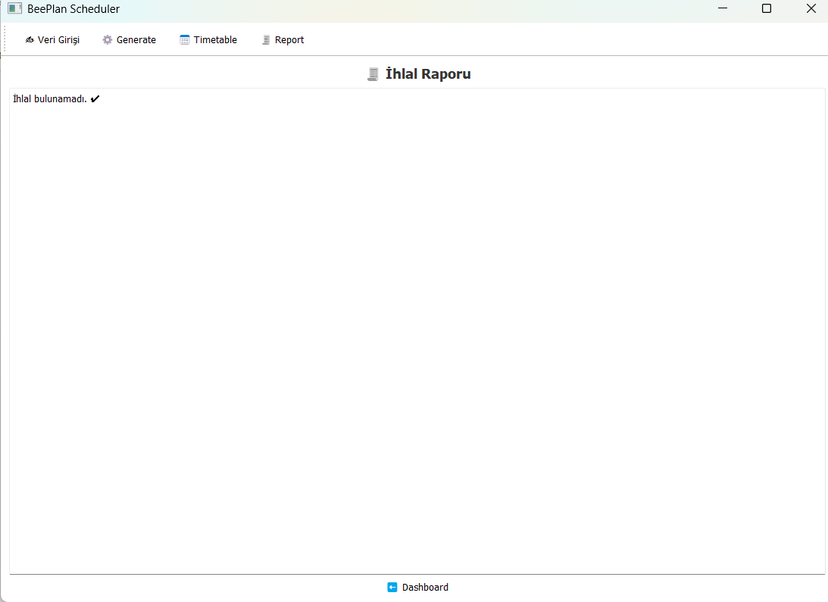

If there are overlap between the courses then there would be a warning message in breach section showing a breach message. In such case, the table will look like this:
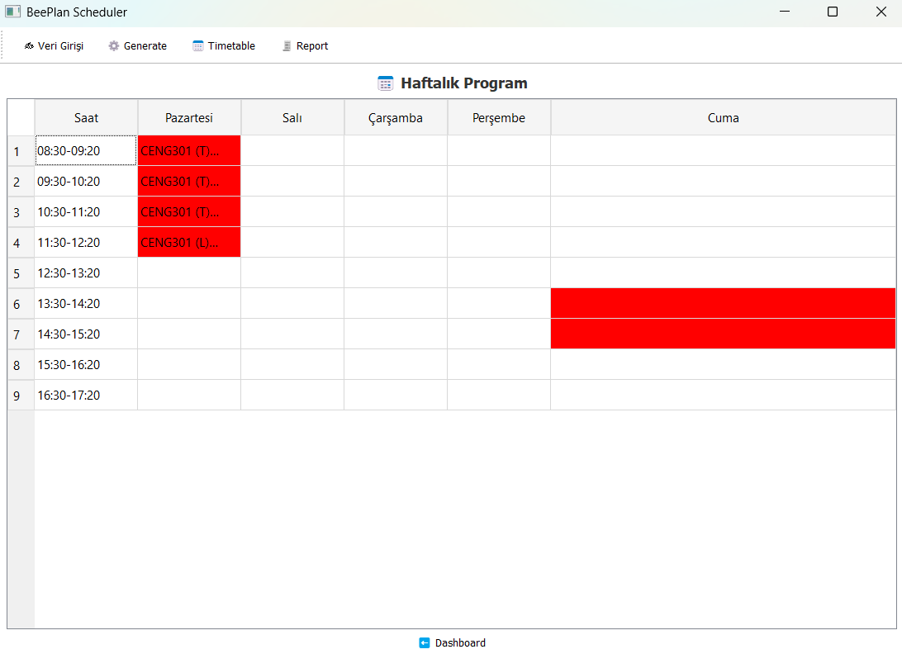
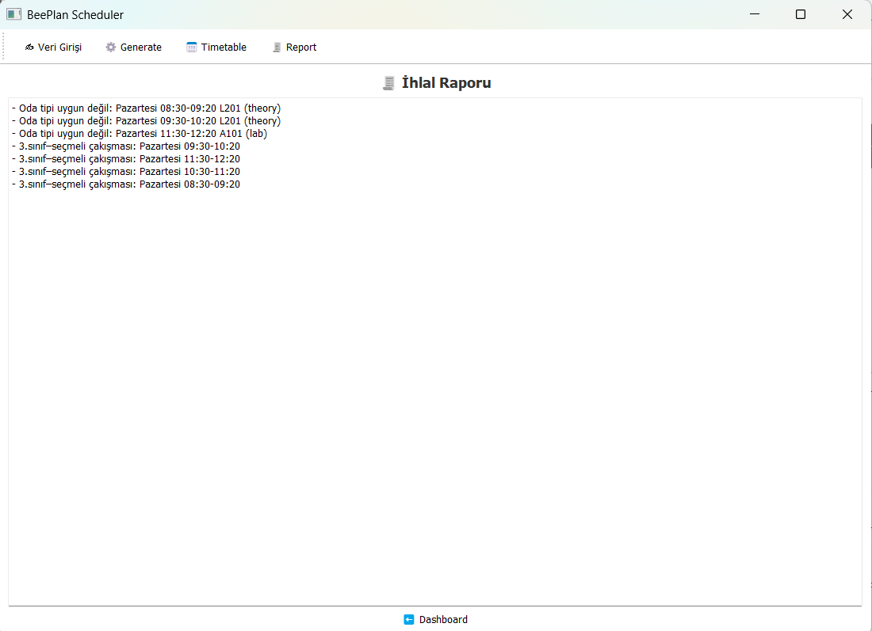

3. AI Usage & Prompts (Student B Focus)
Following the "Prompt > Output > Revision" workflow as per the project requirements:
Process | AI Tool | Prompt | AI Output Analysis | Human Revision
GUI Implementation | CoPilot | "Create a PyQt5 main window with a side navigation bar for BeePlan, including Dashboard and Schedule Editor." | Generated a standard layout but used generic styling. | Customized setStyleSheet to match the yellow-black theme and added logo integration.
Data Structures | Cursor | "Define Python dataclasses for Room, Course, and Instructor Availability with conflict check methods." | Provided solid base classes (@dataclass). | Manually added the FRIDAY_BLOCKED constant and integrated it into the scheduling logic.
Debugging & QA | Cursor | "Find the logical error in this scheduling loop where overlapping slots are not being flagged." | Identified a scope issue in the nested loop for room availability. | Refined the error message displayed to the user via QMessageBox.

4. V&V Test Reports (Verification & Validation)
Conducted during Week 11 to ensure the system meets all academic constraints.
Test Case Table
Test Scenario | Expected Result | Actual Result | Status
Friday Blockage: Assigning a class between 13:30-15:10 on Friday. | System should block the assignment or flag a violation. | The slot remained empty; violation recorded in the report. | Passed
Room Capacity: Assigning 50 students to a 30-capacity Lab. | System should trigger a "Capacity Overflow" warning. | Warning message correctly displayed. | Passed
Conflict Check: Same instructor assigned to two different rooms at once. | System must prevent or flag the collision. | Collision detected and highlighted in red on the GUI. | Passed
AI Tutor & Peer Review Integration
- AI Tutor (DeepSeek): Used to optimize the JSON export function (export_to_json) ensuring UTF-8 character support for Turkish course names.
- Peer Review (from Student A): Student A noted that the "Elective Course Overlap" rule was missing.
- Resolution: I implemented a specific check in the Scheduler.schedule() method to ensure elective courses from the same department do not overlap.

