Estimator Program

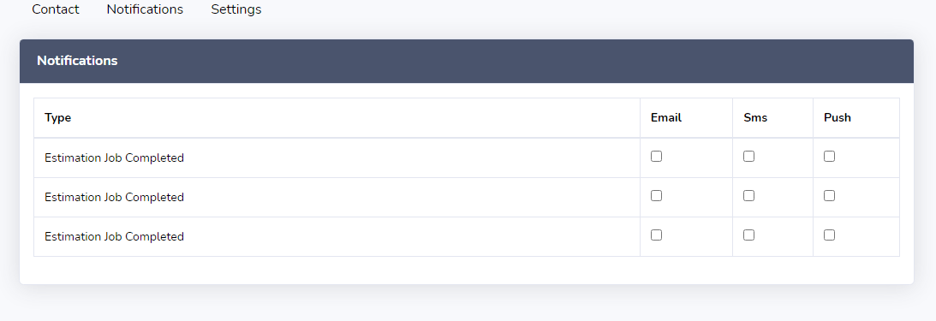
- The list of the jobs will be dynamic or static if dynamic then how can we get this data dynamically.
When I will Create a new Customer, I will choose how my client will informed when a job – estimation Completed.
You can choose either through email – sms (message) to his phone or with a notification through the program when he will login.
In the first option, we must be able to enter the email, the second option to add the telephone number of the client and the third to program the system to send a notification to the client that a job completed.
From my part, I want only the email and the push options. I do not want the sms option.

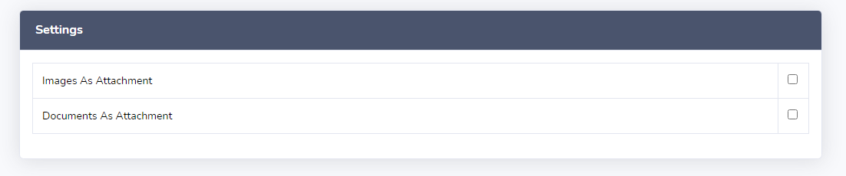
- What is the meaning of checkbox in this section can we apply the drag and drop for the image and documents both according to the customer id.
In this section, you choose what information should include to the final report.
1) Image
2) Documents
3) Timings on Report.
I may don’t want a customer to have access to the photos or to the timings. So I choose what access I want my client to have.

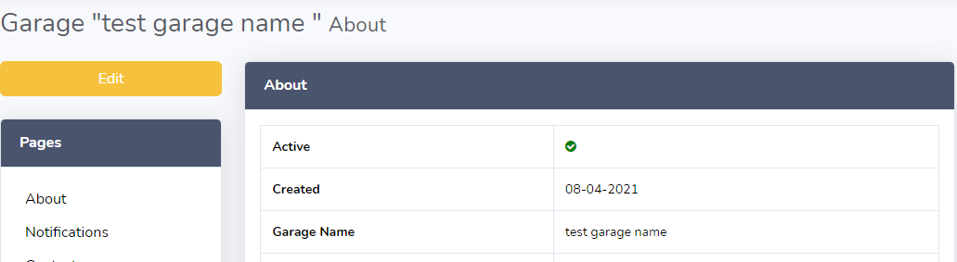

- How can we get the active and inactive status of the garage from where we can fill active information
Forget Active status.
In this Section, I want to be able to create the GARAGE.
The information needed
Name of the Garage
Person In Charge
Repair Time Rate ***
Email
Land Line
Mobile
Fax
Locale
City
Address

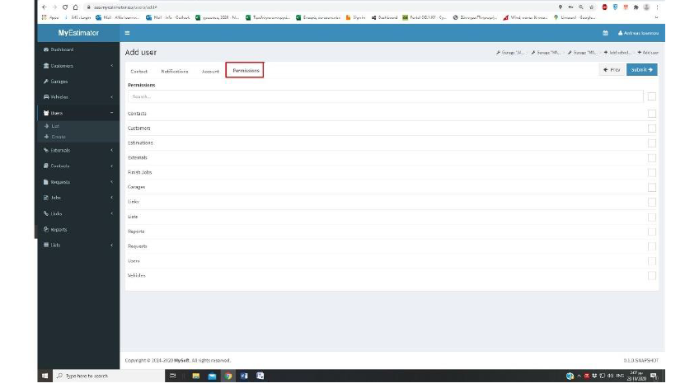
What will be the process for the permission in user section.
In this section, I create the assessors, of each Customer.
Each Customer may have more than one Assessor. (Assessor is the person, who will create the assessment).
Each Assessor should have a unique username and password, in order to login to the system. Permission Access should only have to his assessment and nothing else.

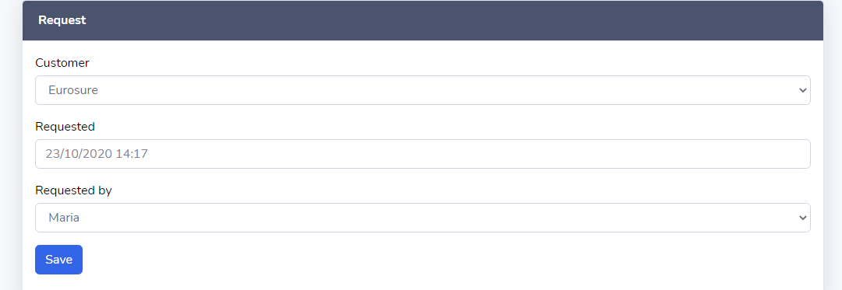

From where the values of requested by will be shown. (Maria ,mary John ) is this customers?.

Maria, mary John, is the a Customer-Person which ask for the assessment.
This Person, create by the Admin.

From where we will get assesors all values.
Assessors.
For each Customer, we will create from Assessors from the User Area.
Therefore, in the Assessor field, we just choose the assessor of the case.
Example ( if we have 2 or more Assessors for a specific Customer, the I choose the one that I want).
Visit Date.
It will enter by the user.

These values will be dynamic or hard coded.

Standard Options and I will choose which one I want

Options for both field
NEW
VERY GOOD
GOOD
FAIR
POOR

