

**College of Electrical & Mechanical Engineering**

**Department of CSIT, Software Engineering**

**Requirement Analysis and Software Architecture Documentation**

**Title: Design and Development of Automated IFRS System**

**Group Members:**

**No. Name ID**

1. **Diriba Bekele (developer) ETS_0333/09**
2. **Eyob Amare (project manager, developer) ETS_0372/09**
3. **Eyob Tadele (developer) ETS_0380/09**
4. **Mikiyas Zerfu (developer) ETS_0700/09**

**Advisor Name: Merid Nigussie Signature_________________**

# **Acknowledgment** First, we would like to thanks our almighty God for the success of our project documentation. Actually, our documentation came into its present look with the help of different people. We would like to thanks all those who help in our documentation. First, our deep and heartfelt appreciation goes to our advisors Mr.Merid Nigussiefor his assistant support. Especially his suggestions were priceless and helpful. Finally, we would like to admire our classmate students who helps us by an idea and gives us comment and suggestion and we would like to thank peoples who participate in the interview. With the help of these various contributions, we think we have made it to the result we have today.

Contents

Acknowledgment i

List of tables iv

List of figures v

Glossary vi

Abstract vii

Chapter 1: Introduction 1

1.1 Background of the organization 1

1.2 Statement of the problem 2

1.2.1 Existing system 2

1.2.2 Major problem of the existing system 2

1.2.3 Proposed system 3

1.2.4 Advantage of the proposed system 3

1.3 Motivation 4

1.4.1 Scope of the project 4

1.5 Objective 6

1.5.1 General objective 6

1.5.2 Specific objective 7

1.6 Methodology 7

1.6.1 Data collection methodology 8

1.6.2 System development tools 9

1.6.3 Implementation methodology 9

1.6.4 Testing Methodology 9

Chapter 2: System Requirement Specification 10

2.1 Background Overview 10

2.2. Functional Requirement 11

2.3. Non-Functional Requirement 12

2.4 Feasibility study 13

2.4.1 Economic Feasibility 13

2.4.2 Technical feasibility 13

2.4.3 Operational Feasibility 13

2.4.4 Schedule feasibility 14

Chapter 3: Requirement Analysis and Modeling 15

3.1 Overview 15

3.2. Scenario-Based Modeling 15

3.2.1 Use case identification 15

3.2.2 Use case And Actor Mapping: 18

3.2.3 Use case diagram 19

3.2.4 Activity diagram 37

3.3 Behavioral/Dynamic Modeling 39

3.3.1 Sequence diagram 39

3.3.2 State Diagram 41

3.4 Class-Based Modeling 42

3.4.1 Identifying classes 42

3.4.2 Class Diagram 42

Chapter Four: System Design 43

4.1 Overview 43

4.2 System Design 44

4.2.1 System Decomposition 44

4.2.2 Module description 45

4.3 Architecture of the system 48

4.3.1 Architectural style 48

4.3.2 Component Diagram 49

4.3.3 Deployment Diagram 49

4.3.4 Entity Relationship Diagram 50

4.3.5 Database Design 51

4.4 User Interface Design 52

Appendix A: Questionnaires 55

References 56

# 

# **List of tables**

Table 1: Use Case Simple Description 17

Table 2: Use Case And Actor Mapping 18

Table 3: User registers into the system 23

Table 4: User login into the system 24

Table 5: Administrator creates the user 25

Table 6: Administrator deletes user 25

Table 7: Users Generate Report 26

Table 8: use case description for Fill Forms 26

Table 9: use case description for the review report 27

Table 10: use case description for Mange users 27

Table 11: use case description for Add reviewer 28

Table 12: use case description for Remove reviewer 28

Table 13: use case description for Search users 29

Table 14: use case description for the View user list 29

Table 15: use case description for Log out 30

Table 16: use case description for Record Transaction 31

Table 17: use case description for Record Income 31

Table 18: use case description for Record Expense 32

Table 19: use case description for Record Properties 32

Table 20: use case description for Add Notes 33

Table 21: use case description for Generate SOCI 33

Table 22: use case description for Generate SCIE 34

Table 23: use case description for Generate SOFP 35

Table 24: use case description for Generate SOCF 35

Table 25: use case description for Save Report 36

Table 26: use case description for View Status 36

# **List of figures**

Figure 1 Incremental Model 7

Figure 2: Questionnaires Analysis 8

Figure 3 schedule Feasibility 14

Figure 4 Use case for overall system 19

Figure 5: Use case with detail for IFRS System 20

Figure 6 Use case Diagram for Users 21

Figure 7 UseCase diagram for Admin of the System 22

Figure 8 UseCase for Reviewer 22

Figure 9: Activity diagram for the Reviewer 37

Figure 10:Activity diagram for Admin 37

Figure 11:Activity diagram for Users 38

Figure 12: Sequence diagram for IFRS System 39

Figure 13: Sequence diagram for IFRS System USER Actions 40

Figure 14: Sequence diagram for IFRS System Reviewer actor Actions 40

Figure 15:State diagram for IFRS System 41

Figure 16: Class Diagram of the overall System 42

Figure 17: Overall System Decomposition 44

Figure 18: MVC architecture 48

Figure 19: Component diagram for IFRS System 49

Figure 20: Deployment Diagram 49

Figure 21: ER Diagram for Overall System 50

Figure 22: Data Base ER Diagram 51

Figure 23 User Interface Design for Login 52

Figure 24 User Interface Design for Sign UP (create an account) 52

Figure 25: User interface design for log in using Mobile Phones 53

Figure 26: User Interface design for fill Forms 54

Figure 27 User interface design for generating a report and select Modules 54

# **Glossary**

Admin – Administrator

CSS – Cascading Style Sheet

DD_IFRS – Design and Development International Financial Reporting System

ER – Entity Relationship

GAAP – Generally Accepted Accounting Principle

GUI – Graphical User Interface

HTML – Hypertext Markup Language

HTTP – Hypertext Transfer Protocol

IASB – International Accounting Standards Boards

Id – Identification

IFRS – International Financial Reporting System

MoFED – Ministry of Finance and Economic Development

MS - Microsoft

MVC – Model - View - Controller

MySQL- My Structured Query Language

SCIE - A statement of profit or loss and other comprehensive income

SOCF – A statement of cash flows.

SOCI - A statement of changes in equity

SOFP - A statement of financial position

SQL – Structured Query Language

# **Abstract**

**Design and Develop IFRS System**

*International Financial Reporting Standards, usually called IFRS, are accounting standards issued by the IFRS Foundation and the International Accounting Standards Board (IASB) to provide a common global language for business affairs so that company accounts are understandable and comparable across international boundaries. The absence of one set of accounting standards in the country, financial statements depict limited information for users which indicates the existence of the urgent need for Ethiopia to have a uniform standard. Since most of the countries in the world are following IFRS, Ethiopia should not isolate itself The Adoption of IFRS and current financial reporting system which is generally accepted accounting principles (GAAP) faces several challenges which include lack of technical skills and inadequate knowledge of company’s professional accountants with regarding how to implement the IFRS standards, Lack of comparative approach and international standardization, High implementation cost of IFRS, Lack of high level of accuracy and reliability which is needed in the financial sector and so on. The proposed system aims to present to provide financial information for making decisions. Those decisions include buying, selling, holding equity and debt instruments, providing loans and other forms of credit, exercising rights to vote on, otherwise influence management Subsequently. And we dive into some IFRS components are A statement of financial position, A statement of profit or loss and other comprehensive income, A statement of changes in equity, A statement of cash flows and Comparative information for the prior period is required for amounts shown in the financial statements. Our contribution is to design and develop Financial information that is more useful, International standardized, comparable, verifiable, timely, understandable and easy to use IFRS system . and also, our system provides Greater clarity and transparency of numbers and improved comparability of financial information with global competitors.*

**አይ.ኤፍ.አር.ኤስ ሲስተም መቅረጽ ና ማበልጸግ**

*ዓለም አቀፍ የፋይናንስ ሪፖርት መመዘኛዎች ብዙውን ጊዜ IFRS ተብለው የሚጠሩ የኩባንያው መለያዎች በዓለም ዙሪያ ያሉ ተፈላጊ እና ተመጣጣኝ ሊሆኑ የሚችሉ የንግድ ሥራ ጉዳዮች አንድ ዓለም አቀፍ ቋንቋ ለማቅረብ በ IFRS ፋውንዴሽን እና በአለም አቀፍ የሂሳብ አያያዝ ደረጃዎች ቦርድ (አይኤስኤኤስ) የተሰጡ የሂሳብ መመዘኛዎች ናቸው ፡፡ በአገሪቱ ውስጥ አንድ የሂሳብ አወጣጥ ደረጃ አለመኖር ፣ የገንዘብ መግለጫዎች ለተገልጋዮች ውስን መረጃን የሚያመለክቱ ናቸው ፡፡ አብዛኛዎቹ የአለም ሀገራት IFRS ን ስለሚከተሉ ኢትዮጵያ እራሷን ለብቻ ማሳጣት የለባትም IFRS ስርዓት ማስርጽ እና አሁን ያለው የሂሳብ አያያዝ መርሆዎች ተቀባይነት ያለው የሂሳብ መርሆዎች (GAAP) የቴክኒክ ችሎታ እና በቂ የኩባንያው ዕውቀት አለመኖርን ጨምሮ በርካታ ፈታኝ ሁኔታዎች ያጋጥሟቸዋል። የ IFRS መስፈርቶችን እንዴት መተግበር እንደሚቻል ፣ የንፅፅር አቀራረብ እጥረት እና የአለም አቀፍ ደረጃ አሰጣጥ ፣ የ IFRS ከፍተኛ አፈፃፀም ወጭ ፣ በገንዘብ ነክ ዘርፍ ውስጥ አስፈላጊ የሆኑ አስተማማኝነት እና የመሳሰሉት ከፍተኛ ደረጃ እጥረት እና የመሳሰሉት። የታቀደው ስርዓት ውሳኔዎችን ለመወሰን የፋይናንስ መረጃ ማቅረብ ነው ፡፡ እነዚያ ውሳኔዎች መግዛትን ፣ መሸጥ ፣ ፍትሃዊነት እና የእዳ መሳሪያዎችን መያዝ ፣ ብድሮችን እና ሌሎች የብድር ዓይነቶችን መስጠት ፣ የመምረጥ መብቶችን መጠቀም ፣ አለበለዚያ በቀጣይ በአስተዳደሩ ላይ ተጽዕኖ ማሳደርን ያካትታሉ ፡፡ እና እኛ ወደ አንዳንድ IFRS አካላት እንገባለን ፣ እነዚያ የገንዘብ ምጣኔ መግለጫ ፣ ትርፉ ወይም ኪሳራ መግለጫ እና ሌሎች አጠቃላይ ገቢዎች ፣ የፍትሃዊነት ለውጦች መግለጫ ፣ የገንዘብ ፍሰቶች መግለጫ እና የገንዘብ መጠን መግለጫ መጠን በሂሳብ መግለጫው ውስጥ ይታያል የእኛ አስተዋፅ more የበለጠ ጠቃሚ ፣ ዓለም አቀፍ ደረጃ አሰጣጥ ፣ ተመጣጣኝ ፣ ሊረጋገጥ የሚችል ፣ ወቅታዊ እና ቀላል የ IFRS ስርዓት ለመጠቀም የገንዘብ ሪፖርት መቅረጽ እና ማዘጋጀት ነው። እንዲሁም የእኛ ስርዓት የበለጠ የቁጥሮች ግልፅነት እና ከዓለም አቀፍ ተወዳዳሪዎቹ ጋር የፋይናንስ መረጃ ተመጣጣኝነትን ይሰጣል*

# **Chapter 1: Introduction**

International Financial Reporting Standards, usually called IFRS, [1] are accounting standards  
issued by the IFRS Foundation and the International Accounting Standards Board (IASB) to  
provide a common global language for business affairs so that company accounts are  
understandable and comparable across international boundaries. They are a consequence of  
growing international shareholding and trade and are particularly relevant for companies with  
shares or securities listed on a public stock exchange. They are progressively replacing the many  
different national accounting standards.

## 1.1 Background of the organization

IFRSs refers to a single set of standards & interpretations applicable to general purpose financial statements and other financial reporting of all profit-oriented entities. IFRSs are issued by the International Accounting Standards Board (IASB). Application of IFRSs is believed to result in financial reports of high quality i.e. comparable, understandable, reliable and relevant to users. It follows a thorough, open, participatory and transparent due process.

Many countries have faced challenges in their decisions to adopt IFRS (International Financial Reporting System), its high implementation cost, as well as its complexity, makes the adoption process tough and Many jurisdictions have cultural, legal, or political obstacles to an immediate full adoption of IFRS. [2] Recently there has been a push towards the adoption of IFRS developed and issued by the International Accounting Standards Board (IASB). In the past few years, many developed and developing countries have adopted international financial reporting standards (IFRS) as the basis for financial reporting. There are over 143 countries that implement the IFRS method for their financial report [1].

The government of Ethiopia issued a proclamation called “Financial Report Proclamation of Ethiopia: 847/2014” and Council of Ministers Regulation 332/2014. Ethiopia has expressed an initiative to integrate its financial statements with international standards. According to the World Bank on the Report on the Observance of Standards and Codes, there is no specific set of accounting regulations in Ethiopia and therefore accounting practices vary across institutions [3].

The National Bank of Ethiopia has already required the banks to prepare their financial statements in accordance with IFRS. In 2011 the Ministry of Finance and Economic Development (MoFED) issued a draft proclamation called Financial Reporting Proclamation of Ethiopia to provide for the financial reporting of Ethiopia. The proclamation requires reporting entities in Ethiopia to follow IFRS [4].

## 1.2 Statement of the problem

### **1.2.1 Existing system**

Various institutions in Ethiopia are currently following GAAP (generally accepted accounting principles) which is a collection of commonly-followed accounting rules and standards for financial reporting. GAAP specifications include definitions of concepts and principles, as well as industry-specific rules. The purpose of GAAP is to ensure that financial reporting is transparent and consistent from one organization to another. There is no universal GAAP standard and the specifics vary from one geographic location or industry to another. [5]

### **1.2.2 Major problem of the existing system**

The problems noticed include

* The adoption of IFRS faces challenges and obstacles including lack of technical skills and inadequate knowledge of the company’s professional accountants with regarding how to implement the IFRS standards [4];
* Lack of comparative approach in the current financial reporting system;
* Lack of international standardization with the currently followed generally accepted accounting principles (GAAP) reporting system;
* The high implementation cost of IFRS;
* Lack of high level of accuracy and reliability which is needed in the financial sector;
* Lack of frequent report generation due to GAAP’s exhaustive workload;
* GAAP accounting is limited in that it doesn’t necessarily present the economic reality the company is operating.
* GAAP accounting nudges companies to prepare financial statements that appeal to creditors rather than shareholders. For equity investors, GAAP accounting provides a manipulated and not necessarily accurate snapshot of the company’s financial position and performance.

### **1.2.3 Proposed system**

The final purpose of the IFRS system is to provide financial information for making decisions. Those decisions include buying, selling or holding equity and debt instruments, providing or settling loans and other forms of credit, exercising rights to vote on, or otherwise influence management [6]. The proposed system financial reports provide information about the resources of, and claims against, an entity and the effects of transactions and other events on those resources and claims. Thus, the project develops a system that can generate the required reports accurately, reliably, securely in a timely manner according to the international standards and tackle the complexity of achieving the standards in adopting the Ethiopian context. The system also solves the transparency of financial issues in most governmental offices as well as solves the existence of a few experts in the standard.

### **1.2.4 Advantage of the proposed system**

* Greater clarity and transparency of numbers.
* Improved comparability of financial information with global competitors, investors, and analysts. [7]
* Since all the calculations are handled by the software, computerized accounting eliminates many of the mundane/every day and time-consuming processes associated with manual accounting. The system will provide a more efficient process and Support for a more efficient audit process.
* The system is designed to be accurate to the minutest detail. Once the data is entered into the system, all the calculations, including additions and subtractions are done automatically by the software. Thus, leads to Reduced risk of errors and non-compliance [8].
* Using IFRS system software it becomes much easier for different individuals to access accounting data outside of the office, securely.
* When a company grows, the amount of accounting necessary not only increases but becomes more complex. With computerized accounting, everything is kept straightforward.
* Using our IFRS software, the entire process of reports accounts becomes faster. Furthermore, statements and reports can be generated instantly at the click of a button. Managers do not have to wait for hours, even days, to lay their hands on an important report. Shorter preparation cycles with the generation of reports at any point in time.
* Viewing reports using a computer allows taking advantage of the option to view data in different formats. It can show data in tables and using different types of charts.

## 1.3 Motivation

The motivation for doing this project was primarily the interest of the global and Ethiopian gov’t to adopt IFRS and it becomes almost mandatory and it is a global reporting standard for all. And the interest to over undertaking the challenge of adopting IFRS in Ethiopia. [3] Due to the challenge of Training an Education as well as its complexity most accountants are not using IFRS. So, we are thinking to tackle the challenges faced by accountants in understanding how IFRS works by designing and developing software that can make their work easier and make the company they work for competing in the international market.

**1.4 Scope and limitation of the project**

### **1.4.1 Scope of the project**

Due to time constraints, a wide range of standards, domain knowledge and cost issues we were forced to implement some IFRS standard. We give priorities for A statement of financial position, a statement of profit or loss and other comprehensive income, a statement of change in equity and a statement of cash flows; which can stand alone and necessary for small and medium enterprises in Ethiopia. Therefore,

A complete set of our IFRS System financial statements comprises:

* ***A statement of financial position*** - In the statement of financial position, assets and liabilities are required to be classified as current or non-current, unless presenting them in order of liquidity provides reliable and more relevant information. Assets and liabilities may not be offset unless offsetting is permitted or required by another IFRS Standard. Users are required to input assets, equity and liabilities into the system. [9]
* ***A statement of profit or loss and other comprehensive income*** - The statement of profit or loss and other comprehensive income includes all items of income and expense. Users are required to enter each and every income and expenses into the system accurately. [9]
* ***A statement of changes in equity*** - The statement of changes in equity is required to show the total comprehensive income for the period; the effects on each component of equity of retrospective application or retrospective restatement in accordance with International Accounting Standards 8; for each component of equity, a reconciliation between the opening and closing balances, disclosing each change separately. total comprehensive income is calculated from the data entered by users in the system that are labeled as income [9].
* ***A statement of cash flows*** - a statement of cash flows to present information about changes in cash and cash equivalents, classified as operating, investing and financing activities. These activities are visualized using the data entered by the user concerning incomes and expenses and identified by the type of activity they are classified in to. [9]
* Comparative information for the prior period is required for amounts shown in the financial statements.

*There are three categories of Named Users as follows:*

❖ **An administrator**

* who can access all functions and features of the Software. [8]
* allowed to add and remove users as well as reviewers from and to the system.
* full administrator rights over User, including adding, editing and deleting users.
* full administrator rights over System entities, adding entities or modules, give privileges for access to User and deleting entities.

❖ **User**

* who can access all of the functions and features of the Software only those determined by an Administrator to be appropriate.
* The user can create an account by providing their name and contact information.
* *After sign in the user can*
* fill some forms for income and expense/input and update data which include Record Transaction, Record Income, Record Expenses and Record Properties [8].
* See previous datasets and detailed transaction history.
* Generate reports include ;

Generate a statement of financial position,

Generate a statement of profit or loss and other comprehensive income,

Generate statement of changes in equity and

Generate a statement of cash flows.

* Ability to report to screen, to a printer or to file
* Comparative visualization with the previous reports.
* These can be an accounting team that is familiar with the working principle and can correctly classify incomes and expenses.
* Ability to add Notes on generated Reports.
* Ability to view the status of the system.

❖ **Reviewer**

• whose access to the Software is ‘Read Only Access’ [8].

• Reviewer Register in the platform to create account

• Ability to report to screen, to the printer or to file

•It is allowed to see reports that are approved and selected by the administrator that includes comparative visualizations too.

• These can be executive managers, governmental entities, international investors, etc.

**1.4.2 Limitation of the project**

The platform doesn’t support the following

* The system implements only some modules from IFRS standards for now, not all which are wide and a lot because of time and knowledge limit.
* The system only supports one language (English).
* The system currently we developed only in desktop and web-based applications not mobile.
* The system doesn’t generate all financial information except those included in the scope.

## 1.5 Objective

### **1.5.1 General objective**

The general objective of the IFRS system is to design and develop an automated IFRS System for small and medium scale enterprises that can provide and generate financial information about the reporting entity. [10]

### **1.5.2 Specific objective**

This project aims at generating a report at any given time and thereby compared with the previously generated reports.

* Getting familiar with financial accounting and the IFRS standards modules
* Conducting interviews and consultancies with experts
* Identifying the relevant stakeholders
* Identifying functional and non-functional requirements of the system
* Developing the system requirement specification accordingly
* Developing appropriate and efficient database design
* Designing the user interface with a proper usability foundation
* Providing reliable design specification document
* Develop the system according to the requirements specification document
* Performing a thorough unit, integration as well as system testing

## 1.6 Methodology

We use an Incremental model for our project which is a process of software development where requirements are broken down into multiple standalone modules of the software development cycle. Incremental development is done in steps from analysis design, implementation, testing/verification, maintenance. And a customer can respond to each building. [11]

We are choosing this model because our IFRS system can be developed module by module therefore it’s suitable model will be Incremental.

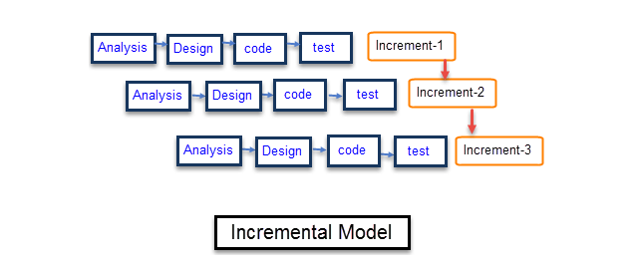

Figure 1 Incremental Model

### **1.6.1 Data collection methodology**

The data gathering process and technique we used to collect information, identify and extract problems and to suggest solutions for IFRS System are an interview, data analysis, observation, and questionnaires.

#### **1.6.1.1 Interview**

We will use this technique to interview personals of different stakeholders of the system.

e.g. bank managers, Teachers, auditors

#### **1.6.1.2 Data analysis**

Data analysis will be another method that will be used for collecting data. Different forms related to accounting will be referred to. And from discussion with experts who are professionals in accounting and auditing. Also analysis of different researches that are published online to implement IFRS System for different countries and expertise their way and adapt to our system.

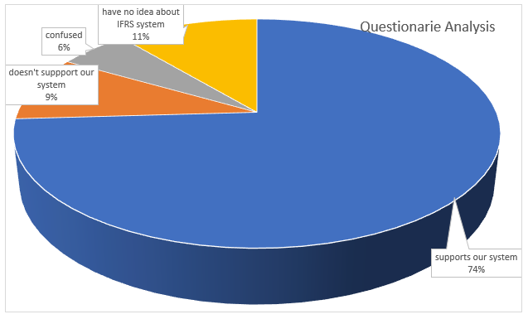

Figure 2: Questionnaires Analysis

#### **1.6.1.3 Observation**

Is also another data collection technique we used that usually done in conjunction with another data gathering method that is used to fill in the gaps and answer questions? Thus, we conduct physical observation to see how general accounting principle works.

#### **1.6.1.4 Questionnaire**

We will use this technique by preparing printed questions or online forms to gather statistical information from respondents.

i.e see APPENDIX A;

### **1.6.2 System development tools**

For this project, we’ll select an object-oriented programming approach. An object-oriented programming approach helps in solving many problems related to software development and the quality of software products. It has some major benefits such as managing software complexity, object-oriented systems can be easily upgraded, and one can easily partition a large project work based on objects.

### **1.6.3 Implementation methodology**

* Coding – visual studio code 2019
* Database - MySQL - The MySQL database has consistent fast performance, high reliability, and ease of use. And it’s suitable for our proposed System. [12]
* Documentation - MS office 2019
* Image editing – Adobe Photoshop
* Gantt chart 📊 – Edraw (Microsoft project)

### **1.6.4 Testing Methodology**

From different testing methodologies, we decide to use the following one to ensure that if the proposed system is to meet its goal or to identify any error/problem and to take any appropriate measure.

**(a) Unit testing**

We use this testing technique to verify the functionality of a specific section of the code of IFRS System, usually at the function level which is Generate reports and manage users. Since we use object-oriented programming, a unit is often an entire interface, such as a class, but could be an individual method. So, we enforced to use this method of testing to ensure that the specific IFRS function is working as expected.

**(b) Regression testing**

When we want to add new modules from IFRS Standards, we use Regression Testing methods. To check whether the previously implemented IFRS standards are working as a requirement or not.

**(c) Integration testing**

Another type of software testing that we will use to verify the IFRS System interfaces between components against a software design. IFRS System Software components may be integrated in an iterative way or all together. It works to expose defects in the interfaces and interaction between integrated components (modules) which refer to implemented IFRS Modules.

**(d) System testing**

This is the third testing techniques we use by completely integrating the system to verify that to ensure if it meets its requirements.

***Alpha testing*:** is simulated by the developer of the system.

***Beta testing*:** after the alpha testing system will be stimulated by clients (end-user) to get user acceptance.

# **Chapter 2: System Requirement Specification**

## 2.1 Background Overview

IFRSs refers to a single set of standards & interpretations applicable to general purpose financial statements and other financial reporting of all profit-oriented entities. IFRSs are issued by the International Accounting Standards Board (IASB). Application of IFRSs is believed to result in financial reports of high quality i.e. comparable, understandable, reliable and relevant to users. It follows a thorough, open, participatory and transparent due process.

Many countries have faced challenges in their decisions to adopt IFRS (International Financial Reporting System), its high implementation cost, as well as its complexity, makes the adoption process tough. Recently there has been a push towards the adoption of IFRS developed and issued by the International Accounting Standards Board (IASB). The government of Ethiopia issued a proclamation called “Financial Report Proclamation of Ethiopia: 847/2014” and Council of Ministers Regulation 332/2014. The National Bank of Ethiopia has already required the banks to prepare their financial statements in accordance with IFRS. In 2011 the Ministry of Finance and Economic Development (MoFED) issued a draft proclamation called Financial Reporting Proclamation of Ethiopia to provide for the financial reporting of Ethiopia. The proclamation requires reporting entities in Ethiopia to follow IFRS. [4]

The purpose of the IFRS system is to provide financial information for making decisions. Those decisions include buying, selling or holding equity and debt instruments, providing or settling loans and other forms of credit, exercising rights to vote on. The proposed system financial reports provide information about the resources of, and claims against, an entity and the effects of transactions and other events on those resources and claims. Thus, the project develops a system that can generate the required reports accurately, reliably, securely in a timely manner according to the international standards and tackle the complexity of achieving the standards in adopting in the Ethiopian context. The system also solves the transparency of financial issues in most governmental offices as well as solves the existence of a few experts in the standard. And overcome problems in the adoption of IFRS which include lack of technical skills, Lack of comparative approach in the current financial reporting system, Lack of international standardization with the currently followed generally accepted accounting principles (GAAP) reporting system.

## 2.2. Functional Requirement

* ***A statement of financial position module***
  + Assets should be presented clearly
  + Liabilities should be presented clearly
* ***A statement of profit or loss and other comprehensive income module***
  + Income should be recorded reliably as well as presented clearly
  + Expenses should be recorded reliably as well as presented clearly
* ***A statement of changes in equity module***
  + Total comprehensive income should be accurately calculated
* ***A statement of cash flows module***
  + The transaction should be recorded periodically and presented in the chronological order
* It should provide a comparative report with the prior year
* It should allow easy data entry
* It should allow easy correction of data entry errors within a batch before posting
* It should allow the correction of errors after the posting process has been completed
* It should able to provide real-time reporting and inquiry.
* Secure registration and profile management facilities for different users.
* It should have the ability to report to the screen or to the printer.
* It should show financial reports electronically outside of the Financial Reporting Dept.
* It should provide report accuracy such that all reports provide summary totals and cross-foot regardless of rounding factors.
* It should keep a detailed transaction history.
* It should have the ability to generate accurate reports according to the standard
* It should have the ability for the user to add notes on generated reports.

## 2.3. Non-Functional Requirement

* **Safety Requirements**

If there is extensive damage to a wide portion of the database due to catastrophic failure, such as a disk crash, the recovery method restores a past copy of the database that was backed up to archival storage (typically tape) and reconstructs a more current state by reapplying or redoing the operations of committed transactions from the backed-up log, up to the time of failure.

* **Security Requirements**

Security systems need database storage just like many other applications. However, the special requirements of the security market mean that vendors must choose their database partners carefully.

* **Software Quality Attributes**
* **Availability:**as the IFRS system is hosted on a server, the system will be online the performance of the server has an effect.
* **Correctness:**the IFRS system should generate an appropriate report and should keep track of all records, because of using a computer for calculations and the system should generate the correct result.
* **Maintainability:**the IFRS system should refactor in order to increase its maintainability; also, standard naming is used for variable and methods naming when we develop IFRS System.
* **Usability:**the IFRS system should satisfy the maximum number of user’s needs as much as possible.
* **Speed**: IFRS system, the entire process of reporting becomes faster. Furthermore, statements and reports can be generated instantly at the click of a button. Managers do not have to wait for hours, even days, to lay their hands on an important report. Shorter preparation cycles with the generation of reports at any point in time.
* **Visuals:** Viewing reports using a computer allows taking advantage of the option to view data in different formats. IFRS system can show data in tables and using different types of charts.
* **Accuracy**: The proposed system will be designed to be accurate to the minutest detail. Once the data is entered into the system, all the calculations, including additions and subtractions are done automatically by the software. Thus, leads to Reduced risk of errors and non-compliance.
* **Scalable**: When a company grows, the amount of accounting necessary not only increases but becomes more complex. With the IFRS system, everything is kept straightforward.

## 2.4 Feasibility study

### **2.4.1 Economic Feasibility**

Report generation is a very costly process that requires much human labor. Report generation in the proposed system is precise that is reports are generated as per user requirements, which reduces the use of paper and manual labor.

### **2.4.2 Technical feasibility**

Keeping in view the above fact, nowadays all organizations are automating the repetitive and monotonous works done by humans. The key process areas of the current system are nicely amenable to automation in the IFRS system and hence the technical feasibility is proved beyond doubt.

### **2.4.3 Operational Feasibility**

The present system has automated most of the manual tasks. Therefore, the proposed system will increase the operational efficiency of the accounting team.

### **2.4.4 Schedule Breakdown**

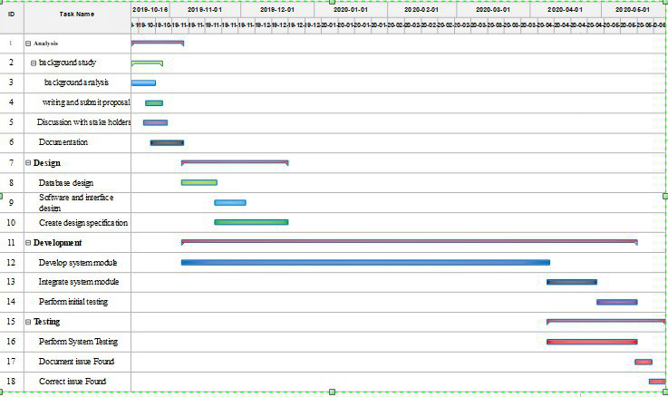

Figure 3 schedule Feasibility

# **Chapter 3: Requirement Analysis and Modeling**

## 3.1 Overview

This chapter enables us to communicate with stakeholders in a language they understand (like charts, models, flow-charts,). Its concept focuses on Elaborate IFRS requirement defined in the requirement specification document, such that it helps us in realistic project estimates and design, implement, and test, classify requirements information into various categories and allocate requirements to sub-systems, Evaluate requirements for desirable qualities.

## 3.2. Scenario-Based Modeling

### **3.2.1 Use case identification**

The use case is A case of use of the **IFRS system** which Describes it's actions Scenario-Based a user and Tells a story about A sequence of events involving, Interactions of a user with the system and Specifies one aspect of the behavior of a system, without specifying the structure of the system. we describe use cases in Textual or tabular descriptions, User stories, Diagrams

Main use cases as there are three categories of Named Users as follows:

**Administrator**:

Sign Up,focuses, Log out**,** manage Users, Remove User, add user, Add Reviewer, Remove Reviewer

**User**:

Sign Up,log in. Review Report, Logout, add notes, generate Reports, fill forms

**Reviewer**:

Sign Up,log in. Review Report, Log out

|  |  |  |
| --- | --- | --- |
| **Id** | **Use case** | **Description** |
| DD_IFRS_S01 | Sign-up | Users and Reviewer Register in the platform to create account |
| DD_IFRS_S02 | Log in | To get/give permission, authorized user, Admin and Reviewers sign in the platform access service |
| DD_IFRS_S03 | Generate Report | The system provides or generates financial information reports for users. |
| DD_IFRS_S04 | Fill forms | fill some forms for income and expense/input and update data |
| DD_IFRS_S05 | Review Report | Reviewers see reports that are approved and selected by the administrator that includes comparative visualizations too. |
| DD_IFRS_S06 | Manage Users | full administrator rights, including adding, editing and deleting users and deleting entities |
| DD_IFRS_S07 | Add Reviewer | The administrator can Add Reviewer to see the report on-screen and produce all outputs |
| DD_IFRS_S08 | Remove Reviewer | an administrator can Remove Reviewer from System database |
| DD_IFRS_S09 | Add Users | Administrator rights to Add Users into the system and apply 'Standard' rights. |
| DD_IFRS_S10 | Remove Users | Administrator rights to Remove Users from the system |
| DD_IFRS_S11 | Search User | Admin search user if he/she want**s** forsome purpose. |
| DD_IFRS_S12 | View User-List | Admin can view users list who haveanaccount in the platform |
| DD_IFRS_S13 | Log out | Users sign out when they don’t use itafter login to get security |
| DD_IFRS_S14 | Record Transaction | Users need to Record different transactions that occurred in their company, including banks. |
| DD_IFRS_S15 | Record Income | Users record their income daily, weekly or monthly. |
| DD_IFRS_S16 | Record Expenses | Users record their expenses daily, weekly or monthly. |
| DD_IFRS_S17 | Record Properties | Users record their properties on their own. |
| DD_IFRS_S18 | Add Notes | Users add notes when they generate reports. |
| DD_IFRS_S19 | Generate SOCI | Generate A statement of profit or loss and other comprehensive income Report |
| DD_IFRS_S20 | Generate SCIE | Generate statement of changes in equity Report |
| DD_IFRS_S21 | Generate SOFP | Generate statement of a financial position report |
| DD_IFRS_S22 | Generate SOCF | Generate all A statement of cash flows report. |
| DD_IFRS_S23 | Save Report | Users can save generated reports for other times. |
| DD_IFRS_S24 | View Status | Users can see the current status of their financial position information. |

Table 1: Use Case Simple Description

### **3.2.2 Use case And Actor Mapping**:

Use case actor mapping is relating the use case with the actor.

|  |  |  |
| --- | --- | --- |
| **Id** | **Use case** | **Actor** |
| DD_IFRS_S01 | Sign up | Reviewer, Users |
| DD_IFRS_S02 | Log in | Admin , Reviewer, Users |
| DD_IFRS_S13 | Log out |
| DD_IFRS_S06 | Manage users | Admin |
| DD_IFRS_S07 | Add Reviewer |
| DD_IFRS_S08 | Remove Reviewer |
| DD_IFRS_S09 | Add User |
| DD_IFRS_S10 | Remove User |
| DD_IFRS_S11 | Search User |
| DD_IFRS_S12 | View User-List |
| DD_IFRS_S05 | Review Report | Reviewer |
| DD_IFRS_S14 | Record Transaction | User’s |
| DD_IFRS_S15 | Record income |
| DD_IFRS_S16 | Record Expenses |
| DD_IFRS_S17 | Record Properties |
| DD_IFRS_S18 | Add Notes |
| DD_IFRS_S19 | Generate SOCI |
| DD_IFRS_S20 | Generate SCIE |
| DD_IFRS_S21 | Generate SOFP |
| DD_IFRS_S22 | Generate SOCF |
| DD_IFRS_S23 | Save Report |
| DD_IFRS_S24 | View Status |

Table 2: Use Case And Actor Mapping

### **3.2.3 Use case diagram**

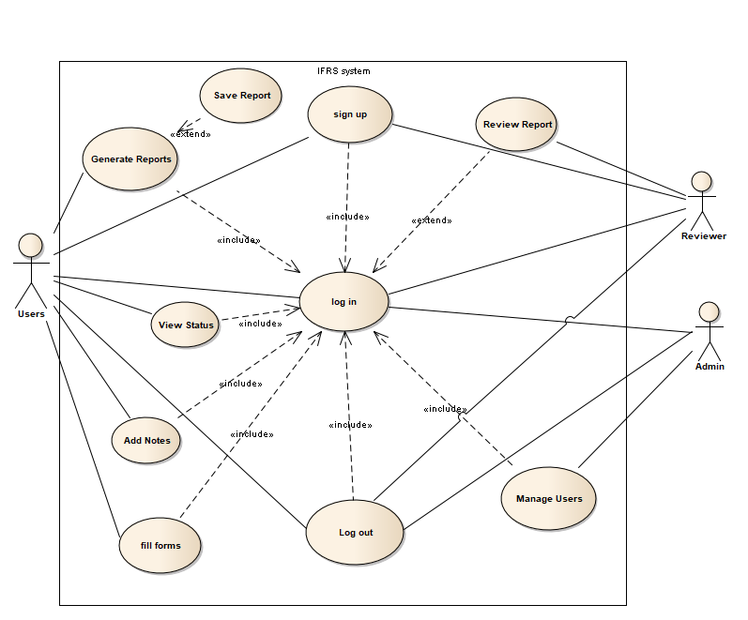

Figure 4 Use case for overall system

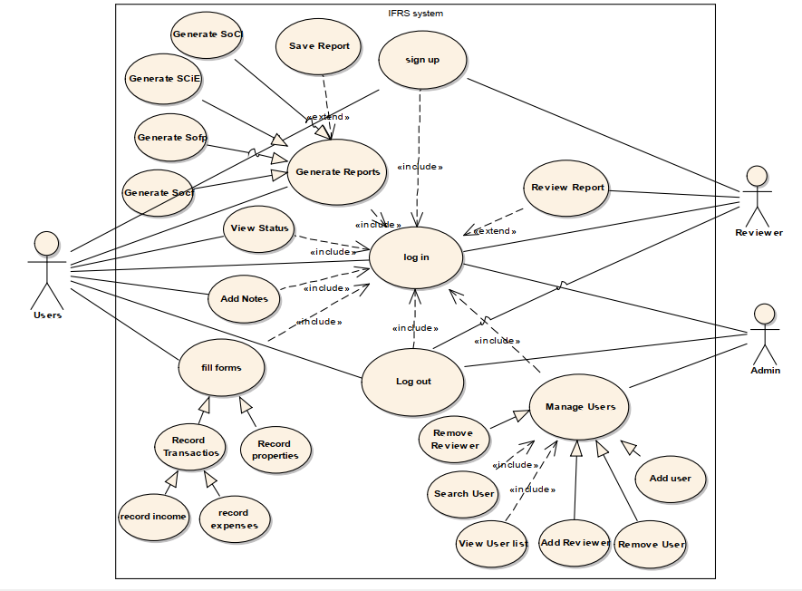

Figure 5: Use case with detail for IFRS System

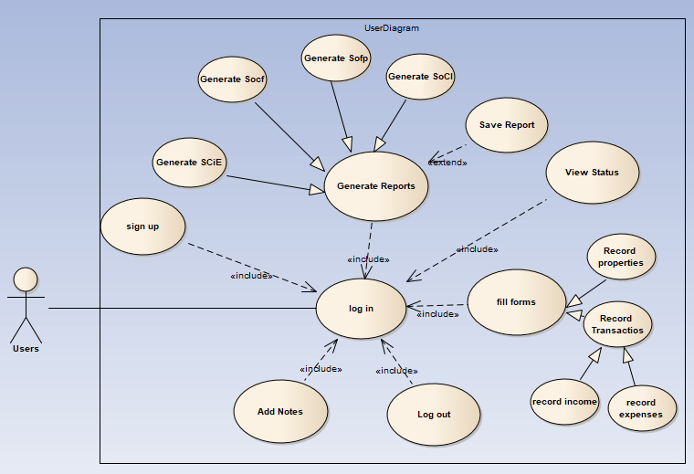

Figure 6 Use case Diagram for Users

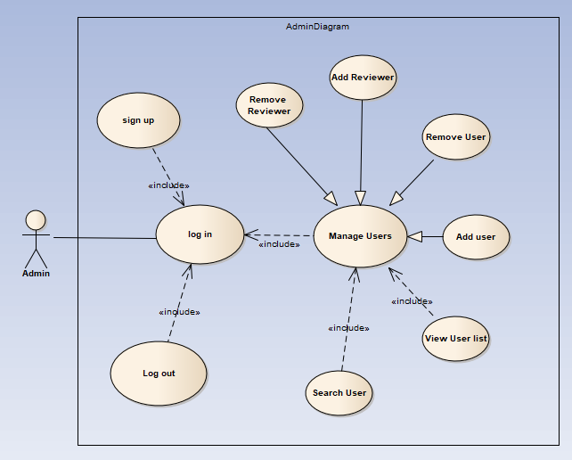

Figure 7 Use Case diagram for Admin of the System

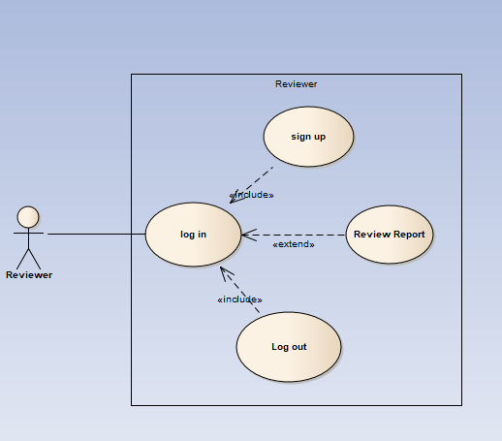

Figure 8 Use Case for Reviewer

**3.2.3 Use case description**

|  |  |  |
| --- | --- | --- |
| **Use Case Id** | **DD_IFRS_S01** | |
| Use case name | Sign up | |
| Created by | Eyob Amare | |
| Created date | 15/12/2019 | |
| Scenario | Register to the system by full filling the form | |
| Brief description | When user full fill the form field, system checks for the validity of the entered values, if correctly filled, redirects to the home page of a user. | |
| Actors | Reviewer, Users | |
| Preconditions | The form should be filled correctly | |
| Flow of events | **User** | **System** |
| 1. The user inputs the required values and then submits them. 2. The user will be redirected to the home page. | 1. The system checks the validity of the entered values; |
| Exception conditions | If the entered values are invalid, the user will be asked to correctly enter them. | |
| Alternative Flow | None | |
| Post-condition | Log in to the system | |

Table 3: User registers into the system

|  |  |  |
| --- | --- | --- |
| **Use Case Id** | **DD_IFRS_S02** | |
| Use case name | Login | |
| Created by | Mikiyas Zerfu | |
| Created date | 15/12/2019 | |
| Scenario | Log in to the system using a username and password. | |
| Brief description | When the user inputs a username and password, the system checks for the validity and matching of inputs values, redirect to the home page of the user. | |
| Actors | Admin, Reviewer, Users | |
| Preconditions | The user should be registered. | |
| Flow of events | **User** | **System** |
| 1. The user loads the login page. 2. The user inputs username and password and then submit. 3. if they are valid, the user will be redirected to the home page. | 1. The system checks the validity of the entered values, |
| Exception conditions | If the entered values are invalid,  the user will be asked to enter them again. | |
| Alternative Flow | None | |
| Post-condition | Log in to the system | |

Table 4: User login into the system

|  |  |  |  |
| --- | --- | --- | --- |
| **Use Case Id** | **DD_IFRS_S09** | | |
| Use case name | Create user | | |
| Created by | Eyob Tadele | | |
| Created date | 15/12/2019 | | |
| Scenario | The administrator creates a new user account. | | |
| Brief description | The administrator adds a user using the “create new user” workflow. The new user gets a username and a password. The password can be reset later. | | |
| Actors | Administrator | | |
| Preconditions | The new user should possess all the required attributes of the user entity (email, etc.) | | |
| Flow of events | **User** | **Admin** | **System** |
| 1. The new user provides essential details to the administrator. 2. A new username and password are given. 3. The user can change the password any time as he wants. | 1. The administrator submits the form. | 1. The system saves the new account. |
| Exception conditions | None | | |
| Post-condition | The added user use the system | | |
| Alternative Flow | None | | |

Table 5: Administrator creates the user

|  |  |  |
| --- | --- | --- |
| **Use Case Id** | **DD_IFRS_S10** | |
| Use case name | Remove User | |
| Created by | Diriba Bekele | |
| Created date | 15/12/2019 | |
| Scenario | The administrator deletes the user account. | |
| Brief description | When a user is removed his/her account is disabled from the system, the user information stored on the system for any future use. | |
| Actors | Administrator | |
| Preconditions | The user must log in to the system and he/she has to have the administrator privilege. | |
| Flow of events | **Admin** | **System** |
| 1. Administrator clicks “remove user”,  3. Administrator confirms by clicking “confirm” | 1. System prompts the admin for confirmation   4. The disabled user has no longer access to the system. Then information about the user will be stored on system archives. |
| Exception conditions | None | |
| Post-condition | The disabled user has no longer access to the system. | |
| Alternative Flow | None | |

Table 6: Administrator deletes user

|  |  |  |
| --- | --- | --- |
| **Use Case Id** | **DD_IFRS_S04** | |
| Use case name | Generate Report | |
| Created by | Mikiyas Zerfu | |
| Created date | 15/12/2019 | |
| Scenario | The user generates IFRS financial reports | |
| Brief description | 1. Generate reports which include a statement of financial position, a statement of profit or loss and other comprehensive income, a statement of changes in equity and a statement of cash flows.  2. Ability to report to screen | |
| Actors | Users | |
| Preconditions | fill some forms for income and expense. | |
| Flow of events | **User** | **System** |
| 1. Click generate report  3. Select the desired modules  5. See generated system | 2. Display available modules  4. Generate reports |
| Exception conditions | None | |
| Post-condition | See a report and compare. | |
| Alternative Flow | None | |

Table 7: Users Generate Report

|  |  |  |
| --- | --- | --- |
| **Use Case Id** | **DD_IFRS_S04** | |
| Use Case Name | Fill forms | |
| Brief Description | Fill forms for income and expense**/**input and update data | |
| Created By | Mikiyas Zerfu | |
| Created Date | 15/12/2019 | |
| Primary Actor | User | |
| Secondary Actor | None | |
| Pre-condition | Login  Record previous  Record transactions  Record properties  Record income  Record expenses | |
| Main Flow | **User** | **System** |
| 1. Click the Fill forms button  2. Record different transactions like incomes and expenses  3. Record properties  4. Fill the forms based on the recorded data  7. Confirm update | 5. Validate forms.  6. Request for update confirmation  8. Update forms and database. |
| Exception conditions | Login() | |
| Post-condition | The forms are filled | |

Table 8: use case description for Fill Forms

|  |  |
| --- | --- |
| **Use Case Id** | **DD_IFRS_S05** |
| Use Case Name | Review Report |
| Use Case Description | Reviewer**s** see reports that are approved and selected by **an** administrator that includes comparative visualizations too. |
| Created By | Mikiyas Zerfu |
| Created Date | 16/12/2019 |
| Primary Actor | Reviewer |
| Secondary Actor | None |
| Pre-condition | Login, Generate Report |
| Main Flow | 1. Click the Review Report button 2. Review the Report |
| Alternative Flow | None |
| Post-condition | The Report is reviewed |

Table 9: use case description for the review report

|  |  |
| --- | --- |
| **Use Case Id** | **DD_IFRS_S06** |
| Use Case Name | Manage Users |
| Use Case Description | Full administrator rights adding, editing and deleting users and deleting entities. |
| Created By | Eyob Amare |
| Created Date | 16/12/2019 |
| Primary Actor | Admin |
| Secondary Actor | None |
| Pre-condition | Login |
| Main Flow | 1. Click the Manage Users button 2. Perform the operations on users and reviewers |
| Post-condition | Users operation is done |

Table 10: use case description for Mange users

|  |  |
| --- | --- |
| **Use Case Id** | **DD_IFRS_S07** |
| Use Case Name | Add Reviewer |
| Use Case Description | A**n a**dministrator can add **a** reviewer to see the report on-screen and produce all outputs |
| Created By | Eyob Tadele |
| Created Date | 16/12/2019 |
| Primary Actor | Admin |
| Secondary Actor | None |
| Pre-condition | Login |
| Main Flow | 1. Click the Add Reviewer button 2. Add the specified reviewer |
| Alternative Flow | None |
| Exception conditions | Login() |
| Post-condition | New reviewer has been added |

Table 11: use case description for Add reviewer

|  |  |
| --- | --- |
| **Use Case Id** | **DD_IFRS_S08** |
| Use Case Name | Remove Reviewer |
| Use Case Description | A**n a**dministrator can remove **a** reviewer from the system database |
| Created By | Diriba Bekele |
| Created Date | 16/12/2019 |
| Primary Actor | Admin |
| Secondary Actor | None |
| Pre-condition | Login, the specified reviewer must be in the system database |
| Main Flow | 1. Click the Review Reviewer button 2. Remove the specified reviewer |
| Alternative Flow | None |
| Exception conditions | Login() |
| Post-condition | Reviewer has been removed |

Table 12: use case description for Remove reviewer

|  |  |
| --- | --- |
| **Use Case Id** | **DD_IFRS_S11** |
| Use Case Name | Search Users |
| Use Case Description | Administrator search for users if he/she wants the user for some purpose |
| Created By | Eyob Amare |
| Created Date | 17/12/2019 |
| Primary Actor | Admin |
| Secondary Actor | None |
| Pre-condition | Login  The specified user must be in the system database |
| Main Flow | 1. Click the Search Users button 2. Enter the name or specific id of the user |
| Alternative Flow | None |
| Post-condition | The specified user is found |

Table 13: use case description for Search users

|  |  |  |
| --- | --- | --- |
| **Use Case Id** | **DD_IFRS_S12** | |
| Use Case Name | View User-List | |
| Use Case Description | An administrator can view users list who have an account on the platform | |
| Created By | Diriba Bekele | |
| Created Date | 17/12/2019 | |
| Primary Actor | Admin | |
| Pre-condition | Login, All the users to be displayed must be registered properly | |
| Main Flow | **Admin** | **System** |
| 1. Click the View User-List button | 2. Display all users recorded in the database of the system |
| Alternative Flow | None | |
| Exception conditions | Login() | |
| Post-condition | All users must be displayed | |

Table 14: use case description for the View user list

|  |  |
| --- | --- |
| **Use Case Id** | **DD_IFRS_S13** |
| Use Case Name | Log out |
| Brief Description | Administrator, users**,** and reviewers sign out when they finish their jobs inside the system to keep privacy after they leave the system and the system clears the session of the logged out users. |
| Created By | Eyob Tadele |
| Created Date | 17/12/2019 |
| Primary Actor | Admin, User, Reviewer |
| Secondary Actor | None |
| Pre-condition | Login |
| Main Flow | 1. Click the Logout button |
| Alternative Flow | None |
| Post-condition | System secured and properly closed |

Table 15: use case description for Log out

|  |  |
| --- | --- |
| **Use Case Id** | **DD_IFRS_S14** |
| Use Case Name | Record Transaction |
| Brief Description | Users need to register different transactions that occurred in their company including bank. |
| Created By | Eyob Amare |
| Created Date | 17/12/2019 |
| Primary Actor | User |
| Secondary Actor | None |
| Pre-condition | Login  Record incomes  Record expenses |
| Main Flow | 1. Click the Fill forms button 2. Click the Record Transaction button 3. Click Record income or Record expenses button 4. Record different incomes and expenses in the company |
| Alternative Flow | None |
| Post-condition | Different transactions set recorded |

Table 16: use case description for Record Transaction

|  |  |  |
| --- | --- | --- |
| **Use Case Id** | **DD_IFRS_S15** | |
| Use Case Name | Record Income | |
| Brief Description | Users record the income daily, weekly or monthly. | |
| Created By | Mikiyas Zerfu | |
| Created Date | 17/12/2019 | |
| Primary Actor | User | |
| Secondary Actor | None | |
| Pre-condition | Login | |
| Main Flow | **User** | **System** |
| 1. Click the Fill forms button  3. Click the Record Transaction button  5. Click Record income button  6. Record incomes in the company  9. confirm | 2. display options  4. display available recordable transaction types  7. validate inputs  8. confirm updates  10. store on system |
| Alternative Flow | None | |
| Post-condition | Daily, weekly or monthly incomes in the company have been recorded | |

Table 17: use case description for Record Income

|  |  |
| --- | --- |
| **Use Case Id** | **DD_IFRS_S16** |
| Use Case Name | Record Expenses |
| Use Case Description | Users record the expenses daily, weekly or monthly. |
| Created By | Diriba Bekele |
| Created Date | 17/12/2019 |
| Primary Actor | User |
| Secondary Actor | None |
| Pre-condition | Login |
| Main Flow | 1. Click the Fill forms button 2. Click the Record Transaction button 3. Click the Record Expenses button 4. Record expenses in the company |
| Alternative Flow | None |
| Post-condition | Daily, weekly or monthly expenses in the company have been recorded |

Table 18: use case description for Record Expense

|  |  |
| --- | --- |
| **Use Case Id** | **DD_IFRS_S17** |
| Use Case Name | Record Properties |
| Use Case Description | Users record the properties in the company |
| Created By | Eyob Amare |
| Created Date | 17/12/2019 |
| Primary Actor | User |
| Secondary Actor | None |
| Pre-condition | Login |
| Main Flow | 1. Click the Fill forms button 2. Click the Record Properties button 3. Record the properties in the company |
| Post-condition | Properties of the company registered |
| Exception conditions | Login() |

Table 19: use case description for Record Properties

|  |  |
| --- | --- |
| **Use Case Id** | **DD_IFRS_S18** |
| Use Case Name | Add Notes |
| Use Case Description | Users add notes when they generate reports |
| Created By | Eyob Tadele |
| Created Date | 17/12/2019 |
| Primary Actor | User |
| Secondary Actor | None |
| Pre-condition | Login |
| Main Flow | 1. Click the Add Notes button 2. Write notes 3. Update the content of the notes. |
| Alternative Flow | None |
| Exception conditions | Login() |
| Post-condition | Notes included |

Table 20: use case description for Add Notes

|  |  |
| --- | --- |
| **Use Case Id** | **DD_IFRS_S19** |
| Use Case Name | Generate SOCI |
| Use Case Description | Generate the statement of profit or loss and other comprehensive income reports |
| Created By | Diriba Bekele |
| Created Date | 17/12/2019 |
| Primary Actor | User |
| Secondary Actor | None |
| Pre-condition | Login |
| Main Flow | 1. Click the Generate Report button 2. Click the Generate SOCI button 3. Generate profit or loss statements in the company |
| Alternative Flow | None |
| Exception conditions | Login() |
| Post-condition | SOCI statements generated |

Table 21: use case description for Generate SOCI

|  |  |
| --- | --- |
| **Use Case Id** | **DD_IFRS_S20** |
| Use Case Name | Generate SCIE |
| Use Case Description | Generate the statement of changes in Equity Report |
| Created By | Mikiyas Zerfu |
| Created Date | 18/12/2019 |
| Primary Actor | User |
| Secondary Actor | None |
| Pre-condition | Login |
| Main Flow | 1. Click the Generate Report button 2. Click the Generate SCIE button 3. Generate statement of changes in equity report |
| Alternative Flow | None |
| Exception conditions | Login() |
| Post-condition | SCIE statements generated |

Table 22: use case description for Generate SCIE

|  |  |
| --- | --- |
| **Use Case Id** | **DD_IFRS_S21** |
| Use Case Name | Generate SOFP |
| Use Case Description | Generate the statement of financial position Report |
| Created By | Eyob Tadele |
| Created Date | 18/12/2019 |
| Primary Actor | User |
| Secondary Actor | None |
| Pre-condition | Login |
| Main Flow | 1. Click the Generate Report button 2. Click the Generate SOFP button 3. Generate statement of a financial position report |
| Alternative Flow | None |
| Exception conditions | Login() |
| Post-condition | SOFP statements generated |

Table 23: use case description for Generate SOFP

|  |  |
| --- | --- |
| **Use Case Id** | **DD_IFRS_S22** |
| Use Case Name | Generate SOCF |
| Use Case Description | Generate the All the statement of cash flows report |
| Created By | Diriba Bekele |
| Created Date | 18/12/2019 |
| Primary Actor | User |
| Secondary Actor | None |
| Pre-condition | Login |
| Main Flow | 1. Click the Generate Report button 2. Click the Generate SOCF button 3. Generate statement of cash flows report |
| Alternative Flow | None |
| Exception conditions | Login() |
| Post-condition | SOCF statements generated |

Table 24: use case description for Generate SOCF

|  |  |
| --- | --- |
| **Use Case Id** | **DD_IFRS_S23** |
| Use Case Name | Save Report |
| Use Case Description | Users save the generated reports for other time |
| Created By | Eyob Amare |
| Created Date | 18/12/2019 |
| Primary Actor | User |
| Pre-condition | Login  Generate Report |
| Main Flow | 1. Click the Generate Report button 2. Click the Save Report button 3. Save the generated reports |
| Exception conditions | Login() |
| Post-condition | Reports saved |

Table 25: use case description for Save Report

|  |  |
| --- | --- |
| **Use Case Id** | **DD_IFRS_S24** |
| Use Case Name | View Status |
| Use Case Description | Users can see the current status of their financial position information |
| Created By | Mikiyas Zerfu |
| Created Date | 18/12/2019 |
| Primary Actor | User |
| Secondary Actor | None |
| Pre-condition | Login  Financial information of the company must be filled properly |
| Main Flow | 1. Click the View Status button |
| Exception conditions | Login() |
| Post-condition | Financial information displayed |

Table 26: use case description for View Status

### **3.2.4 Activity diagram**

**Reviewer**

Figure 9: Activity diagram for the Reviewer

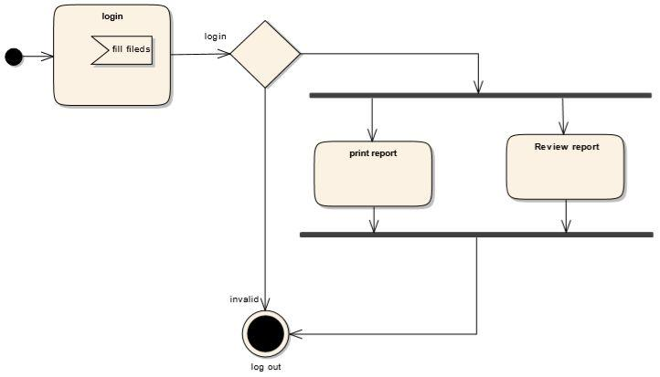

**Admin**

Figure 10:Activity diagram for Admin

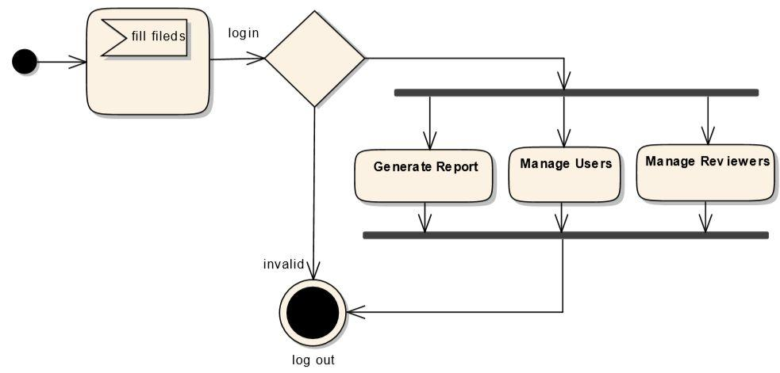

**Users**

Figure 11:Activity diagram for Users

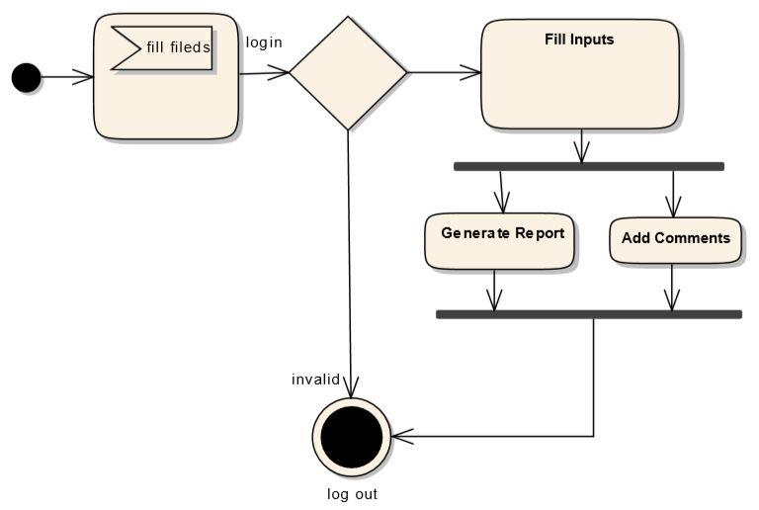

## 3.3 Behavioral/Dynamic Modeling

### 3.3.1 Sequence diagram

Figure 12: Sequence diagram for IFRS System

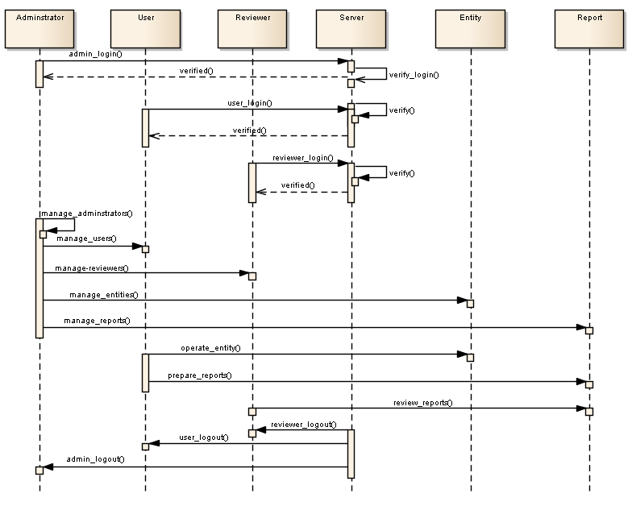

Figure 13: Sequence diagram for IFRS System USER Actions

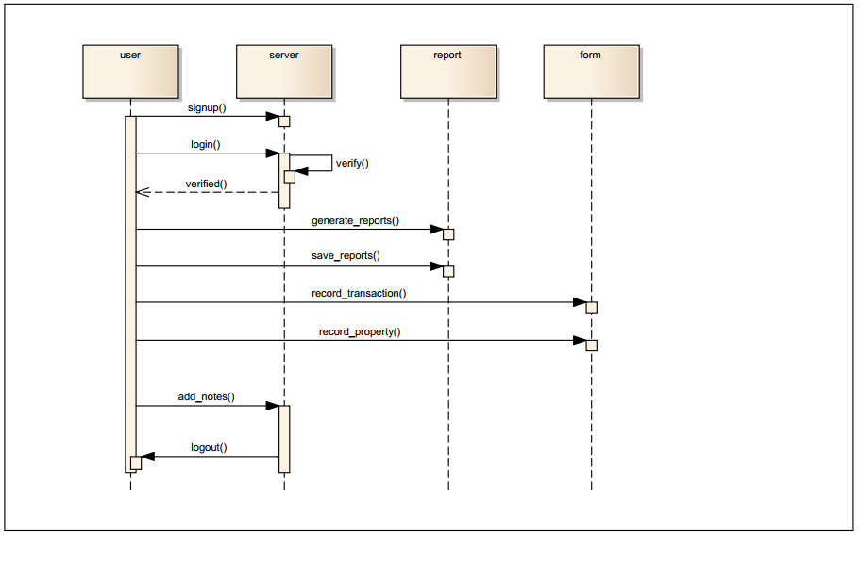

Figure 14: Sequence diagram for IFRS System Reviewer actor Actions

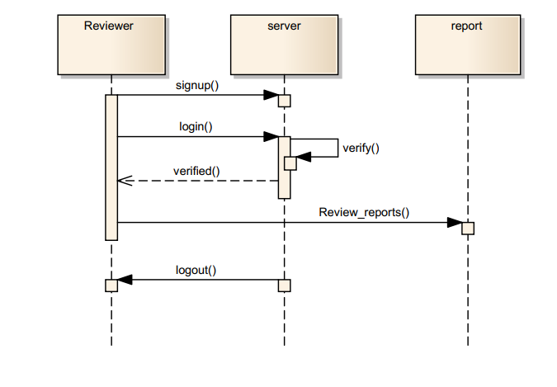

### 3.3.2 State Diagram

Figure 15:State diagram for IFRS System

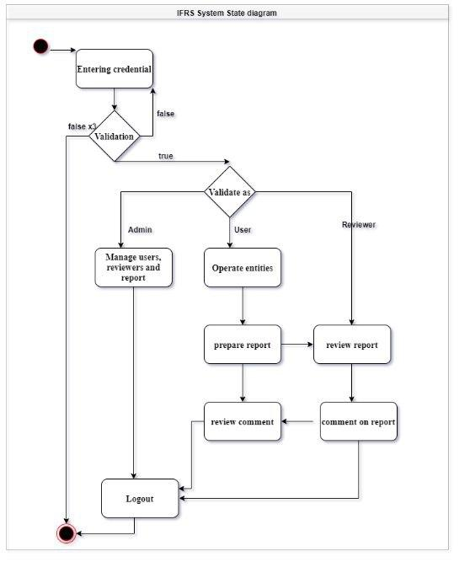

## 3.4 Class-Based Modeling

### **3.4.1 Identifying classes**

There are so many classes in the system of our project. Such as

* Manager
* Authentication
* Users Subsystem
* Administrator
* Users
* Accountant
* Reviewer
* Report Sub System
* SOCF
* SOCI
* SOPL
* SOFP

### 3.4.2 Class Diagram

Figure 16: Class Diagram of the overall System

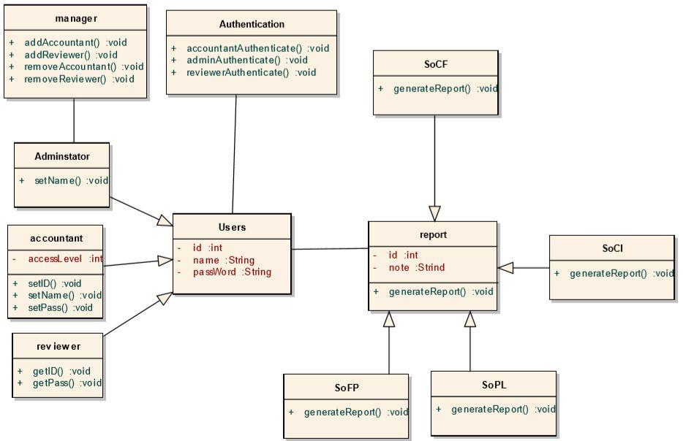

# **Chapter Four: System Design**

## 4.1 Overview

The proposed IFRS system aims to present to provide financial information for making decisions. Those decisions include buying, selling, holding equity and debt instruments, providing loans and other forms of credit, exercising rights to vote on, otherwise influence management Subsequently. And we dive into some IFRS components which are A statement of financial position, A statement of profit or loss and other comprehensive income, A statement of changes in equity, A statement of cash flows and Comparative information for the prior period is required for amounts shown in the financial statements. Our contribution is to design and develop Financial information that is more useful, International standardized, comparable, verifiable, timely, understandable and easy to use IFRS system.

The system will be designed to be updated and modified easily while still using the current system to maximize efficiency. It will be designed the cooperating database to store information for income and expense/input and update data which include Record Transaction, Record Income, Record Expenses and Record Properties and previous datasets and detailed transaction history. The system will be a three-tier application consisting of a presentation tier for managing user interface in the devices for user interaction. It will be developed with java spring framework Application layer will connect the presentation layer with the database server.

The Model is the part of the application that handles the logic for the application data. Often model objects retrieve data (and store data) from a database.

The View is the parts of the application that handles the display of the data. Most often the views are created from the model data. The Controller is the part of the application that handles user interaction.

Typically, controllers read data from a view, control user input, and send input data to the model. For the front end, we use HTML, CSS, Bootstrap, JavaScript, JSP and Spring that is the JavaScript framework that helps us to develop the system easily. Microsoft SQL Server is used as a back-end database.

The system will be a three-tier application consisting of a presentation tier for managing user interface, a web server that contains all the business and logics for the system and database. The web server is maintained using Apache HTTP Server, Microsoft SQL Server is used as a backend database, Code development will be done via spring framework Java.

## **4.2 System Design**

### 4.2.1 System Decomposition

We decompose our system into 4 main modules. and many different submodules as shown in the figure below.

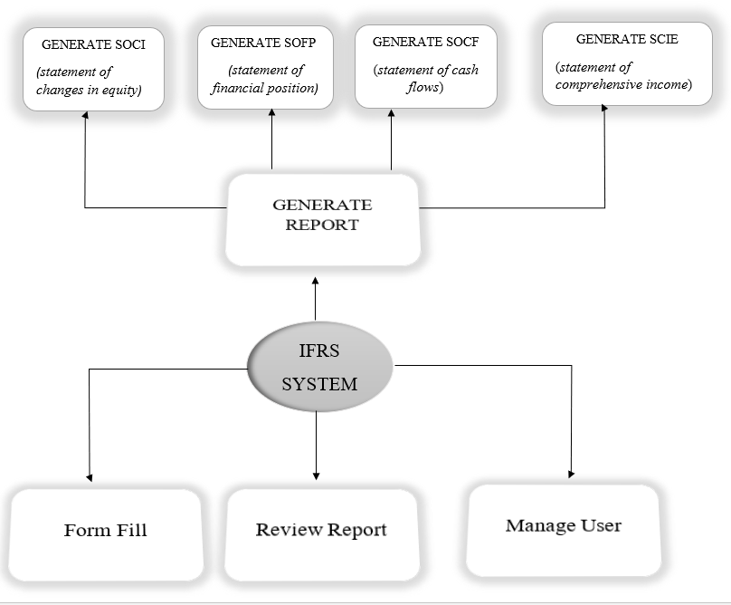

Figure 17: Overall System Decomposition

### 

### 4.2.2 Module description

#### 4.2.2.1. User module

#### There are three types of users in our system:-

#### 1. Admin

#### 2. Reviewer

#### 3. User

* For using the system all users of the system except admin have to create an  
  account(register to System).

1. Process of Creating an account starts with entering the required information username

* First name
* Last name
* Email
* User type
* Password
* Password confirmation

1. Information is verified
2. An appropriate page for the user type is displayed

* For a login to the system the user must register and then login by using his username and password

1. Process of login to the system

* ss Username
* Password

1. Information is verified
2. An appropriate page for the user type is displayed

**List of users**

1. **Administrator**

* An authorized person in the system for managing and manipulating the system.

Admin login to the system by using

* *user name*
* *password*
* Admin has the right access to manage and control everything in the system some of them are listed below
* Can manage user
* Can manage reviewer
* Can manage entity
* Can manage user access
* Can manage security settings
* Can manage user default rights
* Can manage report summary

1. **Reviewer**

* A person, who has an account in the system to get a full review of the report.

Log in to the system by using

* Username
* Password
* Reviewer has some privilege on the system
* A reviewer can review reports
* Reviewers can see nominated entities on a 'read-only' basis.
* Reviewers can see the report on-screen and produce all outputs.

1. **User**

* A person, who has an account in the system plays a major role in the system.

Log in to the system by using

* Username
* Password
* User has the following privileges in the system.
* Can create his/her own account
* Can generate reports
* Can save reports
* Can view status
* Can record properties
* Can record transactions
* Can add notes

**Level of access**

Each user will be given the level of access, which will be used to control how much of the system they can access. There are three levels of access. Such as:

* **Level of access 1(reviewer)**

Users with level of access 1 can only view and get information on the system and can only see nominated entities on a 'read-only' basis

* **Level of access 2(user)**

Users with level of access 2 have all the privileges of users with a level of access 1 and they must register as a user and they can generate new reports and perform different operations on the system.

* **Level of access 3(admin)**

Users with level of access 3 have all the privileges of all users. These users have administrative access. They can manage users; Suspend users or restrict the access they have to the system. They can add Basic and Advanced rights to the user. They can also update or add business rules.

#### 4.2.2.2 **Report generation**

* + This sub-module of the system is used for generating reports based on different report groups. Generate different types of reports like SOCI, SCIE, SOFP, SOCF.

*list of users participated in this module: users*

* + There are prerequisites to generate reports
* Users must have an account on the platform
* Review and copy prior year’s final file
* Enter/import current year’s data
* Validate data

#### 4.2.2.3 **Report review**

* + This module of the system is used for reviewing reports generated.

*Users participated in this module: Reviewer and Admin*

* + There certain prerequisites to review reports
* Admin/reviewers must have a valid account on the platform
* Admin should authorize the review of the reports to the reviewer
* There must be generated reports to be reviewed

#### 4.2.2.4 **Manage User**

* This module of the system is used for Managing Users which include full administrator rights, including adding, editing and deleting users and deleting entities.

*Users participated in this module: Admin*

* The certain prerequisites to Manage user are
* Admin should authorize to perform an action on User
* Log in as Admin.

#### 4.2.2.5 **Form Fill**

* This module is used to fill some forms for income and expense/input and update data.

*Users participated in this module: User of the System.*

## **4.3 Architecture of the system**

### 4.3.1 Architectural style

* Language-Based – Object-oriented
* Layered – Client-Server
* Data-Flow – Batch-sequential
* Shared-Memory –Rule-Based

**Architectural Pattern**

**Model-View-Controller** - MVC is a popular way of organizing our code. Nowadays, MVC  
is the most popular pattern to better organize and also it is user-friendly to do things better.

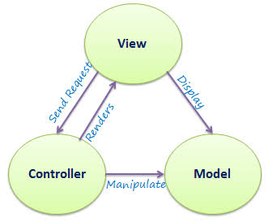

Figure 18: MVC architecture

### 4.3.2 Component Diagram

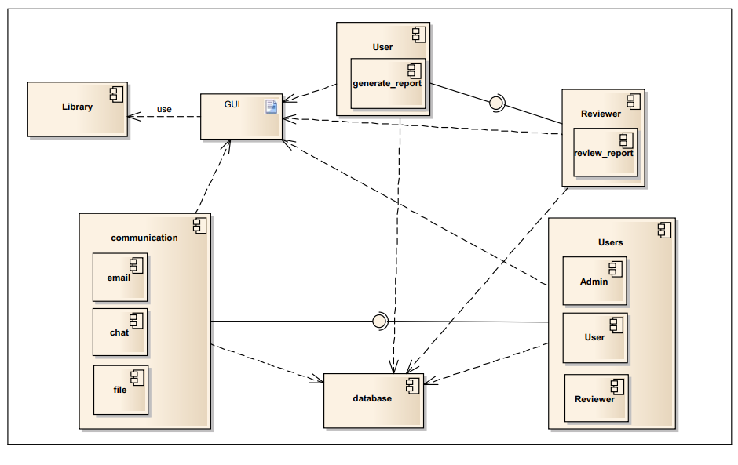

Figure 19: Component diagram for IFRS System

### 4.3.3 Deployment Diagram

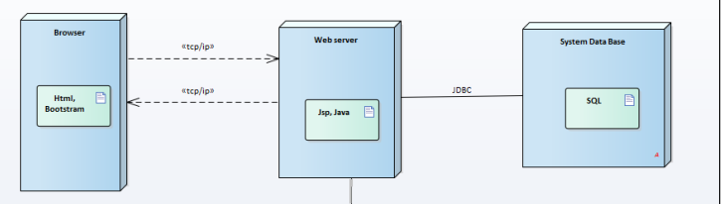

Figure 20: Deployment Diagram

### 4.3.4 Entity Relationship Diagram

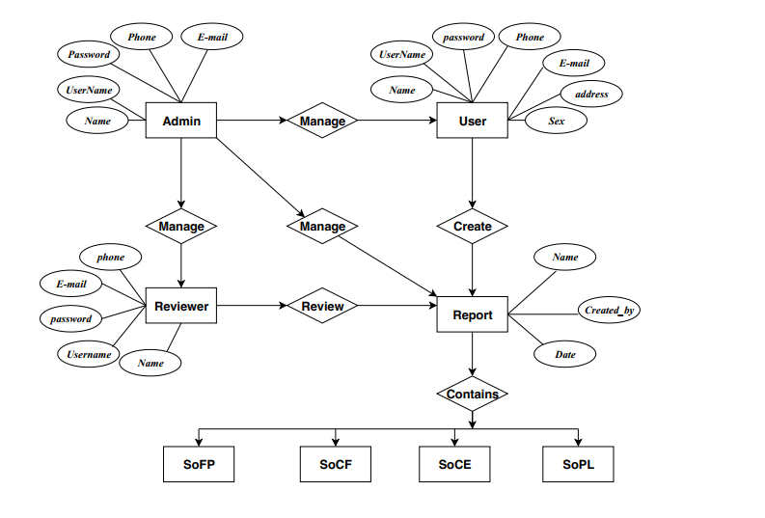

Figure 21: ER Diagram for Overall System

### 

### 4.3.5 Database Design

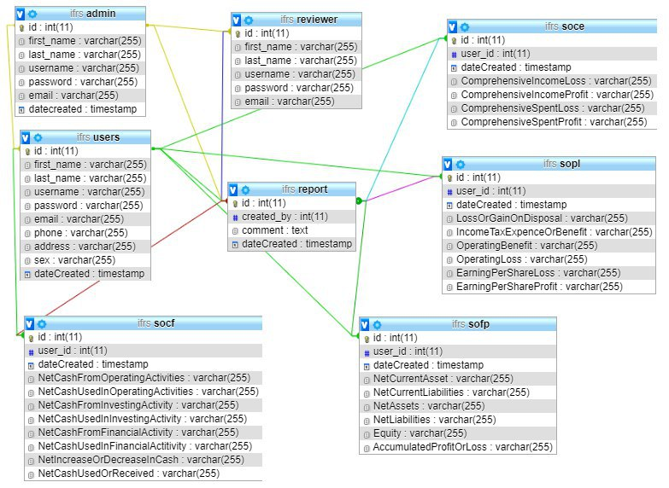

Figure 22: Data Base ER Diagram

## **4.4 User Interface Design**

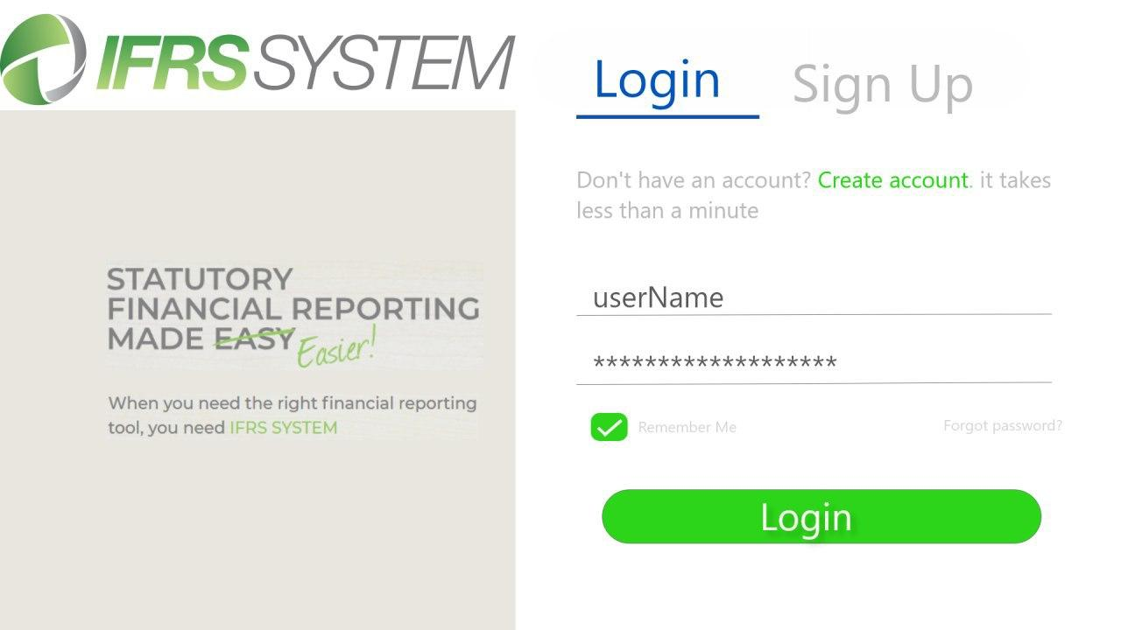

Figure 23 User Interface Design for Login

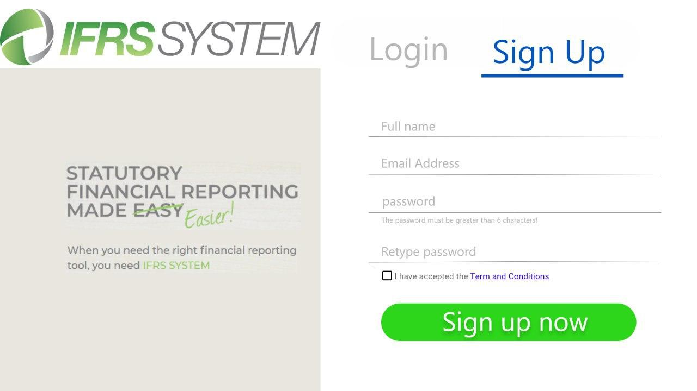

Figure 24 User Interface Design for Sign UP (create an account)

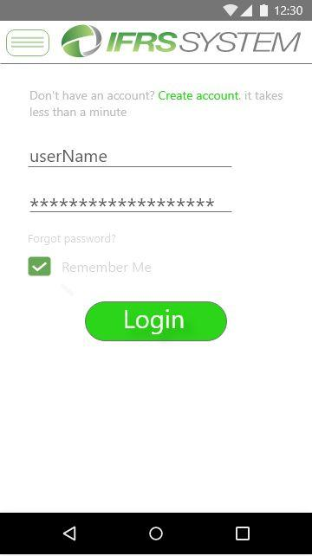

Figure 25: User interface design for log in using Mobile Phones

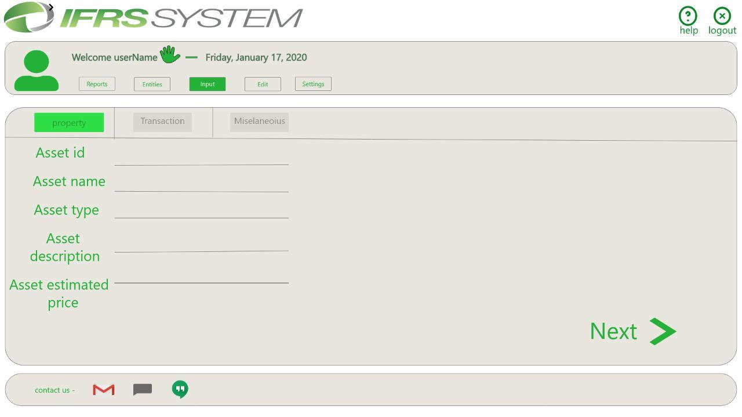

Figure 26: User Interface design for fill Forms

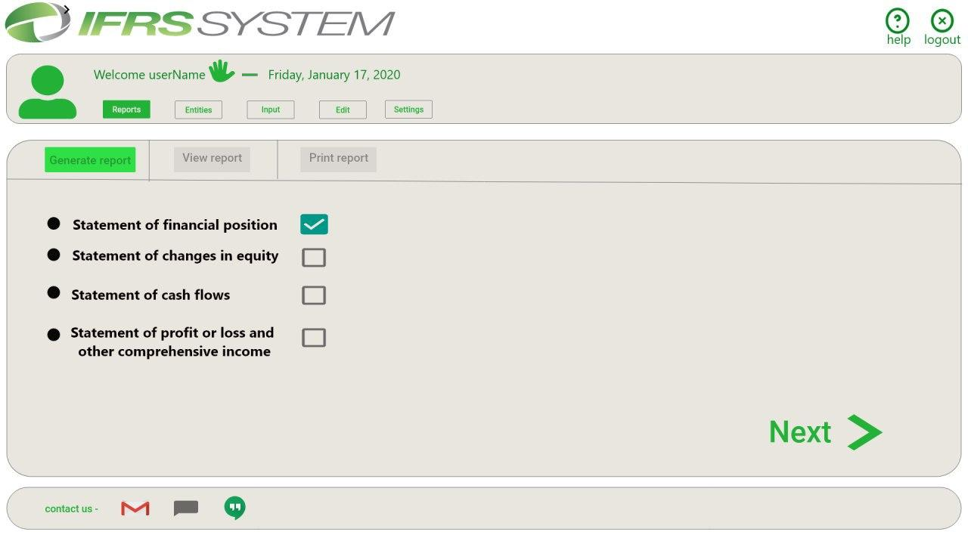

Figure 27 User interface design for generating a report and select Modules

# **Appendix A: Questionnaires**

**Questionnaire to fill by some stakeholders**

**1-Full Name **

**2-Educational Level **

**3-Currently work at **

**4-Do you know IFRS well?**

**5-Have you worked before? Where?**



**6-Tell us about your experience before? about your work.**

* **Role.**
* **Daily tasks.**
* **Responsibility.**



**11-Do you think IFRS should be implemented in some software system?**

**12-Do you think these IFRS components are necessary and basic?**

*A statement of financial position*

*A statement of profit or loss and other comprehensive*

*A statement of changes in equity*

*A statement of cash flows*

***Comparative information for the prior period is required for amounts shown in the financial statements***

**13-Do you think the proposed system will overcome the challenges that occur when using GAAP or manual IFRS? And give us some comments, please?**



**Thank you !!!**

# **References**

|  |  |
| --- | --- |
| [1] | IFRS Foundation, "IFRS," IFRS Foundation, Dec 2017. [Online]. Available: https://www.ifrs.org/about-us/who-we-are/. [Accessed 5 nov 2019]. |
| [2] | Wayne, "IFRS vs GAAP," 2010. |
| [3] | Y. Mihret, "IFRS Adoption in Ethiopia," *A Critical Analysis of the Process, Issues and Implications,* p. 6, 2016. |
| [4] | E. l. teshome, "Benefit and Challenges of adopting IFRS in Case of commercial Bank of Ethiopia," june-2017. |
| [5] | M. A. Shahid, "Fundamental Accounting Principles.pdf," Khilji & Co, 2019. |
| [6] | t. f. e. Wikipedia, "Wikipedia, the free encyclopedia," Wikimedia Foundation, Inc, 26 oct 2019. [Online]. Available: https://en.wikipedia.org/wiki/Financial_statement#Purpose_for_business_entities. [Accessed 04 nov 2019]. |
| [7] | "ifrs.org," 2012. [Online]. Available: cdn.ifrs.org › adoption › 2012-research-on-global-accounting-standards. [Accessed nov 2019]. |
| [8] | IFRS SYSTEM, "A single solution for UK GAAP (FRS 101,FRS 102, FRS 104) and IFRS accounts production," 1 December 2019. |
| [9] | Deloitte, IFRS in your pocket, iasplus, 2019. |
| [10] | "www.ifrs.org," IFRS, 2018. [Online]. Available: https://www.ifrs.org. |
| [11] | R. S. Pressman and B. R. Maxim, Software Engineering A practioner approch, New York: MC-Graw-Hill Education, 2015. |
| [12] | "mysql.com," mysql, 2019. [Online]. Available: https://dev.mysql.com/doc/. [Accessed 04 nov 2019]. |