Chapter 5 — Experimental Results and Analysis
This document summarizes the comparative results across classifiers and the MLP hyperparameter search analyses.

Descriptive Statistics
See attached CSV: descriptive_stats_ch5_MLP_Successful.csv

Balanced Accuracy Boxplot
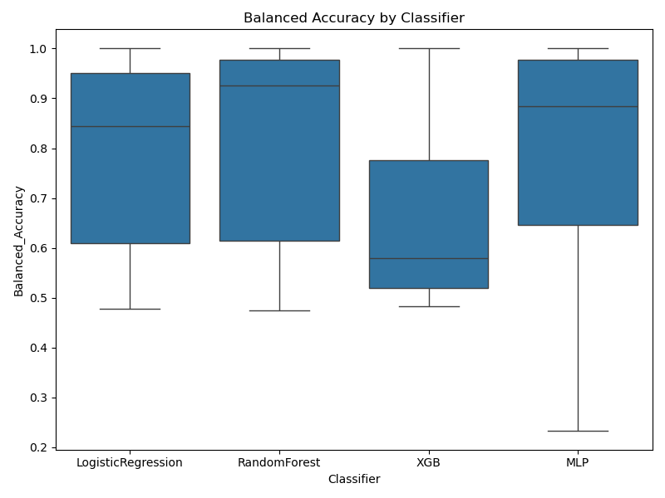

Mean Ranks
See attached CSV: mean_ranks_ch5_MLP_Successful.csv

Wilcoxon Paired Tests
See attached CSV: wilcoxon_ch5_MLP_Successful.csv

Spearman Correlations
See attached CSV: spearman_correlations_ch5_MLP_Successful.csv

Regression (MLP ~ RF + XGB)
