Edge App GUI – Operating Document

Login Page:
• Username/Password Fields: Enter credentials to access the system.
• Login Button: Confirms credentials and opens the main window.
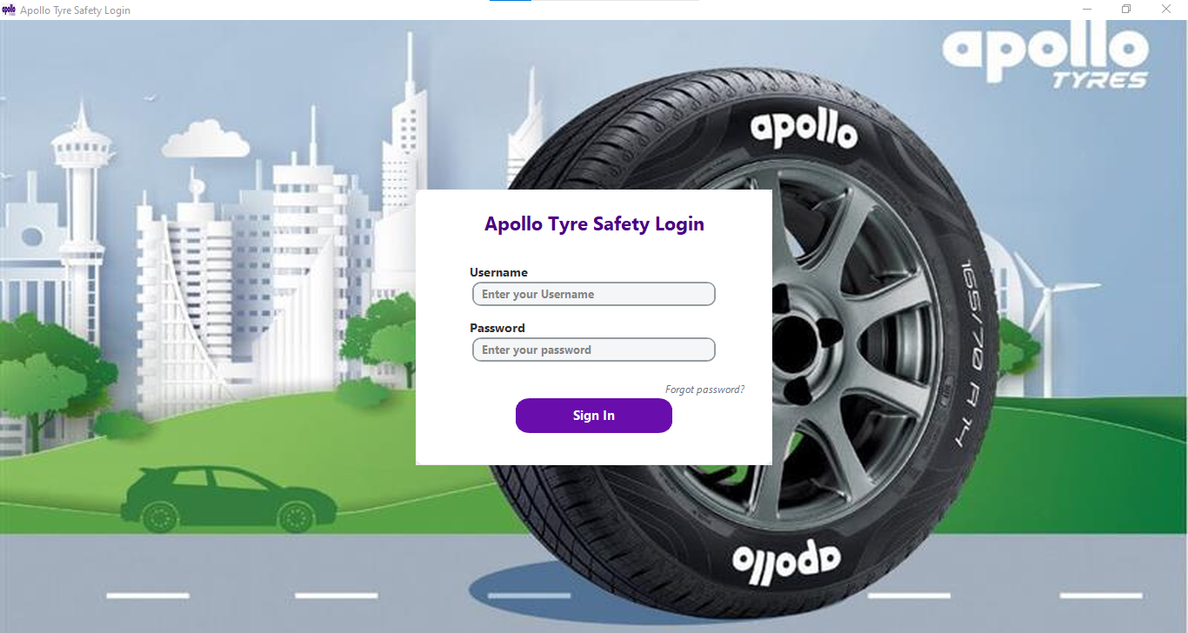
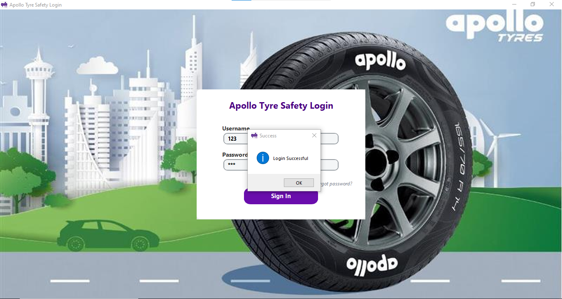

Main Window Buttons & Usage
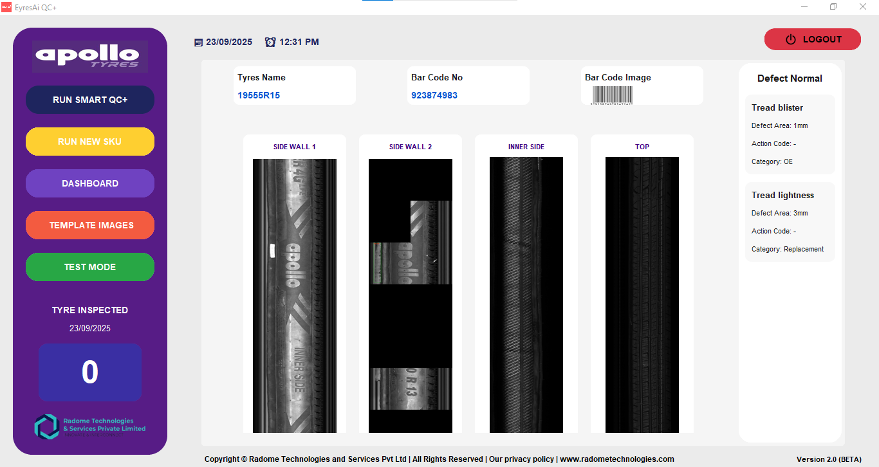

Live Run:
Starts real-time monitoring of production. Captures images continuously, performs AI-based defect detection, and displays Accept/Reject status instantly.
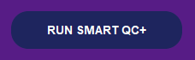



Run New SKU:
Initiates workflow for a new SKU template. Used when a new product or configuration is introduced. Guides through creating or selecting templates for accurate detection.

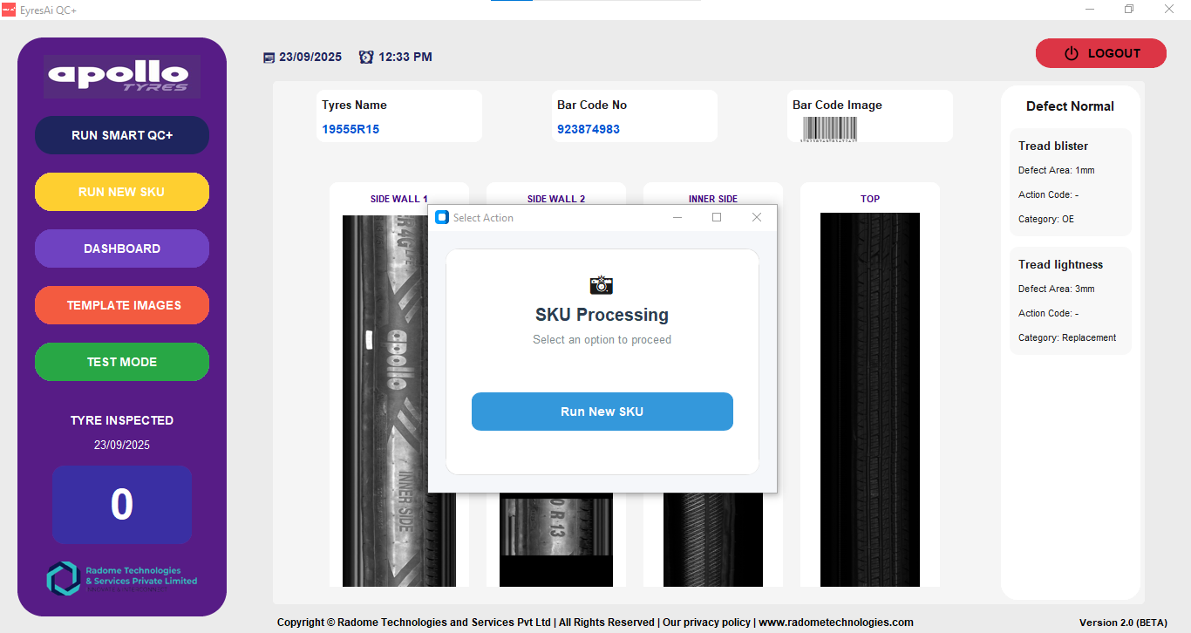
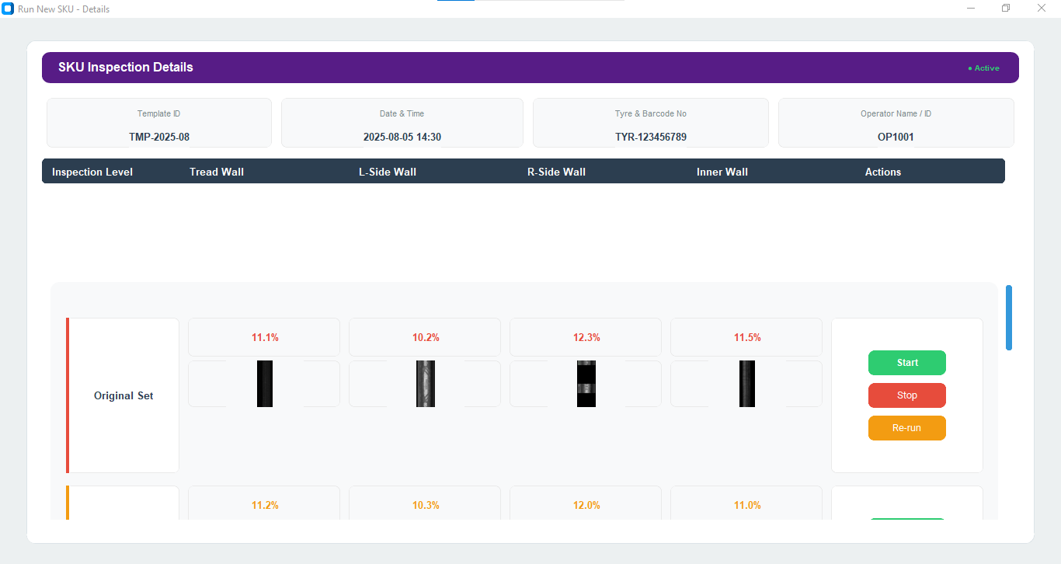
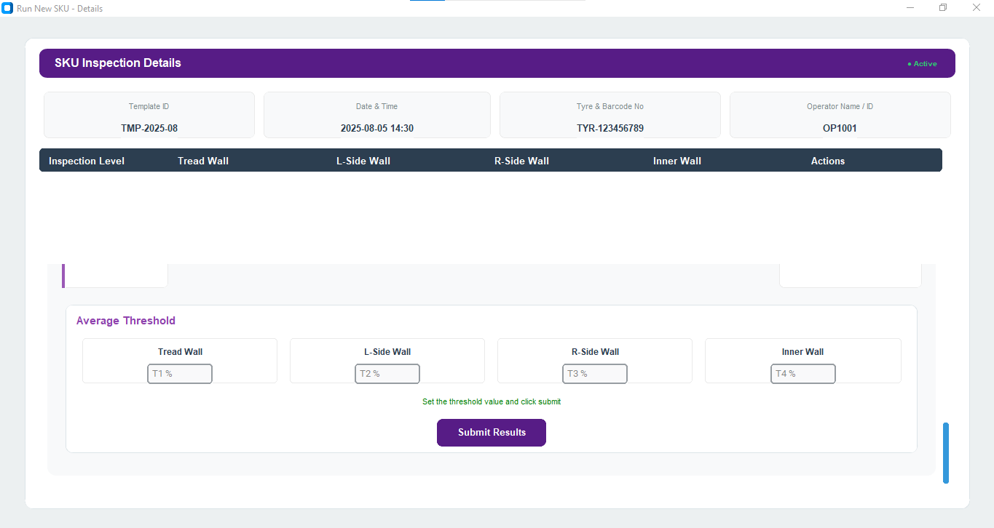

Template Blocks:
Opens template management for creating or editing blocks. Allows saving or modifying templates used for matching during runs.

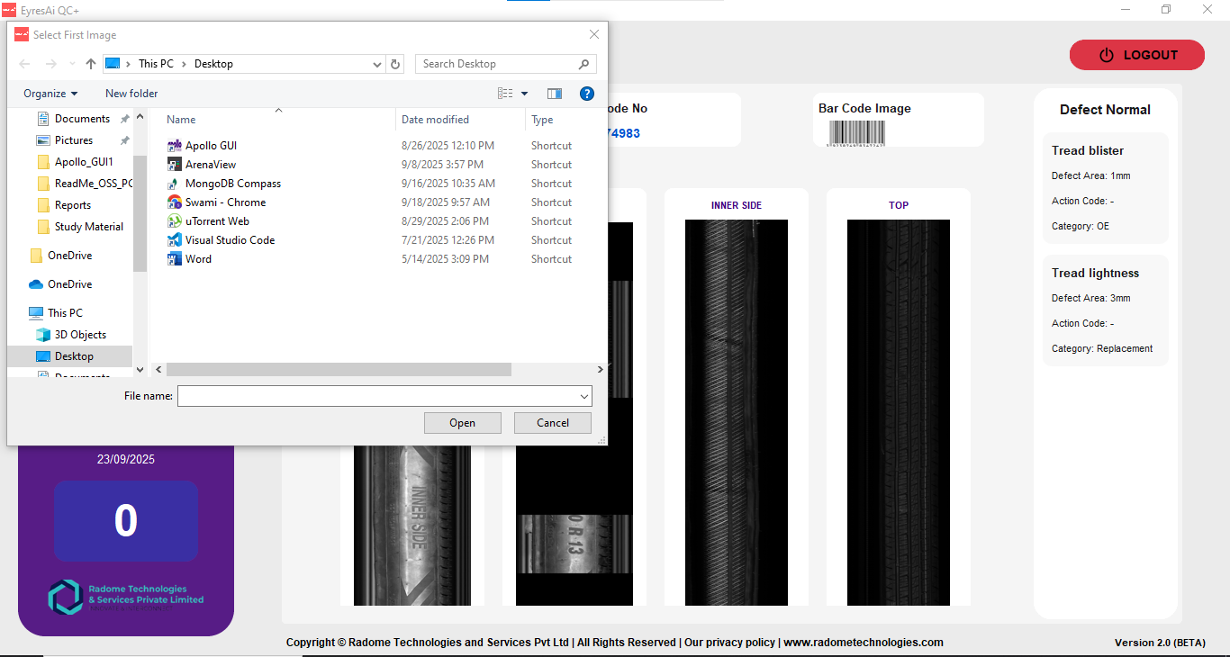

Dashboard:
Displays production data, defect analytics, and performance metrics. Provides visual charts and summaries for quick insights.


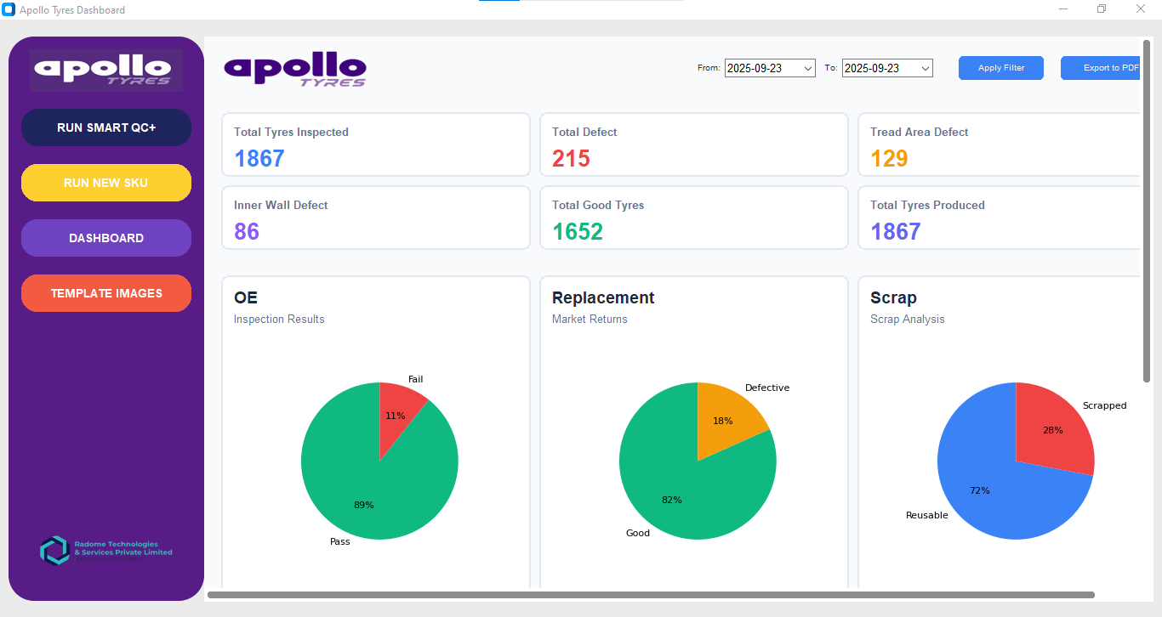

Report:
Generates detailed reports of run sessions, defects, and SKU performance. Can export data for record-keeping or sharing.
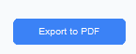
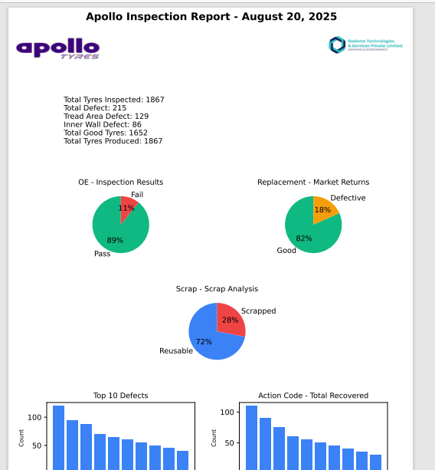

Logout:
Ends the current session securely.
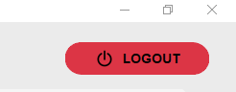

Test Mode:
Simulates camera, lights, and conveyor operations for testing purposes. After simulation, users provide feedback, which is compiled into a report for verification and analysis.

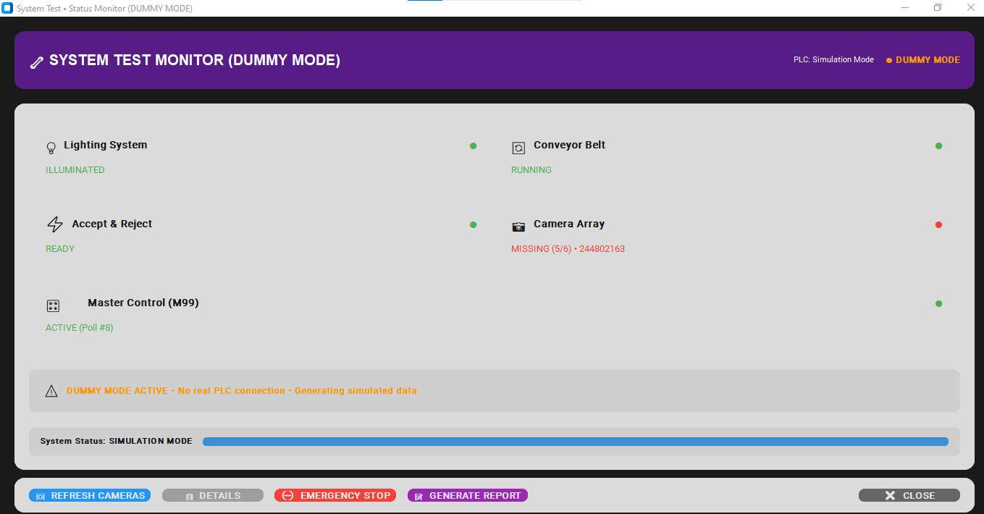

Help:
Opens the application guidelines. Provides instructions and reference information for using the Edge App GUI effectively.
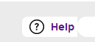

Workflow Flow
1. Login → Main Window.
2. To monitor ongoing production, click Live Run.
3. For new product templates, click Run New SKU → Template Blocks to create/edit templates.
4. To test or verify detection manually, use Upload Image.
5. Use Test Mode to simulate camera, lights, and conveyor and provide feedback.
6. Check Dashboard for live analytics and Report for summaries.
7. Use Help for application guidelines.
8. Use Logout after tasks are complete.

