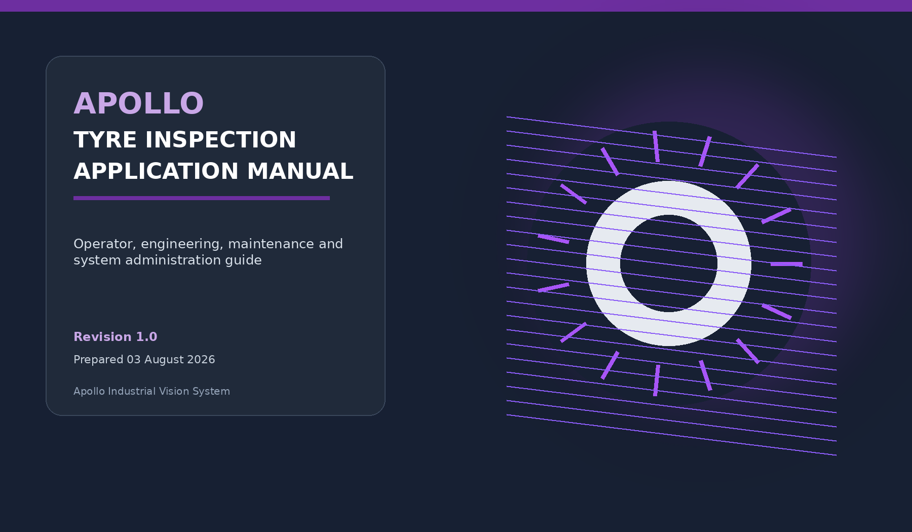
Document type | Application Manual | Revision | 1.0
Applies to | Apollo production workstation | Prepared | 03 August 2026
Primary audience | Operators, Maintenance, Quality, AI, Administrators | Application | EyresAi QC+ / Apollo
Deployment root | C:\Apollo_patch_pos | Launch command | python GUI.py
Controlled-document note
This manual describes the latest available Apollo application architecture and integration material as of 02 August 2026. Device serials, IP addresses, PLC tags, camera settings and laser geometry remain machine-specific and must be verified against the approved deployment package.

Document Control and Contents

Document purpose
This manual provides one end-to-end reference for operating, commissioning, maintaining and supporting the Apollo Tyre Inspection application. It combines operator procedures with enough technical context for maintenance, quality and AI engineering teams to understand what the application is doing at each stage.
Illustration note
The interface views in this manual are generated conceptual illustrations based on the application structure and visual theme. They explain layout and workflow but are not pixel-for-pixel screenshots of every deployed build.

Revision history
Revision | Date | Description | Status
1.0 | 03 Aug 2026 | Initial consolidated application manual covering current GUI, PLC, camera, laser, AI, PostgreSQL and New SKU workflows. | Released for review

Contents
Chapter | Title
01 | Safety, Scope and Operating Boundaries
02 | System Overview and Architecture
03 | User Accounts, Login and Permissions
04 | Application Navigation
05 | Startup and Readiness Validation
06 | System Monitor and Full Hardware Check
07 | Live Tyre Inspection
08 | PLC Trigger and Camera Capture
09 | AI Inference and Decision Flow
10 | Device Configuration
11 | Camera and Laser Capture Tools
12 | Axis Status and PLC Commands
13 | New SKU End-to-End Workflow
14 | Recipe Management and Deployment
15 | Quality, Review and Engineering Tools
16 | Data Storage, Logs and Traceability
17 | Alarms, Errors and Recovery
18 | Graceful Stop and Shutdown
19 | Maintenance and Backup
20 | Installation and Commissioning
21 | Troubleshooting Reference
22 | Quick Reference Checklists and Glossary

01

Safety, Scope and Operating Boundaries
Read this section before production use or configuration changes.

1.1 Intended use
Apollo is an industrial tyre-inspection application that coordinates a Siemens PLC, multiple Lucid line-scan cameras, an optional Teledyne DALSA Z-Trak laser profiler, GPU-based AI inference, operator interfaces and production traceability storage. It is intended for trained personnel working on an approved machine configuration.

1.2 Important operating boundaries
- The application Stop Inspection command is a graceful software stop. It is not a machine emergency stop.
- Use the physical machine emergency-stop circuit whenever personnel or equipment is at immediate risk.
- Do not change camera, laser, PLC or recipe settings while a Live cycle is armed or capturing.
- Do not open Z-Expert, CamExpert or another camera application while Apollo owns the same device.
- Do not replace production source files without a verified backup and a controlled rollback plan.
- Only use approved camera profiles, laser profiles, recipes, calibration data and AI model artifacts for production.
- A successful syntax check does not prove hardware timing. Camera, PLC, laser and network behavior must be validated on the machine.
Production safety
Apollo assists inspection and traceability. It does not replace machine guarding, safety PLC functions, emergency circuits, lockout/tagout procedures or trained quality review.

1.3 Roles of this manual
Audience | Use this manual for
Operator | Startup checks, Live inspection, interpreting status, stopping safely and reviewing history.
Maintenance | Hardware checks, device pages, capture tools, PLC/axis status, network and recovery.
Quality Engineer | Inspection review, repeatability, OSC/action-code work, annotation and ROI measurement.
AI Engineer | New SKU workflow, calibration, patch preparation, training, thresholds and recipe readiness.
Administrator | Users, permissions, deployment, PostgreSQL, backups, logs and controlled updates.

02

System Overview and Architecture
How control, acquisition, analysis and traceability fit together.

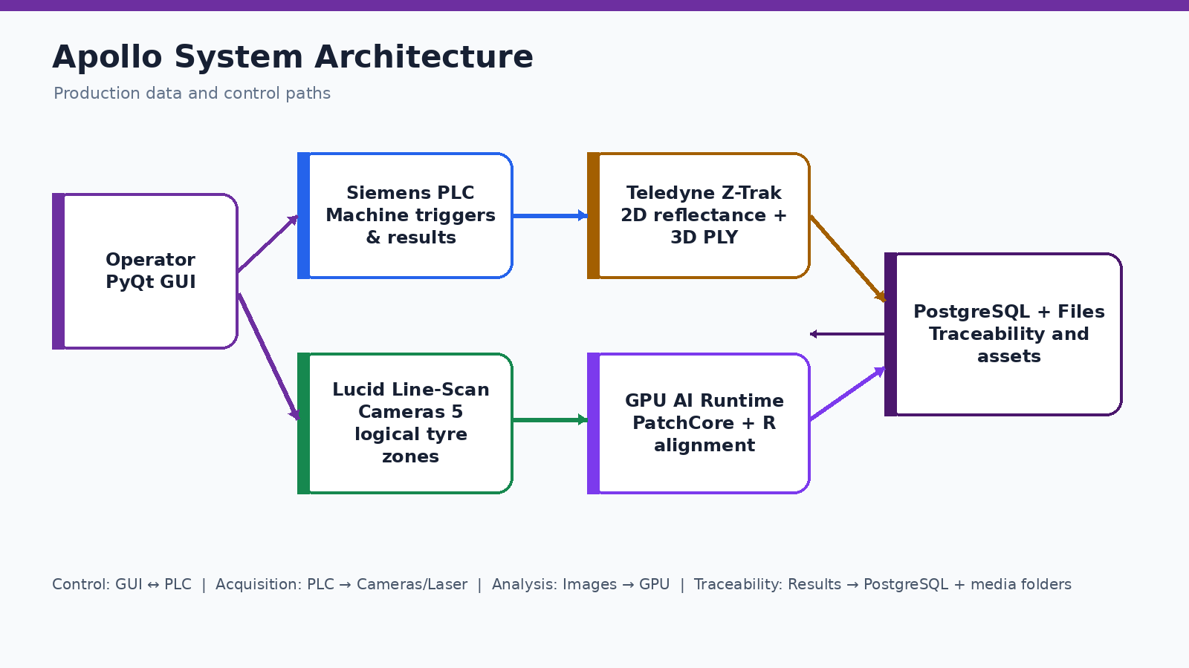
Figure 2-1. Apollo system architecture and major data/control paths.

2.1 Main application components
Component | Primary responsibility
GUI.py | Authentication, main window, page routing, Live controls, result display, PLC result handling and application cleanup.
src/Main_cam.py | Continuous inspection worker, SKU/profile preparation, capture-cycle orchestration, image saving, AI invocation and timing.
src/COMMON/cycle_engine.py | Five-side PatchCore inference orchestration and final cycle result.
src/camera/HARDWARE_TRIGGER.py | PLC edge handling, camera ownership, software trigger, stitching, shared bead/innerwall sequencing and software FFC.
src/Laser/* | Sapera/Z-Trak discovery, UserSet validation, acquisition, reflectance output, PLY creation and 3D viewing.
PostgreSQL layer | Inspection cycles, alarm events, application settings, profiles/assets and offline synchronization.
Security service | Local SQLite user accounts, roles, password protection, session timeout and security audit.

2.2 Five tyre inspection zones
Logical side | Purpose / image source
Sidewall 1 | First outer sidewall line-scan image.
Sidewall 2 | Second outer sidewall line-scan image.
Innerwall | Inner tyre surface; shares a physical camera with bead on the current machine design.
Tread | Circumferential tread line-scan image.
Bead | Bead-seat region captured before the shared camera is prepared for innerwall.

2.3 Threading and hardware ownership
The GUI remains responsive because hardware and inference work run in background Qt or worker threads. One actor thread owns each physical camera. The shared bead/innerwall camera is serialized by role so two Python threads never read the same device simultaneously. Laser acquisition runs in a separate process so Sapera memory and large PLY rendering do not block the GUI.
Why exclusive ownership matters
A second application or hidden page process holding a camera or laser can cause discovery failures, timeouts or incomplete payloads. Navigate away using Apollo controls so page-owned processes are closed cleanly.

03

User Accounts, Login and Permissions
Role-based access protects production actions and engineering functions.

3.1 Login behavior
Apollo shows a secure login before the main window when authentication is enabled. Passwords are protected using scrypt with a unique salt. Failed attempts can lock an account, and inactive sessions can expire automatically. The default security database is stored locally under data/security/apollo_security.db.

3.2 Standard roles
Role | Typical access
ADMIN | Full access, including User Management and all protected actions.
OPERATOR | Live Inspection and Dashboard.
QUALITY_ENGINEER | Live, Repeatability, OSC, Dashboard, Annotation Tool and ROI Measure.
MAINTENANCE | System Monitor/Test Mode, Device, Capture, Axis Status, Dashboard, PLC Auto Start and Servo Reset.
AI_ENGINEER | Run New SKU, Recipe Management, Dashboard, Annotation Tool, ROI Measure and Repeatability.

3.3 User management procedure
- Sign in using an Administrator account.
- Open the profile menu or User Management page.
- Create the user with the correct role and a temporary password.
- Have the user sign in and change the temporary password when prompted.
- Disable old or inactive accounts rather than sharing credentials.
Security rule
Do not set AUTH_ENABLED=False on a production workstation. That development setting bypasses login and grants administrator-level permissions.

04

Application Navigation
The left sidebar exposes only the pages allowed by the current user role.

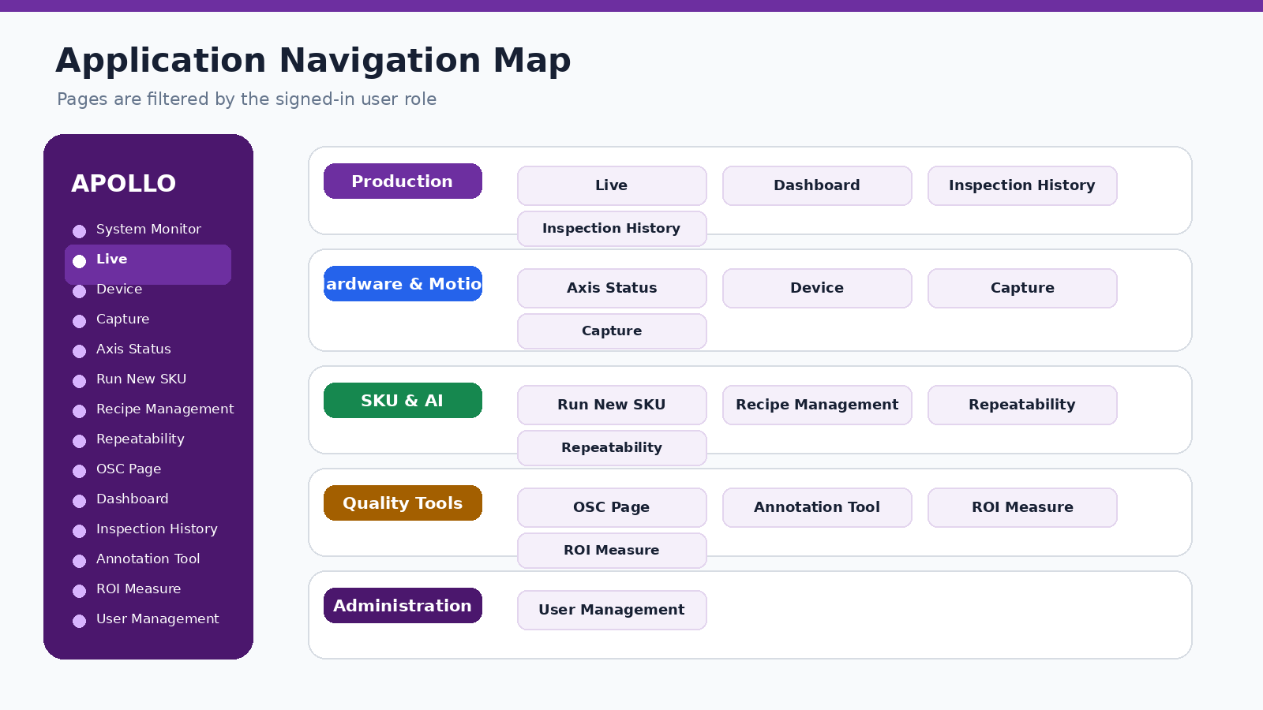
Figure 4-1. Application page map grouped by function.

4.1 Main pages
Page | Use
System Monitor | Hardware readiness, full hardware check, Lab Camera AI and Alarm Center.
Live | Select/resolve SKU, preload models, start or stop continuous tyre inspection and view results.
Device | Discover, configure and verify camera devices and SKU profiles.
Capture | Open Camera and Laser capture/configuration tools.
Axis Status | View PLC axis, servo and motion state; authorized maintenance commands.
Run New SKU | Guided workflow from SKU setup through capture, calibration, training and recipe preparation.
Recipe Management | Create, review, version and deploy PLC-to-SKU recipe mappings.
Repeatability | Capture or compare repeated runs for measurement and consistency assessment.
OSC Page | Maintain condition/action-code plans and controlled quality decisions.
Dashboard | Production and inspection summaries.
Inspection History | Search and review completed cycle traceability.
Annotation Tool | Create/edit image annotations for AI or quality work.
ROI Measure | Measure pixel distances and convert to millimetres after calibration.
User Management | Create, update, enable and disable accounts.

4.2 Header and profile menu
The application header shows date/time and user/session controls. The profile menu provides Help & Documentation, User Management when permitted, Sign Out and Exit Application. Use the application controls rather than closing the console window so active workers can clean up.

05

Startup and Readiness Validation
Use the same sequence at the beginning of every production shift.

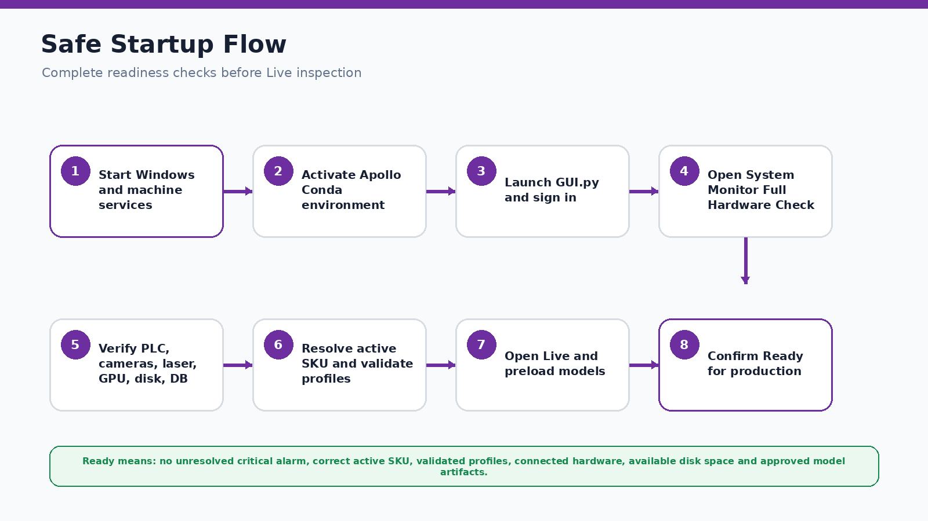
Figure 5-1. Safe startup and readiness sequence.

5.1 Launch procedure
conda activate Apollo
cd /d C:\Apollo_patch_pos
python GUI.py

- Confirm the machine, network switch, PLC, camera power, laser and workstation are powered and stable.
- Confirm no vendor utility is connected to an Apollo camera or laser.
- Activate the approved Apollo Conda environment.
- Start GUI.py and sign in with your own account.
- Open System Monitor and run the Full Hardware Check.
- Resolve every critical failure before starting Live inspection.

5.2 Expected startup logs
Structured logging initialized
Apollo application configuration loaded
Runtime data backend selected
Using device: cuda
Startup completed without AI model loading
Startup completed without PLC/camera/laser initialization
User authenticated
PostgreSQL pool opened ... database=eyresqc_apollo schema=apollo

Lazy startup is intentional
Apollo starts without loading AI models or opening production hardware. Those resources are initialized only when the operator enters the relevant workflow. This shortens startup and prevents hidden ownership conflicts.

5.3 Pre-Live checklist
- ☐ Correct active PLC recipe / SKU is visible.
- ☐ All required five-side AI artifacts are present and validated.
- ☐ The matching camera profile exists.
- ☐ The matching laser profile exists when laser is required.
- ☐ PLC, camera array, laser, GPU, disk and database show Ready/Pass.
- ☐ There is enough free space on the media drive.
- ☐ No unresolved critical alarm is open.

06

System Monitor and Full Hardware Check
The System Monitor is the operational gate before Live and New SKU capture.

6.1 What the check validates
Check | Pass meaning
PostgreSQL | Connection pool opens and required tables are reachable.
PLC | Snap7 client can connect to the configured CPU/rack/slot.
Cameras | All configured physical camera serials are discovered and accessible.
Laser | The required Z-Trak can be found without starting a production capture.
GPU | CUDA/PyTorch can allocate and execute the runtime check.
Disk | Configured media path exists and has adequate free space.
Application health | Configuration, services and key paths are valid.

6.2 Hardware object reuse
The Full Hardware Check creates and stores the shared PLC client and multi-camera manager. Live inspection and the New SKU page reuse these validated objects instead of opening an independent camera stack. This reduces duplicate ownership and ensures the same tested configuration is used downstream.

6.3 Interpreting status
State | Meaning / action
READY / PASS | The component passed its current check.
NOT CHECKED | Run the hardware check; this is not automatically a hardware failure.
WARNING / DEGRADED | The application may continue depending on policy, but investigate before production.
FAILED / CRITICAL | Do not start Live. Correct the issue and rerun the check.
RECOVERED | A previously open alarm has returned to healthy state; verify the component remains stable.

Database vs hardware alarms
Messages such as “No PLC client”, “Cameras not checked” or “Laser not checked” are commissioning states separate from PostgreSQL startup. Fix the first failing layer rather than rebuilding the database unnecessarily.

07

Live Tyre Inspection
The operator workflow for continuous production inspection.

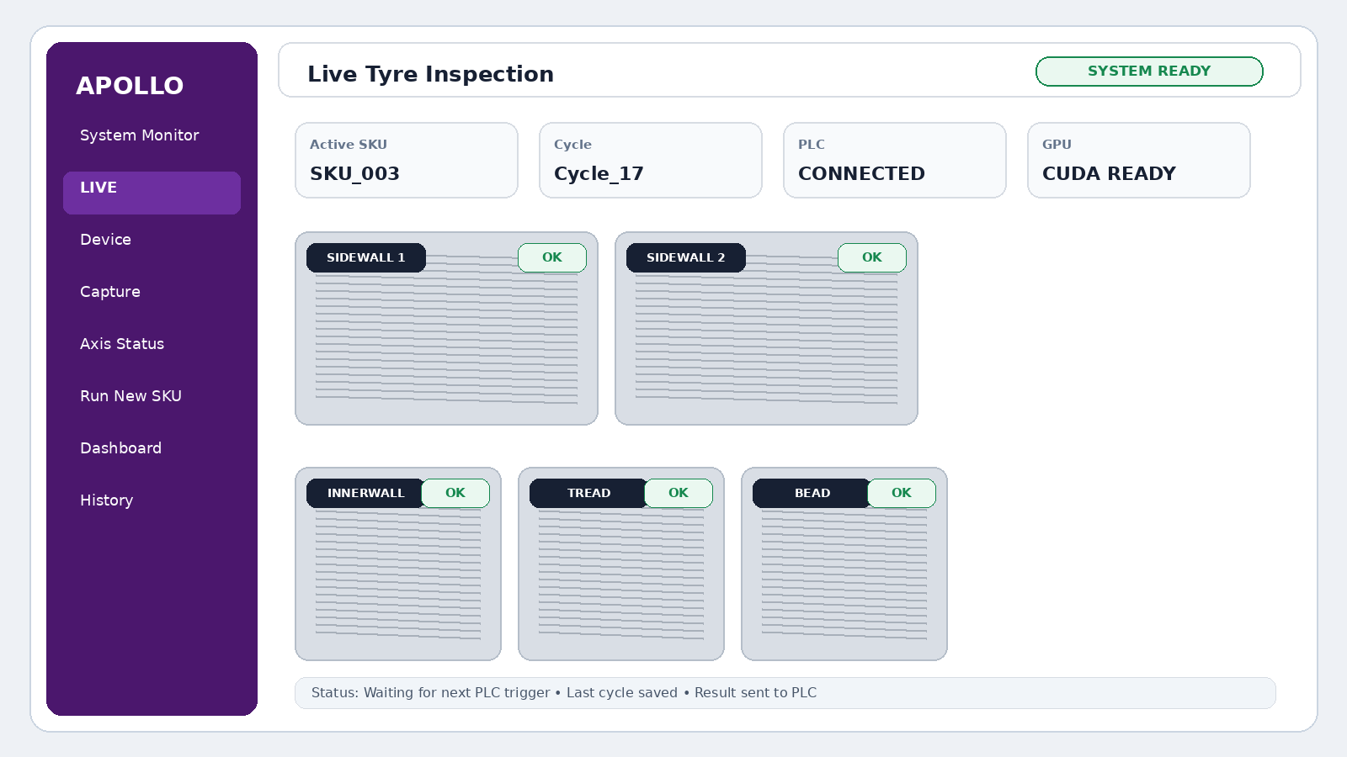
Figure 7-1. Conceptual Live page showing status cards, five-side previews and final results.
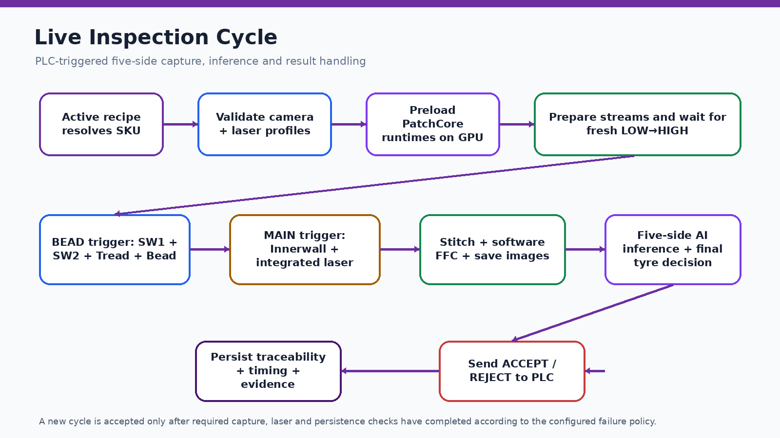
Figure 7-2. End-to-end Live inspection cycle.

7.1 Starting Live inspection
- Complete the Full Hardware Check and confirm the system is Ready.
- Open Live.
- Confirm the active PLC recipe resolves to the intended SKU.
- Allow Apollo to validate runtime assets and preload/warm the selected SKU models.
- Confirm the camera profile and required laser profile validate.
- Select Ready/Start only after the machine is prepared to send triggers.

7.2 What happens during a cycle
- A shared Cycle_N identity is created.
- Camera and laser resources are prepared and both PLC trigger bits are confirmed LOW.
- The BEAD-group rising edge releases sidewall1, sidewall2, tread and bead capture.
- The shared bead camera is prepared for its innerwall role.
- The MAIN/innerwall rising edge captures innerwall and starts the integrated laser scan when enabled.
- Apollo stitches line-scan chunks where required, applies software FFC and saves images.
- Sidewall inference establishes the R/revolution reference; innerwall, tread and bead inference follow.
- A final tyre decision is computed, saved to traceability and sent to the PLC.
- The next tyre is accepted only after required cycle-boundary checks complete.

7.3 Operator status interpretation
Display | Interpretation
Active SKU | The SKU whose profile/model/recipe is being used.
Cycle ID | Current output and traceability identity.
Component health | PLC, cameras, laser, GPU, disk and database readiness.
Per-side result | Sidewall1, sidewall2, innerwall, tread and bead decision/status.
Final tyre result | Combined ACCEPT/REJECT or configured final outcome.
Status console | Current preparation, trigger, capture, save, inference or failure step.

7.4 Stopping Live
Click Stop Inspection once. Apollo requests a graceful stop, waits for the current blocking capture/cycle boundary, closes camera streams and the laser process, finishes queued writes and returns to idle. A delay is possible when a hardware SDK call is still waiting for a buffer or trigger timeout.
Do not repeatedly click Stop
Repeated clicks do not make the hardware SDK return faster and can complicate worker cleanup. If there is immediate danger, use the physical emergency-stop system.

08

PLC Trigger and Camera Capture
How Apollo converts PLC edges into complete five-side images.

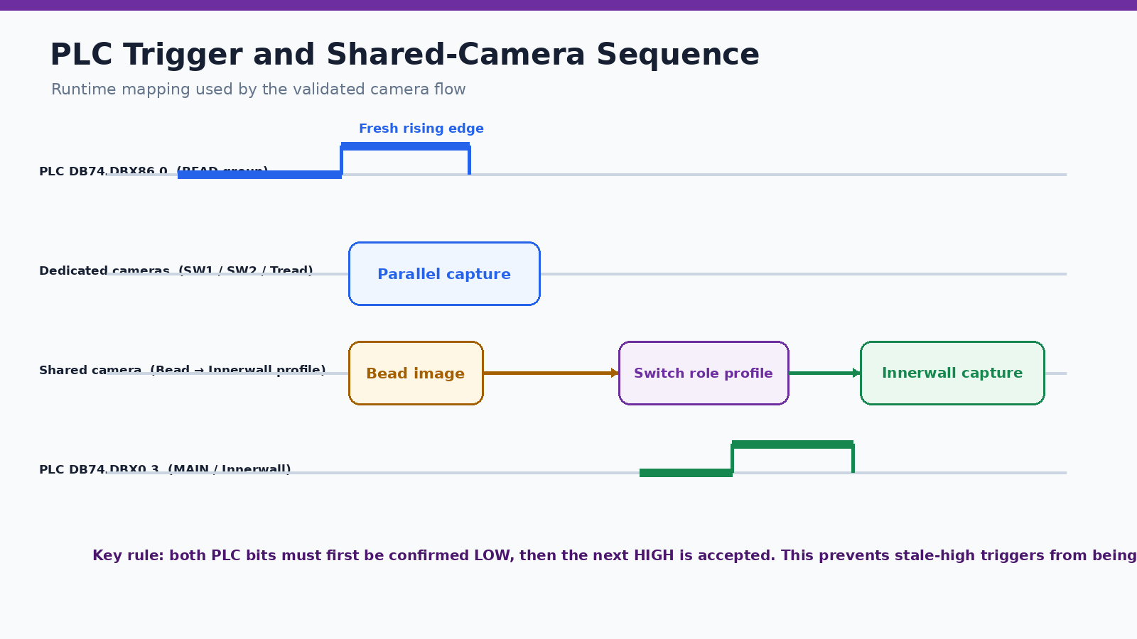
Figure 8-1. Validated PLC trigger order and shared camera role switch.

8.1 Trigger mode
Production camera capture uses PLC software trigger. Apollo detects a fresh rising edge by first proving the configured PLC bit is LOW and then accepting the next HIGH. This avoids reusing a bit that was already high before the cycle began.

8.2 Validated runtime mapping
PLC signal | Camera action
DB74.DBX86.0 (BEAD group) | Dispatch sidewall1, sidewall2, tread and bead in parallel across physical cameras.
DB74.DBX0.3 (MAIN / innerwall) | Capture innerwall after the shared bead/innerwall camera is ready. The integrated laser scan is also taken on this event in the current flow.

8.3 Image formation
For line-scan roles that return multiple chunks, Apollo allocates the final image and copies each chunk into sequential row ranges until the configured final height is reached. The current stitching is deterministic row placement without geometric blending. Direct full-frame roles must exactly match the configured width and height or the cycle is stopped rather than saving a partial frame.

8.4 Software flat-field correction
After capture, Apollo calculates a per-column intensity profile, derives a target value, clips the gain vector to configured limits and applies the gain in row blocks. The corrected image retains the source bit depth. New SKU capture refuses to save a stage unless FFC is confirmed for all five sides.

8.5 Capture integrity expectations
- All required sides returned a non-empty image.
- Image dimensions equal the profile configuration.
- No stale or duplicate PLC edge was accepted.
- No incomplete Arena buffer exceeded the retry policy.
- Shared camera completed bead before innerwall.
- Saving and traceability completed according to failure policy.

09

AI Inference and Decision Flow
Why sidewalls run first and how all five results are combined.

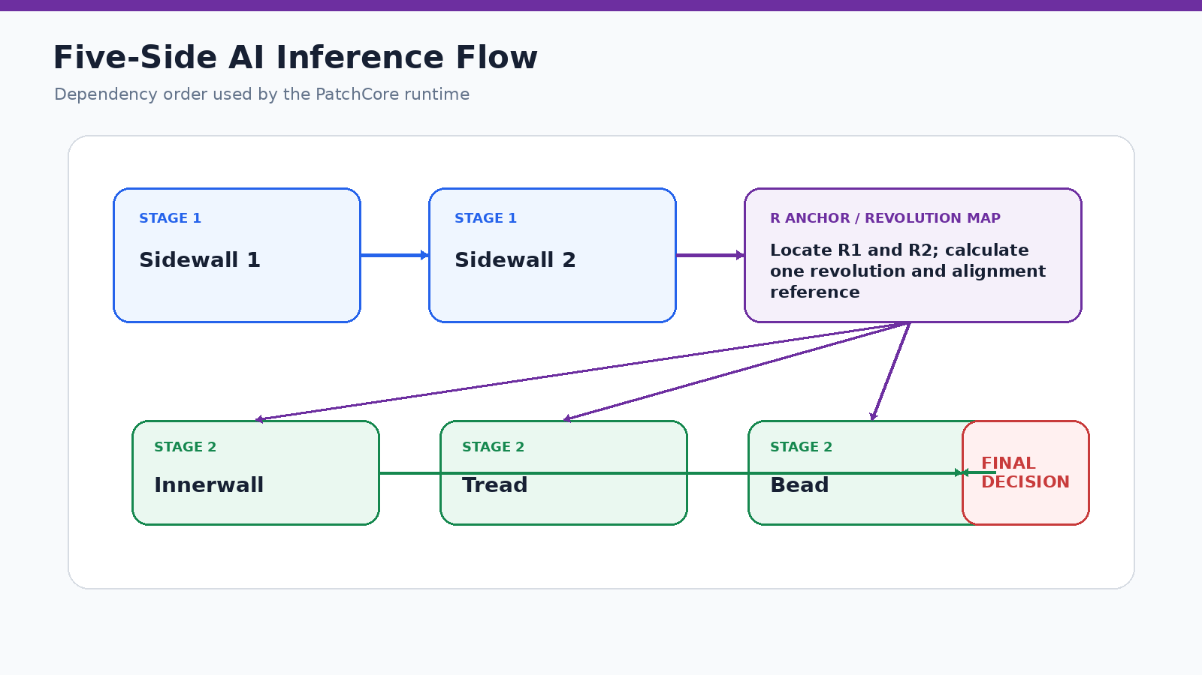
Figure 9-1. Two-stage five-side PatchCore inference dependency.

9.1 Runtime preparation
Before the first cycle, Apollo resolves the selected SKU artifacts, builds or retrieves cached PatchCore side runtimes, moves required models to the configured device and optionally performs warm-up. The cache is tied to the SKU, side, device and artifact signature so a changed model does not silently reuse an old runtime.

9.2 Sidewall stage
Sidewall1 and sidewall2 run first, in parallel when configured. A selected sidewall provides the R1/R2 revolution mapping used to align the other tyre zones. If fewer than two valid R bands are found, Apollo saves a diagnostic preview and records the failure rather than using an unreliable crop.

9.3 Dependent zones
Innerwall, tread and bead use the sidewall revolution reference and their SKU-specific offset calibration to crop the correct physical region before PatchCore scoring. Each side returns evidence and a label; the cycle engine combines the side decisions into the final tyre result.

9.4 Common AI failure indicators
Indicator | Meaning
R_MAPPING_FAILED_PREVIEW.png | R1/R2 could not be located with the configured recipe/search region.
Offset crop outside image | Calibration or revolution/offset values do not fit the captured image geometry.
Missing model artifact | The active SKU is incomplete or points to an incorrect training path.
Different patch position / score | Resize, crop, scoring mode, R mapping or image content differs from the approved baseline.
GPU unavailable | Apollo may fall back to CPU only if configured; production cycle time can change significantly.

Do not “fix” AI by lowering thresholds blindly
First verify the correct image, profile, R recipe, offset calibration, resize settings and model version. Threshold changes should be validated against approved good and defect datasets.

10

Device Configuration
Discover, configure and profile the connected Lucid line-scan cameras.

10.1 Device page responsibilities
- Discover connected cameras and verify serial-to-role assignment.
- Preview a device when no production workflow owns it.
- Set or review width, camera height, final height, pixel format, exposure, gain and line rate.
- Apply a SKU-specific camera profile.
- Save profile settings under media/Camera_Profiles/<SKU>/camera_profile.json.
- Release camera streams when navigating away from the page.

10.2 Shared bead/innerwall camera
Bead and innerwall use one physical camera with separate role settings. The profile must contain distinct bead and innerwall exposure, gain, line-rate and image-geometry values where required. Do not treat the shared camera as two independent devices.

10.3 Recommended configuration order
- Confirm serial-to-side mapping.
- Set pixel format and image geometry.
- Set exposure and gain for the tyre surface.
- Set acquisition line rate for the machine speed.
- Verify packet size, packet delay and jumbo-frame network settings.
- Test one capture for every logical side.
- Save the profile under the intended SKU name.
- Close the device stream before entering Live or New SKU capture.
Profile name vs destination SKU
The New SKU Capture tab can explicitly apply an existing camera profile while saving images to a new destination SKU. Always confirm both names before capture.

11

Camera and Laser Capture Tools
Engineering capture pages for controlled acquisition and troubleshooting.

11.1 Camera capture tab
The Camera capture tool provides a controlled way to run the PLC-software-trigger acquisition path, view terminal status and save raw/corrected outputs according to the selected configuration. It uses a child process and a graceful STOP command so camera resources can finish their own cleanup before the page closes.

11.2 Laser capture tab
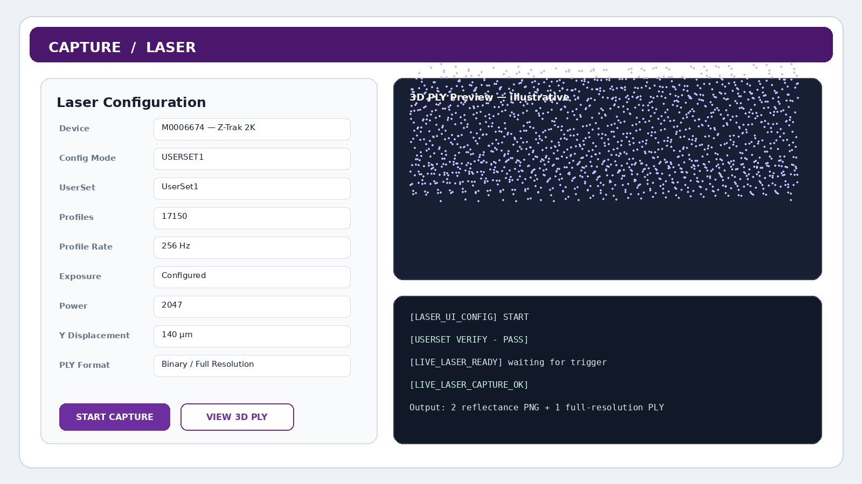
Figure 11-1. Conceptual Laser capture page with compact configuration, PLY preview and status console.
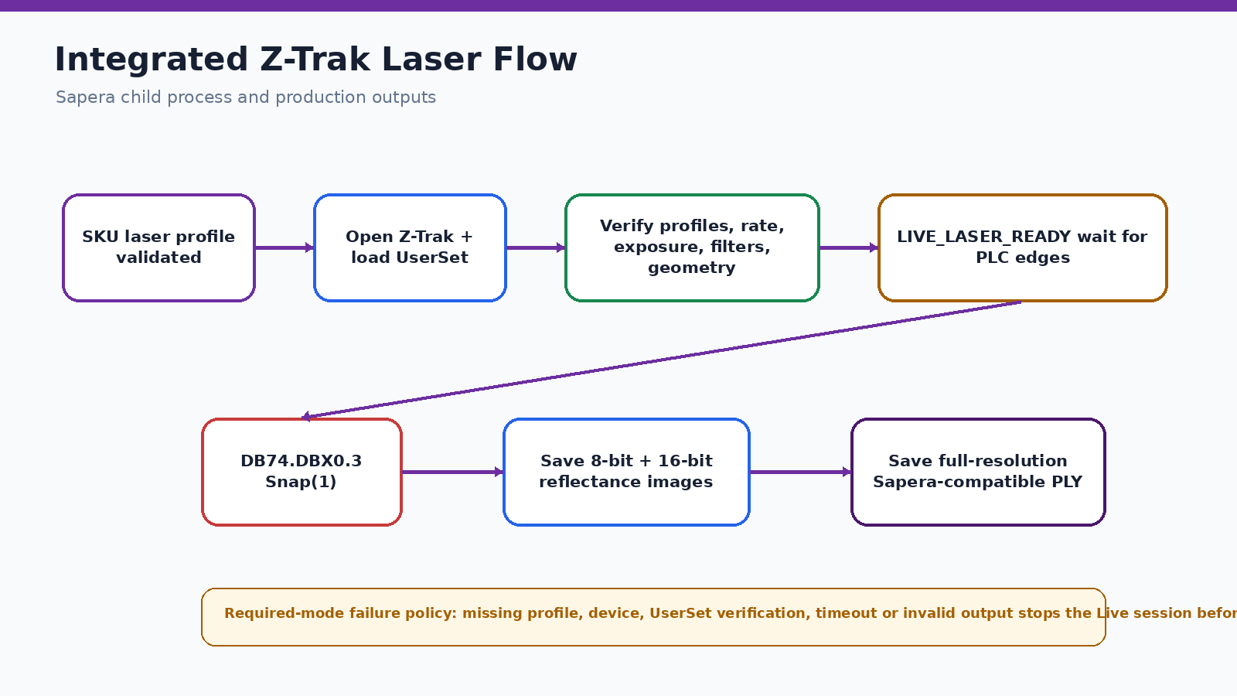
Figure 11-2. Integrated laser preparation, trigger and save flow.

Typical production outputs
media\Laser_Capture\<SKU>\DD-MM-YYYY\Cycle_N\
01_laser_1_ztrak_2k_<SERIAL>\
*_2d_reflectance_preview_8bit.png
*_2d_reflectance_16bit.png
*_pointcloud_fullres_binary_sapera_um.ply

3D PLY viewer
Mode / key | Behavior
Fast Preview | Displays a deterministic subset up to roughly four million points without altering the source PLY.
Full Resolution | Displays every point; can require several gigabytes of memory and is disabled during active capture.
R | Reset the recommended sidewall view.
1 / 2 / 3 | XY / XZ / YZ views.
I | Isometric view.
S | Save a screenshot next to the PLY.

11.3 Sapera/UserSet verification
In UserSet mode, the laser process loads the selected UserSet and verifies critical acquisition, filter and geometry features before capture. Serial-specific Y displacement and the streamed X/Z geometry are checked. A mismatch blocks production capture because an incorrect PLY scale cannot be repaired reliably after the scan.
Exclusive laser access
Close Z-Expert, CamExpert and any previous Apollo laser child process before capture. Sapera resources are exclusive and a hidden process can make the laser appear unavailable.

12

Axis Status and PLC Commands
Maintenance visibility into motion and authorized machine commands.

12.1 Axis Status page
The Axis Status page reads configured PLC position and status values and refreshes them for maintenance review. It is intended for visibility and controlled commissioning, not for bypassing machine interlocks.

12.2 Protected commands
Command | Expected use
PLC Auto Start | Send the configured Auto Start pulse after machine readiness and permission checks.
All Servo Reset | Send the configured reset pulse to clear permitted servo faults.
Recipe target capture | Read live axis values and store them as New SKU recipe targets.
Recipe write/read-back | Write recipe target values to configured PLC DB addresses and verify the PLC returned the same data.

12.3 Axis teaching guidance
- Confirm the machine is in the approved teaching state.
- Select capture-from-PLC or manual entry deliberately.
- Use one consistent physical reference for all targets.
- Review live value, target value and delta before saving.
- Do not activate a recipe until every required target has been verified.

13

New SKU End-to-End Workflow
A controlled path from tyre identity to a deployable production recipe.

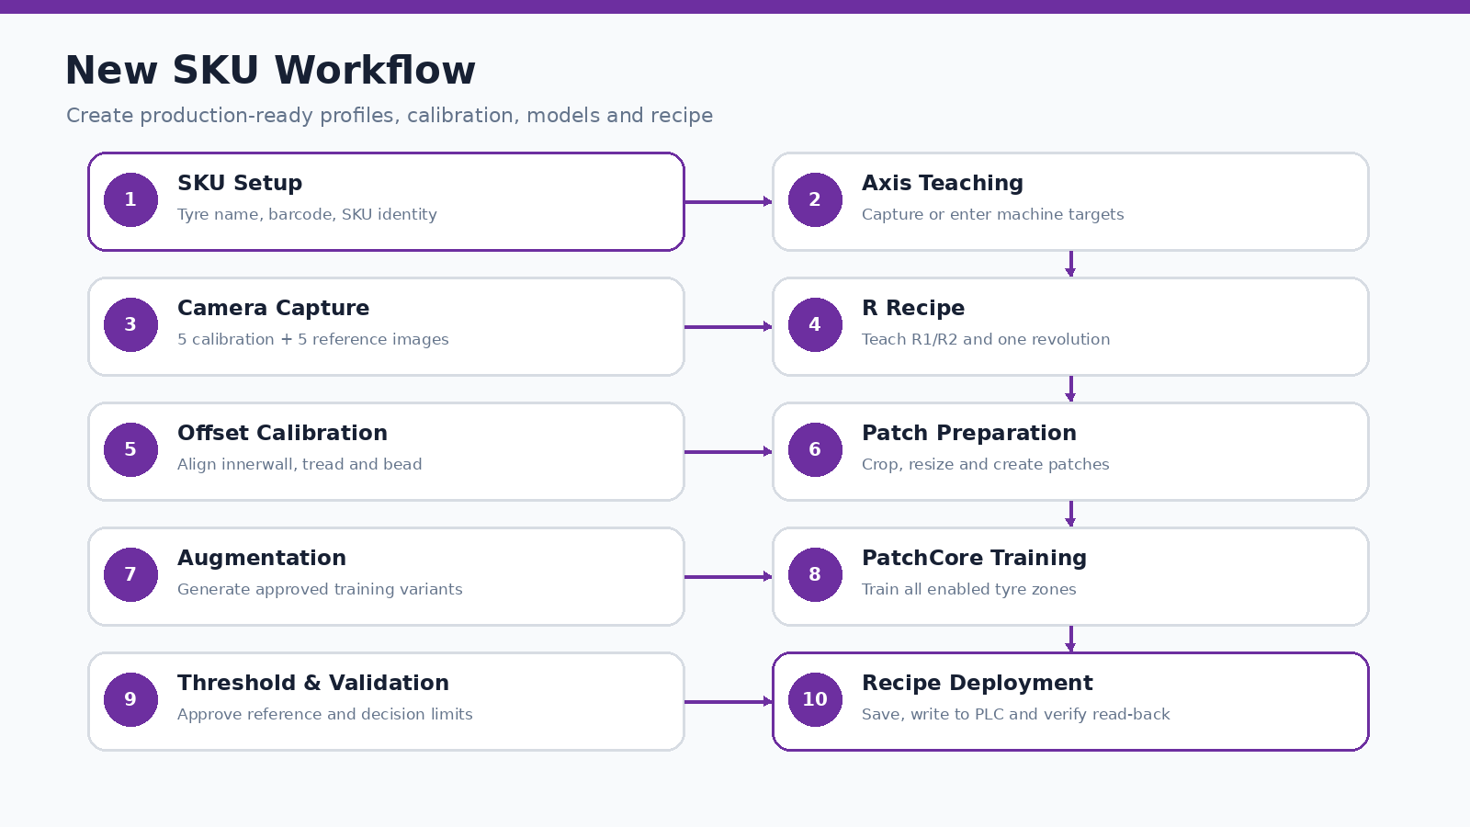
Figure 13-1. New SKU preparation and approval workflow.
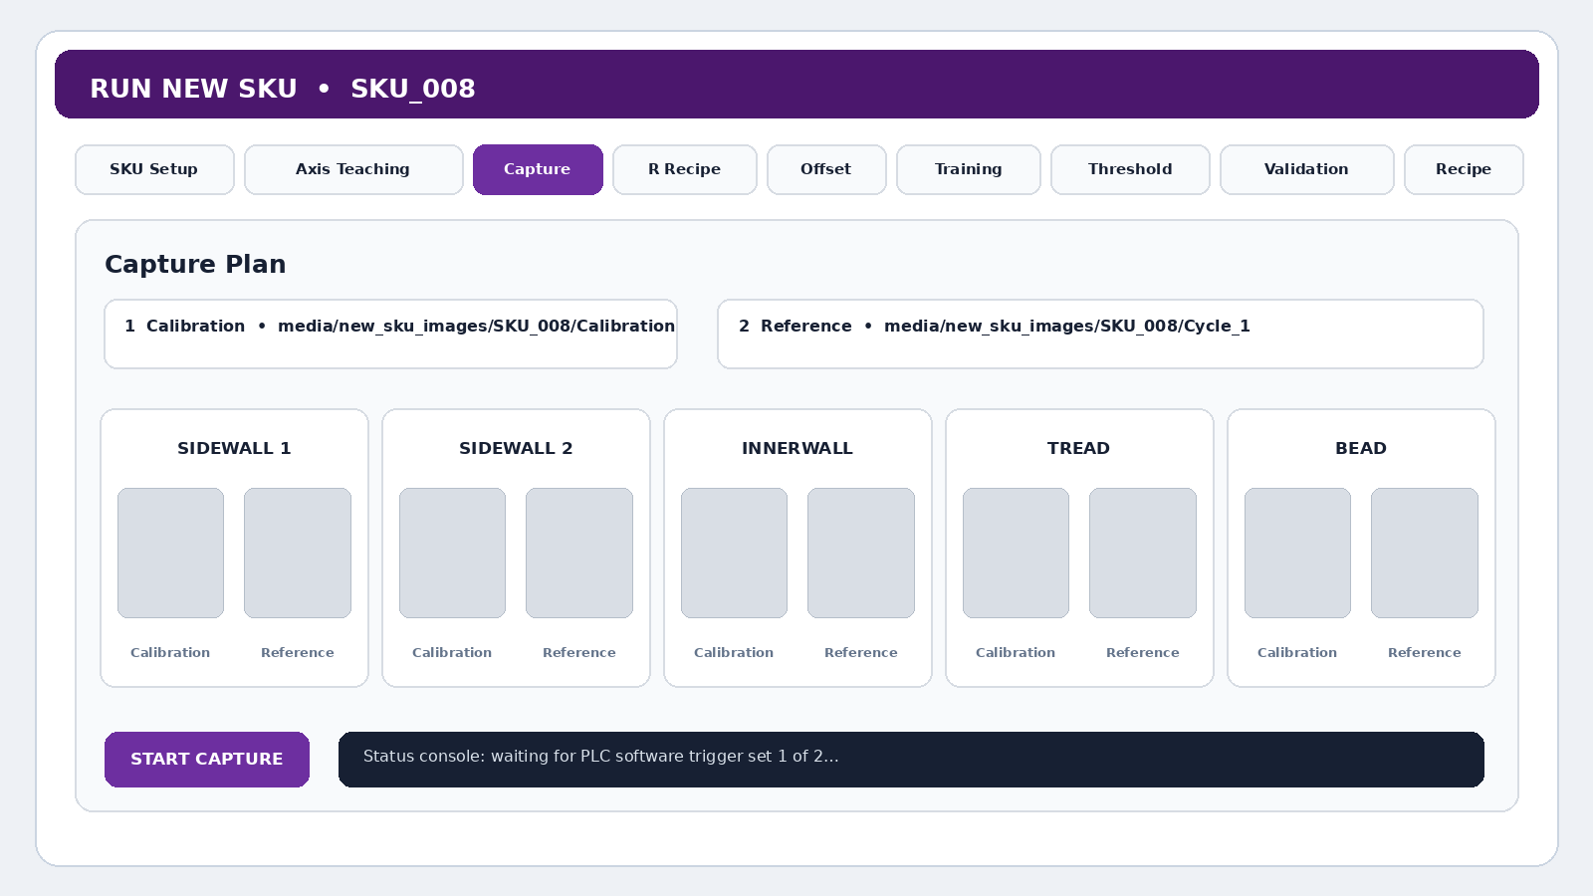
Figure 13-2. Conceptual New SKU Capture tab showing calibration and reference sets.

13.1 SKU Setup
Create the SKU identity and required tyre metadata first. The destination SKU determines where new artifacts are stored. Save the setup before opening capture or calibration steps.

13.2 Axis Teaching
Capture current machine positions from the PLC or enter approved target values manually. Apollo stores the recipe targets with their configured PLC DB addresses and data types. Review all deltas before accepting the axis set.

13.3 Two-set camera capture
New SKU capture is fixed to two complete PLC-software-trigger sets. Streams start once, remain open for both sets and stop once after all ten corrected images are saved.
media\new_sku_images\<SKU>\
Calibration\
sidewall1\sidewall1_calibration.png
sidewall2\sidewall2_calibration.png
innerwall\innerwall_calibration.png
tread\tread_calibration.png
bead\bead_calibration.png
Cycle_1\
sidewall1\sidewall1_reference.png
sidewall2\sidewall2_reference.png
innerwall\innerwall_reference.png
tread\tread_reference.png
bead\bead_reference.png

Capture procedure
- Select the destination SKU.
- Refresh and select the camera profile to apply.
- Review the displayed Calibration and next Cycle_N paths.
- Start Capture and wait for trigger set 1: one calibration image for each side.
- Wait for trigger set 2: one reference image for each side.
- Confirm both thumbnails appear for all five zones and the status reports 10/10 images.
- Open the output folder and verify the original full-size PNG files.
Calibration overwrite behavior
The standard Calibration folder represents the current calibration set, while each reference session creates the next Cycle_N folder. Recalibration variants may use Calibration_2, Calibration_3 and so on in supported workflows.

13.4 R Recipe
Use a clean sidewall calibration image to locate and teach R1 and R2. The recipe stores the R anchors, one-revolution height and supporting detection settings. The optional left-edge inset should remain zero unless the detected tyre boundary includes an unwanted black/background strip.

13.5 Offset Calibration
Innerwall, tread and bead are aligned to the sidewall revolution reference. Apollo pairs the calibration sidewall with the target view, detects the target marker, calculates the offset ratio and saves role-specific calibration JSON and visual overlays. Review every overlay before continuing.

13.6 Patch creation and augmentation
The workflow crops the calibrated one-revolution region, resizes it according to the approved side configuration and creates the PatchCore training patches. Augmentation is applied to the patch dataset only according to the selected plan; avoid creating variants that change the physical meaning of defects.

13.7 Training and threshold
Run PatchCore training for all enabled sides. Expected model output follows the SKU/side path under media/training. The Threshold step uses an approved good reference image and validation samples to establish the decision limit. Record the dataset and model version used.

13.8 Validation and completion
- ☐ Confirm all five required side models exist.
- ☐ Confirm R recipe and offset calibration files are present.
- ☐ Confirm the camera and laser profile links are correct.
- ☐ Run controlled good and known-defect validation samples.
- ☐ Confirm false accept/reject behavior is within the approved limit.
- ☐ Save and approve the recipe only after review by the authorized engineer/quality role.

14

Recipe Management and Deployment
Link PLC recipe numbers to the correct SKU, profiles, calibration and model set.

14.1 Recipe contents
Area | Typical content
Identity | Recipe number, SKU name, tyre metadata and version.
Motion targets | Machine, camera and laser axis target values.
Camera profile | Path or link to media/Camera_Profiles/<SKU>/camera_profile.json.
Laser profile | Path or link to media/Laser_Profiles/<SKU>/laser_profile.json.
AI artifacts | R recipe, offset calibration, side models, thresholds and validation status.
PLC deployment | DB target mapping, write status and read-back verification.

14.2 Deployment procedure
- Open Recipe Management with the required permission.
- Select or create the recipe version.
- Review the SKU, camera profile, laser profile, axis targets and AI readiness.
- Write the recipe data to the configured PLC DB addresses.
- Read back every required value and confirm it matches.
- Set the intended recipe number and verify the PLC active-recipe value.
- Run one controlled tyre cycle and review all saved evidence before releasing production.
Do not bypass read-back
A successful write call alone is not proof that the PLC contains the intended recipe. Apollo’s read-back verification is the commissioning evidence.

14.3 Version and rollback practice
Keep the previous approved recipe, camera profile, laser profile and model package available until the new version has completed controlled production validation. Record who approved the change, the date, the tyre/sample set and the rollback location.

15

Quality, Review and Engineering Tools
Supporting pages for traceability, repeatability, annotation and measurement.

15.1 Dashboard and Inspection History
Dashboard summarizes production and inspection counts. Inspection History provides the detailed traceability view of completed cycles, including cycle identity, SKU, result, timestamps and linked evidence where available. Use History rather than browsing folders when a controlled record is required.

15.2 Repeatability
Use Repeatability to capture or analyze repeated runs under the same setup. Keep the SKU, tyre position, machine speed, profiles, lighting and model version unchanged. Investigate shifts in image geometry, intensity, R mapping, anomaly score or final result.

15.3 OSC / action-code page
The OSC page manages condition codes, action codes and quality decision rules. Treat published revisions as controlled quality data. Draft changes should be reviewed and approved before they influence production routing.

15.4 Annotation Tool
The Annotation Tool supports image labeling for AI and quality review. Use consistent class names, label only visible evidence, keep the original image unchanged and store the annotation with its SKU, side and cycle context.

15.5 ROI Measure
ROI Measure provides pixel-distance measurement and optional conversion to millimetres after calibration. Confirm the correct camera/side scale, image resize state and measurement plane before reporting a physical dimension.
Measurement limitation
A pixel-to-millimetre scale is valid only for the calibrated view and geometry. It is not automatically interchangeable between sidewall, tread, innerwall, bead or a resized image.

16

Data Storage, Logs and Traceability
Understand the authoritative database records and the supporting media folders.

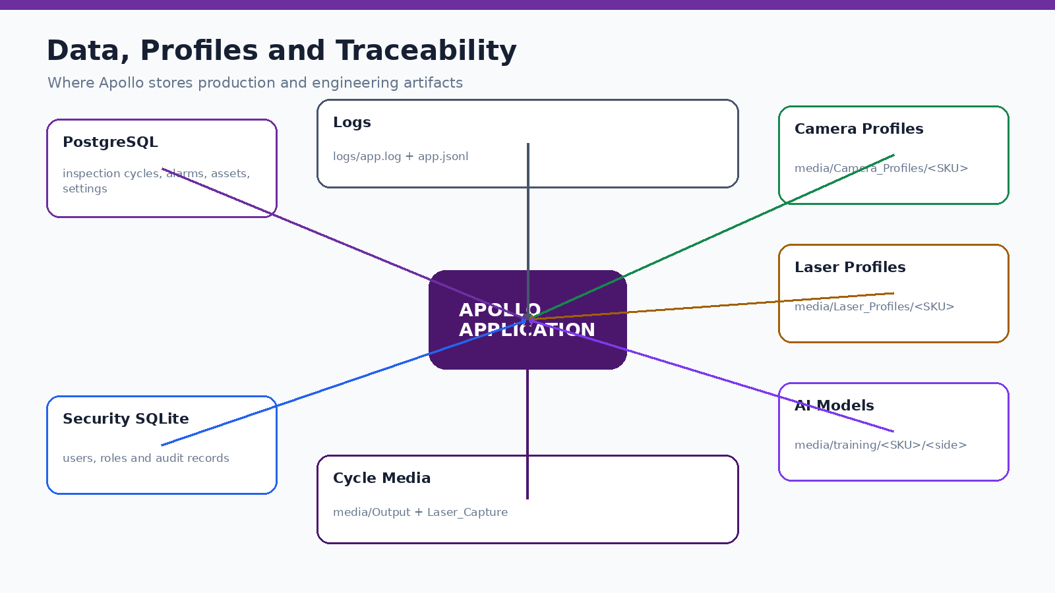
Figure 16-1. Apollo storage and profile architecture.

16.1 Runtime database
Setting | Production value
Host | 127.0.0.1
Port | 5432
Database | eyresqc_apollo
Application user | apollo_user
Schema | apollo

The latest runtime is PostgreSQL-first. Legacy MongoDB support is limited to explicit migration/fallback switches and is not opened during normal GUI startup. A local outbox can preserve completed inspection records temporarily when synchronization is interrupted.

16.2 Important folders
Path | Purpose
media/Camera_Profiles/<SKU>/camera_profile.json | SKU-specific camera acquisition settings.
media/Laser_Profiles/<SKU>/laser_profile.json | SKU-specific laser selection and capture settings.
media/Output/<SKU>/<date>/Cycle_N | Live camera images, AI outputs and cycle evidence.
media/Laser_Capture/<SKU>/<date>/Cycle_N | Laser reflectance images and PLY output.
media/new_sku_images/<SKU> | Calibration and reference images for New SKU work.
media/training/<SKU>/<side> | Training artifacts and PatchCore model files.
logs/app.log | Human-readable structured application log.
logs/app.jsonl | Machine-readable JSON Lines log.
data/security/apollo_security.db | Local users, roles and security audit data.

16.3 Cycle identity and evidence
Camera, laser, AI, database and GUI should refer to the same Cycle_N identity. When investigating a cycle, collect the database row, five camera images, laser outputs if enabled, AI side folders, timing report and the matching log interval.

16.4 Log event examples
AUTH_LOGIN_SUCCESS
INSPECTION_SYNC_SERVICE_STARTED
APP_CONFIG_LOADED
RUNTIME_BACKEND_SELECTED
PERFORMANCE_TIMING
PATCHCORE_CYCLE_COMPLETED
INSPECTION_CYCLE_PERSISTED
ALARM_OPENED / ALARM_RECOVERED
LIVE_LASER_READY / LIVE_LASER_CAPTURE_OK

17

Alarms, Errors and Recovery
Use the alarm state and event code to identify the failing layer.

17.1 Alarm lifecycle
State | Meaning
OPENED | The condition became active for the first time.
REOCCURRED | The same condition became active again or repeated while unresolved.
ACKNOWLEDGED | A user has reviewed the alarm; the technical condition may still exist.
RECOVERED | The health check returned to normal.
CLOSED | The alarm lifecycle is complete according to the application policy.

17.2 Recovery method
- Read the exact component, event code, cycle and zone in the Alarm Center or app.log.
- Determine whether the first failure is database, PLC, camera, laser, GPU, disk or AI assets.
- Correct only the first failing layer.
- Release any hidden process that owns the hardware.
- Rerun the targeted check or Full Hardware Check.
- Confirm the alarm recovers and run one controlled cycle before production.

17.3 Evidence to collect before changing code
- Full terminal log from application startup through the failure.
- Exact cycle folder and all five input images.
- Active SKU, recipe number and profile file versions.
- PLC bit states and timestamps around the failure.
- Camera/laser serial and network status.
- Screenshot of the page status and Alarm Center entry.
- Any generated diagnostic JSON, overlay or failure preview.

18

Graceful Stop and Shutdown
Close workers and hardware resources without corrupting the next start.

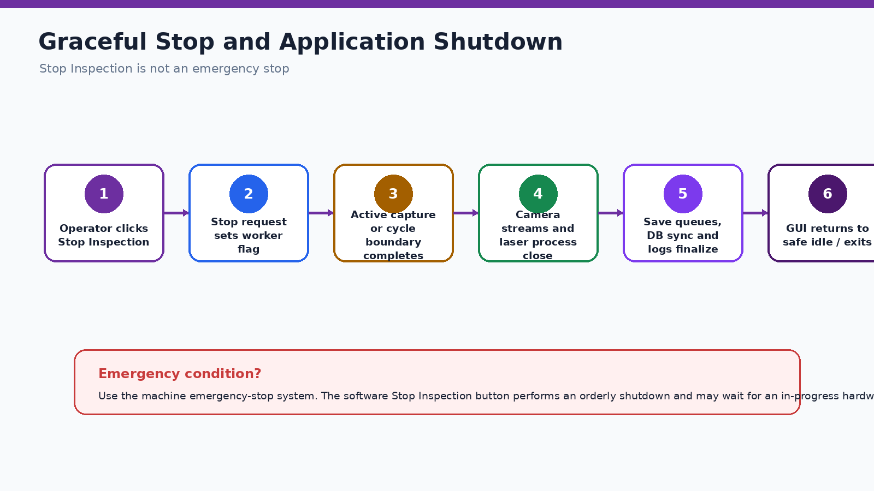
Figure 18-1. Graceful stop and shutdown sequence.

18.1 Stop Inspection
Stop Inspection sets the continuous worker stop request. The worker exits at a safe boundary, then closes camera streams and the laser child process, finalizes saving, releases the PLC session and updates the GUI. The button does not interrupt an operating-system driver call instantly.

18.2 Leaving Device or Capture pages
When navigation leaves the Device page, Apollo destroys page-owned camera handles. When navigation leaves the Capture page, Apollo requests shutdown of the camera runner, Sapera laser runner and PLY viewer. This prevents invisible pages from retaining exclusive ownership.

18.3 Application exit
- Stop Live inspection and wait for the idle state.
- Close any PLY viewer or engineering capture process.
- Use the profile menu → Exit Application.
- Confirm the terminal records application cleanup and stops without a QThread warning.
- Do not power off the workstation while database or image writes are still running.
Abnormal exit signs
“QThread: Destroyed while thread is still running”, deleted Qt worker errors, open Sapera processes or camera streams not started on the next launch indicate the previous shutdown was incomplete. Restart the workstation only after saving the logs.

19

Maintenance and Backup
Preventive tasks that keep capture quality and traceability stable.

19.1 Daily checks
- ☐ Run Full Hardware Check before production.
- ☐ Check camera/laser lenses and protective windows for contamination.
- ☐ Verify free space on the media drive.
- ☐ Review open alarms and the previous shift’s failed cycles.
- ☐ Confirm the active SKU/recipe matches the production plan.
- ☐ Run one controlled test tyre when the machine has been serviced.

19.2 Weekly checks
- ☐ Review app.log for repeated payload, rearm, trigger or database warnings.
- ☐ Verify camera and laser network links, packet settings and switch port errors.
- ☐ Check a representative image from each of the five zones for geometry and FFC consistency.
- ☐ Open one recent PLY in Fast Preview and verify scale/orientation.
- ☐ Test database backup and confirm the output file is non-zero.

19.3 Monthly / controlled-change checks
- ☐ Back up PostgreSQL, .env, profiles, recipes, models, calibration JSON and security database.
- ☐ Record installed Python, Arena, Sapera, CUDA and driver versions.
- ☐ Review user accounts and disable unused access.
- ☐ Run repeatability samples for approved SKUs.
- ☐ Validate a restore on a controlled workstation or spare database when possible.

19.4 PostgreSQL backup
"C:\Program Files\PostgreSQL\17\bin\pg_dump.exe" ^
-h 127.0.0.1 -p 5432 -U apollo_user ^
-d eyresqc_apollo -F c ^
-f C:\Apollo_Backup\eyresqc_apollo_YYYYMMDD.backup

19.5 Configuration backup set
- Approved .env and .env.example (without publishing real passwords).
- media/Camera_Profiles, media/Laser_Profiles and recipe JSON folders.
- media/training model artifacts and validation records.
- data/security/apollo_security.db stored securely.
- PostgreSQL backup and migration files.
- Current source release package and change notes.

20

Installation and Commissioning
Bring up Apollo on a new Windows workstation using the validated deployment package.

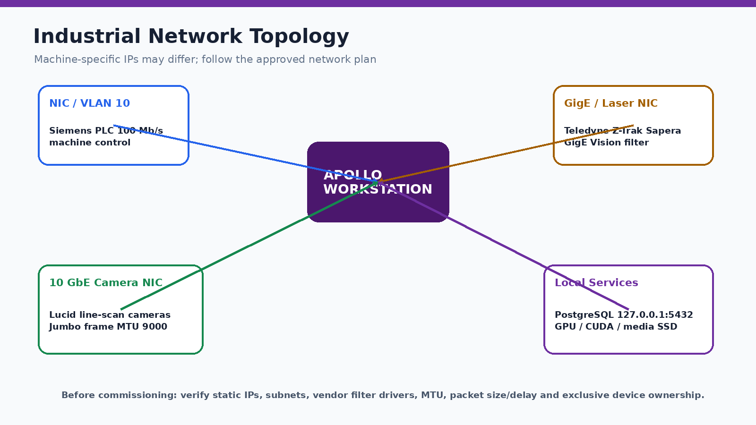
Figure 20-1. Conceptual industrial network and local-service topology.

20.1 Fixed deployment values
Item | Value
Project folder | C:\Apollo_patch_pos
Conda environment | Apollo
PostgreSQL host | 127.0.0.1
PostgreSQL port | 5432
Database | eyresqc_apollo
Application database user | apollo_user
Schema | apollo
Launch command | python GUI.py

20.2 Installation sequence
- Install Windows updates and the approved NVIDIA, Lucid Arena and Teledyne Sapera/Z-Expert software.
- Configure NICs, static IPs, VLANs, jumbo-frame settings and vendor filter drivers.
- Copy the complete deployment package to C:\Apollo_patch_pos.
- Create or restore the Apollo Conda environment from environment.yml when supplied.
- Install requirements, psycopg binary/pool support and python-snap7.
- Install PostgreSQL, create apollo_user, eyresqc_apollo and schema apollo.
- Configure the approved .env with matching database credentials.
- Apply every numbered Apollo migration using the approved migration runner.
- Launch Apollo, run hardware checks and complete one controlled test inspection.
- Create the initial database and configuration backup.

20.3 Environment and dependencies
cd /d C:\Apollo_patch_pos
conda env create -f environment.yml
conda activate Apollo
python -m pip install -r requirements.txt
python -m pip install --upgrade "psycopg[binary,pool]"
python -m pip install "python-snap7<3"

20.4 Database creation summary
"C:\Program Files\PostgreSQL\17\bin\psql.exe" -h 127.0.0.1 -p 5432 -U postgres
CREATE ROLE apollo_user WITH LOGIN;
\password apollo_user
CREATE DATABASE eyresqc_apollo OWNER apollo_user;
\c eyresqc_apollo
CREATE SCHEMA IF NOT EXISTS apollo AUTHORIZATION apollo_user;
ALTER ROLE apollo_user IN DATABASE eyresqc_apollo
SET search_path TO apollo, public;

20.5 Apply migrations
conda activate Apollo
cd /d C:\Apollo_patch_pos
python apply_apollo_postgres_migrations.py

Migration rule
Do not create substitute tables manually and do not run template SQL containing {{schema}} blindly. Use the approved runner so all numbered migrations, indexes, constraints and triggers are applied in order.

20.6 Commissioning acceptance
- ☐ PostgreSQL pool opens and Inspection History loads without missing-relation errors.
- ☐ PLC, all cameras, laser, GPU and disk pass the Full Hardware Check.
- ☐ A valid SKU can preload all model artifacts.
- ☐ One controlled cycle saves five camera images, required laser outputs and database traceability.
- ☐ The final result is transmitted to the PLC and visible in Inspection History.
- ☐ The system can stop and restart without resource ownership errors.

21

Troubleshooting Reference
Start with the first failing layer and preserve evidence before changing settings.

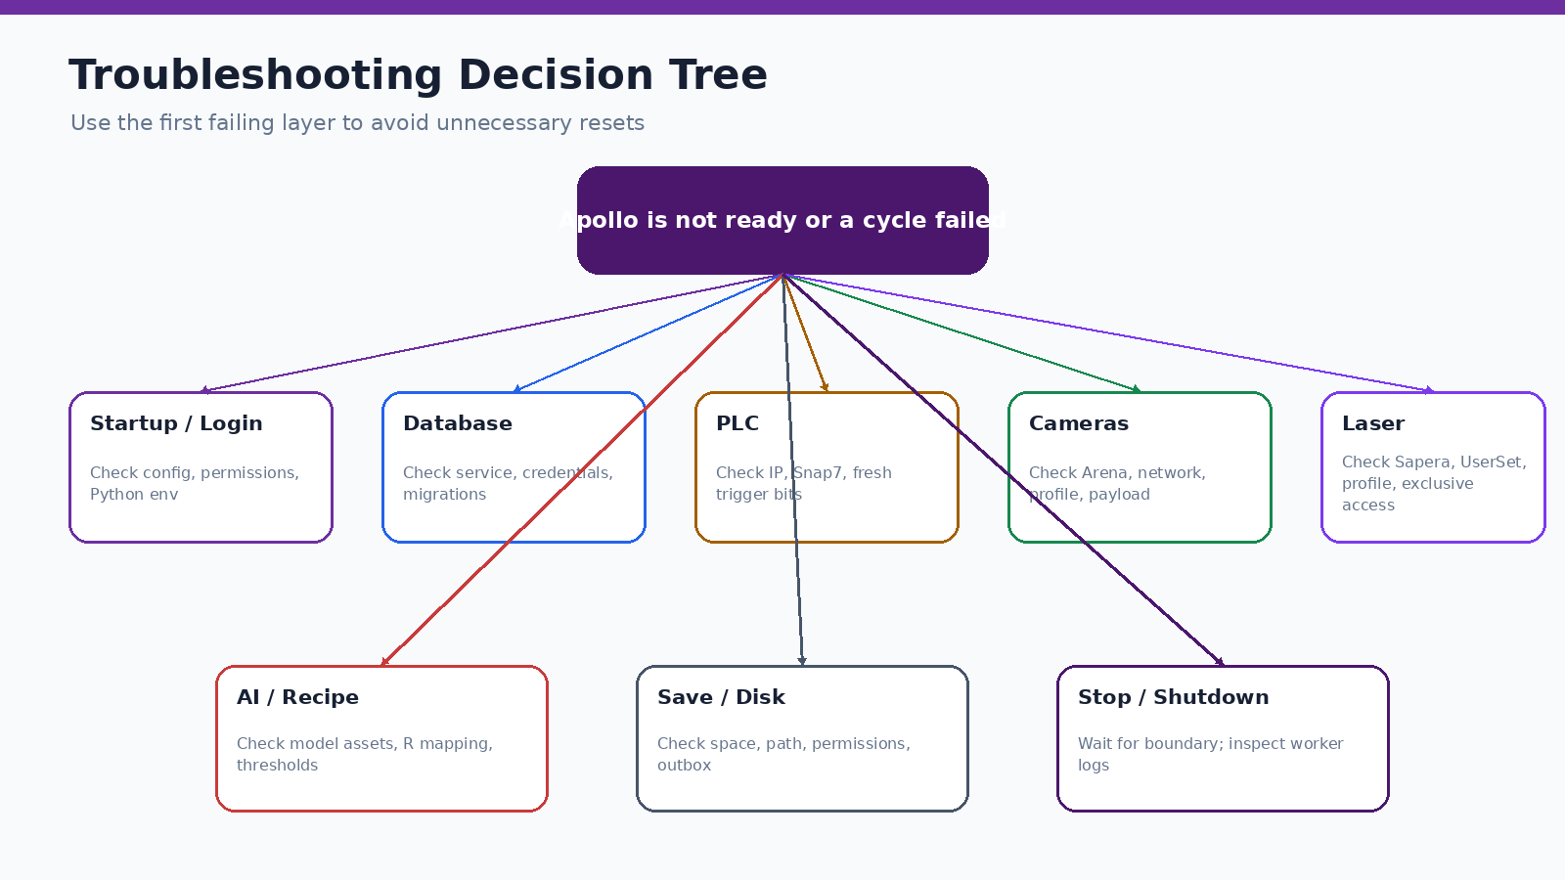
Figure 21-1. High-level troubleshooting decision tree.

21.1 Common startup and database errors
Symptom | Likely cause | Correct action
no pq wrapper available | psycopg installed without usable binary libpq | Install/upgrade psycopg[binary,pool].
No module named psycopg_pool | Connection-pool package missing | Install psycopg[binary,pool] or psycopg-pool.
database eyresqc_apollo does not exist | Wrong/missing database | Create the exact database or deliberately correct the config.
relation apollo.* does not exist | Migrations incomplete | Run the full numbered migration installer.
password authentication failed | Role password and .env do not match | Reset apollo_user password and update the active config.
PoolClosed after startup failure | Initial connection failed and pool was closed | Fix service/credentials and restart Apollo completely.

21.2 PLC and stop issues
Symptom | Checks / action
PLC communication unavailable | Confirm PLC power, IP 192.168.10.1 or deployed value, rack/slot, firewall and python-snap7 version.
No trigger accepted | Confirm bit first goes LOW, then HIGH; verify DB74.DBX86.0 and DB74.DBX0.3 mapping and poll logs.
Cycle waits indefinitely | Check missing second trigger, PLC latch, camera ready state and configured timeout.
Stop Inspection is slow | The worker may be inside a buffer/trigger timeout. Click once, review the latest status line and wait for the safe boundary; use E-stop only for danger.
QThread destroyed warning | Application exited before worker cleanup. Save logs, ensure Exit Application is used and verify page processes close.

21.3 Camera and image issues
Symptom | Checks / action
Camera array not ready | Close Arena/CamExpert, verify serials, NIC/subnet, MTU, packet settings and rerun hardware check.
GenTL / incomplete payload | Check cable/switch load, jumbo frames, packet delay, stream buffers and exclusive access.
Black lines / corrupt image | Check dropped packets, line rate vs tyre speed, trigger timing, exposure and shared-camera rearm.
Wrong final height | Verify camera height, number of chunks and final height in the selected profile.
FFC too bright/dark | Inspect the calibration surface, P95 target, gain clipping and whether the correct role profile was applied.
Second cycle slower | Look for stream reset/rearm, stale process ownership, incomplete buffers or save/DB backpressure.

21.4 Laser and PLY issues
Symptom | Checks / action
Z-Trak not found | Close Z-Expert, verify Sapera filter driver, NIC/subnet, device accessibility and no old child process.
UserSet verify failed | Compare the active UserSet, profiles, rate, exposure, power, filters, AOI and serial-specific Y displacement.
PLY appears white | Do not clear all geometry; use a contrasting background/color or inspect active scalars and camera orientation.
PLY scale distorted | Verify UserSet geometry, X step, Y displacement, AOI and units before capture; do not repair by arbitrary scaling.
Only small PLY saved | Confirm full-resolution enabled, debug step=1 and binary/ascii format setting.
Viewer uses too much memory | Use Fast Preview; Full Resolution can require several GB for ~12 million points.

21.5 AI/New SKU issues
Symptom | Checks / action
R recipe fails | Use the correct calibration sidewall, verify template/search region, threshold and left-edge inset.
Offset crop outside image | Check paired calibration images, R1/R2, one-revolution heights, offset ratio and target role geometry.
Training patches missing | Review preprocess_status.json, crop/resize output and patch folder for each enabled side.
Live differs from local run | Compare exact input image, resize/crop path, R mapping, scoring mode, model artifact and threshold.
Reference set missing | New SKU capture requires two complete trigger sets and should save Cycle_N reference images for all five sides.

22

Quick Reference Checklists and Glossary
Printable operational summaries for normal production and handover.

22.1 Start-of-shift checklist
- ☐ Machine and workstation powered; no vendor utility owns cameras/laser.
- ☐ Apollo environment activated and GUI launched.
- ☐ User signed in with correct role.
- ☐ Full Hardware Check passes.
- ☐ Correct active SKU and recipe confirmed.
- ☐ Camera/laser profiles and AI models validate.
- ☐ Disk space and database healthy.
- ☐ One controlled cycle completed after maintenance or configuration change.

22.2 Normal Live cycle checklist
- ☐ System Ready shown before trigger.
- ☐ BEAD group captures sidewall1, sidewall2, tread and bead.
- ☐ MAIN captures innerwall and required laser scan.
- ☐ Five camera images saved with matching Cycle_N.
- ☐ Laser folder contains expected reflectance images and PLY.
- ☐ AI completes for all enabled sides.
- ☐ Final result is visible, persisted and sent to PLC.
- ☐ No critical alarm remains open.

22.3 New SKU completion checklist
- ☐ SKU metadata saved.
- ☐ Axis targets captured/reviewed.
- ☐ Five calibration and five reference images saved.
- ☐ R recipe approved.
- ☐ Innerwall, tread and bead offset calibrations approved.
- ☐ Patches and augmentation reviewed.
- ☐ Five-side PatchCore models trained.
- ☐ Thresholds and validation accepted.
- ☐ Recipe written to PLC and read back.
- ☐ Controlled production cycle passed.

22.4 Glossary
Term | Meaning
AI / Inference | Automated analysis of the captured tyre images.
Arena SDK | Lucid camera software development kit/runtime.
Cycle_N | Shared identity and folder name for one inspection or reference capture.
FFC | Flat-field correction used to normalize column intensity in line-scan images.
GenTL / GigE Vision | Industrial camera transport standards used by the devices.
MAIN trigger | PLC event used for innerwall capture in the validated current mapping.
BEAD trigger | PLC event that releases sidewall1, sidewall2, tread and bead capture.
PatchCore | Anomaly-detection method used for side-specific tyre inspection.
PLY | 3D point-cloud file produced by the Z-Trak laser workflow.
R1 / R2 | Sidewall reference marks used to determine one tyre revolution and alignment.
Recipe | Versioned mapping of SKU, profiles, calibration, axis targets and PLC values.
Sapera LT | Teledyne DALSA acquisition framework used for Z-Trak.
SKU | Stock keeping unit / tyre product configuration.
UserSet | Vendor-device stored configuration loaded into the Z-Trak laser.

22.5 Source basis and validation status
This manual was compiled from the latest available Apollo source extracts, architecture assessment, role-based security guide, New SKU capture integration notes, PostgreSQL installation SOP, live Sapera laser integration guide, logs and project workflow history. It describes source-supported behavior and identifies conceptual illustrations explicitly. Hardware timing, network stability, PLC sequence and device settings must still be confirmed on the production machine after any change.
End of manual
Keep this document with the approved Apollo release package. Update the revision whenever page names, PLC tags, folder structures, profiles, AI workflow or database schema changes.

