Apollo PatchCore Tyre Inspection Application
Project Explanation Document
Project | EyresQC+ Apollo VIT App
System Type | Industrial PyQt tyre inspection system
AI Runtime | SKU-wise five-side PatchCore inspection
Hardware Integration | Lucid line-scan cameras, Siemens PLC, optional laser integration
Persistence | PostgreSQL, SQLite security DB, SQLite offline outbox, local media storage
Document Date | 2026-07-06

Document purpose
This document explains the Apollo PatchCore tyre inspection project in a clear, button-wise and workflow-wise manner. It is based on the current README and expands it into a project handover/technical explanation document for software, AI, PLC, database and operations teams.

Contents
1. Executive Summary
2. System Scope and Responsibilities
3. Full System Architecture
4. Main Entry Points and Runtime Modules
5. Button-wise Functional Explanation
6. Database and Storage Architecture
7. Five-Side PatchCore AI Runtime
8. Local Test Mode and Deployment Mode
9. PLC, Camera and Software FFC Runtime
10. New SKU Engineering Workflow
11. Installation, Startup and Validation
12. Operational Checklists
13. Troubleshooting Guide
14. Glossary

1. Executive Summary
The Apollo PatchCore Tyre Inspection Application is an industrial desktop application for tyre quality inspection. It provides a single operator-facing PyQt interface and connects hardware acquisition, AI inference, recipe management, SKU engineering, database storage and inspection result reporting into one workflow.
The system supports two operating modes. In local test mode, five predefined images are loaded from the media folder and passed through the same five-side AI pipeline. In deployment mode, Siemens PLC triggers and Lucid line-scan cameras are used to capture five side images, apply software flat-field correction, run SKU-specific PatchCore inference and produce a final OK/NG decision.
- Five tyre sides are processed: sidewall1, sidewall2, innerwall, tread and bead.
- Every SKU has its own PatchCore models, thresholds, sidewall templates and offset calibration JSON files.
- The final tyre result is conservative: any one NG side makes the complete tyre NG.
- PostgreSQL is the primary runtime database; SQLite is used for local security and offline outbox recovery.
- The New SKU workflow creates engineering capture data, templates, offsets, models, thresholds and recipe assets for future live inspection.

2. System Scope and Responsibilities
The application controls the process from user login to final inspection persistence. It is not only an AI inference program; it is a full inspection workstation with hardware checks, recipe control, capture, training, live operation, history, alarms and user management.
Area | Responsibility
User access | Login, role-based page access, user lifecycle and audit.
Device readiness | PLC, camera, laser and component checks before deployment mode.
Image acquisition | Local image loading or PLC-triggered Lucid line-scan camera capture.
Image correction | Software FFC correction applied to stitched camera images before AI.
AI inspection | Five-side PatchCore runtime with SKU-wise models and thresholds.
Recipe/SKU engineering | New SKU setup, axis teaching, template extraction, offset calibration, training and threshold generation.
Persistence | Inspection cycles, images, recipes, assets, alarms and outbox sync.
Operator reporting | Live result UI, dashboards, history, annotations and ROI measurement.

3. Full System Architecture
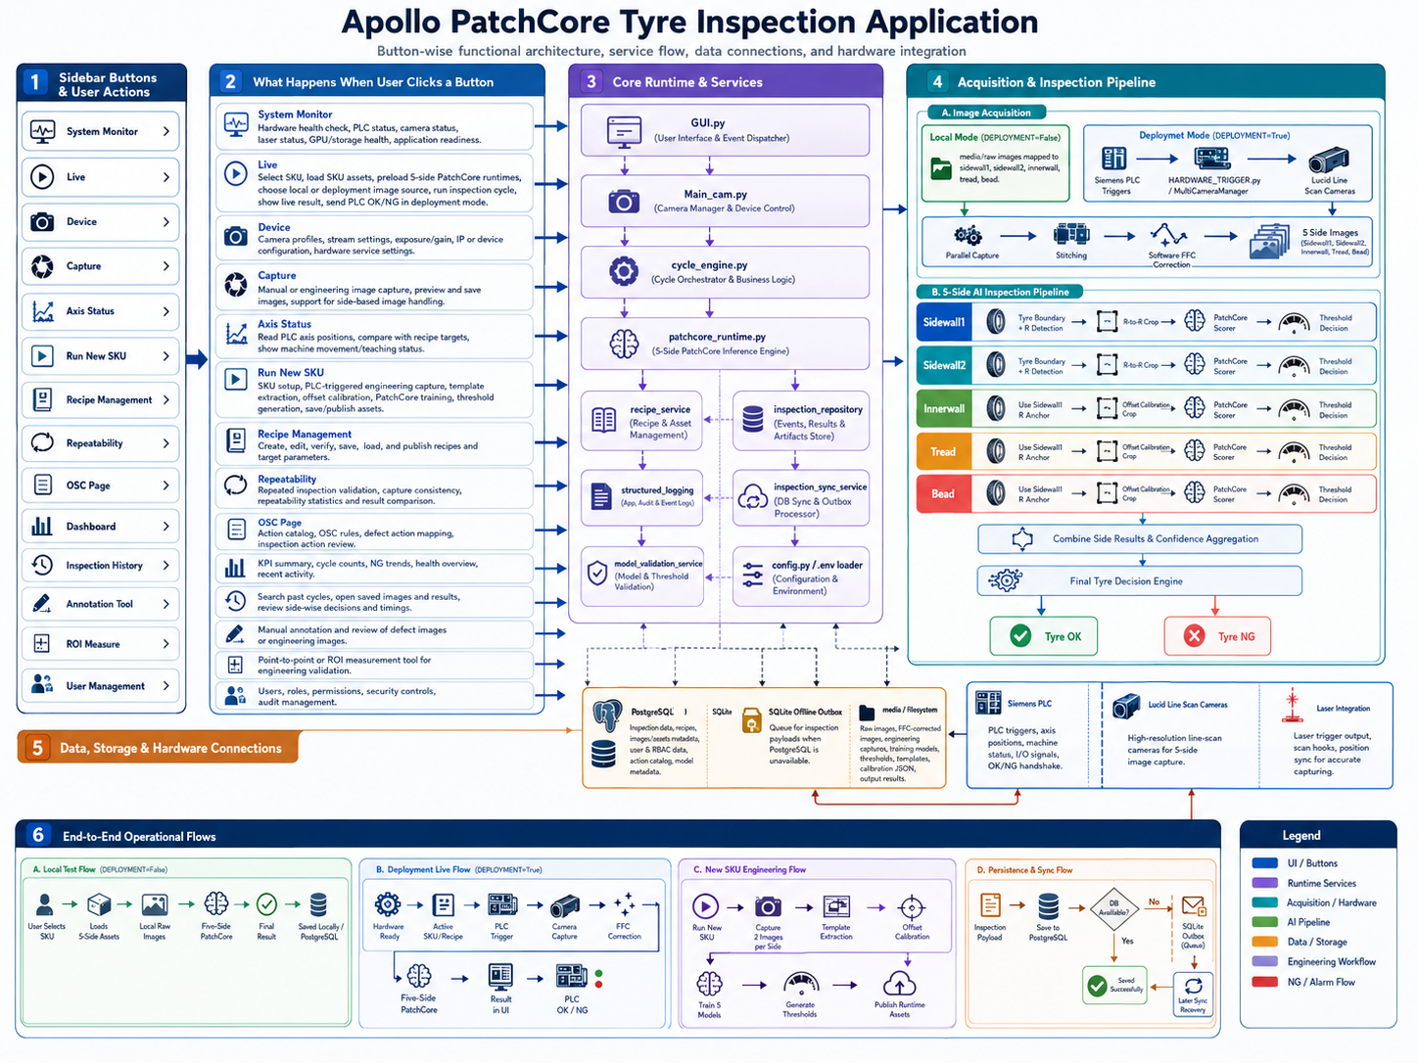

4. Main Entry Points and Runtime Modules
The application is button/page driven, but the live inspection logic is centralized in the runtime modules. This allows local testing and deployment capture to share the same AI decision pipeline.
Module | Explanation
GUI.py | Starts the PyQt application, login flow, main window, sidebar navigation and live dialog routing.
src/Main_cam.py | Controls live cycle startup, continuous/single cycle mode and runtime preparation.
src/COMMON/cycle_engine.py | Builds the side image map, captures or loads images, calls AI runtime and saves result payloads.
src/models/patchcore_runtime.py | Resolves SKU-wise PatchCore assets and runs the side-specific preprocessing and scoring logic.
src/camera/HARDWARE_TRIGGER.py | Handles PLC software trigger waiting, Lucid camera capture, stitching and software FFC.
src/camera/new_sku_software_capture.py | Handles New SKU PLC-triggered two-set capture and side-based image saving.
src/COMMON/recipe_service.py | Creates recipe documents, writes targets to PLC and manages SKU/recipe metadata.
src/COMMON/db.py | Provides database facade and returns repositories/services for the application.
src/COMMON/postgres/* | Contains PostgreSQL settings, migrations, connection handling and asset persistence.
src/COMMON/security.py | Provides local SQLite-backed login, role and audit functionality.

5. Button-wise Functional Explanation
Each sidebar button opens a specific operational area. The sections below explain what happens when the user clicks each button, what files or services are involved and which databases/hardware are touched.
Button | What happens inside | Hardware link | Data/storage link
System Monitor | Opens Test Mode / health view. Runs hardware checks, verifies PLC/camera readiness and updates alarms. | PLC, Lucid cameras, optional laser | test_mode_results, alarm_events, app logs
Live | Loads SKU assets, prepares five-side PatchCore runtimes, selects local/deployment image source and runs inspection. | PLC/cameras in deployment mode | inspection_cycles, inspection_images, file_assets, outbox
Device | Configures SKU-wise camera and laser profiles: serials, exposure, gain, image size, line rate, packet and FFC settings. | Camera nodes, laser profile hooks | device_profiles, media/camera_profiles, media/laser_profiles
Capture | Provides operator-facing capture configuration and preview/save support for capture-related settings. | Camera/capture workers when used | local media capture folders
Axis Status | Reads PLC axis positions and compares current live values with recipe target values. | PLC DB74/DB75/DB53 mapping | recipe target metadata
Run New SKU | Runs SKU creation workflow from setup to engineering capture, template extraction, offset calibration, training and threshold generation. | PLC-triggered capture, camera profile, FFC | skus, sku_recipes, new_sku_images, media assets
Recipe Management | Lists, edits, verifies, saves and loads recipes to machine PLC recipe DB. | PLC DB53 target writes, DB75 recipe number | sku_recipes, skus, active_recipe_state, backups
Repeatability | Runs repeated validation cycles and compares capture/inspection consistency. | Optional capture hardware | repeatability_events, media/Repeatability_Captures
OSC Page | Maintains action catalog, defect mapping and action decision rules. | No direct hardware dependency | action catalog and inspection action tables
Dashboard | Shows KPI cards, cycle counts, NG trends, status cards and recent summaries. | Runtime status feed | inspection repositories, alarms
Inspection History | Searches previous cycles and opens stored images/results with side-wise decision details. | No direct hardware dependency | inspection_cycles, inspection_images, file_assets
Annotation Tool | Supports manual annotation/review of defect or engineering images. | No direct hardware dependency | local media and annotation outputs
ROI Measure | Provides pixel/mm and ROI measurement tools for engineering validation. | No direct hardware dependency | operator-selected images/results
User Management | Creates users, assigns roles, activates/deactivates accounts and reviews security audit events. | No direct hardware dependency | SQLite security DB: users, security_audit

5.1 Live Button Flow
The Live button is the production inspection entry point. The same AI runtime is used in local and deployment modes, but the image source changes based on the DEPLOYMENT setting.
Local mode:
DEPLOYMENT=False -> select SKU -> Load & Prepare -> read media/raw images/1..5 -> five-side PatchCore -> final result -> save result
Deployment mode:
DEPLOYMENT=True -> System Monitor hardware ready -> active PLC recipe -> SKU assets -> PLC trigger -> camera capture -> software FFC -> five-side PatchCore -> final result -> PLC OK/NG

5.2 Run New SKU Button Flow
Run New SKU is the engineering workflow for creating all assets required for future runtime inference. It produces images, templates, calibration JSONs, models, thresholds and recipe records for the selected SKU.
SKU Setup -> Axis Teaching -> PLC-triggered 2-set capture -> Template extraction -> Offset calibration -> Training -> Threshold generation -> Save Recipe -> Load Recipe to Machine

5.3 System Monitor Button Flow
System Monitor should be used before deployment mode. It verifies hardware readiness and stores the connected PLC/camera manager in shared runtime state so the live cycle can use it safely.
System Monitor -> Full Hardware Check -> PLC connection -> Lucid camera connection -> MultiCameraManager stored -> component health + alarm status updated

6. Database and Storage Architecture
The system uses PostgreSQL as the primary runtime database. SQLite is used locally for security and for offline inspection outbox recovery. Local file storage under media/ and Output/ stores raw images, corrected images, models, templates, calibration files, processed outputs and reports.

6.1 PostgreSQL Primary Database
Table group | Tables / purpose
Foundation | application_settings, database_events
SKU / recipe / device | skus, sku_recipes, active_recipe_state, device_profiles
Inspection runtime | inspection_cycles, inspection_cycle_events
Binary/image storage | file_assets, file_asset_chunks, inspection_images, new_sku_images
OSC/action catalog | action_catalog_versions, action_catalog_rows, action_catalog_images, action_catalog_audit_log
AI/action mapping | ai_defect_catalog_map, action_decision_rules, inspection_action_decisions
AI model catalog | ai_models, ai_model_deployments
Runtime operations | alarm_events, repeatability_events, test_mode_results

6.2 SQLite Databases
SQLite database | Purpose
data/security/apollo_security.db | Stores users and security_audit records for local login, RBAC and audit.
data/inspection/inspection_outbox.db | Queues inspection payloads when PostgreSQL is unavailable and syncs later.

6.3 File System Storage
The media folder is the operational asset store. It contains raw/local test images, New SKU engineering images, SKU-specific training outputs, templates, offset calibration data and feature/threshold files. The Output folder stores processed results, annotated images, reports and generated inspection artifacts.
media/
raw images/
new_sku_images/<SKU>/<side>/
training/<SKU>/<side>/
feature_threshold/<SKU>/<side>/
template_extractor/<SKU>/sidewall1, sidewall2/
offset_calibration/<SKU>/innerwall, tread, bead/
Output/

7. Five-Side PatchCore AI Runtime
The PatchCore runtime resolves assets dynamically for the selected SKU. Each side uses its own model and threshold. Sidewall 1 and Sidewall 2 use R detection and R-to-R cropping. Innerwall, tread and bead use the Sidewall 1 R anchor and their side-specific offset calibration JSON to crop the correct region before scoring.

7.1 Required Assets Per SKU
Asset type | Required count | Expected location
PatchCore model | 5 | media/training/<SKU>/<side>/..._patchcore_model.pth
Threshold JSON | 5 | media/feature_threshold/<SKU>/<side>/threshold.json
Sidewall template image | 2 | media/template_extractor/<SKU>/sidewall1 and sidewall2
Offset calibration JSON | 3 | media/offset_calibration/<SKU>/innerwall, tread and bead

Total JSON files required for runtime inference are eight: five threshold JSON files plus three offset calibration JSON files.

7.2 Side Processing Logic
sidewall1/sidewall2:
image -> tyre boundary + R detection -> R-to-R crop -> patch generation -> PatchCore score -> threshold decision
innerwall/tread/bead:
image -> Sidewall1 R anchor -> side offset calibration crop -> patch generation -> PatchCore score -> threshold decision
Final tyre decision
The result logic is conservative: if any side is NG, the complete tyre is NG. Only when all five side decisions are OK is the final tyre OK.

8. Local Test Mode and Deployment Mode

8.1 Local Test Mode
Local mode is used when PLC and cameras are not available. The system maps five local image files to the five inspection sides and runs the same five-side AI inference pipeline.
DEPLOYMENT=False
LOCAL_INSPECTION_INPUT="media/raw images"
media/raw images/1.png -> sidewall1
media/raw images/2.jpg -> sidewall2
media/raw images/3.jpg -> innerwall
media/raw images/4.jpg -> tread
media/raw images/5.jpg -> bead

8.2 Deployment Mode
Deployment mode is used on the machine. It requires hardware readiness from System Monitor, then uses PLC trigger signals to capture images through Lucid cameras. The captured images are stitched and software FFC-corrected before entering the PatchCore runtime.
DEPLOYMENT=True
CAM_TRIGGER_MODE=plc_software
CAM_SOFTWARE_FFC_ENABLED=True
CAM_FFC_FAIL_POLICY=raise

9. PLC, Camera and Software FFC Runtime

9.1 PLC Trigger and Capture Grouping
MAIN trigger: DB74.DBX0.3 -> sidewall1, sidewall2, innerwall, tread
BEAD trigger: DB74.DBX86.0 -> bead
The shared innerwall/bead physical camera is opened only once. The actor queue serializes access to that physical camera, preventing duplicate serial opening.

9.2 Camera Role Mapping
Logical side | Serial / note
sidewall1 | CAM_SIDEWALL1_SERIAL
sidewall2 | CAM_SIDEWALL2_SERIAL
innerwall | CAM_INNERWALL_SERIAL
tread | CAM_TREAD_SERIAL
bead | CAM_BEAD_SERIAL; can share innerwall serial when CAM_SHARED_INNER_BEAD=True

9.3 Software Flat Field Correction
Software FFC is applied after image stitching and before the image is returned to the application. The correction is done in-place to avoid allocating a second full-size Mono16 image for each camera.
stitched Mono16 image -> column mean profile -> target value -> gain per column -> gain clipping -> row-block correction -> corrected image returned

10. New SKU Engineering Workflow
The New SKU workflow creates a complete runtime-ready SKU package. It includes recipe metadata, axis targets, engineering images, templates, offset calibration data, trained PatchCore models and thresholds.
Stage | Purpose | Output
SKU Setup | Enter SKU, tyre, barcode and operator metadata. | SKU metadata and recipe number.
Axis Teaching | Capture or manually enter machine/camera/laser target positions. | Recipe axis targets for PLC DB53 writes.
Capture | PLC-triggered two-set capture, two images per side. | 10 corrected images in media/new_sku_images/<SKU>/<side>/
Template Extraction | Extract sidewall R templates. | sidewall1 and sidewall2 template images.
Offset Calculation | Calibrate side offsets for innerwall, tread and bead. | Three calibration JSON files.
Training | Train PatchCore model per side. | Five .pth model files.
Feature & Threshold | Generate threshold and good-patch scores per side. | threshold.json and good_patch_scores.csv.
Save Recipe | Persist SKU recipe and optionally load it to machine. | PostgreSQL recipe + optional PLC DB writes.

11. Installation, Startup and Validation

11.1 Environment Setup
python -m venv env
env\Scripts\activate
pip install -r requirements.txt
pip install -r requirements-postgres.txt

11.2 PostgreSQL Setup
Run_Postgres_Phase5_Setup.bat
# or manually
python tools/create_postgres_database.py
python tools/create_postgres_schema.py

11.3 Application Startup
python GUI.py
# or
Run_Apollo_GUI.bat

11.4 Validation Commands
python -m compileall GUI.py src
pytest -q tests/test_patchcore_five_side_artifacts.py
pytest -q tests/test_local_five_side_image_map.py

12. Operational Checklists

12.1 First Local Test Checklist
- Set DEPLOYMENT=False and LOCAL_INSPECTION_INPUT="media/raw images".
- Place 1.png to 5.jpg in media/raw images according to the side mapping.
- Confirm the selected SKU has all five models, five thresholds, two templates and three calibration JSON files.
- Run python GUI.py.
- Open Live, select SKU, click Load & Prepare, then Start Live.
- Verify five side decisions and the final tyre decision in the terminal/UI.

12.2 First Deployment Test Checklist
- Set DEPLOYMENT=True and PATCHCORE_MAX_PARALLEL_WORKERS=1.
- Open System Monitor and run the full hardware check.
- Confirm PLC and all configured cameras are connected.
- Open Live and confirm active recipe/SKU resolution.
- Load and prepare the SKU runtime assets.
- Run one PLC-triggered tyre cycle.
- Verify camera profile application, FFC completion, five side decisions, PostgreSQL save and PLC OK/NG output.

13. Troubleshooting Guide
Issue | Likely cause | Action
Missing SKU assets | Model, threshold, template or calibration file is absent. | Check media/training, media/feature_threshold, media/template_extractor and media/offset_calibration for the selected SKU.
Local mode waits for PLC | DEPLOYMENT is still True or local input path is wrong. | Set DEPLOYMENT=False and LOCAL_INSPECTION_INPUT="media/raw images".
Deployment cannot start | System Monitor hardware check has not passed. | Run full hardware check and confirm PLC/cameras are ready.
Raw image saved or AI uses raw image | FFC is disabled or fail policy allows fallback. | Use CAM_SOFTWARE_FFC_ENABLED=True and CAM_FFC_FAIL_POLICY=raise.
PostgreSQL unavailable | Database service or network issue. | Use inspection outbox; confirm sync service later uploads queued payloads.
CUDA or memory error | Too many parallel PatchCore workers or large images. | Start with PATCHCORE_MAX_PARALLEL_WORKERS=1 and increase only after stable validation.

14. Glossary
Term | Meaning
SKU | Tyre recipe/product configuration with its own device profile and AI assets.
PatchCore | Anomaly detection method used to score image patches and decide OK/NG.
FFC | Flat Field Correction; software correction applied to stitched line-scan images.
R detection | Sidewall feature detection used to anchor crop regions.
Offset calibration | Calibration data used to crop innerwall, tread and bead using a sidewall anchor.
PLC | Siemens controller providing triggers, active recipe and result handshakes.
Outbox | Local SQLite queue used to store unsynced inspection payloads when PostgreSQL is unavailable.

Document Use
This document can be shared with software, AI, PLC, database and operations teams to understand how the Apollo tyre inspection application works end to end. The README remains the quick project reference; this document is the expanded explanation and handover guide.

