Haywards Heath College
Drum Light Sequencer
WJEC A Level Electronics Non-Exam Assessment Task 1

Matthias Fuller
1-1-2022

Contents
System Planning 2
Design Brief 2
Research 2
Specification 2
Input Requirements 2
Output Requirements 2
System Development 2
Flowchart 2
Code 2
System Realisation 2
Testing On Breadboard 2
Evaluation 2
Improvements 2

System Planning

Design Brief

Research

Specification
- Capable of reacting to drum inputs (simulated using push to make switches)
- Capable of ‘playing’ two different light sequences
- The first sequence should turn the lights on and off sequentially
- The second sequence should flash all of the LEDs
- With no input, all of the LEDs should be off

Input Requirements

Output Requirements

System Development

Flowchart

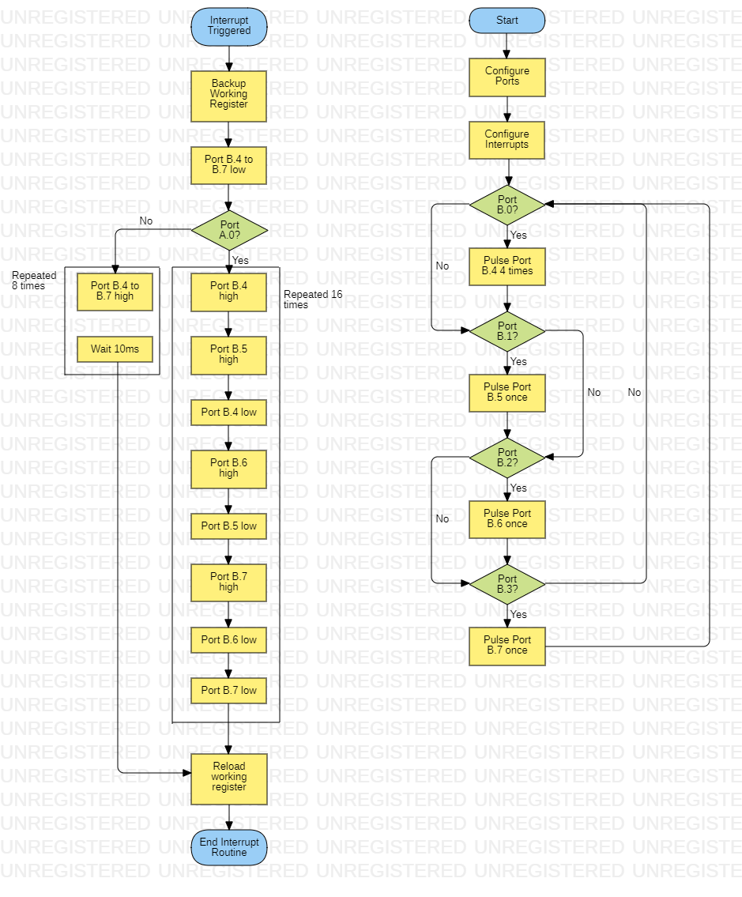

Code

#picaxe 18m2

init:
bsf STATUS, RP0 ; Moves to bank 1
call initPortsB ; Initialise Port B
call initInterrupt ; Setup the interrupts
call main ; "Entry Point"

initPortsB:
movlw b'00001111' ; Sets B0-B3 to Input ; Sets B4-B7 as output
movwf TRISB
bcf STATUS, RP0
return

initInterrupt:
W_SAVE equ B20 ; B20 should be reserved for the W_SAVE
COUNTER equ b27 ; Set the counter (i) = 0 ; Used in interrupt looping
bsf INTCON, INT0IE ; Enable external interrupt
bsf INTCON, GIE ; Enable global interrupts
return

main:
bcf STATUS, RP0 ; Move to bank 0
btfsc TRISB, 0 ; If port B0
call bassPulse
btfsc TRISB, 1 ; If port B1
call snarePulse
btfsc TRISB, 2 ; If port B2
call floorTomPulse
btfsc TRISB, 3 ; If port B3
call highTomPulse
goto main
end

bassPulse: ; Pulses the bass drum 4 times
BASS_COUNTER equ b19
movlw b'00000100'
movwf BASS_COUNTER

bassPulseLoop:
; Strobe the bass drum light (PORTB.3)
bsf PORTB, 4 ; Turn it on
call wait100ms ; Wait (to produce strobe effect)
bcf PORTB, 4 ; Turn it off

; Increment the counter
incf BASS_COUNTER, 1
; Test the counter
btfss BASS_COUNTER, 3 ; Change this bit to change how many pulses
; If the counter is not done
goto bassPulseLoop
; If the counter is done
nop
return

snarePulse: ; Pulse the snare once
bsf STATUS, RP0 ; Move to bank 1
bsf PORTB, 5
call wait10ms
bcf PORTB, 5
return

floorTomPulse: ; Pulse the floor tom once
bsf STATUS, RP0 ; Move to bank 1
bsf PORTB, 6
call wait10ms
bcf PORTB, 6
return

highTomPulse: ; Pulse the high tom once
bsf STATUS, RP0 ; Move to bank 1
bsf PORTB, 7
call wait10ms
bcf PORTB, 7
return

end

resetBits:
bcf PORTB, 4
bcf PORTB, 5
bcf PORTB, 6
bcf PORTB, 7
return

interrupt: ; A.7 = external interrupt
movwf W_SAVE ; Backup working register
btfss INTCON, INT0IF ; Check the correct interrupt has occured
; If it did, then the next instruction will be skipped
retfie ; Return and enable Global Interrupt Register

; Reset the state of the bits
call resetBits

; Handle the interrupt
bsf STATUS, RP0 ; Move to bank 0

; Test A.0
btfsc PORTA, 0
goto serialFlash
goto allFlash

end

; Flash the LEDs
;TODO: Refactor
serialFlash:
movlw b'00000000'
movwf COUNTER

serialFlashLoop:
bsf PORTB, 4
call wait10ms
bsf PORTB, 5
call wait10ms
bcf PORTB, 4
call wait10ms
bsf PORTB, 6
call wait10ms
bcf PORTB, 5
call wait10ms
bsf PORTB, 7
call wait10ms
bcf PORTB, 6
call wait10ms
bcf PORTB, 7
call wait10ms

incf COUNTER, 1 ; increment the file register to itself
btfss COUNTER, 5 ; If the loop has iterated 16 times ; CHANGE THIS TO BE 16 BEFORE HAND IN
goto serialFlashLoop
return

; Ran at the end to reset the interrupt
movf W_SAVE, W ; Move the saved values back into the working register
retfie ; Return and enable Global Interrupt Register

; Flashes all LEDS at once
allFlash:
movlw b'00000000'
movwf COUNTER

allFlashLoop:
; Set all output bits
bsf PORTB, 4
bsf PORTB, 5
bsf PORTB, 6
bsf PORTB, 7
call wait10ms

incf COUNTER, 1 ; increment file register to itself
btfss COUNTER, 4 ; If the loop has iterated 8 times ; CHANGE THIS TO BE 8 BEFORE HAND IN
goto allFlashLoop
return

; Ran at the end to reset the interrupt
movf W_SAVE, W ; Move the saved values back into the working register
retfie ; Return and enable Global Interrupt Register

end

Running a syntax check in Picaxe Editor 6 returns the following output:

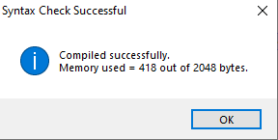

Showing there are no syntax errors in my code, and it takes up only 20% of the maximum storage of the Picaxe 18m2’s internal storage.

System Realisation

Testing On Breadboard

Circuit Diagram

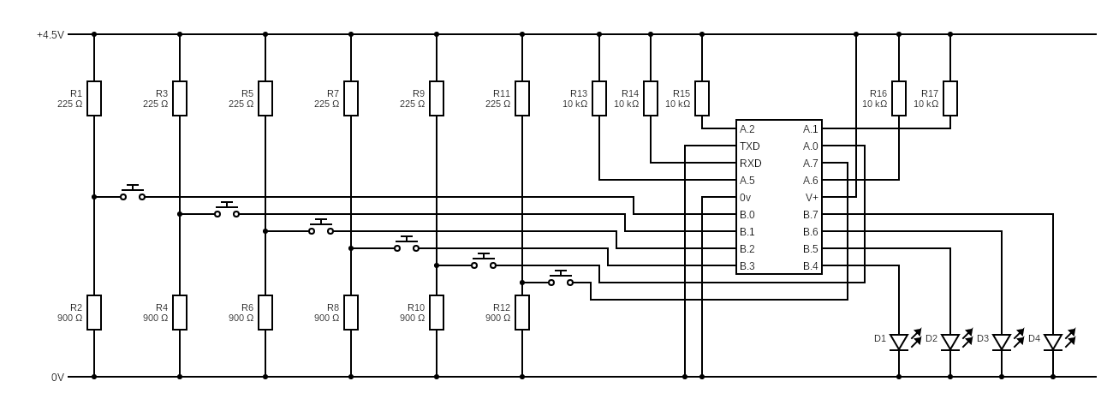

Calculations
Picaxe 18m2 IC Specification
(Specification information from (PICAXE Manual, 2013))
Supply Voltage: 4.5V or 5V
Input High Voltage:
Output High Current: 20mA

Input Current
There doesn’t appear to be direct information on the Picaxe 18m2 input pin current requirements. However, given the fact most pins are bidirectional, it can be assumed that the input current is the same as the output current. Therefore, using Ohm’s Law:

With values substituted:

This value can be used for R1 in the switch voltage dividers.

Switch Voltage Dividers
The equation to calculate the output voltage of a voltage divider is shown below:

Rearranged using (Wolfram|Alpha Widgets: "Rearrange It -- rearranges given equation" - Free Mathematics Widget, n.d.):

Therefore:

Evaluation

Improvements

References

Wolframalpha.com. n.d. Wolfram|Alpha Widgets: "Rearrange It -- rearranges given equation" - Free Mathematics Widget. [online] Available at: <https://www.wolframalpha.com/widgets/view.jsp?id=4be4308d0f9d17d1da68eea39de9b2ce> [Accessed 17 May 2022].

2013. PICAXE Manual. [ebook] p.8. Available at: <https://picaxe.com/docs/picaxe_manual1.pdf> [Accessed 17 May 2022].

