CHAIN-DAAN: AN ITERATIVE WEB-BASED MARKETPLACE FOR LOCAL BUSINESSES AND SUPPLIERS

[Author 1 Name] [Author 2 Name] [Author 3 Name] [Author 4 Name]

Department of Information Technology

COLLEGE OF COMPUTING AND INFORMATION SCIENCES

Mariano Marcos State University City of Batac 2906 Ilocos Norte

October 2026

A Project Presented to the Faculty of College
of Computing and Information Sciences - Department of Information Technology

In Partial Fulfillment of the Requirements for the Degree Bachelor of Science in Information Technology

By

[Author 1 Name] [Author 2 Name] [Author 3 Name] [Author 4 Name]

October 2026

ACKNOWLEDGMENT

The Chain-Daan project team would like to thank our instructor and adviser, [Name], for guidance and feedback during the planning and development of this project. We are also grateful to the business owners, suppliers, and other participants who shared their time and perspectives, if applicable. Their input helped the team consider the practical needs of buyers and suppliers.
We thank our group members, families, and friends for their cooperation and support throughout the project. We also acknowledge the business owners and suppliers whose needs informed the workflows represented in the system. Any remaining errors or limitations in the system and this report are the responsibility of the project team.
The Researchers

ABSTRACT
[AUTHOR 1 NAME], [AUTHOR 2 NAME], [AUTHOR 3 NAME], AND [AUTHOR 4 NAME]

College of Computing and Information Sciences, Department of Information Technology, October 2026, “CHAIN-DAAN: AN ITERATIVE WEB-BASED MARKETPLACE FOR LOCAL BUSINESSES AND SUPPLIERS.” Adviser: [ADVISER NAME]
Chain-Daan is a web-based marketplace designed to connect local business buyers with suppliers. The system provides role-aware accounts, supplier profiles, product and inventory management, order placement, direct messaging, and order tracking. Buyers may select Cash on Delivery or, when a product has a configured QR code, submit GCash payment details and a receipt for manual supplier review. Suppliers can approve or reject submitted payment evidence, manage orders, and share browser-based GPS positions for confirmed deliveries. The project was developed iteratively, with capabilities organized into working increments and refined as requirements and implementation needs became clearer. The client uses React and Vite; the API uses Express and Socket.IO; MongoDB stores application data. The available project files document the implementation and automated test commands, but do not include respondent evaluation scores or a completed live-service integration study. GCash is not processed through a payment gateway, and GPS sharing depends on an active browser session and device permission. The report therefore describes implemented scope and verification limits without claiming measured user effectiveness.

Keywords: Chain-Daan, iterative development, marketplace, ordering system, supplier, inventory, payment review, order tracking

Table of Contents | Update
Title Page | Update
Acknowledgment | Update
Abstract | Update
Table of Contents | Update
List of Figures | Update
List of Tables | Update
List of Algorithms | Update
1 Introduction | Update
1.1 Project Context | Update
1.2 Purpose and Description | Update
1.3 Objectives of the Study | Update
1.4 Significance of the Study | Update
1.5 Scope and Delimitations of the Study | Update
1.6 Operational Definition of Terms | Update
2 Review of Related Literature | Update
2.1 Iterative Software Development | Update
2.1.1 Incremental Delivery and Feedback | Update
2.1.2 Digital Marketplaces and Order Workflows | Update
2.2 Related Systems | Update
2.3 Technical Background | Update
2.4 Conceptual Framework | Update
3 Methodology | Update
3.1 Research Design | Update
3.2 Data Gathering Tools | Update
3.3 Research Instruments | Update
3.4 Data Gathering Procedures | Update
3.5 Statistical Treatment of Data | Update
4 Results and Discussion | Update
4.1 Implemented Capabilities and Iterative Increments | Update
4.2 Verification Evidence and Limitations | Update
5 Conclusions and Recommendations | Update
5.1 Conclusion | Update
5.2 Recommendations | Update
References | Update
Appendices | Update
Appendix A. System Diagrams | Update
Appendix B. Proposed User-Evaluation Questionnaire | Update
Curriculum Vitae | Update

- Results and Discussion 12
  - Result and Discussion 1 12
  - Result and Discussion 2 13
- Conclusions and Recommendations 14
  - Conclusion 14
  - Recommendation 14
References 16
Appendix A Detailed Tables 17
Appendix B Questionnaires 18
Curriculum Vitae 19
Page references in this static contents list require updating after final pagination in Word.

List of Figures
Figure 1 Chain-Daan System Architecture Update page number in Word
Figure 2 Buyer and Supplier Use-Case Diagram Update page number in Word
Figure 3 Chain-Daan Data Model Overview Update page number in Word

List of Tables
Table 1 Core Chain-Daan Data Entities Update page number in Word

List of Algorithms
No separate algorithms are listed in this project.

Introduction

Local business buyers and suppliers often coordinate product discovery, order details, payment, and delivery through separate channels. That separation can make it harder for participants to keep a shared view of an order. Chain-Daan brings these activities together in a role-aware web application. This chapter describes the project context, purpose, objectives, significance, scope, and key terms. The report focuses on the system present in the project repository and distinguishes implemented capabilities from future evaluation and deployment work.

Project Context

The project addresses the coordination needs of two principal user roles: business buyers and suppliers. Buyers need to browse supplier products, submit order details, communicate with a supplier, and check order progress. Suppliers need to manage a catalog and stock, review orders and payment information, and coordinate delivery. The project source includes role-specific client pages, an Express API, MongoDB persistence, and supporting design documents. The repository does not contain a dated record of stakeholder interviews or formal requirements approval, so the report does not claim that a particular field study established these needs.

Purpose and Description

Chain-Daan is intended to provide one web-based workflow for supplier discovery and order coordination. A business buyer can browse products, place an eligible order, choose COD or manual GCash payment, contact a supplier, and follow the order. A supplier can maintain products and stock, review payment submissions, advance eligible order states, and share delivery location. The application uses REST requests for persisted actions and authenticated Socket.IO rooms for selected realtime updates.

The system does not automate GCash settlement: a supplier must independently verify receipt of funds. Delivery tracking displays positions reported by the supplier device; it does not verify the courier, infer a route, or calculate an ETA. These boundaries are part of the current system description, not claims of service performance.

Objectives of the Study

The study aims to describe and document the design and implementation of Chain-Daan as an iterative software project. Specifically, it aims to: (1) identify the buyer and supplier workflows represented in the repository; (2) document the client, API, data model, and external-service boundaries; and (3) summarize how the implemented capabilities can be reviewed through project tests and integration checks.
It also aims to identify constraints that affect use and verification, including manual payment review, replica-set requirements for transactions, and foreground-only browser geolocation. No objective is stated as measuring user satisfaction or usability because the project files supplied for this report contain no evaluation responses.

Significance of the Study

For business buyers, the system brings product browsing, order information, communication, payment submission, and tracking into one interface. For suppliers, it offers catalog and stock management with a workflow for reviewing payments and orders. These are intended contributions of the software; the report does not claim a quantified improvement in time, revenue, satisfaction, or business outcomes.

For the project team, the repository provides a concrete basis for tracing requirements to client pages, API rules, data storage, and tests. For instructors and future developers, the architecture and limitations can support review and continued development. A future evaluation with representative users is needed to determine whether the workflows are understandable and useful in actual business settings.

Scope and Delimitations of the Study

The implemented scope includes role-aware account access, profiles, supplier product catalogs, orders, stock rules, COD and manually reviewed GCash, direct messaging, order status, sales views, feedback, stable tracking identifiers, and browser-based location sharing. The client is built with React and Vite; the server uses Express, Socket.IO, and Mongoose with MongoDB. Cloudinary, SMTP, Google/Facebook OAuth, and OpenStreetMap tiles depend on configuration. The project does not include a GCash gateway, courier integration, background tracking, verified delivery, an ETA service, or documented production service-level targets.

Operational Definition of Terms

The following terms are used in this report according to the implemented Chain-Daan workflows:
Iterative development. A development approach in which the team plans and delivers a working increment, reviews it, and uses findings to shape later work. The project files do not preserve dated iteration records, so the increments described here are a capability-based reconstruction.

Manual GCash review. The buyer submits payment details and a receipt image; the supplier checks the funds and approves or rejects the submission. This workflow is not a GCash payment-gateway integration.
Tracking point. A timestamped location and accuracy value reported by the supplier device for an order. It represents a browser-provided position and is not independently verified by a courier service.

Review of Related Literature

This chapter relates Chain-Daan to iterative software development, digital marketplace workflows, and the technical components used in its implementation. It synthesizes authoritative development and platform references with the project’s own architecture, database, payment, and tracking documents. Because no formal market comparison or user study was included in the repository, the discussion avoids unsupported claims about competing systems or user outcomes.

Iterative Software Development

Iterative development organizes work into increments that can be reviewed and improved. The Agile Manifesto principles emphasize frequent delivery of working software, regular collaboration between developers and business stakeholders, and reflection on how to improve the team’s work [1]. These principles are relevant to Chain-Daan because its buyer and supplier workflows can be reviewed as connected slices, such as placing an order, reviewing payment, and tracking delivery. The repository supports an iterative framing, but does not establish that the team followed a named framework such as Scrum or retained formal sprint records.

Incremental Delivery and Feedback

A useful increment should demonstrate an end-to-end capability rather than only an isolated screen. For example, an order workflow requires client input, API validation, persistence, role authorization, and a clear state shown to both participants. In Chain-Daan, payment review and order confirmation are separate decisions, while inventory changes are tied to eligible state transitions. This separation gives the team specific behaviors to review and refine. The Agile principles provide a rationale for frequent review, but project-specific acceptance still depends on agreed requirements and evidence from the intended users [1].

For this report, the implemented features are grouped into logical increments based on their dependencies and user-visible workflows. This grouping is retrospective: source files and project notes document capabilities, but do not establish the actual dates, sprint boundaries, or stakeholder approvals for each increment.

Digital Marketplaces and Order Workflows

A marketplace workflow connects catalog information with buyer decisions and supplier fulfillment. Chain-Daan represents this relationship through supplier-owned products, buyer orders, order states, payment information, conversations, and tracking points. The data design diagram identifies application-level relationships among profiles, products, sales, conversations, messages, and tracking points [6]. These records support coordination, while server-side ownership checks restrict access to the relevant participants. The project describes an intended local business use case; no supplied study measures marketplace adoption or business impact.

Related Systems

General e-commerce applications commonly organize buyer activity around product discovery and order placement, while supplier-facing tools organize catalog and fulfillment tasks. Chain-Daan combines these roles in a single project-specific application and includes manual GCash review and supplier-reported delivery positions. The available repository does not include a systematic evaluation of named competing platforms, their current feature sets, or their suitability for local businesses; consequently, this section compares workflow concepts rather than asserting that Chain-Daan is superior to a commercial service.

Technical Background

The client is implemented with React, a component-based library for rendering user interfaces, and Vite for the development and build workflow. React’s documentation describes UI construction in terms of components and their rendered output [2]. The server uses Express for HTTP endpoints and Socket.IO for participant-scoped realtime events. Mongoose maps application records to MongoDB collections. MongoDB transactions support the project’s atomic order and stock changes, but multi-document transactions require a replica set or sharded cluster; standalone deployments do not support them [3]. Browser location relies on the Geolocation API and user permission; secure contexts are required [4]. Leaflet provides the client map interface [5].

Conceptual Framework

The project follows an iterative Input–Process–Output (IPO) view. Inputs include buyer and supplier needs, project constraints, product/order data, and feedback gathered during review. The process is repeated planning, analysis, design, implementation, verification, and review. Each cycle produces an improved working version of the marketplace.

The output is a web application with buyer and supplier workflows, plus documentation and verification evidence. Review findings and unresolved issues become inputs to the next iteration. This framework describes the intended development logic; it does not imply that formal stakeholder feedback or measured evaluation results were recorded for every cycle.

Table 1: Core Chain-Daan Data Entities

Entity | Purpose and key relationships
Profile  Product  Sale (order)  TrackingPoint  Conversation  Message  Feedback | Stores buyer/supplier role and account details.  Supplier-owned catalog item with price, stock, images, and optional GCash QR.  Connects buyer, supplier, product, quantity, delivery, status, and payment review.  Stores timestamped supplier-reported order position and accuracy.  Connects two participant profiles for direct messaging.  Stores conversation text, sender, recipient, and read state.  Stores a submitted user message to the project team.

Methodology

The project is documented using an iterative software-development approach. The report’s evidence base consists of the supplied source repository, README and workflow notes, automated test files, and architecture/database/use-case documents. The procedure is a source-based review of the implemented system, not a new survey, controlled experiment, or production deployment audit. Requirements and findings are described qualitatively; unobserved values are not estimated.

Research Design

This work uses an applied software-development design. The system is described by its user roles, functional workflows, technical architecture, and constraints. Development is framed as repeated cycles of planning, design, implementation, verification, and review. Capability-based increments are used to organize the report: marketplace foundation; order and inventory rules; payment workflow; communication and tracking; and hardening/documentation. These groupings are inferred from present features and project notes, not from a dated sprint log.

Data Gathering Tools

Project information was gathered by inspecting the frontend and backend source, package scripts, README and database setup notes, payment and tracking documentation, tests, and existing architecture diagrams. The review looked for user roles, request flows, data entities, authorization boundaries, state transitions, external integrations, and stated operational limitations. The repository’s test commands were recorded as available verification procedures; this report does not claim they were executed as part of document preparation.

No interviews, questionnaires, observation sessions, database logs, or production analytics were supplied. User feedback should be collected in a later evaluation cycle before making claims about usability, satisfaction, efficiency, or business impact.

Research Instruments

The primary review instrument is a requirement-to-evidence checklist linking user-facing functions to relevant client components, API rules, persistence behavior, and automated test files. A proposed user-evaluation questionnaire is included in Appendix B for future use. It is explicitly a draft and was not administered; it has no responses or computed scores.

Data Gathering Procedures

The review first identified the template’s required report sections and the system scope represented by the project files. The team’s documented requirements and workflows were then mapped to source components and diagrams. Features were organized into logical increments, with dependencies and limitations noted. Finally, the documented test commands and live integration requirements were summarized. No private user records were accessed, and no external services or production environment were contacted for this report.

Statistical Treatment of Data

No numerical survey or performance dataset was available; therefore, no mean, percentage, standard deviation, significance test, or ISO/IEC 25010 score is reported. The project is assessed here through qualitative coverage: whether a capability is represented in source or documentation, whether a corresponding automated test file is present, and whether live verification remains outstanding. This descriptive classification is not a substitute for a formal software-quality evaluation.

Results and Discussion

Repository inspection shows a multi-role marketplace implementation with client, API, persistence, payment, messaging, and tracking components. The results below describe the current feature set and evidence boundaries. They do not present a user study, benchmark, or production-readiness certification. The figures are taken from the project’s existing design artifacts and are included to explain the implemented system.

Implemented Capabilities and Iterative Increments

The marketplace foundation includes React/Vite client pages, account and role flows, profiles, supplier product management, and MongoDB persistence. Order workflows add buyer checkout, supplier order views, state validation, and inventory consistency rules. Payment capabilities support COD and manual GCash receipt review, including approval, rejection reasons, and resubmission. Communication and delivery capabilities include direct messaging, stable CD-prefixed tracking identifiers, and supplier browser GPS updates for confirmed orders [6]. These capability groups provide a coherent iterative narrative, although the source repository does not supply historical iteration dates or acceptance records.

Figure 1: Chain-Daan System Architecture
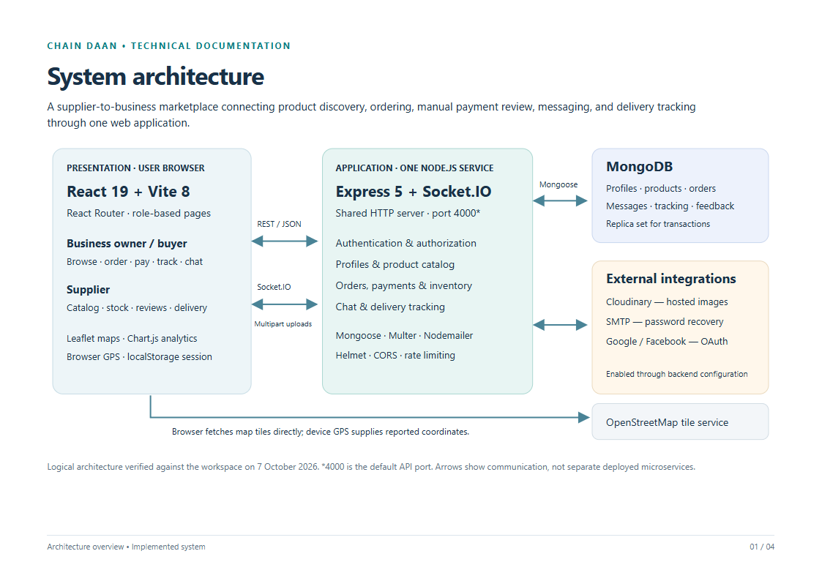
The architecture separates browser presentation, API/business rules, MongoDB persistence, and configured external integrations. The diagram represents the logical architecture documented by the project team, not independently verified production infrastructure.

Verification Evidence and Limitations

The repository contains backend tests for payment, routes, tracking, order status, authentication input, and regression behavior, plus frontend utility tests and lint/build scripts. Their presence supports a repeatable verification plan, but a test file’s existence alone does not establish a passing run. Project notes call for verification against configured Cloudinary and MongoDB services, replica-set transaction behavior, and supplier-to-buyer GPS updates over HTTPS. Those integration conditions and user-evaluation outcomes remain unconfirmed in the materials used for this report.

Conclusions and Recommendations

This chapter summarizes what can be concluded from the available implementation and identifies practical next steps. Conclusions are limited to documented source and project artifacts. Claims about user acceptance, measurable efficiency, real payment settlement, or deployed service reliability require additional evidence.

Conclusion

Chain-Daan is a web-based marketplace project that connects business buyers and suppliers through product, order, payment-review, messaging, and tracking workflows. Its architecture uses a React/Vite client, an Express/Socket.IO API, and MongoDB persistence. Its iterative framing is appropriate for refining connected buyer and supplier workflows in increments. The system includes useful integrity and access boundaries, but GCash review remains manual and GPS tracking remains dependent on an active supplier browser. The supplied materials do not establish user-study results, live integration success, or production performance.

Recommendations

The project team should first complete end-to-end verification using a configured MongoDB replica set and the required Cloudinary, email/OAuth, and HTTPS environments. It should test concurrent order transitions, payment receipt access by both authorized participants, and location updates between separate supplier and buyer devices. The team should then conduct a documented usability evaluation with representative users and report the instrument, participant count, responses, and analysis transparently.

For continued iterative work, maintain a prioritized backlog with acceptance criteria, record review feedback and iteration dates, and link each release to requirements and tests. Before submission or deployment, add the authors’ names, adviser details, final page references, and any institution-required front matter. Do not describe manual payment review as gateway processing or browser GPS as verified courier tracking.

References
[1] Beck, K., et al. (2001). Principles behind the Agile Manifesto. https://agilemanifesto.org/principles.html
[2] Meta Open Source. (n.d.). Describing the UI. React documentation. https://react.dev/learn/describing-the-ui
[3] MongoDB, Inc. (n.d.). Enforce data consistency with transactions. MongoDB Manual. https://www.mongodb.com/docs/manual/data-modeling/enforce-consistency/transactions/
[4] World Wide Web Consortium. (2024). Geolocation API. W3C Recommendation. https://www.w3.org/TR/geolocation/
[5] Leaflet. (n.d.). Leaflet API reference (version 1.9.4). https://leafletjs.com/reference.html
[6] Chain-Daan Project Team. (2026). System architecture, database design, use-case diagrams, payment workflow, and order tracking notes [unpublished project documentation and source repository].

APPENDICES

Appendix A. System Diagrams

The following diagrams are included from the project architecture folder. They summarize the intended application structure, the buyer/supplier use cases, and the logical relationships among persisted entities. Figure 3 describes application-level relationships; MongoDB ObjectId references are not database-enforced relational foreign keys.
Figure 2: Buyer and Supplier Use-Case Diagram
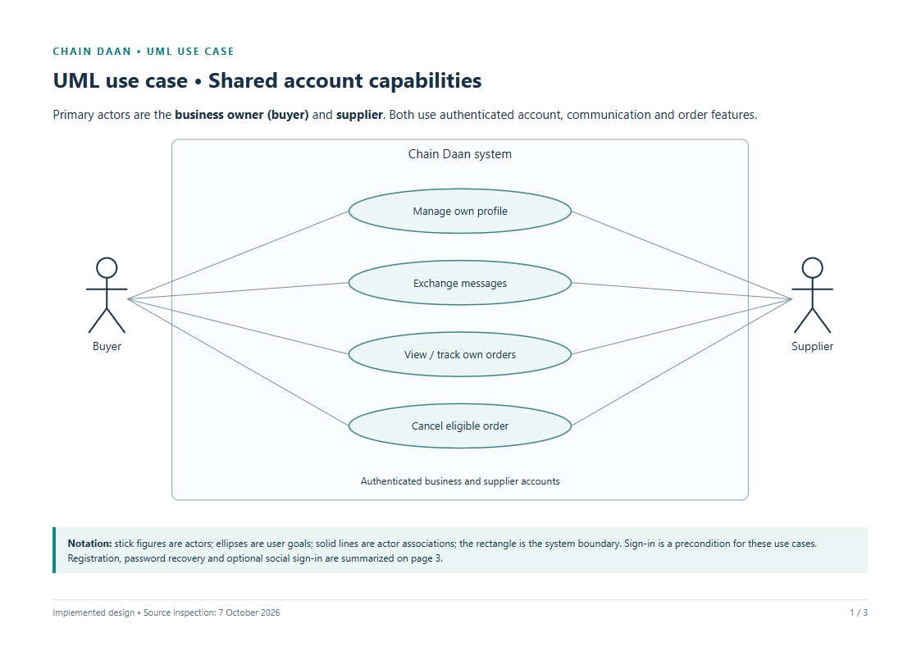
Figure 3: Chain-Daan Data Model Overview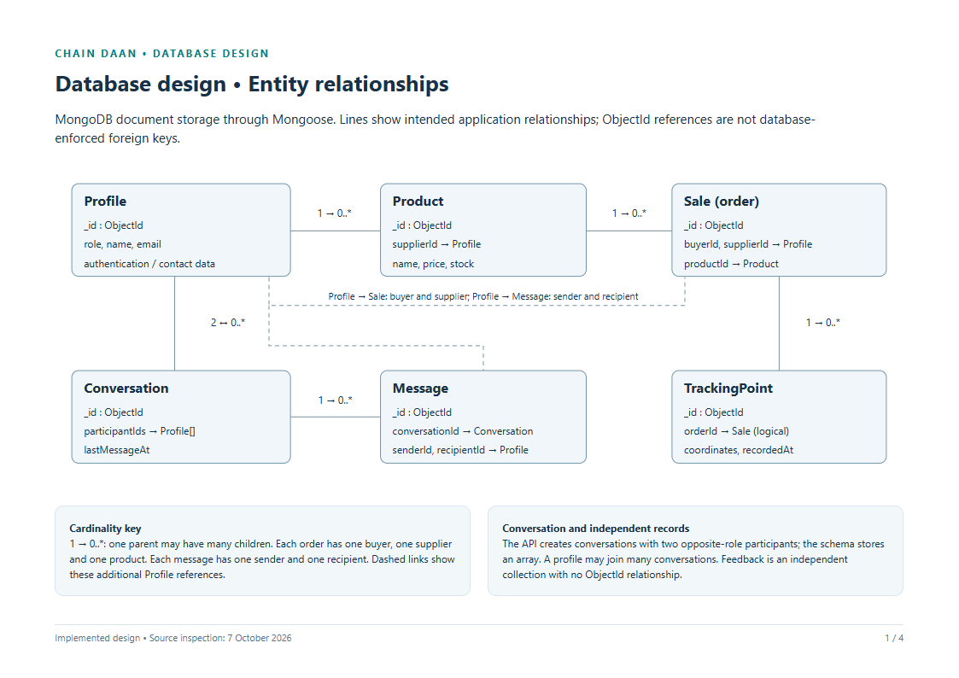

Appendix B. Proposed User-Evaluation Questionnaire

Status: Draft instrument for a future evaluation; it has not been administered and contains no responses. Ask participants to use a test account and complete relevant tasks. Do not collect passwords, payment receipts, or unnecessary personal data. For each statement, select one response: 1 Strongly Disagree, 2 Disagree, 3 Neither Agree nor Disagree, 4 Agree, 5 Strongly Agree, or N/A.
1. I could find the supplier and product information I needed.
2. The product price and available stock were clear.
3. The steps for placing an order were understandable.
4. The system clearly distinguished COD from manual GCash payment.
5. The payment receipt submission instructions were clear.
6. The order status was easy to understand.
7. I could find the messages related to my order.
8. The tracking information clearly showed when a location was last reported.
9. I understood that GPS sharing depends on the supplier device and an active browser.
10. Overall, the system supported the task I attempted.
Open-ended: What was difficult or confusing? What should be improved first? State your user role (buyer/supplier) and the task completed. The team should report participant count, role distribution, response handling, and summary method before presenting results.

CURRICULUM VITAE

[AUTHOR 1 FULL NAME]
Department of Information Technology
College of Computing and Information Sciences, Mariano Marcos State University
City of Batac, Ilocos Norte, Philippines
Email: [Author 1 email, if required]
Contact number: [Optional; include only with consent]

Educational Background

[Degree program, institution, and attendance years]
[Location, if required by the department]

[Secondary education, institution, and years, if required]
[Institution and location]

[Elementary education, institution, and years, if required]

Training and Seminars

[Training or seminar title, provider, and date, if applicable]
[Location or delivery format]

[Additional training, if applicable]
[Provider]
[Date]

Awards and Certifications

[Award or certification, if applicable]
[Issuing organization and date]

[Additional award, if applicable]
[Issuing organization and date]

CURRICULUM VITAE

[AUTHOR 2 FULL NAME]
Department of Information Technology
College of Computing and Information Sciences, Mariano Marcos State University
City of Batac, Ilocos Norte, Philippines
Email: [Author 2 email, if required]
Contact number: [Optional; include only with consent]

Educational Background

[Degree program, institution, and attendance years]
[Location, if required by the department]

[Secondary education, institution, and years, if required]
[Institution and location]

[Elementary education, institution, and years, if required]

Training and Seminars

[Training or seminar title, provider, and date, if applicable]
[Location or delivery format]

[Additional training, if applicable]
[Provider]
[Date]

Awards and Certifications

[Award or certification, if applicable]
[Issuing organization and date]

[Additional award, if applicable]
[Issuing organization and date]

