First Semester, S.Y. 2024 - 2025

**PERFORMANCE BASED ASSESSMENT: GUIDELINES FOR THE COURSES,**

**PRACTICAL RESEARCH 12 AND INQUIRIES, INVESTIGATION & IMMERSION**

**(MIDTERM PERIOD - FIRST SEMESTER)**

**PERFORMANCE STANDARDS:**Visualize and defend possible researchable idea/s related to the field of interest.

**RESEARCH COLLOQUIUM**

**G.R.A.S.P.S.**

| **GOAL** | Your goal is to present your chapters 1, 2, and 3. |
| --- | --- |
| **ROLE** | You are a young researcher who will present the first half of the research to your research adviser. |
| **AUDIENCE** | Your audience will be some of your classmates and teachers. |
| **SITUATION** | You are already halfway through with your research paper. To assure your paper’s validity, reliability, and coherence, you need to present it to your research adviser for suggestions, comments, and constructive criticism. |
| **PERFORMANCE** | A Google document presentation for Chapters 1-3 and a 15-minute oral presentation. |
| **STANDARDS** | Your paper and presentation will be evaluated based on the following criteria:   * Title Page, * Introduction (Thesis statement), * Statement of the Problem, * Null Hypothesis/Hypothesis, * Conceptual Framework/Theoretical Framework, * Scope and Delimitation, * Significance of the Study, * Definition of Terms, * RRL (Support/ Reasoning of Ideas and Details), * RRL (Synthesis), * Sampling Method, * Research Design, * Respondents of the Study, * Instrument Used, * Data Gathering Technique, * Treatment of Data, and * Defense. |

**MATERIALS NEEDED FOR THE PROJECT**

* Google Document for Chapters 1,2, and 3
* Rubrics (see attachments)

**MECHANICS:**

* After all lectures and workshops, the leader together with the members will ask the research adviser for them to be scheduled for a research colloquium.
* The research adviser will schedule a research colloquium.
* The members will present Chapters 1 to 3 for technical corrections (e.g., grammar and language, syntax, punctuation) and coherence checking.
* The research adviser will give comments on the overall structure of the paper, specifying the need for possible improvements and even changes.   
  *(An inadequate defense and accounting for the contents of the paper may suggest the need for further review and revision)*

Prepared by: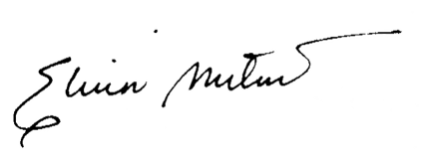

**ELVIN A. MUTUC, MAEd.**

*Research and Communication Area Chair* 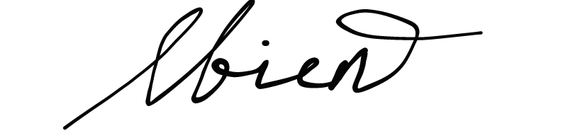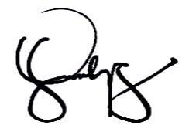

**LIESEL L. BIEN, MAT MARICAH VELASQUEZ, LPT** 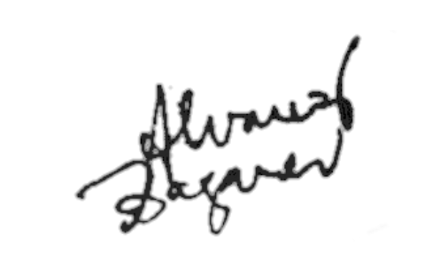

*INQ/RS II - Collaborator INQ/RS II - Collaborator*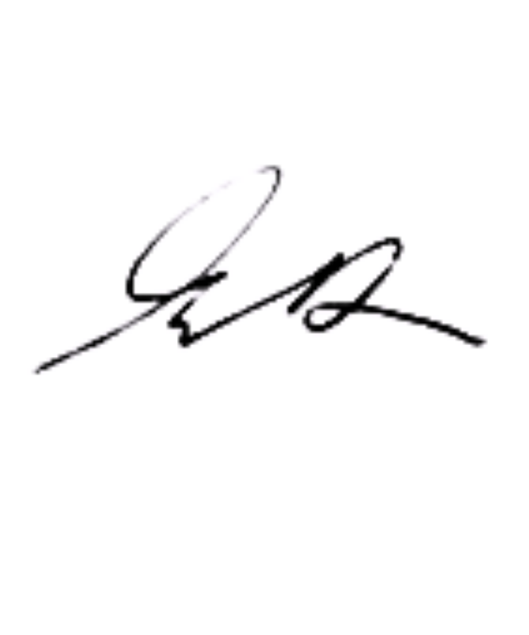

**ELMER DONATO, LPT ROB CRIS BAGARES, LPT**

*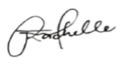INQ/RS II - Collaborator INQ/RS II - Collaborator*

**RACHELLE FEROL, LPT JOSHUA JOSE R. OCON**

*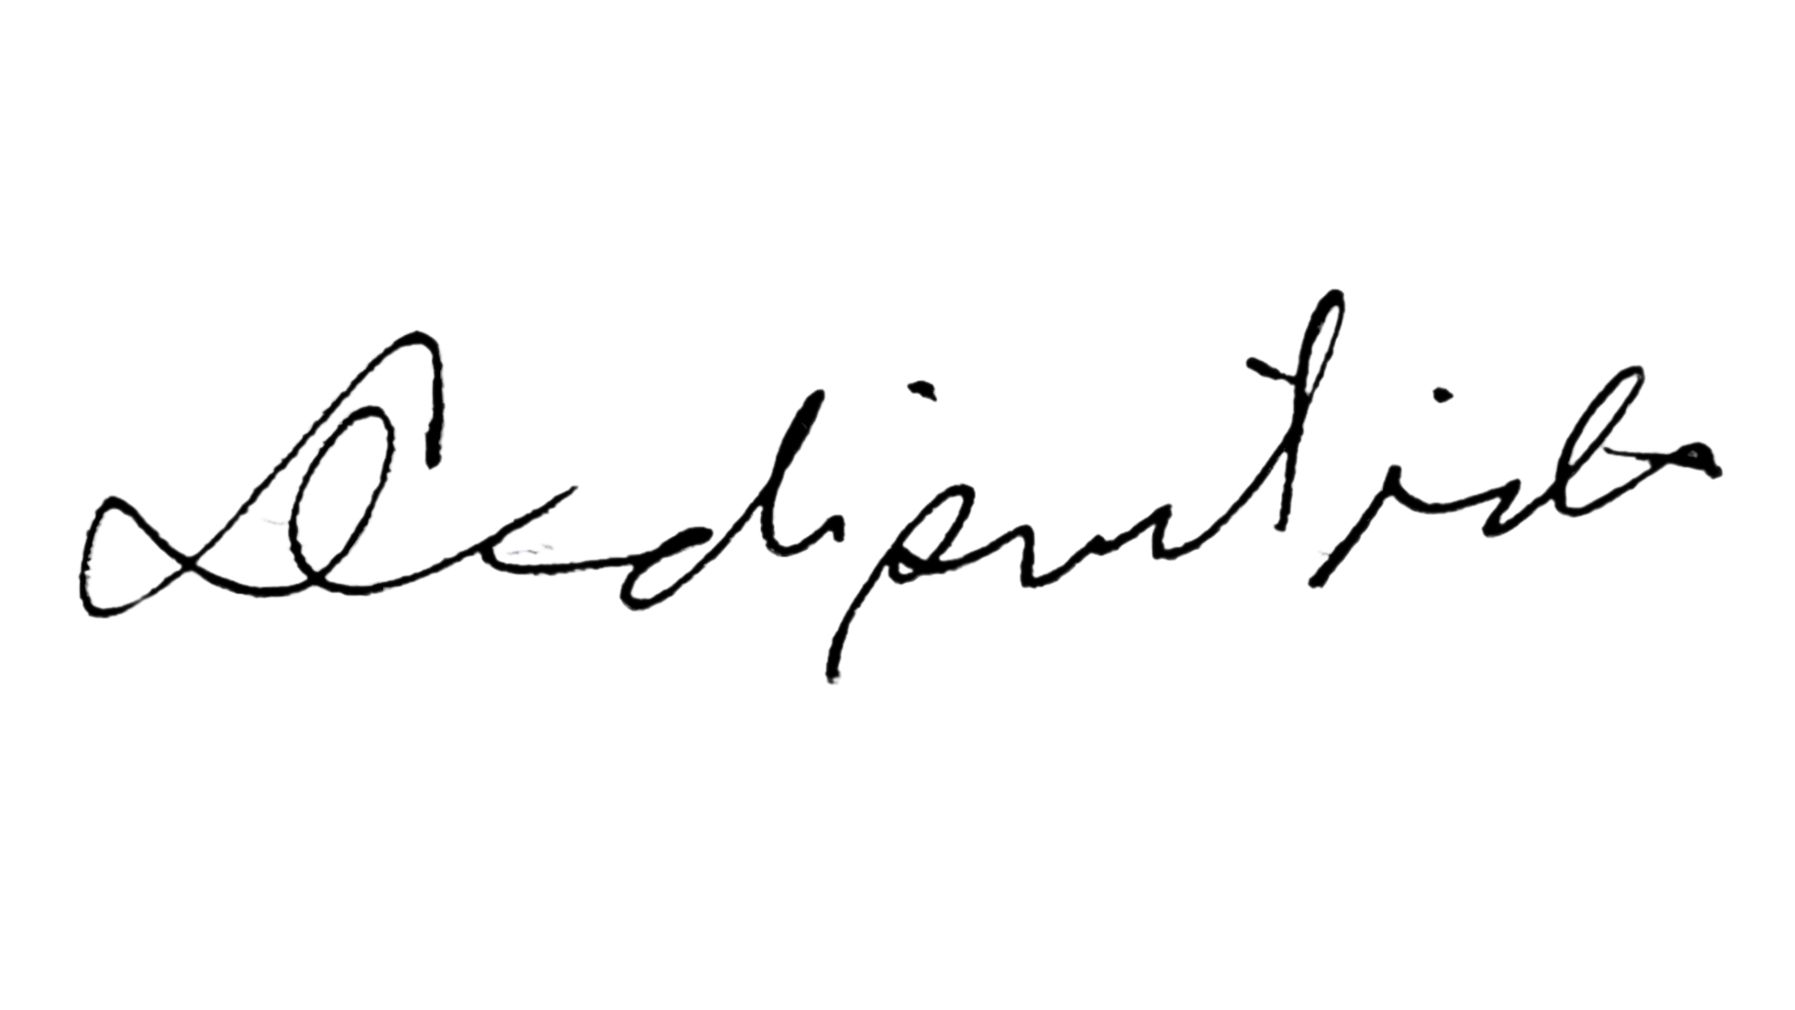INQ/RS II - Collaborator INQ/RS II - Collaborator*

**DAVE ARON DISCUTIDO, LPT GERALDINE FULO, LPT**

*INQ/RS II - Collaborator INQ/RS II - Collaborator*

Checked by:

**JOMIL U. VALLESPIN, MAED**

SHS Assistant Principal for Academics

**PERPETUA R. HERNANDEZ, MAT**

HS Principal

**RUBRICS FOR RESEARCH COLLOQUIUM**

|  | **QUALITY** | **DOES NOT MEET STANDARDS**  **(2)** | **NEARLY MEETS STANDARDS**  **(3)** | **MEETS STANDARDS**    **(4)** | **EXCEEDS**  **STANDARDS**  **(5)** | **SCORE** | **REMARKS** |
| --- | --- | --- | --- | --- | --- | --- | --- |
| **CRITERIA** |
| **1** | **Title Page** | Evidence of 2 | Evidence of 3 | Evidence of four | Title, Researchers’ name, Teacher’s name, Course Period, Date, Neatly finished-no errors |  |  |
| **2** | **Introduction**  **(Thesis statement)** | Weak or no introduction of topic. Paper’s purpose is unclear/the thesis statement is weak or missing. | Basic introduction that states the topic but lacks interest. Thesis statement is somewhat clear and arguable. | Proficient introduction that is interesting and states a topic. Thesis statement is a clear and arguable statement of position. | Exceptional introduction that grabs interest of reader, and states topic. Thesis statement is exceptionally clear, well-developed, and a definitive statement. |  |  |
| **3** | **Statement of the Problem** | Limited or no connections made between the topic and the questions. | Some connections made between the topic and the questions. | Consistent connections made between the topic and questions; IV and DV are clearly stated. | Exceptionally critical, relevant and consistent connections made between the topic and questions; IV and DV are clearly stated. |  |  |
| **4** | **Hypothesis** | Not written as a testable statement but the IV and DV are not included. | Written as a testable statement but the IV and DV are not included. | Written as testable statements and the IV and DV are included; but no predictions that can be supported or rejected. | Written as a testable statement and the IV and DV are included; includes predictions that can be supported or rejected. |  |  |
| **5** | **Conceptual Framework** | Misrepresentation and misinterpretation of the conceptual framework. | Conceptual framework does not fully represent the organization and relationship of the variables. | Conceptual framework represents the organization and relationship of the variables but no clear interpretation. | Conceptual framework represents the organization and relationship of the variables with clear interpretation. |  |  |
| **6** | **Scope and Delimitation** | States the ranges and boundaries of the study. | Describes in detail the ranges and boundaries of the study such as the target respondents and place where study is conducted. | Describes in detail the ranges and boundaries of the study such as the target respondents and place where the study is conducted and explains its relevance to the study. | Describes in detail the ranges and boundaries of the study such as the target respondents, time and place where the study is conducted and explains its relevance to the study. |  |  |
| **7** | **Significance of the Study** | Limited or no beneficiaries of the study; how they will benefit was not stated. | Some beneficiaries of the study; how they will benefit was not stated but in general. | Some beneficiaries of the study; how they will benefit was stated, accordingly. | All the possible beneficiaries are stated; how each will benefit was discussed, accordingly and fully. |  |  |
| **8** | **Definition of Terms** | Only a few terms are defined based on how they will use it in the paper. | More terms are defined operationally but some are denotatively. | More terms are defined operationally (how they are used in the study). | All words needed to be defined, especially the variables, operationally and contextually are included. |  |  |
| **9** | **RRL**  **(Support/ Reasoning of Ideas and Details)** | Offers simplistic, undeveloped, or cryptic support for ideas. Inappropriate or off-topic generalizations, faulty assumptions, errors of fact. | Offers somewhat obvious support that may be too broad. Details are too general, not interpreted, irrelevant to the purpose of the study, or inappropriately repetitive. | Offers solid but less original reasoning. Assumptions are not always recognized or made explicit. Contains some appropriate details or examples. | Substantial, logical and concrete development of ideas. Sequence of ideas is effective. Transitions are effective. |  |  |
| **10** | **RRL**  **(Synthesis)** | Have not successfully summed up the concepts from different authors. | The synthesis was not formulated properly. The ideas from different authors were not utilized properly. | Majority of the ideas from the literature were utilized for the synthesis but forgot to use some of the present literature in the study. | All of the literature was merged into one big statement as a support statement for the research paper. |  |  |
| **11** | **Sampling Method** | Have not identified the sampling method to be used in the research. | The sampling method does not fit the needs of the research. | Has an incomplete statement pertaining to the sample method to be used. | The sampling method involves the technique to be used by the researchers that fits the research paper. They have also identified the locale where they will perform the method. |  |  |
| **12** | **Research Design** | Names the design of the methodology. | Names and defines the design of the methodology. | Names and defines the design of the methodology. Explains how this design is a good match to answer research questions. | Names and defines the design of the methodology. Explains how this design is a good match to answer research questions. Cites sources that support this design choice. |  |  |
| **13** | **Respondents of the Study** | Identifies the size of the participants and their profile. | Identifies the size of the participants, their profile, sampling method, selection, recruitment, but no consent or safeguard process. | Identifies the size of the participants, their profile, sampling method, selection, recruitment and with consent or safeguard process. | Identifies and explains the size of the participants, their profile, sampling method, selection, recruitment and with consent or safeguard process. |  |  |
| **14** | **Instrument Used** | Names and defines the material being used, especially the instrument (survey, questionnaire, test…) | Defines and describes in detail the instrument and highlights key features. | Defines and describes in detail the instrument and highlights key features, and explains how this tool is a good match for the study and questions. | Defines and describes in detail the instrument and highlights the key features, and explains how this tool is a good match for the study and questions. Use proper citation for referencing instrument design. |  |  |
| **15** | **Data Gathering Technique** | List the steps to conduct study specifically that someone could replicate. | List the steps to conduct study specifically that someone could replicate. Articulates who did what and when. | List the steps to conduct study specifically that someone could replicate. Articulates who did what and when. Explains why they choose these steps. | List the steps to conduct study specifically that someone could replicate. Articulates who did what and when. Explains why they choose these steps and articulates how authors are insiders/outsiders with sample/site data collection. |  |  |
| **16** | **Treatment of Data** | Proposed research statistics methods are not appropriate to answer research questions, no justifications for using the methods. The types of measuring instruments, the sampling procedures and plans for data analysis are not defined clearly. Does not recognize the limits or implications of the method to be employed. | Proposed research statistics methods are appropriate to answer research questions, but no justifications for using the methods. The types of measuring instruments, the sampling procedures and plans for data analysis are not defined clearly. Does not recognize the limits or implications of the method to be employed | Proposed research statistics methods are appropriate to answer research questions, with reasonable justifications for using the methods. The types of measuring instruments, the sampling procedures and plans for data analysis are defined clearly. But does not recognize the limits or implications of the method to be employed. | Proposed research statistics methods are appropriate to answer research questions, with reasonable justifications for using the methods. The types of measuring instruments, the sampling procedures and plans for data analysis are defined clearly. Recognizes the limits or implications of the method to be employed. |  |  |
| **17** | **Defense** | Did not know how to explain or expound his/her written output. He/She cannot answer the questions or concerns of the adviser. | Had difficulty in interpreting and explaining his/her written output. He/She answered only a few of the questions or concerns of the panel or adviser. | He/She can explain the written output well and has answered the majority of the panel’s/adviderser’s concern/s. | He/She superbly discusses and answers all of the concerns of the panel/adviser. |  |  |
| **18** | **Response to Questions** | Demonstrates incomplete  knowledge of the topic by responding inaccurately and  inappropriately to questions and  feedback. | Demonstrates minimal knowledge of the topic. Reporters respond to the questions and feedback but are somehow inaccurate and inappropriate. | Demonstrates some knowledge of the topic by responding accurately and appropriately to questions and feedback. | Demonstrates extensive knowledge of the topic by responding confidently, precisely and appropriately to all audience questions and feedback. |  |  |
|  | **TOTAL SCORE** | | | | |  |  |