Table of Contents
TASTE MUMMIES MADE RESTAURANT (TM)
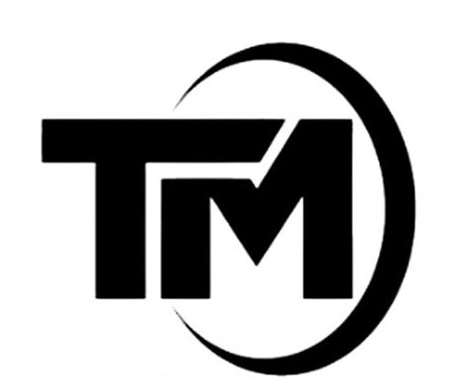
Home in every spoon

Founder’s Story
Taste Mummies Made Restaurant is a brand rooted in home, heritage, and integrity.
The story begins from the early life of Mr. Selasi Atakey Y. Christopher. Growing up in Nyive, a border town, Selasi was introduced to entrepreneurship at the age of 12 when he helped his mother with her roadside koko business. Those early experiences shaped his discipline, respect for customers, and understanding of honest business practices.
His passion for cooking continued to grow and was strengthened through formal education in Home Economics during his Junior High School years, where he gained foundational knowledge in food preparation, hygiene, and nutrition.
The official planning of Taste Mummies Made Restaurant began on 25th February 2025 during a lecture session in class with support from friends, loved ones, helpers, and people who believed in the dream.
Brand Manifesto
We believe food should feel like home.
We believe in integrity, consistency, and care.
We honor tradition while embracing modern technology.
We are committed to health, nutrition, and affordability.
This is Taste Mummies Made Restaurant.
Vision
To provide healthy, nutritious, and affordable homemade breakfast services by combining traditional cooking values with modern technology.
Mission
To deliver healthy breakfast services through skilled personnel and effective, trusted I.T systems.
Home in every spoon

