Superklasse



|  |
| --- |
| Moveable |
| Velocity: Vector  Position: Vector |
| Constructor()  Move (_timeslice: number)  Draw() |



|  |
| --- |
| Cloud |
| Size: Vector |
| Constructor()  Move(_timeslice: number)  Draw() |

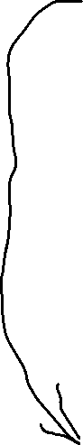

|  |
| --- |
| Leaf |
| Color: string |
| Constructor()  Move(_timeslice: number)  Draw() |

|  |
| --- |
| Squirrel |
|  |
| Move (_timeslice: number)  Draw() |

|  |
| --- |
| Vector |
| X: number  Y: number |
| Constructor(_x: number, _y: number)  Set (_x: number, _y: number)  Scale (_factor: number)  Add (addEnd: Vector)  Random (_minLength: number, _maxLength: number) |

