
UNITY UNIVERSITY
DEPARTMENT OF COMPUTER SCIENCE
Project title: Student skills marketplace
By

Name ID.No
Abdulselam Jeylan 06117/14
Abel Mesfin 04575/14
Eyuel Abiyot 04570/14
Nooreldaim Zeinu 04637/14
Yahya Ibrahim 04572/14
Yohanes Asirtat 04579/14

List of tables
Table 2.1 Users of the current system
Table 3.1 Actors of the proposed system
Table 3.2 Register as service provider usecase description
Table 3.3 Service creation usecase
Table 3.4 Order placing usecase
Table 3.5 Deliver completed work use case
Table 3.6 leave review and rating usecas

List of figures
Figure 1.1 project schedule
Figure 2.1 use case diagram of the existing system
Figure 3.1 Use case diagram for the proposed system
Figure 3.2 Class diagram
Figure 3.3 Object diagram
Figure 3.4 Sequence diagram for login usecase
Figure 3.5 sequence diagram for service listing creation
Figure 3.6 sequence diagram for order placement
Figure 3.7 sequence diagram for delivering completed work
Figure 3.8 sequence diagram for leaving a review
Figure 3.9 activity diagram
Figure 3.10 state diagram
Figure 4.1 system decomposition
Figure 4.2 persistent data modeling
Figure 4.3 component diagram
Figure 4.4 deployment diagram
Figure 4.5 Entity Relation Diagram
figure 4.6 users table
figure 4.7 services table
figure 4.8 orders table
figure 4.9 messages table
figure 4.10 payments table
figure 4.11 reviews table

Table of contents
List of tables 2
List of figures 3
Abstract 6
CHAPTER ONE 7
  - Introduction 7
  - Background of the project 7
  - Statement of the problem 8
  - Purpose of the project 9
  - Objective of the project 9
1.5.1general objective 9
1.5.2 specific objective 9
1.6 Significance of the project 10
1.7 Feasibility study 12
1.7.1 Technical feasibility 12
1.7.2 Operational feasibility 12
1.7.3 Economic fallibility 12
1.8 Scope and limitation 13
1.8.1 Scope 13
1.8.2 limitation 13
1.9 Methodology 14
1.9.1 Fact finding methodology 14
1.9.2 Software Development Methodology 14
1.10 Development tools 15
1.11 Testing plan 15
1.11.1 unit test 15
1.11.2 Integration test 15
1.12 Overview of the project phase 16
1.12.1 schedule 16
1.12.3 Team composition 16
CHAPTER TWO: Overview of the current system 17
2.1 Major functionality of the current system 17
2.2. User of the current system 17
2.3. Problem of the current system 19
2.4. Business rule of the current system 20
CHAPTER THREE: Proposed system 21
3.1 Overview 21
3.2 Functional requirement 21
3.3 Non functional requirement 23
3.4 System model 24
3.4.1 use case model 24
3.4.1.1 actor identification 24
3.4.1.2 use case diagram and description 24
3.4.2 Static model 29
3.4.2.1 class diagram 29
3.4.2.1 object diagram 30
3.4.3 Dynamic model 30
3.4.4.1 sequence diagram 30
3.4.4.2 activity diagram 36
3.4.4.3 state diagram 36
CHAPTER FOUR: System design 38
4.1 Overview 38
4.2 Purpose of the system design 38
4.3 Design goal 38
4.4 proposed system architecture 39
4.5 system process 40
4.6 subsystem decomposition 41
4.7 persistent data management 42
4.8 component diagram 43
4.9 deployment diagram 44
4.10 database design 45
4.10.1 conceptual database design 45
4.10.2 physical database design 46
4.11 access control 48
4.12 user interface design 49
4.13 reference 49
Abstract
Students face significant challenges in monetizing their skills due to fragmented service discovery processes, payment insecurity, and lack of dedicated platforms connecting them with potential clients. This project addresses these issues by developing a comprehensive Student Skills Marketplace designed to streamline service exchange and create economic opportunities for students.
The objective is to design and develop a web-based platform that automates service listing management, ensures secure payment processing, and facilitates seamless communication between students and clients. The system is developed using PHP for server-side processing, MySQL for database management, HTML with Tailwind CSS for responsive frontend design, and JavaScript for dynamic functionality. The project follows Agile methodology for iterative development and testing, with Stripe integration for secure payment processing.
Key features include role-based user management, comprehensive service listing creation and discovery, integrated escrow payment system, real-time messaging functionality, order management with revision capabilities, and rating and review systems to build marketplace trust. The platform addresses critical problems including limited market reach, pricing inconsistency, and absence of standardized service delivery processes.
Testing demonstrates improved service discovery efficiency and secure transaction processing compared to traditional informal methods. This marketplace is ideal for university students, small businesses seeking affordable services, and educational institutions supporting student entrepreneurship. Future enhancements may include multi-language support, mobile applications, and integration with Ethiopian payment systems for broader accessibility.

CHAPTER ONE: INTRODUCTION
The Student Skill Marketplace is a web-based platform designed to connect university students in Ethiopia with potential clients seeking their services. This project aims to create a structured digital environment where students can offer their skills, build portfolios, and generate income while clients can easily discover, evaluate, and engage with student talent. In today's digital economy, specialized platforms have transformed how services are exchanged, yet Ethiopian students lack dedicated infrastructure to market their skills effectively. This project addresses this gap by developing a comprehensive marketplace solution tailored to the unique needs of student service providers and their clients.
The platform will leverage modern web technologies including PHP, MySQL, HTML with Tailwind CSS, and JavaScript to create an intuitive, secure, and efficient marketplace. By incorporating Stripe payment processing, the system will ensure transparent and protected financial transactions for all users. This introduction chapter outlines the project's background, objectives, scope, and implementation approach, establishing the foundation for the development of a solution that empowers Ethiopian students to monetize their skills while providing clients with access to affordable, quality services.
1.2. Background of the Project
In recent years, the gig economy has revolutionized how work is performed and services are delivered globally. Platforms like Fiverr, Upwork, and Freelancer have created opportunities for professionals to offer their skills to a global market. However, there remains a significant gap in the Ethiopian context, particularly for university students who possess valuable skills but lack dedicated platforms to monetize them. Ethiopian students often have remarkable technical, creative, and academic abilities acquired through their education, yet face challenges in connecting with potential clients who might benefit from these skills.
The current economic landscape in Ethiopia presents unique challenges for students. The rising cost of education, coupled with limited part-time employment opportunities, creates financial strain for many students pursuing higher education. Concurrently, businesses, startups, and individuals in Ethiopia often require specialized services that students could effectively provide at competitive rates. This mismatch between student skills and market needs represents an untapped economic opportunity.
The Student Skill Marketplace project aims to address this gap by creating a web-based platform specifically designed for Ethiopian students to offer their services to potential clients. This platform will facilitate connections between skilled students and clients seeking their expertise, while providing secure payment processing through Stripe checkout and Stripe connect integration.
1.3. Statement of the Problem
Effective skill monetization and service exchange are vital for the economic empowerment of students and the growth of service-based economies. In Ethiopia, many talented university students possess valuable technical, creative, and academic skills acquired through their education, yet face significant challenges in connecting with potential clients who could benefit from these services. The current informal approach to student service provision involves fragmented communication channels, manual negotiation processes, and lack of standardized payment mechanisms, leading to missed opportunities, payment disputes, and inefficient resource allocation.
Currently, Ethiopian students rely on traditional service marketing methods that involve social media advertising, word-of-mouth referrals, and direct messaging across multiple platforms, leading to inconsistent service discovery and client acquisition processes. Furthermore, existing informal systems lack secure payment processing capabilities, standardized service delivery frameworks, and trust-building mechanisms, which causes delays in establishing credibility and securing reliable income streams. As a result, students struggle to effectively market their skills to a broader client base and may experience inconsistent earnings, payment security concerns, and limited professional development opportunities, all of which can have a significant negative impact on their academic and financial well-being.
The problem lies in the absence of a dedicated platform that provides students with comprehensive tools for service listing, client communication, secure payment processing, and reputation building. Without automation and centralized marketplace functionality, students waste valuable time and resources in marketing their services across fragmented channels. This inefficiency becomes especially prominent for students with specialized skills who need to reach specific target markets or those seeking to build sustainable income streams while maintaining their academic responsibilities.
This project aims to develop a comprehensive Student Skills Marketplace that incorporates secure payment processing, real-time communication, and trust-building mechanisms to solve these issues. By integrating Stripe payment systems, role-based access control, and comprehensive order management functionalities, the system will automatically facilitate secure transactions, ensure reliable service delivery, and enable efficient skill monetization. Solving this problem will improve student economic opportunities, reduce financial stress during academic pursuits, and enhance the overall efficiency of service exchange between students and clients by ensuring optimal marketplace conditions are maintained.
1.4. Purpose of the Project
The purpose of the Student Skill Marketplace project is to develop a comprehensive web-based platform that connects skilled university students in Ethiopia with clients seeking their services. The platform will create a structured ecosystem where students can showcase their abilities, build portfolios, and generate income while clients can discover, evaluate, and engage student talent efficiently. By implementing Stripe payment integration, the platform will ensure secure, transparent financial transactions that build trust in the marketplace.

The platform aims to foster an environment where students can gain practical experience, develop entrepreneurial skills, and supplement their income while studying. For clients, the marketplace will provide access to a diverse pool of affordable talent with specialized skills that might otherwise be difficult to source. The system will manage the entire service lifecycle from discovery to delivery and payment, creating a seamless experience for all users.
1.5. Objective
1.5.1. General Objective
The general objective of this project is to design and implement a secure, efficient web-based Student Skill Marketplace platform that enable students to monetize their skills.
1.5.2. Specific Objective
The following are the specific objectives of the project that are identified in line with achieving the general objective:

- Design and implement a user-friendly platform with separate interfaces for students and clients
- Create a service listing module that allows students to showcase their skills with appropriate categorization
- Implement a robust order and booking management system to facilitate service delivery
- Integrate Stripe Connect to enable secure payment processing and funds distribution to students
- Develop a messaging system that enables clear communication between students and clients
- Implement a rating and review system to establish trust and credibility in the marketplace
- Create notification systems to keep users informed about relevant activities
- Design the architecture of the system
- Design and implement the DB
- Design and implement the UI prototype
- Test major functionality of the system
1.6 Significant of the Project
The Student Skills Marketplace project plays a crucial role in enhancing business operations, improving efficiency, and meeting user demands within the Ethiopian educational and service economy. Its significance extends across various stakeholders, providing solutions that address unique challenges in the current informal student service provision system
Process Automation and Efficiency
The marketplace streamlines repetitive and time-consuming tasks, reducing manual effort and improving accuracy in service transactions.
Example:
The platform automatically manages service discovery, order processing, payment handling, and commission distribution, eliminating the need for manual coordination between students and clients.
Beneficiaries and Benefits:
- Students: Reduced time spent on marketing and client acquisition; automated payment processing
- Clients: Simplified service discovery and secure transaction processing
- Platform: Efficient resource utilization and reduced operational overhead
Improved Data Management and Security
The system securely stores user profiles, service portfolios, transaction records, and communication history, ensuring data confidentiality and easy access when needed.
Beneficiaries and Benefits:
- Students: Secure portfolio storage and professional reputation building
- Clients: Protected personal and payment information
Enhanced Customer Experience
The platform provides personalized service recommendations, streamlined ordering processes, and integrated communication tools that enhance the overall marketplace experience.
Beneficiaries and Benefits:
- Students: User-friendly service creation and order management interfaces
- Clients: Intuitive service discovery with filtering and rating systems
Business Growth and Competitive Advantage
Students can quickly adapt their service offerings based on market feedback, expand their client base beyond geographical limitations, and build sustainable income streams.
Beneficiaries and Benefits:
- Students: Expanded market reach and professional development opportunities
- Local Economy: Increased entrepreneurship and economic activity
- Educational Sector: Enhanced practical application of academic knowledge
Cost Savings and Resource Optimization
The platform eliminates the need for expensive marketing channels, reduces transaction costs through digital payments, and minimizes administrative overhead.
Beneficiaries and Benefits:
- Students: Reduced marketing and transaction costs
- Clients: Access to affordable services with transparent pricing
- Platform: Scalable revenue model through automated commission collection
Improved Communication and Collaboration
Integrated messaging system with file sharing capabilities facilitates clear project communication, requirement clarification, and delivery confirmation.
Beneficiaries and Benefits:
Students: Clear project requirements and professional communication channels
Clients: Direct access to service providers with documented communication history
Data-Driven Decision Making
The platform analyzes service demand trends, pricing patterns, and skill gaps to help students make informed decisions about service offerings and skill development.
Beneficiaries and Benefits:
- Students: Market insights for strategic skill development
Enhanced Flexibility and Scalability
The marketplace can expand to support additional service categories, and advanced features like skill certification as the platform grows.
Beneficiaries and Benefits:
- Students: Growing platform with expanding opportunities
- Economy: Foundation for broader digital marketplace ecosystem
Ensuring Trust and Quality Assurance
The rating and review system, secure payment escrow, and dispute resolution mechanisms ensure quality service delivery and build trust between students and clients.
Beneficiaries and Benefits:
- Students: Credible platform for building professional reputation
- Clients: Quality assurance and payment protection
- Platform: Sustainable marketplace with high user satisfaction
1.7 Feasibility Study
1.7.1. Technical Feasibility
The Student Skill Marketplace project is technically feasible based on the following considerations:

- The required technologies (PHP, MySQL, HTML, Tailwind CSS, JavaScript) are well-established with extensive documentation and community support
- Stripe API provides comprehensive documentation for payment processing integration
- The project architecture follows standard web application design patterns with proven scalability
- Hosting environments for PHP/MySQL applications are widely available and affordable
- Development tools and environments for the selected technology stack are mature and reliable
- The required security implementations for user data and payment processing are established practices
- The system architecture can accommodate future expansions and feature additions
1.7.2 Operational Feasibility
From an operational perspective, the project is feasible based on these factors:
- The functionality aligns with existing user behaviors but addresses key pain points in the current informal system
- The platform's intuitive design will minimize the learning curve for both students and clients
- Similar marketplace platforms have proven operational success in other contexts
- The system will include comprehensive user guidance and support documentation
- Students and clients are increasingly adopting digital solutions for service exchange
- The marketplace model is well-understood by the target demographic
- Administrative requirements for platform maintenance are reasonable and manageable
1.7.3. Economic Feasibility
The economic feasibility of the project is supported by the following analysis:
- Development costs are justified by the potential revenue through platform commission fees
- The marketplace model creates sustainable revenue through transaction percentages
- Initial investment requirements are reasonable compared to potential returns
- The platform addresses a significant market gap with demonstrated demand
- Operating costs post-launch are proportional to transaction volume, ensuring scalability
- The potential user base (university students in Ethiopia) represents a significant market
- The project leverages cost-effective open-source technologies where possible
- The platform can begin generating revenue immediately upon launch through transaction fees
- Return on investment is projected within an acceptable timeframe based on user adoption estimates
1.8. Scope and Limitation
1.8.1. Scope
The system will support registration, authentication, and profile management for students (service providers), clients, and administrators with appropriate role-based access control.
Students will be able to create, edit, and manage service listings with descriptions, pricing, delivery timelines, and sample work.The platform will provide search, filter, and discovery features to help clients find appropriate services based on categories, skills, ratings, and price ranges. An integrated messaging system will enable pre-order and post-order communication between students and clients within the platform. Stripe integration will handle secure payment collection, holding funds in escrow until service completion, and disbursement to student providers after deducting platform commission. After service completion, clients can rate and review student providers to build platform credibility. Email and in-app notifications will keep users informed about orders, messages, and platform updates.
1.8.2 Limitation
Limitations in the Student Skills Marketplace project refer to the constraints or restrictions that affect the development, functionality, or performance of the system. These limitations should be clearly defined to manage stakeholder expectations and reduce project risks.
Technical Limitations
- Language Support: The platform will support only English as the primary language of communication, because the main target users are students above high school level.
- Mobile Application: Initial deployment will be limited to web browsers with progressive mobile responsiveness rather than native mobile applications
- Communication Tools: The platform will not include integrated video conferencing tools; users must rely on external solutions for video meetings
- Payment Methods: Payment functionality will be constrained to Stripe's supported payment methods and currencies available in the target region
Platform/Device Compatibility
- Browser Dependency: The system requires web browser access and may have varying performance across different browser versions
- Mobile Experience: Limited to responsive web design rather than optimized native mobile applications
User Skill Limitations
- Digital Literacy: The platform assumes users have basic computer and internet skills for navigation and usage
- Language Proficiency: Users must have sufficient English language skills to effectively use the platform and communicate with other users
1.9. Methodology
1.9.1. Fact Finding Methodology
The project team will employ the following methods to gather requirements and understand the needs of all stakeholders:

- Structured interviews with university students to identify their marketable skills and challenges in monetizing them
- Surveys among potential clients to understand service needs and expectations
- Focus group discussions with both students and potential clients to validate initial findings
- Competitor analysis of existing freelance platforms to identify best practices and opportunities for differentiation
- Document analysis of relevant research papers and market reports on gig economy platforms
- Observation of current informal student service provision methods to understand existing workflows
- Expert consultations with faculty members and industry professionals regarding skill marketability
1.9.2. Software Development Methodology
The project will adopt an Agile development approach with Scrum framework to ensure flexibility, stakeholder involvement, and iterative delivery:
- Planning: Define project scope, requirements, and acceptance criteria
- Sprint Reviews: Demonstrate completed features to stakeholders for feedback
- Sprint Retrospectives: Identify process improvements for subsequent sprints
- Continuous Integration: Implement automated testing and deployment pipelines
- User Testing: Involve potential users in testing sprints to validate usability
1.10. Development Tools
- Frontend: HTML5 with Tailwind CSS, vanilla JavaScript (with optional frameworks as needed)
- Backend: Vanilla PHP for server-side processing
- Database: MySQL for relational data storage
- Package Management: Composer for PHP dependency management
- Payment Processing: Stripe API for payment handling and Connect for marketplace payments
- Authentication: PHP session management with proper security measures
- Version Control: Git with GitHub for code management
- Server: Apache web server with proper configuration for security
1.11. Testing Plan
1.11.1. Unit Test
Unit tests will be implemented for all major components to verify that individual parts of the application function correctly in isolation. These tests will cover:
- User authentication and authorization functionality
- Service listing creation and management
- Order processing workflows
- Payment processing integration
- Messaging system functionality
- Rating and review mechanisms
- Notification generation and delivery
Unit tests will be automated using PHPUnit and run as part of the continuous integration pipeline to ensure code quality and prevent regression issues.
1.11.2. Integration Test
Integration tests will verify that different components of the system work together correctly, focusing on:
- Authentication system integration with user profiles
- `Service listing integration with search and discovery features
- Order management integration with payment processing
- Notification system integration with user actions
- Admin dashboard integration with platform data
- Stripe Connect integration with the marketplace payment flow
These tests will validate that data flows correctly between system components and that interdependent features function as expected.
1.12. Overview of Project Phase
1.12.1. Schedule
The project will be executed over an estimated period with the following timeline:

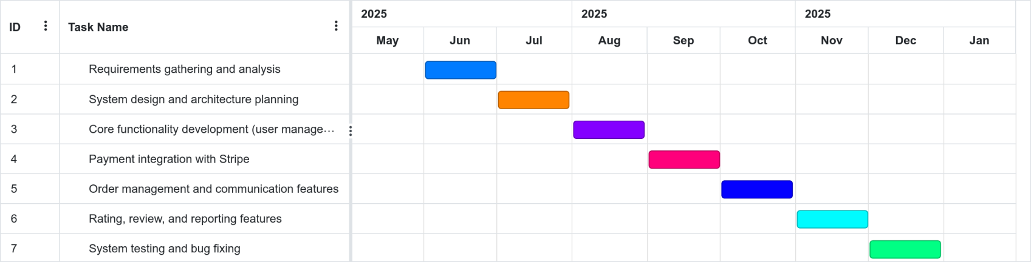
figure 1.1 project schedule gantt chart
1.12.2. Team Composition
The project team will consist of the following roles:
- Project Lead: Responsible for overall project coordination and stakeholder communication
- PHP Developer: Implementation of server-side logic and database interactions
- Frontend Developer: Implementation of user interfaces using HTML, Tailwind CSS, and JavaScript
- Database Administrator: Design and optimization of MySQL database architecture
- UI/UX Designer: Creation of user-friendly interfaces and user experience flows
- System Administrator: Setup and maintenance of development and deployment infrastructure

CHAPTER TWO: OVERVIEW OF CURRENT SYSTEM
2.1. Major functionality of the current system
The current system for connecting students with potential clients in Ethiopia operates as an informal and fragmented arrangement without a dedicated platform. Students typically use various general-purpose communication channels and personal networks to offer their services. The major functionalities of this current system include:
- Students advertise their services through social media platforms like Facebook, Telegram groups, and WhatsApp
- Students create basic portfolios on free platforms to showcase their previous work samples
- Students and clients connect through word-of-mouth referrals from peers, professors, and previous clients
- Service terms, pricing, and deliverables are negotiated through direct messaging or in-person meetings
- Service delivery occurs through email, file-sharing services, or in-person handovers
- Payments are processed through cash transactions, bank transfers, or mobile money services
- Students collect testimonials from satisfied clients informally via text messages or social media comments
- Students maintain personal client lists and communication records using basic tools like spreadsheets or notebooks
These functionalities enable a basic level of service exchange but lack standardization, security features, and scalability that a dedicated platform would provide.
2.2. User of the current system
The current informal system involves several categories of users, each with specific roles and interactions:
Users of the Current system
Users | Description
Students | University students who offer various services based on their skills and academic knowledge. They manage the entire service process from promotion to delivery and payment collection.
Clients | Individuals, small businesses, and organizations seeking services who must search through fragmented channels to find appropriate student providers.
Intermediaries | Other platforms like social medias, friends, family members, and former clients who facilitate connections between students and potential new clients through personal recommendations.

Table 2.1: users of the current system
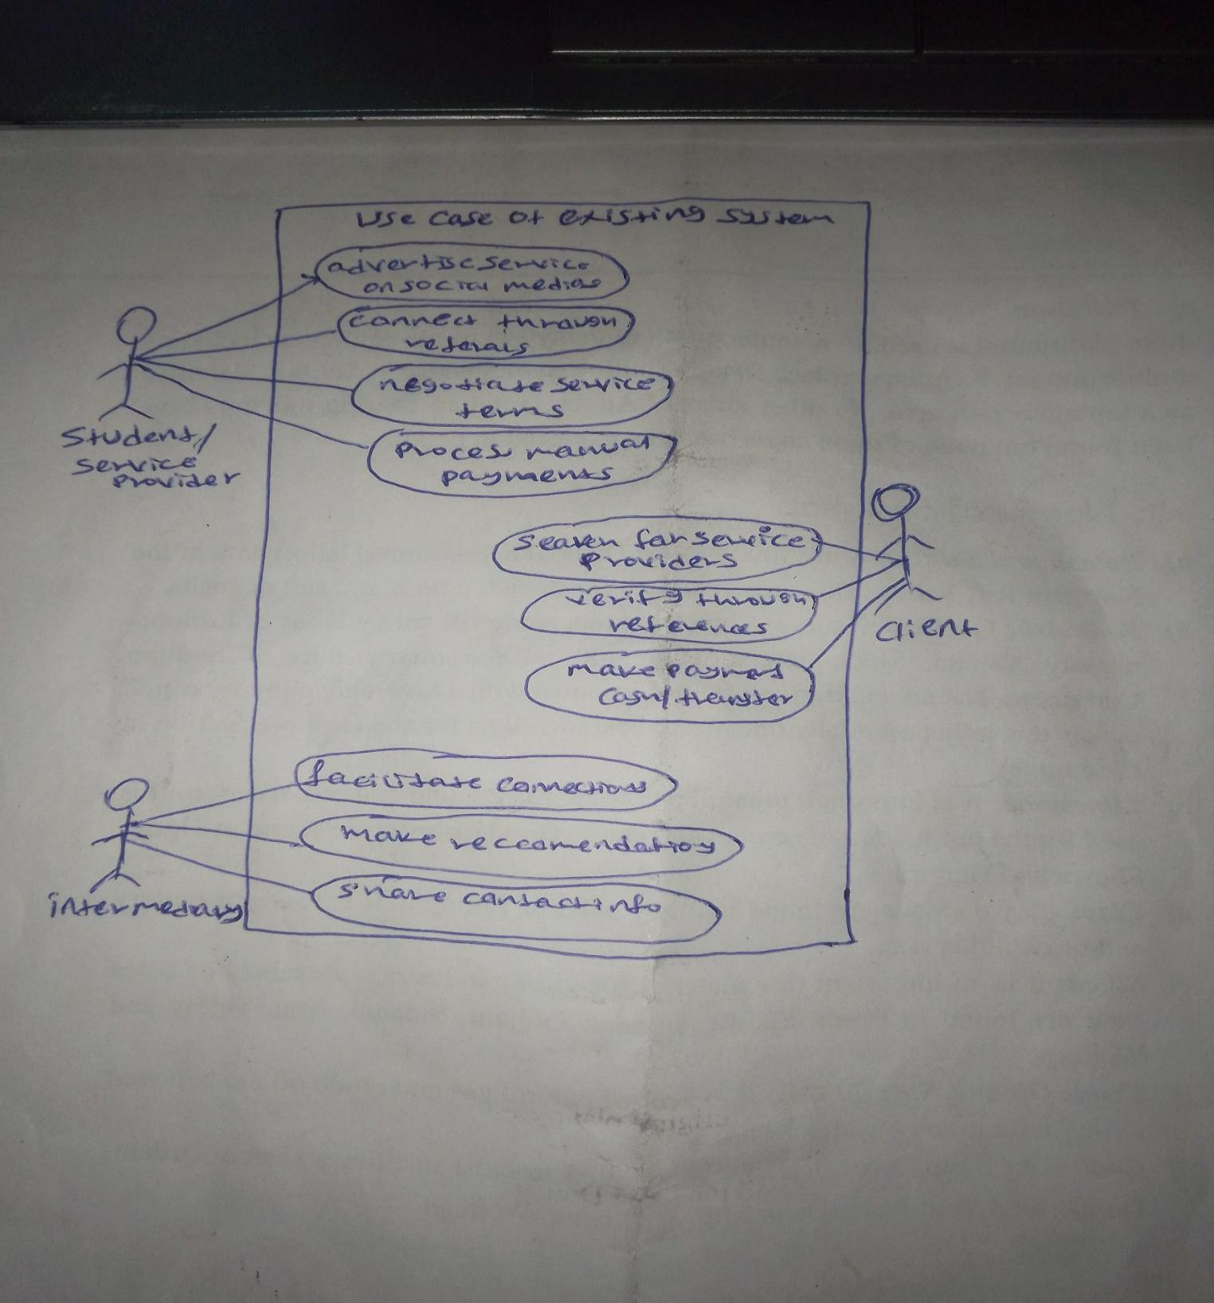
Each user category faces unique challenges in the current system. Students struggle with limited reach and credibility issues, while clients face difficulties in finding and evaluating potential service providers. Both parties lack security mechanisms for transactions and standardized processes for service delivery.

Figure 2.1 use case diagram of the existing system

2.3. Problem of the current system
The current informal approach to student service provision presents numerous problems that limit effectiveness for all participants:

- Fragmented Discovery: Students and clients struggle to find each other across disconnected platforms and networks, resulting in missed opportunities for both parties
- Limited Market Reach: Students can only effectively market their services to their immediate networks, significantly restricting their potential client base
- Pricing Inconsistency: Without market transparency, students lack reference points for appropriate pricing, often resulting in undervaluing their services
- Payment Insecurity: Direct cash or transfer payments offer no protection against non-payment for completed work or advance payment without delivery
- Trust Deficit: Clients have limited means to verify student qualifications or past performance beyond unverified testimonials
- Communication Challenges: Conversations scattered across various messaging platforms create disorganization and difficulty tracking service-related discussions
- Absence of Standards: Service descriptions, delivery expectations, and quality parameters vary widely without platform-enforced standards
- No Dispute Resolution: When conflicts arise over quality, payment, or deliverables, there is no formal system for resolution
- Portfolio Limitations: Students lack a structured way to build and showcase comprehensive portfolios of verified work
- Scheduling Complexity: Managing service delivery alongside academic responsibilities becomes challenging without dedicated project management tools
- Data Security Concerns: Sensitive client information and intellectual property are exchanged without proper confidentiality protections
- No Performance Metrics: Students receive limited structured feedback to improve their services over time
These problems collectively reduce efficiency, limit market potential, and create unnecessary risks for both students and clients in the service exchange process.

2.4. Business rule of the current system
Despite its informal nature, the current system operates according to several implicit business rules that govern interactions between students and clients:
Business rule one
Payment arrangements are established through verbal agreements or messaging platform discussions between students and clients. Payment timing may be structured as advance payment, completion-based payment, or milestone-based payment depending on mutual agreement, with no standardized payment protection mechanisms in place.
Business rule two
Late delivery consequences are handled through informal negotiation between student and client. No standardized penalties exist for missed deadlines.
Business rule three
In cases where a student receives advance payment or deposit and subsequently becomes unresponsive or fails to deliver services (ghosting), clients have no formal recourse mechanism for payment recovery.
Business rule four
Student credibility and reputation are established exclusively through personal referrals and recommendations from previous clients,. No formal rating or verification system exists to validate student qualifications or service quality.

CHAPTER THREE: PROPOSED SYSTEM
3.1. Overview
The proposed Student Skill Marketplace system is a web-based platform designed to connect Ethiopian university students with potential clients seeking their skills and services. The system will be developed using PHP for server-side processing, MySQL for database management, HTML with Tailwind CSS for frontend presentation, and JavaScript for client-side functionality. It will integrate Stripe's payment processing system to handle secure transactions between clients and student service providers.

The platform will operate as a C2C (Consumer-to-Consumer) marketplace where students can register, create service listings, communicate with clients, fulfill orders, and receive payments. Clients can browse available services, place orders, communicate requirements, review deliverables, and process payments. The system will provide robust search and filtering capabilities, secure user authentication, messaging functionality, order management, payment processing, and a review system to build marketplace trust.

The architecture follows a modular design with clear separation between presentation, application logic, and data layers. This approach ensures maintainability, scalability, and security while providing a responsive user experience across devices. The system will be deployed on an Apache web server with appropriate security configurations to protect user data and financial transactions.
3.2. Functional Requirement
The proposed Student Skill Marketplace system must fulfill the following functional requirements:
User Accounts & Authentication
- The system shall allow students to register as service providers with email verification
- The system shall allow clients to register with email verification
- The system shall provide secure login/logout functionality for all users
- The system shall implement role-based access control (admin, student, client)
- The system shall allow users to reset passwords securely
- The system shall allow users to manage their profile information and profile pictures
Service Listings
- The system shall allow students to create service listings with title, description, price, delivery time, and category
- The system shall allow students to edit or delete their service listings
- The system shall allow students to upload sample work as attachments to listings
- The system shall allow students to specify delivery timeframes for each service
- The system shall allow students to categorize services based on predefined categories
- The system shall allow students to add tags to increase service discoverability
Marketplace Browsing
- The system shall provide search functionality by keywords, category, and price range
- The system shall allow filtering of services based on multiple criteria
- The system shall implement pagination for service listing results
- The system shall display student ratings and reviews on service listings
- The system shall allow sorting of service listings by various criteria (price, rating, etc.)

Order Management
- The system shall allow clients to place orders for services
- The system shall allow clients to provide detailed requirements when placing orders
- The system shall allow file uploads for requirements and deliverables
- The system shall allow clients to request revisions to delivered work
- The system shall facilitate order completion and mark orders as finished
Payment Processing
- The system shall integrate Stripe Connect for secure payment processing
- The system shall hold client payments in escrow until order completion
- The system shall automatically transfer funds to students upon order completion
- The system shall deduct platform commission fees from transactions
- The system shall store transaction records securely
Messaging & Communication
- The system shall provide an in-platform messaging system between students and clients
- The system shall allow file attachments in messages
- The system shall notify users of new messages via email and in-app notifications
- The system shall maintain message history for all conversations
Ratings & Reviews
- The system shall allow clients to rate students on completed orders
- The system shall allow clients to leave written reviews for students
- The system shall calculate and display average ratings for students
- The system shall allow students to respond to client reviews
- The system shall display recent reviews on student profiles
Admin Dashboard
- The system shall provide administrators with a comprehensive dashboard
- The system shall allow administrators to manage users (view, suspend, delete)
- The system shall allow administrators to manage service listings
- The system shall allow administrators to manage categories and tags
- The system shall provide system-wide analytics and reports
3.3. Non-functional Requirement
The proposed system must fulfill the following non-functional requirements:
Performance
- The system shall load pages faster.
- The system shall maintain responsiveness during peak usage periods
Security
- The system shall encrypt all sensitive data stored in the database
- The system shall implement secure password hashing using bcrypt
- The system shall protect against SQL injection, XSS, and CSRF attacks
- The system shall implement session timeout after 30 minutes of inactivity
Reliability
- The system shall maintain a uptime during operational hours
- The system shall provide error handling that preserves user input in case of failures
Usability
- The system shall provide a responsive design that works on desktop and mobile devices
- The system shall provide clear error messages and validation feedback
- The system shall provide contextual help and tooltips for complex features
- The system shall maintain consistent navigation and interface patterns
Scalability
- The database design shall support increasing data volumes without performance degradation
- The system shall implement caching strategies for frequently accessed data
Maintainability
- The system shall implement modular design with clear separation of concerns
- The system shall include comprehensive code documentation
Compatibility
- The system shall support major browsers including Chrome, Firefox, Safari, and Edge
- The system shall function properly on devices with varying screen sizes
3.4. System Model
The system model provides a comprehensive visual and conceptual representation of the Student Skills Marketplace platform, illustrating how different components interact, behave, and relate to each other throughout the system's lifecycle. It serves as a blueprint that bridges the gap between functional requirements and technical implementation by modeling the system from multiple perspectives.
3.4.1. Use Case Model
3.4.1.1. Actor Identification
The proposed system involves the following actors, each with specific roles and interactions:
No | Actor | Description
1 | Student | University students who register as service providers on the platform. They create and manage service listings, communicate with clients, deliver services, and receive payments.
2 | Client | Individuals or organizations seeking services. They browse the marketplace, place orders, communicate requirements, review deliverables, make payments, and provide ratings and reviews.
3 | Adminstrator | System administrators who manage the platform, oversee users and listings, handle disputes, configure system settings, and access platform analytics.
4 | Payment system | External payment processing system (Stripe) that handles payment transactions, escrow management, and fund disbursement.
Table 3.1 Actors of the proposed system
3.4.1.2. Use Case Diagram and Description
The following use case diagram illustrates the primary interactions between actors and the system:

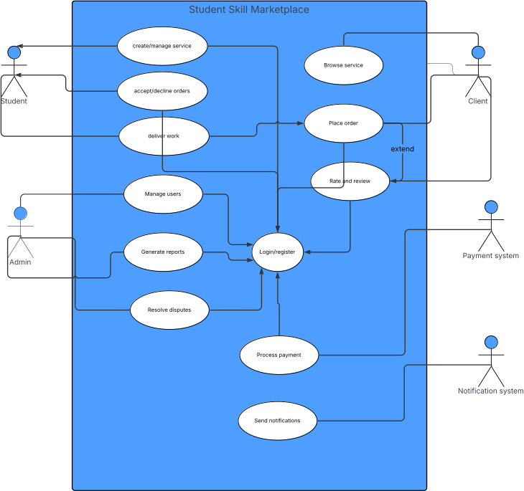
Figure 3.1 Use case diagram

Use Case Description: Register as Student Provider
Attribute | Description
ID | UC-001
Name | Register as Student Provider
Description | A student creates a new account as a service provider on the platform
Actors | Student
Preconditions | Student is not registered in the system
Basic Flow | 1. Student navigates to registration page  2. Student selects "Register as Service Provider"  3. Student enters required information (name, email, password)  4. System validates input  5. System creates new account  6. System sends verification email  7. Student verifies email address  8. System activates account
Alternative flows | - Email already registered: System notifies student and suggests login  - Validation fails: System displays error messages and allows correction
Postconditions | Student account is created and verified in the system
Table 3.2 Register as service provider usecase description

Use Case Description: Create Service Listing
Attribute | Description
ID | UC-002
Name | Create service listing
Description | A student creates a new service listing to offer to potential clients
Actors | Student
Precondition | Student is logged in and has a verified account
Basic flow | 1. Student navigates to "Create New Service" page  2. Student enters service details (title, description, category, tags)  3. Student sets pricing and delivery timeframes  4. Student uploads sample work (optional)  5. Student submits listing  6. System validates listing information  7. System publishes the service listing
Alternative flows | - Validation fails: System displays error messages and allows correction  - Student saves as draft: Listing is saved but not published
Postcondition | New service listing is published and available for clients to discover
Table 3.3 Service creation usecase

Use Case Description: Place Order
Attribute | Descrition
ID | UC-003
Name | Place order
Description | A client places an order for a student's service
Actors | Client, Payment system
Preconditions | Client is logged in and viewing a service listing
Basic flow | 1. Client selects "Order Now" on service listing  2. Client provides project requirements and any necessary files  3. System calculates total price including platform fees  4. Client is redirected to payment processing  5. Client completes payment via Stripe  6. System creates order in "pending" status  7. System notifies student of new order
Alternative flows | - Payment fails: System notifies client and allows retry  - Client cancels during process: Order is not created
Postconditions | Order is created, payment is held in escrow, student is notified
Table 3.4 Order placing usecase

Use Case Description: Deliver Completed Work
Attribute | Description
ID | UC-004
Name | Deliver completed work
Description | A student uploads and delivers completed work to fulfill a client's order
Actors | Student
Preconditions | Student has an active order in "in_progress" status
Basic flow | - Student navigates to order management dashboard  - Student selects the order to deliver  - Student uploads completed work files  - Student adds delivery message with work description  - Student marks order as "delivered"  - System notifies client of delivery  - System updates order status to "delivered"  8. Client receives notification to review the work
Alternative flows | none
post conditions | Order is marked as delivered, client is notified, and payment release process begins
Table 3.5 Deliver completed work use case

Use Case Description: Leave Review and Rating
Attribute | Description
ID | UC-005
Name | Leave review and rating
Description | A client provides feedback and rating for a completed service order
Actors | Client
Preconditions | Client has a completed order and has not yet reviewed the service
Basic flow | - Client receives notification that order is ready for review  - Client navigates to completed orders section  - Client clicks "Leave Review" for the specific order  - Client selects star rating (1-5 stars)  - 5. Client writes detailed review text  - Client submits the review  - System validates review content  - System publishes review on student's profile  - System updates student's average rating  10. Student receives notification of new review
Alternative flows | - Rating only: Client can submit rating without written review  - Review editing: Client can edit review within 24 hours of submission
post conditions | Review is published, student's rating is updated,
Table 3.6 leave review and rating usecase
3.4.2. Static Model
3.4.2.1. Class Diagram
The class diagram represents the structure of the system, showing classes, their attributes, operations,
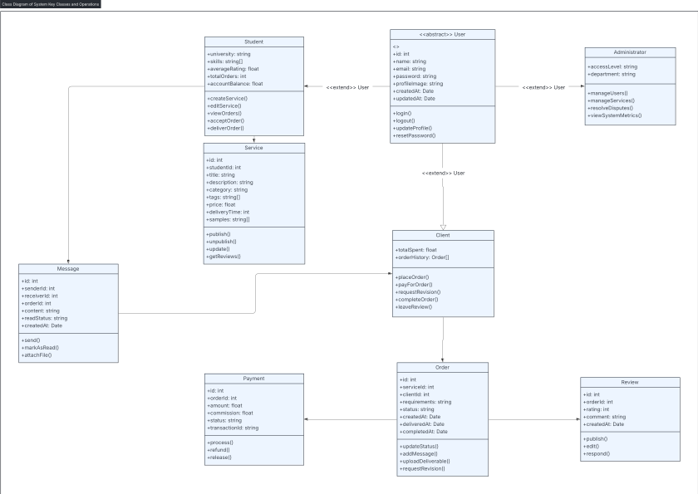
and relationships:
Figure 3.2 Class diagram

3.4.2.2. Object Diagram

The object diagram shows instances of the classes at a specific point in time:
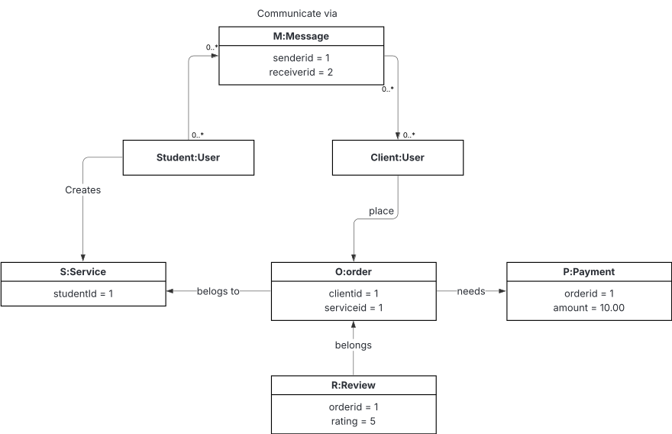
Figure 3.3 Object diagram

3.4.3. Dynamic Model
3.4.3.1. Sequence Diagram
The sequence diagram illustrates the interactions between objects over time for key processes:
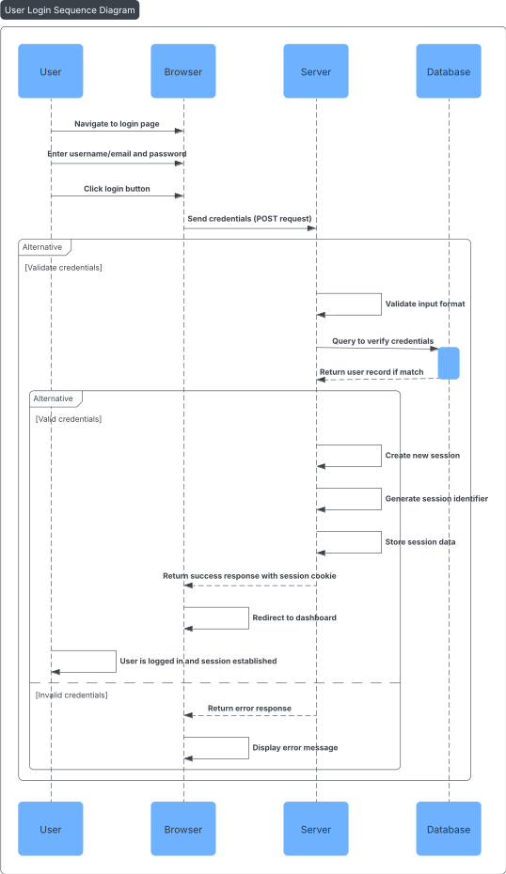
Figure 3.4 Sequence Diagram for LogIn Use Case
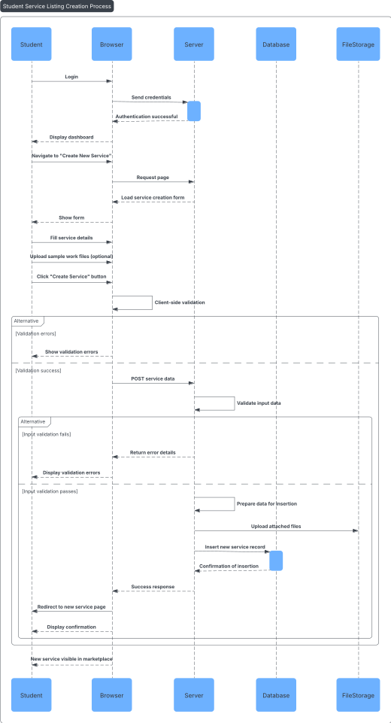
Figure 3.5 sequence diagram for service listing creation
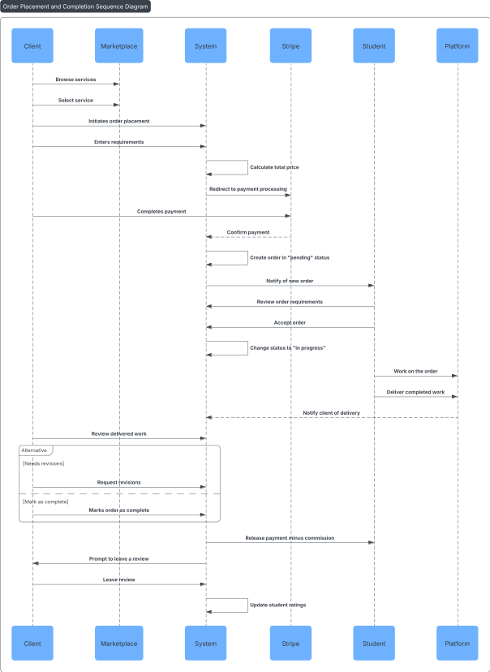
Figure 3.6 sequence diagram for order placement

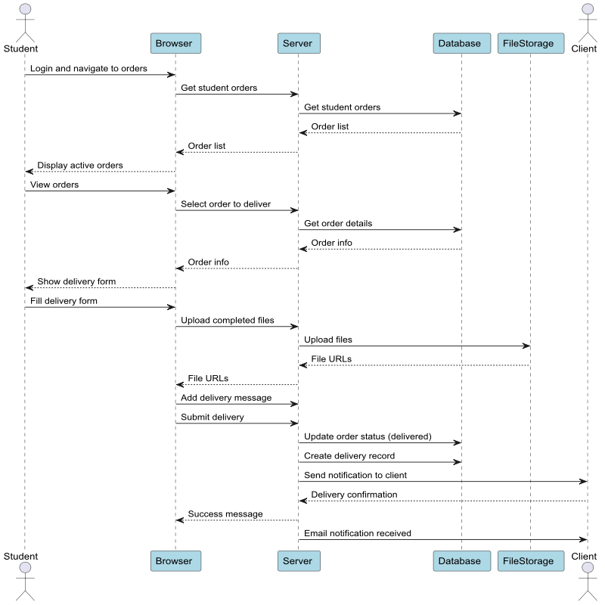
figure 3.7 sequence diagram for delivering completed work

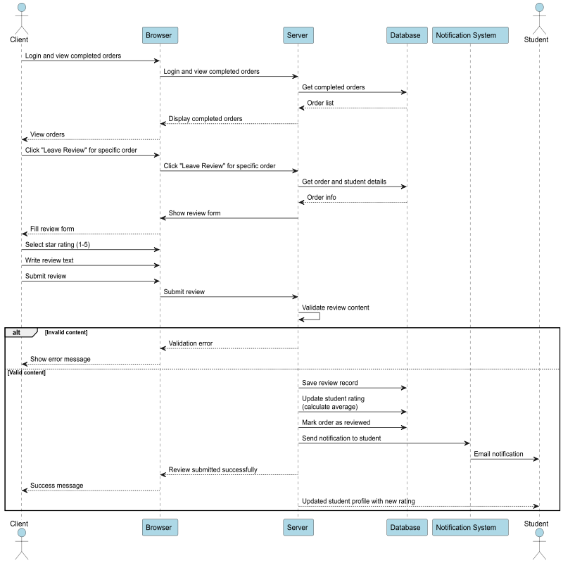
figure 3.8 sequence diagram for leaving a review

3.4.3.2. Activity Diagram
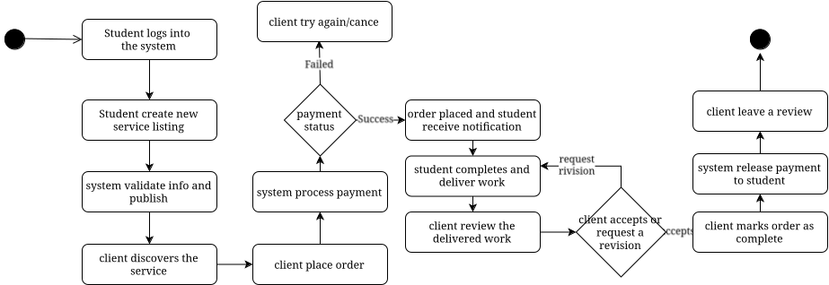
This activity diagram represents the complete workflow from service creation through order fulfillment, illustrating the activities performed by students and clients, system processes, and decision points throughout the service lifecycle.

Figure 3.9 activity diagram

3.4.3.3. State Diagram
A UML state diagram is a behavioral modeling diagram that represents the dynamic aspects of a system by illustrating how objects change their state over time in response to events. It belongs to the Unified Modeling Language (UML) specification and serves as a powerful tool for visualizing the lifecycle and behavior of individual objects, components, or entire systems.
State Diagram: Order Lifecycle
This state diagram illustrates the various states an order can exist in throughout its lifecycle within the Student Skill Marketplace system.
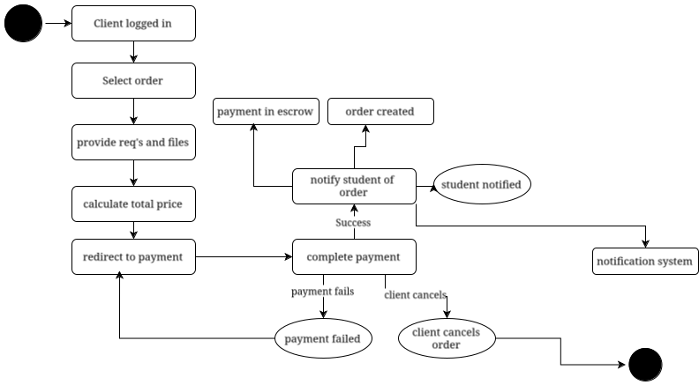
Figure 3.10 state diagram

CHAPTER FOUR: SYSTEM DESIGN
4.1. Overview
The system design phase translates the functional and non-functional requirements identified in the previous chapters into a comprehensive technical blueprint for the Student Skill Marketplace platform. This chapter presents the architectural design, component specifications, data management strategies, and user interface designs that will guide the implementation of the web-based marketplace system.

The design follows a modular, three-tier architecture pattern comprising presentation, application logic, and data persistence layers. This approach ensures maintainability, scalability, and security while supporting the diverse functional requirements of students, clients, and administrators. The system leverages modern web technologies including PHP for server-side processing, MySQL for data persistence, HTML with Tailwind CSS for responsive presentation, and JavaScript for dynamic client-side functionality.

The design incorporates industry-standard security practices, including secure authentication mechanisms, input validation, SQL injection prevention, and encrypted data transmission. Integration with Stripe's payment processing system ensures PCI DSS compliance for financial transactions while maintaining user trust through secure escrow functionality.
4.2. Purpose of the System Design
The primary purpose of this system design is to create a comprehensive technical specification that addresses the identified problems in the current informal student service provision system. The design aims to: Establish a structured platform that standardizes how students offer services and clients engage with providers, replacing the fragmented informal approach with a cohesive digital marketplace. The design specifically addresses the core functional requirements identified in the requirements analysis, including user management, service listing creation and discovery, order processing, secure payment handling, communication facilitation, and administrative oversight.
4.3. Design Goals
The system design is guided by the following strategic goals that ensure the platform meets both immediate functional needs and long-term growth objectives:
Usability and User Experience
Intuitive Navigation: Design user interfaces that require minimal learning curve for students and clients with varying levels of technical expertise.
Responsive Design: Ensure consistent functionality and appearance across desktop, tablet, and mobile devices to accommodate diverse user preferences.
Performance and Reliability
Fast Response Times: Optimize system performance to load pages faster
Efficient Resource Utilization: Implement caching strategies and database optimization to minimize server resource consumption.
Security and Privacy
Data Protection: Encrypt sensitive user information and implement secure data transmission protocols.
Authentication Security: Use industry-standard password hashing and session management practices.
4.4. Proposed System Architecture
The Student Skill Marketplace employs a three-tier client-server architecture that separates presentation, application logic, and data management concerns. This architectural pattern provides flexibility, maintainability, and scalability while ensuring security and performance optimization.
Presentation Tier (Client Layer)
The presentation tier consists of web browsers accessing the system through responsive HTML interfaces styled with Tailwind CSS and enhanced with JavaScript functionality. This tier handles:
User Interface Rendering: HTML templates generate dynamic content based on user roles and system state.
Client-Side Validation: JavaScript validates user input before submission to reduce server load and improve user experience.
Responsive Layout: Tailwind CSS ensures consistent appearance across different device types and screen sizes.
Interactive Elements: JavaScript manages dynamic content updates, form interactions, and real-time notifications.
Application Tier (Business Logic Layer)
The middle tier, implemented in PHP, processes business logic, manages user sessions, and coordinates interactions between the presentation and data layers. Key components include:

Authentication Module: Manages user registration, login, logout, and session security.
Service Management Module: Handles service listing creation, editing, search, and discovery functionality.
Order Processing Module: Manages the complete order lifecycle from placement through completion.
Payment Integration Module: Coordinates with Stripe APIs for secure payment processing and fund management.
Communication Module: Facilitates messaging between students and clients.
Notification Module: Manages email and in-app notifications for system events.
Data Tier (Persistence Layer)
The data tier, implemented using MySQL, manages all persistent data storage and retrieval operations. This layer includes:
User Data Management: Stores student, client, and administrator account information and profiles.
Service Catalog: Maintains service listings, categories, and metadata.
Transaction Records: Persists order, payment, and commission data for financial tracking.
Communication Logs: Stores message history and notification records.
System Configuration: Maintains platform settings and administrative configurations.
External Integration Layer
The system integrates with external services to provide enhanced functionality:
Stripe Payment Gateway: Handles secure payment processing, escrow management, and fund disbursement.
Email Service Provider: Manages email notifications and verification messages.
File Storage Service: Manages uploaded files including service samples and order deliverables.
4.5. System Process
The system operates through interconnected processes that manage the complete lifecycle of marketplace activities. These processes ensure seamless user experiences while maintaining data integrity and security.
User Registration and Authentication Process
Initial Registration: Users select registration type (student or client) and provide required information including email verification.
Email Verification: System sends verification email with secure token to confirm account authenticity.
Profile Setup: Users complete profile information including personal details, skills (for students), and preferences.
Authentication: Secure login process validates credentials and establishes authenticated sessions with appropriate role-based permissions.
Service Listing Process
Service Creation: Students create service listings with title, description, pricing, category, delivery timeframes, and optional sample work.
Content Validation: System validates listing content for completeness, appropriate categorization, and compliance with platform policies.
Publication: Approved listings become searchable and discoverable in the marketplace.
Ongoing Management: Students can edit, deactivate, or delete listings while maintaining order fulfillment obligations.
Order Processing Workflow
Service Discovery: Clients browse, search, and filter services to identify suitable providers.
Order Placement: Clients specify requirements, select service packages, and initiate the ordering process.
Payment Processing: Stripe integration securely processes payment and holds funds in escrow until order completion.
Order Fulfillment: Students receive notifications, review requirements, and deliver completed work through the platform.
Quality Review: Clients review deliverables and may request revisions within defined parameters.
Order Completion: Upon client acceptance, funds are released to students minus platform commission.
Feedback Collection: Both parties can provide ratings and reviews to build marketplace trust.
Communication Process
Message Initiation: Users can initiate conversations related to specific services or orders.
Real-time Messaging: Platform facilitates secure messaging with file attachment capabilities.
Notification Delivery: System sends email and in-app notifications for new messages and important updates.
Message History: All communications are logged and accessible to relevant parties for reference.
4.6. Subsystem Decomposition
The Student Skill Marketplace is decomposed into distinct subsystems, each responsible for specific functional areas while maintaining clear interfaces for inter-subsystem communication.

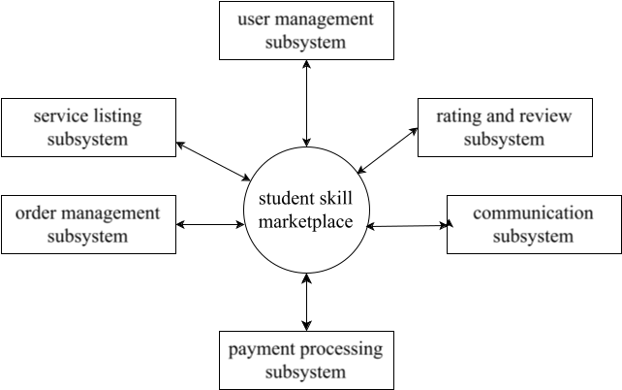
Figure 4.1 system decomposition
4.7. Persistent Data Management
The data management strategy ensures reliable, secure, and efficient storage and retrieval of all system information while maintaining data integrity and supporting analytical requirements.
Database Management System Selection
MySQL has been selected as the primary database management system based on the following considerations:
Reliability: Proven track record in high-transaction web applications
Performance: Optimized for read-heavy workloads typical in marketplace platforms
ACID Compliance: Ensures data consistency for financial transactions
Scalability: Supports horizontal scaling through replication and partitioning
PHP Integration: Native support and extensive documentation for PHP applications
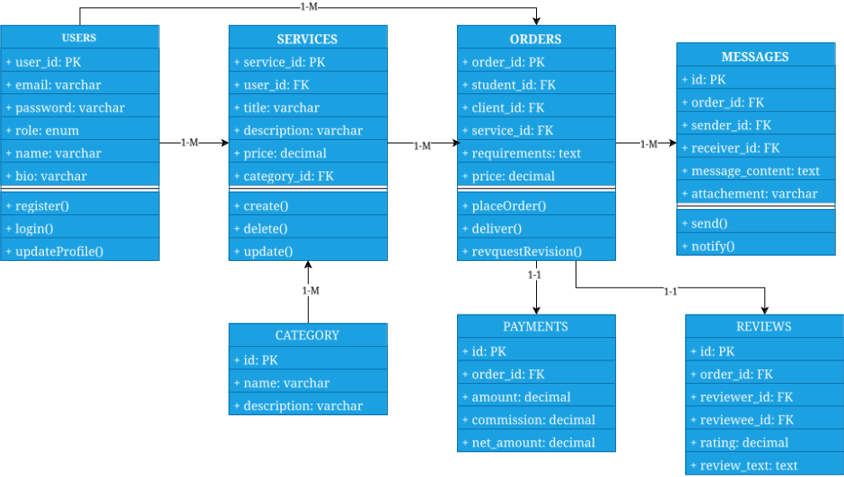
Figure 4.2 persistent data modeling diagram
4.8. Component Diagram
The component diagram illustrates the high-level organization of software components and their dependencies within the Student Skill Marketplace system. This diagram provides a clear view of how different parts of the system interact and the flow of data between components.
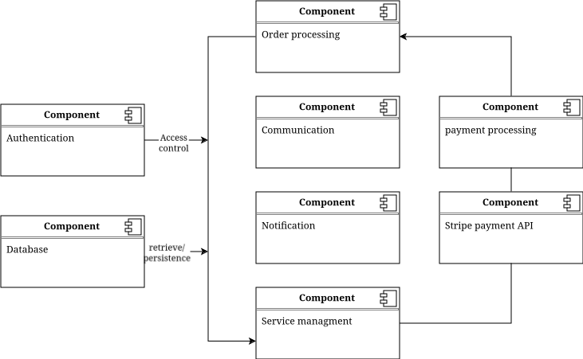
Figure 4.3 component diagram

4.9. Deployment diagram
The deployment diagram shows the physical architecture of the system, including hardware nodes, software components, and network connections required for the Student Skill Marketplace operation.
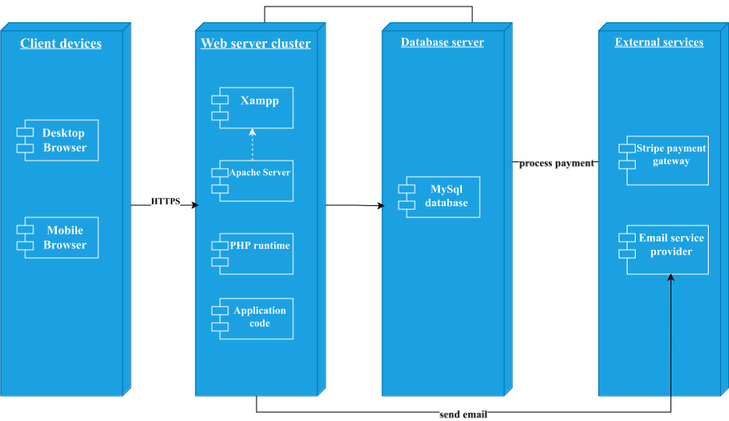
Figure 4.4 deployment diagram
4.10. Database Design
The database design provides the foundation for all data storage and retrieval operations in the Student Skill Marketplace. The design follows relational database principles with careful attention to normalization, performance, and scalability.

4.10.1 Conceptual Database Design
This phase of the database design shows the theoretical design of the data requirement of the database and it is illustrated by Entity Relationship Diagram. Accordingly, the following the
following figure shows the ER-Diagram of the proposed system.
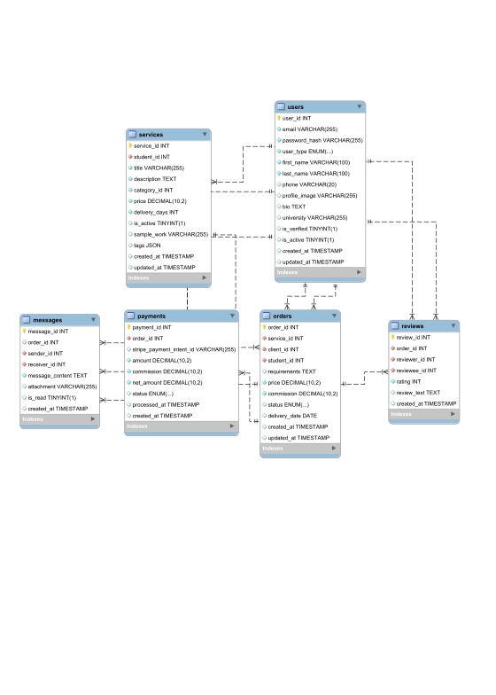
Figure 4.5 Entity Relation Diagram
4.10.2 Physical Database Design
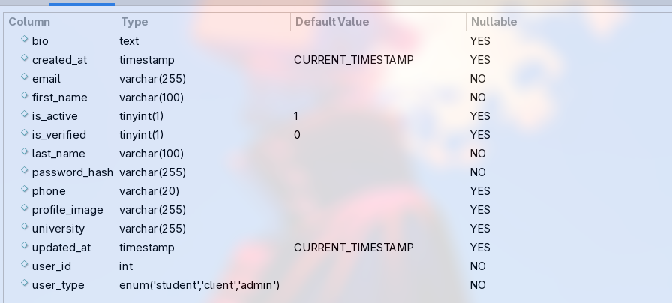
This part of the design shows the physical realization of the data in the database

figure 4.6 users table
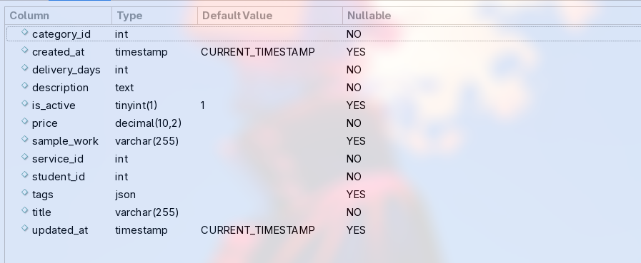
figure 4.7 services table
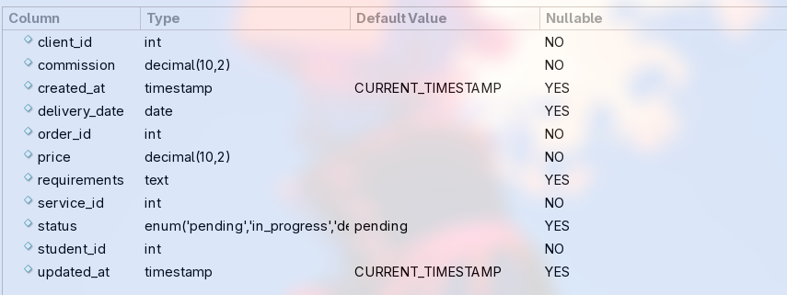
figure 4.8 orders table
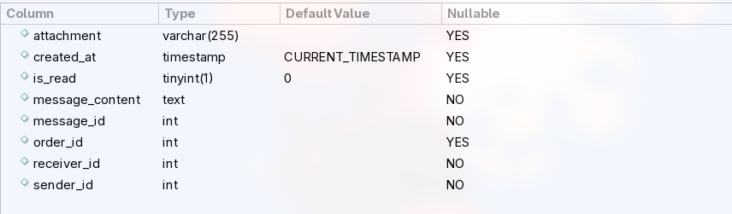
figure 4.9 messages table
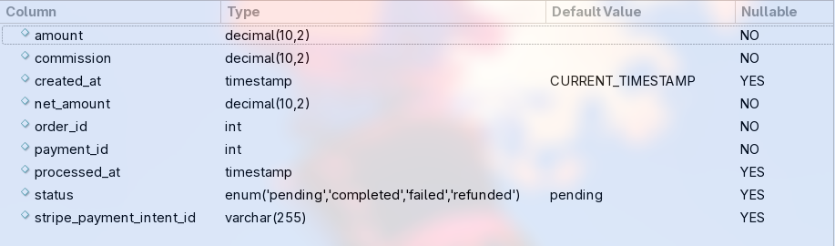
figure 4.10 payments table
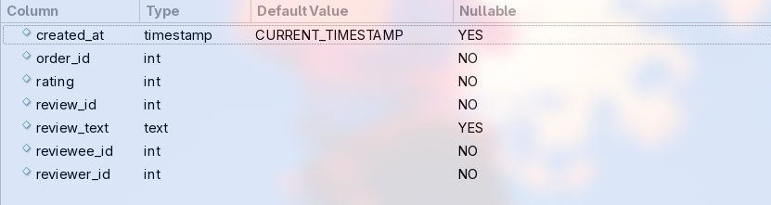
figure 4.11 reviews table
4.11. Access Control
The Student Skill Marketplace implements a role-based access control (RBAC) system that restricts user access to features and data based on their assigned roles within the platform. This mechanism ensures security and maintains appropriate boundaries between different user types while providing seamless access to authorized functionality.
Role-Based Access Control Implementation
The system defines three primary user roles, each with specific permissions and access levels:
Student Role Access:
Students can create and manage their service listings, and fulfill orders, and communicate with clients. For example, when a student logs in, they can access the "Create New Service" page, view their active orders in the dashboard, and respond to client messages. However, they cannot access admin functions like user management or view other students' financial data.
Client Role Access:
Clients can browse services, place orders, and manage their purchases. For instance, a client can search for graphic design services, place an order for a logo design, track the order progress, and leave reviews upon completion. Clients cannot create service listings or access administrative functions.
Administrator Role Access:
Administrators have comprehensive system access including user management, content moderation, and platform analytics. For example, an admin can suspend user accounts, moderate service listings for policy compliance, view platform-wide transaction reports, and configure system settings like commission rates.
4.12. User Interface Design
The user interface design prioritizes usability, accessibility, and responsive design to ensure an optimal experience across all user types and devices.
Will be designed during implementation phase

4.13. References
1. Martin Fowler, (2002). Patterns of Enterprise Application Architecture.
2. Craig Larman, (2004). Applying UML and Patterns: An Introduction to Object-Oriented Analysis and Design and Iterative Development.
3. Sommerville, I. (2015). Software Engineering. 10th Edition. Pearson Education Limited.

