Ayhan Bozkurt
32.768 kHz
RF aletleri varmış labda.

Antenna Power:
10log(W) = dB
10log(1W) = 0dB
10log(1mW) = 0dBm

The reason why we use a resistor and a capacitor at the reset pin is to lower the current flow after we short the circuit. And also, to control the voltage level alteration.

Cstray = A * ε / d
A is the area of the intersection of the GND layer which is the 2nd layer and the connection layer.

Onboard Antenna Gain: 2.1dBi
Longer Range Antenna Gain: 8dBi

The matching network must be placed close to the antenna feed to
ensure it is more effective in tuning the antenna.

JTAG pins:
MTCK
MTDO
MTDI
MTMS
GPIO 33 34 35 36 37 are taken up by the octal PSRAM so we don’t prefer to use.
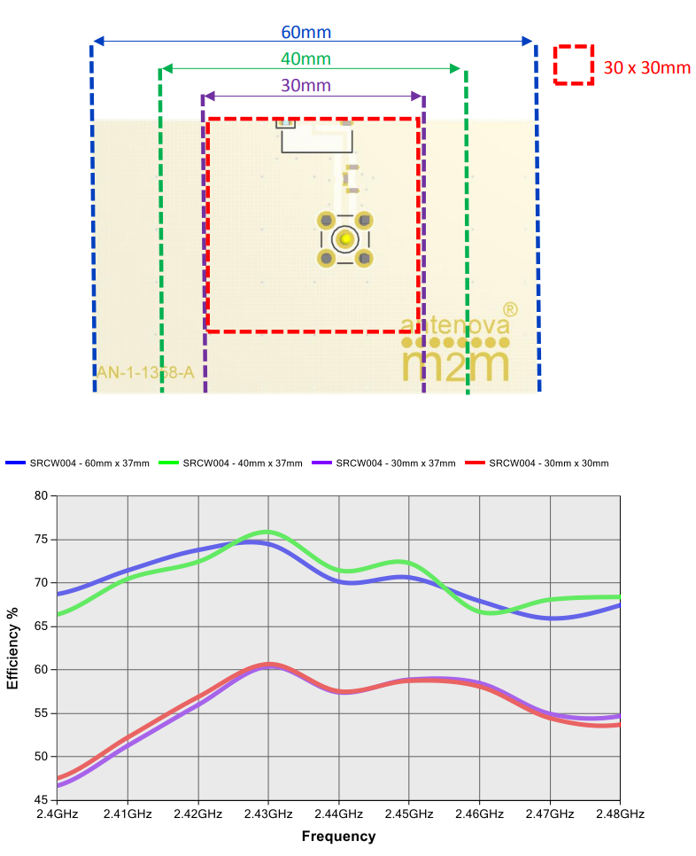

RESET buttons resistor pull up resistor: 100k ohm in pros3

10uF: 1 1 1
1uF: 1 1 1 1 1 1 1 1
0.1uF: 1 1 1 1 1 1 1 1 1
10nF: 1
4.7uF: 1 1 1

