**Eviction Notice**

2025-01-18

**Date:** ___________________________________

john angelo payo junio

**Tenant:** __________________________________

Macarthur Street

**Address:** ___________________________________________________

66

You are hereby notified that you currently owe ₱ _______________ in past due rent and late payments.

33

The rent due each month is in the amount of ₱ _______________;

2024-12, 2025-01

The rent past due covers the dates _________________________________________________;

66

Late payments are in the total amount of ₱ _______________.

This is a demand for payment. You must pay the full amount owed that is stated in this notice within the next _____ days. If you fail to make full payment of the amount due, your right of possession to the property will be terminated and eviction proceedings will begin immediately. Only full payment of the amount owed will prevent the termination of you lease. NO partial payments will be accepted without the written consent of the landlord.

543

Jerson Wayas Lippad

**Pay Rent Immediately To:** _________________________________

tandang soraa ers

**Address:** _____________________________________________________________________

09955835160

**Contact #:** ______________________________________

Jerson Wayas Lippad

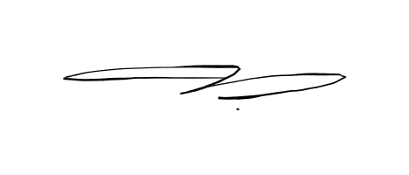

______________________________________

Landlord Signature