This **CONTRACT OF LEASE** made and executed by and between: _________________________________________, Filipino, of legal age, hereinafter collectively known as the **LESSOR.** And

Jerson Wayas Lippad

Jerson Wayas Lippad

_________________________________________, Filipino, of legal age with postal address __________________________________________________________________________________________________________________________________________________hereinafter known as the **LESSEE.**

${tenantaddress}

**WITNESSETH**

The LESSOR hereby lets and leases unto the LESSEE and the LESSEE, hereby accepts in lease from the former, the APARTMENT situated at

apartment testttttttt

________________________________ _________________________________**,** hereby agrees the following terms and conditions:

1. **PERIOD OF RENTALS** - The term of lease is for one (1) year commencing from _________________ and expiring _______________during the period the LESSEE shall pay the LESSOR a monthly rental of ₱_____________ of Philippine Currency payable on the _______ of every month without the need of DEMAND.

7th

43

2024-12-28

2024-12-07

1. **DEPOSIT REQUIREMENT** - Upon signing of the contract, the LESSEE shall pay unto the LESSOR amount equivalent of two months deposit amounting ₱_______________ and payment in applied of back rents at the end of contract, unless otherwise upon termination of the contract expenses billed against the LESSEE for damages and utility services.

43

1. **USE AND PURPOSE** - The LESSEE hereby agrees and warrants that the APARTMENT shall be used exclusively for residential purposes only.
2. **NON-TRANSFERABILITY OF LEASEHOLD** - The LESSEE shall not sub-leases, assign or transfer leasehold rights over the leased property, any such or whatsoever shall make the contract null and void.
3. **UTILITY BILLS** - Charged for water, electricity, telephone and other utility services shall be on the account of the LESSEE.
4. **MAINTENANCE OF THE LEASED PREMISES** - The LESSEE shall settle accounts, repairs with damages made on the structure and all utility bills, this is held mandatory upon expiration of the contact. The LESSEE has inspected the property and found the same to be in tenable condition.The LESSEE shall at its expense maintain the property clean and in sanitary condition and upon the expiration of the contract the lease shall surrender and return the same condition the property where actually found in the beginning of the lease. That the structure shall not be renovated without the prior consent and approval of the LESSOR. That any major repair of maintenance shall not be undertaken without the consent and the approval of the LESSOR. The cost of Maintenance and Repair shall be for the account of the LESSEE.
5. **COMPLIANCE WITH THE LAW** - The LESSEE shall comply with any and all laws, ordinances, regulations or order promulgated by the government authorities and non compliances shall be at risk of the LESSEE.
6. **EFFECT OF RENTAL DELINQUENCY** - If the rental stipulated shall be in **arrears or unpaid for two (2) consecutive months**, or if the LESSEE fails or neglects to perform or comply with the conditions in the contract shall automatically terminate and cancel the said premises and shall vacate the unit peacefully by the LESSEE.
7. **REMEDIAL MEASURE** - In case of violation of any foregoing terms and conditions, the LESSOR reserves the right to terminate this CONTRACT OF LEASE immediately and the LESSEE agrees to vacate the premises without the need of government proceeding or barangay officials; provided however for any valid reason it shall be necessary for the LESSOR or institute an appropriate court action.

IN WITNESS WHEREOF, the parties here unto have affixed their signatures this _____________________________________ at Tandang Sora, Quezon City, Philippines.

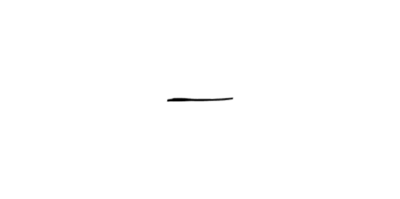

${tenantsignature}

2024-12-07

Jerson Wayas Lippad

Jerson Wayas Lippad

_______________________ _______________________

LESSOR LESSEE

CTC NO.____________ CTC NO.____________

DATE_______________ DATE______________

PLACE______________ PLACE_____________

${lesseewitness_signature}

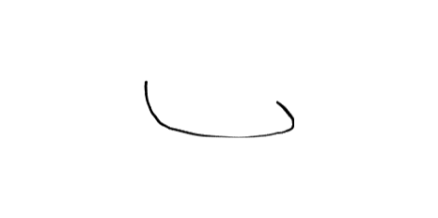

Signed in the presence and witnessed of:

${lesseewitness}

asda

______________________________ __________________________

Signatory witness of LESSOR Signatory witness of LESSEE

REPUBLIC OF THE PHILIPPINES (Quezon City) S.S.

At the above stated locality this ______________________________ personally appeared before me, all known to me the same person who executed the contract of lease covering an APARTMENT and hereon acknowledgement is written, and signed by both parties in their free and voluntary act of deed.

WITNESS MY HAND AND SEAL, the date and place first above written.

Doc No._____

Page No._____

Book No._____

Series of 2024