ATILIM UNIVERSITY SE-112 INTRODUCTION TO SOFTWARE ENGINEERING
Project 1-2

INSTRUCTORS: -Ali Yazıcı
-Arif Eren
Group 17 Members:
-Emirhan Demirci 22244710095
-Eylül Akı 22244710080
-Ege Velimahmutoğlu 22244710091

E-PHARMACY

Our aim in this project is to ensure that people can access the products they need such as medicines, personal care, cosmetics, etc. with fast and reliable content. For this purpose, we are developing an application that works with Swift on the IOS operating system and Kotlin on the Android operating system. Thanks to our application, people will be able to obtain the products they need through couriers. E-pharmacy is not an application open only to certain people, it is an application that can be easily accessed by anyone who registers with their ID and wants to use the application. Users can view, add to cart and purchase all kinds of products related to health and personal care. In addition, it is now very comfortable to access the contents of the products thanks to E-pharmacy. You don't need to spend hours asking someone or researching terms you don't understand. Our app decodes the Latin names of the ingredients on the label and shows you the percentage of harmful ingredients. Our product ratings are 100% unbiased.
For prescription products, the prescription number obtained from the hospital will be checked by the E-pharmacy application with a QR code and opened to your access.

Project Management

Task | Activitiy | Duration(weeks) | Predecssors
A | Financial Calculations | 2 | _
B | Determine the software language of the project | 1 | _
C | Necessary equipment is installed | 2 | B
D | Find software developers suitable for the selected software language | 2 | A
E | Application design is done | 8 | D
F | Agreements are made with courier and transportation companies | 3 | E
G | classification and content control of drugs | 2 | F
H | Final testing and distribution of products | 2 | G

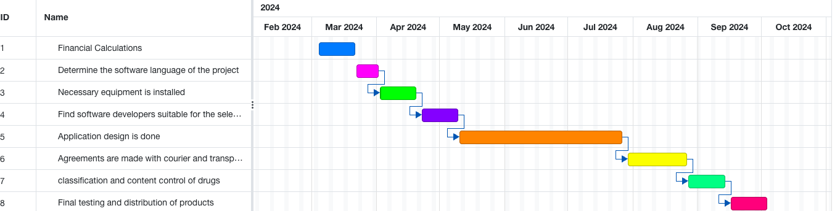

Risk Management

Risks | Affects | Description | B-Plans | Risk Effect  1-4 (Ineffective)  5-8 (Effective)  9-12 (Very Effective)
Staff turnover | Project | One of the software engineer of company leaves the Project while it is ongoing | having engineers in reserve who can be hired for this | 8
Product Competition | Business | another company submits a similar project before the project is finished | increase the recognition of the app with more advertisement | 9

Assignment 2
1.
Functional Reqs ID | Explanation | MOSCOW priority (M, S, C, W)
FR1 | System must allow a customer to create account with (TCKN/password) | M
FR2 | The customers will be able to give feedback | S
FR3 | A customer can see the prices of the products | M
FR4 | The system should be secure | M
FR5 | the customer should be able to select and search for medicines from a menu | M
FR6 | Customers should be able to buy medicines by scanning their prescription | M
FR7 | A customer can change the language | S
FR8 | The customer should receive notification when their medicine is on its way | S
FR9 | Customers must be able to view the content of the products they search for | M
FR10 | Warns customers about products to which they are allergic | S
Non-Functional Reqs ID | Explanation | MOSCOW priortiy  (M, S, C, W)
NFR1 | Software must be multilingual | M
NFR2 | Provides customers with a 2-step secure payment system | S
NFR3 | System must for 7/24 without fail down | M

2.USER-STORY : From the e-pharmacy system, people can buy the products they need, such as medicines, personal care, cosmetics, etc. For example, the user who wants to buy a product must register on the site and, if he wants, he can search for a product he wants. When he decides on the product to buy, he can see the content of the product. At the same time, the pharmacist_admin should be able to edit the content when necessary.

3.
@startuml
actor CUSTOMER
actor Pharmacist_admin
left to right direction
rectangle e-pharmacy {
usecase Login
usecase Buy_product
usecase call_product
usecase content_of_product
usecase change_content_of_product
}
Pharmacist_admin--(change_content_of_product)
CUSTOMER--(call_product)
(content_of_product)..|>(call_product):<<include>>
(Buy_product)..|>(call_product):<<extend>>
(Buy_product)..|>(Login):<<include>>
(change_content_of_product)..|>(content_of_product):<<include>>
@enduml

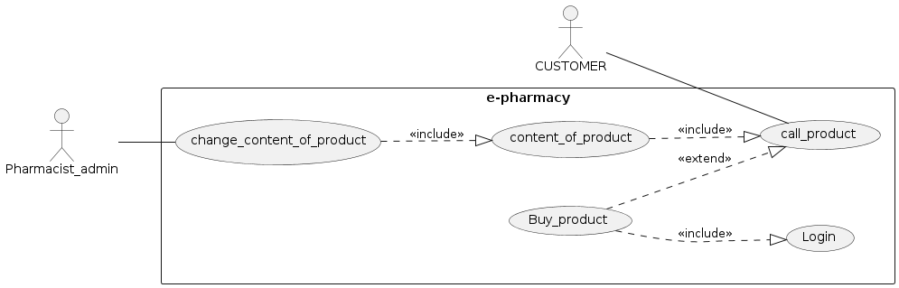

4.
@startuml
class e_pharmacy{
+Name
+User_password
+User_name
+product_type
+product_name
+login()
}
class customer{
-TCKN:int
+Name:String
-password :int
+login()
-call_product()
-buy_product()
-see_content()
}
class pharmacist_admin{
-id:int
-password:int
-change_content()
}
class product{
+name
+type
+ingredients
+price
}
customer "1" - "1..*" product : buy
product "1" - "1"pharmacist_admin
e_pharmacy*--customer
e_pharmacy*--product
e_pharmacy*--pharmacist_admin
@enduml
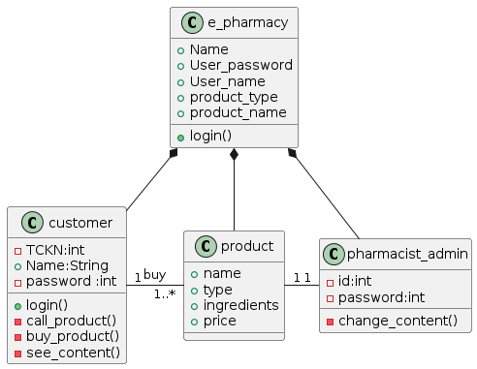

6.
@startuml
start
:open application;
:call product;
while(if logged in?) is (no)
:log in;
endwhile(yes)
:choose product;
:see content of products;
:buy product;
stop
@enduml
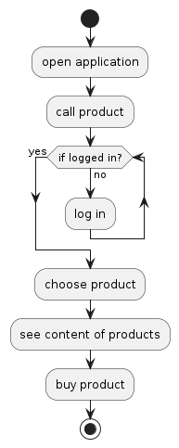

Steps:
- Firstly, user opens the application.
- Secondly, user calls for the product to buy.
- The system checks if the user logged in or not.
- If user is logged in, he/she can choose product to buy
- After user choose the product, he/she can see the content of it.
- Then user buy the product.

- FİGMA:
https://www.figma.com/proto/EW2fYQAczwmbmnPDfzX78f/E-pharmacy?type=design&node-id=1-2&t=Qxpd7T6IIoRnuorZ-1&scaling=scale-down&page-id=0%3A1&starting-point-node-id=1%3A2&mode=design

