**Fundamentals of Web Apps**

* First rule of web development:
  + Always keep the Developer Console open on your browser.

**HTTP GET:**

* The server and web browser communicate with each other using the HTTP protocol.

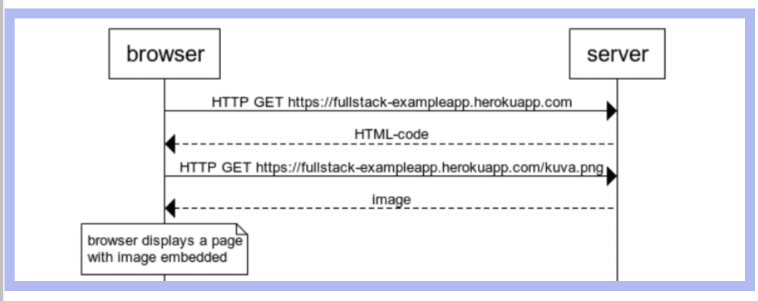

**Loading a page containing JavaScript – Review**

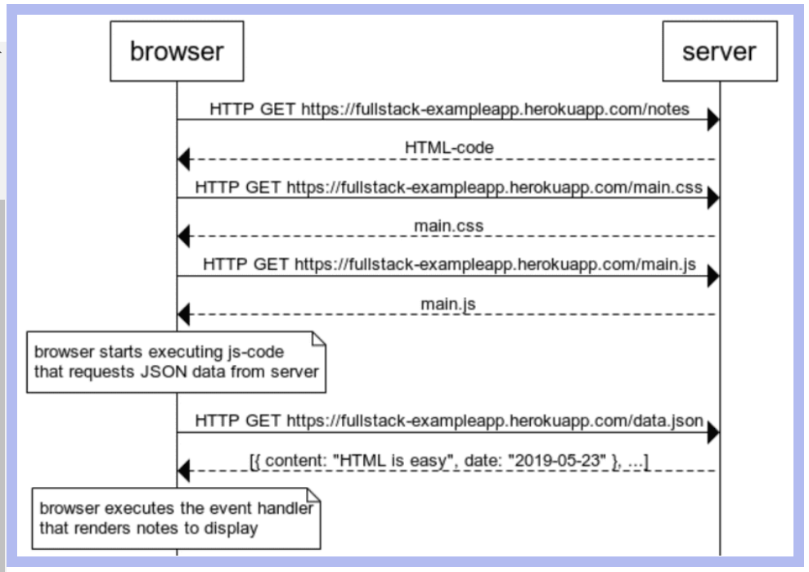

**AJAX ~ Asynchronous JavaScript and XML**

* Term introduced in February 2005

**Single page app:**

* Only one HTML page is fetched from the server, the contents of which are manipulated with JavaScript that executes in the browser.

**JavaScript-Libraries:**

* JQuery ~ developed back when web applications mainly followed the traditional style.
* BackboneJS ~ Favorite of first wave of developers.
* AngularJS ~ Became almost the de facto standard of modern web development
* React – Currently the most popular tool for implementing the browser-side logic of web-apps
* Redux ~ Frequently used together with React
* VueJS ~ Has been capturing some interests.

**Full stack web development**

* Practically, all web applications have at-least two layers:
  + The browser, being closer to the end-user, is the top layer, and the server the bottom one.
  + There is also a database layer below the server.
  + Think of the architecture of a web app as kind of stack of layers.
* Often, we talk about the frontend and backend.
  + The browser is the frontend
  + The server is the backend
* This course focuses on all parts of the application: frontend, backend, and the database.

**JavaScript Fatigue**

* Full stack web development is challenging in many ways.
* JavaScript does not always work as you’d expect it to.
* The asynchronous way its runtime environments work causes all sorts of challenges.
* Communicating on the web requires knowledge of the HTTP protocol.
* One must also handle databases and serve administration and configuration.
* It would also be good to know enough CSS to make applications at least somewhat presentable.
* The world of JavaScript develops fast, tools, libraries and the language itself are under constant development.