PROJECT REPORT

PROJECT INFORMATION
Project Title: Automatic Battery Charger with Auto Cut-Off and LED Indication
Group Name: Circuit Breakers
Team Members:
- Ashama Abbasi
- Ezaan Hassan
- Abdullah Ali
- Kazim Hussain
Date of Submission: 17/01/2026

TABLE OF CONTENTS
- Abstract
- Introduction
- Problem Statement
- Objectives
- Project Overview
- Circuit Description
- Components List with Specifications and Pricing
1. ABSTRACT
This project presents the design and implementation of an automatic battery charger specifically designed for 6V 4.5Ah sealed lead-acid batteries. The charger employs an analog voltage-sensing circuit with automatic cut-off functionality that prevents battery overcharging. The system utilizes an LM358 comparator IC to monitor battery voltage and automatically terminates charging when the battery reaches 6.9V (full charge). The charging current is limited to 400-450mA using a simple resistor-based current limiting technique, ensuring safe and optimal charging at the C/10 rate. Visual indication is provided through an LED that illuminates during charging and turns off when the battery is fully charged. The entire circuit is built using basic analog components, making it cost-effective, easy to understand, and simple to construct. The project demonstrates fundamental electronics principles including AC-DC conversion, voltage regulation, voltage comparison, and transistor switching.
2. INTRODUCTION
2.1 Background
Battery charging is a fundamental requirement in modern electronic systems, from small portable devices to large backup power systems. Lead-acid batteries, despite being one of the oldest rechargeable battery technologies, remain widely used due to their reliability, low cost, and high current capability. However, proper charging is critical for battery longevity and safety.
Traditional manual chargers require constant monitoring and manual disconnection when charging is complete. Overcharging leads to several problems:
- Excessive heat generation
- Electrolyte loss through gassing
- Plate degradation and sulfation
- Reduced battery life
- Safety hazards including swelling and potential explosion
2.2 Need for Automatic Charging
An automatic battery charger eliminates human error by monitoring battery voltage and stopping charging precisely when the battery reaches full capacity. This ensures:
- Extended battery lifespan
- Enhanced safety
- User convenience
- Energy efficiency
- Optimal battery performance
2.3 Project Scope
This project focuses on designing a simple, reliable, and cost-effective automatic charger for 6V 4.5Ah sealed lead-acid batteries commonly used in:
- Emergency lighting systems
- Small UPS (Uninterruptible Power Supply) units
- Solar power storage systems
- Electric toy vehicles
- Portable power banks
- Security alarm systems
The design emphasizes educational value, demonstrating fundamental analog electronics concepts while producing a practical, working device.

3. PROBLEM STATEMENT
3.1 Identified Problems
- Manual Monitoring Requirement: Traditional chargers require users to manually monitor charging time and disconnect the battery, which is inconvenient and often forgotten.
- Overcharging Risk: Leaving batteries connected to manual chargers beyond the required time causes overcharging, leading to:
  - Reduced battery life (from 3-5 years to 1-2 years)
  - Heat generation and potential thermal runaway
  - Electrolyte loss
  - Safety hazards
- Lack of Status Indication: Many simple chargers provide no feedback about charging status, leaving users uncertain about completion.
- Inconsistent Charging: Without current regulation, batteries may charge too quickly or too slowly, both detrimental to battery health.
4. OBJECTIVES
4.1 Primary Objectives
- Design and implement an automatic battery charging circuit using analog components
- Achieve accurate voltage-based cut-off at 6.9V with ±0.1V precision
- Limit charging current to 400-450mA (C/10 rate) for safe charging
- Provide visual indication of charging status through LED indicator
- Demonstrate practical application of voltage dividers, comparators, and power transistors

5. PROJECT OVERVIEW
5.1 System Specifications
Input Specifications:
- Input Voltage: 230V AC, 50Hz
- Power Consumption: ~12W maximum
Output Specifications:
- Output Voltage: 6.9-7.2V (charging voltage)
- Output Current: 350-450mA (regulated)
- Charging Method: Constant current with voltage cutoff
Battery Specifications:
- Type: Sealed Lead Acid (SLA)
- Nominal Voltage: 6V
- Capacity: 4.5Ah
- Charging Voltage: 6.9V (cutoff)
- Charging Current: 450mA (C/10 rate)
Performance Specifications:
- Cutoff Accuracy: ±0.1V
- Charging Time: 10-14 hours (full discharge to full charge)
5.2 Circuit Operation Summary
The circuit operates in six interconnected stages:
- Power Supply Stage: Converts 230V AC to stable 12V DC
- Reference Stage: Creates stable 3.45V threshold voltage
- Sensing Stage: Monitors battery voltage continuously
- Comparison Stage: Compares battery voltage with threshold
- Control Stage: Switches charging current ON/OFF
- Indication Stage: Shows charging status via LED

6. CIRCUIT DESCRIPTION
6.1 Power Supply Section
Purpose: Convert hazardous 230V AC to safe, regulated 12V DC
Components:
- Transformer (T1): Steps down 230V AC to 12V AC, providing electrical isolation
- Bridge Rectifier (BR1): W10M Converts AC to pulsating DC using four 1N4007 diodes
- Filter Capacitor (C1): 3300µF/50V smooths DC ripple to nearly constant voltage
- Voltage Regulator (IC1): LM7812 provides stable 12V ±0.5V output regardless of input variations
- Bypass Capacitors (C2, C3): 100nF ceramic capacitors suppress noise and prevent oscillations
Operation: The 230V AC is reduced to 12V AC by the transformer. The bridge rectifier converts this to approximately 15.6V pulsating DC. The large filter capacitor charges during voltage peaks and discharges during valleys, creating smooth DC with minimal ripple (~1-2V). The LM7812 regulator drops the remaining voltage and provides precisely regulated 12V DC output.
6.2 Reference Voltage Circuit
Purpose: Generate stable 3.45V threshold for comparison
Components:
- Zener Diode (D5): 6.2V 1W (1N4735A) provides stable voltage reference
- Series Resistor (R1): 1kΩ limits Zener current to 5.8mA
- Voltage Divider (R2, R3): 4.7kΩ + 10kΩ preset creates adjustable threshold
- Bottom Resistor (R4): 10kΩ completes the divider to ground
Operation: The Zener diode maintains constant 6.2V across itself when reverse-biased. This stable voltage feeds a voltage divider consisting of R2, R3 (preset), and R4. By adjusting the preset, we can fine-tune the output to exactly 3.45V, which represents the scaled-down version of our 6.9V battery full-charge voltage.
6.3 Battery Voltage Sensing Circuit
Purpose: Monitor battery voltage and scale it for comparator input
Components:
- Voltage Divider (R5, R6): Two 10kΩ resistors divide battery voltage by exactly 2
- Connection Point: Junction between R5 and R6 goes to comparator Pin 3
Operation: The battery voltage (ranging from 6.0V to 6.9V) is divided by 2 using equal resistors, producing 3.0V to 3.45V. This scaled voltage accurately represents battery charge state and is fed to the comparator's non-inverting input. The high resistance (20kΩ total) ensures negligible current draw (0.35mA) from the battery.
6.4 Comparator Circuit (Control Brain)
Purpose: Compare battery voltage with threshold and make switching decision
Component:
- IC2: LM358 dual operational amplifier used as voltage comparator (only one section used)

Pin Configuration:
- Pin 8 (VCC): Connected to +12V supply
- Pin 4 (GND): Connected to ground
- Pin 3 (+): Non-inverting input from battery voltage divider
- Pin 2 (-): Inverting input from reference voltage divider
- Pin 1 (OUT): Output to transistor base circuit
Operation: The comparator continuously monitors two voltages:
- Pin 3: Battery voltage (scaled) - varies from 3.0V to 3.45V
- Pin 2: Reference threshold (fixed) - set to 3.45V
Logic:
- If Pin 3 < Pin 2 (battery not full): Output goes HIGH (~10V) → Charging continues
- If Pin 3 ≥ Pin 2 (battery full): Output goes LOW (~0V) → Charging stops
This automatic decision-making happens continuously and instantaneously switches at the exact threshold voltage.
6.5 Power Control Circuit
Purpose: Switch charging current ON/OFF based on comparator decision
Components:
- Base Resistor (R7): 1kΩ limits base current to safe level
- Power Transistor (Q1): TIP41C NPN transistor acts as electronic switch
- Current Limiting Resistor (R8): 15Ω 5W limits charging current to 400mA
Operation: When comparator output is HIGH (10V):
- Current flows through R7 into transistor base: (10V - 0.7V) / 1kΩ = 9.3mA
- This base current saturates the transistor (turns fully ON)
- Collector-emitter path has very low resistance (~0.3V drop)
- Charging current flows: 12V → 15Ω → Collector → Emitter → Battery
- Current magnitude: (12V - 6V) / 15Ω ≈ 400mA
When comparator output is LOW (0V):
- No base current flows
- Transistor turns completely OFF (high resistance)
- No charging current can flow
- Battery charging stops instantly
6.6 LED Indicator Circuit
Purpose: Provide visual feedback of charging status
Components:
- LED (D6): 5mm Red LED
- Current Limiting Resistor (R9): 1kΩ limits LED current to safe 10mA
Circuit Configuration: +12V → R9 (1kΩ) → LED Anode → LED Cathode → Transistor Collector
Operation: During Charging (Transistor ON):
- Collector voltage ≈ 0.3V (near ground)
- Voltage across LED circuit: 12V - 2V (LED drop) - 0.3V = 9.7V
- Current through LED: 9.7V / 1kΩ = 9.7mA
- Red LED glows
When Fully Charged (Transistor OFF):
- Collector voltage ≈ 12V (pulled high through 15Ω)
- No voltage difference across LED circuit
- No current flows
7. Components List with Specifications and Pricing

Sr. No. | Component | Specification | Quantity | Unit Price (PKR)
1. | Transformer | 230V/12V-0-12V, 500mA, Center-tapped | 1 | 250
2. | Bridge rectifier | W10M (1A, 1000V) | 1 | 50
3. | Filter Capacitor | 3300µF, 50V, Electrolytic | 1 | 120
4. | Voltage Regulator | LM7812, TO-220 package | 1 | 40
5. | Ceramic Capacitor | 100nF (104), 50V | 1 | 10
6. | Comparator IC | LM358N, DIP-8 package | 1 | 40
7. | Power Transistor | TIP41C, NPN, TO-220, 6A, 100V | 1 | 30
8. | Zener Diode | 6.2V, 1W, 1N4735A | 1 | 20
9. | Power Resistor | 15Ω, 5W, Wirewound | 1 | 30
10. | Resistor | 1kΩ, 1/4W, Carbon Film | 3 | 5
11. | Resistor | 10kΩ, 1/4W, Carbon Film | 3 | 5
12. | Resistor | 4.7kΩ, 1/4W, Carbon Film | 1 | 5
13. | Preset Potentiometer | 10kΩ, Multiturn, Top-adjust | 1 | 10
14. | LED | 5mm Red and Green, Clear, 20mA | 1 | 5
15. | Breadboard | standard | 2 | 250
16. | Jumper Wires | 22 AWG, Solid core, Mixed colors, 30 pcs set | 1 | N/A
17. | Battery Connectors | Snap-on type for 6V battery | 1 | 30
18. | Heat Sink | TO-220 compatible, Small | 2 | 100
19. | AC Power Cord | 230V rated, 1.5m | 1 | 50

TOTAL: ~ 1300 PKR

PICTURES:

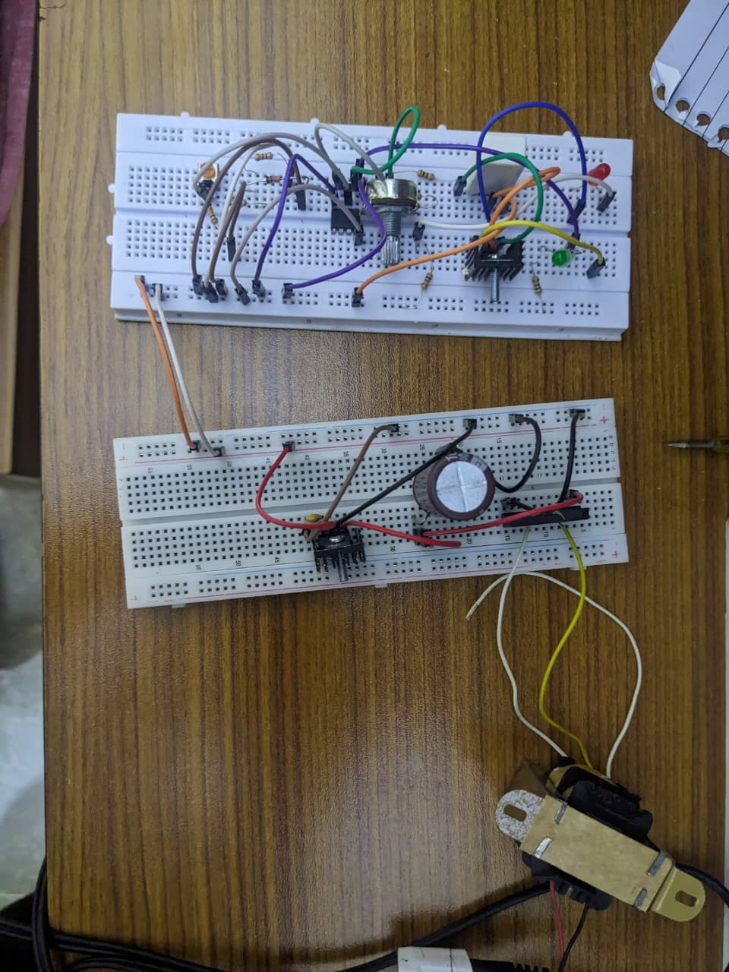

POWER SUPPLY:
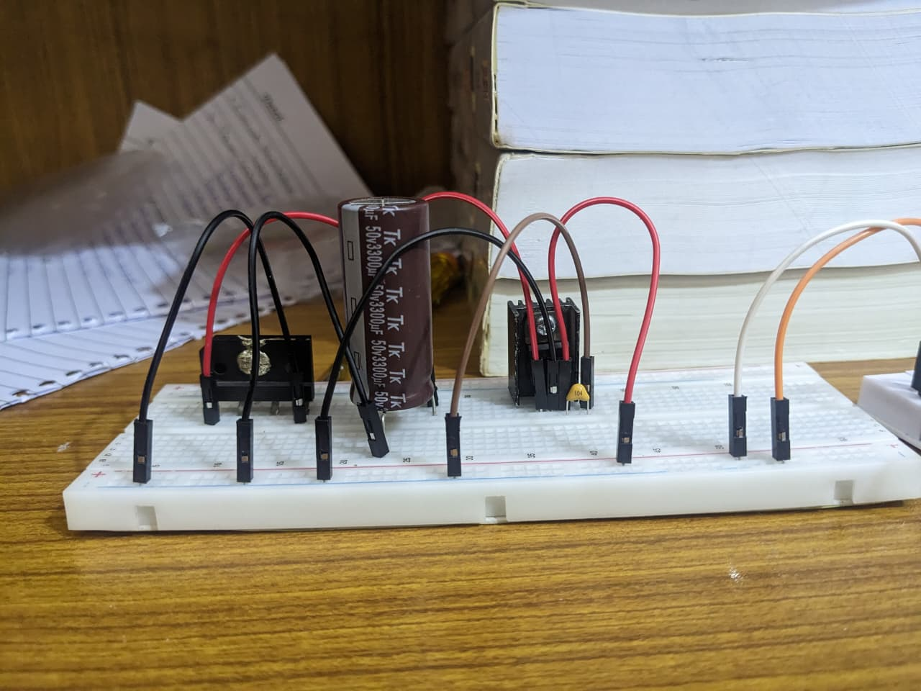

CUT OFF CIRCUIT:
