**Lab # 5**

**Lab Task#01:**

1.Write a program for Selection sort that sorts an array containing numbers, prints all the sort values of array each followed by its location.

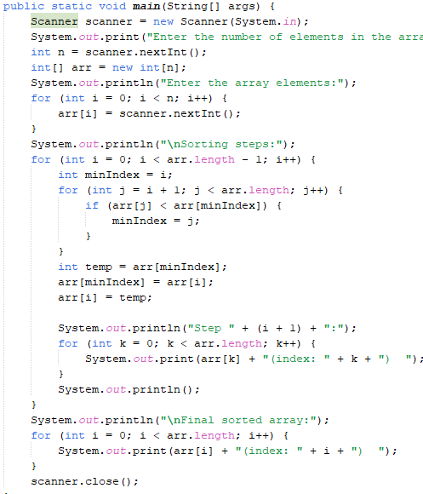**Code:**

**Output:**

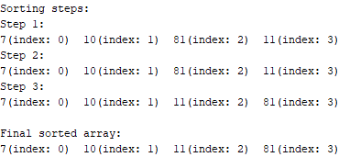

**Lab Task#02:**

Write a program that takes 10 numbers as input in an array. Sort the elements of array by using Bubble sort. Print each iteration of the sorting process.

**Code:**

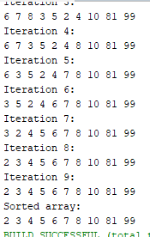 **Output:**

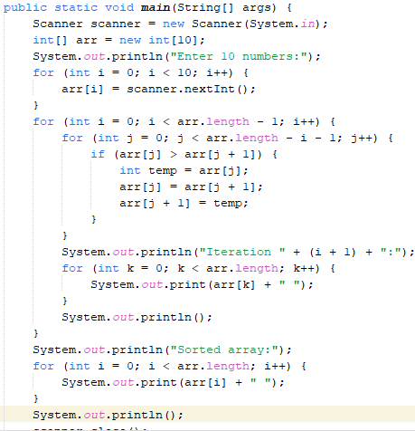

**Lab Task#03:**

3.Write a program that takes 10 random numbers in an array. Sort the elements of array by using Merge sort applying recursive technique. Print each iteration of the sorting process.

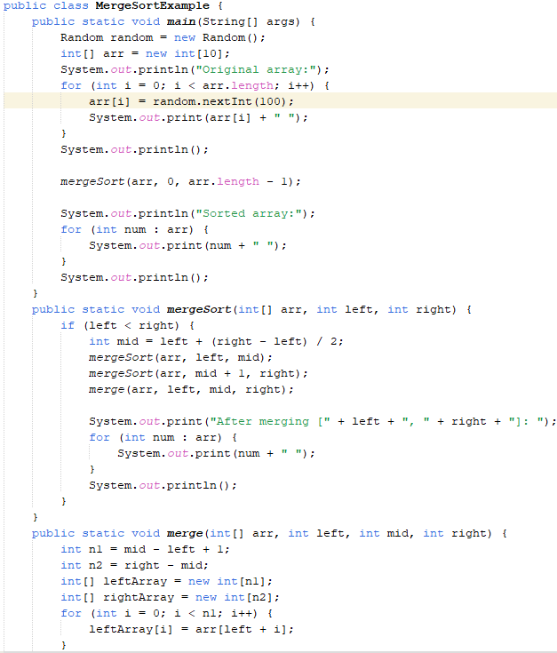**Code:**

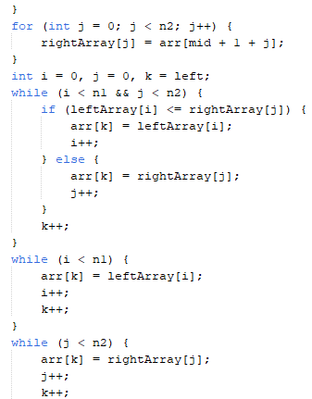

**Output:**

**Home Task#01:**

1.Declare an array of size n to store account balances. Initialize with values 0 to 100000 and sort Account No’s according to highest balance values by using Quick sort.

**Code:**

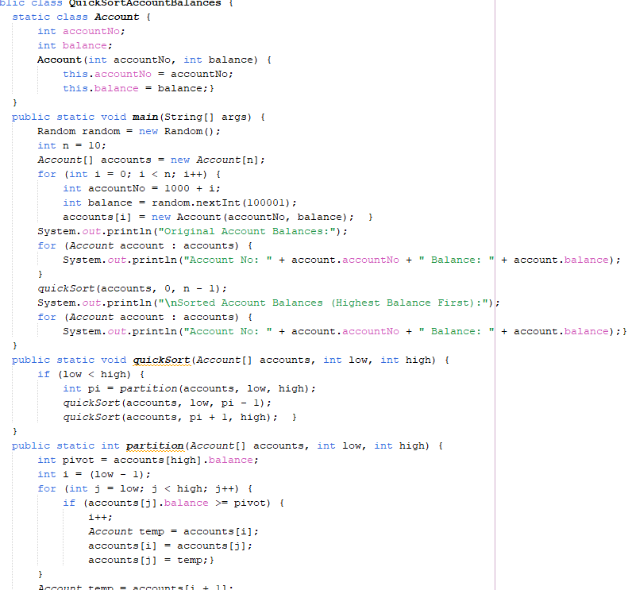

**Output:**

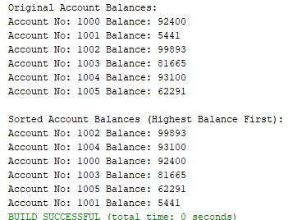

**Home Task#02:**

2. Write a program which takes an unordered list of integers (or any other objects e.g. String), you have to rearrange the list in their natural order using merge sort

**Code:**

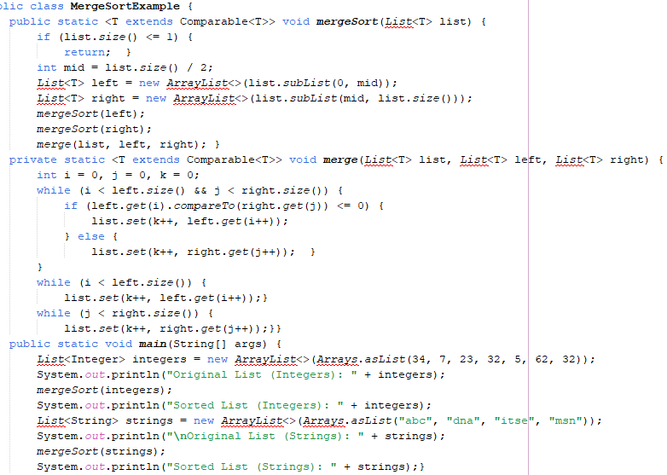

**Output:**

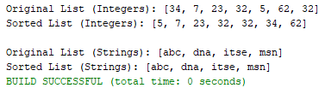

**Home Task#03:**

3.You are given an unordered list of integers or strings. Write a program to Take this list as input. Sort it in naturalorder using Merge Sort. For integers, this means ascending order. For strings, this means alphabetical order. Print the sorted list.

**Code:**

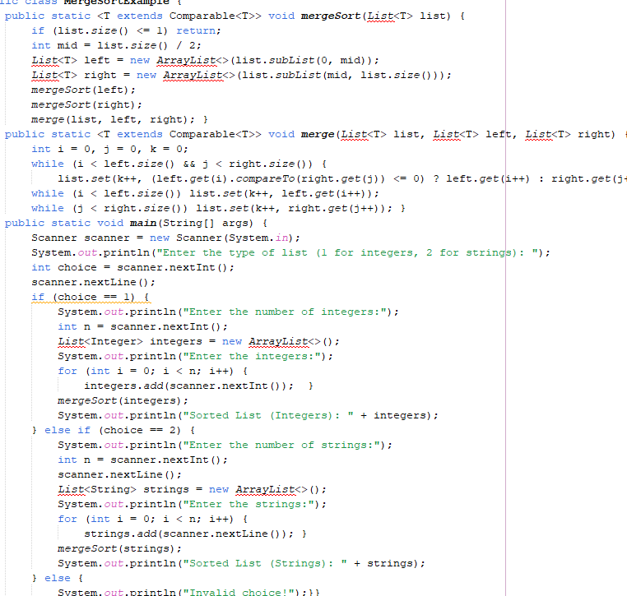

**Output:**

**Home Task#04:**

4.You are given a set of bank accounts, each with a unique account number and a balance. Write a Java program to Declare an array of size n to store account balances. Initialize each balance randomly with values between 0 and 100,000. Sort the accounts in descending order of their balances using Quick Sort. Print the sorted list in the format.

**Code:**

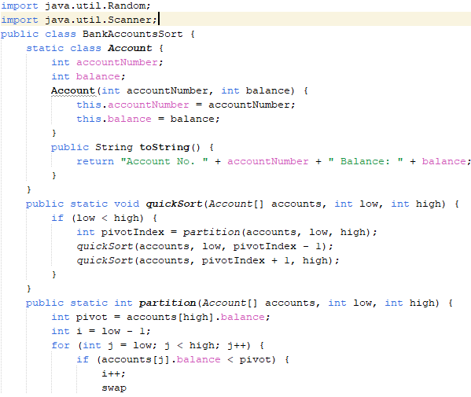

**Output:**

