

School of Advanced Technology

Final Year Project

Project Specification Report

Project Title: Federated Prototype Learning Based Concept Drift Detection System for Multi-Center Medical Data

Student Name: Ziqian.Xu

Student ID: 2578129

Project field: Machine Learning / Federated Learning / Medical AI

Supervisor:

Co-supervisor (if applicable):

- Project Description and Problem Statement
(Overall view of the project with proposed route to realization and answer why this project is important?)
In modern healthcare systems, patient data is distributed across multiple hospitals and medical institutions. Due to privacy constraints, data cannot be centrally shared, which makes Federated Learning (FL) an important paradigm for collaborative model training.
However, real-world medical data is inherently Non-IID (non-independent and identically distributed) and continuously evolving over time, leading to concept drift and distribution shift across different hospitals. These changes can significantly degrade model performance and may go unnoticed in traditional federated learning frameworks.
This project proposes a Federated Prototype Learning-based Concept Drift Detection System, inspired by the FedProto framework. In FedProto, each client (e.g., hospital) computes class-wise prototype vectors (meaning embeddings of each label), which are then aggregated into global prototypes by a central server.
In this project, we reverse and extend this mechanism: instead of only using prototypes for classification, we use them as distribution fingerprints to monitor data consistency. By measuring the distance between local prototypes and global prototypes, the system can detect abnormal deviations that indicate potential concept drift.
When the deviation of a specific class exceeds a dynamic threshold, the system triggers an alert, enabling early identification of distribution shifts in multi-center medical data environments.

- Aims and Objectives
(What the project aims and objectives and how you are going to do it?)
The main goal of this project is to design and implement a lightweight simulation system that demonstrates federated prototype learning and concept drift detection in a multi-hospital scenario.

Objectives:
1.To simulate multi-center medical data using synthetic datasets (e.g., make_classification) representing multiple hospitals and diagnostic categories.
2.To implement a prototype-based federated learning framework:
- Compute local class prototypes at each hospital
- Aggregate global prototypes on a central server
3.To design a concept drift detection mechanism:
    - Measure cosine similarity between local and global prototypes
    - Define drift score as:
drift = 1 − cosine_similarity
4.To construct a dynamic thresholding strategy using historical drift statistics (mean + 3 standard deviations).
5.To simulate concept drift by introducing controlled perturbations (noise or distribution shift) into selected class data.
6.To visualize drift evolution and build a simple interactive dashboard using Streamlit for monitoring results.

- Project Plan: Tasks and Milestones (Gantt Chart)
(Indicate the tasks and milestones that should be achieved and their expected dates; e.g. Understanding of theory, designs of circuits, construction of circuits, software specifications, working demonstrations etc.)
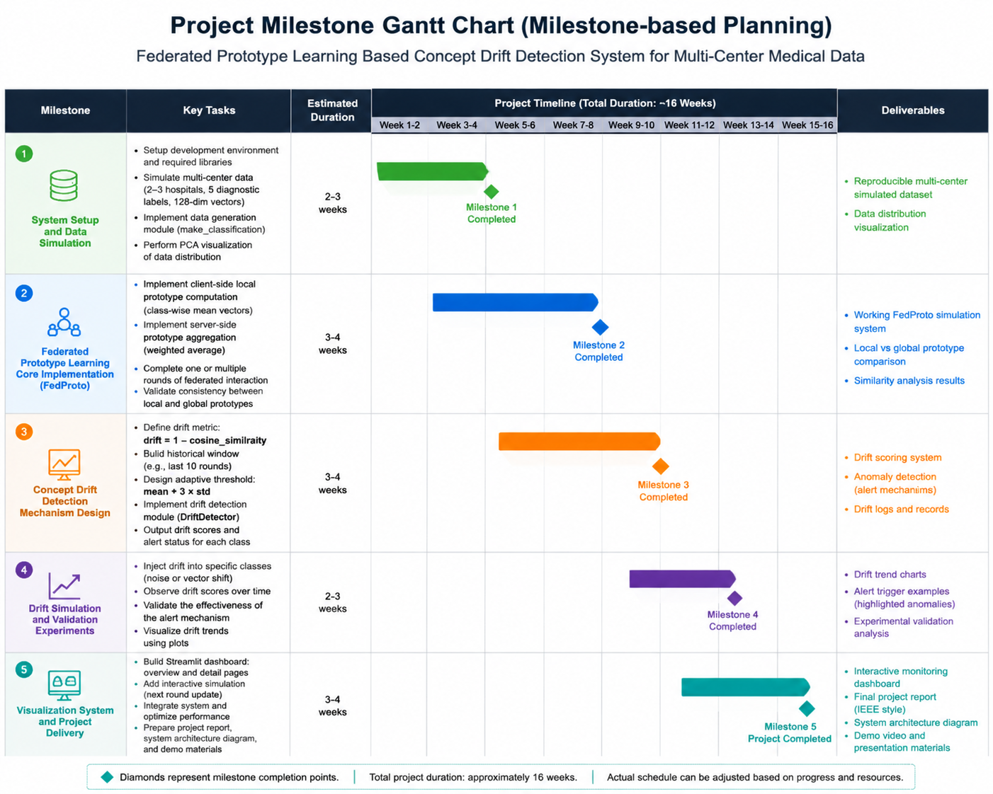

- Project Deliverables
(Indicate what should be completed at the end of the project; e.g. This list should indicate
what will be presented / demonstrated at the final project demonstration.)
At the end of this project, the following deliverables will be provided:
- A fully functional Python-based simulation system for federated prototype learning
- Concept drift detection module with adaptive thresholding
- Synthetic multi-hospital dataset generator
- Visualization of prototype distribution and drift trends
- Streamlit-based interactive dashboard for monitoring drift
- Project report and system architecture diagram
- Optional recorded demonstration video

- Project Industrial Relevance
(Explain the relevance between this project and industrial’s needs)
This project is highly relevant to real-world healthcare AI and distributed machine learning systems.
In practical hospital networks, patient data cannot be shared due to privacy regulations such as HIPAA or GDPR. Federated learning provides a solution by allowing model collaboration without exposing raw data.
The proposed prototype-based drift detection system adds an additional industrial value:
- Enables early detection of data distribution shift across hospitals
- Improves robustness of federated medical AI systems
- Reduces risk of model degradation in real deployment
- Supports monitoring data quality in decentralized environments
Potential applications include:
- Multi-hospital disease prediction systems
- Cross-institution diagnostic support systems
- Real-time monitoring of clinical data consistency

References
[1] Y. Tan et al., “FedProto: Federated prototype learning across heterogeneous clients,” in Proc. AAAI Conf. Artif. Intell., Vancouver, BC, Canada, 2022, pp. 1–9. [Online]. Available: https://arxiv.org/abs/2105.00243

