P L A T F O R M C A P A B I L I T Y A U D I T
Reporting Capabilities
Audit
Graphs, tables and the filtering UI/UX of the Massapro Content Wizz platform
Platform: Massapro Content Wizz (content.massapro.com)
Method: Code-level audit of production build dpl contentplanner-hlaz3gzk8
Scope: Nine user-facing surfaces, stats API, data model, publish pipeline
Date: October 8, 2026

Massapro Internal use

Table of Contents
1. Executive Summary
1. Executive Summary 1
2. Scope, Sources and Method 2
3. Reporting Architecture Overview 2
4. Graphical Reporting Capabilities 3
5. Tabular and List Reporting Capabilities 3
6. Filtering UI/UX Deep Dive 4
6.1 The brand filter on Content Plans 5
6.2 The status filter with live counts on Plan Detail 5
6.3 The selection model and bulk action bar 5
6.4 Interaction patterns, states and accessibility 5
6.5 Surfaces without filtering, and why it already matters 6
7. Gap Analysis 6
8. Conclusions and Recommendations 6

Note: This Table of Contents is generated via field codes. To ensure page number accuracy after editing, please right-click the TOC and select "Update Field."

1. Executive Summary
This report documents the reporting capabilities of the Massapro Content Wizz platform (content.massapro.com) as built in the production release, with a particular focus on its graphs, its tabular and list surfaces, and the filtering user experience that sits on top of them. The audit was performed at code level against the deployed build, covering every user-facing view, the statistics API, the data model and the publishing pipeline. Its purpose is to give product and engineering a single, factual picture of what can be reported on today, how the filtering behaves, and where the gaps are.
The headline finding is that reporting in the platform today is operational rather than analytical. The Dashboard renders seven platform counters as clickable KPI cards, and every list surface shows useful row-level metrics such as post counts per plan, per-status counts, and brand-level totals for plans, media and knowledge items. However, the platform renders no charts of any kind: no trend lines, no distributions, no per-brand comparisons, even though the recharts library and a ready-made chart component wrapper are already installed in the codebase. In parallel, no export path exists at all, so none of the counted data can leave the application in CSV, Excel or PDF form.
Filtering is well crafted where it exists, but its coverage is narrow. The richest filtering experience is concentrated in the Plan Detail workspace, which combines a status filter with live per-status counts, a list-versus-calendar layout switch, a persistent multi-selection model and a bulk action bar that can approve, reschedule and auto-schedule dozens of posts in one operation, complete with keyboard support and ARIA labels. The Content Plans list adds a single brand dropdown filter. The remaining five surfaces (Brands, Brand Detail, Media, Knowledge and Agents) offer no search, no filters and no date-range selection of any kind. All filtering is client-side and in-memory, which makes it instant, but it also means filter state is lost on navigation and the whole dataset is fetched on every load.
The data foundation is ready for better reporting: every post already stores its status, scheduled date, published timestamp and LinkedIn post URN, and the publishing pipeline maintains these fields automatically. What is missing is an analytics-shaped API, chart rendering, richer filters and export. Chapter 8 sets out a prioritized roadmap; the highest-value first step is a per-brand and per-status analytics endpoint feeding two or three dashboard charts, followed by search and date-range filters and CSV export of the post table.

2. Scope, Sources and Method
The audit covers the nine user-facing surfaces of the web application: the Dashboard (Command Center), the Content Plans list, the Plan Detail workspace (in both list and calendar layouts), the Brands grid, the Brand Detail view with its Knowledge, Media, Agents and Overview tabs, the Media panel, the Knowledge panel, the AI Agents panel and the Settings view. For each surface the audit examined the rendered data fields, the controls offered to the user, and the underlying client state logic that drives filtering, selection and layout switching.
Four server-side components were also reviewed because they bound what the interface can ever report: the /api/stats endpoint that powers the Dashboard; the Prisma data model, in particular the ContentPost, ContentPlan, MediaAsset, KnowledgeItem and Agent tables; the publishing module with its PUBLISHING, PUBLISHED and FAILED status transitions; and the lazy scheduler that sweeps due posts when the Dashboard is opened. The version audited is the production deployment dpl contentplanner-hlaz3gzk8 on content.massapro.com.
Three boundaries apply. First, the report describes the platform as built; it does not speculate about unshipped designs. Second, LinkedIn native analytics (impressions, reactions, comments) are out of scope because the integration does not yet read them back, although the schema reserves the identifiers needed to join them later. Third, no mobile applications or third-party dashboards exist, so the web surfaces enumerated above are the complete reporting estate.

3. Reporting Architecture Overview
The application presents five areas in its main navigation: Dashboard, Brands and Pages, Content Plans, AI Agents, and Settings and Tokens. Reporting data reaches the user through three distinct planes. The first plane is the aggregate statistics endpoint (/api/stats), which returns platform-wide counters plus the four most recent plans. The second plane is per-surface entity lists: every view fetches its full entity collection (plans, posts of a plan, brands, media, knowledge items, agents) once over REST and renders it, with all counting, filtering and selection computed in the browser. The third plane is the publish lifecycle, which the scheduler and the publish route maintain on each post as it moves from draft to published or failed.
The statistics endpoint is deliberately simple. It executes seven counts in parallel, all scoped to the signed-in user, and returns them alongside a recent-plans query that includes the related brand, the generating agent and a post count per plan. It also performs a throttled catch-up sweep of due posts, so opening the Dashboard doubles as the platform heartbeat for automatic publishing. Table 1 lists each field and where the interface actually displays it. Notably, one computed field, the published counter, is returned by the API but is not rendered anywhere in the current Dashboard card set, which is an immediate, zero-cost reporting improvement.
Table 1: Fields returned by the /api/stats endpoint and their display surface
Field | Meaning | Displayed in
brands | Number of brands owned by the user | Dashboard KPI card “Brands”
plans | Number of 30-day content plans | Dashboard KPI card “Content Plans”
posts | Planned posts across all plans | Dashboard KPI card “Planned Posts”
media | Media assets across all brands | Dashboard KPI card “Media Assets”
agents | AI agents across all brands | Dashboard KPI card “AI Agents”
knowledge | Knowledge-base items across all brands | Dashboard KPI card “Knowledge Items”
published | Posts with status SCHEDULED or PUBLISHED, combined | Computed by the API; not rendered by any view today
recentPlans | Four newest plans with brand, agent and post count | Dashboard “Recent 30-Day Plans” list
On the data-model side, the reporting-relevant fields are already in place. Every ContentPost carries its day number, post type (TEXT, IMAGE, CAROUSEL, VIDEO, POLL or DOCUMENT), theme, hook and body, a media attachment reference, the generating agent kind, a workflow status, a scheduled date, and, once published, the actual published timestamp and the LinkedIn post URN. Every ContentPlan carries its generation status, a 0-to-30 progress counter, a start date and an error message when generation fails. MediaAsset rows record their type (image or video), their source (upload or AI-generated) and their byte size. This is sufficient to build status distributions, cadence timelines, per-brand comparisons and media mix views without any schema migration; only engagement metrics would require new storage later.

4. Graphical Reporting Capabilities
Graphical reporting today takes three forms, none of which is a chart in the strict sense. The first and most prominent is the Dashboard KPI card row: six cards in a responsive grid (two columns on mobile, six on desktop), each combining an icon, a large two-digit-scale number and a label, and each acting as a navigation shortcut into the corresponding section. While the underlying request is in flight the cards render skeletons rather than zeros, which keeps the page from flashing misleading values. The second form is status color-coding in the Plan Detail workspace, where every post card carries a four-pixel left border in one of six status colors (grey for DRAFT, green for APPROVED, blue for SCHEDULED, purple for PUBLISHED, red for FAILED, amber for the transient PUBLISHING state), so the plan visual reads as an informal heatmap of workflow state. The third form is the calendar layout: a fixed thirty-cell grid that renders the whole plan month at a glance, with populated days showing a type icon, theme and status, and empty days drawn as dashed placeholders.
Beyond these, the platform contains no charts. There are no trend lines for publishing cadence, no pie or donut charts for status distribution, no bar comparisons across brands or plans, and no visualization of media mix or knowledge growth. What makes this notable is that the dependency is already installed: the recharts library is present in package.json, and the shadcn/ui chart wrapper (components/ui/chart.tsx) ships in the component library, but a search of the platform components shows neither is imported by any view. In other words, the technical groundwork for graphical reporting exists and is simply unused, which lowers the cost of the first chart considerably.
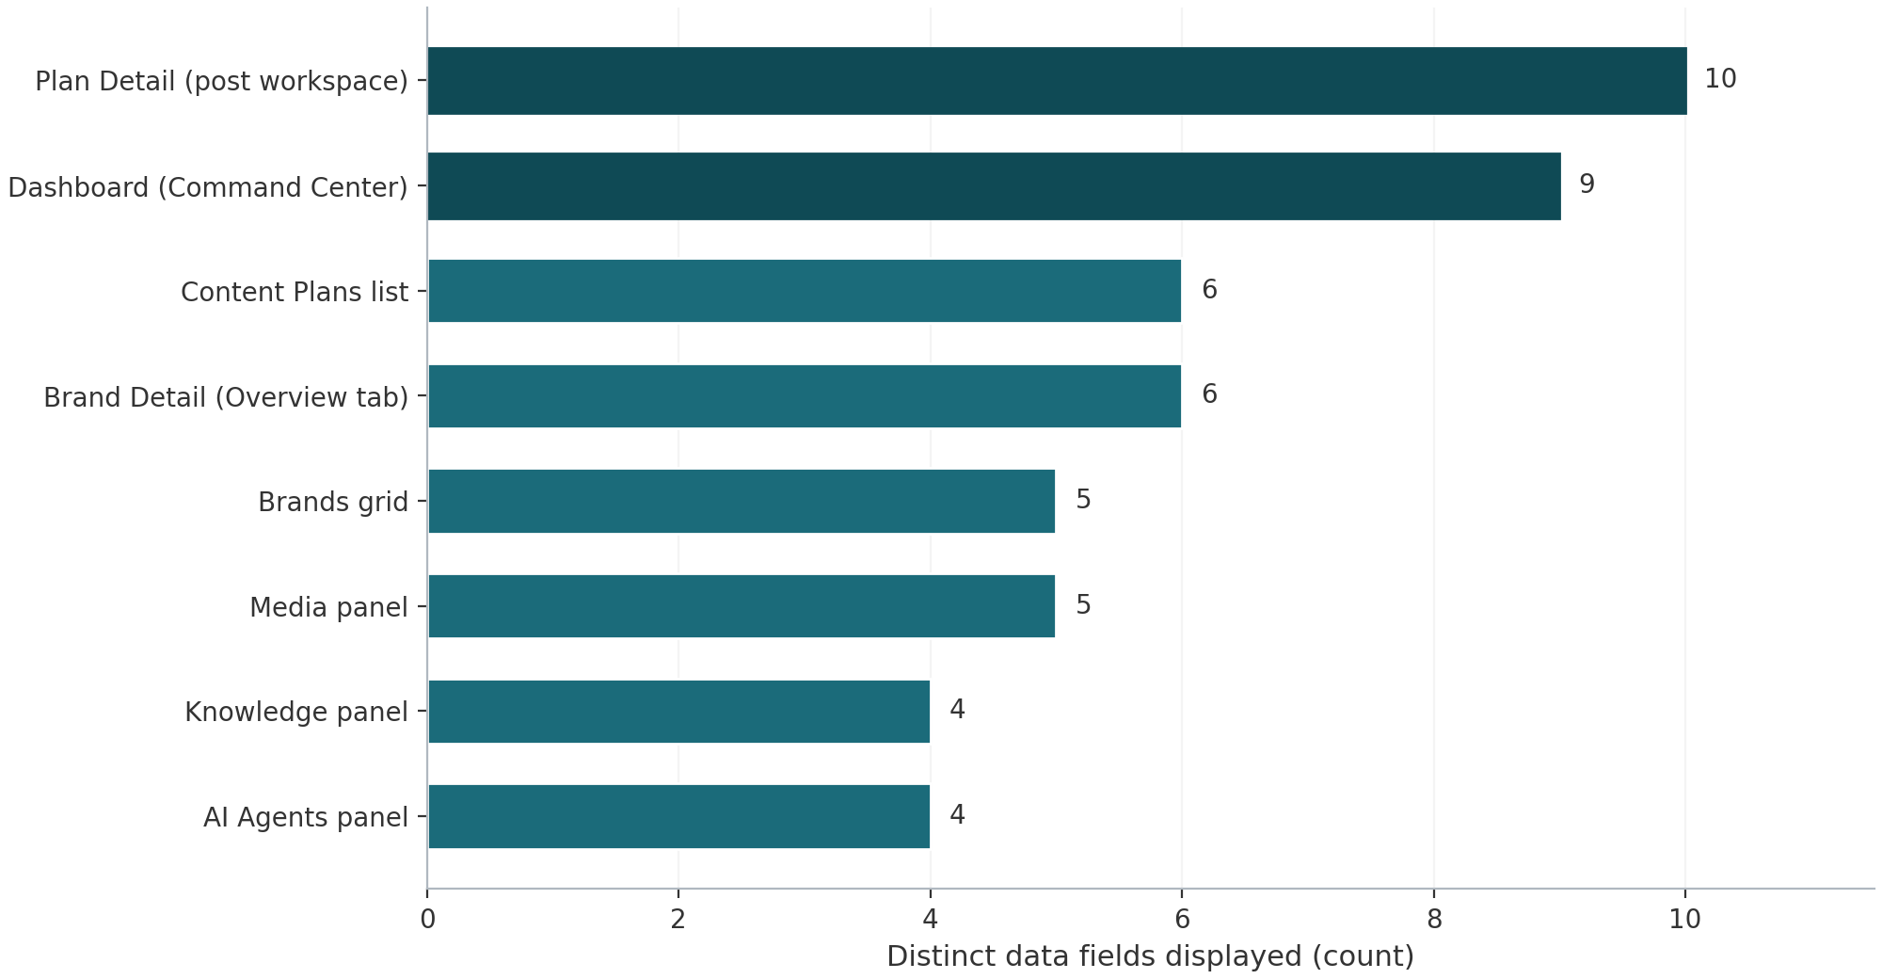
Figure 1: Distinct data fields displayed per surface (count from the code audit; darker bars mark the two richest surfaces)
Figure 1 summarizes how much data each surface actually surfaces, counted as distinct rendered fields. The Plan Detail workspace leads with ten fields per post card plus the plan header, and the Dashboard follows with its seven counters and list metadata. The pattern is consistent: the platform shows operational detail faithfully, but every number is a snapshot count tied to the current screen. Nothing is aggregated across time, and nothing compares one cohort against another, which is precisely the space charts would occupy.

5. Tabular and List Reporting Capabilities
None of the surfaces uses a literal data table with sortable columns; the tabular role is played by card lists. The platform does ship table primitives (components/ui/table.tsx), but like the chart wrapper they are unused. Card lists are a reasonable choice for the content-creation workflow because rows carry long text (hooks, bodies) and status color, yet they impose real reporting limitations: there are no column headers to sort by, no footer totals, no pagination and no column visibility controls. Every list loads its entire dataset, so performance and scroll length degrade gracefully but linearly as content accumulates.
Table 2: Inventory of list surfaces, their rendered fields and interactions
Surface | Rendering | Fields and metrics displayed | Interactions
Dashboard | KPI card grid plus two lists | 7 counters; per brand: name, LinkedIn page, plan count; per plan: title, brand, agent, status, progress | Click card or row to navigate; create brand; generate plan
Content Plans list | Card list | Title, brand, agent, posts N/30, created date, status badge with live progress | Brand filter; open plan; generate plan dialog
Plan Detail | Post cards or 30-day calendar grid | Day number, type icon, theme, status, media-attached flag, hook, 220-character body preview, scheduled datetime; per-status counts; plan strategy and focus notes | Status filter; layout switch; select and bulk-edit; approve all drafts; publish approved; open post dialog
Brands grid | Card list | Name, LinkedIn page, counts of knowledge items, media assets and plans | Open brand; create brand
Brand Detail | Tabs (Knowledge, Media, Agents, Overview) | Overview: description, audience, industry, tone, LinkedIn connection state and targets | Switch tabs; connect or switch LinkedIn target; edit profile
Media panel | Thumbnail grid | Thumbnail or video icon, name, AI or Upload source badge | Upload; generate image; preview; crop and save; attach; delete
Knowledge panel | Accordion list | Title, source type, character count, date | Add item (file, URL, text); expand; delete
AI Agents panel | Card list | Name, role, kind, built-in flag, active state | Create from URL; edit persona; deactivate
Two aspects of this inventory deserve emphasis. First, row-level metrics are genuinely useful where they appear: the plan cards show completion against the fixed 30-post target, the brands grid shows library depth per brand, and the plan workspace shows live per-status counts. These are the numbers a content operator actually needs minute to minute. Second, the inventory also shows what a stakeholder cannot see: there is no surface that aggregates across plans or brands, no view of publishing over time, and no single table of all posts across the workspace that could be scanned, sorted or exported. Those views simply do not exist yet, and Chapter 7 treats them as the core gaps.

6. Filtering UI/UX Deep Dive
Filtering is the strongest and at the same time the most uneven part of the reporting experience. This chapter documents every filter and filter-adjacent control, the interaction model behind them, and the surfaces where the absence of filtering is already noticeable. The controlling principle in the current implementation is that all filtering happens in the browser: each view fetches its full dataset once, and every filter, count and selection is recomputed from that in-memory array, which makes the interaction instantaneous but bounds it by the size of the fetched dataset.
Table 3: Filter and view-switching controls by surface
Surface | Control | Kind | Scope and behavior
Content Plans | Brand selector | Dropdown (Select), 176 px, header toolbar | Client-side; options are All brands plus one per brand; default All; filters the plan card list
Plan Detail | Status selector | Dropdown (Select), 144 px, compact 32 px height | Client-side; All plus the five workflow statuses, each labeled with a live count; filters the list layout
Plan Detail | Layout switch | Dropdown menu, two entries | Switches the post area between list cards and a fixed 30-day calendar grid
Plan Detail | Select all and row checkboxes | Checkbox group | Multi-select over visible posts; selection is a set of post ids that survives filter changes
Plan Detail | Bulk action bar | Contextual toolbar | Appears when selection is non-empty; bulk status apply, auto-scheduling inputs, Apply and Clear
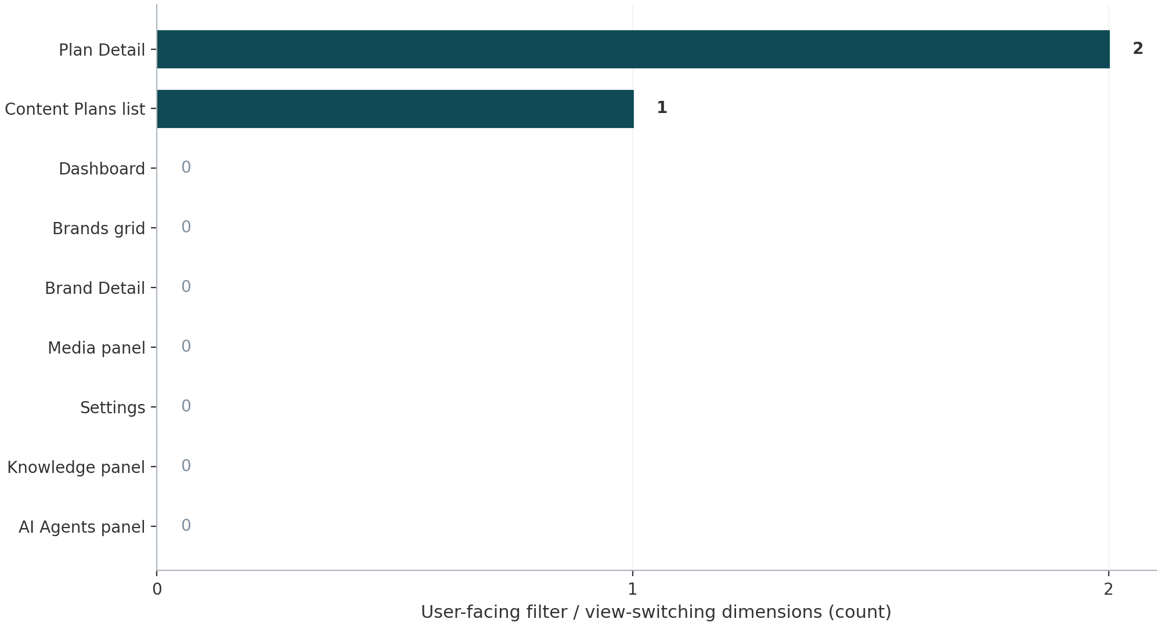
Figure 2: User-facing filter or view-switching dimensions per surface (0 means the surface has none)

6.1 The brand filter on Content Plans
The Plans list is filtered by a single Select control placed in the page header next to the Generate button. It offers an explicit All brands option followed by one option per brand, defaults to All on every visit, and filters the card list by comparing each plan's brandId against the selection. The filter is pure client state: it is not encoded in the URL, not persisted to local storage, and therefore reset by navigation or refresh. With the current portfolio of three brands this is adequate; the control will remain sufficient until the brand count makes scanning the unfiltered list slow, at which point a search field and status filter (the plan list shows no status filter, only per-row badges) become worthwhile.

6.2 The status filter with live counts on Plan Detail
The plan workspace filters its thirty posts by workflow status through a compact Select in the toolbar above the list. Its All option is labeled with the total post count, and each of the five statuses (draft, approved, scheduled, published, failed) is labeled with its current count, for example draft (12). Because the counts are computed from the full posts array rather than the visible subset, they stay stable and truthful no matter which filter is active, which prevents the classic dead-end of filtered counters. When a filter matches nothing, the workspace shows an explicit empty state, No posts match this filter, rather than blank space. One deliberate boundary is worth documenting: the status filter drives the list layout only. In the calendar layout every one of the thirty day cells is always drawn from the full dataset, so switching to the calendar silently ignores the active status filter. Users are not warned of this, and either the calendar should respect the filter or it should display a visible filter-off indicator.

6.3 The selection model and bulk action bar
Selection is designed to cooperate with filtering rather than fight it. A Select all checkbox in the toolbar targets all visible posts, and each post card and calendar cell carries its own checkbox with a stop-click guard so ticking it does not open the post. The selection is stored as a set of post ids, which has a subtle and valuable consequence documented in the code: selections survive status-filter switches, so an operator can filter to draft, select a batch, switch the filter to approved, add more posts, and apply one bulk operation to the union. When any posts are selected, a purple contextual bar appears showing the count, a bulk status dropdown covering all five statuses, and an Apply button, with Clear to reset.
Choosing SCHEDULED in the bulk bar expands three additional inputs in the same bar: a start date, a publishing time defaulting to 09:00, and a posts-per-day selector with values one to four. These feed a server-side auto-scheduler that spreads the selected posts across consecutive days starting at the given date at the chosen per-day rate, each post publishing at its assigned time; the confirmation toast restates the computed schedule in plain language, including the skip count for posts that could not be transitioned. The bulk endpoint returns the updated rows, which are merged into local state without a refetch, so the UI stays responsive and the per-status counts in the filter update immediately. Two further workflow buttons complete the funnel: Approve all drafts, which appears only when drafts exist and moves every draft to approved in one action, and Publish approved, which publishes approved posts sequentially with a live progress label of the form Publishing 3 of 12, pacing requests to respect LinkedIn rate limits.

6.4 Interaction patterns, states and accessibility
Several implementation choices define the feel of the filtering experience. Everything is synchronous with the fetched array, so filters apply without spinners; loading is instead expressed through skeletons on first fetch, and the toolbar disables action buttons while bulk operations run. Accessibility is handled explicitly: the bulk status, start date, time and per-day controls all carry ARIA labels, the select-all checkbox is labeled Select all visible posts, every row checkbox is labeled with the post's hook or day number, and both post cards and calendar cells are keyboard-operable with Enter and Space bound in addition to click. Filter state is, however, ephemeral: it lives in component state only, so navigating away and back, or refreshing, resets to All, and there are no saved or shared filtered views since the state is not reflected in the URL.

6.5 Surfaces without filtering, and why it already matters
Five surfaces offer no search, filter or date control at all. The Media panel renders its grid in insertion order with only an AI or Upload badge per item, so locating an asset means scrolling or previewing; the Knowledge panel is an accordion without search even though items can be long documents; the Agents, Brands and Settings surfaces are small enough that the absence is tolerable today. The gap grows with the libraries: the media library is expected to absorb regenerated images and the knowledge base is meant to hold brand documents, and both are surfaced inside the post editor where a user may need to find one asset among dozens under time pressure. A minimal text search plus a type or source filter on Media and Knowledge would close most of the practical pain, and both datasets already carry the fields (type, source, name, mime) needed to do it client-side with no API change.

7. Gap Analysis
Setting the documented capabilities against what a content operator or a stakeholder reasonably expects from a reporting layer produces eight concrete gaps. They fall into two families: presentation gaps (charts, exports, aggregation views) and control gaps (search, date ranges, type filters, sorting and pagination). None of the eight requires new source data except engagement metrics, because the schema already stores the needed fields; this is why most of them are cheap relative to their value.
Table 4: Reporting gaps, their code-level evidence and cost to close
Gap | Evidence in the build | User impact | Effort
No rendered charts | recharts and chart.tsx installed but imported nowhere | No trends, distributions or comparisons; reporting is count-reading | Low to medium
Stats API has no breakdowns | Endpoint returns 8 flat counters only | No per-brand, per-status or per-week series to feed charts | Low
Computed published counter unused | stats.published returned; no card renders it | Free KPI (scheduled plus published) sits invisible | Trivial
No text search | No search input on any surface | Findability degrades as media and knowledge grow | Low
No date-range filter | scheduledDate and publishedAt stored, never filtered | Cannot ask what published this week or next | Low
No post-type filter | postType stored; shown as badge only | Cannot isolate video or carousel days when planning | Low
No export | No CSV, Excel or PDF path anywhere | Data cannot leave the app for stakeholders or decks | Low to medium
No engagement metrics | linkedinPostUrn and publishedAt stored; no analytics read-back | Reporting stops at publish; no performance feedback loop | Medium to high
Two structural risks amplify the gaps over time. Because every list fetches its whole dataset and filters in memory, the same architecture that makes filtering instant today will start to tax payloads and render time as post and asset counts grow, at which point sorting and pagination (gap family two) become performance work, not just usability work. And because no aggregation endpoint exists, every future chart would currently have to compute over raw rows on the client, which is exactly the pattern the analytics endpoint recommendation in Chapter 8 is designed to preempt.

8. Conclusions and Recommendations
The verdict of the audit is that Massapro Content Wizz has a solid operational reporting layer and no analytical layer yet. Operators can always answer what is the state of this plan and how many posts are left, thanks to honest live counts, color-coded status, a dependable bulk pipeline and thoughtful accessibility. Stakeholders cannot yet answer are we publishing consistently, which brand is ahead, or what did we publish last month, because no chart, time series, cross-brand aggregation or export exists. The filtering UX, where built, is of high quality; the issue is coverage, not craft.
Table 5: Prioritized roadmap for the reporting layer
Priority | Initiative | What to build | Expected outcome
P0 | Analytics endpoint | Extend /api/stats with per-brand, per-status and per-week aggregates over existing columns | One API that every chart and future report view can share
P0 | First dashboard charts | Status donut and an eight-week publishing-cadence line using the installed recharts and chart wrapper; add the unused published counter as a KPI card | The platform's first real graphs with no new dependencies
P1 | Deeper plan filters | Text search, post-type filter and scheduled or published date-range on Plan Detail, applied to both layouts consistently | Operators slice thirty posts by what and when, not only by status
P1 | CSV export | Export of the filtered post table (client-side CSV is sufficient initially) | Stakeholders can take reporting data into decks and spreadsheets
P1 | Library findability | Search plus type or source filter on Media and Knowledge | Libraries stay usable as they grow past dozens of assets
P2 | Performance and retention | URL-persisted filter state, sorting and pagination on long lists | Filters become shareable and lists scale gracefully
P2 | Engagement metrics | Read LinkedIn analytics per stored post URN into a metrics table and a per-brand performance view | Reporting extends from publishing to results
The recommended sequence follows the table. The P0 pair should be treated as one work package because the endpoint and the charts validate each other; both run on data that already exists, and the chart stack is pre-installed, so the incremental dependency cost is zero. The P1 items are independent and can ship in any order, though the plan-level filters and export together turn the Plan Detail workspace, already the platform's best reporting surface, into a de facto report builder. The P2 items are worth scheduling once the P0 analytics endpoint proves which aggregates are actually used; engagement metrics in particular should wait for a confirmed reporting question to answer, since they carry the only real integration cost in this roadmap.
If only one change is made from this report, it should be the P0 pair: an analytics endpoint plus two dashboard charts. It converts the platform's reporting story from counting things to showing patterns, it uses infrastructure that is already deployed and idle, and it creates the shared aggregation layer every later improvement in this roadmap depends on.

