A Compact Tri-Band CPW-Fed Octagonal Monopole Antenna Backed by a 4 × 4 Square-Patch Metasurface for Sub-6 GHz 5G, WLAN, X-Band and Ku-Band Applications
Chanswarang Boro  Department of Electronics and Communication Engineering  National Institute of Technology Silchar  Silchar, Assam 788010, India  e-mail | Nishit Baishya  Department of Electronics and Communication Engineering  National Institute of Technology Silchar  Silchar, Assam 788010, India  e-mail | Anushka Dam  Department of Electronics and Communication Engineering  National Institute of Technology Silchar  Silchar, Assam 788010, India  e-mail
Sanjana  Department of Electronics and Communication Engineering  National Institute of Technology Silchar  Silchar, Assam 788010, India  e-mail | Sovan Bhattacharya  Department of Electronics and Communication Engineering  National Institute of Technology Silchar  Silchar, Assam 788010, India  e-mail | Ujjal Chakraborty  Department of Electronics and Communication Engineering  National Institute of Technology Silchar  Silchar, Assam 788010, India  e-mail
Author order, e-mail addresses and the corresponding author to be confirmed by the guides.

Abstract—In the present manuscript, a compact coplanar waveguide (CPW) fed octagonal monopole antenna backed by a 4 × 4 square-patch metasurface is proposed for multiband wireless applications. The radiator is printed on a low-cost FR-4 substrate of 27 mm × 31 mm × 1.6 mm, and a metasurface of the same footprint is placed 2 mm behind it across an air gap. The structure is designed and investigated in the electromagnetic simulator CST Studio Suite. With the metasurface, the antenna resonates in three bands with |S₁₁| ≤ −10 dB: 3.43–6.13 GHz (56.5 %), 7.64–13.25 GHz (53.7 %) and 13.93 GHz to beyond 15 GHz. Throughout the resonating bands, the lowest reflection coefficient obtained is −29.6 dB at 5.29 GHz. An equivalent-circuit model places the in-phase reflection of the metasurface near 8.0 GHz, inside the second band. The peak realized gain is [xx] dBi at [xx] GHz, compared with [xx] dBi for the antenna without the metasurface. The bands cover 5G NR n79, the upper part of n77/n78, WiMAX, 5 GHz WLAN, the C-band satellite downlink, X-band radar and satellite uplink, and the Ku-band satellite links, so the proposed antenna is suitable to implement in compact multi-standard communication and sensing terminals.
Keywords—CPW-fed antenna, octagonal monopole, metasurface, tri-band, 5G, WLAN, X-band, Ku-band
I. Introduction
With the steady growth of the wireless industry, the demand for compact and low-cost antennas that serve several standards at once has risen sharply, since the antenna is one of the basic blocks of every RF front end [1]. A present-day terminal may have to reach sub-6 GHz 5G new radio and 5 GHz wireless LAN, while sensing and satellite equipment works in the X and Ku bands [2]–[4]. Planar monopoles fed by a coplanar waveguide (CPW) are widely used for such needs, because the feed line and the ground planes lie on the same side of the substrate, no via is required, and the impedance bandwidth is large [5], [6]. Jug-shaped, triangular, elliptical and javelin-shaped CPW-fed patches have been reported for wideband operation, often with notches that avoid interference with neighbouring services [7]–[9].
A printed monopole, however, radiates on both sides of the board, so its gain remains modest. A metal reflector raises the gain only when it is about a quarter wavelength away, which makes the antenna bulky. Artificial magnetic conductors (AMC), frequency selective surfaces (FSS) and metasurfaces reflect the backward wave with an engineered phase and can therefore be placed much closer [10]. Sen et al. backed a UWB monopole with a split-ring metasurface and reported a gain rise of about 5.5 dB [11]. Al-Gburi et al. raised the peak gain of a CPW-fed ring monopole from 6.7 to 11.5 dBi with a 19 × 19 FSS and a total profile of 10 mm [12]. Hussain et al. reached 10.5 dBi with a 5 × 5 FSS 9 mm behind a CPW hexagonal patch [13], and Hammache et al. obtained 8.4 dBi with a 7 × 7 FSS at 20 mm [14]. A CPW-fed octagonal monopole over a 5 × 5 AMC achieved up to 11.5 dBi over 3.5–6.5 GHz [15]. Kundu and Chatterjee loaded printed UWB antennas with FSS layers for ground penetrating radar [16], [17], and a conformal FSS was used to obtain frequency-dependent directive radiation [18]. Rajalakshmi and Gunavathi etched a 2 × 2 hexagonal metamaterial array behind a cross-shaped patch and increased its gain at 2.4 and 5 GHz to 6 and 10 dBi [19].
Most of the reflectors above sit 9–20 mm behind the antenna, and they target a single wide band. In the works reviewed, a compact CPW monopole backed by a closely spaced single-layer metasurface that serves sub-6 GHz, X-band and Ku-band links together has received little attention.
The primary intent of the present manuscript is to propose a compact CPW-fed octagonal monopole on FR-4 and to back it with a 4 × 4 square-patch metasurface placed 2 mm behind it. Section II describes the design and the analytical estimates, Section III discusses the simulated results, Section IV presents the applications and Section V concludes the paper.
II. Antenna Design and Analysis
A. Antenna Geometry
The geometry of the proposed antenna is depicted in Fig. 1(a), and its dimensions are given in Table I. The radiator is a regular octagon of circumradius R = 8.7 mm standing on one vertex. It is printed on an FR-4 substrate (ε_{r} = 4.3, tan δ = 0.025) of 27 mm × 31 mm and 1.6 mm thickness. The octagon is fed by a CPW line of width W_{f} = 3 mm, separated from the two coplanar ground planes by slots of g = 0.5 mm; the feed and slot widths are selected for impedance matching to the 50 Ω port. Each ground plane is W_{g} = 11.5 mm wide and L_{g} = 11 mm long, and the lower vertex of the octagon lies p = 0.5 mm above the ground edge. Since the CPW grounds carry current and take part in the radiation, their length and the patch-to-ground gap mainly control the matching at the lower end of the band [5].
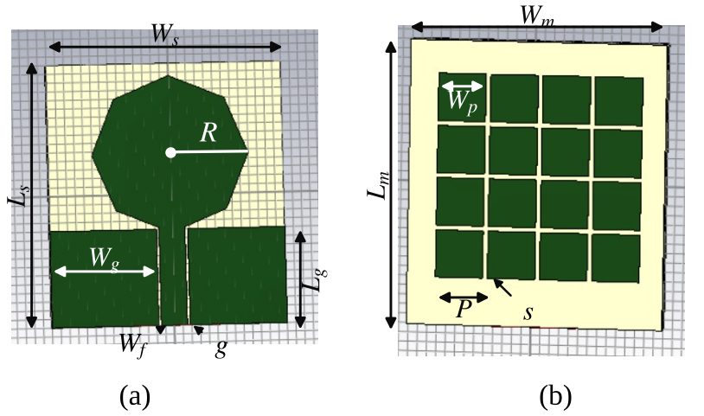
Fig. 1. Geometry of the proposed structure: (a) CPW-fed octagonal monopole antenna, (b) 4 × 4 square-patch metasurface (top view, CST Studio Suite).
To estimate the lower edge of the operating band, the octagon is replaced by a cylindrical monopole of the same height and the same surface area [20], [21]:
$f_{L} = \frac{7.2}{\left(l + r + p\right)k} GHz$ (1)
$r = \frac{A}{2πl}$ (2)
where l = 2R = 17.4 mm is the height of the octagon, A = 2√2R² = 214.1 mm² its area, r = 1.96 mm the radius of the equivalent cylinder and p = 0.5 mm the gap to the ground, all taken in centimetres in (1); k = 1.15 is the empirical factor for an FR-4 substrate [20]. Equation (1) gives f_{L} ≈ 3.15 GHz, within 8 % of the simulated lower edge of 3.43 GHz (Section III). The small difference is expected, because (1) ignores the metasurface and the finite CPW ground.
B. Metasurface Design
The metasurface of Fig. 1(b) is a 4 × 4 array of square copper patches of side W_{p} = 4.8 mm and period P = 5.5 mm, so that adjacent patches are separated by s = 0.7 mm. It is printed on a 1.6 mm FR-4 board of the same footprint as the antenna, with a full copper ground on its back. Such a surface behaves as a parallel LC resonator [10]: the gaps between the patches provide the capacitance, and the current loop through the ground provides the inductance,
$L = μ_{0}t$ (3)
$C = \frac{W_{p}ε_{0}\left(1 + ε_{r}\right)}{π}\cosh^{−1}\left(\frac{P}{s}\right)$ (4)
$f_{0} = \frac{1}{2π\sqrt{LC}} , BW = \frac{1}{η_{0}}\sqrt{\frac{L}{C}}$ (5)
where t is the thickness of the metasurface substrate and η₀ ≈ 377 Ω is the free-space impedance. With the dimensions of Table I, (3)–(5) give L = 2.01 nH, C = 0.197 pF and f₀ ≈ 8.0 GHz, with a reflection phase within ±90° over about 27 % (6.9–9.1 GHz). Near f₀ the surface reflects in phase, whereas a metal plate reflects with a phase reversal of 180°.
The wave radiated backwards crosses the air gap h, is reflected by the metasurface and returns to the antenna. It reinforces the forward radiation when [13]
$φ_{MS} − 2k_{0}h = 2nπ, n = 0, 1, …$ (6)
where φ_{MS} is the reflection phase of the metasurface and k₀ = 2π/λ₀. At f₀, φ_{MS} ≈ 0 and h = 2 mm gives 2k₀h ≈ 38°, so the reflected wave returns within ±90° of the forward wave across the in-phase band of the metasurface. A metal plate at the same gap (φ = 180°) would cancel the forward wave instead.
TABLE I
Dimensions of the Proposed Antenna and Metasurface (mm)
Parameter | W_{s} | L_{s} | h_{s} | R | W_{f} | g
Value | 27 | 31 | 1.6 | 8.7 | 3 | 0.5
Parameter | L_{g} | W_{g} | p | W_{m} | L_{m} | t
Value | 11 | 11.5 | 0.5 | 27 | 31 | 1.6
Parameter | W_{p} | s | P | h
Value | 4.8 | 0.7 | 5.5 | 2

C. Design Stages
The design is carried out in two stages, as depicted in Fig. 2. In stage 1, the octagonal antenna is designed alone and its ground and patch are tuned for impedance matching. In stage 2, the metasurface is placed behind the antenna across the air gap h and the complete structure is simulated again. The simulations use the frequency-domain solver of CST Studio Suite with a waveguide port at the CPW feed, from 1 to 15 GHz.
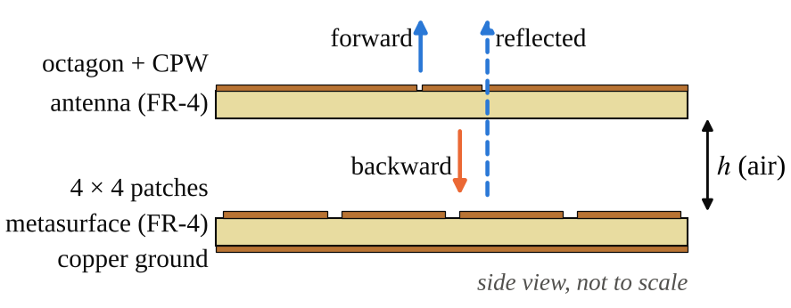
Fig. 2. Side view of the proposed structure: the backward wave of the antenna is reflected by the metasurface and adds to the forward wave (schematic, not to scale).
III. Results and Discussion
A. Reflection Coefficient
The simulated reflection coefficient of the proposed antenna with the metasurface is depicted in Fig. 3, and the bands are summarized in Table II. The structure exhibits three −10 dB bands: band I from 3.43 to 6.13 GHz, band II from 7.64 to 13.25 GHz and band III from 13.93 GHz to beyond 15 GHz, the upper limit of the simulation. The percentage bandwidths of bands I and II are 56.5 % and 53.7 %. Throughout the resonating bands, the lowest reflection coefficient obtained is −29.6 dB at 5.29 GHz, and further resonances appear at 3.95, 9.03, 9.89 and 12.87 GHz. Between the bands, |S₁₁| rises to −6.4 dB at 6.97 GHz and to −8.6 dB at 13.53 GHz. These regions are not designed notches; they mark the edges of the operating bands. Band III stays only about 1 dB below the −10 dB level, so it is marginal and should be confirmed with a finer mesh and by measurement.
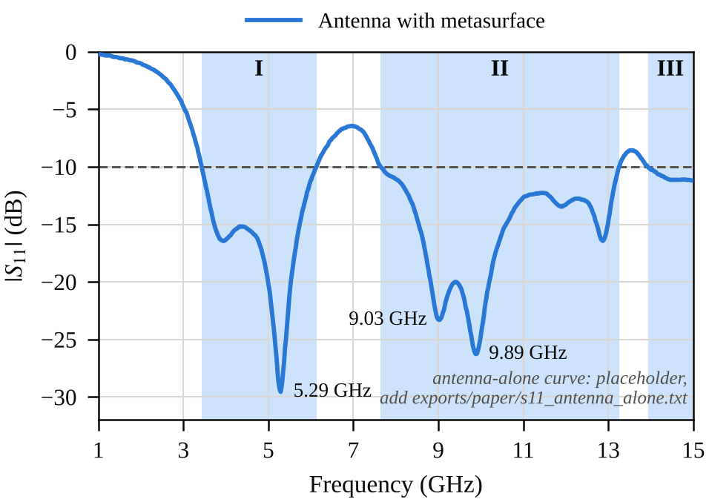
Fig. 3. Simulated reflection coefficient of the proposed antenna with the metasurface; the shaded regions are the three −10 dB bands. The antenna-alone curve (stage 1) is to be added from CST.
Because the copper ground of the metasurface lies only 2 mm behind the antenna, outside the in-phase band of Section II-B it acts close to a metal mirror, and the low-frequency matching of the antenna is expected to be affected most. The reflection coefficient of the antenna without the metasurface (stage 1), to be added to Fig. 3 and Table II, quantifies this effect: lower band edge [xx] GHz without the metasurface.
TABLE II
Simulated Performance of the Design Stages
Stage | −10 dB band (GHz) | FBW (%) | Lowest |S₁₁| (dB) | Peak gain (dBi)
1: antenna alone | [xx] | [xx] | [xx] | [xx]
2: with metasurface | 3.43–6.13  7.64–13.25  13.93–>15 | 56.5  53.7  ≥ 7.3 | −29.6 at 5.29 GHz | [xx]

B. Gain
The simulated realized gain in the broadside direction, with and without the metasurface, is depicted in Fig. 4. [To be completed from the CST gain results: the peak realized gain with the metasurface is [xx] dBi at [xx] GHz against [xx] dBi without it. The largest improvement is expected in band II, where the metasurface reflects in phase (Section II-B); a reduction at frequencies where (6) is not met should be reported as well.]
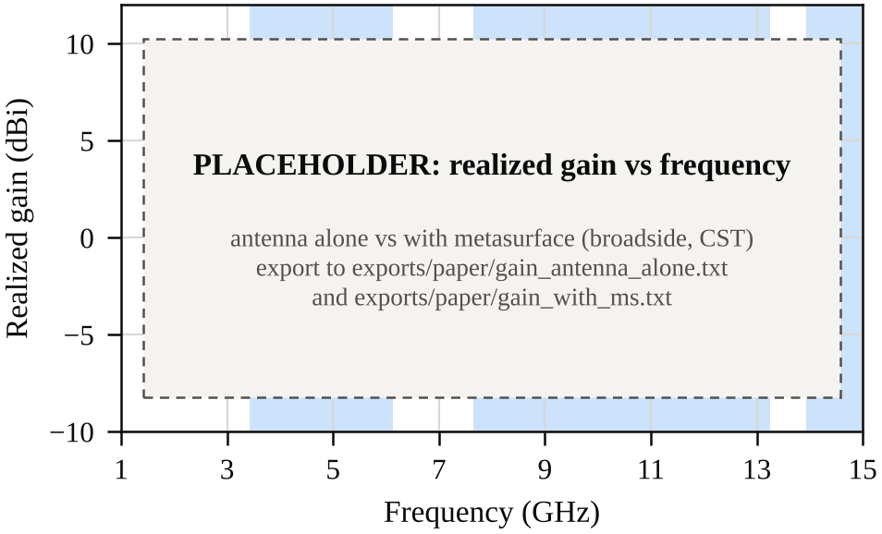
Fig. 4. Simulated realized gain of the antenna with and without the metasurface.
C. Radiation Pattern
The E-plane and H-plane radiation patterns at 5.3, 9.9 and 14.5 GHz, one frequency in each band, are depicted in Fig. 5. [To be completed from the CST far-field results: the pattern shape in each band, the direction of maximum radiation and the front-to-back ratio with and without the metasurface.]
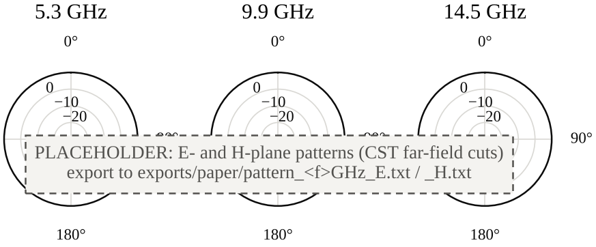
Fig. 5. Simulated E-plane and H-plane radiation patterns (dB) at 5.3, 9.9 and 14.5 GHz.
D. Comparison with Reported Works
Table III compares the proposed antenna with reported printed antennas that use a reflector or a metamaterial layer. The total profile of the proposed structure is 5.2 mm (about 0.059 λ₀ at 3.43 GHz), lower than that of the FSS-backed designs [12]–[14], and its metasurface is no larger than the antenna itself. The metamaterial of [19] is thinner still, as it is etched on the antenna substrate, but it serves two narrow Wi-Fi bands. The gain of the proposed antenna, [xx] dBi, is to be compared once the CST results are available.
TABLE III
Comparison with Reported Antennas
Ref. | Antenna; reflector | Size (mm) | Gap (mm) | Band (GHz) | Peak gain (dBi)
[12] | CPW ring monopole; 19 × 19 FSS | 50 × 50 | 10 (total) | 2.2–11.9 | 11.3 (meas.)
[13] | CPW hexagon; 5 × 5 FSS | 32 × 25; FSS 50 × 50 | 9 | 3–18 | 10.5
[14] | CPW hexagon; 7 × 7 FSS | 30 × 30 | 20 | UWB | 8.4
[15] | CPW octagon; 5 × 5 AMC | 27 × 37; AMC 70 × 70 | air gap | 3.5–6.5 | 9.9–11.5
[19] | Cross patch; 2 × 2 hexagonal CSRR array | 20 × 25 | 0 | 2.4, 5 | 6, 10 (meas.)
This work | CPW octagon; 4 × 4 patch metasurface | 27 × 31 | 2 | 3.43–6.13  7.64–13.25  13.93–>15 | [xx]

IV. Applications
The bands of the proposed antenna are mapped onto the services they serve in Fig. 6 and Table IV. Band I (3.43–6.13 GHz) covers the whole of 5G NR n79 (4.4–5.0 GHz), the C-band satellite downlink (3.7–4.2 GHz) and the 5 GHz WLAN channels of IEEE 802.11a/n/ac/ax (5.15–5.85 GHz) [2], [3], together with 86 % of 5G NR n77 (3.3–4.2 GHz, which contains n78) and of the 3.5 GHz WiMAX band. Band II (7.64–13.25 GHz) contains the complete X band (8–12 GHz) [4], used by marine and weather radars near 9.4 GHz and by the X-band satellite uplink (7.9–8.4 GHz), as well as the Ku-band satellite downlink (10.7–12.75 GHz) [22]. Band III includes the Ku-band VSAT uplink (14.0–14.5 GHz).
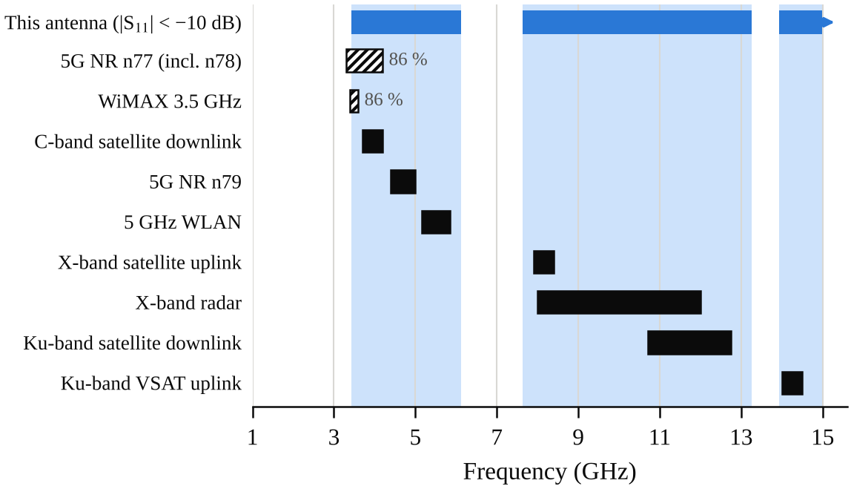
Fig. 6. Bands of the proposed antenna (top) and the services they serve; solid bars are fully covered, hatched bars partly, with the covered share shown.
TABLE IV
Applications of the Proposed Antenna
Band | Range (GHz) | Applications
I | 3.43–6.13 | 5G NR n77/n78 (upper part), n79; WiMAX; C-band satellite downlink; 5 GHz WLAN and ISM
II | 7.64–13.25 | X-band satellite uplink; X-band marine, weather and short-range radar; Ku-band satellite downlink (DTH)
III | 13.93–>15 | Ku-band VSAT uplink

A practical use is a compact multi-standard terminal in which one radiator serves the 5G and WLAN links of band I and an X-band sensing or satellite link of band II. For short-range sensing, two identical antennas can act as the transmitter and receiver of an X-band radar, in the way UWB antennas are used in surface-penetrating radar [9], [16]: the transmission coefficient S₂₁ between them is recorded with and without a target, and the difference reveals the target. The metasurface directs the radiation away from the ground side, which reduces coupling to the electronics placed behind the antenna (to be confirmed with the front-to-back ratio of Fig. 5). Since bands I and II are separated by the unmatched region of 6.13–7.64 GHz, the antenna is not intended for impulse (UWB) radar.
V. Conclusion
A compact CPW-fed octagonal monopole antenna backed by a 4 × 4 square-patch metasurface has been proposed. The outcomes demonstrate that the structure, with a footprint of 27 mm × 31 mm and a total profile of 5.2 mm, provides three impedance bands with |S₁₁| ≤ −10 dB: 3.43–6.13 GHz, 7.64–13.25 GHz and 13.93 GHz to beyond 15 GHz, with a lowest reflection coefficient of −29.6 dB at 5.29 GHz. The equivalent-circuit model places the in-phase reflection of the metasurface near 8.0 GHz, inside the second band. [Gain sentence: the peak realized gain is [xx] dBi, an improvement of [xx] dB over the antenna alone.] The bands serve sub-6 GHz 5G, WLAN, X-band radar and satellite links and the Ku-band satellite links, so the proposed antenna is suitable to implement in compact multi-standard communication and sensing systems. Fabrication and measurement of the prototype are the next step of this work.
References
[1] C. A. Balanis, Antenna Theory: Analysis and Design, 4th ed. Hoboken, NJ, USA: Wiley, 2016.
[2] 3rd Generation Partnership Project, “NR; Base Station (BS) radio transmission and reception,” 3GPP TS 38.104.
[3] IEEE Standard for Information Technology—Telecommunications and Information Exchange Between Systems—Local and Metropolitan Area Networks—Specific Requirements—Part 11: Wireless LAN Medium Access Control (MAC) and Physical Layer (PHY) Specifications, IEEE Std 802.11-2020, 2021.
[4] IEEE Standard Letter Designations for Radar-Frequency Bands, IEEE Std 521-2019, 2020.
[5] R. N. Simons, Coplanar Waveguide Circuits, Components, and Systems. New York, NY, USA: Wiley, 2001, doi: 10.1002/0471224758.
[6] Y. Song, Y.-C. Jiao, G. Zhao, and F.-S. Zhang, “Multiband CPW-fed triangle-shaped monopole antenna for wireless applications,” Prog. Electromagn. Res., vol. 70, pp. 329–336, 2007.
[7] S. Ahmad, U. Ijaz, S. Naseer, A. Ghaffar, M. A. Qasim, F. Abrar, N. O. Parchin, C. H. See, and R. Abd-Alhameed, “A jug-shaped CPW-fed ultra-wideband printed monopole antenna for wireless communications networks,” Appl. Sci., vol. 12, no. 2, Art. no. 821, 2022.
[8] O. P. Kumar, T. Ali, P. Kumar, P. Kumar, and J. Anguera, “An elliptical-shaped dual-band UWB notch antenna for wireless applications,” Appl. Sci., vol. 13, no. 3, Art. no. 1310, 2023.
[9] S. Bhattacharya, A. Chatterjee, P. P. Sarkar, and A. Swarnakar, “A javelin shaped UWB antenna with notch band for remote sensing applications,” Amer. J. Electron. Commun., vol. 5, no. 1, pp. 58–61, Jan. 2025.
[10] D. Sievenpiper, L. Zhang, R. F. J. Broas, N. G. Alexópolous, and E. Yablonovitch, “High-impedance electromagnetic surfaces with a forbidden frequency band,” IEEE Trans. Microw. Theory Techn., vol. 47, no. 11, pp. 2059–2074, Nov. 1999, doi: 10.1109/22.798001.
[11] G. Sen, A. Banerjee, M. Kumar, and S. Das, “An ultra-wideband monopole antenna with a gain enhanced performance using a novel split-ring meta-surface reflector,” Microw. Opt. Technol. Lett., vol. 59, no. 6, pp. 1296–1300, 2017, doi: 10.1002/mop.30527.
[12] A. J. A. Al-Gburi, I. B. M. Ibrahim, Z. Zakaria, B. H. Ahmad, N. A. B. Shairi, and M. Y. Zeain, “High gain of UWB planar antenna utilising FSS reflector for UWB applications,” Comput. Mater. Contin., vol. 70, no. 1, pp. 1425–1436, 2022, doi: 10.32604/cmc.2022.019741.
[13] M. Hussain, M. A. Sufian, M. S. Alzaidi, S. I. Naqvi, N. Hussain, D. H. Elkamchouchi, M. F. A. Sree, and S. Y. A. Fatah, “Bandwidth and gain enhancement of a CPW antenna using frequency selective surface for UWB applications,” Micromachines, vol. 14, no. 3, Art. no. 591, Feb. 2023, doi: 10.3390/mi14030591.
[14] B. Hammache, I. Messaoudene, M. Belazzoug, S. Titouni, A. Messai, and T. A. Denidni, “Gain enhancement of compact CPW-fed ultra-wideband antenna using an FSS reflector,” Microw. Opt. Technol. Lett., vol. 66, no. 10, Art. no. e34344, 2024, doi: 10.1002/mop.34344.
[15] M. AboEl-Hassan, A. E. Farahat, and K. F. A. Hussein, “Gain enhancement wideband CPW antenna based on artificial magnetic conductor,” Sci. Rep., vol. 15, Art. no. 7108, 2025, doi: 10.1038/s41598-025-89622-9.
[16] S. Kundu and A. Chatterjee, “Sharp triple-notched ultra wideband antenna with gain augmentation using FSS for ground penetrating radar,” Wireless Pers. Commun., vol. 117, no. 2, pp. 1399–1418, 2021.
[17] S. Kundu, A. Chatterjee, S. K. Jana, and S. K. Parui, “Gain enhancement of a printed leaf shaped UWB antenna using dual FSS layers and experimental study for ground coupling GPR applications,” Microw. Opt. Technol. Lett., vol. 60, no. 6, pp. 1417–1423, 2018.
[18] A. Chatterjee and S. K. Parui, “Frequency-dependent directive radiation of monopole-dielectric resonator antenna using a conformal frequency selective surface,” IEEE Trans. Antennas Propag., vol. 65, no. 5, pp. 2233–2239, May 2017.
[19] P. Rajalakshmi and N. Gunavathi, “Gain enhancement of cross shaped patch antenna for IEEE 802.11ax Wi-Fi applications,” Prog. Electromagn. Res. Lett., vol. 80, pp. 91–99, 2018.
[20] K. P. Ray, “Design aspects of printed monopole antennas for ultra-wide band applications,” Int. J. Antennas Propag., vol. 2008, Art. no. 713858, 2008, doi: 10.1155/2008/713858.
[21] G. Kumar and K. P. Ray, Broadband Microstrip Antennas. Norwood, MA, USA: Artech House, 2003.
[22] International Telecommunication Union, Radio Regulations, Article 5: Frequency allocations. Geneva, Switzerland: ITU, 2020.

