B. Tech. PROJECT REPORT (Mid-Semester Evaluation)

WIDEBAND MIMO ANTENNA WITH METASURFACE
Phase I: CPW-fed UWB Antenna with a Split-Ring-Resonator Metasurface Reflector

Submitted by:

CHANSWARANG BORO (2314143)
NISHIT BAISHYA (2314088)
ANUSHKA DAM (2314115)
SANJANA (2314060)

DR. UJJAL CHAKRABORTY
MR. SOVAN BHATTACHARYA (CO-GUIDE)

SUPERVISOR’S SIGNATURE

DEPARTMENT OF ELECTRONICS AND COMMUNICATION ENGINEERING

NATIONAL INSTITUTE OF TECHNOLOGY SILCHAR, ASSAM (INDIA)-788010
Contents
Abstract 4
Introduction 4
Background and Motivation 4
Problem Statement 5
Objectives 5
Organisation of the Report 5
Literature Review 6
Single Antennas with a Metasurface Reflector 6
MIMO Antennas with Metasurfaces 6
Comparison and Research Gap 6
Methodology / Proposed Work 8
Design Flow 8
Antenna Design 8
Split-Ring-Resonator Metasurface 9
Antenna with the Metasurface Reflector 9
Simulation Set-up 11
Work Done Till Mid-Semester 12
Antenna Geometry 12
Parametric Study 12
Optimised Antenna 13
Metasurface Unit Cell 15
Antenna with the Metasurface 15
Challenges 15
Work Plan for Next Phase 17
Completing Phase I 17
Phase II: MIMO Antenna with Metasurface 17
Fabrication and Measurement 17
Timeline 17
Expected Outcomes 18
References 18
List of Figures
Fig. 1. Design flow of the project; steps 1–4 are complete. 8
Fig. 2. Side view of the antenna, the 3.9 mm air gap and the SRR metasurface (schematic, not to scale). 10
Fig. 3. Reflection phase needed for in-phase addition at h = 3.9 mm (line) with the ±90° window (band), compared with a metal plate (computed). 11
Fig. 4. Geometry of the CPW-fed antenna (CST model). 12
Fig. 5. |S₁₁| for different ground-edge positions L_{g} (R = 15 mm); best: L_{g} = −7 mm. 12
Fig. 6. |S₁₁| for different patch radii R (L_{g} = −7 mm); best: R = 15 mm. 13
Fig. 7. |S₁₁| of the optimised antenna: (top) resonance markers, (bottom) −10 dB band edges at 2.1615 GHz and 15.734 GHz. 14
Fig. 8. Simulated IEEE gain of the optimised antenna versus frequency. 14
Fig. 9. SRR unit cell: geometry and simulated reflection phase. 15
Fig. 10. |S₁₁| and gain of the antenna without and with the SRR metasurface. 15
List of Tables
Table 1. Single wideband antennas with a metasurface, AMC or FSS reflector. 6
Table 2. MIMO antennas that use a metasurface (background for Phase II). 6
Table 3. Dimensions of the optimised antenna (mm). 9
Table 4. Reflection phase needed at h = 3.9 mm and the error of a metal plate (computed from equation (5)). 10
Table 5. Simulated performance of the optimised antenna (no metasurface). 15
Table 6. Work plan from mid-October to the end-semester evaluation (early December). 17

Abstract
Ultra-wideband (UWB) radios and multiple-input multiple-output (MIMO) antennas together support high data rates over short ranges, but the printed monopoles normally used for UWB radiate on both sides of the board and therefore have low gain. This project develops a wideband MIMO antenna with a metasurface. This mid-semester report covers Phase I: a single coplanar-waveguide (CPW) fed planar monopole backed by a split-ring-resonator (SRR) metasurface.
The monopole was modelled in CST Studio Suite and optimised through two parametric sweeps: the position of the CPW ground-plane edge (L_{g}) and the patch radius (R). The optimised antenna (L_{g} = −7 mm, R = 15 mm) has |S₁₁| ≤ −10 dB from 2.16 GHz to 15.73 GHz, a fractional bandwidth of 151.7 %, which covers the whole 3.1–10.6 GHz UWB band. Its simulated IEEE gain is about 2.9–4.9 dBi across that band. To redirect the backward radiation, a single-SRR metasurface is placed 3.9 mm behind the antenna across an air gap. A reflection-phase analysis shows that, at this small gap, a plain metal plate would work against the forward radiation over most of the UWB band, which is why an in-phase metasurface is needed. The characterisation of the metasurface unit cell and the simulation of the antenna with the metasurface are in progress; their results will be added before the final submission.
A review of ten recent papers on metasurface-loaded single and MIMO antennas places the work in context. Phase II will extend the design to a multi-port MIMO antenna, evaluate its isolation and diversity performance, and validate a fabricated prototype by measurement.

Introduction

Background and Motivation
Short-range wireless links for high-definition video, personal-area networks, imaging and sensing need data rates that narrowband radios cannot provide. Ultra-wideband (UWB) technology meets this need by spreading very low-power signals over a very wide band: in 2002 the FCC allowed unlicensed UWB operation from 3.1 to 10.6 GHz at a power spectral density of at most −41.3 dBm/MHz [1]. Multiple-input multiple-output (MIMO) techniques raise capacity further: with several antennas at each end of the link, capacity grows roughly in proportion to the number of antennas without extra bandwidth or transmit power [2], [3]. Combining the two needs several wideband antennas that are compact, well matched over the whole band and weakly coupled to each other [4].
Printed planar monopoles are the most common UWB radiators. A planar disc or polygon above a ground plane behaves like a thick cylindrical monopole, and its closely spaced resonances overlap into a very wide impedance band [5], [6]. A coplanar-waveguide (CPW) feed keeps the signal strip and the ground on the same side of the substrate, needs no vias and lets several elements share one ground later [7]. The price is gain: a printed monopole radiates almost equally into both half-spaces, so roughly half of its power leaves through the back of the board and the gain stays at a few dBi [8].
A reflector behind the antenna can turn the backward radiation forward. A metal plate, however, reflects with a 180° phase shift and must sit a quarter wavelength away (24.2 mm at 3.1 GHz) for the reflected wave to add in phase, and over a band as wide as UWB no fixed gap satisfies that. Metasurfaces, two-dimensional arrays of sub-wavelength resonant cells [9], can be designed to reflect in phase near their resonance [10], [11], so they can sit much closer to the antenna and keep the structure thin. The split-ring resonator (SRR) [12] is a compact cell whose resonance is tuned by its geometry alone.

Problem Statement
Design a compact CPW-fed planar monopole that covers the full 3.1–10.6 GHz UWB band, and raise its gain with a split-ring-resonator metasurface placed 3.9 mm behind it across an air gap without losing the impedance bandwidth. Then extend the design to a multi-port MIMO antenna with high isolation and good diversity performance.

Objectives
- O1 (Phase I, done): design and optimise a CPW-fed planar monopole with |S₁₁| ≤ −10 dB over at least 3.1–10.6 GHz.
- O2 (Phase I, in progress): design a split-ring-resonator unit cell and characterise its reflection phase.
- O3 (Phase I, in progress): place the metasurface 3.9 mm behind the antenna and quantify the change in gain, radiation pattern and matching, compared with no reflector and with a plain metal plate at the same gap.
- O4 (Phase II): extend the design to a 2-/4-port MIMO antenna with the metasurface and evaluate isolation, envelope correlation coefficient (ECC), diversity gain (DG), total active reflection coefficient (TARC), channel capacity loss (CCL) and mean effective gain (MEG).
- O5 (Phase II): fabricate a prototype and validate it by measurement.

Organisation of the Report
The Literature Review summarises ten recent papers on metasurface-loaded single and MIMO antennas. Methodology describes the design flow, the governing equations and the simulation set-up. Work Done Till Mid-Semester presents the parametric study, the optimised antenna and the status of the metasurface. The Work Plan and Expected Outcomes describe the rest of the project.

Literature Review
The review covers two groups of papers, selected as described in the separate literature-review document: (i) single wideband antennas whose gain is raised by a metasurface, artificial magnetic conductor (AMC) or frequency selective surface (FSS) reflector, which bear directly on Phase I, and (ii) MIMO antennas that use metasurfaces, which inform Phase II. Every value below was checked against the full text of each paper.

Single Antennas with a Metasurface Reflector
Sen et al. (2017) [13]: [to be completed from the full text]
AboEl-Hassan et al. (2025) [14]: [to be completed from the full text]
Hussain et al. (2023) [15]: [to be completed from the full text]
Al-Gburi et al. (2022) [16]: [to be completed from the full text]
Hammache et al. (2024) [17]: [to be completed from the full text]

MIMO Antennas with Metasurfaces
Sufian et al. (2021) [18]: [to be completed from the full text]
Hasan et al. (2022) [19]: [to be completed from the full text]
Althuwayb et al. (2023) [20]: [to be completed from the full text]
Wu et al. (2023) [21]: [to be completed from the full text]
Metasurface mmWave MIMO (2021) [22]: [to be completed from the full text]

Comparison and Research Gap
Table 1. Single wideband antennas with a metasurface, AMC or FSS reflector.
Ref. | Antenna / feed | Substrate | Reflector: unit cell, array | Gap, backing | Band (GHz) | Peak gain (dBi): no MS → MS
[13] | ? | ? | ? | ? | ? | ?
[14] | ? | ? | ? | ? | ? | ?
[15] | ? | ? | ? | ? | ? | ?
[16] | ? | ? | ? | ? | ? | ?
[17] | ? | ? | ? | ? | ? | ?
This work | CPW-fed planar monopole | see design | Single split-ring resonator (SRR) array (design ongoing) | 3.9 mm, air (0.028λ_{L}) | 2.16–15.73 (no MS) | ≈ 1.3–5.1 (IEEE gain, no MS) → pending

Table 2. MIMO antennas that use a metasurface (background for Phase II).
Ref. | Ports, size (mm) | Band (GHz) | Metasurface and its role | Isolation (dB) | ECC | Peak gain (dBi)
[18] | ?; ? | ? | ?; ? | ? | ? | ?
[19] | ?; ? | ? | ?; ? | ? | ? | ?
[20] | ?; ? | ? | ?; ? | ? | ? | ?
[21] | ?; ? | ? | ?; ? | ? | ? | ?
[22] | ?; ? | ? | ?; ? | ? | ? | ?

[Research gap: to be completed from the full texts.]

Methodology / Proposed Work

Design Flow
The work follows the flow of Fig. 1. The antenna is optimised first, one parameter at a time, so that the effect of each parameter is visible. The metasurface is then designed as a unit cell, placed behind the optimised antenna and compared with no reflector and with a plain metal plate at the same gap. Phase II reuses the optimised antenna as the MIMO element.
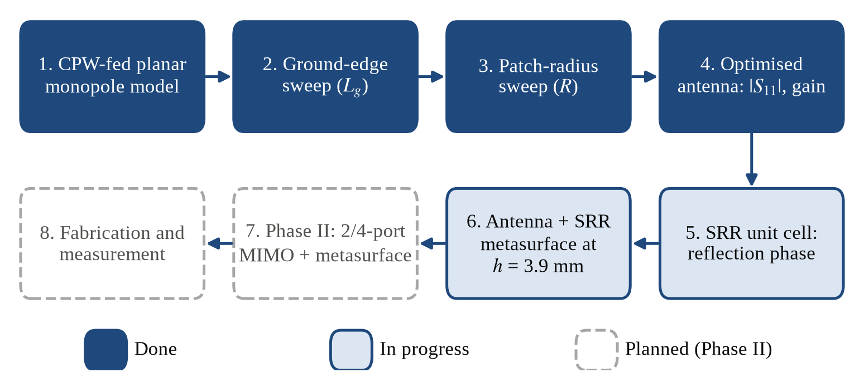
Fig. 1. Design flow of the project; steps 1–4 are complete.

Antenna Design
The radiator is a planar patch of radius R fed by a 50 Ω CPW line. The signal strip of width W_{f} is separated from the two coplanar ground planes by slots of width g, and the top edge of the ground planes lies at y = L_{g}, so L_{g} sets how close the ground comes to the patch. Two quantities dominate the matching of a printed monopole: the ground geometry near the feed, which controls the coupling between patch and ground, and the patch size, which sets the lowest resonance and how the higher-order resonances overlap [6]. The lower band edge of a planar monopole can be estimated from an equivalent cylindrical monopole [5], [6]:
$f_{L}≈\frac{7.2}{L+r+p} GHz$ (1)
where L is the height of the patch, r the radius of the equivalent cylinder (2πrL equals the patch area) and p the gap between the patch and the ground, all in centimetres. Equation (1) ignores the substrate, which lowers the frequency further, so it serves only as a starting point for the CST sweeps. The bandwidth is reported as the fractional bandwidth
$FBW=\frac{2\left(f_{H}−f_{L}\right)}{f_{H}+f_{L}}$ (2)
where f_{L} and f_{H} are the lower and upper −10 dB frequencies; UWB operation requires f_{L} ≤ 3.1 GHz and f_{H} ≥ 10.6 GHz, i.e. FBW ≥ 109 % from (2). CST reports the IEEE gain G, which includes conduction and dielectric losses but not the mismatch at the port; the realized gain also includes the mismatch:
$G_{R}=\left(1−{\left|Γ\right|}^{2}\right)G$ (3)
where Γ = S₁₁ is the reflection coefficient at the port. Inside the −10 dB band |Γ|² ≤ 0.1, so the realized gain is at most 0.46 dB below the IEEE gain (computed from (3)). Table 3 lists the antenna dimensions.
Table 3. Dimensions of the optimised antenna (mm).
Symbol | Description | Value
W_{s} × L_{s} | Substrate (board) size | pending
h_{s} | Substrate thickness | pending
R | Radius of the radiating patch | 15
L_{g} | y-coordinate of the top edge of the CPW ground planes | −7
W_{f} | Width of the CPW signal strip | pending
g | Width of the CPW slots | pending

Split-Ring-Resonator Metasurface
Each metasurface cell is a single split-ring resonator: a metal ring interrupted by one split. The ring behaves as an inductance L and the split as a capacitance C [12], so the cell resonates at
$f_{0}=\frac{1}{2π\sqrt{LC}}$ (4)
A larger ring raises L and a narrower split raises C, and both lower f₀ in (4). The cell is characterised on its own with unit-cell (periodic) boundaries and a Floquet port, which gives the reflection phase φ_{R} of an infinite array under normal incidence. Near resonance an in-phase reflector has φ_{R} close to 0°, and its useful band is usually taken as the range where φ_{R} stays within ±90° [10], [11].

Antenna with the Metasurface Reflector
The metasurface is placed 3.9 mm behind the antenna substrate with only air in between (Fig. 2).
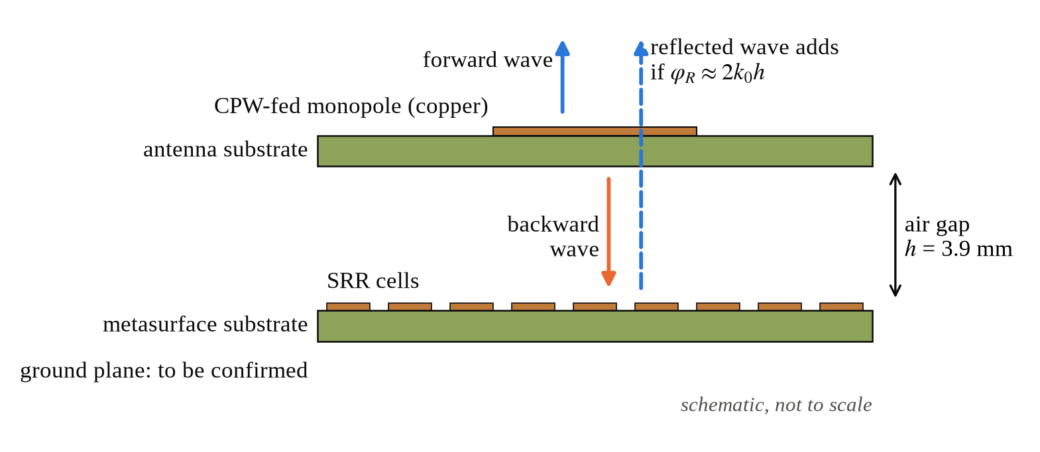
Fig. 2. Side view of the antenna, the 3.9 mm air gap and the SRR metasurface (schematic, not to scale).
The wave radiated backwards travels to the metasurface and back, a round trip of 2h, and is reflected with phase φ_{R}. It adds constructively to the forward wave when
$φ_{R}−2k_{0}h=2nπ$ (5)
where k₀ = 2π/λ₀ and n is an integer; the reflection still helps as long as the phase error stays within ±90°. A metal (PEC) plate has φ_{R} = 180°, so (5) would require h = λ₀/4. Table 4 and Fig. 3 evaluate (5) at h = 3.9 mm (computed, not simulated).
Table 4. Reflection phase needed at h = 3.9 mm and the error of a metal plate (computed from equation (5)).
f (GHz) | λ₀ (mm) | h/λ₀ | Needed φ_{R} = 2k₀h | PEC error 180° − 2k₀h | PEC reflection
2.16 | 138.7 | 0.028 | 20° | 160° | reduces
3.10 | 96.7 | 0.040 | 29° | 151° | reduces
5.00 | 60.0 | 0.065 | 47° | 133° | reduces
6.85 | 43.8 | 0.089 | 64° | 116° | reduces
9.61 | 31.2 | 0.125 | 90° | 90° | boundary
10.60 | 28.3 | 0.138 | 99° | 81° | adds
15.73 | 19.1 | 0.205 | 147° | 33° | adds

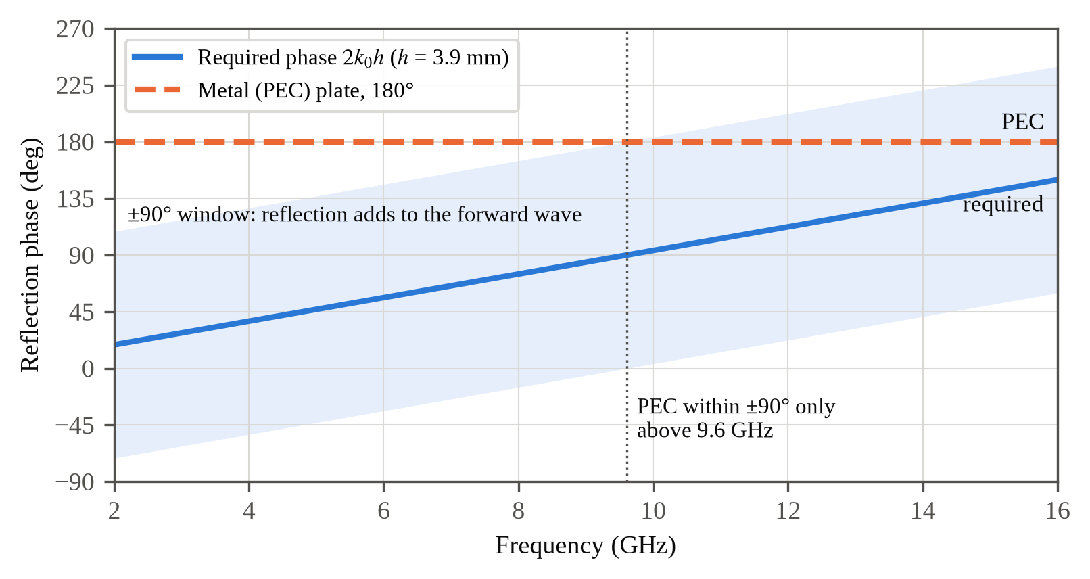
Fig. 3. Reflection phase needed for in-phase addition at h = 3.9 mm (line) with the ±90° window (band), compared with a metal plate (computed).
The needed phase rises from 20° at 2.16 GHz to 147° at 15.73 GHz. A metal plate lies more than 90° away from it below about 9.6 GHz, so at this gap it would reduce the forward gain over most of the UWB band. A metasurface whose reflection phase follows the band in Fig. 3 can instead add to the forward beam. This ray picture ignores the near-field coupling between antenna and metasurface, which is strong at 0.040λ₀ (at 3.1 GHz); the metasurface also loads the antenna, so its matching must be re-checked, and L_{g} re-tuned if needed, with the metasurface in place.

Simulation Set-up
All simulations use CST Studio Suite 2019 with the frequency-domain solver over 0–18 GHz. The CPW line is excited by a waveguide port that spans the signal strip, both slots and part of each ground plane, and open (add-space) boundaries surround the structure. The ground-edge sweep used ten values from −20 mm to −7 mm and the radius sweep 4 mm to 15 mm (13 values). Gain was obtained from far-field monitors spread over 1–18 GHz. The metasurface unit cell uses unit-cell boundaries in x and y and a Floquet port in z.

Work Done Till Mid-Semester

Antenna Geometry
Fig. 4 shows the CPW-fed antenna; its dimensions are listed in Table 3. Substrate: pending (from the CST parameter list).
Result pending: CST simulation
CST screenshot of the antenna geometry
Fig. 4. Geometry of the CPW-fed antenna (CST model).

Parametric Study
Fig. 5 shows |S₁₁| for ten values from −20 mm to −7 mm of the ground-edge position L_{g} with R = 15 mm. As L_{g} increases, the ground edge moves towards the patch: the first resonance moves up from about 1.6 GHz to 2.7 GHz and becomes much deeper, and the matching between 3 and 10 GHz improves. For most ground positions |S₁₁| stays between about −3 dB and −10 dB over large parts of 3–10 GHz; only L_{g} = −7 mm keeps it below −10 dB across the whole band, so this value was fixed.
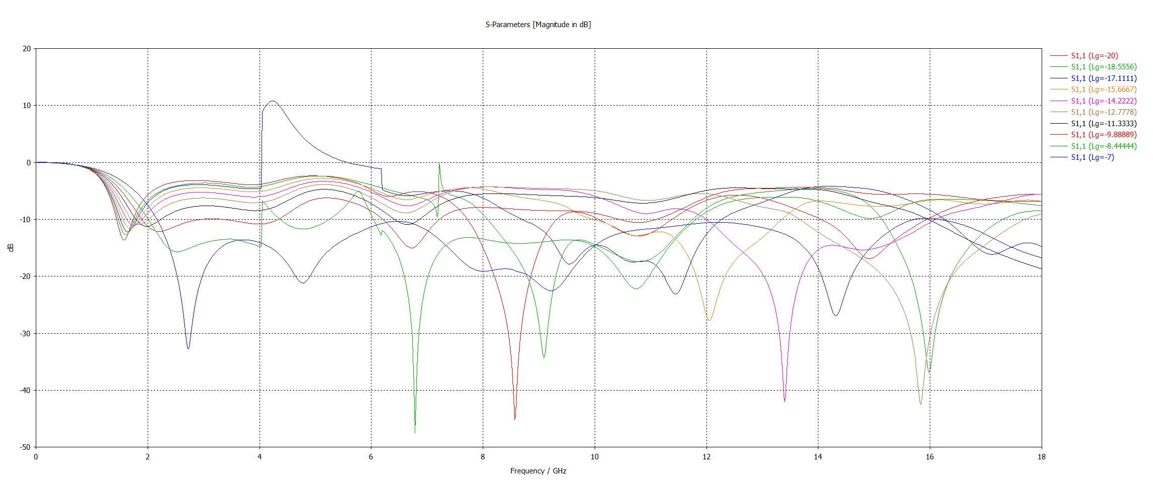
Fig. 5. |S₁₁| for different ground-edge positions L_{g} (R = 15 mm); best: L_{g} = −7 mm.
Fig. 6 shows the radius sweep, 4 mm to 15 mm (13 values), with L_{g} = −7 mm. Small patches resonate too high and leave much of the band poorly matched; enlarging the patch lowers the first resonance and brings the higher-order resonances together, and R = 15 mm gives the widest continuous −10 dB band of all radii simulated. Both selected values lie at the upper end of their sweep ranges, which were limited by the board size.
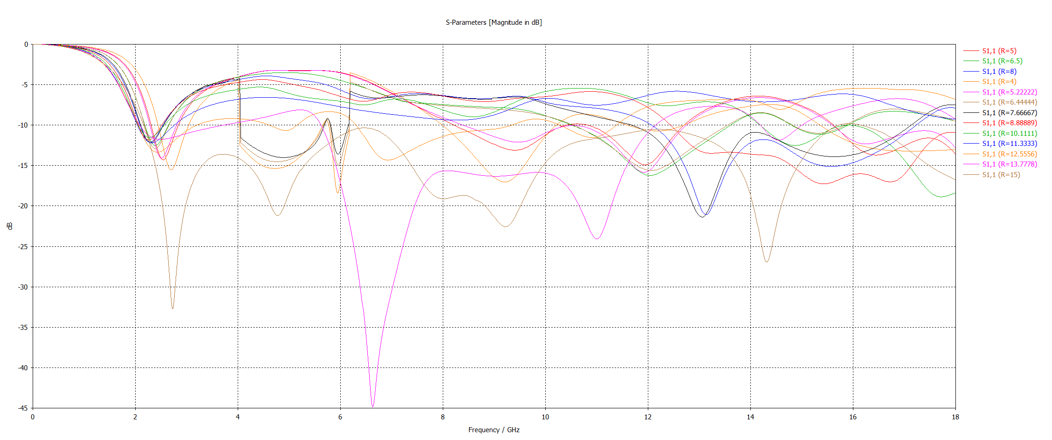
Fig. 6. |S₁₁| for different patch radii R (L_{g} = −7 mm); best: R = 15 mm.
Some sweep curves show abrupt steps at about 4.0 GHz and 6.2 GHz, and one curve of the ground sweep rises above 0 dB between these frequencies. A passive antenna cannot reflect more power than it receives (|S₁₁| ≤ 0 dB), so these are numerical artefacts of the broadband frequency sweep for those parameter values, not physical behaviour. They do not affect the selected design, whose final response (Fig. 7) is smooth; the affected points will be re-simulated with denser frequency sampling.

Optimised Antenna
Fig. 7 shows the response of the optimised antenna (L_{g} = −7 mm, R = 15 mm). |S₁₁| stays below −10 dB from 2.16 GHz to 15.73 GHz, a fractional bandwidth of 151.7 % from (2), which covers the entire UWB band with margin at both ends. Four resonances, at 2.73 GHz (-32.6 dB), 4.78 GHz (-21.2 dB), 9.23 GHz (-22.6 dB), 14.32 GHz (-27.1 dB), overlap to form the band. The weakest points are near 6.5 GHz and 12.2 GHz, where |S₁₁| is only about −10.3 dB and −10.5 dB; these points will be watched when the metasurface is added.
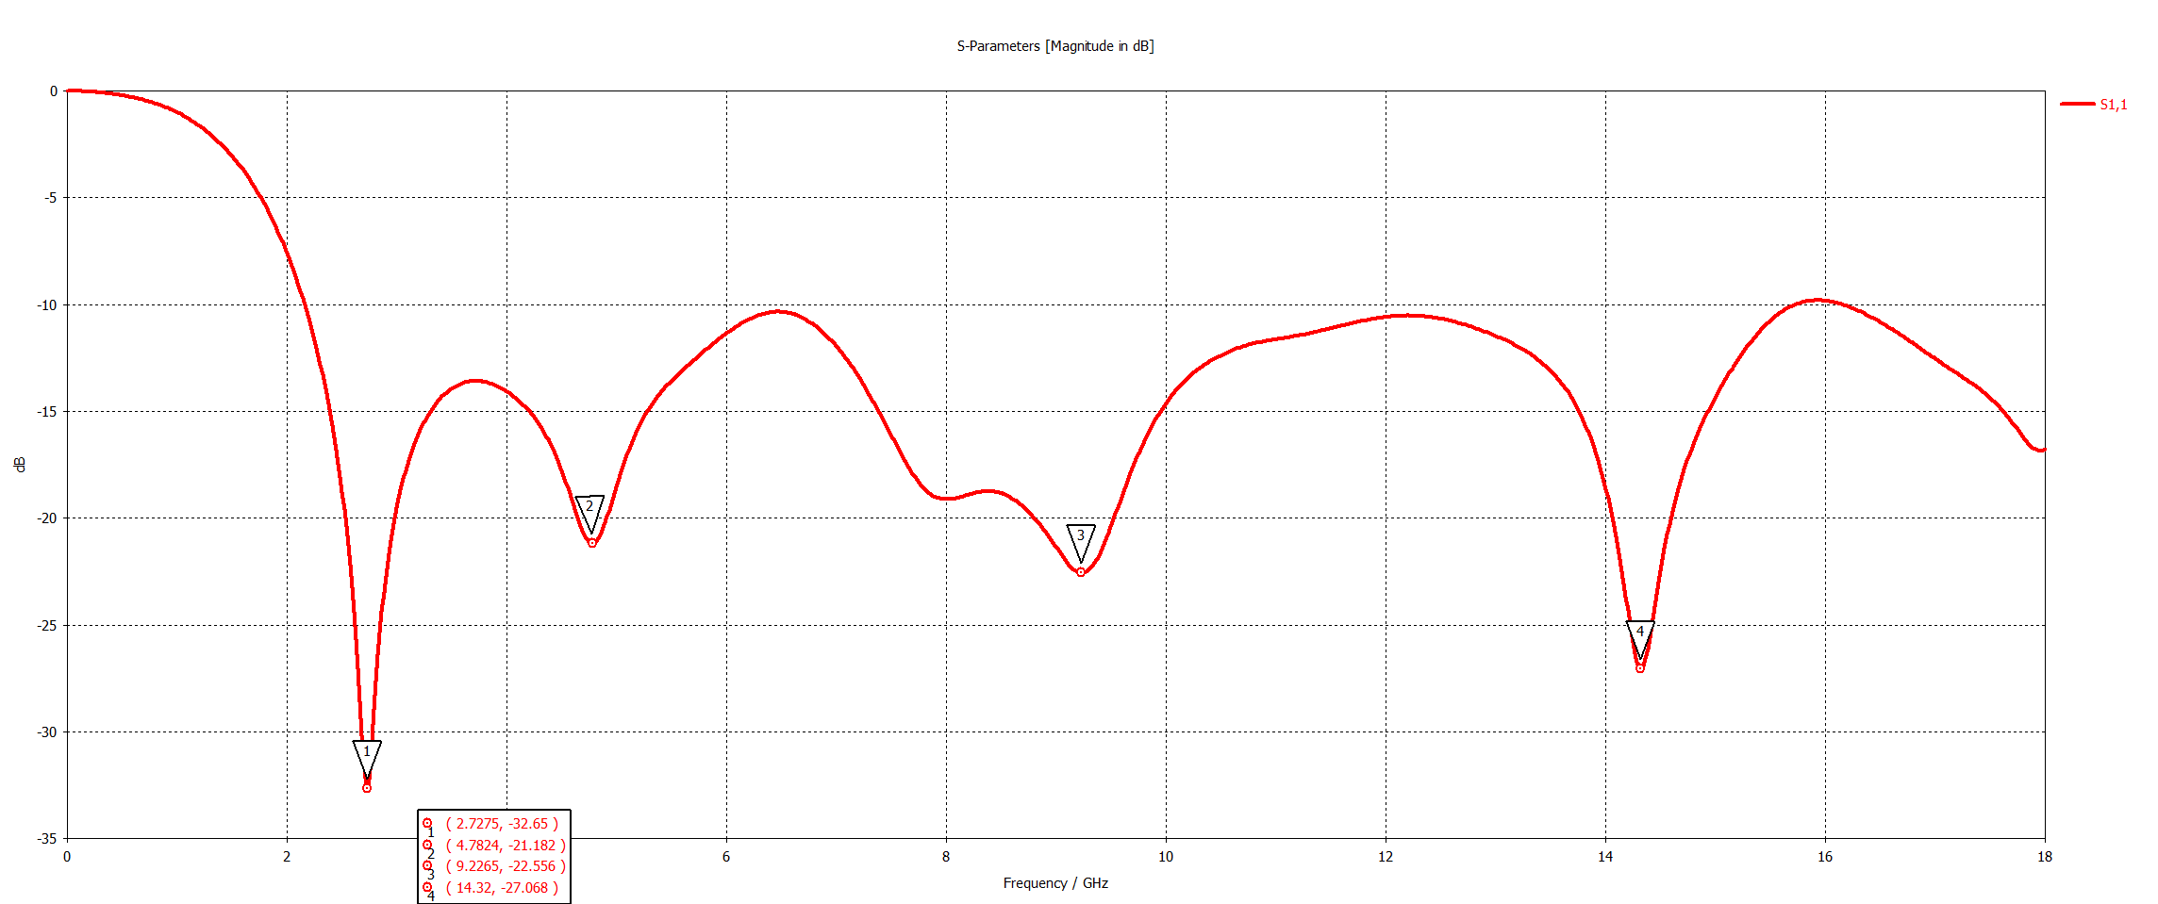
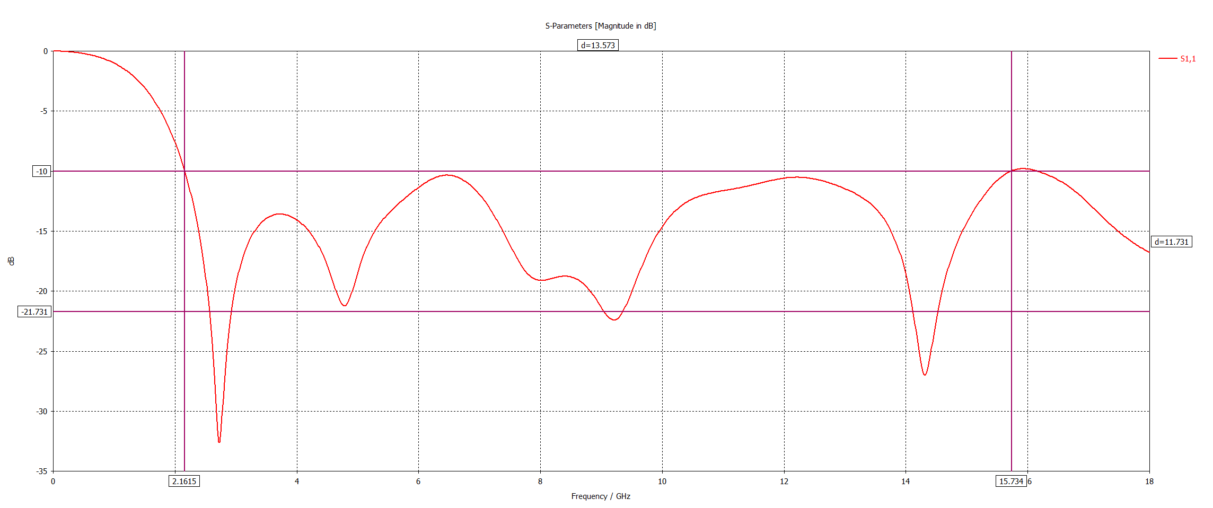
Fig. 7. |S₁₁| of the optimised antenna: (top) resonance markers, (bottom) −10 dB band edges at 2.1615 GHz and 15.734 GHz.
Fig. 8 shows the simulated IEEE gain. It rises from about 1 dBi at 2 GHz to 3.3 dBi near 3.6 GHz, stays between about 2.9 and 4.9 dBi across 3.1–10.6 GHz (lowest near 6.3 GHz, highest near 8.5 GHz) and peaks at ≈ 5.1 dBi at ≈ 13.5 GHz (values read from the plot). These values are typical of a printed monopole that radiates on both sides of the board, and they are the baseline the metasurface has to improve. Realized gain and radiation patterns will be added with the metasurface results.
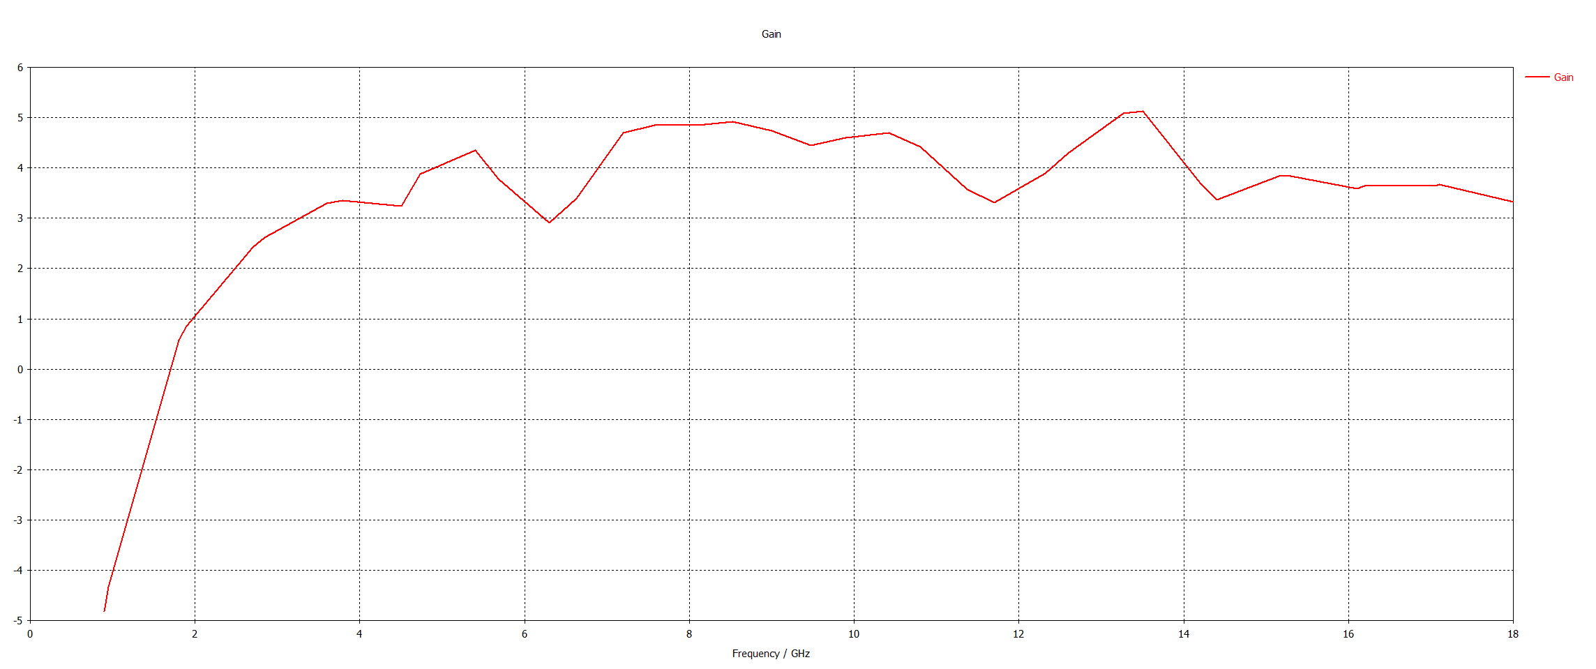
Fig. 8. Simulated IEEE gain of the optimised antenna versus frequency.
Table 5. Simulated performance of the optimised antenna (no metasurface).
Quantity | Value
−10 dB band | 2.16–15.73 GHz
Fractional bandwidth | 151.7 %
Resonances | 2.73, 4.78, 9.23, 14.32 GHz
Deepest |S₁₁| | -32.65 dB at 2.73 GHz
IEEE gain, 3.1–10.6 GHz | ≈ 2.9–4.9 dBi (read from plot)
Peak IEEE gain | ≈ 5.1 dBi at ≈ 13.5 GHz

Metasurface Unit Cell
The single-SRR unit cell is being simulated with unit-cell boundaries and a Floquet port to obtain its reflection phase, which will be compared with the window of Fig. 3. Cell: pending; period: pending; array: pending; substrate: pending.
Result pending: CST simulation
SRR unit cell geometry and reflection phase (Floquet port)
Fig. 9. SRR unit cell: geometry and simulated reflection phase.

Antenna with the Metasurface
The antenna with the SRR metasurface 3.9 mm behind it is being simulated with the same mesh and monitors as the antenna alone, together with a plain metal plate at the same gap as a baseline.
Result pending: CST simulation
S11 and gain: no reflector / metal plate / SRR metasurface
Fig. 10. |S₁₁| and gain of the antenna without and with the SRR metasurface.

Challenges
- Simulation time. Each full-band run takes a long time on the available PC, so sweeps use coarser settings and the final design is re-run on its own.
- Sweep artefacts. Non-physical steps (and one curve above 0 dB) in the broadband frequency sweeps; the affected points will be re-run with denser frequency sampling.
- Sweep limits. The selected L_{g} and R lie at the edge of their ranges, which the board size bounds.
- Marginal matching. |S₁₁| is only about 0.3–0.5 dB below the −10 dB line near 6.5 and 12.2 GHz; the metasurface may detune these points.
- Metasurface bandwidth. The antenna covers a 7:1 band, while a single SRR resonance is in phase over a much narrower range, so the metasurface is expected to raise the gain over part of the band only.

Work Plan for Next Phase

Completing Phase I
- Characterise the SRR unit cell (reflection phase and magnitude) and compare it with the in-phase window at h = 3.9 mm.
- Simulate the antenna with the metasurface and with a metal plate at the same gap; compare |S₁₁|, realized gain, front-to-back ratio and radiation patterns at 4, 7 and 10 GHz.
- Re-tune L_{g} if the metasurface detunes the band, and re-run the sweep points that showed artefacts.

Phase II: MIMO Antenna with Metasurface
The optimised antenna becomes the MIMO element. Two and then four elements will be placed with 90° rotations, so that neighbouring elements are orthogonally polarised, on a shared CPW ground as in practical devices; the metasurface will extend under the whole board. The design will be judged by the standard MIMO metrics [4]: isolation between ports (target above 15 dB, aiming for 20 dB), envelope correlation coefficient (target below 0.01, from S-parameters and from far-field patterns), diversity gain (close to 10 dB), total active reflection coefficient, channel capacity loss (below 0.4 bit/s/Hz) and mean effective gain. The team's Python post-processing scripts already compute all of these from CST Touchstone exports.

Fabrication and Measurement
The antenna and the metasurface will be fabricated as separate printed boards and held 3.9 mm apart with non-metallic spacers. S-parameters will be measured on a vector network analyser and radiation patterns and gain in an anechoic chamber, then compared with simulation.

Timeline
Table 6. Work plan from mid-October to the end-semester evaluation (early December).
Period | Task | Output
7–15 Oct | Unit-cell reflection phase; antenna with metasurface; metal-plate baseline; realized gain and patterns | Phase I results
16–31 Oct | 2-port, then 4-port layout on a shared ground; isolation study | MIMO S-parameters
1–15 Nov | MIMO with metasurface; ECC, DG, TARC, CCL, MEG; patterns | Full simulated MIMO results
16–25 Nov | Fabrication; measurement on a VNA and in an anechoic chamber | Measured results
26 Nov–early Dec | Comparison of measurement and simulation; final report and presentation | End-semester submission

Expected Outcomes
- A low-profile CPW-fed UWB antenna (air gap 3.9 mm, about 0.04λ₀ at 3.1 GHz) whose SRR metasurface raises the forward gain and front-to-back ratio wherever its reflection phase meets the in-phase condition, while keeping the 2.16–15.73 GHz impedance band.
- A fair comparison of no reflector, a metal plate and the SRR metasurface at the same gap.
- A 2-/4-port MIMO antenna with the metasurface, with isolation above 15 dB (target 20 dB) and ECC below 0.01 across the UWB band.
- A fabricated and measured prototype, and a draft paper.

References
[1] Federal Communications Commission, “Revision of Part 15 of the Commission’s rules regarding ultra-wideband transmission systems,” First Report and Order, ET Docket 98-153, FCC 02-48, Apr. 2002.
[2] G. J. Foschini and M. J. Gans, “On limits of wireless communications in a fading environment when using multiple antennas,” Wireless Pers. Commun., vol. 6, no. 3, pp. 311–335, Mar. 1998, doi: 10.1023/A:1008889222784.
[3] E. Telatar, “Capacity of multi-antenna Gaussian channels,” Eur. Trans. Telecommun., vol. 10, no. 6, pp. 585–595, Nov./Dec. 1999, doi: 10.1002/ett.4460100604.
[4] M. S. Sharawi, “Printed multi-band MIMO antenna systems and their performance metrics,” IEEE Antennas Propag. Mag., vol. 55, no. 5, pp. 218–232, Oct. 2013, doi: 10.1109/MAP.2013.6735522.
[5] N. P. Agrawall, G. Kumar, and K. P. Ray, “Wide-band planar monopole antennas,” IEEE Trans. Antennas Propag., vol. 46, no. 2, pp. 294–295, Feb. 1998, doi: 10.1109/8.660976.
[6] K. P. Ray, “Design aspects of printed monopole antennas for ultra-wide band applications,” Int. J. Antennas Propag., vol. 2008, Art. no. 713858, 2008, doi: 10.1155/2008/713858.
[7] R. N. Simons, Coplanar Waveguide Circuits, Components, and Systems. New York, NY, USA: Wiley, 2001, doi: 10.1002/0471224758.
[8] C. A. Balanis, Antenna Theory: Analysis and Design, 4th ed. Hoboken, NJ, USA: Wiley, 2016.
[9] C. L. Holloway, E. F. Kuester, J. A. Gordon, J. O’Hara, J. Booth, and D. R. Smith, “An overview of the theory and applications of metasurfaces: The two-dimensional equivalents of metamaterials,” IEEE Antennas Propag. Mag., vol. 54, no. 2, pp. 10–35, Apr. 2012, doi: 10.1109/MAP.2012.6230714.
[10] D. Sievenpiper, L. Zhang, R. F. J. Broas, N. G. Alexópolous, and E. Yablonovitch, “High-impedance electromagnetic surfaces with a forbidden frequency band,” IEEE Trans. Microw. Theory Techn., vol. 47, no. 11, pp. 2059–2074, Nov. 1999, doi: 10.1109/22.798001.
[11] F. Yang and Y. Rahmat-Samii, “Reflection phase characterizations of the EBG ground plane for low profile wire antenna applications,” IEEE Trans. Antennas Propag., vol. 51, no. 10, pp. 2691–2703, Oct. 2003, doi: 10.1109/TAP.2003.817559.
[12] J. B. Pendry, A. J. Holden, D. J. Robbins, and W. J. Stewart, “Magnetism from conductors and enhanced nonlinear phenomena,” IEEE Trans. Microw. Theory Techn., vol. 47, no. 11, pp. 2075–2084, Nov. 1999, doi: 10.1109/22.798002.
[13] Sen, Banerjee, Kumar, and Das, “An ultra-wideband monopole antenna with a gain enhanced performance using a novel split-ring meta-surface reflector,” Microw. Opt. Technol. Lett., vol. 59, pp. 1296–1300, 2017, doi: 10.1002/mop.30527.
[14] M. AboEl-Hassan, A. E. Farahat, and K. F. A. Hussein, “Gain enhancement wideband CPW antenna based on artificial magnetic conductor,” Sci. Rep., 2025, doi: 10.1038/s41598-025-89622-9.
[15] M. Hussain et al., “Bandwidth and gain enhancement of a CPW antenna using frequency selective surface for UWB applications,” Micromachines, vol. 14, no. 3, Art. no. 591, 2023, doi: 10.3390/mi14030591.
[16] A. J. A. Al-Gburi, I. Ibrahim, Z. Zakaria, B. H. Ahmad, N. A. Shairi, and M. Y. Zeain, “High gain of UWB planar antenna utilising FSS reflector for UWB applications,” Comput. Mater. Contin., vol. 70, no. 1, pp. 1425–1436, 2022.
[17] Hammache et al., “Gain enhancement of compact CPW-fed ultra-wideband antenna using an FSS reflector,” Microw. Opt. Technol. Lett., 2024, doi: 10.1002/mop.34344.
[18] M. A. Sufian, N. Hussain, H. Askari, S. G. Park, K. S. Shin, and N. Kim, “Isolation enhancement of a metasurface-based MIMO antenna using slots and shorting pins,” IEEE Access, vol. 9, pp. 73533–73543, 2021.
[19] M. M. Hasan, M. T. Islam, M. Samsuzzaman, M. H. Baharuddin, M. S. Soliman, A. Alzamil, I. I. M. Abu Sulayman, and M. S. Islam, “Gain and isolation enhancement of a wideband MIMO antenna using metasurface for 5G sub-6 GHz communication systems,” Sci. Rep., vol. 12, 2022, doi: 10.1038/s41598-022-13522-5.
[20] A. A. Althuwayb et al., “Metasurface-inspired flexible wearable MIMO antenna array for wireless body area network applications and biomedical telemetry devices,” IEEE Access, 2023.
[21] R. Wu, J. Dong, and M. Wang, “Wearable polarization conversion metasurface MIMO antenna for biomedical applications in 5 GHz WBAN,” Biosensors, vol. 13, no. 1, Art. no. 73, 2023, doi: 10.3390/bios13010073.
[22] “Metasurface-based wideband MIMO antenna for 5G millimeter-wave systems,” IEEE Access, 2021.

