MIMO Antenna with FSS
Chanswarang Boro, Nishit Baishya, Anushka Dam, Sanjana
Department of Electronics and Communication Engineering
National Institute of Technology Silchar, Assam (India)-788010
Under the guidance of Dr. Ujjal Chakraborty and Mr. Sovan Bhattacharya (Co-Guide)

Abstract—This paper presents a four-port multiple-input multiple-output (MIMO) antenna placed over a frequency selective surface (FSS), and compares it with the single antenna from which it is built. The single antenna is a ten-sided (decagonal) patch with a coplanar-waveguide (CPW) feed on an FR-4 board. In simulation, its reflection coefficient is below −10 dB from 2.16 to 15.73 GHz. Four such elements form the MIMO antenna, and the FSS behind it is a 6 × 5 array of concentric split rings. All models are simulated in CST Studio Suite. With the FSS, the reflection coefficient at port 1 of the MIMO antenna is below −10 dB from 1.71 to 5.48 GHz and from 5.73 GHz to the end of the simulated range at 15 GHz, with a short rise to −9.2 dB at 5.62 GHz between them. The lower band edge moves down from 2.16 to 1.71 GHz. Port isolation, gain, envelope correlation coefficient and radiation patterns of the MIMO antenna: TO BE ADDED.
Keywords—MIMO antenna, frequency selective surface, split-ring resonator, CPW feed, wideband antenna
I. Introduction
A MIMO system uses several antennas at each end of a wireless link. It can carry more data than a single-antenna link without using more bandwidth or more transmit power [1], [2]. For this to work, the antennas must be well matched and must stay independent of each other, so a MIMO antenna is judged by its port isolation and its envelope correlation coefficient (ECC) as well as by its bandwidth and gain [3], [4].
Wideband systems, such as ultra-wideband (UWB) links in the 3.1–10.6 GHz band [5], need antennas that stay matched over several gigahertz. Printed planar monopoles are a common choice, because a flat patch behaves like a thick monopole and gives a very wide impedance bandwidth [6], [7]. A CPW feed keeps the feed line and the ground on the same side of the board, which makes the antenna easy to fabricate [8]. The weak point of a printed monopole is its gain. It radiates to the front and to the back of the board, so about half of the power goes in the unwanted direction [9].
An FSS is a flat periodic array of metal cells that reflects or passes a wave depending on its frequency [10]. Placed behind an antenna, it sends the backward wave to the front and raises the gain. Many single-port wideband antennas use an FSS in this way [11]. Ranga et al. used a dual-layer FSS reflector behind a UWB antenna [12]. Kundu et al. added two FSS layers to a printed UWB antenna and reached a peak gain of 8.7 dBi [13]. With single-layer FSS reflectors, peak gains of 11.5 dBi [14], 10.5 dBi [15] and 8.4 dBi [16] have been reported for CPW-fed monopoles. A reflector made of split-ring cells was used behind a UWB monopole in [17].
Fewer works combine a periodic surface with a MIMO antenna. A four-port antenna over a metasurface of split-ring cells reached 8.3 dBi with more than 15.5 dB isolation in [18], and a two-port UWB antenna with FSS layers was reported in [19]. This paper follows the design in two steps. First, a single CPW-fed decagonal antenna is designed and its result is given. Then four such elements are arranged as a MIMO antenna and placed over an FSS made of concentric split rings, and the result is compared with that of the single antenna. Section II describes the structures, Section III gives and compares the simulated results, and Section IV concludes the paper.
II. Antenna Design
A. Single Antenna
The single antenna is shown in Fig. 1. It is printed in copper on one face of a 50 × 50 × 1.6 mm FR-4 board (ε_{r} = 4.3). The radiator is a ten-sided (decagonal) patch of circumradius R = 15 mm. It is fed by a CPW line with a 3.0 mm signal strip and 0.5 mm slots, and a rectangular ground lies on each side of the strip. The top edge of the ground stops 0.73 mm below the patch. This small gap was chosen by sweeping the ground position and the patch radius, because it controls the match at the low end of the band. The dimensions are listed in Table I.

Fig. 1. Single CPW-fed decagonal antenna (copper pattern, CST).
B. Four-Port MIMO Antenna
Fig. 2 shows the four-port MIMO antenna. It uses four elements of the same kind as the single antenna, arranged in two rows and two columns. TO BE CONFIRMED: patch and feed dimensions equal to those of the single antenna. The two upper elements are fed from the top edge of the board and the two lower elements from the bottom edge, so the upper pair is a mirror image of the lower pair and the four patches face each other at the middle of the board. The upper and lower halves are shifted sideways by a small amount, which gives the board a stepped outline. Board size, element spacing and port numbering: TO BE ADDED.
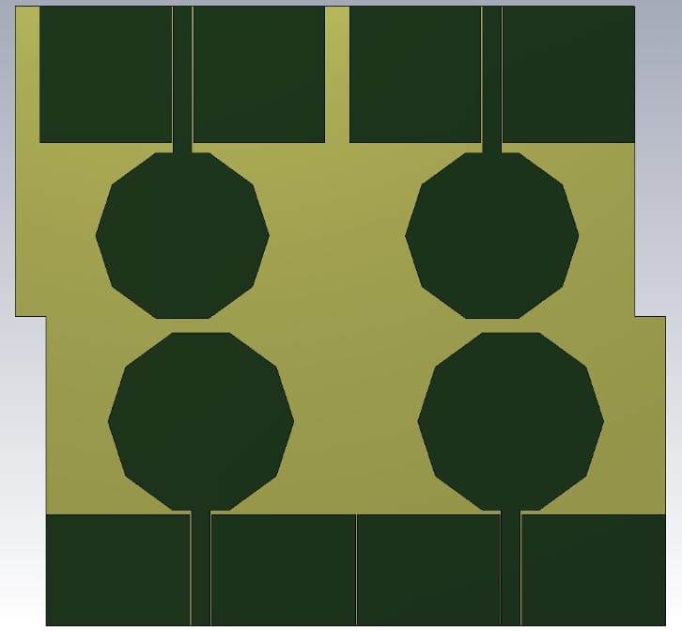
Fig. 2. Four-port MIMO antenna with decagonal patches and CPW-style feeds (top view, CST).
C. FSS Unit Cell and Array
The FSS is shown in Fig. 3. Its unit cell has two concentric metal rings, and each ring is cut by a narrow split. The cell is repeated in 6 columns and 5 rows, which gives 30 cells on one board. A split ring acts as a resonant circuit: the metal ring gives an inductance L, and the split and the gap between the two rings give a capacitance C. The cell resonates at
$f_{0} = \frac{1}{2π\sqrt{LC}}$ (1)
Near this frequency the surface reflects most of the wave that falls on it [10]. Two rings of different size resonate at two different frequencies, which widens the range over which the surface reflects. Unit-cell simulation (reflection and transmission of the FSS, and its reflection phase): TO BE ADDED.
 | 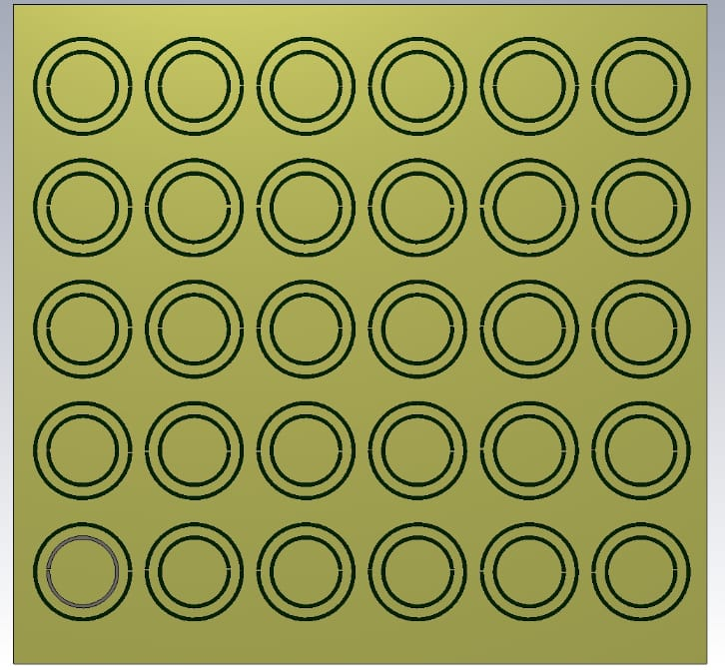
(a) | (b)
Fig. 3. FSS: (a) unit cell with two concentric split rings, (b) 6 × 5 array (top view, CST).
D. MIMO Antenna over the FSS
In the combined structure of Fig. 4, the MIMO antenna is placed over the FSS, so the FSS lies behind all four elements. The two boards have nearly the same footprint. The wave that the antenna radiates backwards travels across the gap h, is reflected by the FSS and returns to the antenna. It adds to the forward wave when [15]
$φ_{FSS} − 2k_{0}h = 2nπ, n = 0, 1, 2, …$ (2)
where φ_{FSS} is the reflection phase of the FSS and k₀ is the free-space wavenumber. The gap h therefore decides at which frequencies the FSS helps. Gap h between the antenna and the FSS: TO BE ADDED.
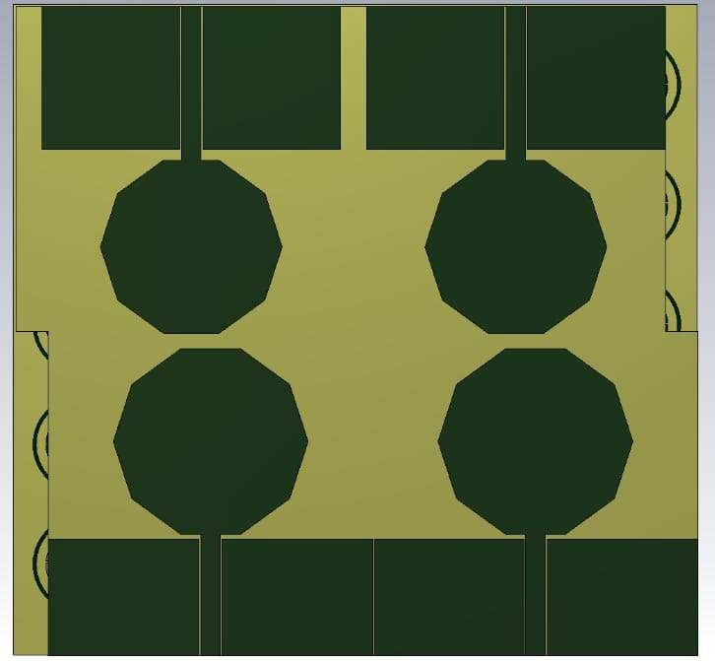
Fig. 4. Four-port MIMO antenna placed over the FSS (top view, CST).
TABLE I
Dimensions of the Structures
Part | Parameter | Value (mm)
Single antenna | FR-4 board, length × width × thickness | 50 × 50 × 1.6
Single antenna | Decagon circumradius R | 15
Single antenna | CPW strip width; slot width | 3.0; 0.5
Single antenna | Ground length (along the feed) | 18
Single antenna | Gap between ground and patch | 0.73
MIMO antenna | Board length × width | TO BE ADDED
MIMO antenna | Spacing between elements | TO BE ADDED
FSS cell | Outer and inner ring radii | TO BE ADDED
FSS cell | Ring width and split width | TO BE ADDED
FSS | Cell period; board size; substrate | TO BE ADDED
Stack | Gap h, antenna to FSS | TO BE ADDED

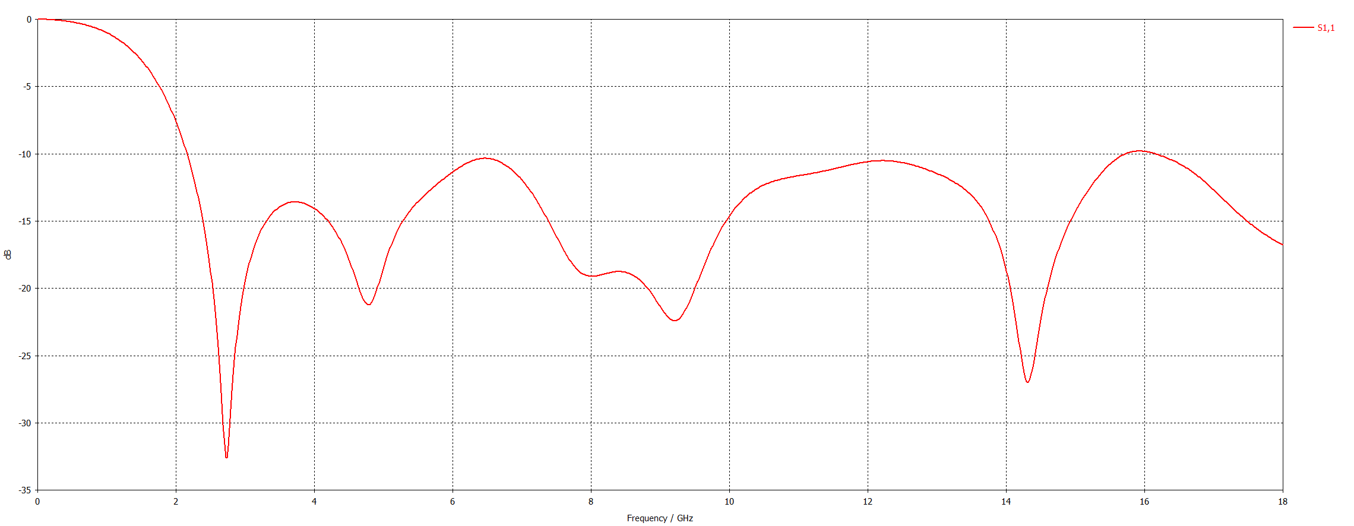
(a)
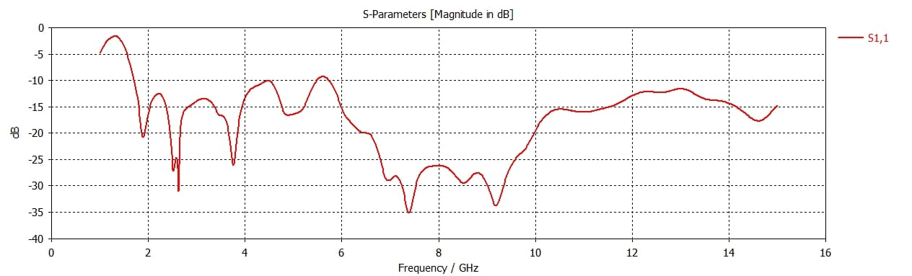
(b)
Fig. 5. Simulated reflection coefficient S₁₁ (CST): (a) single antenna, 0–18 GHz; (b) port 1 of the four-port MIMO antenna, 1–15 GHz. TO BE CONFIRMED: (b) is taken here as the MIMO antenna with the FSS.

III. Results and Discussion
A. Single Antenna
The single antenna was simulated in CST Studio Suite from 0 to 18 GHz. Its reflection coefficient is shown in Fig. 5(a). An antenna is taken as matched where S₁₁ is below −10 dB, which means that less than 10 % of the input power is reflected. S₁₁ is below −10 dB from 2.16 to 15.73 GHz, a single band 13.6 GHz wide with a fractional bandwidth of 152 %. The resonances are at 2.73 GHz (−32.6 dB), 4.78 GHz (−21.2 dB), 9.23 GHz (−22.6 dB) and 14.32 GHz (−27.1 dB). The match is weakest near 6.5 GHz (−10.3 dB) and near 12.2 GHz (−10.5 dB), where the curve only just stays below the limit. The simulated gain of the single antenna is about 2.9–4.9 dBi over 3.1–10.6 GHz.
B. MIMO Antenna with FSS
The MIMO antenna was simulated from 1 to 15 GHz. Fig. 5(b) shows the reflection coefficient at port 1. S₁₁ falls below −10 dB at 1.71 GHz and stays below it up to 5.48 GHz, a fractional bandwidth of 105 %. From 5.48 to 5.73 GHz the curve rises slightly above the limit and reaches −9.2 dB at 5.62 GHz. From 5.73 GHz it is below −10 dB again up to 15 GHz, the end of the simulated range, so the upper edge of this second band is not known yet.
The deepest resonance is −34.9 dB at 7.38 GHz. Other resonances deeper than −20 dB are at 1.90, 2.62, 3.76, 8.50 and 9.18 GHz. The match is best from 6.5 to 10.0 GHz, where S₁₁ stays below −20 dB. Above 10.5 GHz it stays between −11.5 and −17.6 dB.
C. Comparison of the Two Results
Fig. 6 draws the two curves on the same axes, and Table II lists the main values side by side. Three changes can be seen. First, the lower band edge moves down from 2.16 to 1.71 GHz, so the MIMO antenna with the FSS is matched 0.46 GHz lower than the single antenna. Second, the best match moves to the middle of the band. The single antenna has its deepest resonance at 2.73 GHz and is only just matched near 6.5 GHz, while the MIMO antenna with the FSS stays below −20 dB from 6.5 to 10.0 GHz. Third, the single antenna is matched over one continuous band, but the MIMO antenna with the FSS rises to −9.2 dB at 5.62 GHz, which splits its matched range into two bands. A small change of the feed gap or of the gap h could be tried to remove this rise.
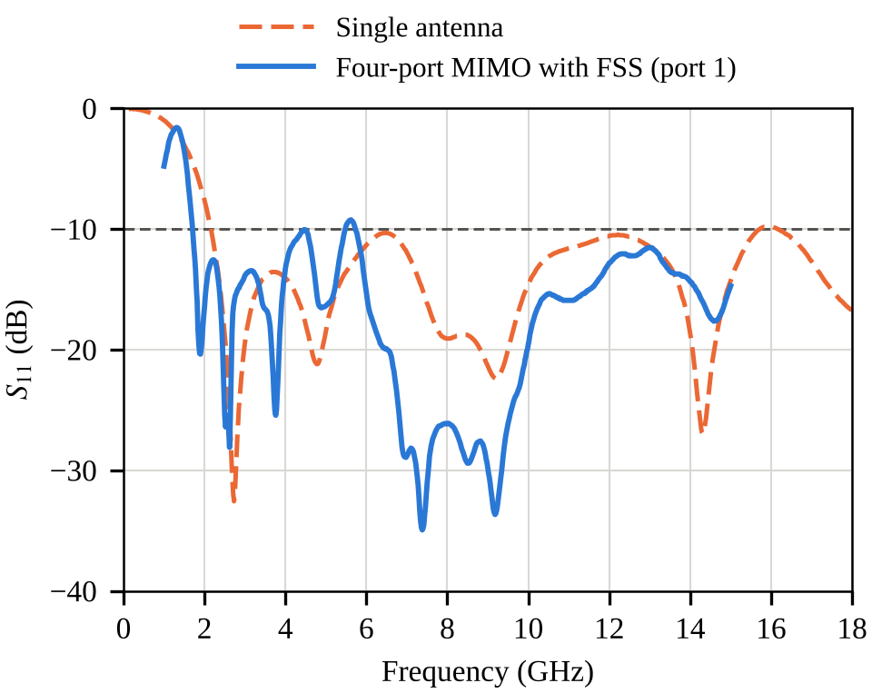
Fig. 6. S₁₁ of the single antenna and of the four-port MIMO antenna with the FSS on the same axes (curves read from the CST plots of Fig. 5).
This comparison has a limit. The two models differ in two ways at once, because the MIMO antenna has three more elements and also the FSS behind it. The changes above cannot yet be assigned to one cause. S₁₁ of the MIMO antenna without the FSS: TO BE ADDED.
TABLE II
Single Antenna and MIMO Antenna with FSS (Simulated)
Quantity | Single antenna | MIMO with FSS (port 1)
Simulated range (GHz) | 0–18 | 1–15
S₁₁ < −10 dB (GHz) | 2.16–15.73 | 1.71–5.48 and 5.73–15†
Fractional bandwidth (%) | 152 | 105 and ≥ 89
Lower band edge (GHz) | 2.16 | 1.71
Deepest resonance | −32.6 dB at 2.73 GHz | −34.9 dB at 7.38 GHz
Weakest point in the matched range | −10.3 dB near 6.5 GHz | −9.2 dB at 5.62 GHz
Gain, 3.1–10.6 GHz (dBi) | 2.9–4.9 | TO BE ADDED
Isolation; ECC | not applicable | TO BE ADDED
†End of the simulated range; the upper edge of this band is not known.
D. Results to Be Added
The reflection coefficient at one port is the only result of the MIMO antenna available at present. The following results are needed to complete the paper and are not reported here: (i) S₁₁ of the MIMO antenna without the FSS; (ii) reflection coefficients at ports 2, 3 and 4; (iii) isolation between the ports (S₂₁, S₃₁, S₄₁); (iv) gain and efficiency against frequency, with and without the FSS; (v) ECC and diversity gain; (vi) radiation patterns: TO BE ADDED. Figs. 7–9 keep the place of the main missing plots. The ECC can be computed from the S-parameters with the method of [4] or from the far-field patterns [3].
TO BE ADDED
CST S-parameters of all four ports, 1–15 GHz
Fig. 7. Reflection coefficients of ports 2–4 and isolation between the ports. TO BE ADDED.
TO BE ADDED
CST realized gain (and efficiency) against frequency
Fig. 8. Gain of the MIMO antenna with and without the FSS. TO BE ADDED.
TO BE ADDED
CST far-field cuts in the two principal planes
Fig. 9. Radiation patterns at selected frequencies. TO BE ADDED.
E. Comparison with Reported Work
Table III places this work next to reported antennas that use an FSS or a metasurface reflector. The values of the other works are those given by their authors. The matched range of the present antenna is wide, but its gain and isolation must be added before a fair comparison can be made.
TABLE III
Comparison with Reported Antennas
Ref. | Ports | Reflector | Band (GHz) | Peak gain (dBi) | Isolation (dB)
[14] | 1 | 19 × 19 FSS | 2.2–11.9 | 11.3 | —
[15] | 1 | 5 × 5 FSS | 3–18 | 10.5 | —
[18] | 4 | 10 × 10 split-ring metasurface | 3.08–7.75 | 8.3 | > 15.5
This work | 4 | 6 × 5 split-ring FSS | 1.71–5.48, 5.73–15 | TO BE ADDED | TO BE ADDED
—: single-port antenna. Values of the other works are peak gains reported by their authors.
IV. Conclusion
A single CPW-fed decagonal antenna on FR-4 was designed first. In simulation it is matched (S₁₁ below −10 dB) from 2.16 to 15.73 GHz. Four such elements were then arranged as a four-port MIMO antenna and placed over an FSS made of a 6 × 5 array of concentric split rings. The simulated reflection coefficient at port 1 of this structure is below −10 dB from 1.71 to 5.48 GHz and from 5.73 to 15 GHz, with a short rise to −9.2 dB at 5.62 GHz between them. Compared with the single antenna, the lower band edge moves down by 0.46 GHz and the best match moves to 6.5–10.0 GHz, but the matched range is no longer one continuous band. The remaining dimensions, the result of the MIMO antenna without the FSS, the isolation between the ports, the gain, the ECC and the radiation patterns are still to be added, and they will show how much the FSS improves the antenna. Fabrication and measurement of the antenna are planned as the next step.
References
[1] G. J. Foschini and M. J. Gans, “On limits of wireless communications in a fading environment when using multiple antennas,” Wireless Pers. Commun., vol. 6, no. 3, pp. 311–335, Mar. 1998, doi: 10.1023/A:1008889222784.
[2] E. Telatar, “Capacity of multi-antenna Gaussian channels,” Eur. Trans. Telecommun., vol. 10, no. 6, pp. 585–595, Nov./Dec. 1999, doi: 10.1002/ett.4460100604.
[3] M. S. Sharawi, “Printed multi-band MIMO antenna systems and their performance metrics,” IEEE Antennas Propag. Mag., vol. 55, no. 5, pp. 218–232, Oct. 2013, doi: 10.1109/MAP.2013.6735522.
[4] S. Blanch, J. Romeu, and I. Corbella, “Exact representation of antenna system diversity performance from input parameter description,” Electron. Lett., vol. 39, no. 9, pp. 705–707, May 2003, doi: 10.1049/el:20030495.
[5] Federal Communications Commission, “Revision of Part 15 of the Commission’s rules regarding ultra-wideband transmission systems,” First Report and Order, ET Docket 98-153, FCC 02-48, Apr. 2002.
[6] N. P. Agrawall, G. Kumar, and K. P. Ray, “Wide-band planar monopole antennas,” IEEE Trans. Antennas Propag., vol. 46, no. 2, pp. 294–295, Feb. 1998, doi: 10.1109/8.660976.
[7] K. P. Ray, “Design aspects of printed monopole antennas for ultra-wide band applications,” Int. J. Antennas Propag., vol. 2008, Art. no. 713858, 2008, doi: 10.1155/2008/713858.
[8] R. N. Simons, Coplanar Waveguide Circuits, Components, and Systems. New York, NY, USA: Wiley, 2001, doi: 10.1002/0471224758.
[9] C. A. Balanis, Antenna Theory: Analysis and Design, 4th ed. Hoboken, NJ, USA: Wiley, 2016.
[10] B. A. Munk, Frequency Selective Surfaces: Theory and Design. New York, NY, USA: Wiley, 2000.
[11] A. J. A. Al-Gburi, I. M. Ibrahim, Z. Zakaria, M. K. Abdulhameed, and T. Saeidi, “Enhancing gain for UWB antennas using FSS: A systematic review,” Mathematics, vol. 9, no. 24, Art. no. 3301, 2021, doi: 10.3390/math9243301.
[12] Y. Ranga, L. Matekovits, K. P. Esselle, and A. R. Weily, “Multioctave frequency selective surface reflector for ultrawideband antennas,” IEEE Antennas Wireless Propag. Lett., vol. 10, pp. 219–222, 2011, doi: 10.1109/LAWP.2011.2130509.
[13] S. Kundu, A. Chatterjee, S. K. Jana, and S. K. Parui, “Gain enhancement of a printed leaf shaped UWB antenna using dual FSS layers and experimental study for ground coupling GPR applications,” Microw. Opt. Technol. Lett., vol. 60, no. 6, pp. 1417–1423, Jun. 2018, doi: 10.1002/mop.31171.
[14] A. J. A. Al-Gburi, I. B. M. Ibrahim, Z. Zakaria, B. H. Ahmad, N. A. B. Shairi, and M. Y. Zeain, “High gain of UWB planar antenna utilising FSS reflector for UWB applications,” Comput. Mater. Contin., vol. 70, no. 1, pp. 1425–1436, 2022, doi: 10.32604/cmc.2022.019741.
[15] M. Hussain, M. A. Sufian, M. S. Alzaidi, S. I. Naqvi, N. Hussain, D. H. Elkamchouchi, M. F. A. Sree, and S. Y. A. Fatah, “Bandwidth and gain enhancement of a CPW antenna using frequency selective surface for UWB applications,” Micromachines, vol. 14, no. 3, Art. no. 591, Feb. 2023, doi: 10.3390/mi14030591.
[16] B. Hammache, I. Messaoudene, M. Belazzoug, S. Titouni, A. Messai, and T. A. Denidni, “Gain enhancement of compact CPW-fed ultra-wideband antenna using an FSS reflector,” Microw. Opt. Technol. Lett., vol. 66, no. 10, Art. no. e34344, 2024, doi: 10.1002/mop.34344.
[17] G. Sen, A. Banerjee, M. Kumar, and S. Das, “An ultra-wideband monopole antenna with a gain enhanced performance using a novel split-ring meta-surface reflector,” Microw. Opt. Technol. Lett., vol. 59, no. 6, pp. 1296–1300, 2017, doi: 10.1002/mop.30527.
[18] M. M. Hasan, M. T. Islam, M. Samsuzzaman, M. H. Baharuddin, M. S. Soliman, A. Alzamil, I. I. M. Abu Sulayman, and M. S. Islam, “Gain and isolation enhancement of a wideband MIMO antenna using metasurface for 5G sub-6 GHz communication systems,” Sci. Rep., vol. 12, Art. no. 9433, 2022, doi: 10.1038/s41598-022-13522-5.
[19] Y. Usha Devi, B. T. P. Madhav, S. Das, T. Islam, and M. El Ghzaoui, “Dual-notched UWB orthogonal MIMO antenna with improved gain characteristics using frequency selective surfaces for wireless communication applications,” J. Circuits, Syst. Comput., 2024, doi: 10.1142/S0218126624502323.

