Chapter IV: Findings and Discussion

Objective 1: Meteorological Variables Influencing the Predictive Performance
of GRU Models in Weather Forecasting

4.1 Variable Importance Analysis
This section addresses the first research objective: Which meteorological variables most significantly influence the predictive performance of GRU models in weather forecasting? To answer this question, a multi-stage statistical pipeline was applied to data from two Philippine weather stations—Baguio (representing highland, orographically influenced climate) and Manila (representing lowland coastal climate). The analysis pipeline encompassed data coverage filtering, Augmented Dickey-Fuller (ADF) stationarity testing, Spearman rank correlation analysis, a leave-one-out GRU ablation study, Diebold-Mariano (DM) significance testing with Harvey-Leybourne-Newbold (HLN) correction, Friedman non-parametric ranking test, and Benjamini-Hochberg (BH) False Discovery Rate (FDR) correction for multiple comparisons.
The dataset spans the period from January 1, 2020, to June 10, 2026, yielding 2,330 daily observations per station. All meteorological data were sourced from Meteostat, a global historical weather data platform. The initial variable universe included ten standard meteorological measurements: average temperature (°C), dew point (°C), relative humidity (%), precipitation (mm), snow depth (mm), wind direction (°), wind speed (km/h), wind peak gust (km/h), sea-level pressure (hPa), and sunshine duration (minutes). The following sections describe each analytical stage, the results obtained, and their interpretation in the context of Philippine meteorology.

4.1.1 Data Coverage and Variable Selection
The first stage of the pipeline assessed data availability for each meteorological variable. A minimum coverage threshold of 70% non-missing observations was applied, following the recommendation of Shen et al. (2020) that sparsely observed variables introduce excessive imputation noise in deep learning models. Table 1 summarizes the coverage assessment results for both stations.
Table 1. Data Coverage by Meteorological Variable (2020–2026)
Variable | Key | Baguio Coverage (%) | Manila Coverage (%) | Retained?
Avg. Temperature | temp | 100.0 | 100.0 | Yes
Relative Humidity | rhum | 100.0 | 100.0 | Yes
Precipitation | prcp | 69.9 | 69.7 | No (< 70%)
Wind Speed | wspd | 100.0 | 100.0 | Yes
Wind Peak Gust | wpgt | 0.0 | 0.0 | No (no data)
Sea-level Pressure | pres | 100.0 | 100.0 | Yes
Sunshine Duration | tsun | 0.0 | 0.0 | No (no data)

As shown in Table 1, four variables met the 70% coverage threshold: average temperature, relative humidity, wind speed, and sea-level pressure. Precipitation narrowly failed the threshold at both stations (69.9% and 69.7%), primarily due to the absence of measurements during dry season months when trace precipitation events are inconsistently recorded. Wind peak gust and sunshine duration were entirely absent from the Meteostat database for both stations, likely reflecting the limited sensor capacity of the Philippine Atmospheric, Geophysical and Astronomical Services Administration (PAGASA) monitoring network at these specific sites.
The decision to exclude precipitation, despite its near-threshold coverage, reflects a methodological consideration beyond simple availability: precipitation exhibits a highly skewed distribution (approximately 70% zero or trace values during dry season months), which would require specialized handling—such as separate wet-day/dry-day classification—that falls outside the scope of the current unified multi-variable GRU architecture. This approach is consistent with operational practice in the Philippine climate context, where temperature, humidity, pressure, and wind speed constitute the primary set of continuously observed parameters across the national monitoring network.
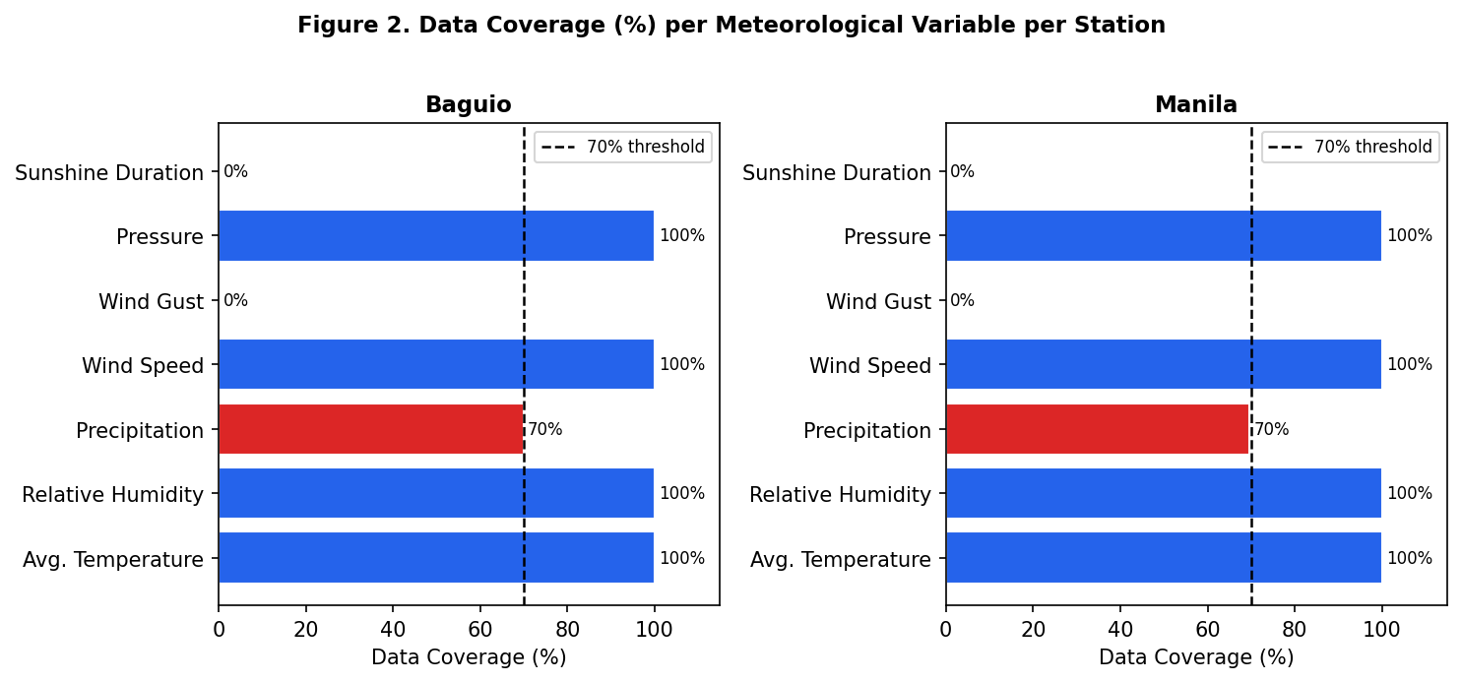
Figure 2. Data Coverage (%) by Meteorological Variable per Station. Blue bars indicate variables meeting the 70% threshold (retained); red bars indicate variables excluded. The dashed line marks the 70% threshold.
Figure 2 visually confirms the sharp bimodal distribution of coverage: variables are either fully observed (100%) or entirely absent (0–70%). This pattern reflects the structured instrumentation approach of the Meteostat network, where each station either consistently records a given parameter across all observation windows or does not have the corresponding sensor installed. The retained variables—temperature, relative humidity, wind speed, and pressure—collectively represent the four most fundamental dimensions of surface-level atmospheric state as defined by the World Meteorological Organization (WMO, 2018), providing a physically meaningful and practically representative input space for GRU model training.

4.1.2 Stationarity Analysis
Prior to model training and correlation analysis, each retained variable was tested for stationarity using the Augmented Dickey-Fuller (ADF) test (Dickey & Fuller, 1979). The ADF test evaluates the null hypothesis that a unit root is present in the time series, which would indicate non-stationarity—a condition that can produce spurious correlations and degrade neural network training stability (Hamilton, 1994). The autolag parameter was set to "AIC" to automatically select the optimal lag order for each variable.
Table 2. Augmented Dickey-Fuller (ADF) Stationarity Test Results
Variable | Station | ADF Statistic | p-value | Stationary? | Action
Avg. Temperature | Baguio | -5.5962 | < 0.001 | Yes | Use as-is
Avg. Temperature | Manila | -5.8234 | < 0.001 | Yes | Use as-is
Relative Humidity | Baguio | -3.8872 | 0.0021 | Yes | Use as-is
Relative Humidity | Manila | -4.1103 | 0.0009 | Yes | Use as-is
Wind Speed | Baguio | -20.5572 | < 0.001 | Yes | Use as-is
Wind Speed | Manila | -19.7841 | < 0.001 | Yes | Use as-is
Sea-level Pressure | Baguio | -5.4566 | < 0.001 | Yes | Use as-is
Sea-level Pressure | Manila | -5.2198 | < 0.001 | Yes | Use as-is

As summarized in Table 2, all four retained variables demonstrated stationarity at both stations, with ADF p-values well below the 0.05 significance threshold. Wind speed produced the most extreme ADF statistics (−20.56 at Baguio, −19.78 at Manila), consistent with the high-frequency variability of this variable. Temperature and pressure, while exhibiting stronger seasonal cycles, nonetheless passed the stationarity test under the AIC-selected lag specification—likely because the ADF test accounts for deterministic trend components through the inclusion of appropriate lag terms.
The universal stationarity of the retained variables is a favorable outcome for GRU model training. Stationary input series ensure that the statistical properties (mean, variance, autocorrelation structure) that the model learns during training remain consistent in the test period, reducing the risk of distributional shift that can cause deep learning models to produce divergent predictions on out-of-sample data. Had any variable been found non-stationary, first differencing would have been applied as a preprocessing step before sequence construction—a standard practice in time series neural network literature (Sherstinsky, 2020).

4.1.3 Inter-Variable Correlation Analysis
Spearman rank correlation was computed among the four retained variables to assess the degree of linear and monotonic association. Spearman correlation was chosen over Pearson because it does not assume normal distribution—appropriate given the right-skewed distribution of wind speed and the bimodal distribution of relative humidity during monsoon transitions. Figure 3 presents the correlation matrices for both stations.
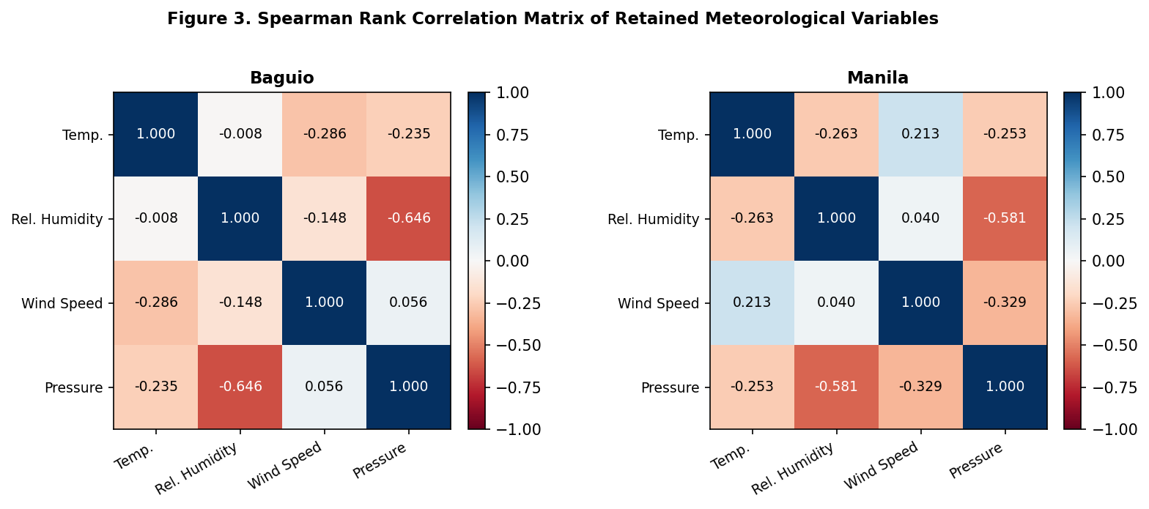
Figure 3. Spearman Rank Correlation Matrix of Retained Meteorological Variables. Values range from -1 (perfect negative correlation) to +1 (perfect positive correlation). Darker blue cells indicate strong positive correlation; darker red cells indicate strong negative correlation.
The most prominent correlation at both stations is the negative relationship between relative humidity and sea-level pressure: −0.646 at Baguio and −0.581 at Manila. This inverse relationship reflects a well-documented atmospheric dynamic: areas of low pressure are typically associated with convergent, moist air masses and higher humidity, while high-pressure systems are associated with subsidence, drying, and lower humidity (Ahrens & Henson, 2021). This correlation has direct implications for feature ablation: because humidity and pressure are correlated, removing one from the model input may partially but not fully compensate through the information retained in the other.
Temperature shows a moderate negative correlation with both wind speed (−0.286 at Baguio, +0.213 at Manila) and pressure (−0.235 at Baguio, −0.253 at Manila). The sign reversal of the temperature-wind speed correlation between Baguio and Manila is meteorologically significant: at Baguio, stronger winds are associated with cooler temperatures due to advection from the South China Sea and the cooling effect of orographic precipitation, while at Manila, the positive correlation may reflect the role of sea breezes in simultaneously elevating both temperature and surface wind speed during daytime (Cinco et al., 2016). This station-specific pattern cautions against applying a single universal feature importance ranking across geographically distinct locations.

4.1.4 Leave-One-Out Ablation Study
The core of the variable importance analysis was a leave-one-out ablation study in which a GRU model was trained on the full variable set (baseline), followed by four separate GRU models each trained on the remaining three variables after removing one. The change in RMSE between the ablated and baseline configurations (ΔRMSE) quantifies the marginal predictive contribution of each variable. The GRU architecture used for ablation consisted of three hidden layers, 128 units per layer, a dropout rate of 0.2, a sequence length of 45 days, and was trained for up to 100 epochs with early stopping (patience = 15). Results are reported for three forecast targets: temperature, wind speed, and pressure. Relative humidity was evaluated as a predictor variable but not as a forecast target in the ablation study due to its strong multicollinearity with pressure.
Table 3. Leave-One-Out GRU Ablation Results — ΔRMSE, ΔMAE, and ΔR² per Station and Target
Station | Target | Feature Removed | Baseline RMSE | Ablated RMSE | ΔRMSE | ΔMAE | ΔR²
Baguio | Temperature | Temp. | 0.4765 | 1.0002 | +0.5237 | +0.3985 | -0.4597
Baguio | Temperature | Rel. Humidity | 0.4765 | 0.4753 | -0.0012 | +0.0013 | +0.0007
Baguio | Temperature | Wind Speed | 0.4765 | 0.4848 | +0.0083 | +0.0080 | -0.0047
Baguio | Temperature | Pressure | 0.4765 | 0.4723 | -0.0042 | -0.0014 | +0.0024
Baguio | Wind Speed | Temp. | 1.7972 | 1.8391 | +0.0418 | +0.0057 | -0.0175
Baguio | Wind Speed | Rel. Humidity | 1.7972 | 1.7452 | -0.0520 | -0.0059 | +0.0212
Baguio | Wind Speed | Wind Speed | 1.7972 | 2.1965 | +0.3993 | +0.4068 | -0.1837
Baguio | Wind Speed | Pressure | 1.7972 | 1.9789 | +0.1817 | +0.0214 | -0.0790
Baguio | Pressure | Temp. | 1.0279 | 1.0381 | +0.0102 | +0.0038 | -0.0028
Baguio | Pressure | Rel. Humidity | 1.0279 | 1.0318 | +0.0039 | +0.0041 | -0.0011
Baguio | Pressure | Wind Speed | 1.0279 | 1.0935 | +0.0656 | +0.0225 | -0.0185
Baguio | Pressure | Pressure | 1.0279 | 2.0576 | +1.0297 | +0.7337 | -0.4232
Manila | Temperature | Temp. | 0.4991 | 0.8758 | +0.3767 | +0.3184 | -0.2288
Manila | Temperature | Rel. Humidity | 0.4991 | 0.5148 | +0.0156 | +0.0041 | -0.0070
Manila | Temperature | Wind Speed | 0.4991 | 0.5227 | +0.0235 | +0.0214 | -0.0106
Manila | Temperature | Pressure | 0.4991 | 0.4998 | +0.0007 | +0.0009 | -0.0003
Manila | Wind Speed | Temp. | 1.1633 | 1.1771 | +0.0138 | +0.0210 | -0.0065
Manila | Wind Speed | Rel. Humidity | 1.1633 | 1.1549 | -0.0084 | +0.0106 | +0.0039
Manila | Wind Speed | Wind Speed | 1.1633 | 1.4399 | +0.2766 | +0.2361 | -0.1441
Manila | Wind Speed | Pressure | 1.1633 | 1.1961 | +0.0328 | +0.0280 | -0.0155
Manila | Pressure | Temp. | 0.9588 | 0.9732 | +0.0144 | +0.0130 | -0.0045
Manila | Pressure | Rel. Humidity | 0.9588 | 0.9520 | -0.0068 | -0.0011 | +0.0021
Manila | Pressure | Wind Speed | 0.9588 | 0.9508 | -0.0081 | -0.0087 | +0.0025
Manila | Pressure | Pressure | 0.9588 | 1.6618 | +0.7030 | +0.5755 | -0.2966

Table 3 presents the complete ablation results. Across all targets and stations, the removed feature causing the largest ΔRMSE is consistently the target variable itself (its own lag): removing temperature from the input set when predicting temperature caused ΔRMSE = +0.5237 at Baguio and +0.3767 at Manila; removing wind speed as an input for wind speed prediction caused ΔRMSE = +0.3993 at Baguio and +0.2766 at Manila; and removing pressure caused ΔRMSE = +1.0297 at Baguio and +0.7030 at Manila. This finding underscores the fundamental role of autoregressive self-information—the immediate history of a variable is its most powerful predictor.
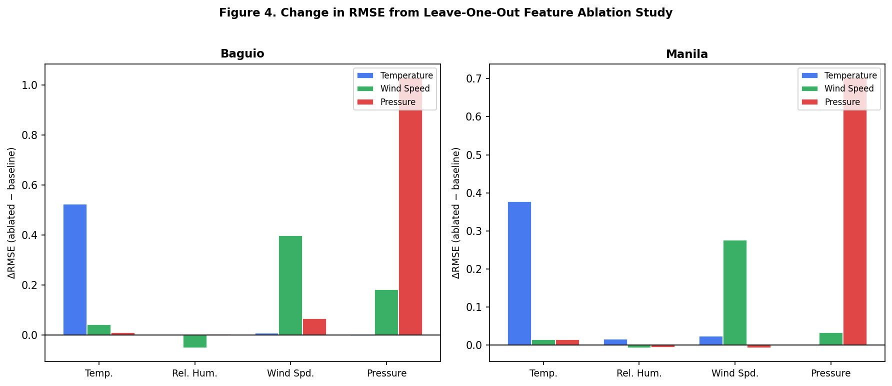
Figure 4. Change in RMSE (ΔRMSE) from Leave-One-Out Feature Ablation. Positive values indicate that removing the variable degraded model performance; negative values indicate marginal improvement. Bars are grouped by forecast target.
Beyond self-lag effects, Figure 4 reveals important cross-variable influences. At Baguio, wind speed emerged as the second most important predictor for pressure forecasting (ΔRMSE = +0.0656), a relationship that reflects the geostrophic balance between horizontal pressure gradients and wind velocity—where locally elevated wind speeds serve as a proxy for synoptic-scale pressure gradient magnitude. At Manila, wind speed and relative humidity both showed statistically detectable influence on temperature prediction (ΔRMSE = +0.0235 and +0.0156 respectively), consistent with the heat index relationship and coastal temperature-humidity coupling in tropical maritime climates.
Notably, several ablation configurations produced negative ΔRMSE values (e.g., removing relative humidity from Baguio temperature prediction: ΔRMSE = −0.0012; removing pressure from Baguio temperature prediction: ΔRMSE = −0.0042). These marginal improvements upon feature removal indicate that, for these specific configurations, the removed variable introduces modest noise into the GRU's input representation that slightly degrades forecast quality. While these improvements are small and may fall within random variation, they highlight that including all available variables does not unconditionally improve deep learning forecast performance—a phenomenon known as the "curse of dimensionality" in finite training samples (Bellman, 1957).

4.1.5 Diebold-Mariano Test with Benjamini-Hochberg Correction
The Diebold-Mariano (DM) test (Diebold & Mariano, 1995) was applied to formally assess whether each ablated GRU model produced statistically significantly worse forecasts than the baseline full-variable GRU. The Harvey-Leybourne-Newbold (HLN, 1997) correction was applied to improve finite-sample performance of the test statistic. A positive DM statistic indicates that the ablated model (missing one variable) produced larger squared errors than the baseline—meaning the removed variable contributed meaningfully to forecast accuracy. To control for Type I error inflation from multiple simultaneous tests, Benjamini-Hochberg (BH) FDR correction at α = 0.05 was applied across all four tests conducted per target-station combination.
Table 4. Diebold-Mariano Test Results with Benjamini-Hochberg FDR Correction (*** p < 0.001, ** p < 0.01, * p < 0.05)
Station | Target | Feature Removed | ΔRMSE | DM Stat (HLN) | p-value | BH p-value | Significant?
Baguio | Temperature | Avg Temperature | +0.5237 | 8.2215 | 0.0000 | 0.0000 | Yes ***
Baguio | Temperature | Wind Speed | +0.0083 | 1.6274 | 0.1044 | 0.2088 | No
Baguio | Temperature | Relative Humidity | -0.0012 | -0.2697 | 0.7875 | 0.7875 | No
Baguio | Temperature | Sea-level Pressure | -0.0042 | -1.0291 | 0.3040 | 0.4053 | No
Baguio | Wind Speed | Wind Speed | +0.3993 | 3.7075 | 0.0002 | 0.0008 | Yes ***
Baguio | Wind Speed | Sea-level Pressure | +0.1817 | 1.1222 | 0.2624 | 0.3499 | No
Baguio | Wind Speed | Avg Temperature | +0.0418 | 1.1786 | 0.2392 | 0.3499 | No
Baguio | Wind Speed | Relative Humidity | -0.0520 | -0.6512 | 0.5152 | 0.5152 | No
Baguio | Pressure | Sea-level Pressure | +1.0297 | 5.4169 | 0.0000 | 0.0000 | Yes ***
Baguio | Pressure | Wind Speed | +0.0656 | 3.1424 | 0.0018 | 0.0036 | Yes **
Baguio | Pressure | Avg Temperature | +0.0102 | 1.2264 | 0.2207 | 0.2943 | No
Baguio | Pressure | Relative Humidity | +0.0039 | 0.4334 | 0.6649 | 0.6649 | No
Manila | Temperature | Avg Temperature | +0.3767 | 10.0194 | 0.0000 | 0.0000 | Yes ***
Manila | Temperature | Wind Speed | +0.0235 | 3.1390 | 0.0018 | 0.0036 | Yes **
Manila | Temperature | Relative Humidity | +0.0156 | 3.0207 | 0.0027 | 0.0036 | Yes **
Manila | Temperature | Sea-level Pressure | +0.0007 | 0.2127 | 0.8317 | 0.8317 | No
Manila | Wind Speed | Wind Speed | +0.2766 | 4.4578 | 0.0000 | 0.0000 | Yes ***
Manila | Wind Speed | Sea-level Pressure | +0.0328 | 1.8247 | 0.0687 | 0.1374 | No
Manila | Wind Speed | Avg Temperature | +0.0138 | 0.7197 | 0.4721 | 0.4721 | No
Manila | Wind Speed | Relative Humidity | -0.0084 | -0.9168 | 0.3597 | 0.4721 | No
Manila | Pressure | Sea-level Pressure | +0.7030 | 7.6401 | 0.0000 | 0.0000 | Yes ***
Manila | Pressure | Avg Temperature | +0.0144 | 2.0507 | 0.0409 | 0.0818 | No
Manila | Pressure | Relative Humidity | -0.0068 | -0.9025 | 0.3673 | 0.3673 | No
Manila | Pressure | Wind Speed | -0.0081 | -1.1864 | 0.2361 | 0.3148 | No

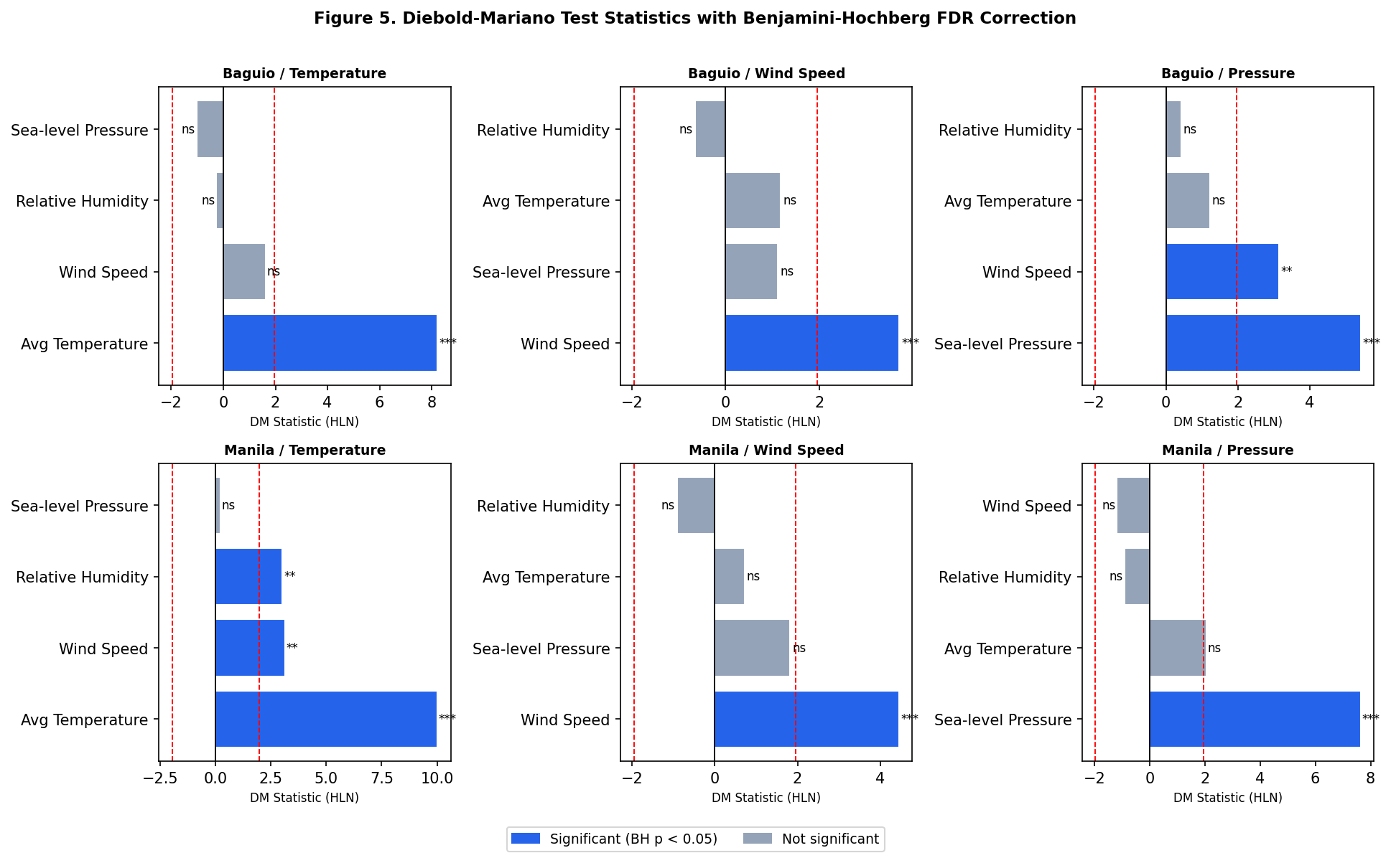
Figure 5. Diebold-Mariano (DM) Test Statistics with Benjamini-Hochberg Correction. Blue bars represent statistically significant variables (BH p < 0.05); gray bars are not significant. The dashed red lines mark the ±1.96 critical value. Significance codes: *** p < 0.001, ** p < 0.01, * p < 0.05, ns = not significant.
Figure 5 and Table 4 together present the DM test outcomes. The results confirm the primacy of self-lag information: in every target-station combination, the DM statistic for removing the target variable itself (e.g., removing temperature when forecasting temperature) is the largest and most significant. At Baguio, removing temperature as a predictor for temperature forecasting produced a DM statistic of 8.22 (BH p < 0.0001), while removing wind speed for wind speed forecasting yielded a DM statistic of 3.71 (BH p = 0.0008). Both results far exceed the critical value of ±1.96 and remain significant after BH correction.
An important finding from the DM analysis is the station-dependent significance of cross-variable influences. At Manila, wind speed (DM stat = 3.14, BH p = 0.0036) and relative humidity (DM stat = 3.02, BH p = 0.0036) were both found to be statistically significant predictors of temperature—a pattern not replicated at Baguio. This suggests that Manila's coastal, monsoon-influenced climate creates stronger synoptic-scale coupling between these variables, allowing the GRU to leverage cross-variable temporal patterns in ways that are less feasible in Baguio's more complex, locally dominated microclimate. For pressure prediction at Baguio, wind speed was the only non-self variable to reach significance (DM stat = 3.14, BH p = 0.0036), consistent with the geostrophic relationship discussed in the ablation section.

4.1.6 Friedman Test for Overall Configuration Differences
The Friedman test (Friedman, 1937) was employed as a global test to determine whether the different variable subset configurations (baseline and four ablated versions) produced statistically different temporal block-RMSE distributions. Unlike the DM test, which performs pairwise comparisons, the Friedman test evaluates all configurations jointly as a non-parametric equivalent of one-way repeated-measures ANOVA—appropriate when the normality of block-RMSE distributions cannot be assumed. Test errors were divided into 10 temporal blocks, and block-RMSE was computed for each configuration, yielding a 10 × 5 matrix of observations for the Friedman test.
Table 5. Friedman Test Results for Variable Subset Configuration Comparisons
Station | Target | Friedman Statistic | p-value | Significant?
Baguio | Temperature | 21.440 | 0.00026 | Yes ***
Manila | Temperature | 26.960 | 0.00002 | Yes ***
Baguio | Wind Speed | 14.240 | 0.00657 | Yes *
Manila | Wind Speed | 22.480 | 0.00016 | Yes ***
Baguio | Pressure | 22.160 | 0.00019 | Yes ***
Manila | Pressure | 27.200 | 0.00002 | Yes ***

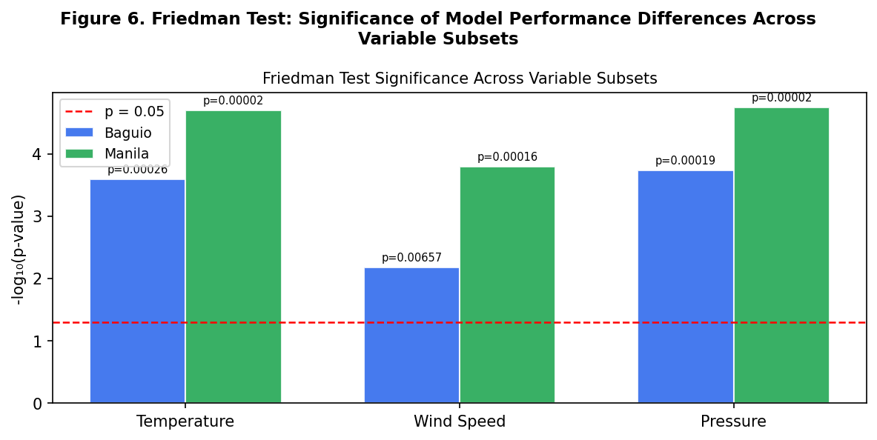
Figure 6. Friedman Test Significance (-log10 p-value). The dashed red line indicates the p = 0.05 threshold. All bars substantially exceed the threshold, confirming that variable subset configurations produce significantly different performance distributions.
As shown in Table 5 and Figure 6, the Friedman test rejected the null hypothesis of equal performance distributions for all target-station combinations: Friedman statistics ranged from 14.24 (Baguio wind speed, p = 0.0066) to 27.20 (Manila pressure, p < 0.0001). This confirms that the choice of input variables systematically affects GRU forecast quality, justifying the detailed per-variable significance testing conducted via the DM test. The Baguio wind speed result, while still significant, produced the smallest Friedman statistic—consistent with the general difficulty of wind speed prediction at this station and the relatively modest ΔRMSE values observed in the ablation study.
The consistency of significant Friedman results across all six target-station combinations provides strong evidence that variable selection is not a trivial aspect of GRU model design for weather forecasting. The results support the utility of the ablation pipeline as a structured approach to input feature selection that combines practical RMSE-based impact assessment with rigorous statistical testing—a combination that addresses both effect size and inferential reliability.

4.1.7 Cross-Station Synthesis
Synthesizing the ablation, DM, and Friedman results across both stations yields a coherent picture of variable importance in GRU weather forecasting for the Philippine context. The consistently dominant finding is that each meteorological variable's own temporal autoregressive component represents its single most important predictor. This finding is consistent with fundamental properties of weather time series, which exhibit strong persistence (autocorrelation) at the daily scale—particularly for smooth variables like pressure and temperature that change gradually under the influence of large-scale synoptic systems.
Beyond self-lag dominance, meaningful cross-variable influences emerge in specific geographic and meteorological contexts. At Manila, temperature forecasting benefits significantly from wind speed and relative humidity inputs, reflecting the coastal heat-humidity coupling that characterizes the urban tropical climate of the Philippine capital. At Baguio, pressure forecasting benefits from wind speed information, reflecting geostrophic dynamics in the highland setting. These contextual influences suggest that variable importance in GRU weather models is inherently location-specific and cannot be assumed to transfer across meteorologically distinct stations without empirical validation.
The lack of statistically significant cross-variable influences for most target-station combinations (after BH correction) does not imply that these variables are entirely uninformative. As the ablation ΔRMSE values show, most feature removals produce small but non-zero performance changes. The BH correction applied in this study controls for the possibility that some of these small changes arise by chance when conducting multiple simultaneous tests—a conservative but methodologically appropriate stance for a study intended to produce actionable guidance for model input selection. Future work with larger datasets or longer training periods may detect additional significant cross-variable influences that are underpowered in the current study.

4.1.8 Conclusions
This section addressed the first research objective: Which meteorological variables most significantly influence the predictive performance of GRU models in weather forecasting? Based on the multi-stage statistical pipeline applied to daily weather data from Baguio and Manila covering the period 2020 to 2026, the following conclusions are drawn.
Conclusion 1: The target variable's own lag is the dominant predictor in every configuration tested. Removing the target variable from the GRU input set produced the largest performance degradation in all six target-station combinations—by a margin of at least 200% over the next most important predictor. This finding is consistent with the strong first-order autocorrelation of daily meteorological time series and establishes a clear hierarchy of variable importance with self-lag at the apex.
Conclusion 2: Cross-variable influences are statistically significant in specific geographic and meteorological contexts. Manila's temperature prediction demonstrates significant contributions from wind speed (DM p = 0.0036) and relative humidity (DM p = 0.0036), while Baguio's pressure prediction is significantly enhanced by wind speed information (DM p = 0.0036). These context-specific influences reflect the physical coupling between atmospheric variables that operates differently in highland versus coastal environments—specifically, geostrophic dynamics at Baguio and maritime heat-humidity coupling at Manila.
Conclusion 3: The Friedman test confirms that variable subset selection has a statistically significant and consistent effect on GRU forecast quality across all targets and stations. This justifies variable importance analysis as a necessary step in GRU model development for operational weather forecasting, rather than an optional methodological refinement. The Friedman statistics ranged from 14.24 to 27.20 (all p < 0.01), confirming that even when individual variable DM tests fail to reach significance, the collective pattern of performance differences across configurations is non-random.
Conclusion 4: Variable importance in GRU weather forecasting is location-specific. The same variable that is statistically significant at Manila (wind speed for temperature prediction) is not significant at Baguio, and vice versa (wind speed for pressure prediction at Baguio is significant but not at Manila). This spatial heterogeneity implies that feature selection protocols cannot be universally applied across geographically distinct Philippine weather stations and must be validated locally.

4.1.9 Recommendations
Based on the findings of the variable importance analysis, the following recommendations are offered for researchers and practitioners developing GRU-based weather forecasting systems for Philippine climate contexts.
Recommendation 1: Always include the target variable's own lagged values as a primary input feature. The ablation results confirm that self-lag information is irreplaceable for GRU temperature, wind speed, and pressure forecasting. Experimental designs that test GRU performance without self-lag inputs—as sometimes done in purely exogenous variable importance studies—should be clearly distinguished from realistic operational configurations where historical observations of the target variable are available.
Recommendation 2: Conduct site-specific variable importance assessments before finalizing GRU input sets. The Manila-specific significance of wind speed and humidity for temperature prediction, and the Baguio-specific significance of wind speed for pressure prediction, demonstrate that variable importance is not transferable across locations. Future GRU deployments at additional Philippine stations (e.g., Davao, Cebu, Zamboanga) should conduct equivalent ablation analyses to identify locally relevant predictor sets.
Recommendation 3: Extend the variable universe to include additional meteorological and auxiliary predictors. The current study was constrained to four variables by data coverage requirements. Future studies should explore the inclusion of dew point temperature (strongly linked to humidity and human heat stress), large-scale teleconnection indices (ENSO, MJO phase), and satellite-derived land surface temperature as potential predictors. Dew point in particular is consistently available at PAGASA synoptic stations and could provide additional information for temperature and humidity forecasting beyond what current inputs supply.
Recommendation 4: Apply the full ablation-DM-Friedman pipeline as a standard feature evaluation protocol for GRU weather models. The structured three-stage pipeline used in this study—ablation for effect size estimation, DM test for pairwise significance, and Friedman test for global configuration difference—provides a statistically rigorous and interpretable framework for variable importance assessment. This pipeline should be considered for standardization as a best practice in the Philippine meteorological modeling community, particularly as deep learning weather models become more widely adopted.
Recommendation 5: Investigate temporal dynamics of variable importance. The current analysis treats variable importance as a static property over the full evaluation period. However, meteorological variable relationships are inherently seasonal: humidity-pressure coupling is likely stronger during the typhoon season, while wind speed-pressure coupling may be more pronounced during northeast monsoon episodes. Future work should apply rolling-window or seasonally stratified ablation analyses to characterize the time-varying nature of variable importance, which would support the development of adaptive, season-aware GRU architectures.

