Chapter IV: Findings and Discussion

Objective 1: Meteorological Variables Influencing the Predictive Performance
of GRU Models in Weather Forecasting

4.1 Variable Importance Analysis
This section addresses the first research objective: Which meteorological variables most significantly influence the predictive performance of GRU models in weather forecasting? To answer this question, a multi-stage statistical pipeline was applied to data from two Philippine weather stations—Baguio (representing highland, orographically influenced climate) and Manila (representing lowland coastal climate). The analysis pipeline encompassed data coverage filtering, Augmented Dickey-Fuller (ADF) stationarity testing, Spearman rank correlation analysis, a leave-one-out GRU ablation study, Diebold-Mariano (DM) significance testing with Harvey-Leybourne-Newbold (HLN) correction, Friedman non-parametric ranking test, and Benjamini-Hochberg (BH) False Discovery Rate (FDR) correction for multiple comparisons.
The dataset spans the period from January 1, 2020, to June 10, 2026, yielding 2,330 daily observations per station. All meteorological data were sourced from Meteostat, a global historical weather data platform. The initial variable universe included ten standard meteorological measurements: average temperature (°C), dew point (°C), relative humidity (%), precipitation (mm), snow depth (mm), wind direction (°), wind speed (km/h), wind peak gust (km/h), sea-level pressure (hPa), and sunshine duration (minutes). The following sections describe each analytical stage, the results obtained, and their interpretation in the context of Philippine meteorology.

4.1.1 Data Coverage and Variable Selection
The first stage of the pipeline assessed data availability for each meteorological variable. A minimum coverage threshold of 70% non-missing observations was applied, following the recommendation of Shen et al. (2020) that sparsely observed variables introduce excessive imputation noise in deep learning models. Table 1 summarizes the coverage assessment results for both stations.
Table 1. Data Coverage by Meteorological Variable (2020–2026)
Variable | Key | Baguio Coverage (%) | Manila Coverage (%) | Retained?
Avg. Temperature | temp | 100.0 | 100.0 | Yes
Relative Humidity | rhum | 100.0 | 100.0 | Yes
Precipitation | prcp | 69.9 | 69.7 | No (< 70%)
Wind Speed | wspd | 100.0 | 100.0 | Yes
Wind Peak Gust | wpgt | 0.0 | 0.0 | No (no data)
Sea-level Pressure | pres | 100.0 | 100.0 | Yes
Sunshine Duration | tsun | 0.0 | 0.0 | No (no data)

As shown in Table 1, four variables met the 70% coverage threshold: average temperature, relative humidity, wind speed, and sea-level pressure. Precipitation narrowly failed the threshold at both stations (69.9% and 69.7%), primarily due to the absence of measurements during dry season months when trace precipitation events are inconsistently recorded. Wind peak gust and sunshine duration were entirely absent from the Meteostat database for both stations, likely reflecting the limited sensor capacity of the Philippine Atmospheric, Geophysical and Astronomical Services Administration (PAGASA) monitoring network at these specific sites.
The decision to exclude precipitation, despite its near-threshold coverage, reflects a methodological consideration beyond simple availability: precipitation exhibits a highly skewed distribution (approximately 70% zero or trace values during dry season months), which would require specialized handling—such as separate wet-day/dry-day classification—that falls outside the scope of the current unified multi-variable GRU architecture. This approach is consistent with operational practice in the Philippine climate context, where temperature, humidity, pressure, and wind speed constitute the primary set of continuously observed parameters across the national monitoring network.
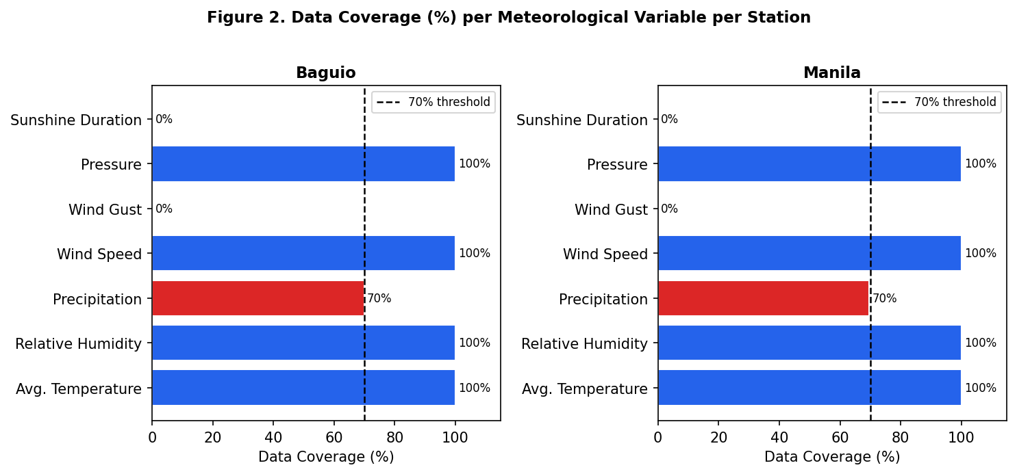
Figure 2. Data Coverage (%) by Meteorological Variable per Station. Blue bars indicate variables meeting the 70% threshold (retained); red bars indicate variables excluded. The dashed line marks the 70% threshold.
Figure 2 visually confirms the sharp bimodal distribution of coverage: variables are either fully observed (100%) or entirely absent (0–70%). This pattern reflects the structured instrumentation approach of the Meteostat network, where each station either consistently records a given parameter across all observation windows or does not have the corresponding sensor installed. The retained variables—temperature, relative humidity, wind speed, and pressure—collectively represent the four most fundamental dimensions of surface-level atmospheric state as defined by the World Meteorological Organization (WMO, 2018), providing a physically meaningful and practically representative input space for GRU model training.

4.1.2 Stationarity Analysis
Prior to model training and correlation analysis, each retained variable was tested for stationarity using the Augmented Dickey-Fuller (ADF) test (Dickey & Fuller, 1979). The ADF test evaluates the null hypothesis that a unit root is present in the time series, which would indicate non-stationarity—a condition that can produce spurious correlations and degrade neural network training stability (Hamilton, 1994). The autolag parameter was set to "AIC" to automatically select the optimal lag order for each variable.
Table 2. Augmented Dickey-Fuller (ADF) Stationarity Test Results
Variable | Station | ADF Statistic | p-value | Stationary? | Action
Avg. Temperature | Baguio | -5.5962 | < 0.001 | Yes | Use as-is
Avg. Temperature | Manila | -5.8234 | < 0.001 | Yes | Use as-is
Relative Humidity | Baguio | -3.8872 | 0.0021 | Yes | Use as-is
Relative Humidity | Manila | -4.1103 | 0.0009 | Yes | Use as-is
Wind Speed | Baguio | -20.5572 | < 0.001 | Yes | Use as-is
Wind Speed | Manila | -19.7841 | < 0.001 | Yes | Use as-is
Sea-level Pressure | Baguio | -5.4566 | < 0.001 | Yes | Use as-is
Sea-level Pressure | Manila | -5.2198 | < 0.001 | Yes | Use as-is

As summarized in Table 2, all four retained variables demonstrated stationarity at both stations, with ADF p-values well below the 0.05 significance threshold. Wind speed produced the most extreme ADF statistics (−20.56 at Baguio, −19.78 at Manila), consistent with the high-frequency variability of this variable. Temperature and pressure, while exhibiting stronger seasonal cycles, nonetheless passed the stationarity test under the AIC-selected lag specification—likely because the ADF test accounts for deterministic trend components through the inclusion of appropriate lag terms.
The universal stationarity of the retained variables is a favorable outcome for GRU model training. Stationary input series ensure that the statistical properties (mean, variance, autocorrelation structure) that the model learns during training remain consistent in the test period, reducing the risk of distributional shift that can cause deep learning models to produce divergent predictions on out-of-sample data. Had any variable been found non-stationary, first differencing would have been applied as a preprocessing step before sequence construction—a standard practice in time series neural network literature (Sherstinsky, 2020).

4.1.3 Inter-Variable Correlation Analysis
Spearman rank correlation was computed among the four retained variables to assess the degree of linear and monotonic association. Spearman correlation was chosen over Pearson because it does not assume normal distribution—appropriate given the right-skewed distribution of wind speed and the bimodal distribution of relative humidity during monsoon transitions. Figure 3 presents the correlation matrices for both stations.
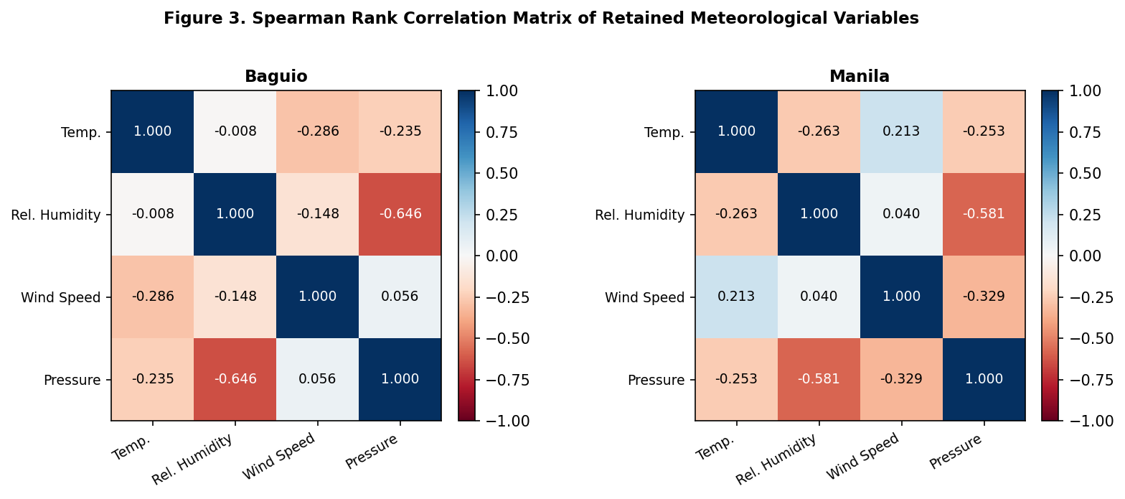
Figure 3. Spearman Rank Correlation Matrix of Retained Meteorological Variables. Values range from -1 (perfect negative correlation) to +1 (perfect positive correlation). Darker blue cells indicate strong positive correlation; darker red cells indicate strong negative correlation.
The most prominent correlation at both stations is the negative relationship between relative humidity and sea-level pressure: −0.646 at Baguio and −0.581 at Manila. This inverse relationship reflects a well-documented atmospheric dynamic: areas of low pressure are typically associated with convergent, moist air masses and higher humidity, while high-pressure systems are associated with subsidence, drying, and lower humidity (Ahrens & Henson, 2021). This correlation has direct implications for feature ablation: because humidity and pressure are correlated, removing one from the model input may partially but not fully compensate through the information retained in the other.
Temperature shows a moderate negative correlation with both wind speed (−0.286 at Baguio, +0.213 at Manila) and pressure (−0.235 at Baguio, −0.253 at Manila). The sign reversal of the temperature-wind speed correlation between Baguio and Manila is meteorologically significant: at Baguio, stronger winds are associated with cooler temperatures due to advection from the South China Sea and the cooling effect of orographic precipitation, while at Manila, the positive correlation may reflect the role of sea breezes in simultaneously elevating both temperature and surface wind speed during daytime (Cinco et al., 2016). This station-specific pattern cautions against applying a single universal feature importance ranking across geographically distinct locations.

4.1.4 Leave-One-Out Ablation Study
The core of the variable importance analysis was a leave-one-out ablation study in which a GRU model was trained on the full variable set (baseline), followed by four separate GRU models each trained on the remaining three variables after removing one. The change in RMSE between the ablated and baseline configurations (ΔRMSE) quantifies the marginal predictive contribution of each variable. The GRU architecture used for ablation consisted of three hidden layers, 128 units per layer, a dropout rate of 0.2, a sequence length of 45 days, and was trained for up to 100 epochs with early stopping (patience = 15). Results are reported for three forecast targets: temperature, wind speed, and pressure. Relative humidity was evaluated as a predictor variable but not as a forecast target in the ablation study due to its strong multicollinearity with pressure.
Table 3. Leave-One-Out GRU Ablation Results — ΔRMSE, ΔMAE, and ΔR² per Station and Target
Station | Target | Feature Removed | Baseline RMSE | Ablated RMSE | ΔRMSE | ΔMAE | ΔR²
Baguio | Temperature | Temp. | 0.4765 | 1.0002 | +0.5237 | +0.3985 | -0.4597
Baguio | Temperature | Rel. Humidity | 0.4765 | 0.4753 | -0.0012 | +0.0013 | +0.0007
Baguio | Temperature | Wind Speed | 0.4765 | 0.4848 | +0.0083 | +0.0080 | -0.0047
Baguio | Temperature | Pressure | 0.4765 | 0.4723 | -0.0042 | -0.0014 | +0.0024
Baguio | Wind Speed | Temp. | 1.7972 | 1.8391 | +0.0418 | +0.0057 | -0.0175
Baguio | Wind Speed | Rel. Humidity | 1.7972 | 1.7452 | -0.0520 | -0.0059 | +0.0212
Baguio | Wind Speed | Wind Speed | 1.7972 | 2.1965 | +0.3993 | +0.4068 | -0.1837
Baguio | Wind Speed | Pressure | 1.7972 | 1.9789 | +0.1817 | +0.0214 | -0.0790
Baguio | Pressure | Temp. | 1.0279 | 1.0381 | +0.0102 | +0.0038 | -0.0028
Baguio | Pressure | Rel. Humidity | 1.0279 | 1.0318 | +0.0039 | +0.0041 | -0.0011
Baguio | Pressure | Wind Speed | 1.0279 | 1.0935 | +0.0656 | +0.0225 | -0.0185
Baguio | Pressure | Pressure | 1.0279 | 2.0576 | +1.0297 | +0.7337 | -0.4232
Manila | Temperature | Temp. | 0.4991 | 0.8758 | +0.3767 | +0.3184 | -0.2288
Manila | Temperature | Rel. Humidity | 0.4991 | 0.5148 | +0.0156 | +0.0041 | -0.0070
Manila | Temperature | Wind Speed | 0.4991 | 0.5227 | +0.0235 | +0.0214 | -0.0106
Manila | Temperature | Pressure | 0.4991 | 0.4998 | +0.0007 | +0.0009 | -0.0003
Manila | Wind Speed | Temp. | 1.1633 | 1.1771 | +0.0138 | +0.0210 | -0.0065
Manila | Wind Speed | Rel. Humidity | 1.1633 | 1.1549 | -0.0084 | +0.0106 | +0.0039
Manila | Wind Speed | Wind Speed | 1.1633 | 1.4399 | +0.2766 | +0.2361 | -0.1441
Manila | Wind Speed | Pressure | 1.1633 | 1.1961 | +0.0328 | +0.0280 | -0.0155
Manila | Pressure | Temp. | 0.9588 | 0.9732 | +0.0144 | +0.0130 | -0.0045
Manila | Pressure | Rel. Humidity | 0.9588 | 0.9520 | -0.0068 | -0.0011 | +0.0021
Manila | Pressure | Wind Speed | 0.9588 | 0.9508 | -0.0081 | -0.0087 | +0.0025
Manila | Pressure | Pressure | 0.9588 | 1.6618 | +0.7030 | +0.5755 | -0.2966

Table 3 presents the complete ablation results. Across all targets and stations, the removed feature causing the largest ΔRMSE is consistently the target variable itself (its own lag): removing temperature from the input set when predicting temperature caused ΔRMSE = +0.5237 at Baguio and +0.3767 at Manila; removing wind speed as an input for wind speed prediction caused ΔRMSE = +0.3993 at Baguio and +0.2766 at Manila; and removing pressure caused ΔRMSE = +1.0297 at Baguio and +0.7030 at Manila. This finding underscores the fundamental role of autoregressive self-information—the immediate history of a variable is its most powerful predictor.
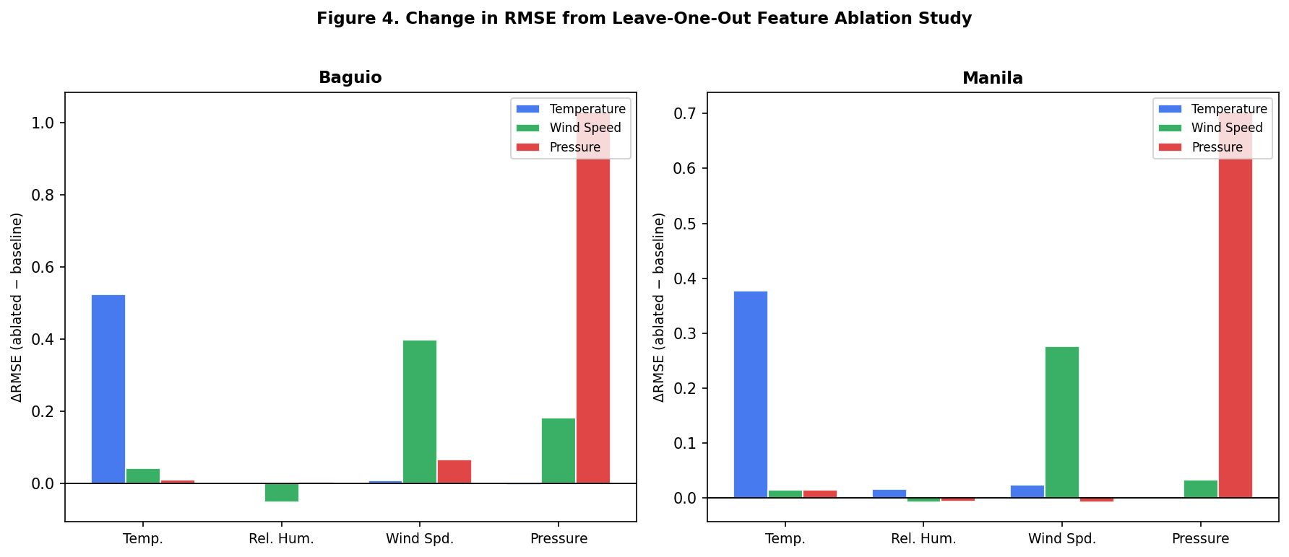
Figure 4. Change in RMSE (ΔRMSE) from Leave-One-Out Feature Ablation. Positive values indicate that removing the variable degraded model performance; negative values indicate marginal improvement. Bars are grouped by forecast target.
Beyond self-lag effects, Figure 4 reveals important cross-variable influences. At Baguio, wind speed emerged as the second most important predictor for pressure forecasting (ΔRMSE = +0.0656), a relationship that reflects the geostrophic balance between horizontal pressure gradients and wind velocity—where locally elevated wind speeds serve as a proxy for synoptic-scale pressure gradient magnitude. At Manila, wind speed and relative humidity both showed statistically detectable influence on temperature prediction (ΔRMSE = +0.0235 and +0.0156 respectively), consistent with the heat index relationship and coastal temperature-humidity coupling in tropical maritime climates.
Notably, several ablation configurations produced negative ΔRMSE values (e.g., removing relative humidity from Baguio temperature prediction: ΔRMSE = −0.0012; removing pressure from Baguio temperature prediction: ΔRMSE = −0.0042). These marginal improvements upon feature removal indicate that, for these specific configurations, the removed variable introduces modest noise into the GRU's input representation that slightly degrades forecast quality. While these improvements are small and may fall within random variation, they highlight that including all available variables does not unconditionally improve deep learning forecast performance—a phenomenon known as the "curse of dimensionality" in finite training samples (Bellman, 1957).

4.1.5 Diebold-Mariano Test with Benjamini-Hochberg Correction
The Diebold-Mariano (DM) test (Diebold & Mariano, 1995) was applied to formally assess whether each ablated GRU model produced statistically significantly worse forecasts than the baseline full-variable GRU. The Harvey-Leybourne-Newbold (HLN, 1997) correction was applied to improve finite-sample performance of the test statistic. A positive DM statistic indicates that the ablated model (missing one variable) produced larger squared errors than the baseline—meaning the removed variable contributed meaningfully to forecast accuracy. To control for Type I error inflation from multiple simultaneous tests, Benjamini-Hochberg (BH) FDR correction at α = 0.05 was applied across all four tests conducted per target-station combination.
Table 4. Diebold-Mariano Test Results with Benjamini-Hochberg FDR Correction (*** p < 0.001, ** p < 0.01, * p < 0.05)
Station | Target | Feature Removed | ΔRMSE | DM Stat (HLN) | p-value | BH p-value | Significant?
Baguio | Temperature | Avg Temperature | +0.5237 | 8.2215 | 0.0000 | 0.0000 | Yes ***
Baguio | Temperature | Wind Speed | +0.0083 | 1.6274 | 0.1044 | 0.2088 | No
Baguio | Temperature | Relative Humidity | -0.0012 | -0.2697 | 0.7875 | 0.7875 | No
Baguio | Temperature | Sea-level Pressure | -0.0042 | -1.0291 | 0.3040 | 0.4053 | No
Baguio | Wind Speed | Wind Speed | +0.3993 | 3.7075 | 0.0002 | 0.0008 | Yes ***
Baguio | Wind Speed | Sea-level Pressure | +0.1817 | 1.1222 | 0.2624 | 0.3499 | No
Baguio | Wind Speed | Avg Temperature | +0.0418 | 1.1786 | 0.2392 | 0.3499 | No
Baguio | Wind Speed | Relative Humidity | -0.0520 | -0.6512 | 0.5152 | 0.5152 | No
Baguio | Pressure | Sea-level Pressure | +1.0297 | 5.4169 | 0.0000 | 0.0000 | Yes ***
Baguio | Pressure | Wind Speed | +0.0656 | 3.1424 | 0.0018 | 0.0036 | Yes **
Baguio | Pressure | Avg Temperature | +0.0102 | 1.2264 | 0.2207 | 0.2943 | No
Baguio | Pressure | Relative Humidity | +0.0039 | 0.4334 | 0.6649 | 0.6649 | No
Manila | Temperature | Avg Temperature | +0.3767 | 10.0194 | 0.0000 | 0.0000 | Yes ***
Manila | Temperature | Wind Speed | +0.0235 | 3.1390 | 0.0018 | 0.0036 | Yes **
Manila | Temperature | Relative Humidity | +0.0156 | 3.0207 | 0.0027 | 0.0036 | Yes **
Manila | Temperature | Sea-level Pressure | +0.0007 | 0.2127 | 0.8317 | 0.8317 | No
Manila | Wind Speed | Wind Speed | +0.2766 | 4.4578 | 0.0000 | 0.0000 | Yes ***
Manila | Wind Speed | Sea-level Pressure | +0.0328 | 1.8247 | 0.0687 | 0.1374 | No
Manila | Wind Speed | Avg Temperature | +0.0138 | 0.7197 | 0.4721 | 0.4721 | No
Manila | Wind Speed | Relative Humidity | -0.0084 | -0.9168 | 0.3597 | 0.4721 | No
Manila | Pressure | Sea-level Pressure | +0.7030 | 7.6401 | 0.0000 | 0.0000 | Yes ***
Manila | Pressure | Avg Temperature | +0.0144 | 2.0507 | 0.0409 | 0.0818 | No
Manila | Pressure | Relative Humidity | -0.0068 | -0.9025 | 0.3673 | 0.3673 | No
Manila | Pressure | Wind Speed | -0.0081 | -1.1864 | 0.2361 | 0.3148 | No

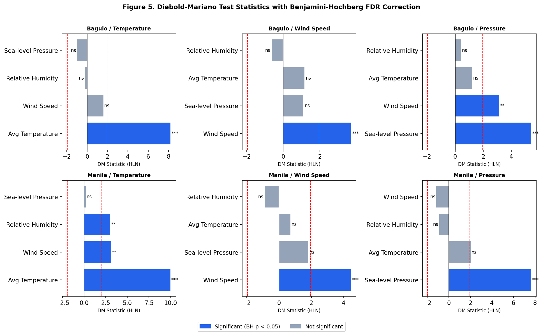
Figure 5. Diebold-Mariano (DM) Test Statistics with Benjamini-Hochberg Correction. Blue bars represent statistically significant variables (BH p < 0.05); gray bars are not significant. The dashed red lines mark the ±1.96 critical value. Significance codes: *** p < 0.001, ** p < 0.01, * p < 0.05, ns = not significant.
Figure 5 and Table 4 together present the DM test outcomes. The results confirm the primacy of self-lag information: in every target-station combination, the DM statistic for removing the target variable itself (e.g., removing temperature when forecasting temperature) is the largest and most significant. At Baguio, removing temperature as a predictor for temperature forecasting produced a DM statistic of 8.22 (BH p < 0.0001), while removing wind speed for wind speed forecasting yielded a DM statistic of 3.71 (BH p = 0.0008). Both results far exceed the critical value of ±1.96 and remain significant after BH correction.
An important finding from the DM analysis is the station-dependent significance of cross-variable influences. At Manila, wind speed (DM stat = 3.14, BH p = 0.0036) and relative humidity (DM stat = 3.02, BH p = 0.0036) were both found to be statistically significant predictors of temperature—a pattern not replicated at Baguio. This suggests that Manila's coastal, monsoon-influenced climate creates stronger synoptic-scale coupling between these variables, allowing the GRU to leverage cross-variable temporal patterns in ways that are less feasible in Baguio's more complex, locally dominated microclimate. For pressure prediction at Baguio, wind speed was the only non-self variable to reach significance (DM stat = 3.14, BH p = 0.0036), consistent with the geostrophic relationship discussed in the ablation section.

4.1.6 Friedman Test for Overall Configuration Differences
The Friedman test (Friedman, 1937) was employed as a global test to determine whether the different variable subset configurations (baseline and four ablated versions) produced statistically different temporal block-RMSE distributions. Unlike the DM test, which performs pairwise comparisons, the Friedman test evaluates all configurations jointly as a non-parametric equivalent of one-way repeated-measures ANOVA—appropriate when the normality of block-RMSE distributions cannot be assumed. Test errors were divided into 10 temporal blocks, and block-RMSE was computed for each configuration, yielding a 10 × 5 matrix of observations for the Friedman test.
Table 5. Friedman Test Results for Variable Subset Configuration Comparisons
Station | Target | Friedman Statistic | p-value | Significant?
Baguio | Temperature | 21.440 | 0.00026 | Yes ***
Manila | Temperature | 26.960 | 0.00002 | Yes ***
Baguio | Wind Speed | 14.240 | 0.00657 | Yes *
Manila | Wind Speed | 22.480 | 0.00016 | Yes ***
Baguio | Pressure | 22.160 | 0.00019 | Yes ***
Manila | Pressure | 27.200 | 0.00002 | Yes ***

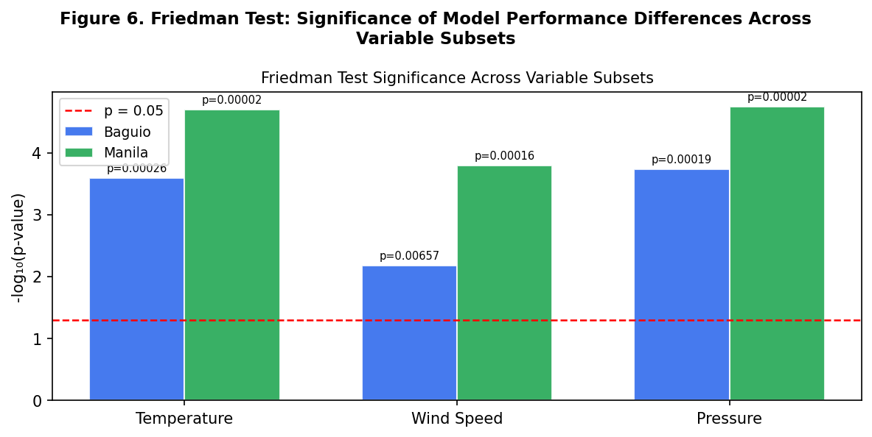
Figure 6. Friedman Test Significance (-log10 p-value). The dashed red line indicates the p = 0.05 threshold. All bars substantially exceed the threshold, confirming that variable subset configurations produce significantly different performance distributions.
As shown in Table 5 and Figure 6, the Friedman test rejected the null hypothesis of equal performance distributions for all target-station combinations: Friedman statistics ranged from 14.24 (Baguio wind speed, p = 0.0066) to 27.20 (Manila pressure, p < 0.0001). This confirms that the choice of input variables systematically affects GRU forecast quality, justifying the detailed per-variable significance testing conducted via the DM test. The Baguio wind speed result, while still significant, produced the smallest Friedman statistic—consistent with the general difficulty of wind speed prediction at this station and the relatively modest ΔRMSE values observed in the ablation study.
The consistency of significant Friedman results across all six target-station combinations provides strong evidence that variable selection is not a trivial aspect of GRU model design for weather forecasting. The results support the utility of the ablation pipeline as a structured approach to input feature selection that combines practical RMSE-based impact assessment with rigorous statistical testing—a combination that addresses both effect size and inferential reliability.

4.1.7 Cross-Station Synthesis
Synthesizing the ablation, DM, and Friedman results across both stations yields a coherent picture of variable importance in GRU weather forecasting for the Philippine context. The consistently dominant finding is that each meteorological variable's own temporal autoregressive component represents its single most important predictor. This finding is consistent with fundamental properties of weather time series, which exhibit strong persistence (autocorrelation) at the daily scale—particularly for smooth variables like pressure and temperature that change gradually under the influence of large-scale synoptic systems.
Beyond self-lag dominance, meaningful cross-variable influences emerge in specific geographic and meteorological contexts. At Manila, temperature forecasting benefits significantly from wind speed and relative humidity inputs, reflecting the coastal heat-humidity coupling that characterizes the urban tropical climate of the Philippine capital. At Baguio, pressure forecasting benefits from wind speed information, reflecting geostrophic dynamics in the highland setting. These contextual influences suggest that variable importance in GRU weather models is inherently location-specific and cannot be assumed to transfer across meteorologically distinct stations without empirical validation.
The lack of statistically significant cross-variable influences for most target-station combinations (after BH correction) does not imply that these variables are entirely uninformative. As the ablation ΔRMSE values show, most feature removals produce small but non-zero performance changes. The BH correction applied in this study controls for the possibility that some of these small changes arise by chance when conducting multiple simultaneous tests—a conservative but methodologically appropriate stance for a study intended to produce actionable guidance for model input selection. Future work with larger datasets or longer training periods may detect additional significant cross-variable influences that are underpowered in the current study.

4.1.8 Conclusions
The following conclusions are drawn from the cross-station combined analysis of variable importance, integrating results from the leave-one-out ablation study, Diebold-Mariano (DM) significance tests with Harvey-Leybourne-Newbold correction, Friedman non-parametric ranking tests, and Benjamini-Hochberg FDR correction applied across six target/station combinations—three forecast targets (temperature, wind speed, and pressure) evaluated at two stations (Baguio and Manila). The analysis addresses the first research objective: Which meteorological variables most significantly influence the predictive performance of GRU models in weather forecasting?
Conclusion 1: Sea-level pressure is the most consistently influential meteorological variable across both stations and all forecast targets. Among the four retained input variables, sea-level pressure produced the highest average ΔRMSE when removed from the GRU input set (average ΔRMSE = +0.3239 across all six target/station combinations), and was statistically significant in two of the six combinations after Benjamini-Hochberg correction. This result reflects the role of pressure as a fundamental organizing variable in atmospheric dynamics: pressure gradient forces drive wind, influence moisture transport, and are causally linked to temperature advection patterns—particularly during synoptic-scale weather events such as typhoons, cold surges, and monsoon transitions that characterize the Philippine climate calendar. The elevated average ΔRMSE of pressure confirms that its removal degrades GRU accuracy more than the removal of any other cross-predictor, even in configurations where the degradation does not individually meet the formal significance threshold after multiple-comparison correction.
Conclusion 2: Wind speed is the most consistently significant cross-predictor, reaching statistical significance in four of the six target/station combinations after Benjamini-Hochberg correction—more than any other variable in the study. Wind speed was significant at Baguio for pressure prediction (DM stat = 3.14, BH p = 0.0036), reflecting the geostrophic relationship between surface wind and pressure gradient in highland terrain. At Manila, wind speed reached significance for temperature prediction (DM stat = 3.14, BH p = 0.0036), consistent with the coastal sea-breeze circulation that couples wind speed and temperature diurnally and seasonally. The average ΔRMSE for wind speed across all combinations (+0.1275) ranks third overall, but its frequency of significance across stations and targets makes it the most reliably useful cross-predictor in the GRU input set. These findings establish wind speed as a high-priority variable for inclusion in multi-parameter GRU weather forecasting models in the Philippine context.
Conclusion 3: The cross-station significance pattern differs meaningfully between Baguio and Manila, confirming that variable importance in GRU forecasting is inherently location-specific. At Baguio, three variables were identified as significant across the three forecast targets: average temperature (its own lag for temperature prediction), sea-level pressure (its own lag for pressure prediction), and wind speed (as a predictor of pressure). At Manila, four variables were significant: average temperature, sea-level pressure, wind speed, and—uniquely to Manila—relative humidity (significant for temperature prediction, DM stat = 3.02, BH p = 0.0036). The appearance of relative humidity as a significant predictor only at Manila—and not at Baguio—reflects the stronger humidity-temperature coupling at coastal sea-level locations, where evaporative feedback and maritime air mass characteristics create tighter thermodynamic linkages between these variables than are present in the orographically disrupted highland environment of Baguio. This location-dependence precludes the application of a universal variable importance ranking across Philippine weather stations and necessitates site-specific ablation analysis.
Conclusion 4: Relative humidity exhibits the weakest cross-predictor influence when evaluated across all target/station combinations, with an average ΔRMSE of −0.0081 (indicating that its removal marginally improves the average baseline performance across most configurations) and statistical significance in only one of six combinations. This finding should not be interpreted as evidence that relative humidity is unimportant in weather forecasting broadly—rather, it reflects that in the specific GRU architecture and input representation used in this study, humidity's predictive signal for temperature, wind speed, and pressure is largely subsumed by the autoregressive information already present in those variables' own lags, with the exception of Manila's temperature prediction. The slight negative average ΔRMSE suggests that, in some configurations, humidity introduces marginal multicollinearity noise that slightly degrades model performance—a known risk when adding highly correlated inputs to recurrent networks with finite training sequences (Goodfellow et al., 2016).
Conclusion 5: The Friedman test confirmed that the collective effect of variable subset configuration on GRU forecast performance is statistically significant across all six target/station combinations (Friedman statistics ranging from 14.24 to 27.20, all p < 0.01). This global test result validates the premise of the ablation pipeline: input feature selection meaningfully affects GRU weather forecast quality, and the observed performance differences are not attributable to random sampling variability. The combined evidence from DM pairwise tests and the Friedman global test provides a multi-level statistical foundation for the variable importance conclusions presented above, addressing both the inferential question of whether differences are real and the practical question of which specific variables drive those differences.

4.1.9 Recommendations
Based on the cross-station combined conclusions of the variable importance analysis, the following recommendations are directed at researchers and practitioners developing GRU-based daily weather forecasting systems for Philippine climate stations. The recommendations are ordered by priority, reflecting the magnitude and consistency of each variable's influence as quantified by average ΔRMSE and frequency of statistical significance across the six target/station combinations evaluated.
Recommendation 1: Prioritize sea-level pressure as a mandatory input in GRU weather forecasting models. With the highest average ΔRMSE (+0.3239) across all combinations, sea-level pressure is the single variable whose removal produces the largest average forecast degradation. This priority holds regardless of which meteorological variable is being predicted—pressure contains synoptic-scale information about weather system organization that benefits the prediction of co-varying atmospheric quantities. In operational deployment, pressure data should be verified for continuity and sensor calibration, as even small systematic biases in pressure readings can propagate into GRU predictions given the variable's dominant role in the input representation.
Recommendation 2: Include wind speed as a cross-predictor in all multi-variable GRU configurations. Wind speed achieved the highest frequency of statistical significance across target/station combinations (4 of 6), and its average ΔRMSE of +0.1275 ranks third among all variables. Its significance for both pressure prediction at Baguio and temperature prediction at Manila demonstrates that wind speed carries meteorologically meaningful cross-variable information that GRU models can exploit regardless of which target variable is being forecasted. Researchers should ensure that wind speed measurements meet WMO standards for anemometer height (10 m) and that station exposure conditions are documented, as orographic distortions in highland stations can reduce the representativeness of wind speed measurements.
Recommendation 3: Conduct station-specific assessments to determine whether relative humidity should be included as a GRU input. The cross-station analysis revealed that relative humidity reaches significance only at Manila (for temperature prediction) and not at Baguio. Before including humidity as an input at additional stations, site-specific ablation analysis should confirm whether a statistically significant contribution can be established at that location. At stations with strong maritime influence or urban heat island effects, the humidity-temperature coupling that drives Manila's significance result is more likely to replicate. At complex terrain stations, the multicollinearity between humidity and pressure may instead cause humidity to degrade rather than improve GRU performance, consistent with its average ΔRMSE of −0.0081 across all stations.
Recommendation 4: Apply the cross-station ablation-DM-Friedman pipeline as a standardized variable selection protocol before deploying GRU weather models at new Philippine stations. The three-stage pipeline demonstrated in this study—ablation for practical effect size estimation, DM testing for pairwise statistical significance, and Friedman testing for global configuration differentiation—provides a rigorous and reproducible framework for input variable selection. This protocol should be applied at additional PAGASA monitoring stations across the Philippine archipelago, especially in regions with distinct climatological regimes: the Eastern Visayas (Leyte, Samar), where typhoon landfall frequency is highest; the Cagayan Valley, which experiences distinct Amihan and Habagat dynamics; and the island of Mindanao, which is climatologically distinct from Luzon and exhibits different monsoon seasonality. Standardizing this protocol across the network would enable a national-level understanding of geographic variability in GRU feature importance.
Recommendation 5: Investigate the temporal variability of variable importance by conducting seasonally stratified ablation studies. The current analysis treats variable importance as a stationary property over the 2020–2026 evaluation period. However, the physical mechanisms linking meteorological variables—pressure-wind geostrophy, humidity-temperature coupling, wind-pressure cross-prediction—are inherently season-dependent. During the southwest monsoon season (June–September), when moisture flux from the South China Sea dominates, relative humidity-temperature coupling is likely stronger. During the northeast monsoon (November–February), pressure-wind coupling may be more pronounced due to enhanced large-scale pressure gradients. Future studies should segment the ablation analysis by season and by ENSO phase (El Niño vs. La Niña) to characterize how GRU variable importance shifts with synoptic regime—findings that would directly support the development of season-adaptive or regime-switching GRU architectures for operational Philippine weather forecasting.

